IOMPS Reports During September 2013

26th September 2013
Image missing
Mrs Anne Hopner receives her copy of 'Gannet Getaway' from IOMPS President Tony Curtis (left) and print author Dave Welsh (right).
The nights are drawing in now and this tells us that we are in the Season of Autumn with Winter just around the corner! So, what better way to spend those cold, wet and windy Wednesday evenings between now and next May than among photographic (or do I mean photogenic?) friends. Perhaps readers should be left to judge that for themselves!
Looking forward, the Society’s new Programme promises something to suit everyone, no matter what their special interests might be! The opening night, when we all caught up with friends and acquiaintences and exchanged tales of our respective summer activities and trips away, is now behind us. So, we now look forward to a real mix of interesting guest presentations and competitions in the coming months focusing on new techniques aimed at improving photographic skills and knowledge. Whilst there is always a serious side to photography, our main focus is on enabling members and their guests to gain enjoyment from sharing a common interest in a friendly and welcoming atmosphere where we can all discuss new ideas and make friends with like-minded people.
Four subjects have been set for our Winter assignment competitions. These are ‘Circles’; ‘Instruments’; ‘Night Time’; and, for the Isle of Man Bank Cup, ‘Manx Heritage’.
The Society is keen to encourage guests to come along to our weekly meetings. Naturally, it is our hope that, if they are interested in photography, they might wish to return on a regular basis and become full members. The members of the Society use digital media and we have a wide range of abilities in our membership from beginner to ‘expert’ (in a few cases). So, no-one should feel apprehensive about coming along or feel under any pressure to enter competitions, if that is not their scene! All that is required is an interest in taking photographs, irrespective of the level of proficiency reached. Whatever that level, new members wishing to improve the standard of their images will receive every encouragement and be able to seek assistance from those who are more experienced and knowledgeable.
Our next meeting, which will be at 7.30pm on Wednesday, 2nd October, at ‘Thie Ellyn’, off Withington Road in Douglas, will take the form of a critique session of any digital photographs upon which members would like to receive helpful feedback. These images can include any taken on our opening night earlier this week. This will not be a competition, so there really is no limit on numbers you can bring along and these can include any that members might wish to enter in competitions over the winter months. Members are also reminded to bring along their print entries next Wednesday for the first ‘open’ competition, to be judged the following Wednesday, 9th October.
The picture this week shows Society President, Tony Curtis, Dave Welsh author of the most popular print, 'Gannet Getaway' with Mrs Anne Hopner from Kirk Michael who was the winner of the prize draw to choose a "favourite print" at the Society’s 75th Anniversary Exhibition held during the Summer at the House of Manannan in Peel.
More information about the Society and its activities is available on our website. Just enter www.iomps.com in your browser of choice. If you wish to contact the Society, please e-mail contact@iomps.com and we shall do our best to respond.
We shall look forward to welcoming old and new members and their guests to our weekly meetings. There is a nominal charge of £1 for non members which is payable at the door.
By Antony Hamilton

25th September 2013 - Promotions ...the good news
My apologies for the delay, i thought this had already been posted..
During the summer your committee met and discussed the subject of promotions - of promoting those individuals whose work during last season suggested that their work was of sufficient merit to justify being placed in a higher grouping.
I am delighted to confirm that the following have accordingly been promoted as follows
From Standard Group to Intermediate
- Annette Slater
- Elaine Dewhirst
- Jiri Podobsky
- Martyn Parnell
- Sam Bucknall
From Intermediate to Advanced
- Jantet Servante
- Patricia Harvey
I feel sure that members will join me in congratulating all the above for their efforts, and of wishing them well for the coming season....

22nd September 2013 - New Season Starts Wednesday 25th September
Dear Member,
I hope you have all enjoyed the summer break and had the opportunity to take lots of new photos. We are all excited to see what new photos you all have in store for the new season which is here already!
IOMPS meetings re-start on Wednesday 25th September, the programme is on the website www.iomps.com and the first meeting is a chance to catch up with old friends, meet new members and also take some photos so please bring your cameras along. Please remember subs are due.
The second night will be a critique session of photos taken on the first night, or other photos that you would like some feedback on. This will be on digital files only, which are to be brought along on the second evening. This is not a competition, so you can bring along any images you are hoping to use throughout the new season.
Prints for the first open will be due on the second night as well.
Those members who had worked shown at the House of Manannan exhibition please can you bring along your folio carries in order to take your prints home on the first night.
If you haven’t yet had a chance to look at your photos for the three way battle against Western and Southern now is your chance and entries can be either emailed to Claire.stringer@iomps.com or brought along on the first night for consideration.
We would ask that all members this year when submitting their entries ensure the case / memory stick / CDs are clearly marked with your name and also your group (Standard/ Intermediate / Advanced) as there are many members who have been promoted this year, and it will assist in ensuring all entries are judges in the correct category. Don’t forget mono entries should be marked accordingly on the back of the print.
We look forward to seeing you all and welcoming any new members on Wednesday.
Regards
The Committee

16th September 2013 - Summer Outing to Billown Mansion
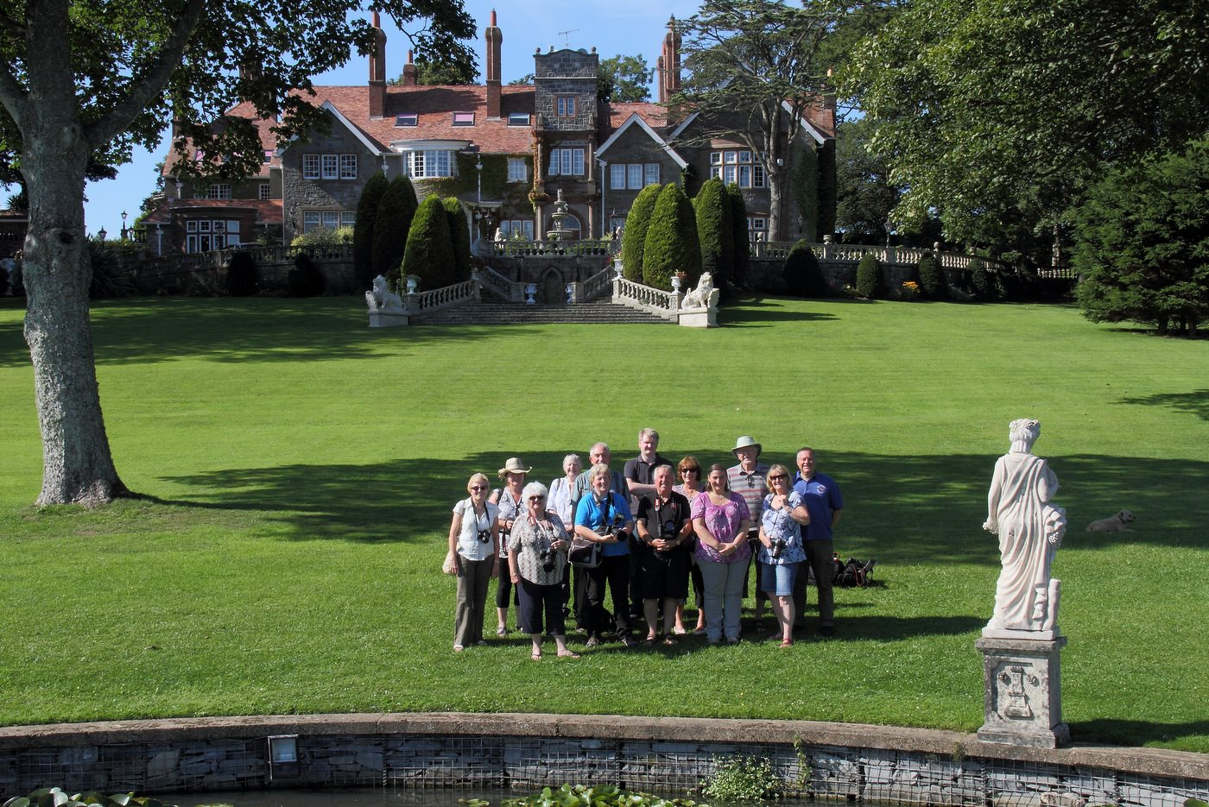
Members of the IOMPS on the lawn at Billown Mansions
The Society was very privileged to be allowed into the grounds at Billown Mansions to take photos. It was a glorious afternoon and there was plenty to photography, from the swans on the lake to the statues, the gorgeous house within the grounds or the many bugs and butterflies within the flower gardens.

16th September 2013 - IOMPS Visit to Ramsey Lifeboat Station
Image missing
Members of the Isle of Man Photographic Society at Ramsey Lifeboat Station
Several members of the Society attended a summer outing arranged to visit Ramsey Lifeboat Station. We were warmly greeted by Alistair who gave us a tour of the inside of the lifeboat and the controls on board. It was very interesting being able to see inside a lifeboat and many of us hope we never have to encounter it for real!
It was a crew training nights and the crew where conducting radio training, and one member kindly put on all his life gear and kindly posed for a few photos. We were given free reign to take photos inside and out of the life boat and room within the station.

16th September 2013 - New Season Starts Wednesday 25th September
The weather is changing, and autumn seems very close.... the "season of mists and mellow fruitfulness" will soon be upon us! It has been an excellent summer, and for the IOM Photographic Society, a very busy one - the highlight perhaps being a very successful exhibition in conjunction with Manx Heritage and the House of Manannan in Peel. The exhibition was to mark our 75th anniversary - the oldest club on the island dedicated to the art of photography - and combined a showing of a wide range of images by current club members with a display of camera and darkroom equipment used over the years. In addition, Andrew Barton, a leading local professional photographer, was generous in organising a series of 4 full-day workshops, each exploring aspects of photographic skills, and which was directly linked to the society's exhibition.
In addition, a series of outings was arranged during our "out-of-season" months, giving opportunity for members and potential members to explore and to take photographs in areas likely to provide good images - so included Billown Mansion (lovely gardens and lakes), Ramsey Lifeboat station, a boat trip to the Calf of Man (for wonderful coastal scenery and wildlife), and Ballaglass Glen (for the bluebells and river scenery) - and some of which will no doubt appear in competition in our new season, starting shortly......
The opening night is Wednesday, 25th September at Thie Ellyn, starting at 7:30pm - and will combine a social get-together after the summer break with some "practical activities". These will include an explanation of print mounting techniques and the rules for competition entries - important since many of our evening programmes include competition work - together with a studio set-up enabling either some still-life "table-top" shots lit by torches and side-lights or some portrait images lit by studio flash. Members are requested to bring their cameras to make use of the studio facility, and to provide some images for our meeting the following week (on 2nd October). That meeting will be in the format of a "two judges" evening - and listening to their respective thoughts and commentaries on a series of images to gain an insight into just what a judge is looking for in a competition entry. This is not a "competition night" but is intended to provide good entertainment (and lots of debate!) whilst demonstrating the difficulties - and the foibles / personal taste etc implicit in taking on the role of a judge..... and the different opinions and results that may come from having a different judge on an actual competition night......
IOM Photographic Society meetings are open to the public - non-members with a charge of £1 on the door - and all will be given a very warm welcome. Meetings are at Thie Ellyn (the Art Society building) in Withington Road, starting at 7:30pm. Full details of our programme can be found on the website at www.iomps.com, which also includes a personalised gallery for the display of work by our members.
By Chris Blyth

IOMPS Reports During October 2013

28th October 2013 - Double Event Week at the Isle of Man Photographic Society
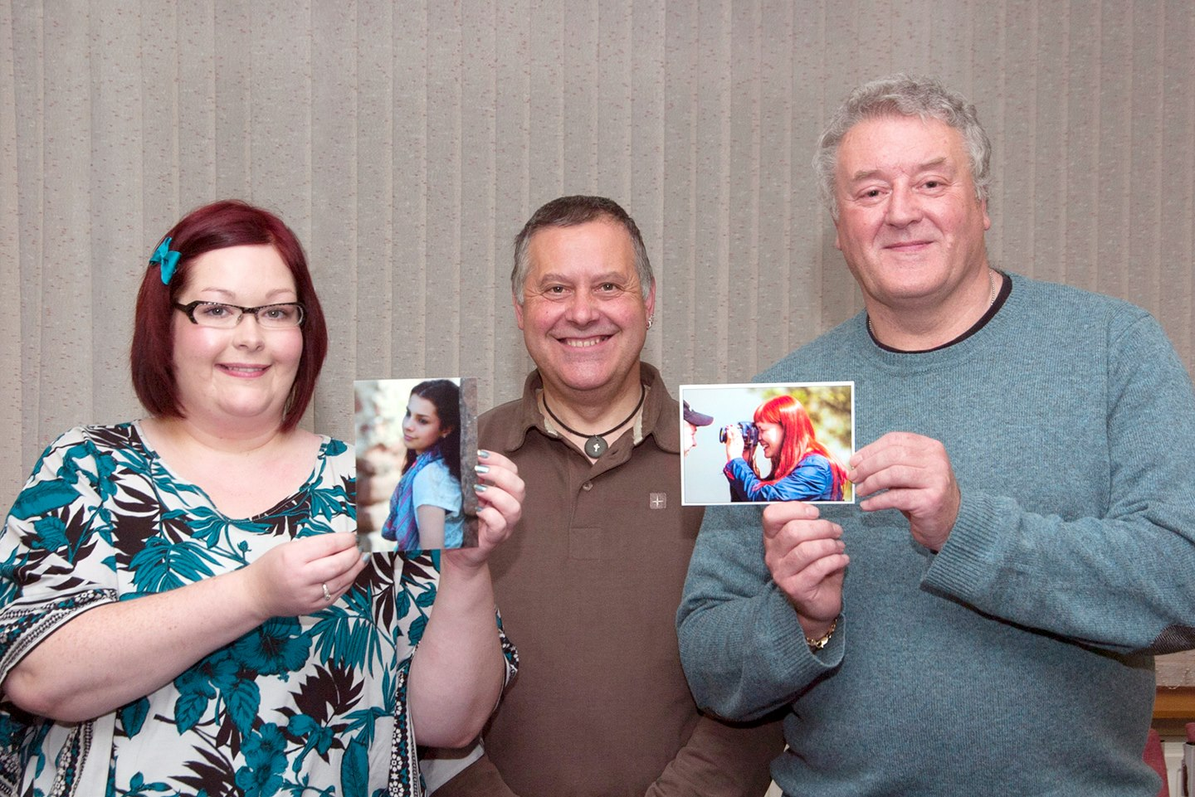
Judge Tony Curtis (centre) with Small Print winners Catherine Gillam and Martyn Parnell
The Isle of Man Photographic Society held a Small Print competition on Wednesday 23rd and took part in a three way digital slide battle on Friday 25th October
The Small Print competition was the first of the 2013 - 2014 season. It's a competition designed to encourage newer members to enter competitions and enables this to be done at minimum cost. Prints don't have to be mounted and can be any size up to 7.5 x 5 inches (127mm x 190mm). Entries are restricted to the Standard and Intermediate groups and can be any subject in colour or black & white.
Judges for this competition are normally drawn from the advanced section and on this occasion was judged by our President, Tony Curtis.
The competition is in two halves with the Standard Group being critiqued first. It was pleasing to see a record number of 32 entries in this section, mainly due to the recent influx of new members. Tony went through each one in detail and commented on both the good and bad points and made his own suggestions when necessary as to possible improvements. At the end he declared his selection of commendations and places up to sixth place. The Intermediate group with 22 entries was then judged with the places scored as follows:-
STANDARD
- 1st Sophie by Catherine Gillam
- 2nd Frozen in Time by Sue Collier
- 3rd Working Horse by Mark Falconer
- 5th Water Lily by Karen Norton
- 6th Sunset Gliders by Catherine Gillam
INTERMEDIATE
- 1st In Love Mode by Martyn Parnell
- 2nd Snack Time by Anne Bidwell
- 3rd Heron Landing by Annette Slater
- 4th Jackdaws by Jiri Podobsky
- 5th Sunflower by Shirley Lotfy
- 6th Sea Lion by Shirley Lotfy
The second event of the week was the annual three-way Digital Slide Battle between clubs on the Island, held at Glen Helen with John Watterson judging.
There was a good turnout from all three clubs and the evening started with a lovely buffet and then we got down to business.
John commented on each image and gave a score out of 20. At the half way point the IOMPS was leading by just 5 points but there was still a long way to go.
The final results were as follows:
1st Place - Isle of Man Photographic Society 401 points
2nd Place - Southern Photographic Society 380 points
3rd Place - Western Photographic Society 373 points
As well as the shield for the winning club there is a shield for the best image.
There were two images that scored 18 points on the evening, "Black-rimmed snout hoverfly reaching cuckoo flower with orange tip butterfly eggs" by Jiri Podobsky and "Turtle" by Robert Blyth-Skyrme, both IOMPS members. "Turtle" was chosen as the overall winner.
By Bob Servante

26th October 2013 - Three Way Inter Club Battle Results
Image missing
"Turtle" by Robert Blythe-Skyrme best overall image in the competition
Congratulations all round.
Last night was the three way battle between all the clubs on the Island, held at Glen Helen with John Watterson judging. John was very thorough with each image and his knowledge of the area / people in some of the photos was exceptional.
There was a good turnout from all three clubs and the evening started with a lovely buffet and then we got down to business.
At the half way point the IOMPS was leading but just 5 points but there was still a long way to go.
The final results were as follows:
1st Place – Isle of Man Photographic Society 401 points
2nd Place – Southern Photographic Society 380 points
3rd Place – Western Photographic Society 373 points
There were two images that scored 18 points on the evening, “Black-rimmed snout hoverfly reaching cuckoo flower with orange tip butterfly eggs” by Jiri Podobsky and “Turtle” by Robert Blyth-Skyrme both IOMPS members.
There can however, only be one overall winning image which this year was awarded to “Turtle” by Robert Blyth-Skyrme.
Thank you to everyone who submitted entries and enabled us to put together the winning images.
We now have the honour of organising next year’s event so keep those great images coming!
by Claire Stringer

24th October 2013 - First Digital Competition of the Season
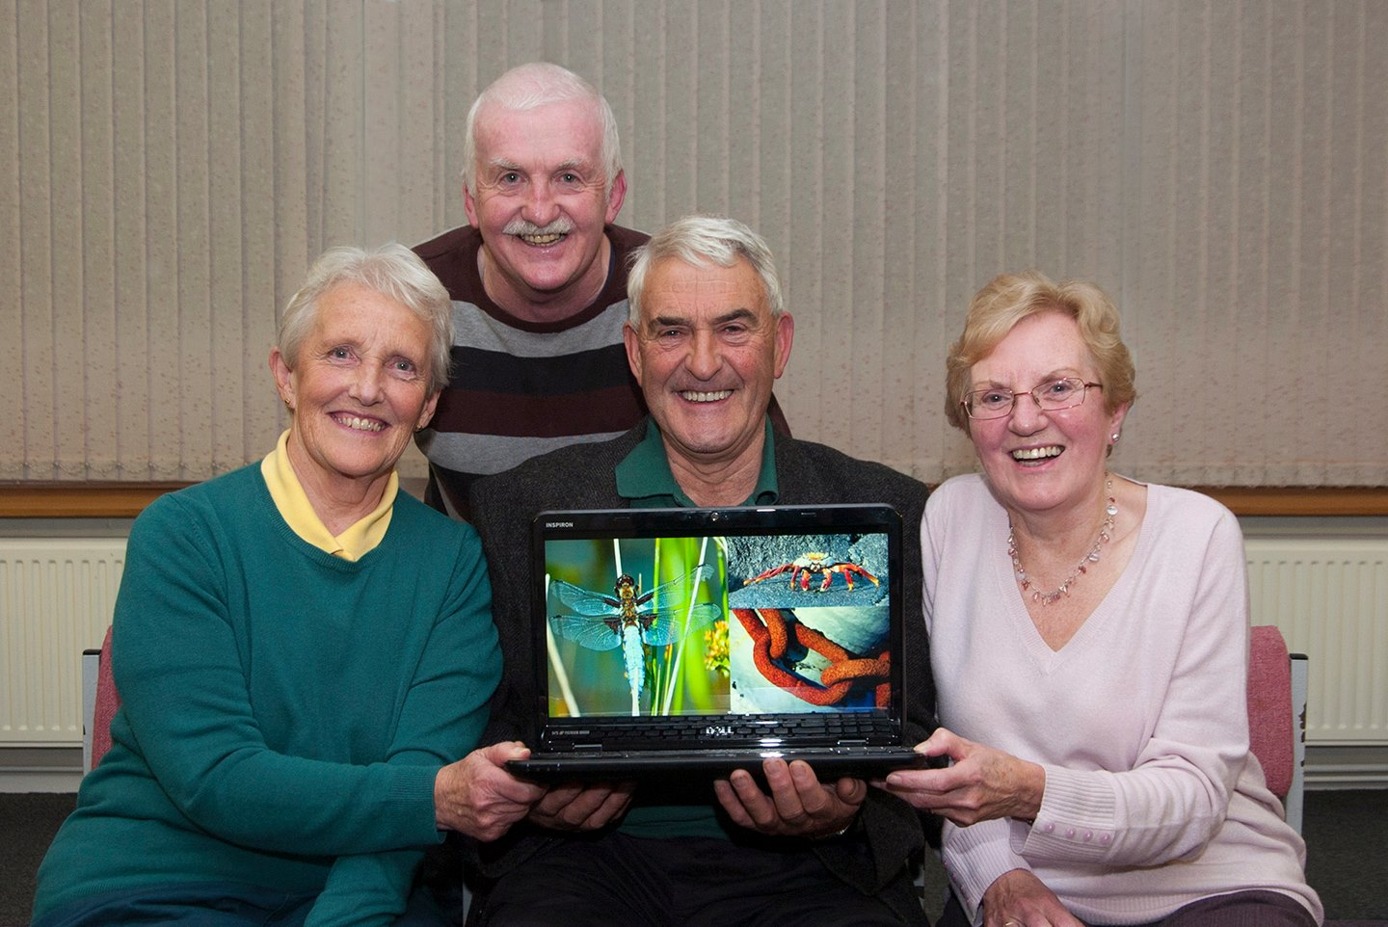
Open Digital competition winners Norma Cowell, Brian Speedie and Shirley Lotfy with Judge Alex Maddrell
The Society was pleased at its last meeting to extend a warm welcome back as its judge highly respected local personality and keen photographer, Alex Maddrell. This time, he was invited to assess and rank the projected digital images entered by members in the second part of our October ‘open’ competition.
There was a total of 69 entries and Alex began by complimenting members of the Society on the extremely high quality of the images presented to him for assessment. He made special mention of the quality of the entries in the ‘Standard’ section, saying that many of them were good enough to compete against entries in the higher ‘Intermediate’ section.
Alex began by recounting a chance meeting he had had with two professional photographers when out walking with his dog a few months ago up by the Chasms. They were different nationalities and he had used the opportunity to quiz them about their thoughts on what a judge should look for in assessing competition entries. Though he was an experienced judge, had used their comments as a guide when judging this competition.
As a former head teacher, Alex is no stranger to speaking to large groups and his eloquence and detailed explanations on every entry were much appreciated by everyone present. He offered perceptive, helpful and encouraging comments on the best use of available lighting, angle of view, composition, achieving the required tonal range in mono and overall presentation, taking time to suggest where improvements might have been made. Undaunted by the wide range of subject matter before him, his assessment of the images was as sound as you would expect from such a knowledgeable judge. With a never waning sense of enthusiasm, Alex gave clear, concise explanations and reasoning to justify the rankings he had eventually decided upon.
He announced his final ‘orders of merit’ as follows:-
Results:
Standard Group – 1st ‘Damselfly’, by Norma Cowell; 2nd ‘Where are you?’, by Nessie Gillen; 3rd ‘Pride of Madeira’ by Beryl Quayle; 4th ‘Golden Sleeper’ by David Norton; 5th ‘Watch out Guy – He’s behind you!’ by Mark Corlett; and 6th ‘Ice Cold in Laxey’ by Mark Thorsby. Very Highly Commended was ‘Boiling Mud’ by Joy Brodie. Highly Commended were ‘Dark Green Fritillary’ by Aida Podobska; ‘Summer Reminiscence’ by Nessie Gillen; ‘Museum Motif’ by Tim Norton; ‘Nepalese Red Lacewing’ by Sue Collier; ‘The Red Arrows’ by Mark Thorsby; and ‘Evacuees’ by Mark Falconer. Commended were ‘Gaudi Ceiling’ by Tim Norton; ‘Here’s Looking at You’ by
Intermediate Group – 1st ‘Sally Lightfoot Crab’ by Shirley Lotfy; 2nd ‘Whelk Catch’ by Jenny Shanley; 3rd ‘Fun in Sheffield City centre’ by Phyllis Christian; 4th ‘King Vulture’ by Anne Bidwell; 5th ’Chevvy Reflection’ by Jenny Shanley; and 6th ‘Blowing in the Wind’ by Phyllis Christian. Two entries, ‘Autumn’ by Hazel Walsh and ‘St Botolph’s Church, Boston’ by Martyn Parnell were Very highly Commended. Highly Commended were ‘Up, Up and Away’ by Annette Slater and ‘Jackdaw’ by Jiri Podobosky. Commended were ‘Oyster Catcher’ by Annette Slater; ‘South Barrule Autumn’ and ‘Miss Tiggywinckle’ both by Elaine Dewhurst;
Advanced Group – 1st ‘Rusty Linkspan’ by Brian Speedie; 2nd ‘Duck Hydroplaning’ by Bob Servante; 3rd ‘Full Power’ by Sue Jones; 4th ‘Warhorse’ by Brian Speedie; 5th ‘Under Sail’ by Sue Jones’; 6th ‘Staring into Space’ by Claire Stringer. Very Highly Commended were ‘The Passages’ and ‘Waxwing’ by Diane McCudden; and ‘Our Victorian Portrait’ by Patricia Harvey. Highly Commended were ‘Red Arrows in Formation’ by Janet Servante; ‘The Painted Hall, Greenwich’ by John Phipp; and ‘Canoeist’ by Claire Stringer. Commended were ‘The Apothecary, Haworth’ by John Phipp; and ‘Time for Lunch’ by Mark Stringer.
In his vote of thanks, the Society President thanked Alex for taking so much time and care to judge once more and said how appreciative we were to have such high calibre judges on the Island supporting amateur photography. Members had learned a great deal from listening to his expert analysis, as always.
On Wednesday, 30th October at 7.30 pm at Thie Ellyn, off Withington Road, Douglas, we shall have our first assignment competition of the year, the subject being ‘Circles’. This will be for both prints and projected digital images and promises to be very entertaining. We shall look forward to welcoming you then and would ask readers to note that there is a nominal charge for non members.
By ANTONY HAMILTON

17th October 2013 - First Open Competition of the Season
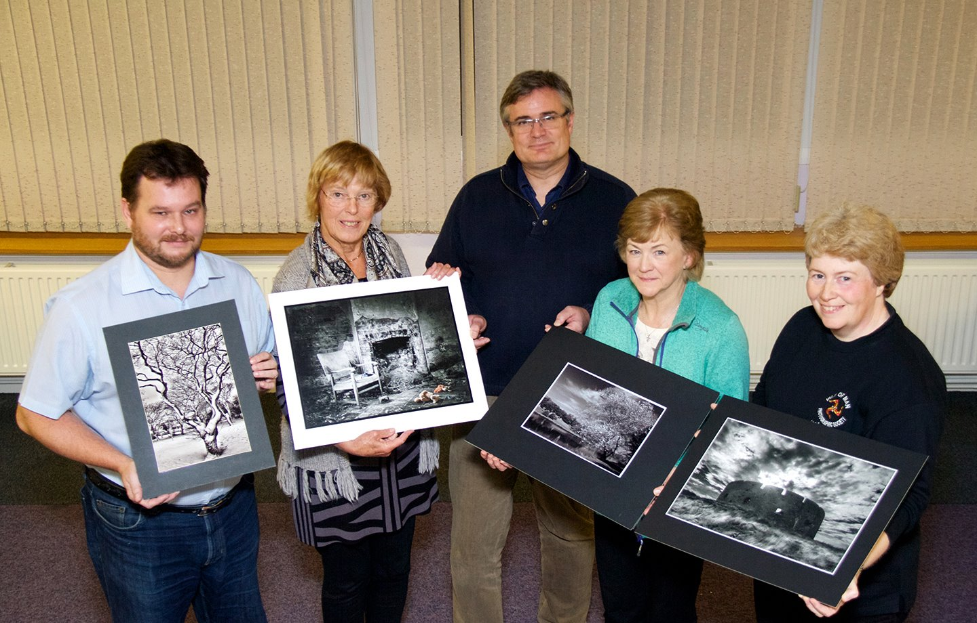
Judge Andrew Barton (centre) with Open Print winners Mark Falconer, Ruth Nicholls, Elaine Dewhirst and Sue Jones
An Open Prints competition provided the entertainment for the latest meeting of the IOM Photographic Society, and was judged by Andrew Barton, a popular and frequent visitor to the club. Andrew has a very good "eye" as a professional for an image which has impact and quality - whether in the "decisive moment" of its taking, or in the craft and technique of its preparation. His commentary was, as always, well considered and pertinent, clarifying the good points of each image but also suggesting where improvements might be made - for example in the composition, printing, or mounting. Nearly 80 images were entered in the competition, a significant number being from new members - all received a full evaluation in what proved to be an excellent, high quality entry, and a very encouraging start to our competitive programme.
Mark Falconer, a new member in the Standard group, had a very good evening, with success in both the mono and colour prints sections. A crisp and high resolution image of trees giving an almost 3D effect, provided his winning entry in the mono section, whilst an image of two young ladies shot at Peel Castle gave him a second place (interestingly, shot on one of the seminars organised in support of the club's 75th anniversary exhibition at the House of Manannan). Mark Corlett gained a 3rd place with a dramatic winter view of Sky Hill. In the colour prints section, an image of a girl sitting on one of a series of park benches gave Mark Falconer another first place - the line of benches giving a very strong compositional lead-in line. Good exposure and printing of an otter with its baby earnt Paul Dougherty second place in the section, whilst Norma Cowell's portrait of a young man against a background of an Agneash cottage gave her a third place.
In similar fashion, the Intermediate group was dominated by Elaine Dewhirst, in both the mono and colour sections. A well exposed and printed image of trees by a lakeside was judged as "very well handled" and gave Elaine her mono win, whilst her image of a child in the bath was considered a "little flat in the lighting and perhaps too tightly cropped" but nevertheless earnt her a third place. Splitting Elaine's awards for second place was Jenny Shanley's image of tombstones at Jurby in the snow, the shadows creating a very graphic and stark image. Elaine's shot of a swan rising out of the water, the wing feathers beautifully backlit and almost transparent won the colour section, whilst another bird image, also with outstretched wings , gained Annette Slater a second place. Jiri Podobsky's Manx cat image, full of detail in the fur, with good lighting and well printed ensured a third place.
The Advanced group provided both the largest entry and perhaps the closest competition, with awards being spread widely, though the two members often regarded as the most skilled in the club, vied with each other for the main awards. Sue Jones came out on top in the mono section with a shot of Derby Fort on Langness, the fort backlit against a dramatic sky, with Ruth Nicholls coming in second with a strong male portrait, the characterful face well shown against a street grafitti background. A bicycle parked against a bench in the snow had good lighting and was well printed, giving Claire Stringer a third place. Leading positions swapped in the colour section - Ruth's high quality image of a chair in a derelict cottage with some abandoned toys on the floor, winning first place, and Sue this time in second place with her studio shot of glass bottles, the lighting emphasising the reflections, colours and shadows. Brian Speedie produced an excellent portrait of a meerkat with a child in the background, the child clearly enjoying the moment and the face slightly (but deliberately) out of focus, for a third place.
RESULTS : STANDARD GROUP Mono Prints - Mark Falconer (1 & 2), Mark Corlett (3), Aida Podobska (4), Joy Brodie (% & 6). Colour Prints - Mark Falconer (1 & 4), Paul Dougherty (2 & 6), Norma Cowell (3), Sue Collier (5). INTERMEDIATE GROUP Mono Prints - Elaine Dewhirst (1 & 3), Jenny Shanley (2), Anne Bidwell (4 & 5). Colour Prints - Elaine Dewhirst (1 & 4), Annette Slater (2 & HC), Jiri Podobsky (3), Jenny Shanley (5), Peter Brew (6), Ian Lumsden (HC). ADVANCED GROUP Mono Prints - Sue Jones (1), Ruth Nicholls (2), Claire Stringer (3), Bob Servante (4), Mark Stringer (5 & 6), Tony Curtis (HC), Chris Blyth (HC). Colour Prints - Ruth Nicholls (1), Sue Jones (2), Brian Speedie (3), Janet Servante (4), Bob Servante (5 & HC), Claire Stringer (6), Mark Stringer (HC).
IOM Photographic Society meetings are held at Thie Ellyn (the Art Society building) in Withington Road, Douglas, starting at 7:30pm. and are open to all, non-members (with an entry fee of £1) will always be given a warm welcome.
By Chris Blyth

10th October 2013
Image missing
Judges Chris Blyth and Ruth Nicholls who gave an excellent critique of members images
Despite the appalling wet weather, Wednesday 2nd October saw a good attendance of IOMPS members both old and new.
This second meeting of the season followed on from last week's practical evening where everyone had a chance to pick up hints and tips on the use of lighting and how to mount their photos for competitions.
This evening everyone had a chance to show off their work in the form of randomly presented digital projected images where the authors remained anonymous. The images were then informally critiqued by two judges, both seasoned members and accomplished photographers.
The judges, Chris Blyth and Ruth Nicholls have many years of photographic experience and took turns to assess each image, and while Chris noted several technical and compositional mistakes, Ruth was kinder and pointed out the aesthetic and artistic merits of the pictures.
They both showed their vast knowledge of photography by suggesting various ways and means of improving and enhancing each image in turn.
As this was not a competition the audience were encouraged to interrupt and ask questions or make comments of their own.
The evening was both informative and entertaining with Chris and Ruth imparting many supportive, helpful and encouraging words of advice.
Each year the Isle of Man photographic clubs are invited to take part in The Celtic Challenge. This is a prestigious competition of international standard in which eight of the Celtic Nations enter images for assessment and judging.
We were treated to a viewing of the Manx print entries by Ruth Nicholls who had worked hard to gather enough entries to take to Ireland for this years competition.
There were some very high quality photos and one, “Street Voices” by Ron Shimmin had gained a wonderful score of 19 out of a possible 20 points.
It was a very strong competition and unfortunately the Isle of Man came last with 487 points due in part to having very few entrants.
So, if you think you have some cracking images remember to have them ready for Ruth to enter into next years Celtic Challenge.
On 16th October there will be an Open Digital competition. Also, entries are due in on the same evening for the next Small Print competition where prints should be un-mounted and no more than 7.5” x 7” in size.
For a nominal charge of just £1.00 anyone is welcome to join us at Thie Ellyn (off Withington Rd.) on Wednesday evenings at 7.30pm.
Please visit www.iomps.com for more information about the society.
By Anne Bidwell

1st October 2013 - The new season has started at IOMPS
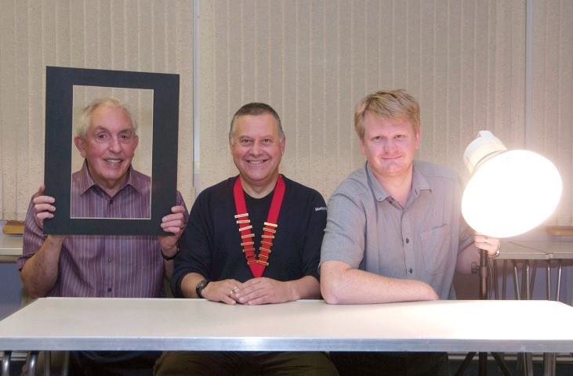
Committee members Ian Lumsden (left) and Mark Stringer (right) who along with President Tony Curtis demonstrated print framing and mounting and lighting techniques during the first evening of the new season
The Isle of Man Photographic Society held the first meeting of the new
2013-14 season on Wednesday evening the 25th September at Thie Ellyn off
Withington Road, Douglas.
As well as regular members returning after the summer break many new faces
were evident in the room.
Our President, Tony Curtis, opened the evening with a welcome to all the new
people who hopefully will become new members. Tony went on to report on the
success of the Society's 75th Anniversary Exhibition at Peel that which was
run over the summer. The Guest book indicates that the Exhibition attracted
visitors world wide. After covering the first few weeks of the Programme, he
introduced three workshops which were going to be run during the evening.
The first one covered mounting and framing aimed at newcomers and included
examples of entries from previous competitions. The other two were studio
set-ups - one for small objects, including how to produce High Key results
using ambient fluorescent and tungsten lighting and the other for Portraits
using studio flash, umbrellas and soft boxes.
Members had been encouraged to bring their own cameras to take
general photographs during the evening with a view to presenting some of
these in a non-point scoring judging. These will be critiqued by two judges
in a ''just for fun'' competition.
After the workshops a tea and coffee break was held and the evening finished
off with a chat with friends old and new.
Next week entries are due for the second competition of the season - Open
Digital.
By Bob Servante

IOMPS Reports During November 2013

28th November 2013 - Open Print Competition
Open Print winners with Judge John Atkinson. L to R: Sue Jones, Nessie Gillen, Mark Falconer, John Atkinson, Annette Slater, Elaine Dewhirst - (image missing)
The Isle off Man Photographic Society held its latest Open Print competition
of the 2013 - 2014 season on Wednesday evening the 20 November at Thie
Ellyn, off Withington Road, Douglas.
Our President, Tony Curtis, opened the evening and briefly introduced the
Judge for the evening, John Atkinson. John gave a fuller introduction of his
photographic history and explained his criteria for judging. He explained
that the mechanics of getting a good photograph were built into modern
cameras and so differences in image impact came down to the artistic input
from the Photographer. John then proceeded to critique every photo in the
three sections, Standard, Intermediate and Advanced and awarding
commendations and top places in each section. Top places were as follows:-
STANDARD MONO
1st Bobbing Boats by Nessie Gillen
2nd Red Bull Dude by Nessie Gillen
3rd Prowess by Norma Cowell
STANDARD COLOUR
1st Injebreck Reflections by Mark Falconer
2nd Jumping Jills by Mark Faulconer
3rd Succulent by Sue Collier
INTERMEDIATE MONO
1st The Unguilded Lilly by Annette Slater
2nd 8 O'clock Shadow by Jenny Shanley
3rd Hot Shoeing the Horse by Elaine Dewhirst
INTERMEDIATE COLOUR
1st Is it Christmas Yet? By Elaine Dewhirst
2nd Young Reindeer by Jiri Podobsky
3rd A Splash of Colour by Annett Slater
ADVANCED MONO
1st Lone Tree by Sue Jones
2nd Fontrevaud Abbey by Ruth Nicholls
3rd Who's for Peace by Bob Servante
ADVANCED COLOUR
1st The Haunting by Sue Jones
2nd Arctic Turn with Sand Eel by Janet Servante
3rd Cam Donald in Reflective Mood
by Bob Servante

18th November 2013 - Small Print Competition

Small Print Competition winners Martyn Parnell (left) and Mark Falconer with Judge John Phipp (centre)
~~John Phipp, an experienced club judge and a past President, was called upon once more last Wednesday to assess and comment on the entries in the Society’s second ‘Small Prints’ Competition of the season. Drawing on his photographic knowledge and skills, he was quickly in his stride and discussing the 47 entries, 32 in the Standard Category and 15 in the Intermediate Category. His comments were perceptive but also gentle in nature with constructive tips being offered along the way.
The Society has always been keen to help and encourage the less experienced to improve their photographic skills. With this in mind, the ‘Small Print’ Competition was introduced a few years ago as an inexpensive vehicle to incentivise the less experienced to submit their work for kindly appraisal and advice, with the usual need to have the print images mounted, which can be a bit costly, being removed. For this reason, the more advanced workers are excluded from entering this competition.
Up to three images can be submitted for the competition and, to qualify as a ‘small print’, the maximum print size permitted, including any border, is 5 by 7.5 inches.
John offered his expert advice on how each of the entries might have been improved, though he described several as being so good he could only compliment the photographer on a job well done! He touched on the need for a careful choice over the angle of view and such techniques as the importance of good composition, the use of different apertures for different subjects and cropping to remove distracting peripheral detail or parts of the image that added nothing to the subject matter. In these ways, the photographer could improve the impact of the image.
He went on to explain to members that any prints entered in this competition for critical appraisal can not be entered in any of the Society’s monthly competitions but are eligible for entry in a mounted format in the Annual Competition at the end of the season.
The Small Print Competitions run by the Society are rather different to the others in that they are more in the nature of a tutorial where the more experienced members try to offer advice designed to help those who are striving to improve. Consequently, there are no real ‘winners or losers’. In fact, John confirmed what others had been saying over recent months, namely that there had been a highly commendable improvement in the overall standard, especially with the Standard Class entries, that selecting an order of merit was becoming increasingly more difficult for judges! However, John had been set a task to select his personal rankings for the two Classes, which he gave as follows:-
Standard Class – 1st was ‘What U Looking At?’ by Mark Falconer (a beautifully sharp shot of an owl looking straight into the camera lens) who also bagged 2nd place with a clever shot, called ‘Happy Snapper’, illustrating what can be done to throw a secondary image in the background out of focus; 3rd place went to Sue Collier for ‘Beach Chums’; 4th to Norma Cowell for ‘Wakey Wakey’; 5th to Joy Brodie for ‘Fish Supper Anyone?’; and 6th to Aida Podobska for ‘Dark Green Fritillary’. Because the overall standard was so considered to be so meritorious, the judge also awarded Very Highly Commended to Beryl Quayle for ‘Pretty as a Peacock’, to Nessie Gillen for ‘Brotherly Love’ and to Mark Thorsby for ‘Tuesday’s Child’. ‘Winter Tram’ by Mark Falconer and ‘Chinese Float-Away’ by Tim Norton were Highly Commended and ‘Sophie’ by Cat Gillam, and ‘Young Buck’ by Mark Thorsby were given a Commended classification.
Intermediate Class – 1st place was awarded to Martyn Parnell for ‘Heron Suzuki’ (a top class image from the TT Races); Annette Slater maintained her improving natural history photography by being ranked 2nd with her entry titled ‘Grey Heron Resting’ and, as if to prove the point, she also gained 3rd and 4th places with ‘White Peahen’ and ‘Head Held High Wearing His Sapphire Crown’ respectively; 5th was ‘Hibiscus’ by Shirley Lotfy; and 6th ‘Winter Coat’ by Jiri Podobsky. Two further entries, ‘Gull Detail’ by Shirley Lotfy and ‘Waiting’ by Anne Bidwell were both Highly Commended by the judge.
After a break for refreshments, the Lancashire and Cheshire Photographic Union’s Mono Print Folio, made up of 40 digital images from the North West region, was viewed. This is probably the smallest of the Folios that the Lancashire and Cheshire Photographic Union circulates because there tend to be fewer monochromatic entries submitted. Nevertheless, the panel of UK judges is hard to please and nothing but the best is considered acceptable. So, members were delighted to see that one image from a member of the Society, Diane McCudden, had been selected for inclusion, being awarded 13 out of the maximum 15 points. This demonstrates once more the Society’s ability to compete with the best.
The Society is pleased to give advance confirmation that it is bringing the well known ‘Bebington Salon’ to the Isle of Man again on the 14th May 2014. The Bebington Salon is one of the national exhibitions from the UK and is a great opportunity for all those interested in photography to both see work from the adjacent island and to compete with the best, with entries being judged at a national level. When the Society invites Bob Dennis to bring the Salon over he always tries to include any Isle of Man images that were accepted by the judging panel as having achieved the required standard. Acceptance of an image by the Salon also leads to the award of points towards the BPE* accreditations.
By Antony Hamilton

14th November 2013
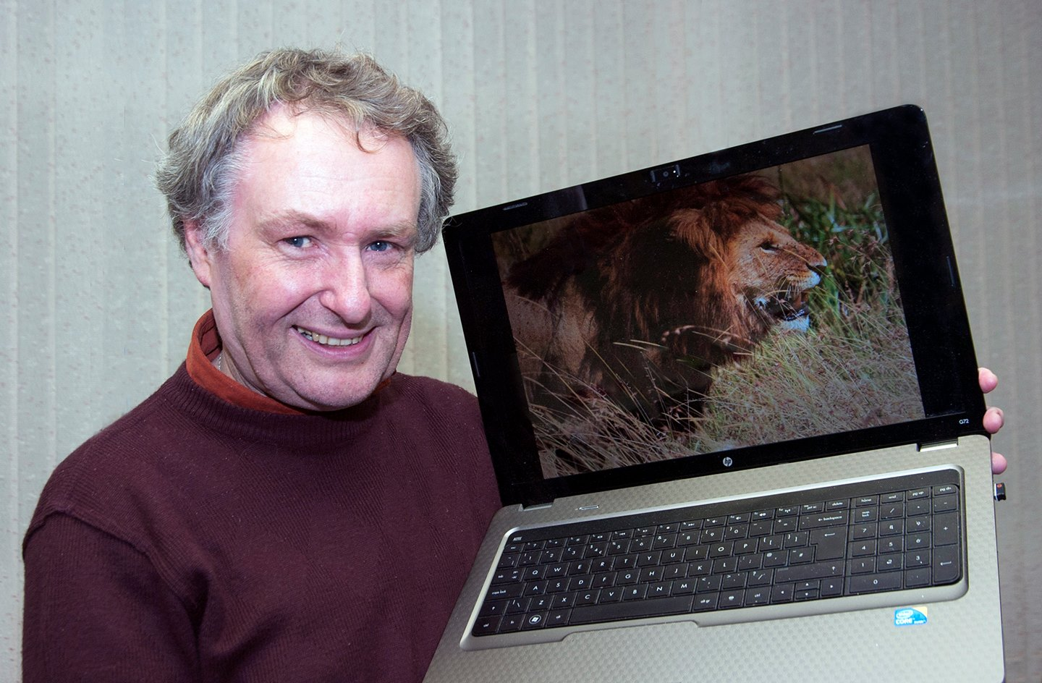
Dr Jeremy Paul with one of his excellent wildlife images
The IOM Photographic Society was this week delighted to welcome Dr Jeremy Paul, a regular visitor to the Society and a very popular speaker, as was proved by a large and enthusiastic audience. Dr Paul is a world class wildlife artist, a category winner of the BBC Wildlife Artist of the Year competition for the three consecutive years 2010-2012, and exhibitions of his work have been held in a number of leading international galleries. He holds a doctorate in marine biology, and has developed his painting skills over nearly 30 years - the two going together to ensure the accuracy of detail of the wildlife being portrayed, and of their setting in their natural environment.
On his last visit to the Society just over a year ago, Dr Paul had shown images from two trips undertaken to Botswana and to Svalbard - this time a more recent visit to the Masai Mara on the Tanzanian / Kenyan borders was the major feature of his images. Taken on a specialist photographic safari with a small number of fellow artists, his images were show stoppers - a mixture of stunning shots of wildlife, whether small birds such as red-beaked oxpeckers and lilac breasted rollers, or of the larger mammals such as cape buffalo, cheetahs and hippos, as well as amazing landscape images showing the "big skies" of Africa, the colours of the sunsets, or the changing cloud patterns with an approaching storm. The shots were all accompanied by an expert commentary, explaining details (sometimes gory!) of the habitat, feeding habits, and lifestyle of the creatures being shown - a virtuoso performance which enthralled our audience.
To complete what was an exceptional photographic display, Dr Paul showed a "time lapse" sequence of images taken at 20-30 minute intervals to demonstrate the development of several of his works. Initially a background roughly painted on to an mdf board, through the various stages of sketching out and painting in his layout, through the multiple paint layers to develop the complexity of detail, through to the finished work - an absorbing and fascinating process explained very quietly but as always, with great skill and authority.
The Manx Museum in Douglas is currently (and until early January) holding an exhibition of his paintings and his photography - I can only strongly recommend that anyone reading this article and who has not yet seen the exhibition, should go...... it is an unmissable show of artistic excellence, with many beautiful and highly detailed illustrations of wildlife, presented with backgrounds very much in tune with their natural environment - be it an albatross in the stormy Antarctic ocean, a cheetah on the African savannah, or a polar bear on Svalbard....
IOM Photographic Society meetings are open to the public - non-members with a charge of £1 on the door - and all will be given a very warm welcome. Meetings are at Thie Ellyn (the Art Society building) in Withington Road, starting at 7:30pm. Our next meeting on 20th November is the judging of an Open Prints Competition. Full details of our programme can be found on the website at www.iomps.com, which also includes a personalised gallery for the display of work by our members.
By Chris Blyth

7th November 2013 - PHOTO COMPETITION IN CIRCLES

Circles assignment print winners Mark Falconer, Nessie Gillen, Elaine Dewhirst and Sue Jones with Judge Ray Kelly (centre)
Last wednesday October 30th, the Isle of Man Photographic Society held an assignment competition entitled “Circles”.
As usual there were three ability groups each showing entries in mono prints, colour prints and digital projected images.
The unenviable task of judging was down to Ray Kelly who did so with his succinct and humorous style and with kind comments and good points well made.
As the assignment brief was “circles!, Ray kept that in mind as he perused each image to see how well the picture fitted the subject.
New member, Mark Falconer's “Brummy Buttons” was the best mono print in the Standard group entries. An excellent, well seen photo.
The best colour print in the same group was by another new member, Nessie Gillen. Nessie's “Retro Candy” showed a double row of Polo Fruits.
The best digital image belonged to Mark Thorsby. “Abstract Circles” was a lovely picture of a droplet in water with ripples.
In the Intermediate group Elaine Dewhirst won both the mono and colour prints section with “Ever Decreasing Circles” a sharp and well lit image of some cookie cutters. Also “”Steam Train Wheels”, a well taken photo in a good format.
The Intermediate digital entry was won by Anne Bidwell with an amusing image called “Smartie Pants” which was a picture made from Smarties shaped into a pair of panties.
Finally the Advanced group had their work judged by Ray with Sue Jones and Ron Shimmin taking the top places.
Sue won both the mono print and digital sections with “Shades” and “Decreasing Circles”. “Shades” was a simple composition of a pair of sunglasses in shadow. Her digital entry “Decreasing Circles” was a very pleasing image of coloured circles in a light tube.
Ron Shimmin's “Circles In The Park” was a view of a park seen through three circles cut into a stone slab. A well lit, sharp and colourful image.
Ray judged clearly and fairly and was very impressed by all of the entries. He said how the club has gone from strength to strength over the past year and how much the standard of the members work has improved.
RESULTS
Mono Prints
Standard
1 & 3 Mark Falconer
2 & 4 Nessie Gillen
5 & 6 Joy Brodie
Intermediate
1 & 2 Elaine Dewhirst
3 & 4 Anne Bidwell
Advanced
1 & 5 Sue Jones
2 & 4 Bob Servante
3 & 6 Claire Stringer
Colour Prints
Standard
1 & 4 Nessie Gillen
2 Mark Falconer
3 Norma Cowell
5 Mike Trout
6 Joy Brodie
Intermediate
1 & 6 Elaine Dewhirst
2 Jenny Shanley
3 Anne Bidwell
4 Shirley Lotfy
5 Ian Lumsden
Advanced
1 Ron Shimmin
2 & 3 Sue Jones
4 Bob Servante
5 Dave Welsh
6 Chris Blyth
Digital
Standard
1 Mark Thorsby
2 Joy Brodie
3 Thomas Carr
4 & 5 Nessie Gillen
6 Norma Cowell
Intermediate
1 Anne Bidwell
2 & 4 Shirley Lotfy
3 & 5 Phyllis Christian
6 Hazel Walsh
Advanced
1 & 5 Sue Jones
2 & 3 Bob Servante
4 Janet Servante
6 Claire Stringer
On 13th Nov. there will be an Small Print competition and a viewing of the L&CPU Mono Portfolio. Also, entries are due in on the same evening for the next Open Prints competition.
For a nominal charge of just £1.00 anyone is welcome to join us at Thie Ellyn (off Withington Rd.) on Wedneday evenings at 7.30pm.
Please visit www.iomps.com for more information about the society.
By Anne Bidwell

IOMPS Reports During December 2013

18th December 2013 - Triptych Competition

Triptych competition winner John Phipp (left) with Judge Ray Davies
~~To bring the first half of our Winter Programme to a close, the Society held its Christmas Social at ‘Edwards’, King Edward Bay Golf Club, where a splendid meal was served by the attentive staff in the well-appointed Restaurant. The menu was varied and seemed to suit all present. It was rather a stormy night (weather wise) but the atmosphere inside was warm, friendly and festive, as is always the case with this venue.
The Committee had arranged a triptych competition in advance with the results to be announced on the night. In order to qualify as a triptych, an entry in the competition was required to be of three separate images on a common theme to be mounted on board of a specified size and these had to relate clearly to each other. Triptychs are used for those occasions when a sequence of photos can tell a story more effectively than a single image.
The judge for the evening was Society member, Ray Davies. Work and family commitments had meant that Ray had been a less frequent visitor on the Society’s regular Wednesday evenings over the last couple of years but it was good to see that his eloquence and judgement had not been impaired by his enforced absence! We had all been looking forward to seeing him again and he did not disappoint by his presentation on the night. He quickly set about giving a critique on each of the 14 entries, prefacing his remarks with a clear explanation of the criteria he had used in arriving at his conclusions.
As the subject for the competition was ‘open’ and individual members could decide for themselves what theme to pick, the 14 entries covered just as many topics. This added greatly to the entertainment and interest for those present. Judging any open competition is a challenging task but it quickly became clear when we heard his comments and reasoning that Ray was well up to that challenge, drawing on his knowledge and experience in analysing the merits of each one in turn. His comments also offered a useful insight as to what features he felt were important in judging such a competition. For example, he mentioned the relationship between the three images; the composition of each; the developing story each image told; and the extent to which each image complemented the other two.
He began giving his commentary by complimenting all of the entrants for the overall quality of their images and of their presentation. He pointed to the positioning and arrangement of the three print images, and suggested how the entries might have been given even more impact, adding that all of the 14 boards had been presented to a commendably high standard.
Ray had chosen an entry titled ‘Painted Doors, Funchal’ by John Phipp as the overall winner, earning for him the award of the Wesley Trophy (which will be presented at the annual Society dinner in April, 2014). The judge had been impressed with the sharpness and detail in the the images of three painted doors on the island of Madeira which demonstrated a high degree of photographic skill. A close second place went to Annette Slater for her three images of a game of Chess titled ‘A Game of Two Halves’. Though the title could have been better, in his opinion, Ray felt that the level of photographic skill displayed, especially the differential focussing, coupled with the presentation of the unfolding moves warranted such a high placing. Third place went to ‘October Frightfest’, a rather scary image by Sue Jones and fourth place to ‘Nativity Scene’ by Ron Shimmin, a beautifully crisp and sharp image with a great deal of impact. Fifth was ‘Sadie, Little Miss Mischief’ by Dave Walsh, a delightful set off images of a charmingly photogenic child. Sixth was Bob Servante’s image titled ‘The Red Dragon’. Ray decided to give a ‘Highly Commended to ‘Peel Portraiture’ by Tony Curtis and a Commended’ to ’Swallows on Lantana’ by Richard Shafto.
A most enjoyable social evening was brought to a close by our President, Tony Curtis, as he thanked Ray Davies for his thoughtful and perceptive judging, all those who had entered the competition; the staff at ‘;Edwards’ for the most enjoyable meal; and he offered best wishes to all for the festive season.
We congratulate one of our Junior Members, Sam Bucknall, in having one of his images chosen by a panel of eminent judges for inclusion in the 2014 Crowe Morgan Calendar for the third consecutive year. This well respected local Accountancy practice has been producing a desk calendar each year for distributed to its international client base, giving marvellous publicity to the Isle of Man, and using it as a vehicle to encourage children of school age to become interested in improving their photography.
The Society is now enjoying a festive break and, no doubt, our members are busy making plans to capture a winning image (or more) over the holiday period whilst hoping (as this article is penned) that Father Christmas might bring them a few photographic goodies on Christmas morning!
Our next meeting will be held at Thie Ellyn, off Withington Road at 7.30 pm on Wednesday, 8th January when our President will be entertaining us with a presentation of his own photography. The entries will also be due in on that night for the third of our ‘small prints’ competitions. All guests will be most welcome to come along, for whom there will be a small charge, unless they are in full time study.
by Anthony Hamilton

11th December 2013 - Assignment Competition 'Instruments'

Assignment Print winners with Judge Dennis Wood. Left to Right: Elaine Dewhirst, Mark Thorsby, Dennis Wood, Ian Lumsden and Nessie Gillen.
~~An assignment competition for both prints and digitally projected images on the theme of "instruments" was the topic for this week's meeting of the IOM Photographic Society. A wide variety of images were presented - featuring musical, medical and scientific instruments as well as various other interpretations of the theme. As has been the norm during this season, we again had a large audience for the event - photography is clearly alive and flourishing on the Island!
Our judge for the assignment - and an excellent choice - was Dennis Wood, a life-long photographer with lots of experience and enthusiasm. This was all readily apparent in a discerning commentary, giving a very measured critique of each entry and explaining in great detail his thoughts on the image, at the same time packed with helpful advice. Of particular note was the judge's insistence on a firm interpretation of the assignment - was an image of a musician, for example, more a portrait of the artist than of the instrument being played? If of the artist, then it perhaps failed a critical criterion for the competition...... Dennis also made clear that all his comments were predicated on the understanding that they were entirely his opinion given the environment of a photographic competition - out of that context, if the photographer gets pleasure or fulfilment from his or her images, then that was sufficient.
As with several of our judges this year, what is known as our "standard" group got a special (and deserved) mention for the exceptional quality of their entries, often difficult to distinguish from nominally more experienced members...... it should be no surprise that a number in the group are very likely to find rapid promotion come the year end !
Results reflected an extremely competitive evening, with a wide range of members gaining awards, though particular mention should be made of Nessie Gillen in the standard class, winning both the colour print and digital sections, whilst Ian Lumsden's winning of the intermediate colour prints section proved a popular choice. In the advanced class, Ron Shimmin won both the mono and colour print sections with two high quality images.
Results Standard Class - Mono Prints :Mark Thorsby (1), Mark Falconer (2 & 5), Nessie Gillen (3 & 4),Norma Cowell (6). Colour Prints : Nessie Gillen (1 & 5), Mark Falconer (2), Norma Cowell (3), Richard Shafto (4), Paul Dougherty (6). Digital : Nessie Gillen (1), Karen Norton (2), Mark Thorsby (3 & 5), Mark Falconer (4), Tim Norton (6). Intermediate Group - Mono Prints : Elaine Dewhirst (1 & 3), Annette Slater (2). Colour Prints :Ian Lumsden (1), Shirley Lotfy (2 & 3), Jenny Shanley (4), Peter Brew (5), Elaine Dewhirst (6). Digital : Jiri Podobsky (1), Martyn Parnell (2), Annette Slater (3 & 4), Shirley Lotfy (5 & 6). Advanced Group - Mono Prints: Ron Shimmin (1 & 3), Sue Jones (2 & 6), Bob Servante (4 & 5). Colour Prints : Ron Shimmin (1), Chris Blyth (2), John Phipp (3), Sue Jones (4 & 6), Bob Servante (5). Digital : Bob Servante (1 & 6), John Phipp (2), Chris Blyth (3), Sue Jones (4 & 5).
by Chris Blyth

4th December 2013 - Open Digital Competition

Open Digital Competition winners Martyn Parnell, Dianne McCudden and David Norton with Judge John Watterson (second left)
~~Last week the Isle of Man Photographic Society held a very well attended Open Digital competition which was judged by John Watterson.
John is the sports editor of Isle of Man Newspapers and is also a very good sports photographer himself.
John had many anecdotes to tell alongside his concise judging comments. He noted the exceptional standard of entries, especially from the standard group. He was especially pleased to see local landscapes among so many outstanding entries.
The Standard group was the largest with 34 images in the competition, and John awarded top spot to David Norton for his stunning photo of a jellyfish in tropical water.
Martyn Parnell came first in the Intermediate group with a well caught and thrilling shot of a rally car driven by Andy Leece which had just recovered from a crash, showing how dangerous that sport can be.
In the Advanced group, Dianne McCudden won first place with her beautiful shot of a wild cheetah marking its territory.
RESULTS
Standard
1st David Norton - “Moon Jelly”
2nd Mark Thorsby - “A River Runs Through It”
3rd Aida Podobska - “One Very Thirsty Fly”
4th Joy Brodie - “The Hermitage”
5th Mark Corlett - “Been Swimming”
6th Norma Cowell - “After The Storm”
Intermediate
1st and 4th Martyn Parnell - “A Picture With Impact” and “First Snow”
2nd Annette Slater - “Sifting Through Nature's Larder”
3rd Elaine Dewhirst - “Wise Old Owl”
5th Anne Bidwell - “Foxgloves”
6th Shirley Lotfy - “Blue Footed Booby Collecting A Feather”
Advanced
1st Dianne McCudden - “Male Cheetah Marking His Territory”
2nd Brian Speedie - “Mother Nature”
3rd Bob Servante - “Cabbage White”
4th Sue Jones - “Sands Of Time”
5th and 6th John Phipp - “Under The Cutty Sark” and “Hold Tight”
by Anne Bidwell

IOMPS Reports During January 2014

30th January 2014 - Night Time Competition
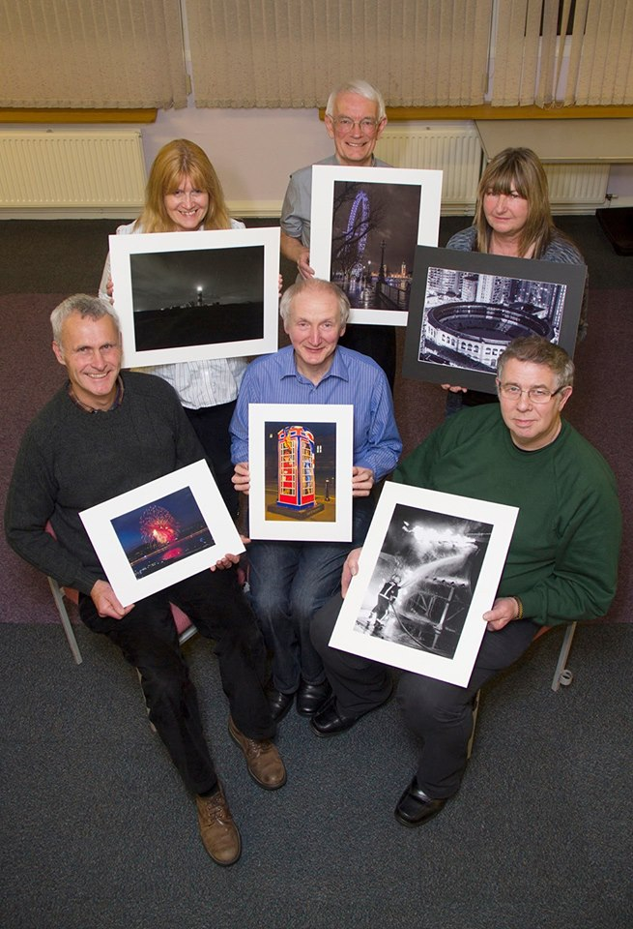
“Night Time” assignment print winners Richard Shafto; Joy Brodie; Jiri Podobsky; Annette Slater and Bob Servante with Judge Eddie Fryer
The latest meeting of the IOM Photographic Society opened with congratulations to one of our members, Paul Dougherty, who had the previous week enjoyed having one of his images awarded “photograph of the week” in the Sunday Times Travel Section. The image was of a street trader in China pushing a cardboard load on his bicycle – a particular “well done” as it was the second time in less than a year that he has achieved this distinction. Our evening continued with an assignment competition for both prints and digitally projected images on the subject of “Night Time”, being judged by Eddie Fryer from the Western club. Eddie is a very popular choice as a judge, giving a very measured and considered commentary on each entry, carefully clarifying what he believes the photographer has achieved, and assessing the areas of strengths and weaknesses – and always in a sympathetic and encouraging tone, the aim being to improve photographic and artistic skills.
The Standard Group mono prints section was won by Joy Brodie, with an image of the Point of Ayre lighthouse, described as being “dark, foreboding and very atmospheric”, whilst Nessie Gillen came in as runner-up with a shot of Ramsey Harbour, the lights from the harbour wall being reflected in the water. A lovely image of a Douglas fireworks display and their reflections in the water gave Richard Shafto a win in the colour prints section, whilst an eerie shot of the front of Marown Church with the moon behind, gave Mark Thorsby a second place (plus several queries as to just how some of the ghostly effects had been achieved !). Mark then rounded off his evening with a first place in the digital section with a well composed image of three of the street lights from Douglas promenade, the lights just overlapping each other and giving a lovely recession to the shot. Joy Brodie’s bonfire night image came in second place.
In the Intermediate Group, Annette Slater swept the board in the mono prints section, a first place coming for an image of a Spanish bullring taken from an elevated position, and second place for a busy city centre nightscape, the lights from the buildings and traffic illuminating the scene. In the colour prints, Jiri Podobsky gained first place with a high-impact shot of a bright and richly lit telephone kiosk, the composition being absolutely spot-on for a quite dramatic effect. Annette Slater continued her success, gaining second place with an image of burning wire wool being spun like a catherine wheel firework and the sparks whirling around the night sky. In the digital section, Martyn Parnell’s image of a rock musician playing a guitar, lit by stage lights and showing his sweat and concentrated effort, deservedly won first place. Sam Bucknall, a junior member, came in as runner-up with an atmospheric and busy image of gamblers around their gaming tables – with several follow-up questions as to whether school or after-school activities ?
Bob Servante was the winner of the Advanced Mono Prints with a well composed night shot of a fireman dousing a fire, the water from the hose giving a strong lead-in line to a dramatic image with flames and billowing smoke. Patricia Harvey’s moonscape, taken with a digiscope, was a more tranquil image but also well composed and very detailed, was second. The colour prints were won by Patricia Harvey with a wonderful image of the Thames riverbank, the London Eye illuminating the left side and Parliament the right, and the riverside lights and people providing interest and detail through the centre. Dave Welsh’s shot of Malta’s Valetta Harbour by night earned a second place. In the digital section, a well composed image of a steam train leaving Douglas Station- smoke and steam providing drama – gave Sue Jones maximum points, whilst Bob Servante’s good form continued with a second place for an image of a fireworks display.
IOM Photographic Society meetings are open to the public - non-members with a charge of £1 on the door - and all will be given a very warm welcome. Meetings are at Thie Ellyn (the Art Society building) in Withington Road, starting at 7:30pm. Full details of our programme can be found on the website at www.iomps.com, which also includes a personalised gallery for the display of work by our members.
Results “Night Time” Assignment : Standard Group – Mono Prints : Joy Brodie (1 & 5), Nessie Gillen (2), Mark Falconer (3 & 6), Aida Podobska(4). Colour Prints : Richard Shafto (1 & 4), Mark Thorsby (2), Joy Brodie (3), Nessie Gillen (5 & 6). Digital : Mark Thorsby (1 & 4), Joy Brodie (2), Karen Norton (3 & VHC), Aida Podobska (5 & 6). Intermediate Group : Mono Prints : Annette Slater (1 & 2), Elaine Dewhirst (3). Colour Prints : Jiri Podobsky (1 & 5), Annette Slater (2 & 3), Roger Oram (4), Shirley Lotfy (6 & C). Digital : Martyn Parnell (1 & 3), Sam Bucknall (2), Roger Oram (4), Anne Bidwell (5 & HC), Hazel Walsh (6), Annette Slater (C), Jiri Podobsky (C). Advanced Group : Mono Prints : Bob Servante (1 & 3), Patricia Harvey (2), Ron Shimmin (4), Sue Jones (5 & 6). Colour Prints : Patricia Harvey (1), Dave Welsh (2 & 4), Chris Blyth (3), Ron Shimmin (5 & 6). Digital : Sue Jones (1), Bob Servante (2 & 5), Chris Blyth (3 & 4), Patricia Harvey (6).
By Chris Blyth

23rd January 2014 - It's All Luck at the Isle of Man Photographic Society

Chris Wormwell with one of the images from his presentation "It's All Luck".
On Wednesday 12 January the Isle of Man Photographic Society played host to
Isle of Man photographer Chris Wormwell who specialises in wildlife
photography and gave us a presentation entitled "It's All Luck"
Chris has had a serious interest in Wildlife Photography for many years and
has travelled the world in pursuit of this. His main interest is bird
photography and so his large array of kit includes a huge 500mm f4 image
stabilised lens.
The "Luck" in the title of his presentation became obvious to only mean the
final piece of the jigsaw. When attempting to capture an image of some
exotic breed of wildlife it became obvious the capturing of these images
has involved a great deal of preparation. Travelling to a location at the
right time of year, with the correct equipment, choosing a location locally,
waiting for the right light conditions, hiding and then waiting. With "luck"
all the hard work pays off and the bird, animal or insect turns up and you
get the shot.
The presentation was inspiring with a variety of wildlife shown
demonstrating what is possible with dedication to the art.

Small Print winners Norma Cowell and Ian Lumsden with Judge Antony Hamilton. (image missing)
The second part of the evening was a Small Print Competition for the
Standard and Intermediate groups. Our Judge for the evening was one of our
past Presidents, Antony Hamilton. Antony explained his criteria for the
judging as not only being all the normal skills being displayed such as
correct exposure, focus and composition but also for an image that displayed
something out of the ordinary. He then proceeded to talk about his thoughts
on every image displayed, both good and bad points and offered suggestions
on how he thought improvements could be made. The results are as follows:-
STANDARD
1st Best Christmas Present by Norma Cowell
2nd Please Don't Bark With Your Mouth Full by Sue Collier
3rd In the Pink by Sue Collier
4th Enjoying a Dip by Mark Falconer
5th Family Trio by Norma Cowell
6th Shaggy Inkcaps by Beryl Quayle
INTERMEDIATE
1st Detail - Syracuse Cathedral by Ian Lumsden
2nd A Drop of Colour by Annette Slater
3rd A Fearless Volunteer by Shirly Lotfy
4th Teamwork by Anne Bidwell
5th Pondering by Anne Bidwell
6th Garden Fence Gossip by Anne Bidwell
Next week entries are due for the Open Digital competition.
By Bob Servante

16th January 2014 - Tony Curtis Disappearing Theme
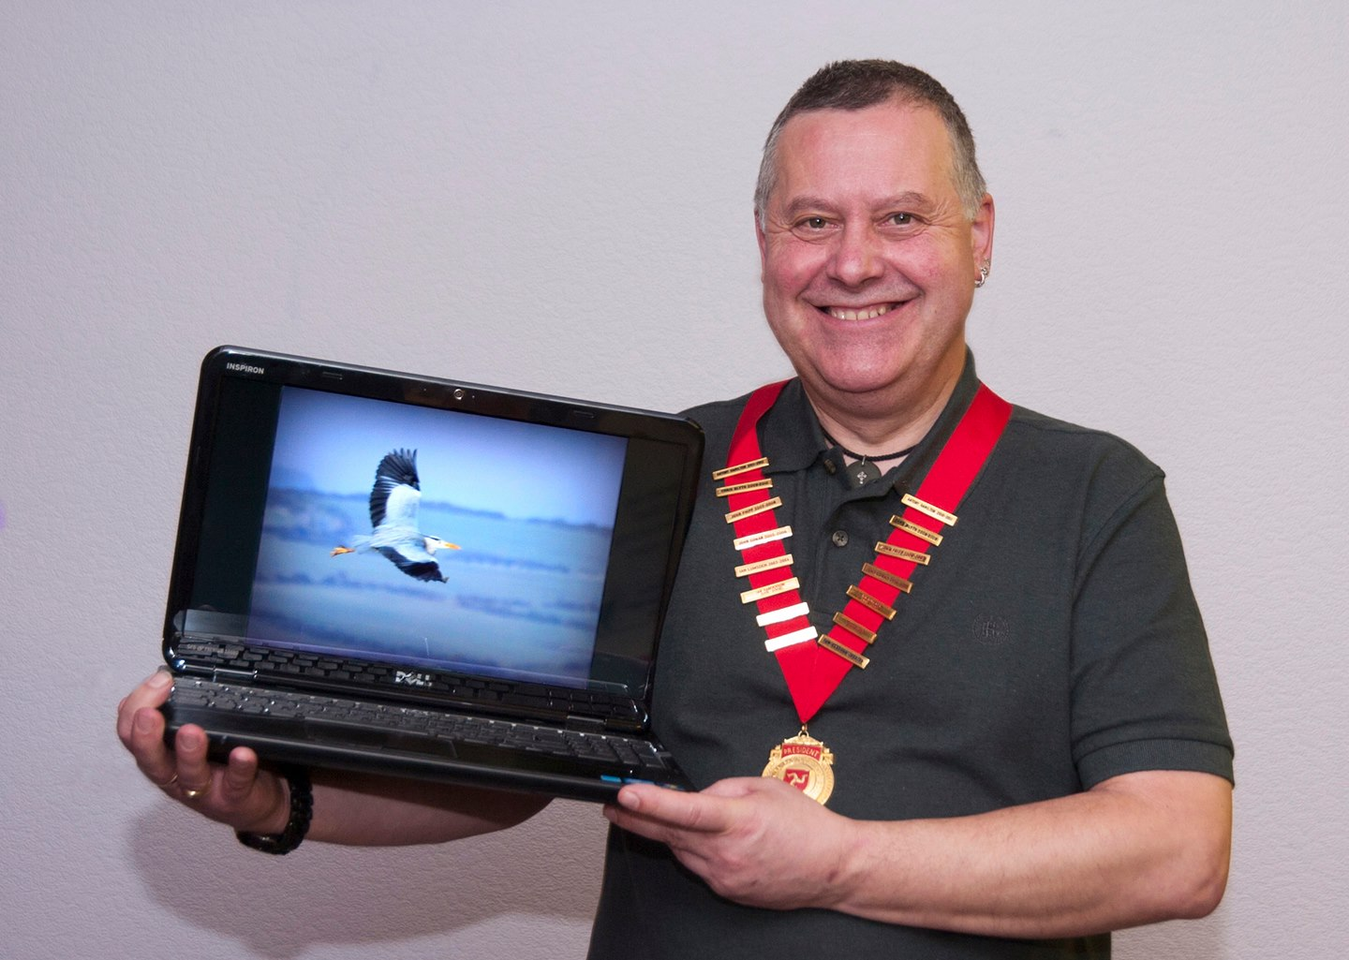
IOMPS President Tony Curtis with one of the images from his presentation
~~The most recent gathering of the IOMPS on January 8th saw a presentation by Club President, Tony Curtis. His theme was “disappearing” based on this part quote by Henri Cartier-Bresson - “Photographers deal in things which are constantly changing...”
A photograph captures a moment in time and that moment can never be recaptured because undoubtedly something will have changed such as the sun going down or a cloud going dark, a shaft of sunlight is a momentary sight gone in seconds. Also, a child, animal or bird is never still for long.
Tony ably demonstrated his theme of “disappearance” by presenting images, many and varied of his own photographic work, most of which he took during his lunch breaks!
His images included landscapes and coastlines which are quite difficult to turn into a balanced composition without having too much of either sea or land in the frame. He showed us scenes of last years winter freeze including some beautiful naturally sculpted waves of snow in Kirk Michael. We saw some stunning wildlife photos including wild wallabies in the Curraghs, a hard to find red legged partridge, fabulous scandinavian waxwings, and a heron in flight for which Tony had patiently waited for two hours!
Another change of subject was beach racing and the T.T. with some outstanding shots of bikes and riders including some famous faces. Tony amused the members with anecdotes of how he actually ended up getting some of those photos!
Tony is also a wedding photographer and he showed us some wedding shots which had been incredibly difficult to shoot due to either weather or the venue not being suitable for taking great pictures. He told us how he often had to use combinations of flash and exposure to make colours, textures and light look natural in the photos.
By the end of his presentation Tony had clearly demonstrated that photography really is dealing with ever changing things. We usually get only one chance to get our pictures right so it's good to think in advance of what you want your finished picture to look like then to go out and, especially with wildlife - be patient!
On January 22nd the society will be holding an assignment competition entitled Night Time. Images will be in both printed and digital format.
Entries for the next Open Print competition will also be due in on the same evening.
The society was very saddened to learn of the recent passing of one of its members.
Roy Gerrard died on January 5th after a long and brave fight with illness. The committee and all the members of the IOMPS would like to send their condolences to his family during this very sad time.
By Anne Bidwell

12th January 2014 - L&CPU & Laxey Exhibition entries
Dear Member,
The L&CPU annual Club Competition entry is due shortly and as a result we need prints and digital entries for consideration.
If you received a top placing in the annual competition or have another image that you would like to be considered for selection please can you bring these into club by no later than the 22nd January.
All digital images should be brought in on a pen drive / CD or emailed to me at Claire.stringer@iomps.com
Also just a reminder that anyone wishing to have their work shown as part of the Laxey exhibition needs to confirm their definite statement of intent by Wednesday 15th January to Chris chrisblyth@isleofman.com
The actual prints mounted or framed needs to be handed in by the 22nd January.
Kind Regards
Claire

1st January 2014 - IOMPS Exhibition at Laxey Hodgson Loom Gallery
Dear Member,
Hope you all had a lovely Christmas and Happy New Year to you and your families.
As you will see from the programme we have an exhibition running at the Laxey Hodgson Loom Gallery from the 8th February to the 8th March.
This will be our third year of holding this exhibition and is a great opportunity for members of the Society to have their work shown and be available for sale.
Please by email Chris Blyth chrisblyth@isleofman.com by the 19th January to confirm your wish to have your work included in the exhibition.
The email should contain a list of up to 5 images that you wish to be included in the exhibition in order of priority. The gallery has space for 75-80 images and the committee will ensure that all members who wish to exhibit gets an equal share of the space available, taking your highest priority images first.
The email should also contain the titles of the items you are wishing to exhibit and their suggested selling prices (allowing for gallery commission on any sales) and a jpeg of the image that can be used for the PR catalogue / invitations. If you can also include a brief photographic CV about yourself and your interests in photography which will be included in the catalogue which is available at the exhibition.
All images need to be handed to Chris at the meeting on the 22nd January and need to be either mounted on card (of any size) or framed.
If mounted Velcro stickers will be placed on the rear of the mount to enable hanging and if you enter a framed print then you should ensure a string or wire is attached for hanging.
There is normally an opening preview evening which members of the Society and their partners are invited to and details will be provided nearer the time.
Look forward to seeing you all on the 8th January for the Presidents Evening.
Kind Regards
Claire

1st January 2014 - IOM Photographic Society

On Wednesday 11th December IOMPS members enjoyed "Travels in Chile" presented by Peter Clague.
~~The IOM Photographic Society is now at the half-way point through the season, and it’s been an absolutely cracking one so far..... numbers attending have been high throughout the programme of events, our occasional speakers (both of them) provided excellent audio-visual presentations, whilst entries from newer members in our regular competitions have been universally praised by our judges, and in some ways have challenged our more established members. It all promises to be an exceptional year for the society.....
Our two speakers were Dr Jeremy Paul (with a superb presentation of wildlife photos taken on safari in the Masaai Mara on the borders of Kenya and Tanzania) and Peter Clague (with travel photos from a trek in Chile, including the two widely varying landscapes of the Atacama desert and the mountains of Patagonia) – and both providing authoritative, interesting commentaries and excellent entertainment for our members. Another highlight early in the programme was the three way digital battle with the Western and Southern Clubs (the other photo clubs on the island) held at Glen Helen – not only did the IOMPS win the overall trophy, but two entries from our members vied for the title of best image in competition – a most pleasing result, but accompanied with the perhaps dubious requirement to organise the same event next year.....
As regards competitions, we have as usual had regular assignment and open competitions for our members, these always being judged by external judges to ensure impartiality in their results – and we would readily acknowledge and thank them for their generous contributions to the success of our programme, the commentaries given to each entry providing invaluable guidance on critical features such as composition, contrast, use of colour, and lead-in lines for successful image-making. Here newer members have shone a light for the society, bringing new ideas and a fresh approach to their images which is necessitating older members to try harder – a situation remarked upon by several of our judges.
Mark Falconer and Nessie Gillen look to be setting the pace in the Standard Group, but with strong competition from Norma Cowell, Mark Thorsby, Joy Brodie, Sue Collier and others in our various classes. In the Intermediate Group, Jenny Shanley, Elaine Dewhirst and Annette Slater are the ones to watch, though again with others such as Shirley Lotfy, Jiri Podobsky and Phyllis Christian providing competition. The Advanced Group is, as usual, being dominated by Sue Jones, Ron Shimmin, Ruth Nicholls and Bob Servante, with Brian Speedie emerging as something of a surprise this season.
The second half of the programme starts on Wednesday, 8th January with a presentation by our President, Tony Curtis, of some of his work – title as yet unknown since he is working on it over the Christmas break – but sure to be entertaining! Thereafter our regular competitions and presentations will resume, culminating in late March with our Annual Competition, this year being judged by husband and wife team of John and Margaret Sixsmith, both highly qualified and experienced, so certain to be a highlight event for anyone interested in photography. The programme closes in May with the Bebington Salon, a digitally projected presentation of some 400 images, competitively chosen from some 2800 entries and representing the best of current british photography – again sure to be a very popular evening.
All meetings of the IOMPS are held at the Art Society in Withington Road, Douglas, and are open to the public, non-members with an entry fee of £1. Full details of the programme are available on our website www.iomps.com.
by Chris Blyth

IOMPS Reports During February 2014

26th February 2014 - Last Open Print Points Up for Grabs at I.O.M.P.S
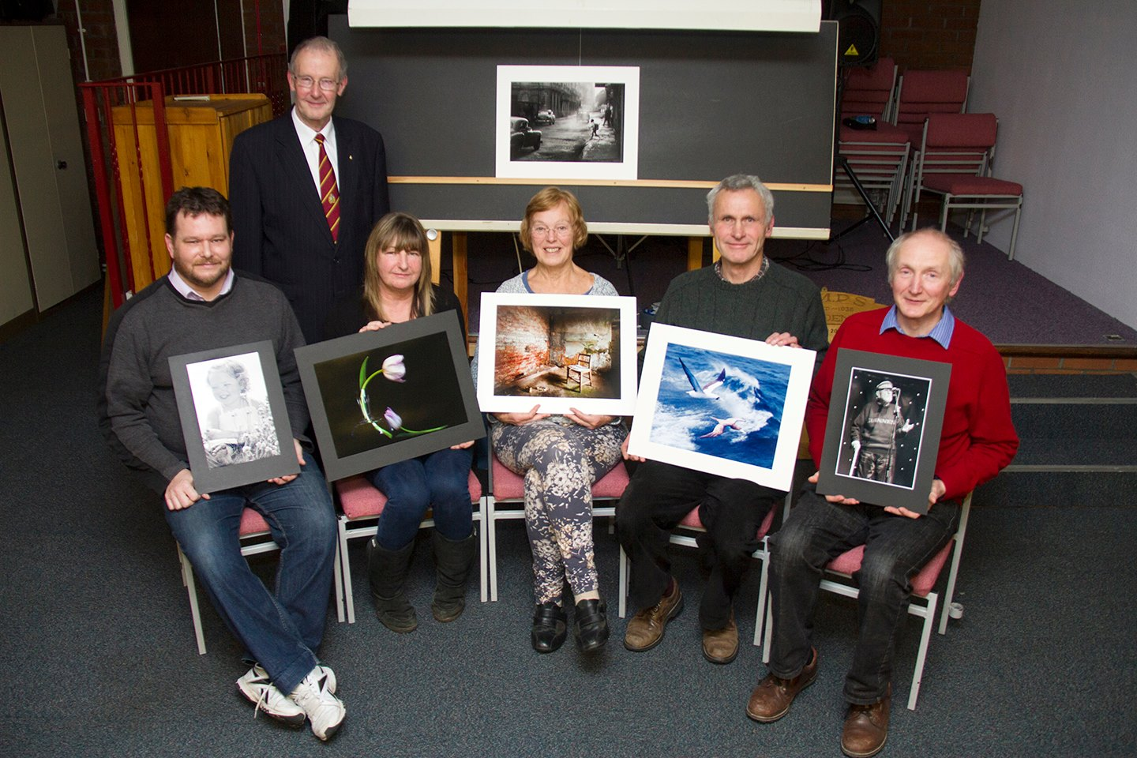
Judge Robert Louden Brown with Open Print winners Mark Falconer; Annette Slater; Ruth Nicholls; Richard Shafto and Jiri Podobsky
On Wednesday evening 19th February the Isle of Man Photographic Society held
its last Open Print competition of the 2013 -2014 season.
Our President, Tony Curtis introduced our Judge for the evening, Robert
Louden Brown, Consultant in Public Health, Medical and Health Education and
Illustration. Robert's list of qualifications and work history was
impressive. His interest in photography started when he was a young boy and
some of its various forms have been part of his working life ever since.
Despite having to make judgements on professional photographic presentations
over many years, it was the first time he had been asked to judge a print
competition for a Photographic society. After adding some of his own
introduction he started with the Standard class Monochrome & Colour. From
his comments within the first few minutes it became obvious that he was more
than aptly qualified to judge. Both good and bad points were put forward
regarding each image in a precise straightforward manner. Results are as
follows:-
Standard Mono
1st Happy Little Angel by Mark Falconer
2nd Full Head of Steam by Mark Falconer
3rd Stone Sentinel by Mark Thorsby
4th Mud Bath by Nessie Gillen
5th Magnificent Frigate Birds on Line by Richard Shafto
6th Water Music by Nessie Gillen
Standard Colour
1st Caribbean Boobies by Richard Shafto
2nd A Glimpse of Paradise by Joy Brodie
3rd Safe With Mum by Paul Dougherty
4th Gone in a Flash by Paul Dougherty
5th Dark Rose by Nessie Gillen
6th Coming to get Ya! by Mark Falconer
Intermediate Mono
1st Laurence Kermode at 98 by Jiri Podobsky
2nd Rescue Me by Jenny Shanley
3rd Point of Ayre by Anne Bidwell
4th One O'clock by Annette Slater
5th Juvenile Cormorant by Anne Bidwell
6th Monks Bridge by Elaine Dewhirst
Intermediate Colour
1st Dying of Thirst by Annette Slater
2nd Chase the Ball by Elaine Dewhirst
3rd The Shed by Jenny Shanley
4th Isle of Manx Dance by Jiri Podobsky
5th King's Cross Station Concourse by Shirly Lotfy
6th Storm Clouds Gathering by Elaine Dewhirst
Advanced Mono
1st Schooltime, Havana by Ruth Nicholls
2nd St Michael's Chapel by Sue Jones
3rd Harbour Storm by Bob Servante
4th The Female Spy by Patricia Harvey
5th Bomber Command Memorial, London by Ron Shimmin
6th Holmes Contemplates the Case by Bob Servante
Advanced Colour
1st Kitchen Chair by Ruth Nicholls
2nd The Photographer by Sue Jones
3rd Chateau De Queribus by Ron Shimmin
4th Havana Morning by Ruth Nicholls
5th "Hussar" - Napoleonic War Re-enactment by Ron Shimmin
6th Looking Towards the New Dawn by Janet Servante
By Bob Servante

18th February 2014 - IOMPS Exhibition opens at the Hodgson Loom Gallery in Laxey
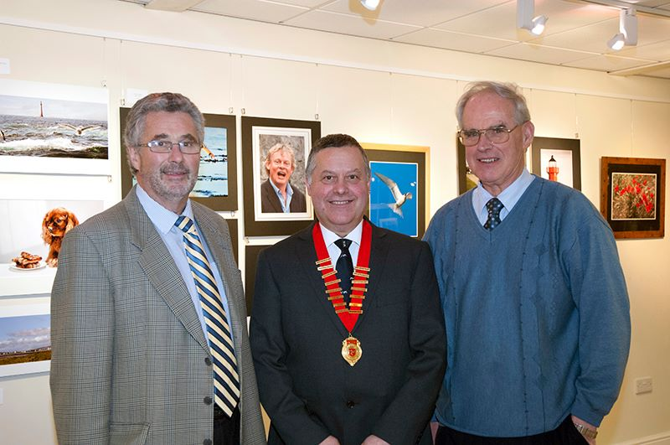
Steve Rodan SHK; Isle of Man Photographic Society President Tony Curtis and Committee Member and Exhibition Co-ordinator Chris Blyth. Mr Rodan officially opened the IOMPS Exhibition of Members work at the Hodgson Loom Gallery in Laxey Woollen Mills on Friday 7th February 2014. The Exhibition runs until 8th March.

13th February 2014 - Competition Season Hots Up at IOMPS
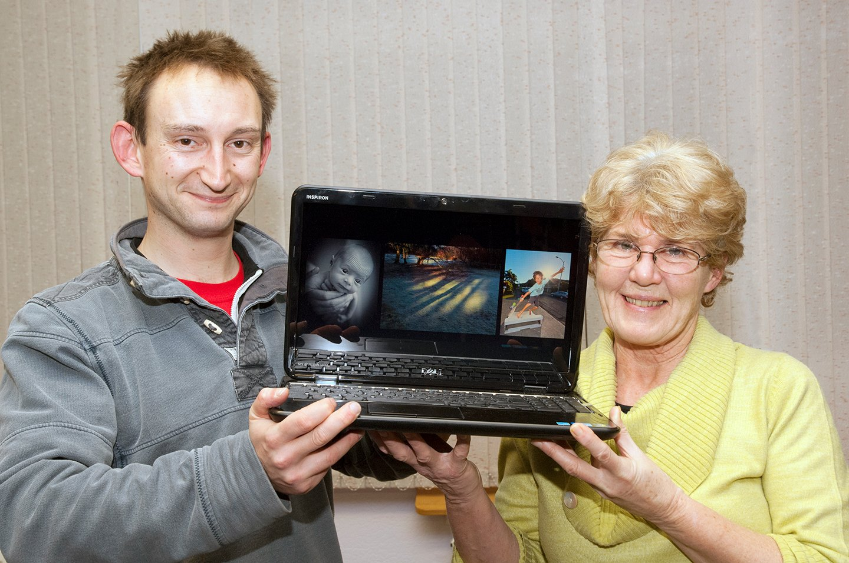
Judge Dave Kneale with one of the Open Digital competition winners Jenny Shanley
On the cold, wet & windy night of Wednesday February 5th, the Isle of Man
Photographic Society held a Digital Image competition at Thie Ellyn, off
Withington Road, Douglas.
The 2013 - 2014 Club season is now well into it's second half and as such,
the various competitions held throughout the season are either finished or
coming to a climax. The Assignment competitions have already been decided
and leading Contenders in the Open Standard, Intermediate and Advanced
competitions are fighting to take the lead. This was the penultimate Open
round and with a potential of eleven points available to anyone means
current leaders needed to watch their back as points are fairly close in
most sections.
After opening the evening, our President, Tony Curtis introduced the
competition and our Judge for the evening, Dave Kneale, a Sports
photographer and Journalist. Before giving his deliberations on each image
he warned the Intermediate and Advanced groups that the Standard group's
quality was very high and they had better watch out!
Dave gave his verdict on each image, explaining that after considering the
basic qualities of a photograph he wanted to understand the story it
portrayed. He had taken great care and had produced in-depth notes for each
one. Results as follows:-
STANDARD
1st Baby Emily by Nessie Gillen
2nd City Street to Cathedral by Mark Falconer
3rd Wheely OK by Karen Norton
4th Kingfisher by Patricia Larkham
5th Portrait of a Pigeon by Catherine Gillam
6th Run For It by Norma Cowell
INTERMEDIATE
1st Winter Shadows by Jenny Shanley
2nd Out of the Blue by Martyn Parnell
3rd It Rained All Summer by Phyllis Christian
4th Winter Treat for Birds Served by Jiri Podobsky
5th Horses Going to Work by Jiri Podobsky
6th Douglas Bay by Night by Sam Bucknall
ADVANCED
1st Getting Air by Robert Blyth-Skyrme
2nd Firefighting by Sue Jones
3rd Working Gun Dog by Diane McCudden
4th Sidecar 36 by Diane McCudden
5th Wheatear by Bill Callow
6th Stag at Bay by Chris Blyth
Next Wednesday will be the final Open Print competition of the season, with
entries due for the last Digital competition.
By Bob Servante

12th February 2014 - Club Cancelled Due To Weather.
Hi Everyone,
We have to appologise for the short notice, but with the expected bad weather the committiee has taken the decision to cancel tonights meeting, although the club house will be open so entries for next weeks print competition can be droped off, 7.00 till 7.30pm.
Please note that prints for next week can be dropped off 7.00 till 7.30pm or they can be left at Sue's house before 12 noon tomorrow (Thursday).
We would ask, if possisble could you please pass on this message to anyone who might not see it,
It had planned to be a really interesting evening so hopefully it can be re-scheduled.
Regards
The Committiee

6th February 2014 - Attention to detail is key to success
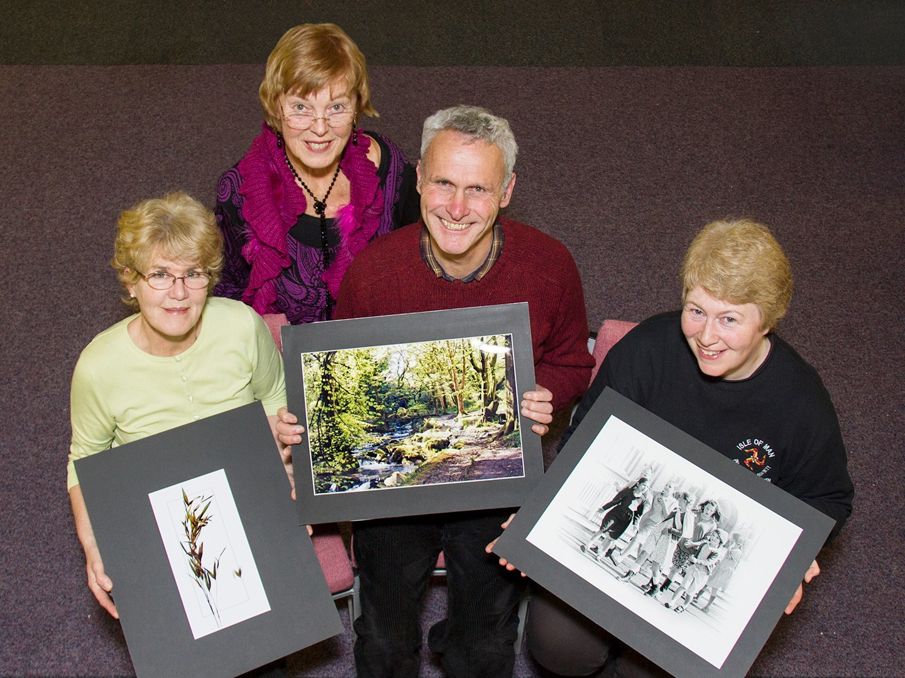
Judge Ruth Nicholls (second left) with Open Print winners Jenny Shanley; Richard Shafto and Sue Jones
The IOMPS' recent Open Print competition attracted a large number of entries which made difficult work for the judge, Ruth Nicholls LRPS, DPAGB, EFIAB, BPE3*
It was immediately clear that Ruth had indeed worked hard perusing and assessing each and every photograph in detail. She reminded the members how important is the presentation of images in terms of careful and compatible mounting. The title of a picture also needs careful consideration so that it is suitable and conveys to a judge what the image's author is trying to say. Ruth reminded us that from a judges point of view attention to detail makes all the difference in a competition.
Ruth spent time talking about each photo, patiently picking out particular details and providing helpful ideas and technical tips on improving certain features.
The standard of photography was, as usual very good across the groups but everybody benefited in some way from a veritable master class from Ruth throughout her evening's judging.
IOMPS president, Tony Curtis thanked Ruth for giving so willingly of her time and for sharing some of her vast knowledge with the members, and said he hoped that in the future she might like to give a lecture.
In the Standard group, Ruth awarded top places to Mark Falconer for a stunning black and white head shot of an owl; and to Richard Shafto's beautiful composition of Ballaglass Glen.
First places in the Intermediate group went to Jenny Shanley and Sam Bucknell. Jenny's japanesque image of a grass head was excellent with simple clean lines.
Sam Bucknall is a junior member who's photography is maturing very quickly. He clinched the top two places with some excellent mono photographs including a thatched cottage and a young man poised to throw a ball.
The Advanced group's winners were Sue Jones with a very sharp black and white photo of an animated group of evacuee girls. Robert Blyth-Skyrme's winning photo was the epitome of tranquility with boats on still water in hues of pink and blue.
RESULTS
Standard Mono
1st Mark Falconer - “Unwavering Stare”
2nd & 3rd Nessie Gillen - “White Beach” & “Baby Bella”
4th & 5th Sue Collier - “Nepalese Buffalo” & “White Rose”
6th Norma Cowell - “Old Ballaugh Church”
Standard Colour
1st & 3rd Richard Shafto - “Springtime In Ballaglass” & “Masked Booby”
2nd Nessie Gillen - “Pink Portal Rose”
4th Dave Norton - “Thirsty Pigeon”
5th Mark Falconer - “Three Legs Welcome”
6th Norma Cowell - “Strings”
Intermediate Mono
1st & 2nd Sam Bucknall (Jnr) “Go It, Paul” & Thatched Cottage, Bride”
3rd & 5th Elaine Dewhurst - “Eye Catching” & “Shaded Balcony”
4th Jenny Shanley - “Snow On Jurby Cross”
6th Phyllis Christian - “Just A Bundle Of Fluff”
Intermediate Colour
1st Jenny Shanley - “Grass Head”
2nd Annette Slater - “Roses Are Red”
3rd Sam Bucknall (Jnr) “Evening Glory”
4th & 5th Shirley Lotfy - “Small Tortoiseshell On Inula” & “Waiting For High Tide”
6th Ian Lumsden - “Greek Theatre, Taormina, Sicily”
Advanced Mono
1st & 4th Sue Jones - “Evacuees” & “Engine Driver”
2nd & 3rd Ron Shimmin - “Cafe In The Park” & “The Bridge To Besalu”
5th Patricia Harvey – My Pride And Joy”
6th Bob Servante - “Keep Calm And Carry On”
Advanced Colour
1st Robert Blyth-Skyrme - “Tranquility”
2nd Janet Servante - “Hen Blackbird”
3rd Sue Jones - “Abandoned”
4th & 6th Ron Shimmin - “In The Pyramid” & “The Road To Mont-Louis”
5th Bill Callow - “White Beach”
The society is holding their annual photographic exhibition (with work on sale) from 8th Feb - 8th March at The Laxey Hodgson Loom Gallery.
This is a popular exhibition showcasing the many and varied works of the society's members, so please go along and enjoy.
The next IOMPS meeting will see both a Small Print competition and a presentation by local photographer, David Sylvester – The Studio Colby..
Everyone is welcome to attend and for non members there is a small charge of just £1.00
Please visit www.iomps.com for more information about the society.
By Anne Bidwell

IOMPS Reports During March 2014

20th March 2014 - The judge’s decision is final…..

Competition judge Andrew Barton LMIPP LMPA pictured with the photo 'Jewellery With Attitude' which he awarded Best overall image in the two-way competition between the IOMPS and North West Bristol Camera Club (image missing)
A Two-Way Competition with Bristol has become an annual fixture in the IOM Photographic Society diary, with thanks largely to Sylvia Kelly who is one of our “off-shore” members, but whose prime loyalty is now with Bristol, having moved and become a member there. The competition format is that each club provides 30 digitally projected images from their members, each club then holding its own competition with a local judge. All images are marked out of ten, and the combined scores from both judges then deciding the overall winner.
On this occasion, the IOMPS judge was the well-known local photographer Andrew Barton, a frequent visitor and supporter of the society. Given the format, Andrew’s assumption was that each club had provided 30 of their best images, and that in his judging, he could and would accordingly take a more critical stance than perhaps for normal club competitions. As usual, Andrew took considerable time and effort to comment upon each image being shown, a very full commentary on composition, contrast, use of light and the clarity being given. The standard of entry was exceptional, with natural history (particularly bird life) featuring in many of the images.
As Bristol had been able to hold their competition several weeks prior to us, Club President Tony Curtis was able to announce the Bristol judge’s marks at the same time as Andrew giving his. Whilst many marks were broadly comparable, it was clear that the two judges had somewhat different opinions as to the respective merits of a number of images – a difference that was to have major implications for the final result. A particular difficulty for several of the IOMPS entries was what Andrew identified as a “digital sizing” issue, with resulting pixellation of the image – commonly known as “jaggies” or loss of smoothness in diagonal lines. Given Andrew’s more critical approach, these were marked down quite severely.
Sadly for the IOMPS, the overall combined score of the judges made Bristol the winning club by 468 points to 456. However, it became apparent that the Bristol judge had given the win to the IOMPS by 242 to 238 points, whilst Andrew had given Bristol a win by 230 points to 214. Both judges were also asked to award a “Best Image in Competition” – again the two judges differed but only in degree, both awarding the accolade to Bristol entries. A superb image of yellow irises backlit in the most subtle of ways, revealing great detail in the petals and with delightful shadows was the choice of the Bristol judge. Andrew’s selection was a portrait “Jewellery With Attitude” - a young lady wearing ear-rings and a necklace, shot to professional standards with great use of studio lighting and with lovely skin tones.
The next meetings of the Society are on Thursday (Prints) and Friday (Digital) 27th and 28th March – the highlight occasion of the Annual Competition, this year being judged by the husband and wife team of John and Margaret Sixsmith, both international judges with impressive photographic careers, and sure to be exceptional evenings. All meetings are held at Thie Ellyn (The Art Society Building) in Withington Road, Douglas, starting at 7:30pm. Meetings are open to the public, with an entry charge of £1 for non-members.
By Chris Blyth

13th March 2014 - DAVID SILVESTER'S PHOTO TUTORIAL
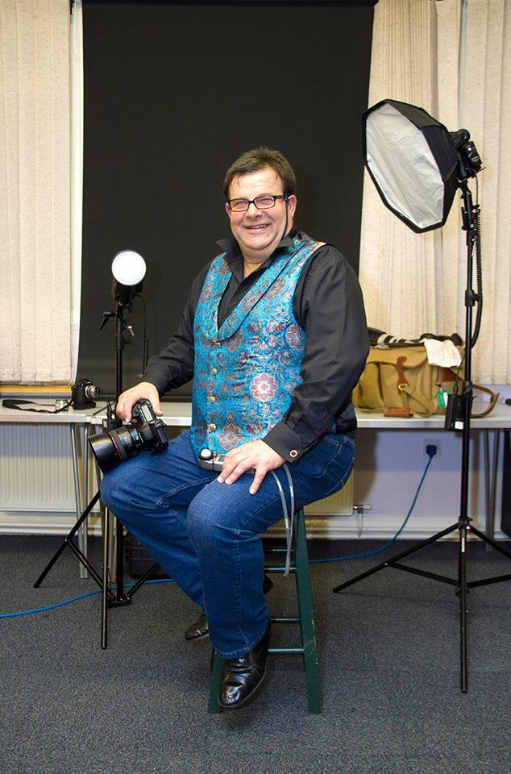
David Silvester ASISLP, LSWPP who presented a critique and portrait evening for IOMPS members on March 5th
~~Last Wednesday March 5th the IOMPS was pleased to host a presentation by local photographer David Silvester ASISLP, LSWPP. He is a very experienced photographer and did his first wedding shoot in 1978.
The informal evening began and ended with a slide show which introduced us to a small portfolio of Dave's work. His artistic and creative eye was evident in his beautiful portraits of babies and small children. His stunning wedding photos evoked all the happiness of the big day. Also included were T.T. and Rally shots full of speed and colour.
Next, Dave agreed to critique some work which a small number of members had bravely submitted! He warned us that his judging might be harsh but instead it was quite kind hearted and very educational. After describing each image including it's merits, Dave showed us step by step how some manipulation or small tweaks in editing software such as Photoshop or Lightroom, could transform good images into excellent ones. Everyone benefited in some way from his practical demonstrations which were easy to follow and expertly explained.
After a break for a chat and a well earned cup of tea, David moved on to portrait photography. A make do studio and lights were quickly set up and one of the members kindly agreed to be Dave's model. A fun filled demonstration then followed with questions and answers, gremlins and glitches, along with Dave's easy going and witty commentary!
Dave's knowledge was swiftly established with his expert use of lighting. He said that it's imperative to use a light meter so you can set your camera's aperture and focus correctly. He used a standing flash light set at f8 and a fill light whose settings could keep being changed for differing shadow effects. We saw how with clever use of lighting the model's skin tones could be lifted and softened in order to flatter and to create a perfect portrait for the customer.
David Silvester has an “open door” policy at his Colby studio and is always happy to welcome visitors. He can be contacted via his website www.thestudiocolby.com
The recent IOMPS photographic exhibition at Laxey Loom Gallery was very successful with several members achieving sales of their work. Many thanks to all who were involved.
We remind members that their entries for the IOM Bank Cup are due in on March 19th. Also on that evening will be the Three Way Digital Battle with Rochdale and Oldham. Visitors are welcome.
By Anne Bidwell

5th March 2014 - Final Digital and Small print competition of the season

Judge Marianne McCourt with Open Digital winners Peter Keena; Jenny Shanley and Bill Callow
Though the Isle of Man is relatively small geographically and might seem somewhat isolated at times from the facilities on the adjacent island, those of us who enjoy living in this splendid place are extremely fortunate to have easy access to several highly regarded professional photographers. These professionals are always ready and willing to give generously of their time to support the Society. One such photographer is Marianne McCourt who had kindly agreed to judge our February ‘open’ competition for projected digital images at the end of last month.
Marianne is passionate about the art of photography and excels at recording moments in time, sometimes fleeting, by making the best use of light to enhance her subjects. Specialising in contemporary lifestyle portraits and wedding photography in the Isle of Man, but with clients both on and off Island, she is very well qualified to judge, being a member of the Society of Wedding and Portrait Photographers (SWPP) and of the British Press Photographers Association (BPPA), and also an associate member of The Royal Photographic Society.
In her introductory remarks, Marianne commented on the range and quality of the images she had been asked to judge and said how much she had enjoyed viewing them. She had used her favoured Light Room software which she finds easier than some other packages. When assessing the 58 entries in the three classes, covering a wide variety of topics, she had paid particular attention to focusing and composition, emphasising the importance of achieving critical sharpness in most photography work, except where blurring was deliberate to create a particular effect. She had also looked for the context of each image to understand the story the author was trying to convey.
She then proceeded to comment concisely on each entry, offering helpful advice and complimenting many of the authors on their efforts. She had looked for originality and impact, that extra dimension which causes one image to rise above the others. It quickly became clear from her remarks that she was not too keen on ‘over-production’ to adjust images and, indeed, warned of the need to exercise care because over sharpening, for example, usually left undesirable tell-tale signs in the final image which were easy to spot.
The entry was a bit smaller than usual but this might have been a reflection of the considerable time members had devoted to producing such a range of attractive images for the excellent Spring Exhibition of the Society at the Hodgson loom Gallery at Laxey Woollen Mills. This public exhibition will close on Saturday, 8th March, 2012, but is not to be missed!
Marianne’s ranked the top entries as follows –
Standard Class : 1st “The Street Musician’s Dog” by Peter Keena; 2nd “A Fungi to be with” by Tim Norton; 3rd “Heave!” by Mark Falconer; 4th “Pretty” by Nessie Gillen; 5th “Wollaton Hall” by Mark Thorsby; and 6th “Green Turtle Coming up for Air” by Richard Shafto. “Fungus Laccaracia Amethystina” by Aida Podobska was Very Highly Commended.
Intermediate Class : 1st “Ice” by Jenny Shanley; 2nd “Smitten Kitten” by Hazel Walsh; 3rd “Hot Blue and Righteous” by Hazel Walsh; 4th “Barracuda” by Anne Bidwell; 5th ”Poppy Detail” by Shirley Lotfy; and 6th “Three’s a Crowd” by Annette Slater. No fewer than six images were Very Highly Commended, namely “Billown Mansion” by Sam Bucknall; “Fire” by Jenny Shanley; “Happy Couple” by Jiri Podobsky; “Waiting for Lunch” by Annette Slater; “The First Corner” by Martyn Parnell; and “Female Flightless Cormorant Tidying Nest” by Shirley Lotfy.
Advanced Class : 1st “Chris” by Bill Callow; 2nd “Gerbera” by Patricia Harvey; 3rd “Young Lion” by Diane McCudden; 4th ”D Day Darlings” by Sue Jones; 5th “Start of Life’s Journey” by Bob Servante; and 6th “Enigma” by Sue Jones. “Dunlin” by Bill Callow was Very Highly Commended.
A well deserved vote of thanks was proposed by Society President, Tony Curtis, on Marianne’s keen eye for detail and the thoroughness with which she had carried out her assessments. For this, Society members were extremely grateful.
After a break for refreshments, the results of the Small Prints Competition were displayed. One of the Society’s members, Pam Kershaw, had been the judge but had been unable to be present on the night. Her judging had resulted in the following order of merit:
Standard Class : 1st “Coffee Anyone” by Sue Collier; 2nd “Kuna Girl with a Parakeet” by Richard Shafto; 3rd “Gaze” by Catherine Gillam; 4th “ Great White Pelicans” by Richard Shafto; 5th “Winter Shapes” by Aida Podobska; and 6th “Gecko” by Catherine Gillam. “Mosta Dome, Malta” by Mark Thorsby was Highly Commended. “Handsome Elvis?” by Mark Falconer was Commended.
Intermediate Class : 1st “Bull Sea-Lion Catching the Last Rays” by Shirley Lotfy; 2nd “Bricks and Bars” by Ian Lumsden; 3rd “Ballacallin in Winter” by Jiri Podobsky; 4th “The Spinner” by Shirley Lotfy; 5th “Greek Temple Pillars” by Ian Lumsden; and 6th “Tension” by Ian Lumsden. Annette Slater was Highly Commended for her image titled “Wading for Tea”. “Dive, Dive, Dive” by Anne Bidwell was Commended.
On Wednesday, 12th March at 7.30pm at Thie Ellyn, off Withington Road, Douglas, the Society has its Two-Way Battle with the Bristol Photographic Club which is always highly entertaining followed by a viewing of the Lancashire and Cheshire Colour Portfolio.
By Antony Hamilton

IOMPS Reports During April 2014

17th April 2014 - Isle of Man Bank Cup
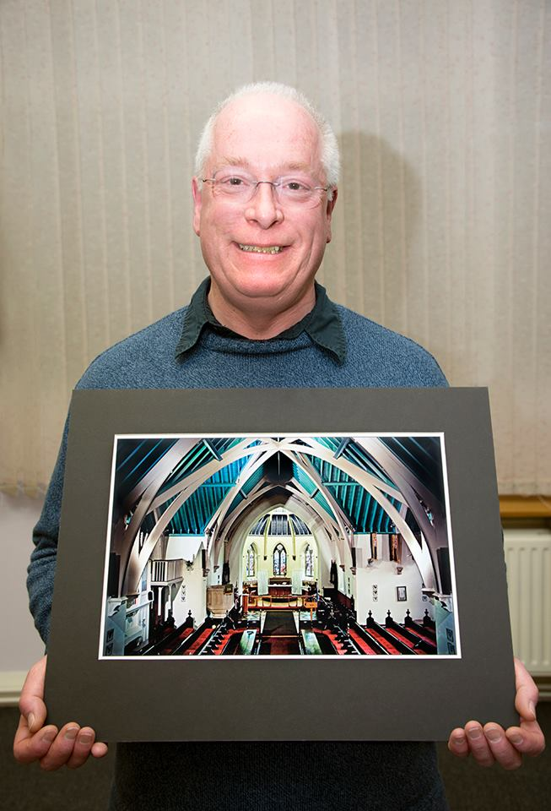
Peter Cartmel with the print which won the Isle of Man Bank Cup - "The Royal Chapel - St Johns" by Ron Shimmin
On Wednesday 2nd April the Isle of Man Photographic society held its last competition of the 2013-14 season, The Isle of Man Bank Cup, an annual Isle
of Man themed print competition.
The Isle of Man Bank Cup is an annual print competition introduced several years ago with a cup donated by the Isle of Man Bank. The Isle of Man Bank
not only provided the cup then but has generously continued to support the society with various projects through the years since. The competition is
for colour and monochrome images, one of each per entrant and based around an annual theme such as Manx Churches, Manx Landscapes or as it was this year, Manx Heritage. The competition is unique as so far as all three classes within the club, Standard, Intermediate and Advanced compete as one.
Colour and mono are judged separately with the final winner being chosen from the final top photograph from each section.
Our Vice President, Antony Hamilton introduced our Judge Peter Cartmel. Peter is known for the high quality of his photographic work,
always applying great attention to detail, and so was an obvious choice to judge one of the society's main competitions of the year.

Manx Heritage Judge Peter Cartmel with the monochrome section winner Richard Shafto
From his comments it was obvious Peter had spent quite some time studying the entries and where necessary, made comments on how he thought an image could have been improved. In some cases the image could have been improved by simply adjusting it in image manipulation software. His placings and the final winner are as follows:-
Monochrome:
1st Our Lost Heritage - The Railway at Kirk Michael by Richard Shafto
2nd Mining Remains by Ruth Nicholls
3rd Cottage Interior, Cregneash by Patricia Harvey
4th Ancient Stones, Braaid Circle by Sue Jones
5th Maughold Church by Joy Brodie
6th Monks Bridge, Rushen Abbey by Ron Shimmin
Colour:
1st The Royal Chapel, St Johns by Ron Shimmin
2nd Art Deco Architecture, Villa Marina Arcade by Sam Bucknall
3rd The Millenium Tapestry with Expanded details by Bob Servante
4th In the Shadow of Snaefell by Sue Jones
5th Manx Loaghtan Sheep by Joy Brodie
6th St Germans Cathedral and Half Moon Battery, Peel Castle by Patricia
Harvey
Overall Winner of the Isle of Man Bank Cup was Ron Shimmin with "The Royal Chapel - St Johns"
After a break for tea & coffee the evening concluded with a digital slide presentation of recently accepted images into the Lancashire and
Cheshire Photographic Union's annual exhibition. The Island clubs are affiliated to the L&CPU and both club or members can enter this competition
with the best work being forwarded to a National Salon. Standards are high and so it was gratifying to see several images originating from the Isle of
Man.
At the end of the evening the themes for next season were announced and are:-
Isle of Man Bank Cup - Manx Culture
Assignment Themes - Reflections, People and Flowers/Flora
By Bob Servante

13th April 2014 - Isle of Man Photographic Society's Annual Dinner

All the award winners - at the prize giving dinner
The end of the Isle of Man Photographic Society's 2013 - 14 season was recently marked with the society's annual dinner at The Cherry Orchard in Port Erin. After an enjoyable meal, Club President Tony Curtis reflected on various highlights of the season, concluding that it had been a successful one for a number of reasons. An exhibition held at Laxey Woolen Mills had been a great success, with several images being sold. Several members had also achieved acceptances in various UK exhibitions, competitions and publications. Fresh blood from several new members in the Standard group this season had sent a warning to the Intermediate and Advanced groups not to sit on their laurels. The society has gone from strength to strength in recent years and the future looks promising. Tony's next task was to present this season's winners with their certificates and trophies. Even though next season doesn't start until September, there are still some events over the Summer, most notable is the arrival of the Bebington Salon of Photography. This is being presented on Wednesday 14th May 2014 at Thie Ellyn, Off Withington Road, Douglas. The event offers the chance for anyone interested to view top national quality images from this annual exhibition. The Salon viewing is open to all, not just IOMPS members and doors open at 7pm for a 7.30pm start with an entry fee of £2 person. Well worth anyone interested in current photographic exhibition trends making a note in their diary.
The Isle of Man Photographic Society wishes to thank the Isle of Man Arts Council for their continued support.
The final task of the evening was for Tony to hand over his chain of office as President to new President, Antony Hamilton.
By Bob Servante

All the Cups and Trophies

10th April 2014

Annual Competition digital winners with Judge John Sixsmith EFIAP BPE5* EPSA
L to R: Norma Cowell; Nessie Gillen; Phyllis Christian; Martyn Parnell; Judge John Sixsmith; Claire Stringer; Annette Slater; Sue Jones and Patricia Larkham
The IOM Photographic Society was fortunate to gain John Sixsmith EFIAP BPE5* EPSA , a distinguished judge from the Lancashire & Cheshire Photographic Union, to adjudicate this year’s annual digital competition. As with his wife Margaret, who judged our print competition on the previous evening, his main area of interest lies in nature photography and indeed they run residential courses in Scotland for the Field Studies Centre. And like Margaret, John’s judging was speedy but quite decisive, quickly identifying the main pros and cons of each image being presented and what worked for him – and given nearly 300 images in the morning session to review, he had to be quick! From that session emerged the winning selection – and which then became the subject of the evening session for our members. Given that only winning images were being presented – representing the best of a large entry - the judge’s comments were generally favourable, only modest criticism separating outright winners from the also-rans.
What became very apparent by the end of the second evening was the domination of our lady members over the men – of the 15 sections judged each evening, 13 of the print sections and 14 of the digital sections were won by the ladies - almost a clean sweep. And almost inevitably, the awards for "best images in competition" also went to the ladies – Sue Jones taking the award for best mono print (with a lovely shot of a lone tree in a high key treatment), Janet Servante for the best colour print (with a well caught shot of Grizabella from the "Cats" stage show), and Patricia Harvey sweeping both the best natural history image and the best digital image (with an image of a marine iguana). So it’s a "well done" to them – the men will just have to try harder next year ! Sam Bucknall won the award for best junior image in competition.
The evening finished with a joint presentation by John and Margaret on the theme of "photographic vision" – and the need for photographers to think and to consider when taking their images, not just pressing the button and hoping ! That will sometimes mean stepping back and taking time to see other opportunities – a slightly different viewpoint, waiting for the right light, using the elements such as trees to provide a frame, a path to provide a lead-in line, or some clouds in the sky to provide interest and contrast…. All beautifully illustrated with some wonderful images from places such as the Cairngorms, Iceland and Yosemite.
Tony Curtis, Club President gave the vote of thanks for two excellent evenings, much enjoyed by our members.
Results Annual Digital Competition.
Standard Group : Colour - Joy Brodie (1, VHC, HC & C), Karen Noton (2), Tim Norton (3), Nessie Gillen (VHC), Norma Cowell (HC & C), Sue Collier (HC), Patricia Larkham (2 x C), Richard Shafto (C), Thomas Carr (C). Monochrome – Nessie Gillen (1, 2 & C),Mark Falconer (3 & 3 x C), Sue Collier (VHC). Natural History – Patricia Larkham (1 & 3), Richard Shafto (2), Norma Cowell (C). Creative Nessie Gillen (1 & 2), Joy Brodie (3). Record – Norma Cowell (1), Joy Brodie (2), Patricia Larkham (3), Richard Shafto (C).
Intermediate Group : Colour – Martyn Parnell (1 & 3), Hazel Walsh (2), Annette Slater (VHC), Phyllis Christian (HC), Shirley Lotfy (C). Monochrome – Hazel Walsh (1 & 3), Martyn Parnell (2 & C). Natural History – Annette Slater (1), Shirley Lotfy (2 & 3), Jenny Shanley (C). Creative – Hazel Walsh (1, 2 & 3). Record – Phyllis Christian (1), Shirley Lotfy (2 & 3).
Advanced Group -: Colour – Sue Jones (1 & 3), Bob Servante (2 & C), Diane McCudden (HC & C), Patricia Harvey (HC). Monochrome – Claire Stringer (1),Chris Blyth (2 & C), Sue Jones (3, VHC & HC), Mark Stringer (C). Natural History – Patricia Harvey (1 & C), Ruth Nicholls (2 & 3), Bob Servante (VHC), Diane McCudden (HC & C). Creative – Ruth Nicholls (1), Mark Stringer (2), Sue Jones (3), Chris Blyth (C). Record – Sue Jones (1, 2 & 3), Claire Stringer (C), Patricia Harvey (C).
~~By Chris Blyth

10th April 2014 - Bebington Salon
~~Dear Member,
We are fortunate again this year in that the Bebington Salon is coming to the Isle of Man.
The Salon is part of the BPE exhibitions, information about these exhibitions can be found at www.britishphotographicexhibitions.org.uk
It is a great opportunity to be able to see exhibition standard photography.
It is open to anyone, members, friends and family so please come along and support this event.
Wednesday 14th May 2014 at Thie Ellyn 7 for a 7.30pm start £2 entry fee per person.
Regards
Claire

3rd April 2014

Annual Competition print winners with Judge Margaret Sixsmith EFIAP FBPE EPSA. Janet Servante; Sue Jones; Richard Shafto; Shirley Lotfy; Judge Margaret Sixsmith; Elaine Dewhirst; Mark Falconer; Annette Slater and Nessie Gillen
The IOM Photographic Society was delighted to welcome Margaret Sixsmith EFIAP FBPE EPSA from Hoylake Photographic Society as our highly qualified, external judge for the occasion of the Annual Print Competition, one of the highlight events of our calendar. In the morning, our judge gets to see the entire entry, this year totalling nearly 250 prints, and has to select the winning images. These then become the subject of the evening meeting, when our audience receives the results, together with a commentary explaining and justifying the selection. Margaret’s judging, as you would expect, was speedy but very considered, each print being checked and examined carefully. Her selection in the morning showed an excellent eye, with an occasional request for full title when this was thought helpful in understanding the intent of the photographer. With nearly 250 excellent prints to consider, the judge’s task can never be easy – often it is a matter of looking for a weak element such as a lack of contrast or distracting elements in the composition to justify a print’s exclusion. It was readily apparent that only prints of the very highest quality would emerge successful - with “quality” the key element, whether of the printing, or of the composition and subject matter. Even a subject thought to be “horrible” (a composite with ghosts and haunting, surreal imagery springs to mind!) was awarded if the quality of the image and treatment by the photographer justified.
Come the evening, a large audience gathered to enjoy the competition. Margaret gave a clear and concise commentary to her awards, making it very easy for our audience to understand the reasons for her choice. Given that only winning images were being shown, criticism was muted, with compliments more the order of the day. “Simplicity” in the image was frequently a favourable comment, giving a focus of attention for the image and elegance in the composition, whilst “images that tell a story” were also favoured.
Following the judging, Margaret was joined by her husband John for a joint slide show on “Pure Nature”, nature photography now being their main interest. Indeed, they run several residential training courses every year in Scotland for the Field Studies Council. The presentation came in the form of a practical workshop, with helpful hints on taking nature images, whether of small subjects such as lichens and insects, moths and butterflies, or of larger animals such as pine martens, otters and horses. The importance of being aware of both the subject and its background was particularly stressed – vital for achieving the most pleasing compositions – and of using the camera controls to help in the process. The presentation was richly illustrated with a wide range of stunning images – and much enjoyed by our audience.
Annual Print Competition Results : Standard Group - Open Monochrome : Mark Falconer (1, 2 & C),Joy Brodie (3), Nessie Gillen (HC), Norma Cowell (C). Open Colour : Nessie Gillen (1 & 3), Norma Cowell (2 & HC), Joy Brodie (HC), Richard Shafto (C x 2), Thomas Carr (C). Natural History : Joy Brodie (1 & 3), Richard Shafto (2). Creative : Nessie Gillen (1 & 2), Joy Brodie (3). Record : Richard Shafto (1), Mark Falconer (2 & 3).
Intermediate Group – Open Monochrome : Elaine Dewhirst (1 & 2), Annette Slater (3). Open Colour : Annette Slater (1 & 2), Elaine Dewhirst (3 & C),Sam Bucknall (HC), Ian Lumsden (C), Shirley Lotfy (C). Natural History : Shirley Lotfy (1 & 3), Annette Slater (2). Creative: Jenny Shanley (1 & 2). Record : Shirley Lotfy (1 & 2), Sam Bucknall (3).
Advanced Group – Open Monochrome : Sue Jones (1, 2 HC and C), Ron Shimmin (3), Bob Servante (HC and C x2). Open Colour : Janet Servante (1), Ron Shimmin (2 and C x2), Ruth Nicholls (3 and HC x3), Patricia Harvey (C). Natural History : Janet Servante (1 & 2), Ruth Nicholls (3), Mark Stringer (C). Creative : Sue Jones (1), Ruth Nicholls (2 & 3). Record : Sue Jones (1 & 2), Bob Servante (3), Ron Shimmin (HC).
By Chris Blyth

IOMPS Reports During May 2014

7th May 2014
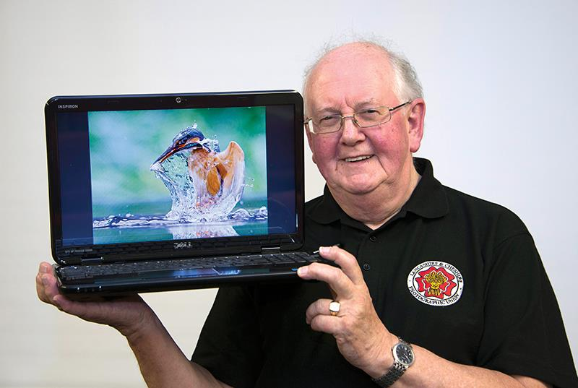
Bebington Salon presenter Bob Dennis with one of the many excellent images from Wednesday's viewing of The Bebington Salon of Photography held at Thie Ellyn.

