IOMPS Reports During September 2016

29th September 2016 – IOMPS New Season Underway
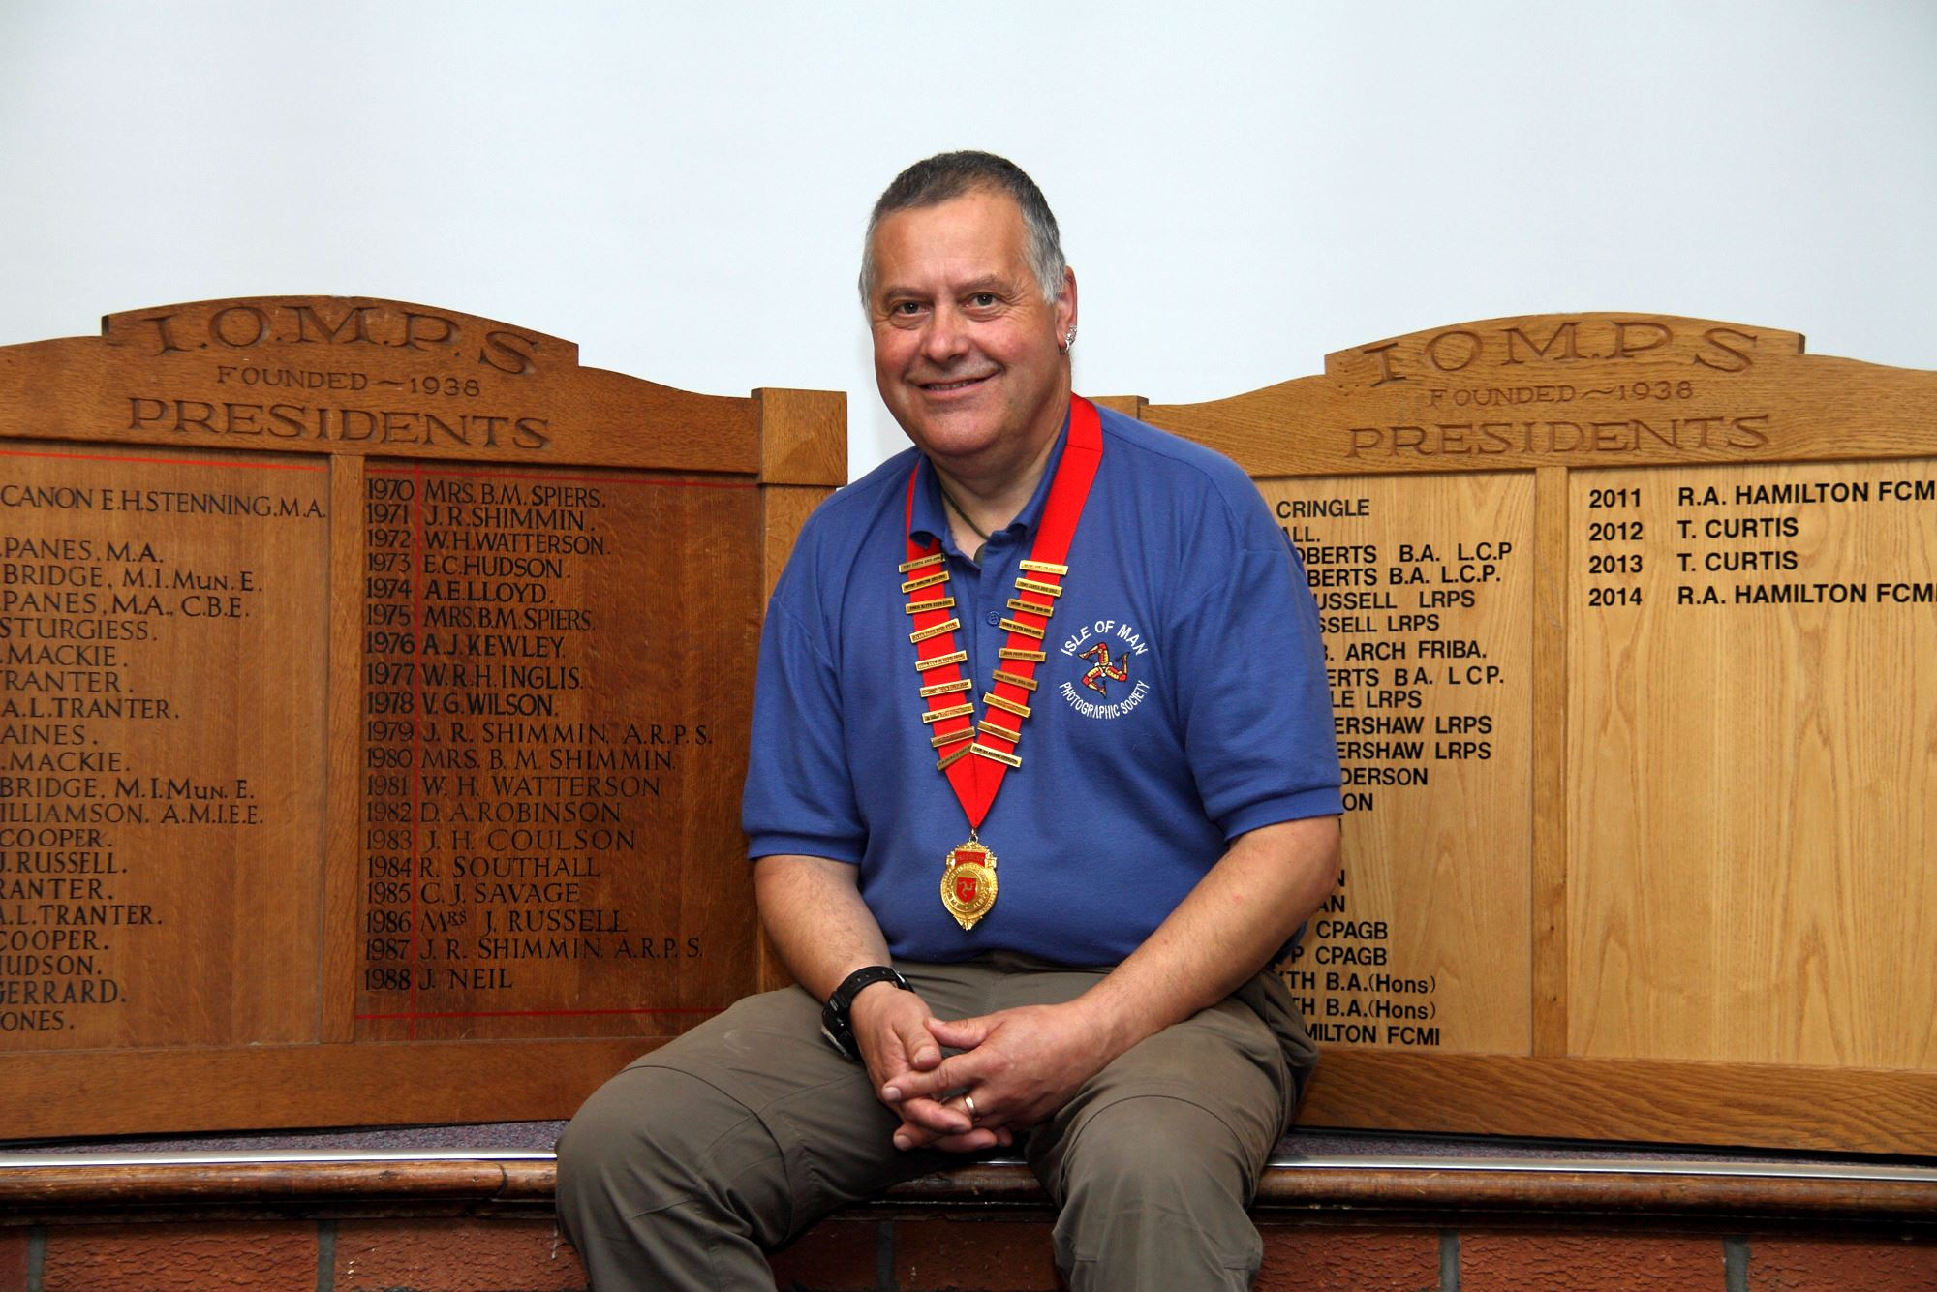
President Tony Curtis welcomed both old and new members to the first evening of the new season on Wednesday 28th September
Following a busy summer of outings which included visits to an aircraft hanger, Lorne House, Jurby race days and the Calf Sound, Wednesday 28th September was the first meeting of the 2016/17 season of the Isle of Man Photographic Society.
The evening was an informal meeting and included a slideshow of the previous year’s digital annual entries. Visitors were also able to pay their annual membership and view examples of ‘print panel’ submissions – a competition which is held in December.
The club meets every Wednesday at Thie Ellyn with a 7.30pm start time, guests are welcome and there is a £1 entry fee for non-members. This year’s schedule runs until 26th April and features a variety of open and themed competitions, critique sessions, guest speakers and presentations.
This season’s themed competitions are: ‘Old & New’, ‘Song, Book or Film Title’, ‘Man & Machine’ and ‘Something Manx’. Competitions are judged by a selection of well-known photographers who provide extensive feedback on the images submitted.
Guest speakers this season include Phil Kneen on the 30th November and Dr. Jeremy Paul on the 8th February.
We are always looking for new speakers so if you are a local photographer who may wish to present to the group please do get in touch via our facebook page: www.facebook.com/IOMPS.
The full programme can be viewed here: http://www.iomps.com/programme
By Hazel Walsh

IOMPS Reports During October 2016

27th October 2016 – October Digital Open Competition
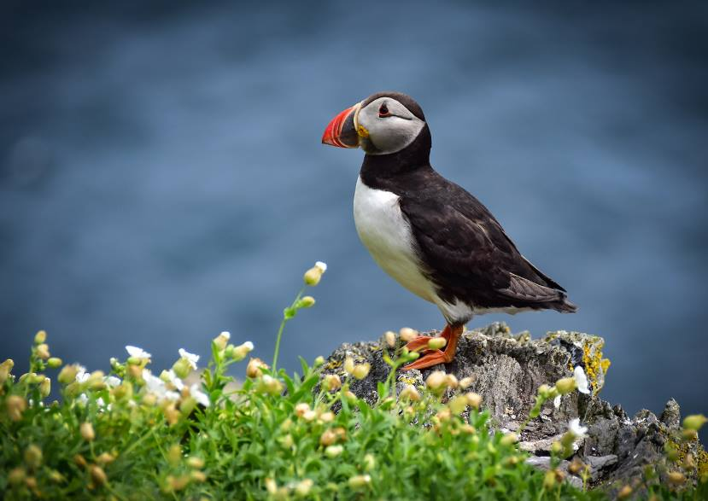
Best Image in the first digital Open competition of the season was “The Puffin” by Barry Murphy
On Wednesday evening 19th October the Isle of Man Photographic Society held an Open Digital Competition at Thie Ellyn, off Withington Road, Douglas.
Our President, Tony Curtis, introduced Ray Kelly as our judge for the projected digital images. There were 34 entries in the three classes.
Before judging any pictures Ray remarked that there were no bad images in tonight’s competition. He also commented that an extraordinarily high proportion of the images entered were natural history photographs – about half of them had birds, animals or insects as their subject.
Results for the Standard Class:
3rd: “Look No Hands”, a monochrome image of a surfer balancing on a surf board by Tim Norton.
2nd: “Flying towards the Sunset” by Kevan Osborn. A distant bird flying into the sunset with Bradda Head in the background.
1st: “Cormorant, Douglas Harbour” by Michael Howland, a very sharp and nicely posed cormorant on an orange buoy. Ray commented that the photo would have been better if the buoy had been a different colour, but there was nothing the photographer could do about that!
Results for the Intermediate Class:
3rd :”Angel Wings” by Sue Leeming. A beautiful sharp action shot of a gull in flight.
2nd: “Quarry Falls, Laxey” by Barry Murphy. A very attractive long exposure shot of this small waterfall, including a rainbow.
1st: “The Puffin” also by Barry Murphy, a pin sharp photograph of a puffin in profile, with lovely colours.
Results for the Advanced Class:
3rd: “Horse Play Time” by Chris Nicholls. A dynamic and colourful action shot of the white horses in the Carmargue. Ray commented that the picture could have been improved if more of the water in the foreground could be included to show fully the reflection of the horses.
2nd: “Flying Puffin” by Sue Blythe. A good image of a puffin carrying fish flying directly towards the photographer. Unfortunately the weather had been cloudy, so the colours in this picture were quite dull.
1st: “Chukka Chase” by Bob Servante. A beautifully timed action shot taken at a polo match in the Isle of Man this year. The horses were pin sharp, and remarkably the shot was timed so that all eight hooves were off the ground!
The Best photograph of the evening was judged to be “The Puffin” by Barry Murphy.
Unfortunately none of the three excellent photographs of puffins shown were taken in or around the Isle of Man.
By Richard Shafto

20th October 2016 – October Open Print Competition
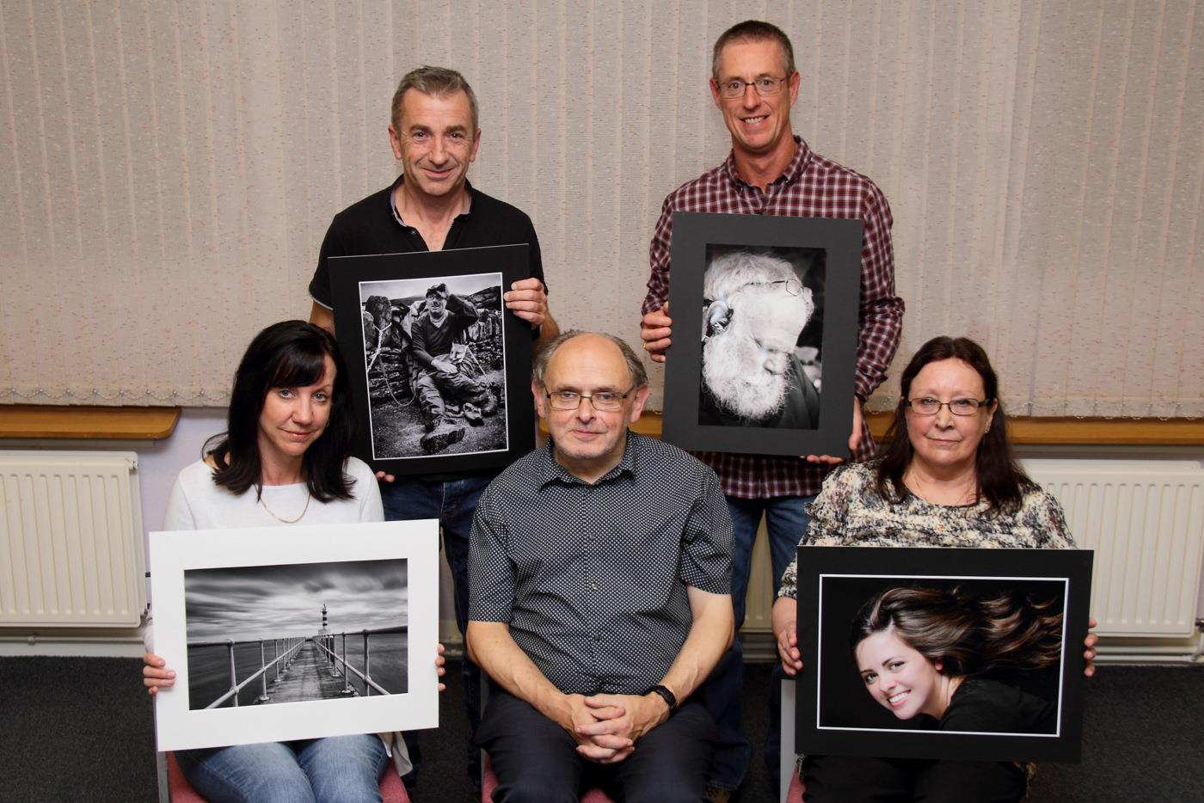
Open Print Winners with Judge Seamus Whelan
The IOM Photographic Society was this week treated to an Open Prints competition, the first of our regular competitions in the new season just started. Our judge was Seamus Whelan who proved an able and confident judge with a keen eye for composition – obvious distractions in the image or empty spaces which failed to contribute to the overall image were quickly picked up, as were mono images which lacked contrast.
Rather disappointingly, the …standard group entry was limited to images from just one member Jonathan Carey, who thus automatically won both groups – a pleasing portrait of a bearded male in the mono section, and a lively street scene in the colour. The intermediate group however rose to the challenge, and in a very competitive group, it was Barry Murphy who emerged the winner in both mono and colour sections – a very strong portrait of a rambler against a stone wall winning Barry the mono prize, and a delightful and very well composed image of church pews in lovely light winning the colour. In the advanced section, a good entry also ensured keen competition, with Sue Blythe winning the mono section with a lovely and very sensitively printed image of a pier leading the eye to a lighthouse at the end, and demonstrating excellent depth of field and composition. Janet Servante proved the benefit of attending club outings, winning the colour section with a superb portrait of one of our models at a recent studio lighting demonstration held in the Douglas Market Hall, her hair beautifully caught in a cascade effect.
Our President, Tony Curtis, gave Seamus a well-earned vote of thanks.
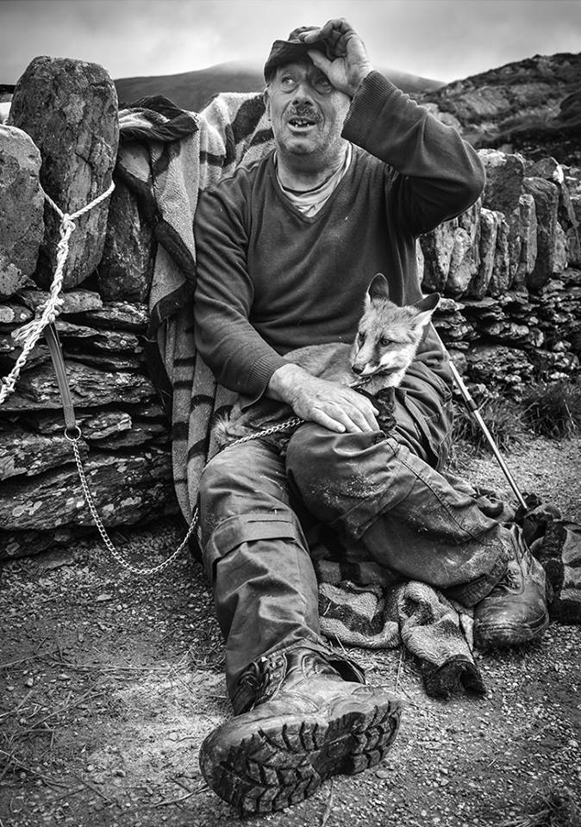
“Tom Jackie” by Barry Murphy gained Best Image in the first Open Print competition of the season
Our next meeting on 26th October will include presentations from Ruth Nicholls (Croatia) and husband Chris Nicholls (Italy). IOMPS meetings are held at Thie Ellyn (the Art Society building) in Withington Road, starting at 7:30pm. Meetings are open to the public – non-members with a charge of £1 – and all will be given a very warm welcome.
Results: Standard Group. Mono Prints – Jonathan Carey (1st). Colour Prints – Jonathan Carey (1st). Intermediate Group. Mono Prints – Barry Murphy (1 & 3), Joy Brodie (2), Sue Leeming (4 & 5), Richard Shafto (6). Colour Prints – Barry Murphy (1 & 5), Shirley Lotfy (2 & 6), Richard Shafto (3 & 4), Beryl Quayle (HC). Advanced Group. Mono Prints – Sue Blythe (1 & 3), Bob Servante (2 & 5), Chris Blyth (4), Ron Shimmin (6 & HC). Colour Prints – Janet Servante (1), Ruth Nicholls (2), Chris Blyth (3 & 4), Bob Servante (5), Ron Shimmin (6 & C), Sue Blythe (HC). Best Image in Competition – Barry Murphy with “Tom Jackie”.
By Chris Blyth

13th October 2016 – Studio Lighting and Lightroom
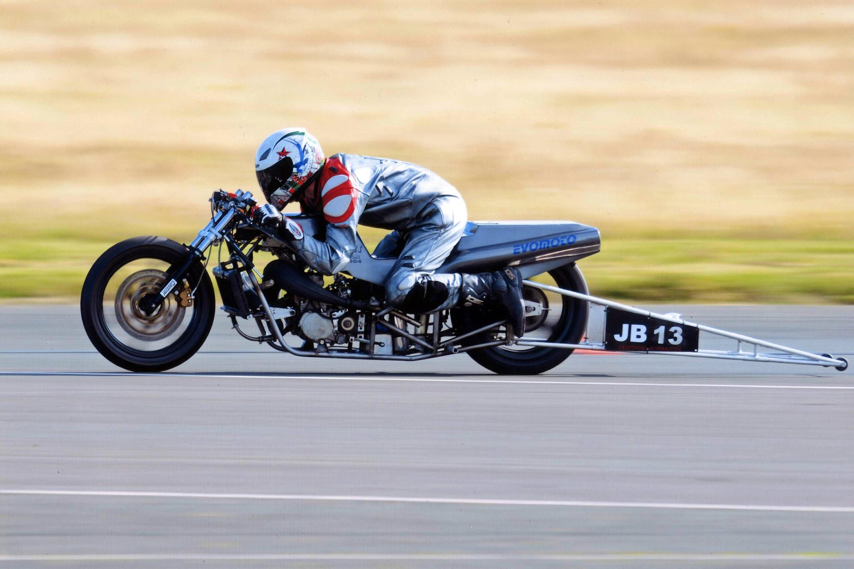
Mike Trout’s image of a drag racer at speed won the fun competition which was the result of a recent IOMPS outing to a drag racing event held at Jurby
This week’s meeting of the IOM Photographic Society was something of a “mix and match”, with a variety of topics being covered. Club President, Tony Curtis, was at one end of the hall presenting a well-prepared session on studio lighting– with himself, when necessary, as the model. The session covered one and two light techniques, lighting for both male and female models, and the positioning of the lights to create various shadow effects on the …face – a very helpful and confidence building presentation for those not familiar with studio lighting.
At the other end of the hall, Richard Leach was demonstrating Lightroom – a digital software package much used by photographers and which has a wealth of features to explore. Richard’s expert presentation, delivered in a very clear and confident manner, majored on the “library” module – essentially a cataloguing system for all the images which build up in one’s computer system over time. The important element – a proper filing system to enable speedy and easy access to any particular image – was stressed, with the essential element in that process being a consistent and recognisable structure to the filing. Thus this might include date, location (or GPS details now available on many modern digital cameras), a colour tag or star rating to show important features, the camera or lens hardware being used, or “word tags” in the metadata (such as clouds, rain, seascape etc)– any or all of which might enable the easy recall of specific images. The presentation also covered some information on batch processing and presets – intended to simplify and speed up image processing for the photographer.
The meeting closed with Tony judging a number of entries to a print competition based on a recent drag racing event at Jurby and which had been the subject of a club outing. Whilst a number of entries were similar in viewpoint and style, Tony’s winning selection, an image by Mike Trout, was of a drag racer at speed on the runway, the background nicely blurred by camera “panning” to emphasise the movement.
Our next meeting on 19th October will include the new season’s first Open Digital Images competition – certain to include some excellent images. IOMPS meetings are held on Wednesday evenings at Thie Ellyn (the Art Society building) in Withington Road, starting at 7:30pm. Meetings are open to the public – non-members with a charge of £1 – and all will be given a very warm welcome.
By Chris Blyth

IOMPS Reports During November 2016

24th November 2016 – November Open Print Competition
“American Great Blue Heron” by Chris Blyth gained “Best Image” in the November Open Print Competition
The IOM Photographic Society this week enjoyed an Open Prints competition, the second of our regular open competitions in our season just started (“open” in the sense that any subject matter is permitted rather than being a specified assignment topic). Our judge was Eddie Fryer, a regular and very popular judge from the Western society, who can always be trusted to give a comprehensive and well considered assessment of our efforts – and with a disappointingly small entry of just under 40 images, Eddie was able to take full advantage of the time available to give a very full and constructive commentary on each image.
Thomas Carr won the Standard Mono section with a river-side image of rocks and rushing water, whilst Jonathan Carey took the colour section with a quite stunning image of an alleyway filled with windows, washing, TV aerials and air conditioning units – a jumble of distracting items but executed with real aplomb and to a very high quality. Barry Murphy’s portrait of an elderly man won him the Intermediate Mono section, the image handled with sympathy but loaded with character and with all the signs of age and experience, whilst a strong close-up shot of an Iberian Wolf earnt Richard Shafto a first place in the Intermediate Colour section.
In the Advanced section, Bob Servante topped the list with a lovely image of a sheep shearer hard at work, the fleece falling around his ankles whilst the next sheep waiting its turn could be seen over the fence. In the Advanced Colour section , a subdued and understated image of an american great blue heron with its catch in beak gave Chris Blyth a first place and perhaps surprisingly, the award of “best image on the night”.
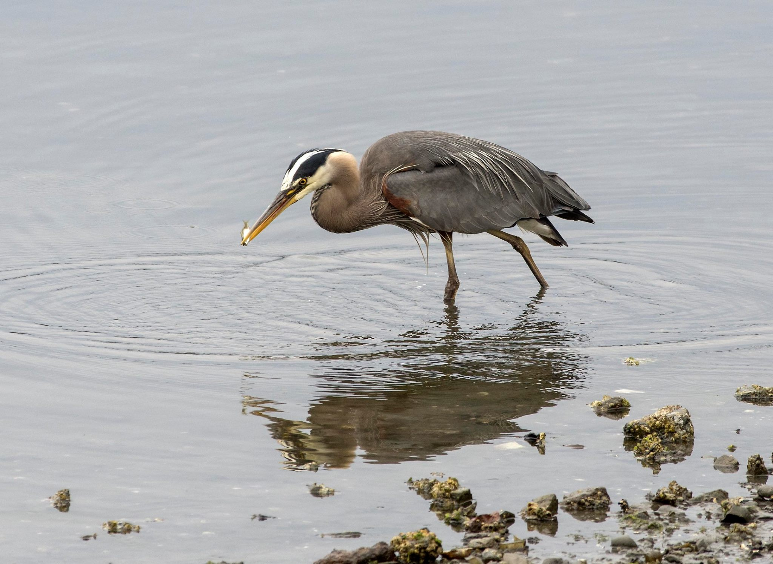
Our President, Tony Curtis, gave Eddie a well-earned vote of thanks, pointing out that for the first time in many weeks, all sections had been won by male competitors – but perhaps a situation unlikely to be repeated anytime soon!
Our next meeting on 30th November will include a presentation from well-travelled and well-known local photographer, Phil Kneen – sure to be a stimulating and interesting experience. IOMPS meetings are held at Thie Ellyn (the Art Society building) in Withington Road, starting at 7:30pm. Meetings are open to the public – non-members with a charge of £1 – and all will be given a very warm welcome.
Results – Standard Group. Mono Prints – Thomas Carr (1), Jonathan Carey (2). Colour Prints – Jonathan Carey (1), Thomas Carr (2). Intermediate Group. Mono Prints – Barry Murphy (1 & 5), Joy Brodie (2), Richard Shafto (3), Sue Leeming (4 & 6). Colour Prints – Richard Shafto (1), Joy Brodie (2), Sue Leeming (3 & 5), Barry Murphy (4 & 6). Advanced Group. Mono Prints – Bob Servante (1 & 5), Ron Shimmin (2 & 4), Chris Blyth (3). Colour Prints – Chris Blyth (1 & 3), Bob Servante (2 & 4), Janet Servante (5 & C), Ron Shimmin (6) Best Image in Competition – Chris Blyth with “ American Great Blue Heron”
By Chris Blyth

17th November 2016 – The Farne Islands and Bamburgh Castle
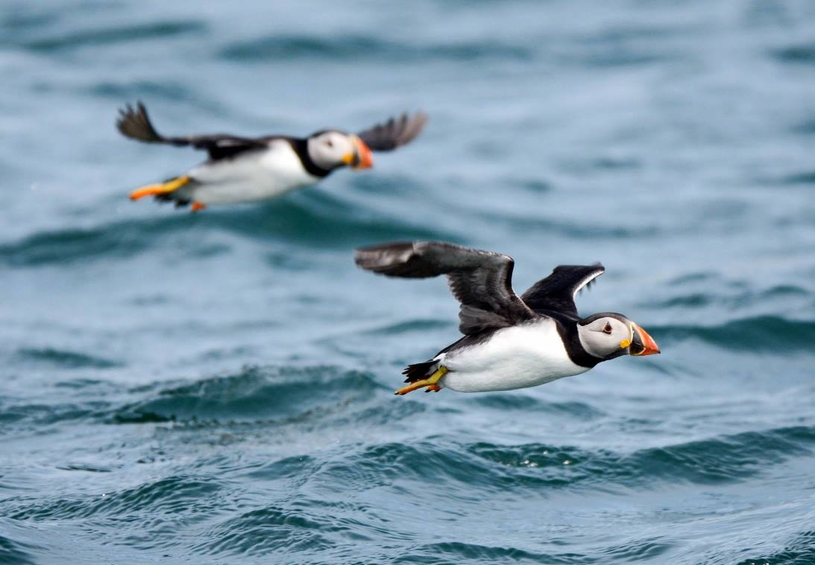
Puffins in flight by Mike Trout, one of many excellent images taken during a trip to the Farne Islands
This week the Society was treated to a talk by Bob Servante and Mike Trout on the Farne Islands and Bamburgh Castle. Bob and Mike, another member of the Society, visited the Northumberland coast earlier this year to see the nesting sea birds. Although the weather was too rough on the Saturday they made the most of it by spending the rest of the day wandering around the harbour at Seahouses before heading up to Bamburgh Castle. The Castle is an impressiv…e site with its great fortifications and the great hall with its high wooden ceiling. Bob even managed to get a photograph of a blue tit coming out of the castle wall.
Thankfully the weather calmed on Sunday and they made the rough crossings to the Inner Farne Island and it was worth the wait. They were surrounded by hundreds of seabirds flying around them as they travelled over, such as geese, shags, cormorants, guillemots and gulls. Once they landed they were ‘welcomed’ by hundreds of artic terns diving bombing them, protecting their chicks. Luckily the rest of the wildlife was more welcoming.
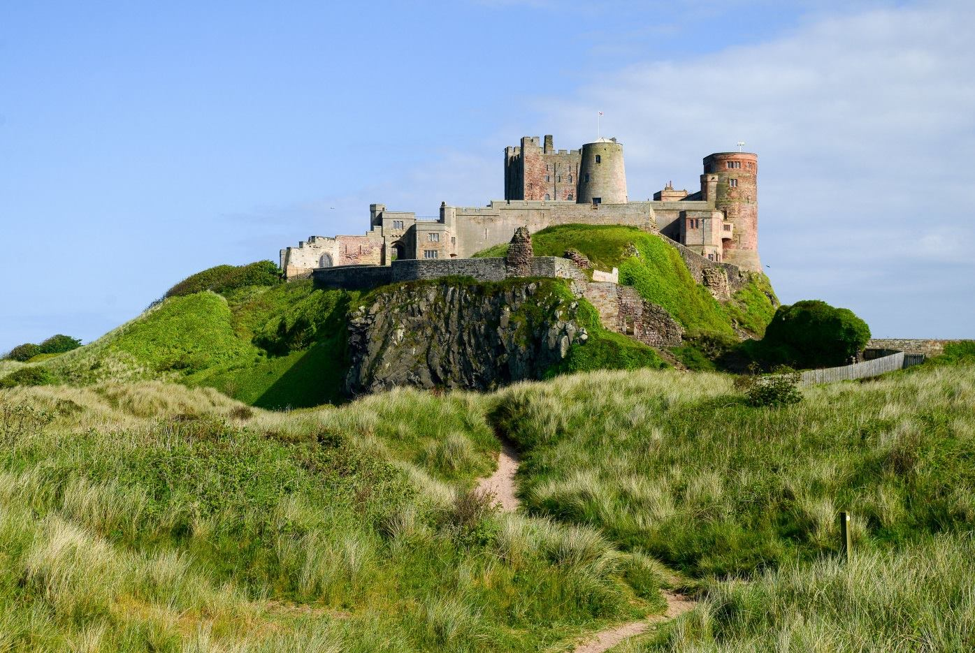
Bamburgh Castle by Bob Servante
Although they only had an hour to explore the small Island they managed to see most of it and visit not only the wonderful wildlife but also some of the historic building that still remain, such as the lighthouse and St Cuthbert’s Church. They were witness to thousands of puffins, watching them bring in sand eels for their hungry chicks hidden in their burrows. In addition to these charismatic birds, various other sea birds were seen including shags, guillemots, cormorants, razorbills and several species of gulls many of which also nest on the Island. The Farne Islands also support a notable colony of around 6000 grey seals and many were seen hauled out on the rocks around the coastline.
The second half of the evening was a showing of the L&CPU Portfolio. This contained around 60 photographs taken by other photography clubs in the north of England. The portfolio contained both colour and black and white images, providing a great visual experience for our members. There was a vast variety in the subjects photographed from nature to people to landscapes. It certainly gave out members something to aspire to for future competitions. The overall winning photograph was of a surfer riding a large wave. A wonderful image and a worthy winner.
By Lara Howe

10th November 2016 – First Assignment Competition ‘Old and New’
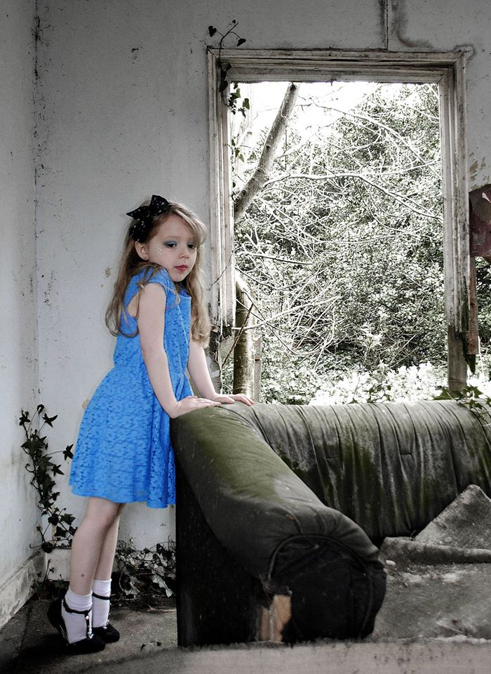
‘The New Blue Dress’ by Hazel Walsh gained Best Digital Image in this season’s first assignment competition ‘Old and New’
Wednesday 2nd November was the first of the season’s themed competitions – with the theme being ‘Old and New’. The judge for the evening was former member Ray Davies, a keen judge who very kindly explained his judging process to us before he commenced with his comments. This was very valuable and helps members to understand what to look for when taking and selecting their competition images. Ray explained several of the aspects he fo…cuses on including impact, technical quality, manipulation (if any), storytelling, subject matter, lasting interest and the images title and presentation.
In the prints section there were no standard entries, but in the intermediate section mono first place went to Beryl Quayle for her image of old townscapes contrasting with a modern coach of tourists in Stockholm. In the colour section the winner was Barry Murphy with his clever image ‘The Old & New Testaments’ which depicted a well lit image of a kindle alongside prayer books in a church pew.
In the advanced section the mono prize went to Bob Servante for his image ‘Cunningham’s Camp Entrance 1934/2016’ which cleverly interspersed an old photo within a current image of the camp entrance. In the advanced colour Chris Blyth took first place for his image ‘As it was then and As it is Now’.
In the digital section first place for the standard group went to Tim Norton for his image ‘Mother and Chick’. In the intermediate the winner was Hazel Walsh with ‘The New Blue Dress’ and in the advanced section first place went to Sue Blythe for ‘Dale Grimshaw’s Street Art (2016) at Brick Lane (1800’s).
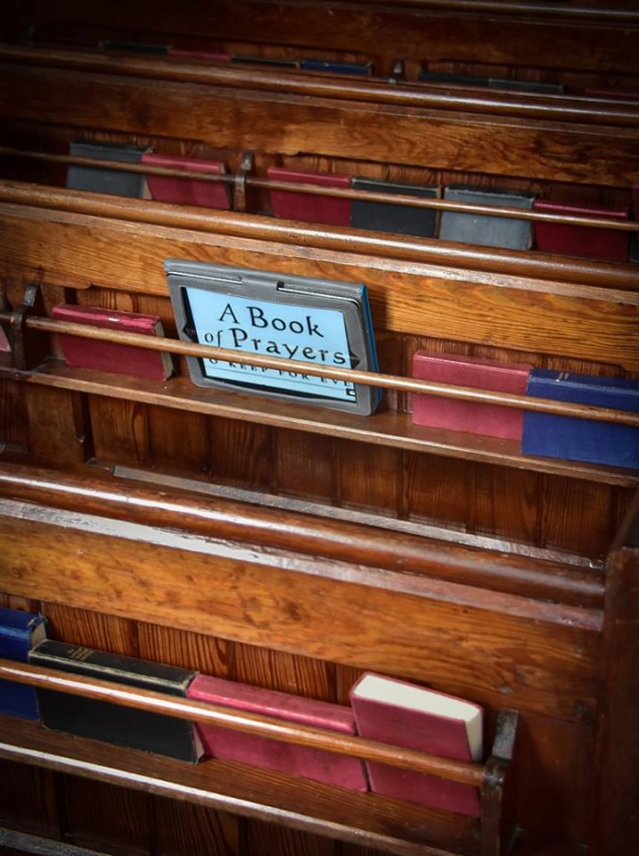
‘The Old & New Testaments’ by Barry Murphy took Best Print in the ‘Old and New’ assignment
In both the print and digital competitions the award for best image went to the intermediate members with Barry Murphy winning best print and Hazel Walsh winning best digital image.
It was a busy week for the society as Thursday 3rd November was the annual three way battle that takes place between Isle of Man, Western and Southern photographic societies. The judge for the event, held at Peel Football Club, was David Kneale who provided comprehensive feedback on the 90 images entered. Western took the trophy once again this year scoring a total of 493 points with IOM scoring 477 and Southern 465.
The prize for the best image in the competition also went to Western for ‘Marsh Rider’ by Dorothy Flint.
The society’s next meeting will be on Wednesday 16th November and will feature an Open Print competition. Meetings start at 7.30pm at Thie Ellyn in Douglas and all are welcome.
By Hazel Walsh

3rd November 2016 – From Tuscany to Croatia
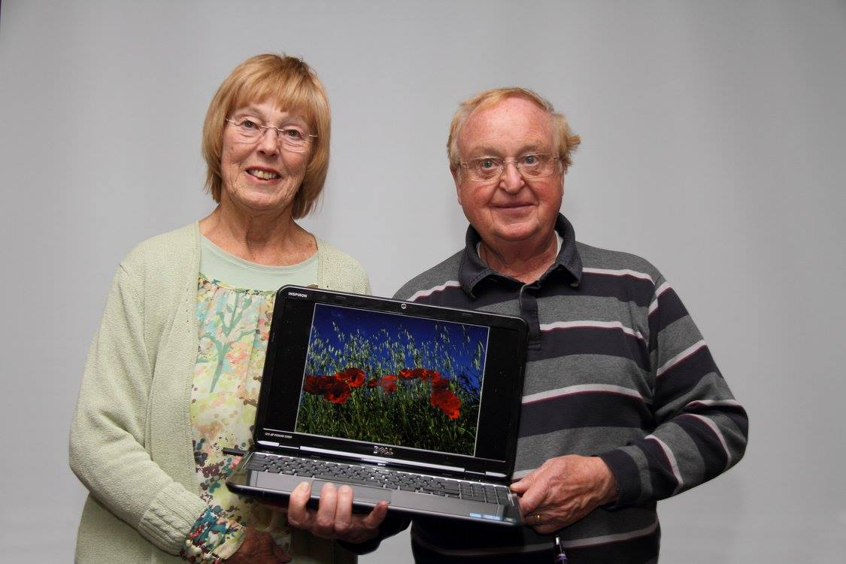
Ruth and Chris Nicholls
Last week, members were treated to two high quality presentations by that well known double act, Ruth and Chris Nicholls. Chris began with his images of Tuscany and Umbria, surely one of the most picturesque areas in the world. The show depicted popular tourist destinations like Pisa, the walled village of San Gimignano with its distinctive towers, Sienna, and Orvieto, but also revealed the delights of quite a few lesser known Italian towns.
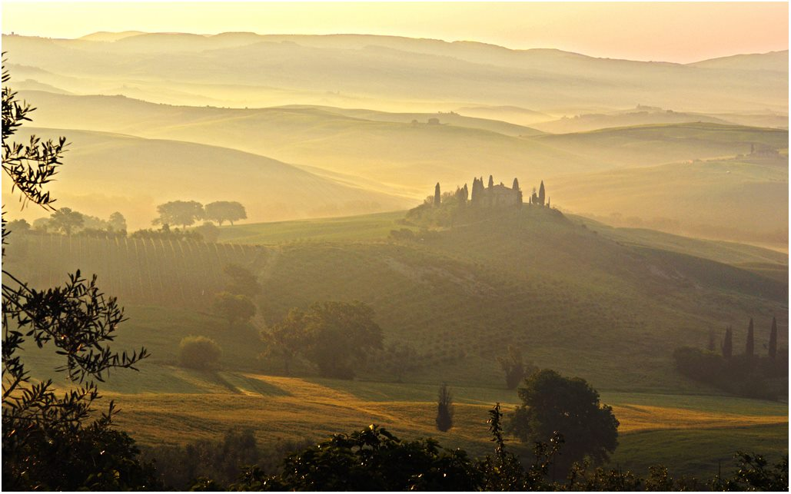Villa Belvedere by Chris Nicholls
Chris started at Pisa, with its leaning tower, Cathedral and wonderful Baptistery, a World Heritage Site. He then moved into rural Tuscany, where we were shown views of the Villa Belvedere, often featured in photographic magazines. Perched on a hill, the villa’s iconic image shows the mist rolling in at the start of the day and Chris had waited patiently early in the morning to capture it. The tiny hilltop village of Pienza featured next, commanding spectacular views across the Orcia Valley and then San Quirico, a charming walled town on the northern edge of the Valley amid a sweeping rural landscape.
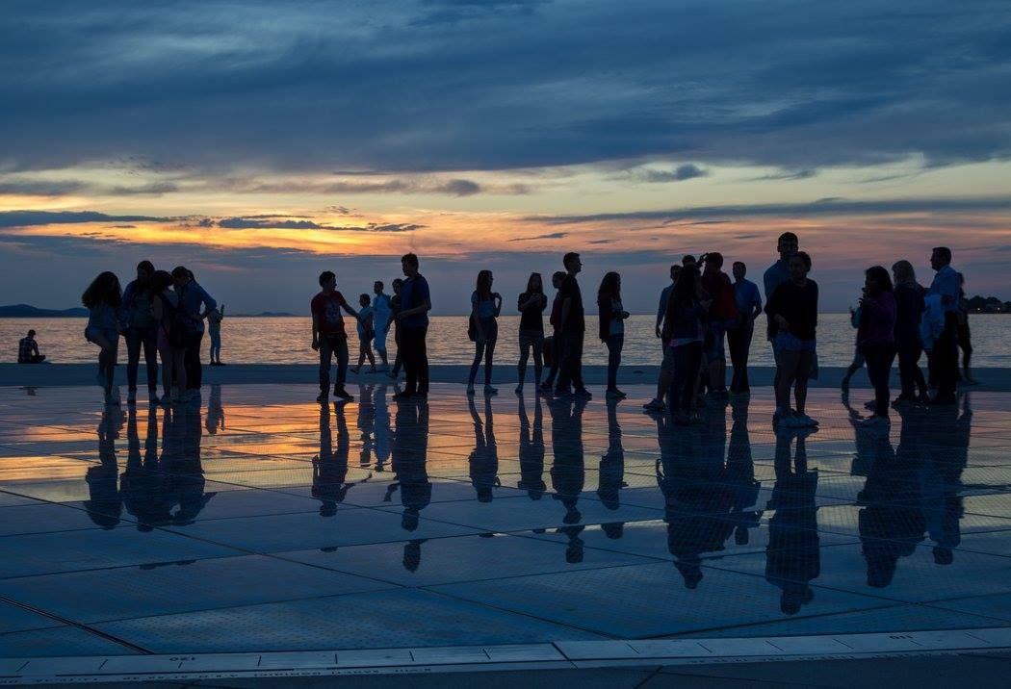Zadar sunset by Ruth Nicholls
After a brief stop at the charming little Chapel of the Madonna di Vitaleta and the Benedictine monastery of St Antimo, dating back to 1770, we arrived in Siena with its magnificent medieval architecture and the Piazza del Campo – another World Heritage Site – where the Palio horse races are held. The stunning Gothic cathedral was shown to good effect.
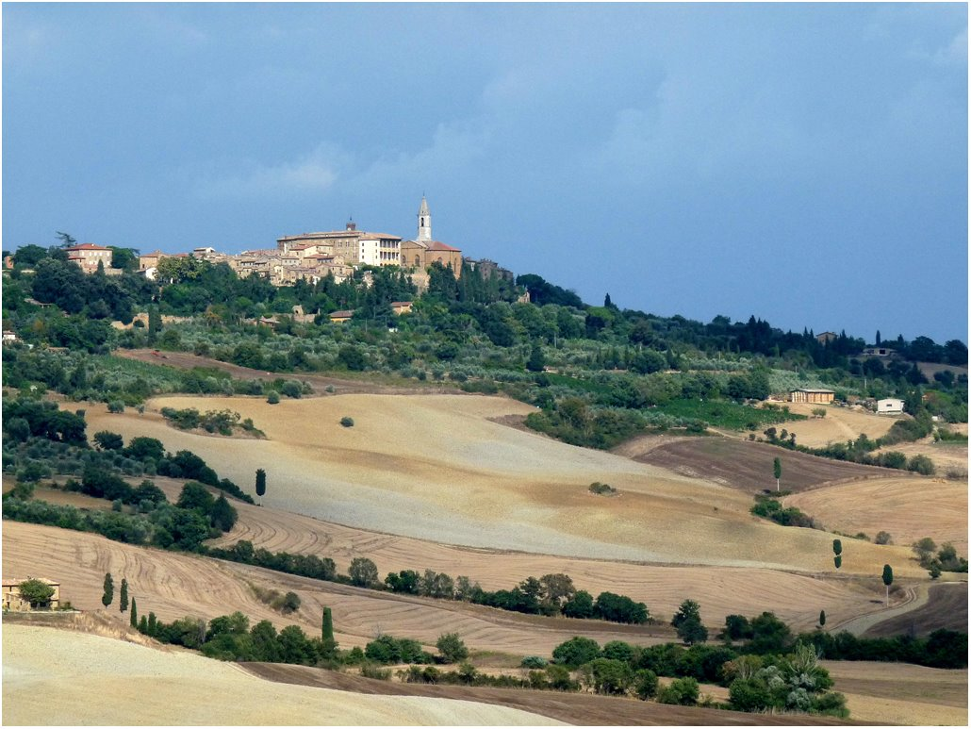
Tuscany landscape by Chris Nicholls
Further excursions off the beaten track eventually led us to the city of Orvieto with its narrow streets and magnificent 13th century Duomo, the city’s most dramatic focal point. The striking black-and-white façade and its intricate carvings contrasted with the austere interior.
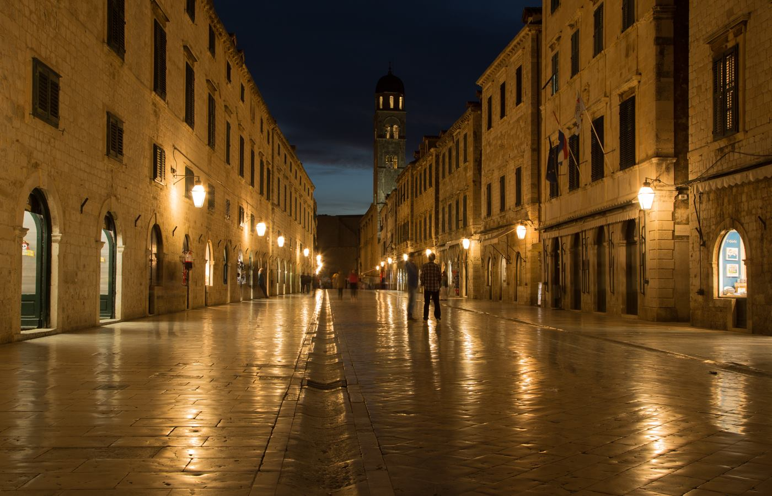
The Stradun, Dubrovnik by Ruth Nicholls
Ruth then took over and gave an excellent presentation on Croatia. It quickly became clear that this country remains something of a hidden treasure to many as we were first shown the wonderful sight of the old town and harbour at Dubrovnik, another UNESCO World Heritage Site. The images of the walled city were truly spectacular. It is such an atmospherically beautiful place, especially in the evenings after the cruise passengers have departed. There was as short visit to the small, traffic free island of Lokrum to view the Benedictine monastery. Ruth then moved us north to Hvar Island, Starigrad, Zadar and historic town and harbour at Trogir before reaching the beautifully dramatic waterfalls at in Plitvice Lakes National Park.
On the 9th November at 7.30 pm at Thie Ellyn, Bob Servante will present ‘The Farne Islands’, and the entries for the next Open Prints competition will also be due in.
By Antony Hamilton

IOMPS Reports During December 2016

29th December 2016 – 2016 Review

The Stradun, Dubrovnik by Ruth Nicholls from her presentation on Croatia
The IOM Photographic Club takes a short break over the Christmas period, so perhaps this is an opportune moment to review progress so far this season – it has certainly been busy and enjoyable so far, and with lots of good things to look forward to in the new year.
The programme as always has been a mixture of events – of presentations, plus our usual run of competitions, topped off with various practical activities – all designed to provide a varied package of events to ensure there is something in the programme for everyone. Presentations have included a fascinating evening with Phil Kneen, well known local photographer with a very wide and enthusiastic audience of followers. His website says he “shoots people” so a lot of portraits were shown, but mixed with many travel and reportage images (he has worked for national papers such as the Independent and the Guardian, reporting for example on “the jungle”, the refugee camp at Calais). His photography, as I hope he would agree, is “different”, with an almost unique feel to it, being based on film rather than digital imaging, often with out-of-date film with sometimes unpredictable results – he proved an excellent speaker with a sense of humour and anecdotes to ensure his audience’s!
attention….
Other presentations have come from our own members – Ruth and Chris Nicholls, both excellent photographers, showed travel images from Croatia and Italy respectively, and Bob Servante and Mike Trout presented some superb natural history shots from a trip earlier this year to the Farne Islands – a bird watching paradise during the summer.
Activities have included a practical with studio lighting techniques, and a “critique” session when two members volunteered to act as judges of a range of images, with active participation from other members from the floor – and which ensured the task and difficulties faced by our judges in actual competitions were better understood.
Competition-wise, we have had the usual “cut and thrust” with a number of members vying for winning positions – but currently all classes remain wide-open, with everything hanging on performance during the final part of our year. But to date, our standard group shows Jonathan Carey and Thomas Carr trading places in the print competitions, whilst in the digital classes, any of Tim Norton, Michael Howland, Peter Keena or Kevan Osborn are currently in the running. Barry Murphy is doing well in many of the Intermediate classes, and depending on the section, Richard Shafto, Hazel Walsh, Joy Brodie, Beryl Quayle and Sue Leeming providing strong competition. Meanwhile, Sue Blyth leads in three of the advanced section competitions, with Bob Servante leading another two, and Chris Blyth the final section – but with Ron Shimmin, Ruth Nicholls, Chris Nicholls and Janet Servante all having a chance to turn the tables in one or more sections.
IOM Photographic Society meetings are held on Wednesday evenings at Thie Ellyn (the Art Society building) in Withington Road Douglas, starting at 7:30pm. Our meetings are open to the public, with a nominal charge for non-members. All will be made welcome.
By Chris Blyth

22nd December 2016 – Print Panel Competition
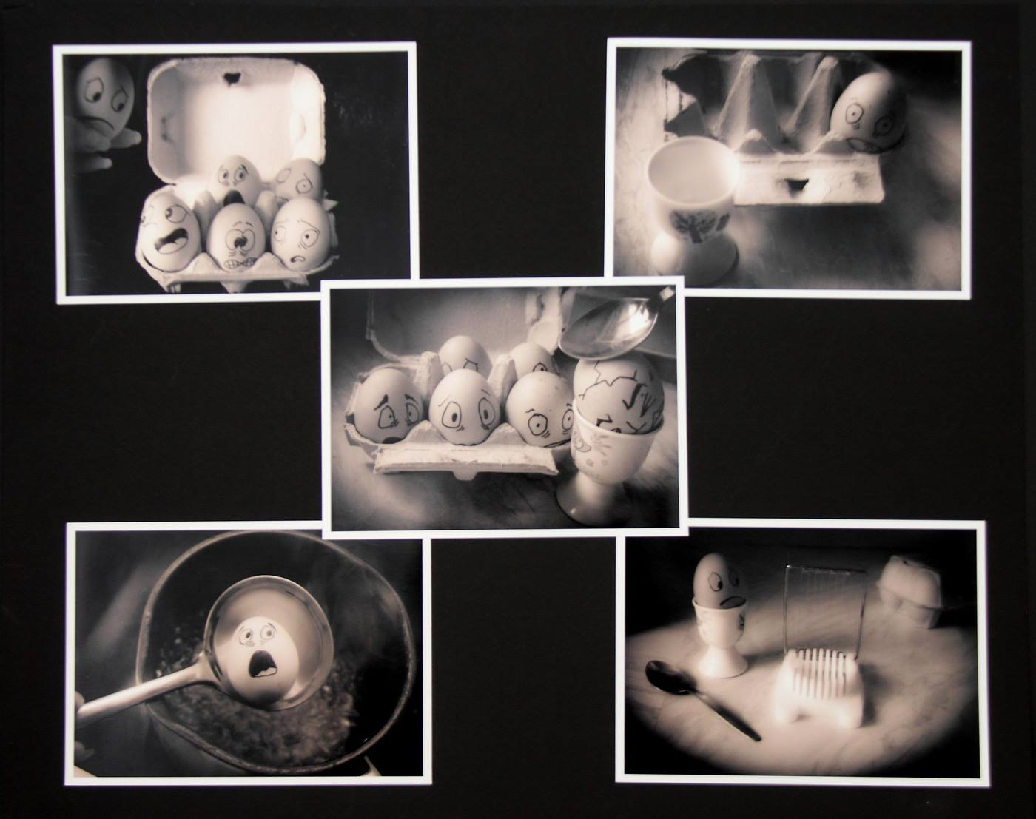Sue Leeming’s winning print panel “Endings”
It was the last club night for the year so it was a relaxed evening with an informal print panel competition followed by a social night of catching up and discussing the latest photography projects. The committee had decided that the images would be judged by the club members with a score of 1 to 5 for each print. Giving a maximum score of 110. There were eight print panel entrants, each with a very different theme but all of a high calibre.
The compe…tition was a close contest with only 18 points between the top three positions. In third place was Richard Shafto with “The first six”. A colourful panel showing the first six bikes off the Grand Strand. A nice presentation of the images. In second place with Ron Shimmin with “Street Art” taken in London. Another colourful panel with an original presentation. The edges of the prints were torn adding to the overall impact of the arrangement. However, in first place, another original panel of images was Sue Leeming with “Endings”. A collection of images depicting the demise of a box of eggs before being cooked or eaten. Each egg had a face of terror drawn on it. A very original and well thought out concept. An “eggcellent” example of creativity and a worthy winner.
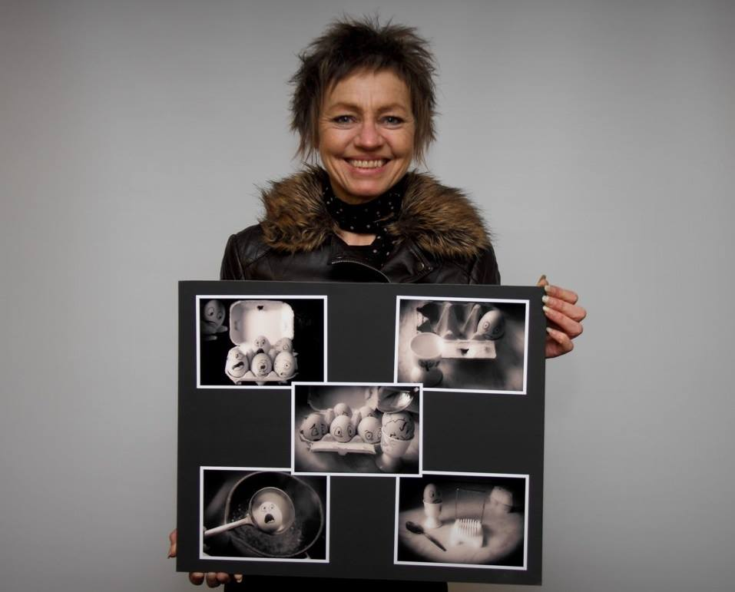
Sue Leeming with her winning panel
The evening finished with nibbles, a chat about all things photography and the plans for next year. The Club wishes everyone a Merry Christmas and a Happy New Year. Any one is most welcome to join us on a Wednesday night. The New Year starts on 4th January with a presentation by the Vice President John Phipp. A great start to the New Year.
By Lara Howe

15th December 2016 – ‘Song, Book or Film Title’ Assignment
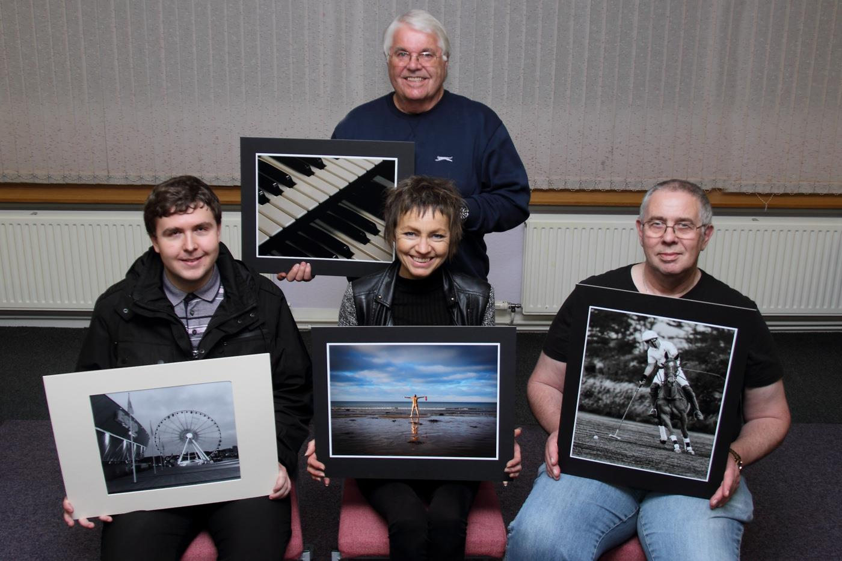
Some ‘Song, Book or Film Title’ print winners with Judge John Keelan
Wednesday 7th December was the second themed competition of the year – ‘Song, Book or Film Title’. The judge for the evening was John Keelan, previously president of the Southern photographic society and a member of the Western Photographic Society. John was an excellent judge, providing thoughtful and thorough commentary on each image and giving hints and tips for improvement.
Upon first viewing each image members were given the opportun…ity to guess at the song, book or film title that the image was related to, whilst some were readily interpreted others required several guesses and clues for the audience.
The evening commenced with the advanced print entries. Third place in the mono section went to Bob Servante for his study ‘Guitar Man’, a well lit image of another of our members in concert. In second place was Sue Blythe with a landscape scene of a lake titled ‘What lies Beneath’. First place went to Bob Servante for ‘Polo Solo’ – an excellent shot taken at a local polo match.
In the colour section third place went to Sue Blythe for a long exposure taken on Westminster Bridge and titled ‘London Calling’, second place went to Bob Servante with ‘Goodbye Yellow Brick Road’. In first place and winning best image in the print competition was Sue Blythe with her natural history image of a Polar Bear on the ice – ‘Wild Thing’.
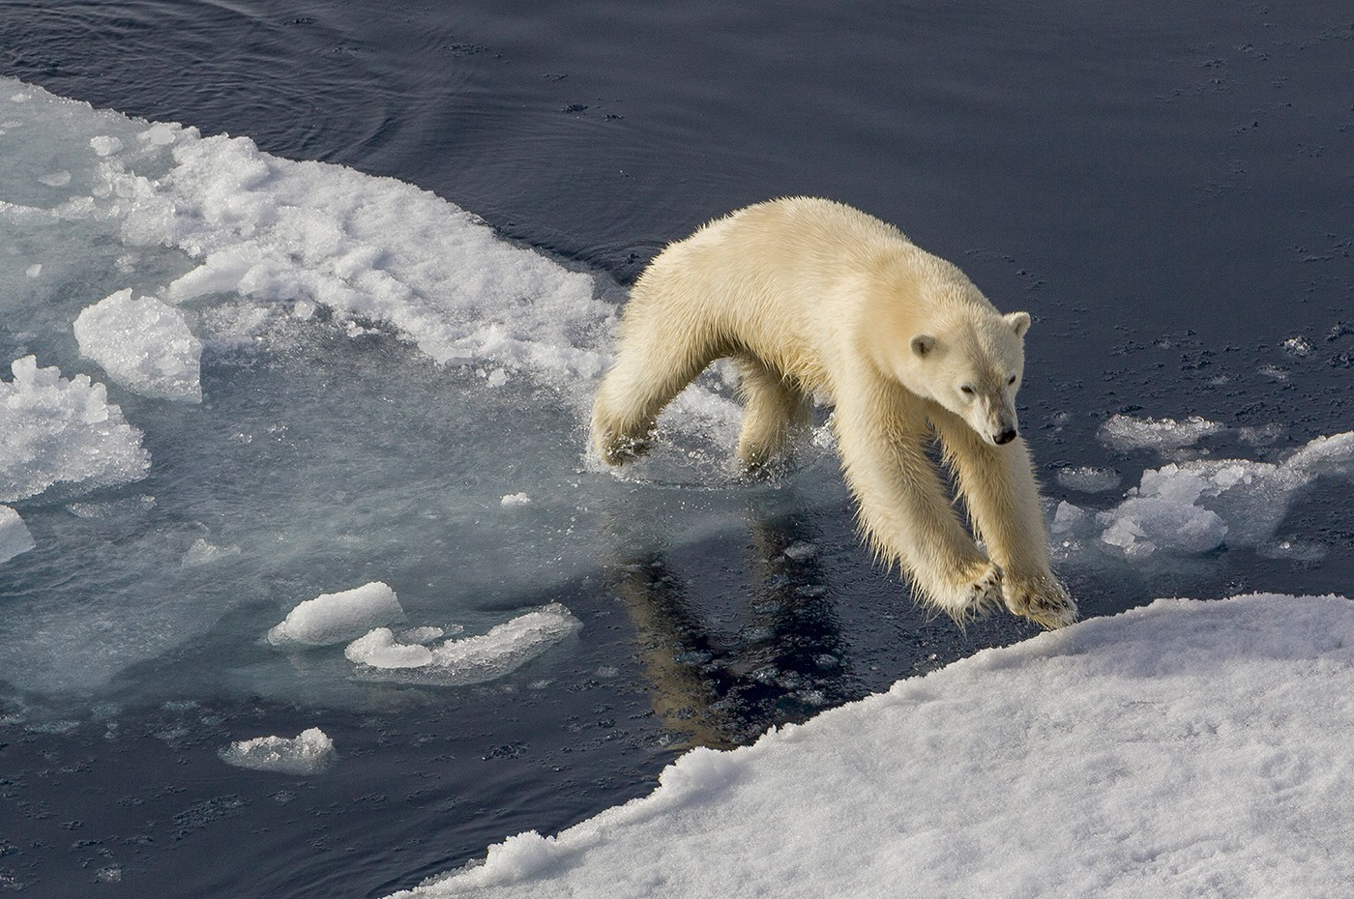Best Print in the “Song, Book or Film Title” assignment was awarded to Sue Blythe for “Wild Thing”
In the standard section there were 4 entries all from Thomas Carr, second place in mono was ‘The Big Wheel’ and in first place was ‘Oh, Christmas Tree’. In the colour section second place went to ‘Toy Story’ and first place to ‘The Lighthouse’.
In the intermediate print mono section third place went to Sue Leeming for ‘Gone with the Wind’ and Sue also won first place with ‘Ebony and Ivory’ a close up study of piano keys. Second place went to Barry Murphy for his image ‘The Fallen’.
In the colour section there were ten entries. In third place was Shirley Lotfy’s image ‘Baby its Cold Outside’, and in second place was Barry Murphy with ‘Another Brick in the Wall’. First place again went to Sue Leeming for her cheeky image ‘Free Willy’.
In the standard digital section first place went to Peter Keena for his humorous image ‘Help!’ showing a rubber glove emerging from a pond. In the intermediate section first place went to Sue Leeming for ‘Light my Fire’, a clever image of two matches igniting – this image also won best in competition in the digital section. In the advanced section first place went to Sue Nicholls for ‘The Railway Children’.
A full list of competition results can be found on our website and here you will also find the societies programme for the rest of the season. On the 4th January there will be a presentation by vice president John Phipp and we will view another section of the L&CPU portfolio.
By Hazel Walsh

8th December 2016 – An evening with Phil Kneen
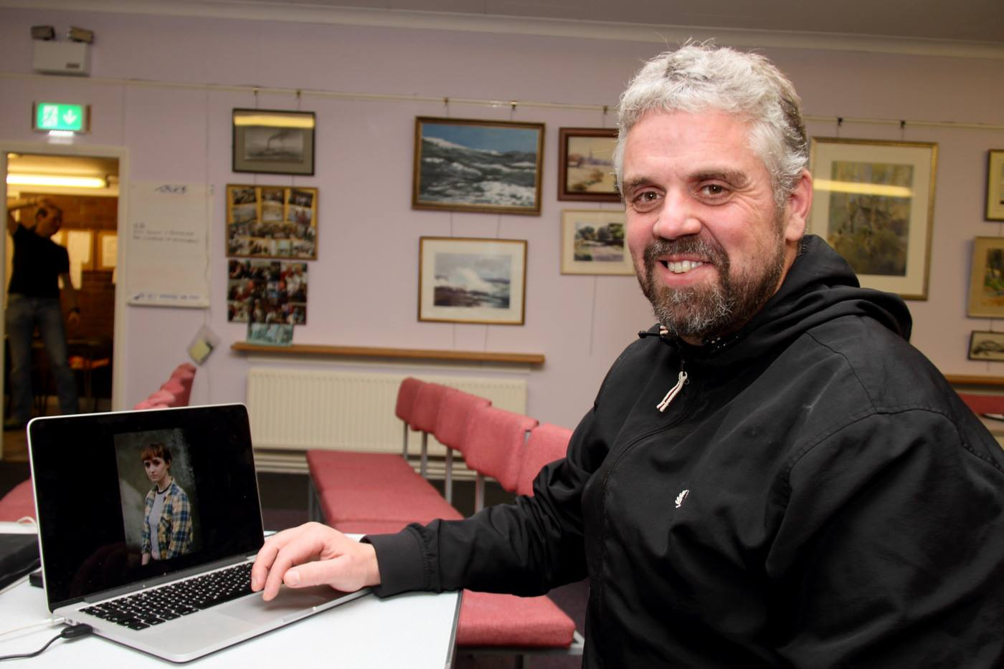Phil Kneen with one of the images from his presentation
The final meeting in November was listed in the Society programme simply as–‘ a presentation by Phil Kneen’. As Monty Python might have said, the evening proved to be a case of “…..and now for something completely different!” In an age when most photographers have been converted to the delights of the digital age, Phil has taken a very personal decision to reject that medium in order to work almost en…tirely with film.
Phil started out working in his teens for that old Manx firm, Keigs, and later for Island Photographics. However, it is only in the last 10 to 15 years that he has taken his photography seriously. Self confidence and a willingness to give anything and everything a try has enabled him to establish his own particular style and to progress.
Describing himself as a freelance photo-journalist who “shoots people”, he shuns flash in favour of using natural light wherever possible. Even in poor lighting conditions, he perseveres by up-rating his film to its tolerance limits. He has completed commissions for the Guardian and the London Times, as well as for several magazines and posts many of his images on social media sites where he has found a market for them.
Phil’s presentation was varied and illustrated his creativity to good effect. One rather fascinating sequence showed life in the migrant camp (‘The Jungle’) in Calais. The dreadful, muddy conditions in which as many as 7,000 people were living in makeshift huts and crude tents proved to be rather shocking. He said only a minority could be classed as genuine refugees, with the vast majority being economic migrants trying to reach the UK to work or claim benefits. Living on this beautiful Island of ours, it made us realise just how lucky we are!
His persistence with film, most of it well passed its use by date, gave the images a slightly unusual appearance which he described as ‘natural’. Though he talked rather disarmingly about his work, he is serious about what he does and is currently studying for his Masters in Photography. His simple belief is that if you take a photo of something you like and you enjoy the image, then it’s a good photo! He certainly left us all with much to think about, as President, Tony Curtis, observed in his vote of thanks.
The next meeting, apart from the Christmas social evening on the 14th December, will be on the 4th January, 2017 when we have Presidents Evening, and a L&CPU Portfolio. The print entries will also be due that night for the next ‘Open’ competition. Guests will be made most welcome on payment of a nominal charge.
By Antony Hamilton

1st December 2016 – Critique Session at Thie Ellyn
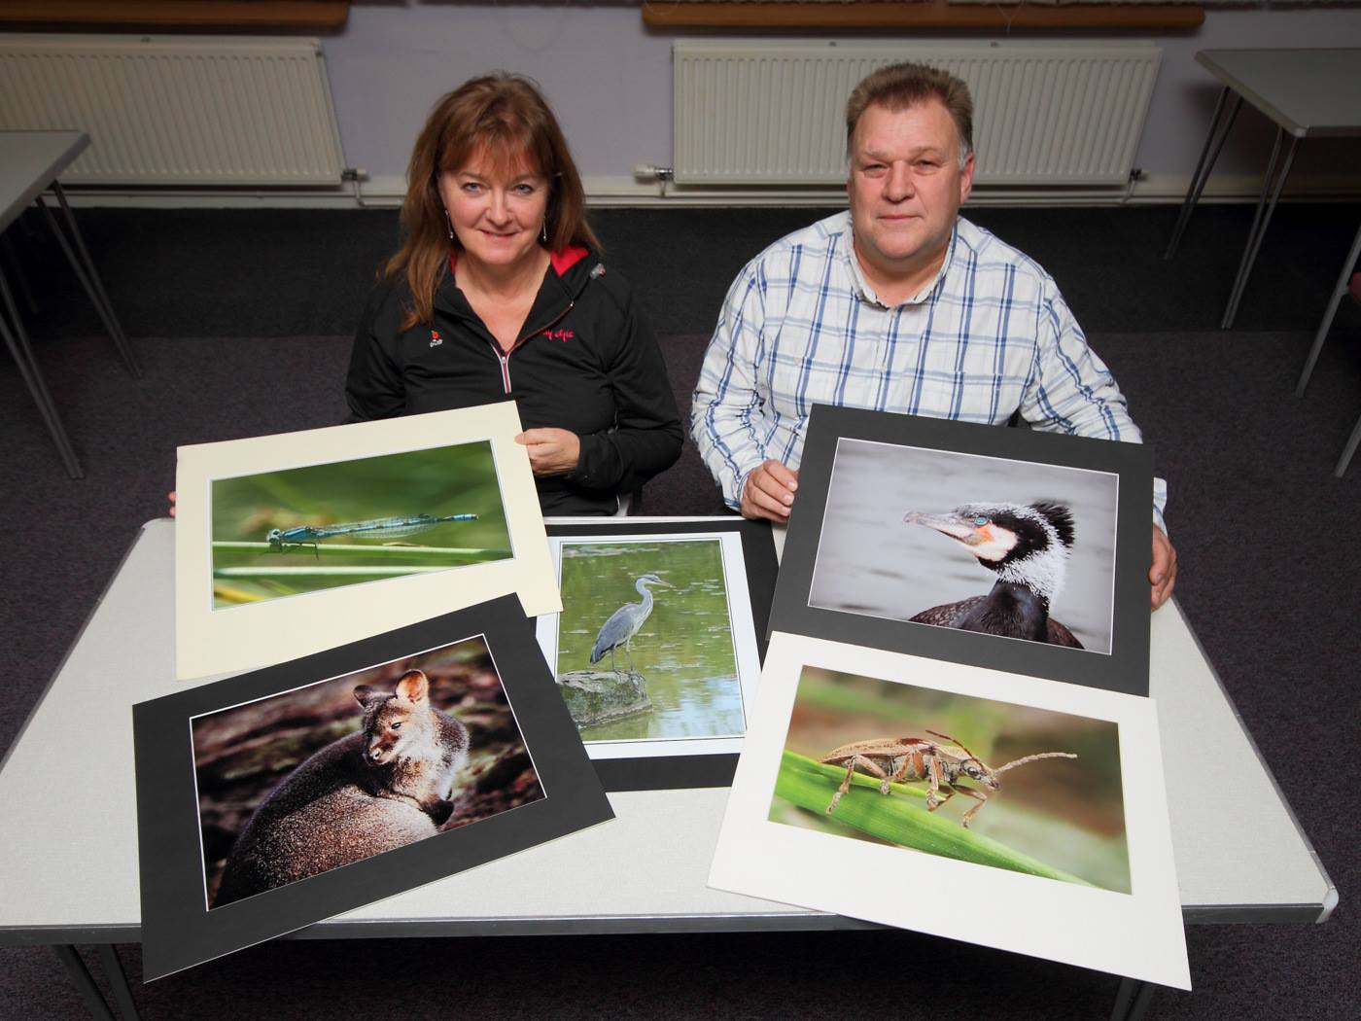Beryl and Jeremy with a selection of images which were put forward for the recent critique session
On Wednesday evening 23rd November the Isle of Man Photographic Society held a Critique Session at Thie Ellyn, off Withington Road, Douglas….
This was a departure from the format of our normal Wednesday meetings, when there is usually a competition or a presentation, This members had been invited to bring in any wildlife photographs – or anything else – that they would like the members to comment on. Many of the pictures brought in had been previously been criticised by various judges, and the photographers wanted a second opinion from the membership. Any member was allowed to comment on the pictures, but two informal judges (our thanks to Beryl and Jeremy) were appointed to lead the discussion, which they did very effectively.
The first half of the evening was devoted to a viewing of prints. Unsurprisingly the members disagreed among themselves on how each image could have been improved, but there were a few exceptional works that everybody admired.. A number of excellent macro photographs of insects were presented and for these shots pin sharp focusing had been a challenge. This led on to a detailed discussion about macro photography and the technique for using a flash for a macro shot. Most members had never tried this.
The most frequent comments from the audience were about cropping – they felt that most of the images presented could have been improved if part of the picture had been been cut off. Some prints were criticised for being poorly mounted and others were criticised for being too dark, but under better lighting they might have appeared better.
The second part of the evenings entertainment involved a slideshow of digital images. As in the first part of the evening, most of the images had wildlife as their subject. This time comments were often about how Photoshop could have been used to improve the image. Many images were criticised for distractions which the photographer might not have noticed – either in the background or foreground.- or bits at something at the edges which caught the eye.
The slideshow ended with a couple of spectacular photographs of fireworks at this years TT. True, the images were not perfect, but they made a tremendous impact on the audience.
Our President Tony Curtis brought the critique session to a close and summed up the evening. Although the number attending was less than usual, it was felt that the evening had been a great success, as everyone had felt able to make a contribution
By Richard Shafto

IOMPS Reports During January 2017

26th January 2017 - January Open Digital Competition
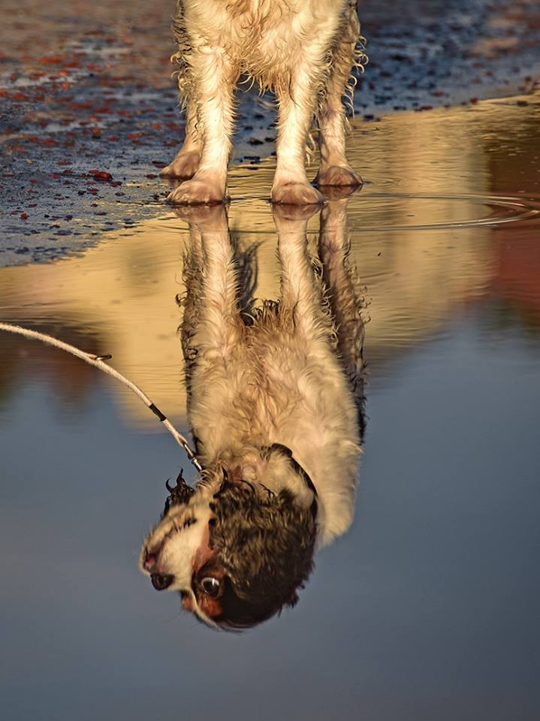Best overall image in January's Open Digital Competition was "Doggy Paddle" by Barry Murphy
The judge for our January 'Open' Digital Competition was the well respected photographer Andrew Barton LBIPP LMPA. Andrew had plenty of constructive criticism for the 50 or so projected images, but also praise for the really excellent photographs. The standard of the very best images, Andrew really liked, but he was still able to make some additional points. Each entry was given equal attention and it was true that many of the photographs could have been improved by taking more care when the shot was taken or by judicious adjustment of colour, contrast or lightness/darkness when the image was processed.
The competition started with the showing of images produced by the Standard Group. The winner of this section was Richard Leach who had entered a spectacular shot of the fireworks taken at the 2016 TT. Pictures by Peter Keena, Monument Valley 3rd place, and Michael Howland, Villa Marina Arcade 2nd place, also received many compliments from our judge.
The images submitted by the Intermediate Group were of a very high standard. Andrew pointed out that many of the images needed to be "warmed up" by the appropriate increase of yellow in the colour balance. But there were some stunning images which Andrew admitted he liked a lot. The first three places were "Puffin Perch" and "Star Light" both taken by Sue Leeming and the winner was "Doggy Paddle" by Barry Murphy. This winning shot was a dog, with its head not in the frame of the picture. The dog's head was only visible reflected in the water in which it was paddling.
The Advanced Group also provided some spectacular images. There were a few images that were near perfect. In third place was Ruth Nicholls' "The Fugitive" - a dreamlike vision of a masked fallen woman in black and white. Second was "Horse Fight" by Chris Nicholls. "Beautiful Blue Tit" by Sue Blythe was the winner - an extraordinary image of a tiny bird, with its head pin sharp and much of its body slightly out of focus. Andrew found little to criticise in this image which he found to be technically perfect.
"Doggy Paddle" by Barry Murphy was judged to be the best digital image of the evening.
The Society's next meeting is on Wednesday 1st February, 7.30pm at Thie Ellyn, off Withington Road, Douglas, and will be the Assignment competition 'Man and Machine'.
Meetings are open to the public with a nominal charge for non members. New members and guests are always welcome.
By Richard Shafto

19th January 2017 - January Open Print Competition
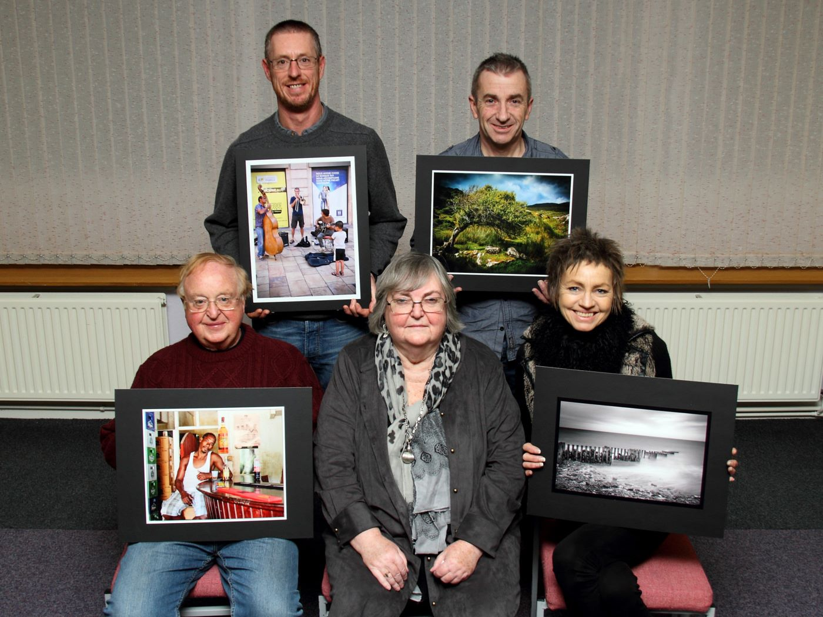
Some of the Open Print winners with Judge Patricia Tutt
For the January ‘open’ print competition, Dr Patricia Tutt RIBA, ARPS, CPAGB, returned as our guest judge and was given a warm welcome by the membership. Patricia is a well known architectural historian and authoress, and a stalwart of the Western Photographic Society.
It became clear from the outset that she had adopted a painstaking approach to the task of judging. Her comments on each entry were meticulous, constructive and enlightening, revealing the research she had carried out to assist her understanding of them. She complimented the entrants on the presentation and quality of their images, in both colour and monochrome, which she had enjoyed viewing in both natural and artificial lighting.
Less than 40 images had been entered, much fewer than normally expected, but perhaps members were still recovering from the excesses of the festive season!
Patricia’s perceptive comments covered composition, sharpness, and the importance of producing the full tonal range in monochrome images. There was a wide range of subject matter before her, but she had found the variety pleasing.
After completing her critique, she announced the following awards:-
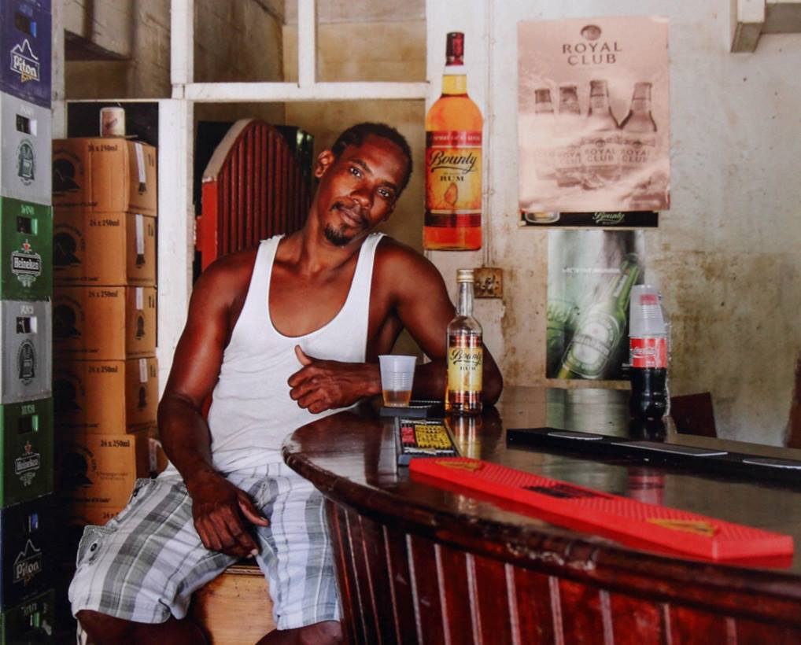
Best image in the January ‘Open’ Print competition went to ‘Caribbean Spirit’ by Chris Nicholls
Results:
Standard Class Mono – 1st ‘Down the River’ by Jonathan Carey.
Standard Class Colour – 1st ‘Every Penny Counts’ by Jonathan Carey; 2nd ‘Bridge in Calgary’ by Kevan Osborn; 3rd ‘Pretty Flamingo’ by Kevan Osborn.
Intermediate Class Mono – 1st ‘Glen Mooar Groynes’ by Sue Leeming; 2nd ‘The Shelter’ by Barry Murphy; 3rd ‘Till the Cows Come Home’ by Barry Murphy; 4th ’Leading Light’ by Sue Leeming.
Intermediate Class Colour – 1 ‘Where the Fairies Meet’; by Barry Murphy; 2nd ‘Tholt y Will’ by Sue Leeming; 3rd ‘I’m a Big Softie’ by Richard Shafto; 4th ‘Topiary garden’ by Richard Shafto; 5th A Brief Pause’ by Sue Leeming; 6th ‘The Lilies’ by Barry Murphy.
Advanced Class Mono – 1st ‘Baker Street’ by Sue Blythe; 2nd ‘No-One About’ by Ruth Nicholls; 3rd ‘Classical Scholars’ by Ron Shimmin; 4th ‘No Connection’ by Chris Nicholls; 5th ‘Indoors People’ by Chris Nicholls; 6th ‘Passing the Time’ by Sue Blythe. Bob Servante was highly Commended for ’Helena Andreyevna Serebryakova’ and Commended for ‘Earnley Church, West Sussex’.
Advanced Class Colour – 1st ‘Caribbean Spirit’ by Chris Nicholls; 2nd ‘Old French Brasserie’ by Ron Shimmin; 3rd ‘Evening Light, Lake Bled’ by Ruth Nicholls; 4th ‘Bike Art’ by Dave Welsh; 5th ‘Salmon Fishing, Katmai National Park, (Alaska); 6th ‘Stuffed’ by Sue Blythe. Highly Commended were ‘Best Mates Together’ by Dave Welsh; ‘The Ice-Breaker’ by Sue Blythe; and ‘The Gig’ by Bob Servante. Commended were ‘Church by The Sea’ by Chris Nicholls and ‘Child’s Play’ by Ruth Nicholls.
The best overall winning entry on the night was judged to be ‘Caribbean Spirit’ by Chris Nicholls.
The Society will next meet at 7.30 pm on Wednesday 25th January at Thie Ellyn, off Withington Road, Douglas, for a Critique Session when new members and guests (for a nominal charge) are always most welcome.
By Antony Hamilton

12th January 2017 - Bali Presentation and L&CPU Folio
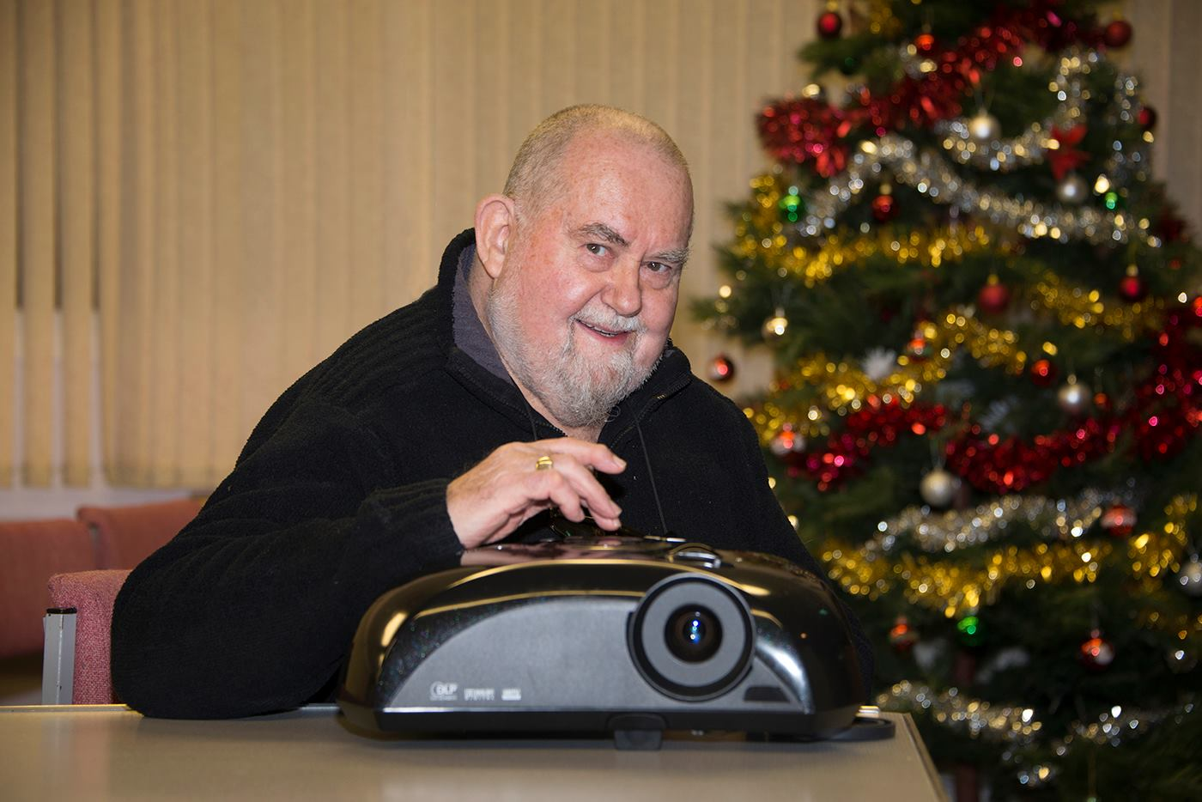
IOMPS Vice President John Phipp
The second half of the seasonal programme of the IOM Photographic Society got under way this week with a “sandwich” – the first part of the evening being an audio-visual presentation on Bali by our Vice President, John Phipp, and the second part a showing of a print portfolio from the Lancashire and Cheshire Photographic Union.
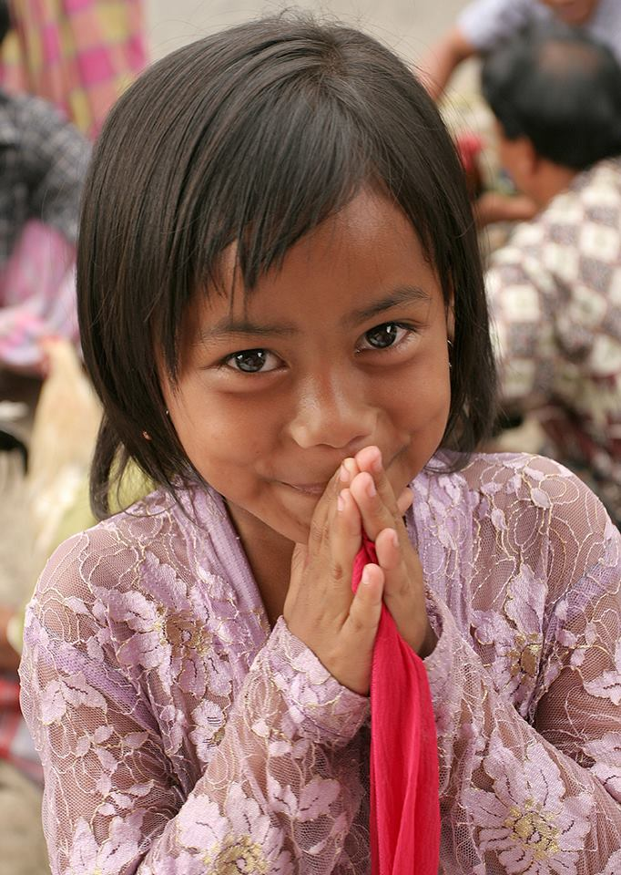
'Bali Girl' by John Phipp
John’s digital presentation was delig...htful, well put together and included a wide selection of images based on a visit made in 2006. It covered many scenic shots of the local landscape, including the terraces cut into the hillsides to enable the growing of rice and other crops, images of the many picturesque temples as well as of the local people and their brightly coloured attire, all accompanied by an informative commentary. Following John’s presentation, Antony Hamilton shared his experience of Bali and confirmed the attractiveness of the country and the people with details of his own visit.
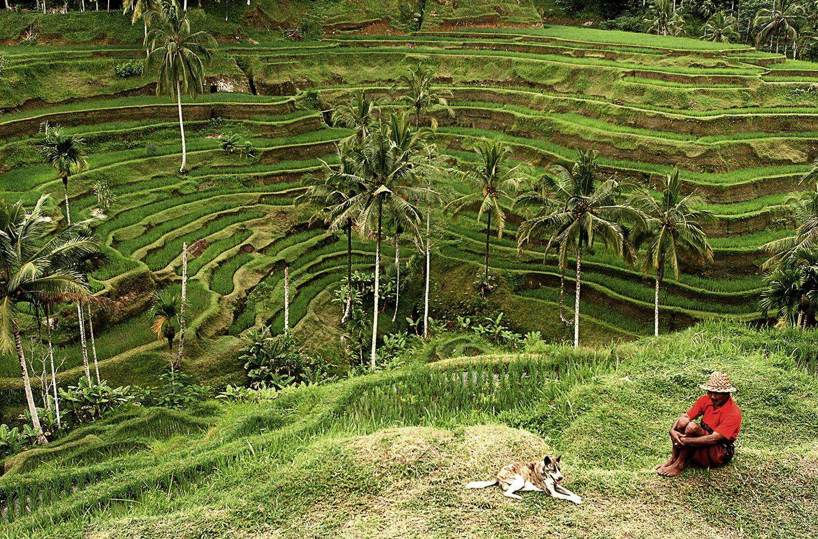
Bali landscape by John Phipp
The L&CPU print portfolio comprised more than 60 images, largely of natural history shots but also including other genres. The images are selected competitively from entries submitted by the nearly 100 clubs in the federation – and assessed by a panel of three judges on the basis of a maximum score of 5 points per judge – and a top score therefore of 15. To be included in the portfolio usually requires a minimum score of 12 points (though an occasional 11 creeps in, if of an interesting subject) whilst the maximum score of 15 is a rarity. One such was titled “The Ice Lady” – an image of a woman in an ice-blue dress against an snowy background – absolutely stunning, beautifully printed and well worth its maximum points. The portfolios are highly aspirational and hopefully motivational, showing some of the best images currently being taken – and setting a standard for club members to aim for.
The Society meets at the Art Society Building (Thie Ellyn) in Withington Road, Douglas, with all meetings starting at 7:30pm. Meetings are open to the public, and all will be given a very warm welcome. Our next meeting on Wednesday, 18th January will include an open digital competition.
By Chris Blyth

5th January 2017 - 2017 Preview
Bamburgh Castle by Bob Servante from his presentation on the Farne Islands
Following the usual Christmas break, the second part of the winter programme for the IOM Photographic Society has now started. The programme through to the end of April when we break again for the summer months, is pretty intense - loaded with a full schedule of weekly meetings covering a range of competitions, some "activity evenings", and a number of presentations. Highlight events with external s...peakers include an evening with Dr Jeremy Paul - with images under the title "Travels of a Wildlife Artist" - always a very popular speaker and always with a superb selection of photos to illustrate his work, whilst later in the season several members will also be showing their work, including Di McCudden, Chris Nicholls, Sue Blythe and Club President Tony Curtis - and certain to cover a wide range of subject matter to interest other members.
Two competition evenings worthy of particular mention are the Two Way Digital Battle with the Bristol Club, and the Three Way Battle with the Rochdale and Oldham Clubs. In the Two Way Battle, both clubs submit a range of images which are judged locally at both clubs under a points scoring system - and the marks are added together to reach a final overall winner. Fortunately, I cannot remember an evening when the two judges reached a different result in terms of the winning club, though the scores awarded to individual images have sometimes differed significantly ! In the Three Way Battle, we are blessed with a particularly skilled videographer at the Oldham Club who videos the competition for us, and then sends us the recording - always a fascinating evening as (apart from our Annual Competition) it is one of the few opportunities for our work to be judged by an accredited L&CPU judge and to be measured against two equivalent clubs from the adjacent island. Whilst we have historically always come second to Oldham (who have some exceptional photographers in their membership), we hope to make them work hard for their success!!
Lastly, the major event of the competition programme is our Annual - the biggest competition in the calendar and the one with lots of silverware at stake.... A highly qualified UK judge is invited to preside over the images presented over two evenings (one for prints, and one for digital images) and to comment on the winning images, and the evenings finish with the judge giving a presentation of his or her work - again an excellent opportunity to understand just what is happening in the wider world of photography enthusiasts......
Our meetings are held at Thie Ellyn (the Art Society building) in Withington Road, Douglas on Wednesday evenings starting at 7:30pm. All meetings are open to the public, non-members with a modest entry charge, and all will be made very welcome.
By Chris Blyth

IOMPS Reports During February 2017

15th February 2017 - John Keelan - "Taylorian Musicals"
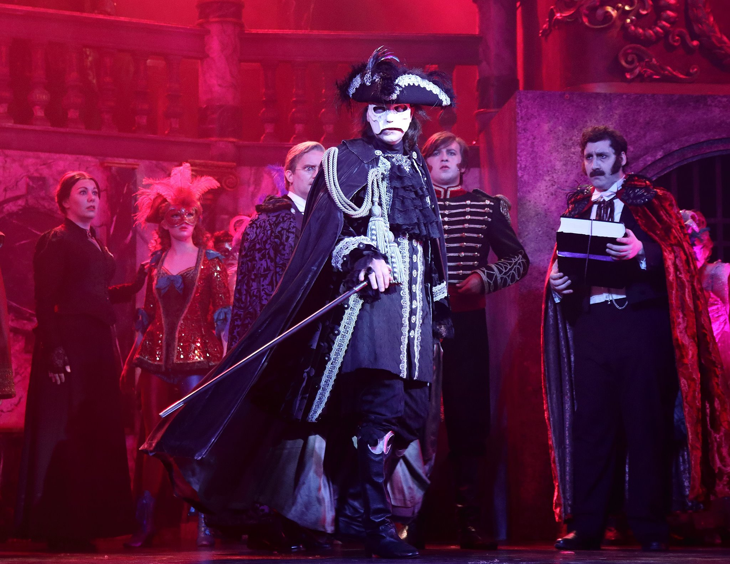
John Keelan's excellent images from his presentation on photographing Taylorian Productions dress rehearsals
John Keelan was the Society’s guest last Wednesday evening and his subject was listed in the programme as ‘Taylorian Musicals’. John, a stalwart of the Southern Photographic Club, was making a welcome return to Thie Ellyn and gave four short audio-visual presentations of images he had captured inside the Island’s Victorian Gaiety Theatre in Douglas. These covered the dress rehearsals for four shows staged by Taylorian Productions. This theatre company was formed in 2007 by th...e late Patrick Taylor, an English Solicitor and benefactor, with co-founder John Cumberlidge, Artistic Director.
Any photography in a darkened theatre presents many challenging technical and practical difficulties and is only ever possible with specific prior permission. John had been commissioned by the theatre company to undertake these assignments but, in doing so, he quickly realized that the Directors can be very demanding and quite formidable. Consequently, dark clothing and soft shoes had to be worn to avoid any distraction for the cast and crew. Multiple lenses, a back-up camera and a selection of varying camera angles were required. He explained that camera settings need to be as silent as possible, especially using digital media, and fast shutter speeds combined with a high ISO were essential, since flash cannot be deployed. Above all, the photographer had to be able to work unseen and unheard – and to get it right first time!
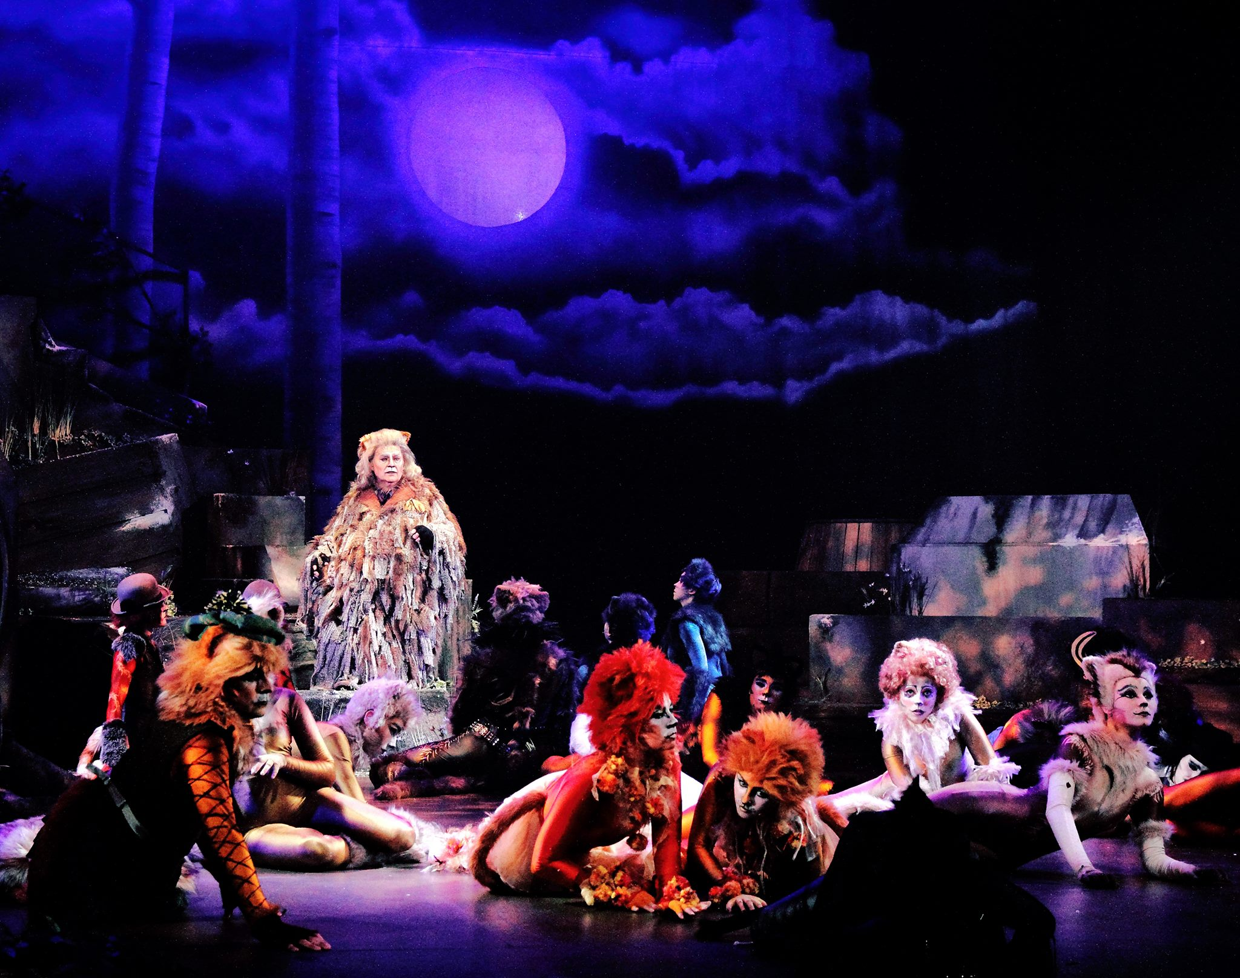
John’s images of all four shows - ‘Cats’, ‘Evita’, ‘Oliver’ and Sunset Boulevard’ - were atmospheric and colourful, with the beautiful costumes, superb facial expressions and drama being captured to great effect. The musical accompaniment added to our enjoyment and John was thanked for sharing his knowledge and expertise of this specialist art form so openly with the membership.
Attention was then turned to planning the Society’s 2017 Summer outings. Two of our members, Ian Lumsden and Barry Murphy, each gave a short digital presentation based on two recent group events, namely a walk around Scarlett to view the various rock formations and disused lime kilns and a boat trip from Port St Mary to the Chicken’s Rock Lighthouse. Another member, Bob Servante, had brought two monochrome prints to display featuring wildlife around the Sound and a local polo match.
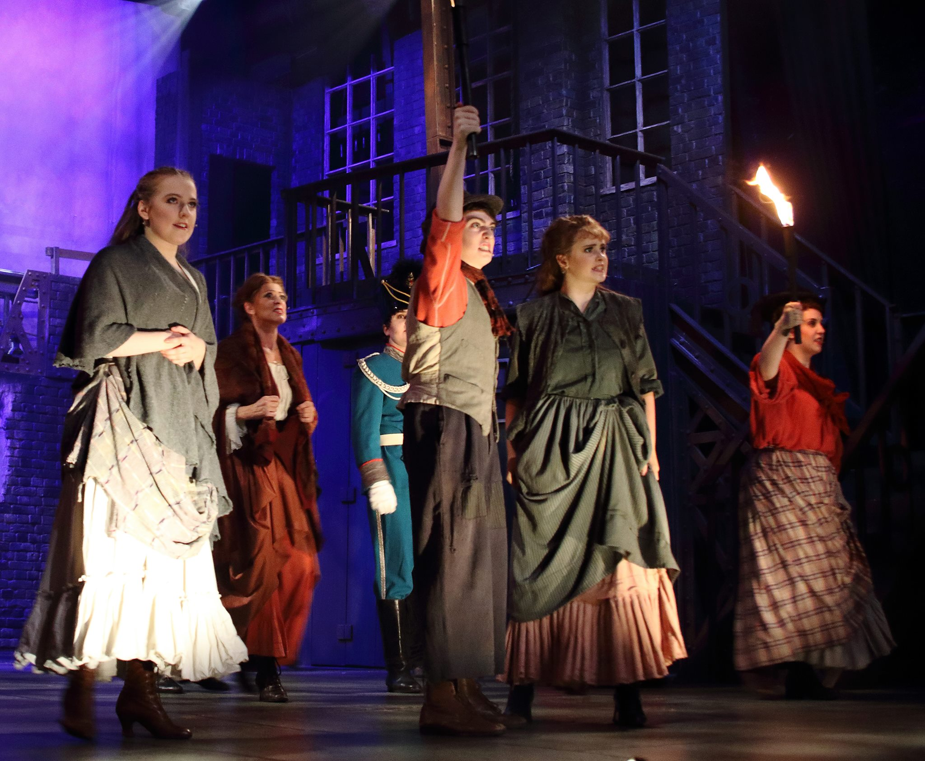
This was the first time ideas for outings had been sought by the Committee in this way and it proved to be highly successful with a list of helpful suggestions being compiled for consideration over the next three months.
The next meeting will be on Wednesday, Wednesday, 1st March at 7.30 pm when there will be a presentation titled 'Filming the Isle of Man' by Charles Guard, reflecting on 30 years of making documentaries. As always, guests are most welcome on payment of a nominal charge.
By Antony Hamilton

