Reports for the 2017 – 2018 Season

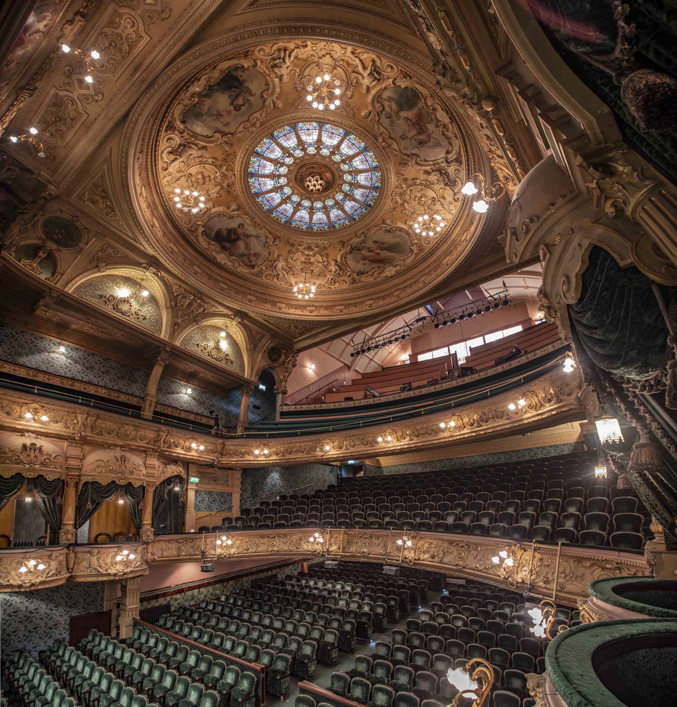
‘Tis the end of the season of regular weekly meetings for the IOM Photographic Society, and time perhaps to reflect on both the events of the past few months and the way forward for the Society as identified in our recent Annual General Meeting.
The past season can be considered another successful one for the Society – an increase in membership, lots of excellent speakers and presentations on photography, several practical sessions (for example, on macro close-up work and on table-top imaging plus a number of social outings to places such as the Gaiety, Tynwald and the Steam Railway Workshops), and with the balance provided by competitions both internal and external with other clubs where the helpful advice provided by our judges is intended to encourage and assist members to improve their skills.
On a slightly different tack, photography is a universal feature of all our lives – we all read newspapers and magazines with a heavy photographic content, we all watch television, most of us own mobile phones and use them to take photos – and yes, those images of our landscape, of our holidays, family and friends, give pleasure and hopefully happy memories. But could those images be improved? What skills are required to turn a “snapshot” or a “selfie” into something more artistic, making better use of the light, in focus, with a better composition and with better use of colour and line? Yet at the same time, our lives seem to be getting ever busier – putting pressure on the opportunity to take time out, to relax and think about the things which are or should be important to us (particularly our family and friends), and perhaps to record those experiences with some great photographs.
To build on the success of the past season and to encourage anyone with an interest in photography to join the Society, the emphasis of our next season will be on “photo fun and enjoyment” – to reduce a perceived slant on competitions and to give more emphasis to social activities, developing skills with more practical applications such as workshops, and sharing our mutual enthusiasm for photography with themed evenings and more photographic presentations. Meantime, we will, of course, be arranging a variety of summer outings to places of interest where members will have opportunity to take their cameras and get some shots. Full details of our programme and activities can be found on the website www.iomps.com and on Facebook at Isle of Man Photographic Society. Our meetings are open to non-members and all will be given a very warm welcome.
Chris Blyth

The Annual Battle with the North-West Bristol Camera Club
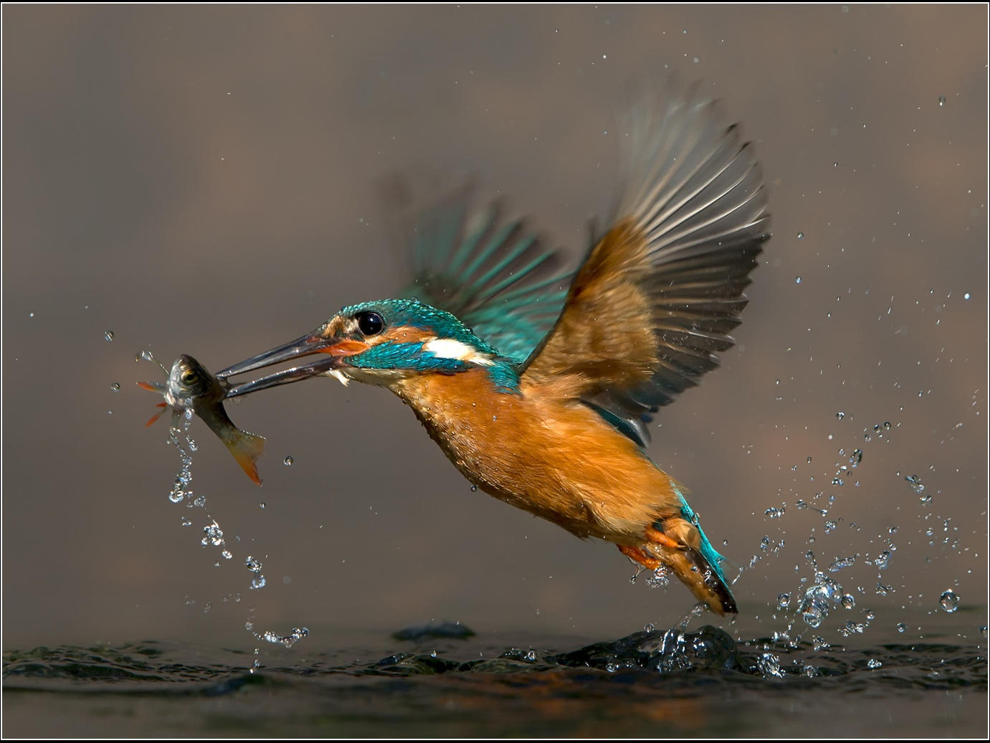

By Chris Blyth
“When the going gets tough, the tough get going” could have been the mantra on Wednesday evening, with the really cold weather ensuring that only the most determined members of the IOM Photographic Society turned out for one of the few opportunities in our calendar to compete with a club from the neighbouring island – the annual two-way digital battle with the North-West Bristol Camera Club.
This is always a keenly fought competition, and with a slightly unusual format in that both clubs submit 30 images each, with both clubs appointing their own local judge to evaluate the images, every image being scored out of a maximum of 20 points – and the winning club depending on the accumulated scores from both judges. In previous years, the judges have fortunately agreed as to the winning club – so no serious falling out – though the mark awarded to individual images obviously varies, sometimes quite substantially. And this year was no different !
Our judge was well-known local photographer Steve Babb, who provided a well-paced commentary with remarks that met general approval and agreement – and whilst proving slightly more generous than the Bristol judge in his marks, both agreed that the IOMPS entry was the winning one. Steve’s result showed a total mark of 507 for the IOMPS versus 466 for Bristol, whilst the Bristol judge gave a result of 494 versus 470. The commentary as ever confirmed that the personal taste of the judge is always a factor – with Steve generally marking down images which had been heavily “photoshopped” or had an abstract quality, whilst images with a story to tell were more generously treated. The only image from both clubs which earned the maximum score of 20 points from both judges was our own Jeremy Broome-Smith with his shot of a kingfisher with its catch of a fish in its beak, emerging from the water – a superb natural history shot which has proved a winner on several occasions.

Table Top Photography with Andrew Barton

By Lara Howe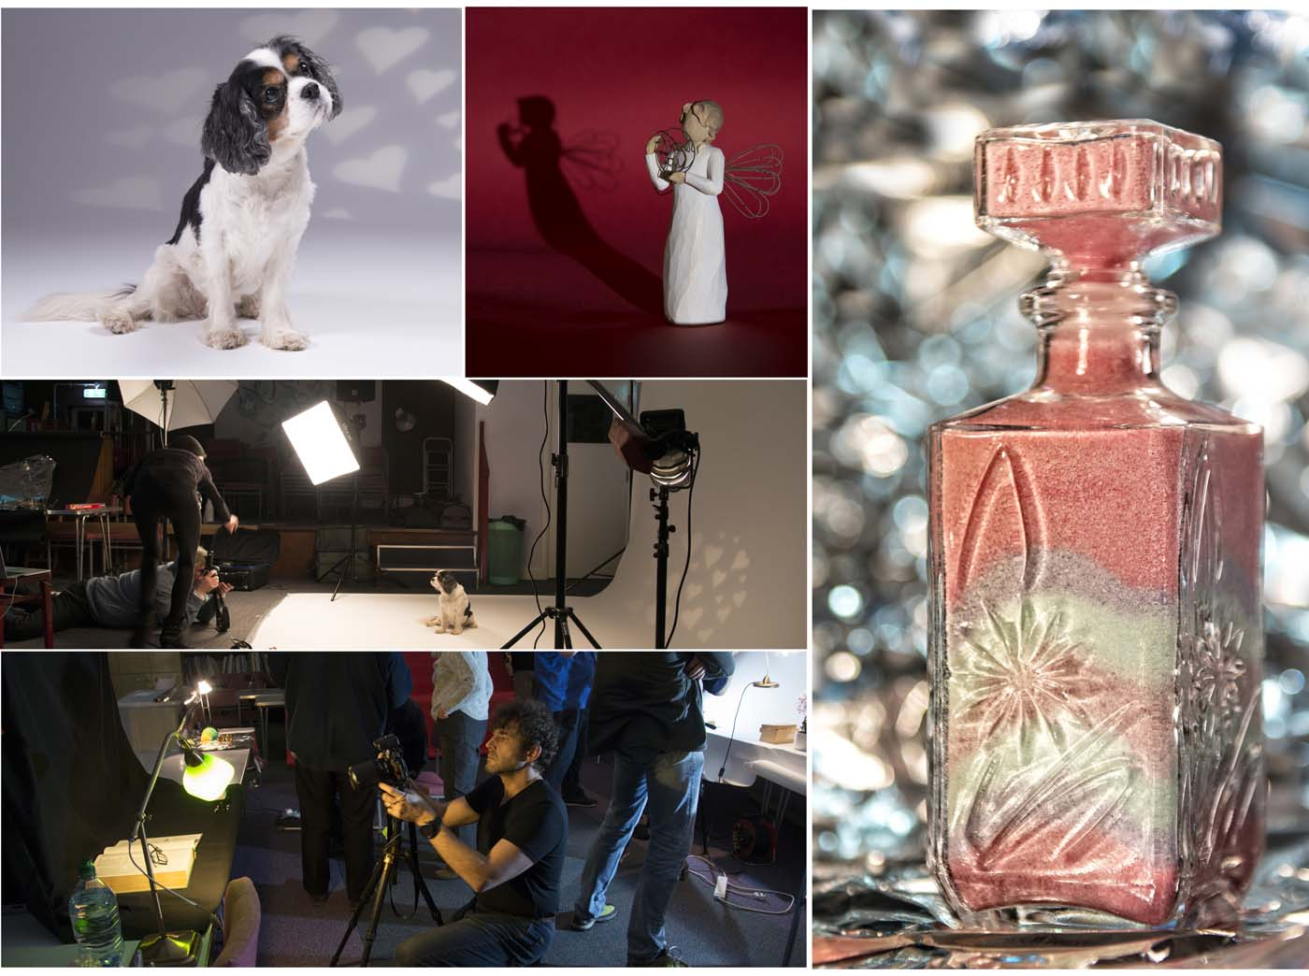
Scenes from the recent table top photography workshop lead by Andrew Barton
This week we were lucky to be joined by local professional photographer and good friend to the Society Andrew Barton LBIPP LMPA who lead a workshop on table top photography.Andrew had spent a great deal of time transforming our club room at Thie Ellyn to accommodate a full studio set at one end of the room with a number of table top set-ups arranged around the rest of the area. He even brought chocolates which went down well with the members but actually he had alternative reasons which became clear as the evening progressed.The evening began with Andrew explaining the use of lights and the importance of them for our photography. He then used studio flash to photograph Izzy, a very cute spaniel brought in by one of the members before moving on to the table top demonstration. This is where we found out about the chocolates. The wrappers were stuck together with sellotape and used as DIY gels to change the colour of the desk lamps.The workshop was based on the use of lighting which can be found around the house and members brought in a variety of desk lamps, work lights and torches with some members even providing their own backgrounds. Andrew was on hand to help members photograph a variety of objects and demonstrate what could be achieved by moving the lights around the subject.We experimented with different backgrounds, including tinfoil, cloth and coloured papers, and different ornament’s, from books, to sun glasses to paperweights. Some objects proved more successful than others. It gave the members a chance to experiment and try out new skills. Giving them lots to think about and ideas to try at home.Nigel Owen gave the vote of thanks to Andrew for providing members with an excellent practical evening greatly enjoyed by all.

The next meeting on Wednesday 7th March at Thie Ellyn, the Art’s Society Building in Withington Road, Douglas will be a Lancashire and Cheshire Photographic Union print portfolio and discussion. Meetings start at 7.30pm. They are open to the public and everyone is very welcome to come along.

Sicily and Provence
By Chris Blyth
It is always a pleasure to have members of the IOM Photographic show their work – it shows a confidence in their own work and a willingness to share their knowledge and expertise with other members, something the committee is particularly keen to encourage. This week, husband and wife team, Chris and Ruth Nicholls gave two travelogue presentations, both of a very high standard and both warmly received.
A presentation on “Sicilian Secrets” started our evening, with Ruth providing a wealth of detail in a comprehensive tour of the sights of Northern Sicily and a visit to the island of Lipari – her tour took us from Palermo (the capital) to Trapani and Marsala, and then on to Cefalu and Lipari. The warm colours of the Italian sunshine, the lovely images of the landscape and of life in the towns and villages provided a real escape on a cold Manx evening – and all accompanied by a clear, indeed vivid commentary as to the day’s activities, together with an explanation of local history and stories. A part of the world perhaps not often visited but one which Ruth’s images will certainly have encouraged !

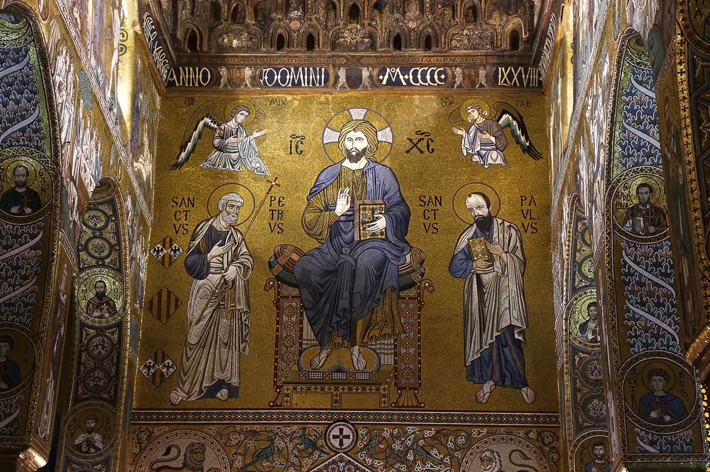
A detail from the Royal Chapel in the Palace in Palermo, Northern Sicily
by Ruth Nicholls
After the break, husband Chris then introduced his presentation on “Provence”, a part of France which he and Ruth have visited frequently, and clearly very much enjoyed. With an emphasis on images rather than commentary, Chris’s presentation of over 200 images had a genuine “ambience” – his shots carefully composed, the warmth and textures of the stonework of the buildings, and his enjoyment of local life very obvious. Many of the “travel hot-spots” of the lower Rhone valley appeared in the presentation – Le Baux, Rocamadour, Roussillon, Ales, Uzes, and Gordes for example, but all treated with a genuine understanding and feeling – we were there, with him!

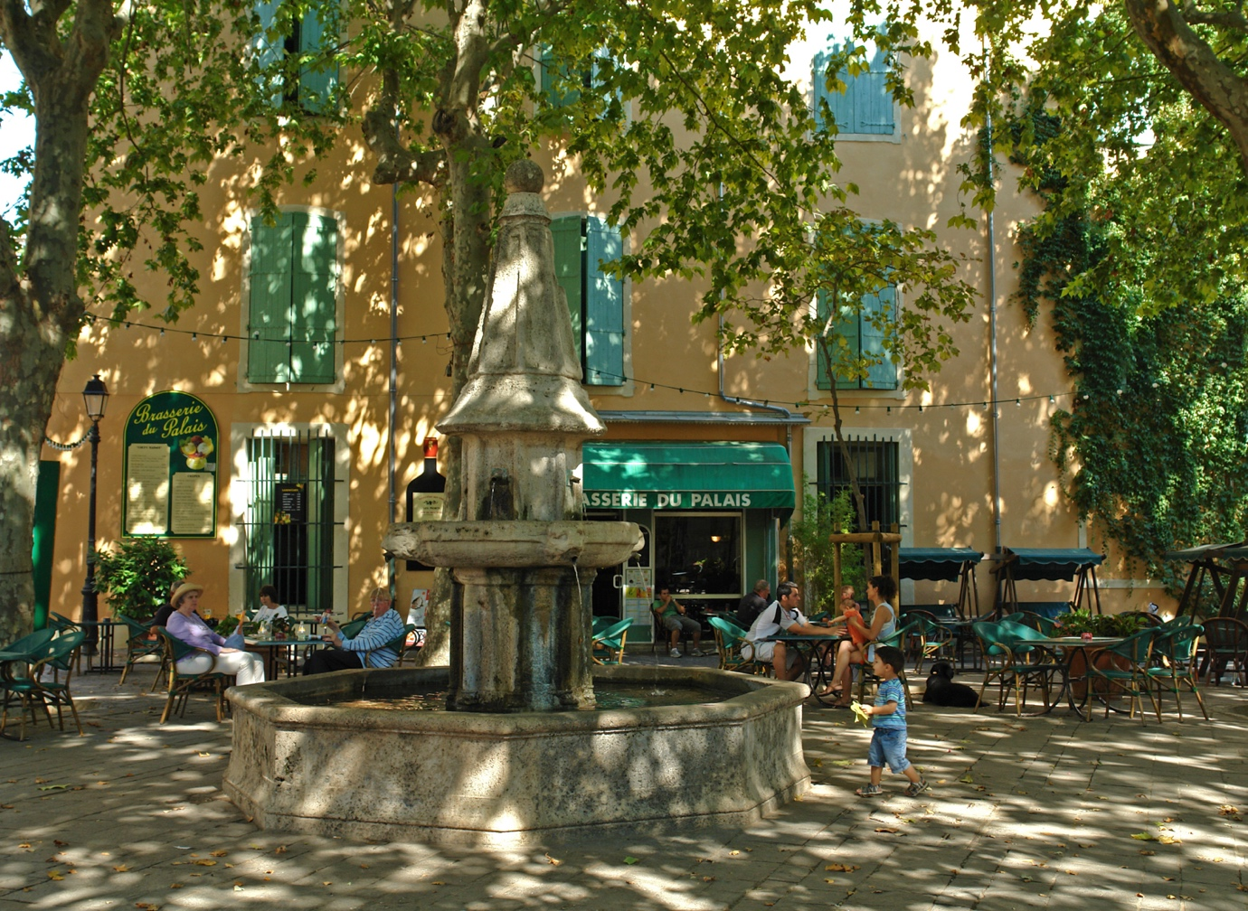
Provence by Chris Nicholls
Club President Chris Blyth gave the vote of thanks for an evening of photographic excellence by two very talented and skilled members – and one that was very obviously greatly enjoyed by the audience.

JANUARY DIGITAL ‘OPEN’ COMPETITION
By Chris Blyth
It is always a pleasure to welcome Eddie Fryer to the IOM Photographic Society – he has been a regular visitor to the club over the years, and is a popular judge who gives a meticulous assessment of each image presented in competition. This week he was judging an Open Digitally Projected Image competition – “open” in the sense of any subject being possible. This makes it particularly difficult for a judge in that he (or she) has to make the winning decision having perhaps been shown some excellent images across a wide range of genres – and how to decide between a portrait or a landscape, a natural history shot against a still life? Eddie can always be relied upon to show much good sense, explaining in detail his thoughts on each image, and clarifying why (in his opinion) one shot is better than another.
Michael Howland won the Standard Mono class with a lovely close-up shot of a pied wagtail, whilst Peter Keena took the honours in the Standard Colour group with a wonderfully colourful landscape image, the shape of the hills creating delightful lead-in lines to the brilliant oranges and yellows of vegetation in the foreground. Beryl Quayle led in the Intermediate Mono section with an evocative image of sheep on a hillside, backlit, the landscape regressing into the background in muted shades of grey. Jiri Podobsky meanwhile showed his talent in the Intermediate Colour class with a portrait image of two youngsters playing accordions, the colours and composition well balanced in the image. A large entry in the Advanced Mono section proved highly competitive, Chris Nicholls emerging as the winner with a lovely vertical format image of a woman in a narrow alley, the textures of decaying plaster on the walls well shown, and the woman nicely balanced in one corner by laundry hanging from a washing line in the opposite corner. The Advanced Colour section was similarly very competitive, with some top quality natural history images taking the top four positions, any one of which could have been the winner. However, a delightful image of a female merganser by Chris Blyth came out in first place, also taking “best image in competition”.
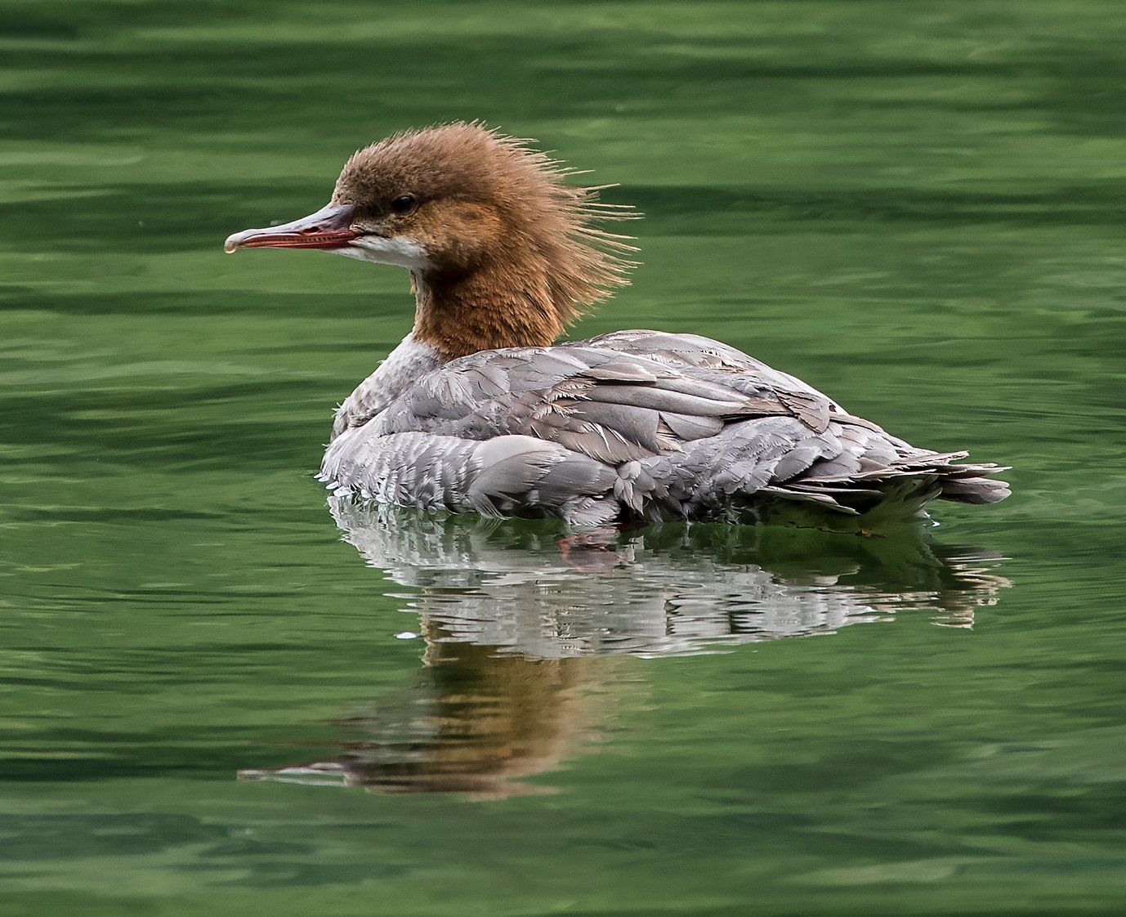
‘Female Merganser’ by Chris Blyth

Exhibition at the Hodgson Loom Gallery, Laxey Woollen Mills

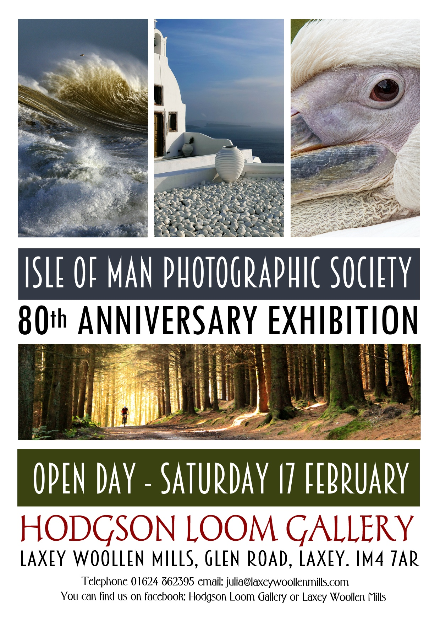
The IOM Photographic Society is once again delighted to be holding its Annual Members Exhibition at the Hodgson Loom Gallery in the Laxey Woollen Mills, commencing on Saturday 17th February, and running for the next 4 weeks.
The gallery is the ideal location for the exhibition, spacious and with lots of windows giving excellent natural lighting to the images on display – and as always, beautifully curated by Julia Ashby-Smyth in a highly distinctive and artistic way. The great majority of the prints are for sale at very attractive prices – the opportunity for visitors to get some “statement” images with great impact to hang on a wall….
This is the 80th year of the Society, the oldest photographic club on the island, and founded in late 1938 in the days when photos were only available from black and white film, colour film only becoming popular and economical after the Second World War. Many of the members at that time would have processed their images in their own “darkrooms” – often a converted cupboard or bathroom, using chemicals to process a negative film and an enlarger to produce the final print. Today, we take for granted using digital files from a mobile phone or camera and a home printer to produce our prints – a much simpler but still deeply satisfying method to display images of our families, nature, scenery or our holiday activities.
The Hodgson Loom Gallery is open Monday – Saturday, 10:00am to 5:00pm, with a wide range of top quality artisan products for sale, together with an on-site café facility.
Chris Blyth

January Open Print Competition
By Lara Howe
It was the third open print competition and we were lucky to have Henry Uniacke judge the night’s images. Henry’s views were somewhat different from previous judges so it made for an interesting night. His different approach and interpretation gave the members a new way of viewing their images. A very stimulating evening was had by all and generated much thought and discussion amongst the members.
The standard of photographs was high and varied in the choice of image. In the standard group Jonathan Carey won the monochrome with “TT swingers” and Paul Dougherty won the colour class with his image, “the weaver”. In the intermediate class Beryl Quayle won both colour and monochrome classes with her “Superwomen” and “Spirit of Ecstasy” images. In the advance group Ruth Nicholls won both classes with her images “Home Fires Burning” and “Instability”. With instability winning best image in the competition. A beautifully composed monochrome image of a tower of wooden blocks.
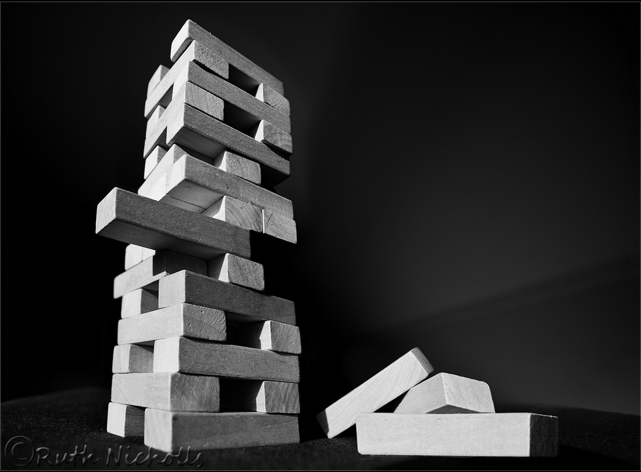
The meeting finished with a presentation from the Salmon family on their safari lodge in Botswana and the amazing wildlife that can be seen on the reserve, such as lions, wild dogs and cheetahs. The presentation was well received by the club members, as a result of which several members were obviously keen to explore this beautiful country.

Studio Portrait Photo-Shoot
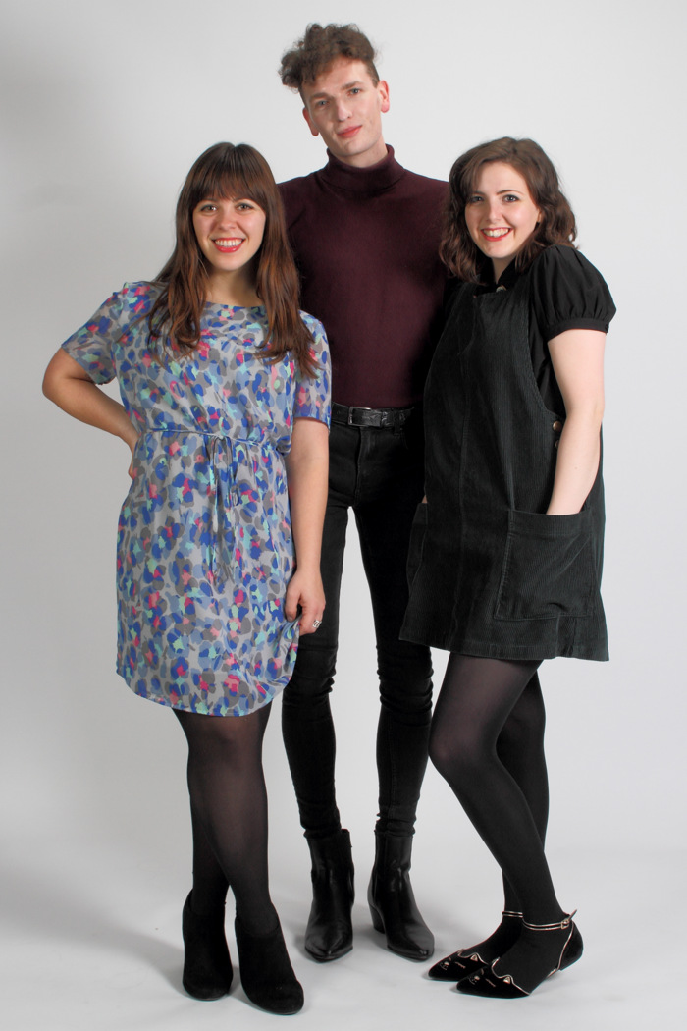
Image by Tony Curtis
A dozen or so of our members participated in a special “studio portrait” event this week at Thie Ellyn – three models (Kim, Grianne and Will) kindly volunteering to sit for us in two set-ups arranged with lights and back-drops provided by Chris Blyth, Tony Curtis and Jeremy Broome-Smith.
With a brief introductory explanation of the advantages of studio lights and the likely settings required, members set to with enthusiasm – and a very sociable and enjoyable session resulted. A rotation of models and of members during the evening ensured that everyone had opportunity to shoot each model against both a white and a black background – whilst “artefacts” such as a hair dryer, a venetian mask and an umbrella provided much laughter as well as variety to the images. Participants will be providing examples of their images to the models as a “thank you” for their time and their patience.
Chris Blyth
The IOMPS wishes all its members, family and friends a Happy New Year and 2018 a year when artistic aspirations and hopes become reality.
The first half of our winter season finished on a successful note, with membership up, competition entries up, some excellent judges, and several presentations which had been much enjoyed by the members. We now look forward to the second half of our year with great anticipation.
We start on 3rd January with a presentation by the club President – a travelogue on Venice exploring its history and culture, as well as some modern day issues for the city – plus the opportunity for members to show a selection of their images on Cregneash and their interpretation of its culture and lifestyle. It should be an excellent evening and a real kick-start for the balance of our programme.
As usual, the programme incorporates a series of competitions both internal and external, several with clubs from the neighbouring island which are always fun, albeit highly competitive and full of suspense. A number of photographic presentations, as well as several training and educational sessions are also scheduled, including a session on macro photography (close-up images) which I know will include some literally eye-opening images, plus a practical evening with local professional photographer Andrew Barton. The season ends with the Annual Competition, this year being judged by Gwen and Phil Charnock – both superb photographers and highly regarded as judges, and – tasked to provide us with a presentation of their work – with an archive of images well able to show the full range of their talents.
The Society meets on Wednesday evenings at the Art Society building (Thie Ellyn) in Withington Road, Douglas, all meetings starting at 7:30pm. All meetings are open to the public, non-members with an entry fee of £1, and all will be given a very warm welcome. Full details of our programme and much information about the Society can be found on our website at www.iomps.com
By Chris Blyth
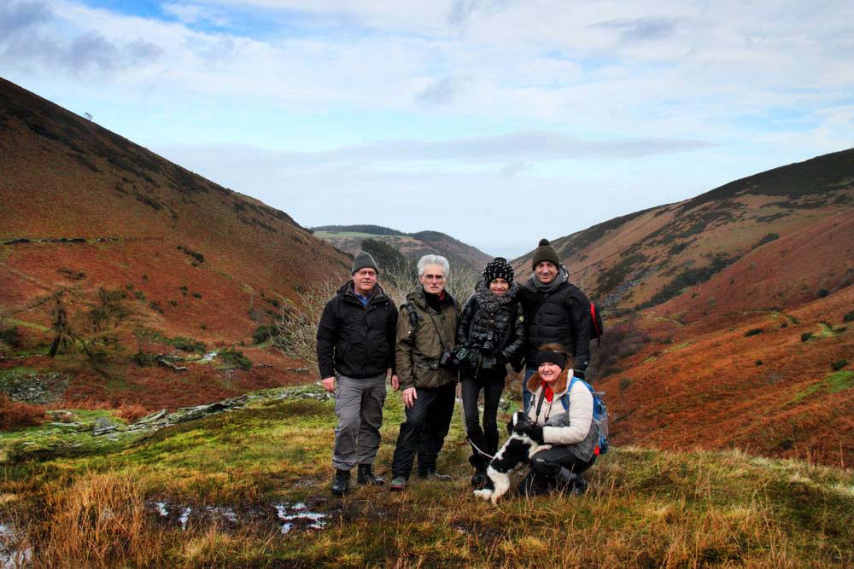
CAPTION: IOMPS Members Tony Curtis, Bill Callow, Sue Leeming, Barry Murphy and Beryl Quayle who enjoyed a post Christmas Photo Walk to the Black Dub in Glen Auldyn on 30th December
“In the bleak mid-winter, frosty wind made moan ….“ as the carol by Christina Rossetti says, and as was evident for a recent meeting of the IOM Photographic Society when, amidst a flurry of sleety hail and snow, only our most determined members turned out for a showing of the latest Lancashire and Cheshire Photographic Union print portfolio and for our Christmas social.
The folio, comprising some 60 A3 prints, included a wide selection of genres and which was perhaps of a higher and more enjoyable quality than has been apparent in some recent folios. The images had been chosen from submissions by the various clubs within the L&CPU federation (more than 90 in total). The images had been assessed by 3 judges, each marking on a score of 1-5 (thus a maximum of 15 points), and generally scoring at least 11 or 12 points to be chosen for the folio. Our members enjoyed making their own assessments and giving their scores – but the objective is to provide ideas for one’s own images and hopefully encouragement.
The natural history shots were excellent, with some stunning images of birds and insects in glorious detail in particular – and making clear that only the most meticulous attention to quality and “the decisive moment” for one’s images will produce a winner in this category. A range of portraits – especially in monochrome – found wide approval, as did the landscapes, though several motorcycling images were dismissed as pretty run-of-the-mill, perhaps not surprisingly given our local opportunities. Two images by photographers from the Western Society were included in the folio and were warmly applauded by members.
Our next meeting is on Wednesday 3rd January when Club President, Chris Blyth, will be showing a presentation on “Venice- La Serenissima”, and members will be showing images of Cregneash – a challenge set up over the summer months to produce 10-12 images each, to encapsulate one’s thoughts and impressions of the culture and lifestyle of living in the village. The club meets at the Art Society Building (Thie Ellyn) in Withington Road, Douglas, with all meetings starting at 7:30pm. Meetings are open to the public and all will be given a very warm welcome. Full details of our programme can be found on our website at www.iomps.com
By Chris Blyth
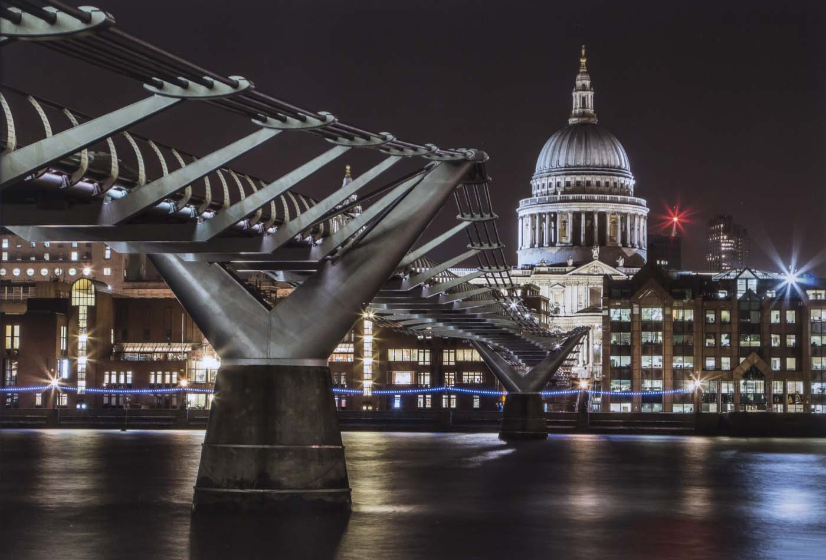
CAPTION: One of the images from the latest Lancashire and Cheshire Photographic Union print portfolio

Two Superb Presentations
Members of the IOM Photographic Society enjoyed a superb evening of photographic excellence this week – with a distinctive contrast between two presentations, one showing the old and the other the new. Our evening started off with a presentation by Jack Kaighin – a popular visitor with a history of showing a selection of his wonderful old lantern slides of island life taken from about 1900 or so onwards. He also demonstrated some excellent up-to-date skills with his presentation – not as usual on a magic lantern but with a digitally projected series of slides which he had scanned using a macro set-up and which had preserved all the beautiful colours and details of the old slides. The first slides shown were of several “series” of eight or twelve images – rather like a comic book – of a small boy playing a trick on his older sister and her boyfriend, for example, and of express steam engines of the day. Slides of old Peel followed – the fishing boats, herring being filleted on the quay, the castle, the harbour and the people – were followed by images of St Johns, Ramsey, and Laxey– all evoking memories of life as it was, and all accompanied by a highly informative commentary.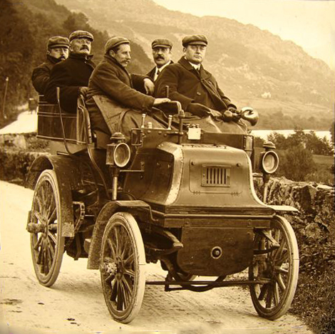 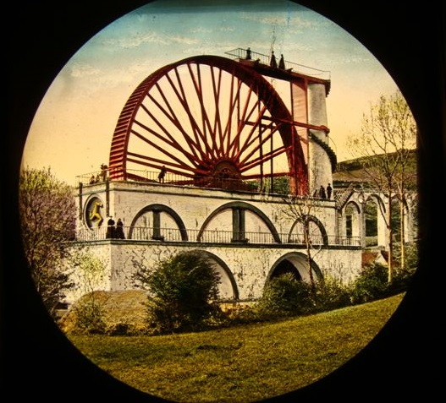 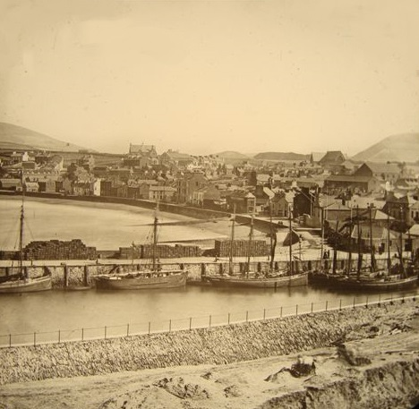
Bill Callow then followed with a wide range of images – both colour and monochrome – demonstrating his skills as well as his approach to photography – but in particular his landscape work. Truly a man for all seasons, he contended that his preference was for days of mist, rain and clouds – enabling his use of the light to highlight the particular subject of the images – of snow on the hills, some colourful trees, or of a pathway through the woods, for example. The commentary was insightful, pointing out that the camera equipment used today is almost irrelevant as most cameras are highly capable, even the cheapest. So it is the imagination and thought going into the shot that makes a great image – as his work clearly showed. His compositions were particularly noteworthy – carefully constructed, with lead-in lines, with detail in the critical areas of focus ensuring that the viewer could always appreciate the reason for the shot – with artistry resulting, not just snapshots.
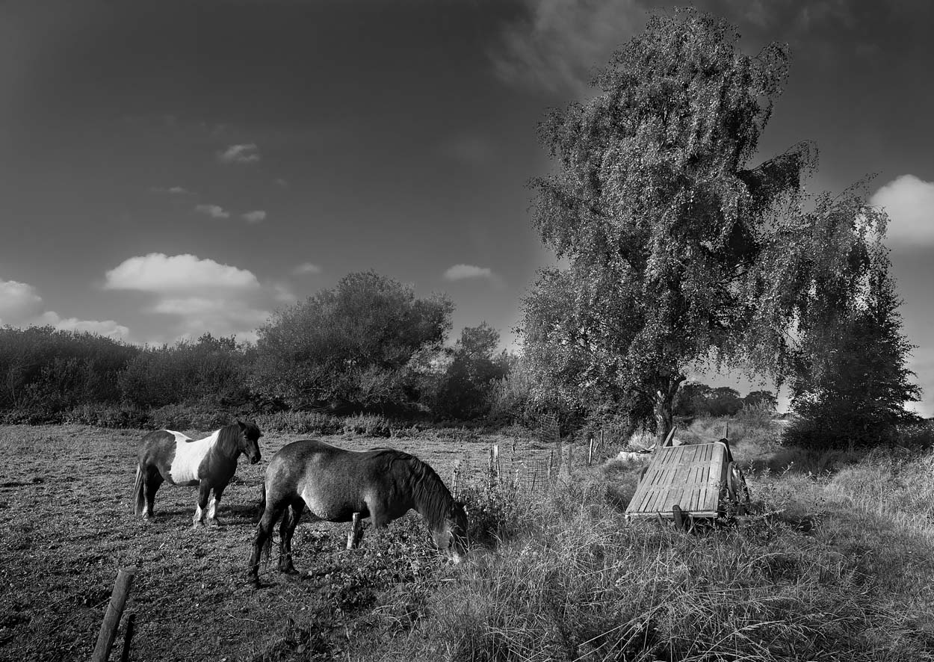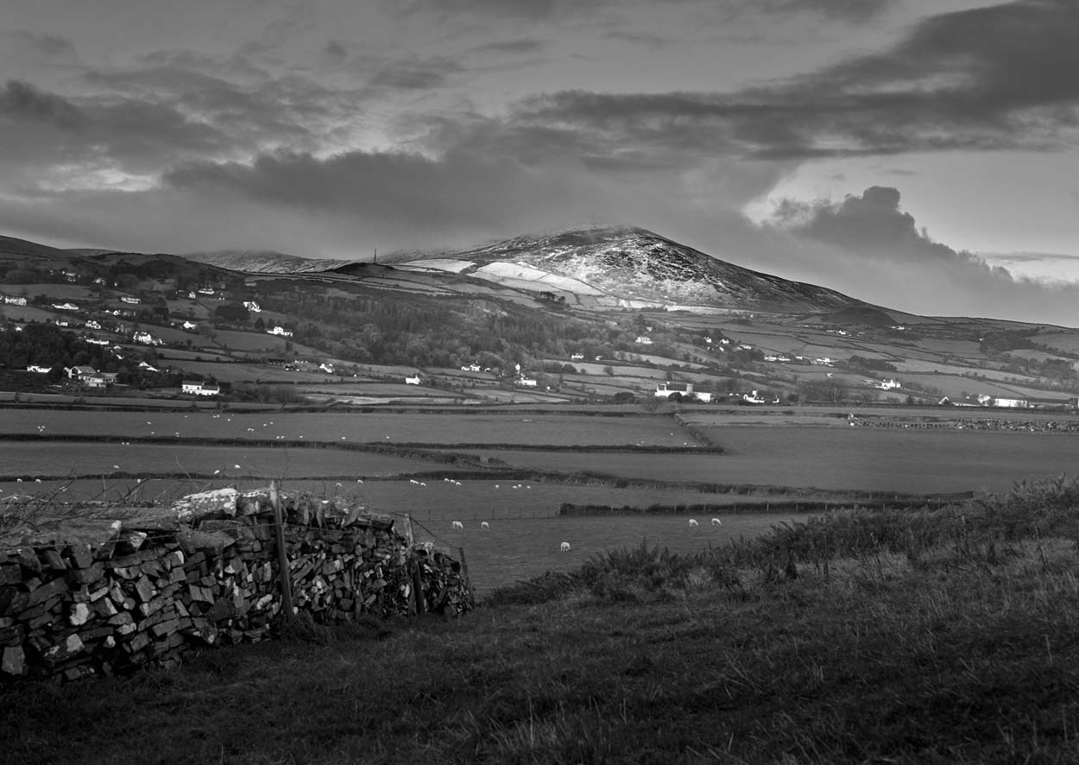
Club President, Chris Blyth, gave a well-earned vote of thanks to both speakers for a most enjoyable evening.
The Society meets at the Art Society Building (Thie Ellyn) in Withington Road, Douglas, with all meetings starting at 7:30pm. Meetings are open to the public, and all will be given a very warm welcome. Full details of our programme can be found on our website at www.iomps.com. Our next meeting on Wednesday, 3rd January will include a presentation by Chris Blyth, and the opportunity for club members to show their images of Cregneash – a challenge set over the summer months.

A Competition with a Difference
“A Bit on the Side” by Barry Murphy – Best image in the Competition
Tonight the Second Open Digital Competition of the year was held. Our judge for the evening was David Kneale, the Chief Photographer for IOM Newspapers.
But this was a competition unlike any other ever held by the Isle of Man Photographic Society, as tonight the Society experimented with a new procedure for judging the images. Our Competition Secretary (Jeremy Broome-Smith) explained that the judge had not seen any of the photographic images before the night and would be given very little time to decide which were the best six images in each of the six categories to be judged. He told us that this is the procedure used by most of the photographic societies in the UK to judge their competitions:
- Each image was viewed for 5 or 6 seconds with no comments from the judge.
- Then each image was shown again for about one minute while the judge made his comments.
- The judge then picked the six best from up to 12 of the competition images and in less than a minute ranked them in order, from 1st to 6th.
David Kneale welcomed this method of judging as it saved the judge a lot of time viewing and reviewing the images before the competition night. He had no difficulty in making all the snap decisions required in a very tight timeframe.
Lara Howe won first places for her images in both the Standard Colour and Monochrome sections with “Stonechat” (colour) and “Ring tailed Lemur” (mono).
In the Intermediate Class Joy Brodie won first places with “Sunrise, Dune 45, Namibia” (colour) and “Sydney Opera House” (mono).
In the Advanced Colour Class our judge admitted to some difficulty in deciding on a winner as there were several outstanding entries that could have won, the best images being in 6th place “The Eagle is landing” (a spectacular wildlife image by Sue Blythe), 5th “And he walked away” (an amazing image of a car crash by Jeremy Broome-Smith), 4th “Cascade” (a water abstract image by Barry Murphy), 3rd “Tulip Staircase” (An exquisitely photograph looking up a spiral staircase by Sue Blythe), 2nd “View from the Artist’s Window” by Jeremy Broome-Smith and 1st place was awarded to Barry Murphy for an unusual image of two horses viewed from ground level “Miss Elle & the Duke”.
Judging the Advanced Monochrome section proved equally difficult as there were so many good images to pick from. Barry Murphy came up trumps again, being awarded the first two places for “Silencio por Favor” and “A Bit on the Side”.
Our judge gave the award for the Best Shot of the Competition to Barry Murphy’s Monochrome image of drill bits, titled “A Bit on the Side”.
The overall verdict on the new method for judging the competition was very positive and it will no doubt be used again. However, the audience was left wondering if the results would have been similar if the judge had been given a few hours, rather than a few minutes, to examine the photographs. No one will ever know!
The Society meets at the Art Society Building (Thie Ellyn) in Withington Road, Douglas, with all meetings starting at 7:30pm. Our next meeting on Wednesday, 29th November will include an Open Digitally Projected Images competition. Meetings are open to the public, and all will be given a very warm welcome. Full details of our programme can be found on our website at www.iomps.com.
Results of 2nd Digital Competition: Standard Colour – 1st Lara Howe, Tim Norton 2nd & 5th, 3rd Michael Howland, 4th & 6th Peter Keena, Standard Mono – 1st & 5th, Lara Howe, 2nd Jonathan Carey, 3rd Tim Norton, 4th Peter Keena, 6th Michael Howland. Intermediate Colour – 1st & 2nd Joy Brodie, 2nd & 5th Beryl Quayle, 3rd Jiri Podobsky, 6th Richard Shafto, Intermediate Mono – 1st & 2nd Joy Brodie, 3rd & 4th Jiri Podobsky, 5th and 6th Beryl Quayle, Advanced Colour – 1st & 4th Barry Murphy, 2nd & 5th Jeremy Broome-Smith, 3rd & 6th Sue Blythe, Advanced Mono – 1st & 2nd Barry Murphy, 3rd & 6th Jeremy Broome-Smith, 4th Sue Blythe, 5th Sue Leeming.
Richard Shafto

Tynwald Visit
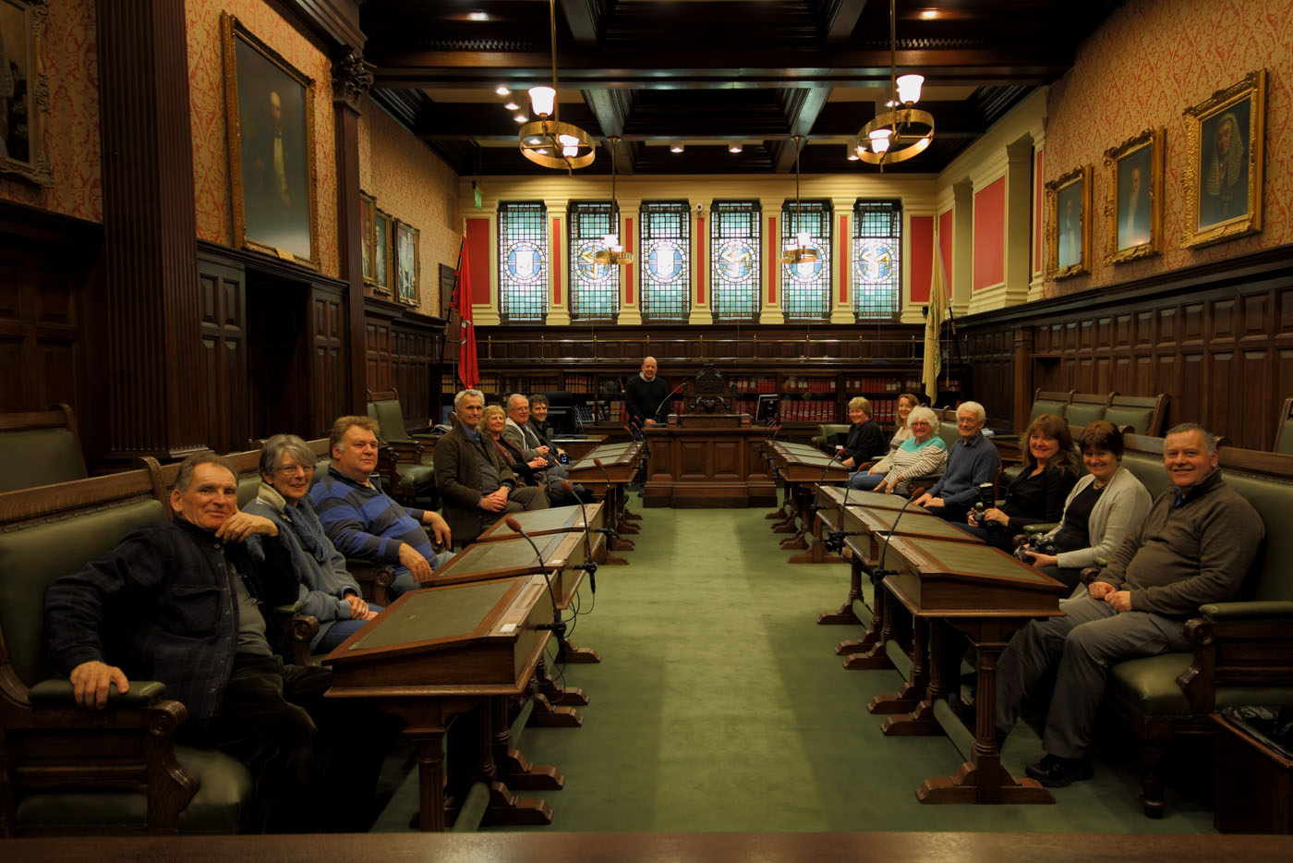More than a dozen members and friends came to Tynwald this week for a photoshoot of this iconic building. It was originally the home of the Bank of Mona head office, but following its bankruptcy in the 1890’s, passing to the Government, albeit with some extensive refurbishment and rebuilding since then (though some remnants of its banking history can still be found within). Kindly arranged by Paul Dougherty and with the permission of the President of Tynwald, our visit proved highly successful – particularly bearing in mind that the current club assignment is for “Record” – and Tynwald certainly provides a wealth of subject matter meeting this task. Paul was especially helpful in ensuring maximum opportunity for our photography – lighting and having time and space to “get the shot” can be difficult within the confines of a building, but all left at the end of our evening well satisfied and with images which I am sure will appear soon in various club competitions.
A big “thank you” to Paul Dougherty for facilitating a very special outing !
Chris Blyth

Bad Weather Cancelled Meeting!
The meeting of the IOM Photographic Society was cancelled this week due to the extreme weather conditions around the island that had been experienced overnight and earlier in the day – extensive flooding, roads awash, and advice from the IOM Constabulary that “only essential travel should be undertaken”.
However, the Society did enjoy some off-island success over the weekend. We belong to the Lancashire and Cheshire Photographic Union – our regional federation, covering nearly 100 clubs spread around the north-west of England. Other regional federations cover the rest of the UK. The L&CPU organise an annual “digital knockout” competition requiring 8 digital images to be entered from each club, with no more than 2 images from any single photographer, and with the first 4 images to be from 4 separate photographers.
This year, 41 clubs entered, and due to the volume of entries, the judge actually assessed only the first 4 images from each club – giving a total of 164 images to comment on and to be awarded points. As a knockout competition, one point is awarded for each round that an image progresses – rather like a photographic “Strictly Come Dancing” – except the competition is limited to just 5 rounds (giving a maximum score of 5 points per image, and a total maximum this year of 20). Bearing in mind the small size of our club and that 41 clubs entered, our result – 7th equal – represented a very pleasing outcome and continued our run of successes over recent months. The club image achieving the highest score was a natural history shot of a brown bear in Katmai National Park in Alaska.
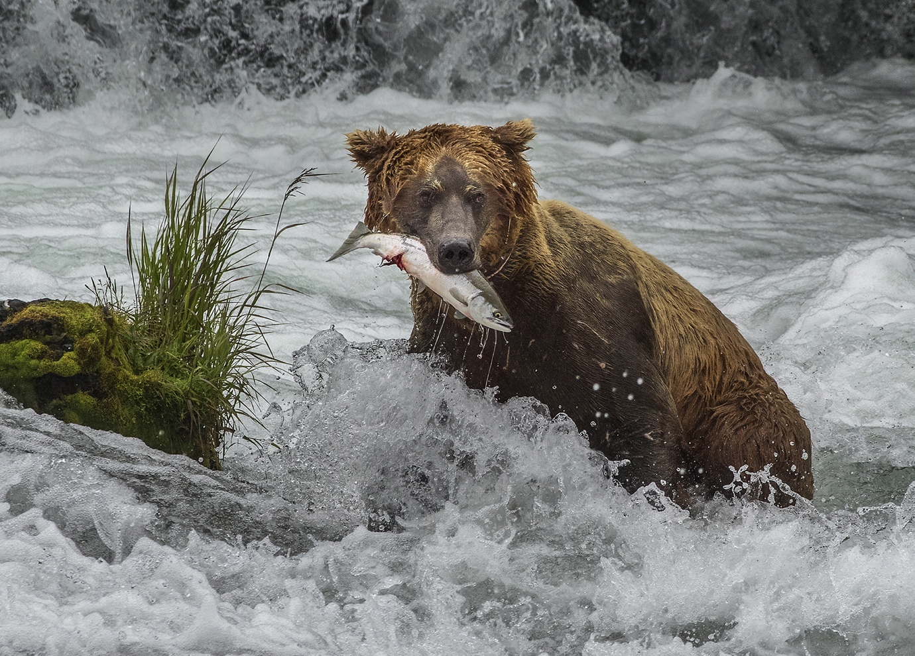
The Society meets at the Art Society Building (Thie Ellyn) in Withington Road, Douglas, with all meetings starting at 7:30pm. Our meeting on Wednesday, 29th November will include an Open Digitally Projected Images competition. The next meeting on Wednesday, 6th December will include 2 digital presentations – the first by Jack Kaighin, with some old lantern slides of the island, whilst Bill Callow will follow with a presentation of some of his latest work. Meetings are open to the public, and all will be given a very warm welcome.
Chris Blyth

