Reports for the 2018-2019 Season
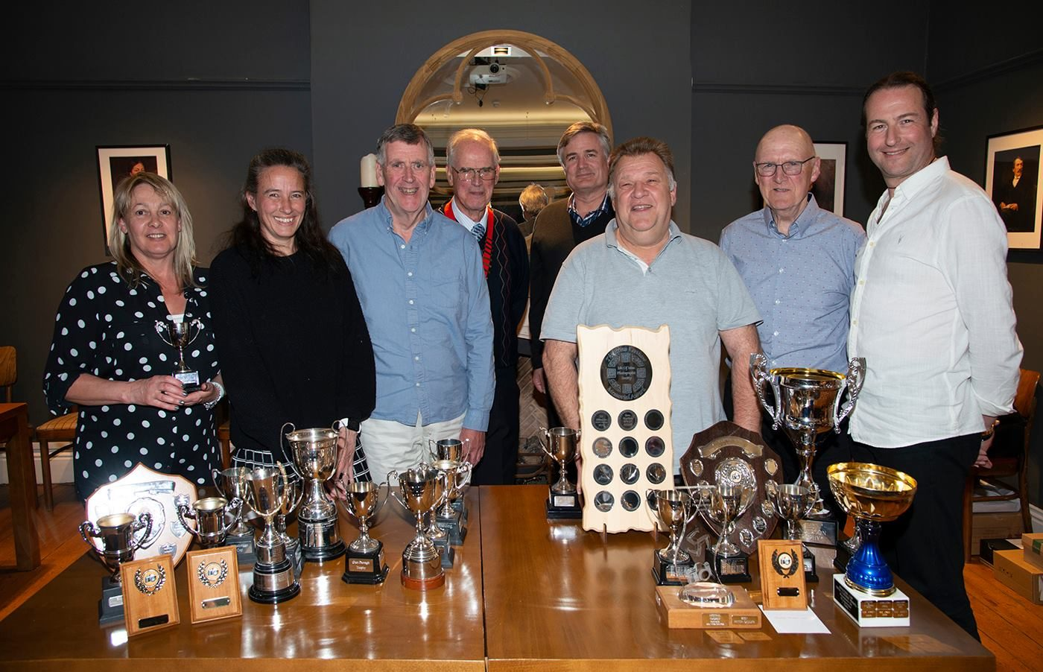
The Society’s Annual dinner was held at the British Hotel on North Quay in Douglas this week, where 30 members, partners and friends enjoyed an excellent social evening.
The arrangements worked perfectly – the chosen meals being served by the staff, with side dishes set out on the tables. A multi-part quiz, set by our President and his wife provided much discussion and entertainment – with Nigel Owen, Tim Norton and their wives plus Jiri Podobski emerging as winners with a top score of 46 out of 60 – very well done considering the severity of some of the questions.
Meanwhile, a slideshow of the annual competition entries provided visual entertainment and the opportunity to see all the entries, not just those selected by our visiting judge.
A raffle on behalf of the Ocean Stars Trust, a charity working with schools in Sri Lanka, raised the wonderful sum of £93 – a big “thank you” to all who supported this activity.
Andrew Barton, our guest of honour, awarded the trophies to those attending the event – Geoff Atkinson, Janet Henry and Claire Schreuder in the Intermediate group, Nigel Owen and Jeremy Broome-Smith in the Advanced.
The evening concluded with the official handing over the chain of office from out-going President, Chris Blyth, who thanked all members and committee for their support during his term – to the incoming President, Jeremy Broome-Smith, who looked forward to serving members to the best of his abilities.
By Chris Blyth

The Annual Competition – Prints
The IOM Photographic Society held its Annual Print Competition on 11th April , and was delighted to have Jeremy Malley-Smith LRPS DPAGB BPE2* to judge. Jeremy is an accredited judge with our federation, the Lancashire and Cheshire Photographic Union, and brings particular expertise in the subjects of wildlife, macro and landscape.
He faced a major task, as he was presented with more than 210 images submitted by our members, who are split into Intermediate and Advanced groups, with their entries judged in the five different genres of Open Colour, Open Mono, Nature, Creative and Record. Given the sheer size of entry, the morning session was spent selecting those images chosen as winners, to be shown during the usual evening meeting, time not permitting comment on every image. However, eventually some 75 images were selected covering the 10 sections being judged – each section usually being awarded a first, second and third place plus commendations as necessary. In the Intermediate group, Claire Schreuder shone, winning four of the five sections – open colour with a well lit still-life image of soup ingredients being made ready for cooking, the open mono with a street musician backlit against some shops, the creative with an image of nuts and bolts seen in close-up as though a city of sky-scrapers, and the record section with a stained glass window image. In contrast, Steve Johnstone swept the board in the Nature section, taking all three winning positions, a stunning shot of a greenshank wading in shallow water and beautifully reflected in the surface earning him first place. Geoff Atkinson, Beryl Quayle, Richard Shafto, Jonathan Carey gained commendations in various sections.
In the Advanced group, honours were more evenly spread, albeit in hard fought competitions. Jeremy Broome-Smith won the open colour section with a delightful long exposure shot of a beach scene, Ruth Nicholls the open mono with a wonderful Italian church interior, Sue Blythe taking first place in nature with a very close-up and detailed image of an approaching tiger, and Ron Shimmin showing his experience and expertise winning both the record section with a shot of the altar in Westminster Cathedral and the creative with an imaginative treatment of a collection of umbrellas.
The evening finished with our judge showing a selection of his wildlife shots taken in Scotland. These included otters, ospreys, pine marten, and eagles, all shown with helpful advice as to equipment required, the techniques and time needed to get close to the subjects and to get “the shot”. What was readily apparent throughout the evening was Jeremy’s enthusiasm and enjoyment of photography in all its forms – a joy shared with our audience and who appreciated the opportunity to see his work.
The Society’s season of weekly meetings is rapidly coming to a close, but our members will have opportunity during the summer to practice their skills with field trips and social events – details will be found in due course on our website www.iomps.com. Members of the public interested in attending these events should make contact via the website for further details.
The IOMPS thanks the Arts Council for their continued support.
By Chris Blyth
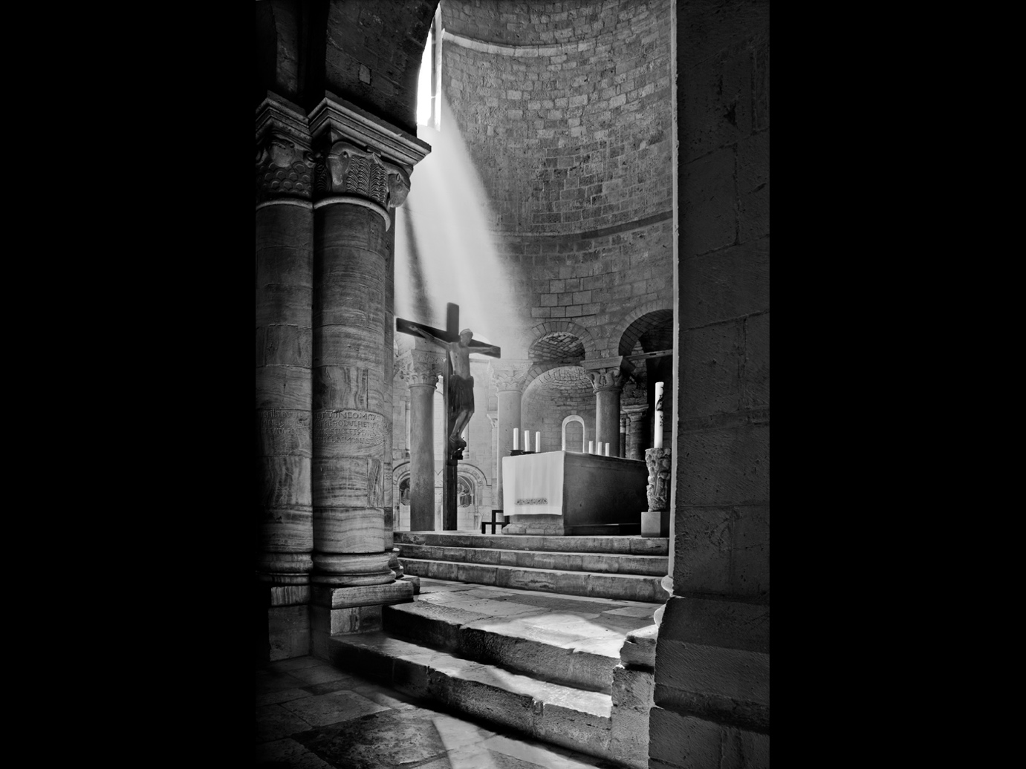Abbezzia Sant’Antimo by Ruth Nicholls gained Best Mono Print in the Annual competition

The Annual Competition – Digital Images
The second evening of the Annual Competition for the IOM Photographic Society saw the judging of digitally projected images by Jeremy Malley- Smith LRPS DPAGB BPE2*, our visiting judge and one accredited with our Federation, the Lancashire and Cheshire Photographic Union. As with the print competition the previous evening, members – split into the two groups of Intermediate and Advanced – had submitted more than 210 images in the five classes of Open Mono, Open Colour, Nature, Creative and Record for consideration. Jeremy’s specialities include landscape, natural history and macro – so well qualified for the task, and one he tackled with immense enthusiasm, someone who clearly enjoys photography in all its various genres.
First up were the Intermediate group with a high quality set of entries, but unlike in the prints, the awards were this time more evenly spread amongst the group – Richard Shafto winning the Open Colour with a lovely shot of two kittens (an “aaahh” moment!), Claire Schreuder taking both the Open Mono and the Creative sections, the latter with a composite of a face intermingled with coloured smoke swirls as though hair (very imaginative”), Steve Johnstone repeating his success in the Nature category with a delightfully composed shot of a stag in the mist, and Janet Henry taking honours in the Record with a shot of a Rome bridge flanked by an intriguing statue in the foreground.
In the Advanced group, placings and commendations were well spread amongst the group, but the awards were dominated by Jeremy Broome-Smith, winning three of the sections – the Open Mono with an image of two motorcyclists in close competition on a dirt track, the dust ensuring focus on the riders (and which also won Best Digital Image in competition), the Creative with a detailed (almost weird!) composite involving a waterfall, a lighthouse, a twist of land and much else besides, and the Record with a quite beautiful Islington church interior. Nigel Owen took the Open Colour section with a wonderful close-up of a sunflower centre, pin sharp and with vibrant colours , whilst Sue Blythe completed the group with a win in Nature, this time of a kingfisher emerging from water with a minnow in its beak, again highly detailed and with excellent colours.
The evening finished with our judge, Jeremy Malley-Smith giving a presentation of a recent photographic safari to Botswana, taking in the Okavanga Delta and the Chobe National Park – and resulting in some stunning shots of the wildlife (elephants, lions, hippos, bee-eaters, rollers, antelope etc) – all much enjoyed by our members. Yet another excellent evening of photography!
The IOMPS season of weekly meetings is now coming to a close, but our members will have opportunity during the summer to practice their skills with field trips and social events – details will be found in due course on our website www.iomps.com.Members of the public interested in attending these events should make contact via our website for further details.
The IOMPS thanks the Arts Council for their continued support.
By Chris Blyth

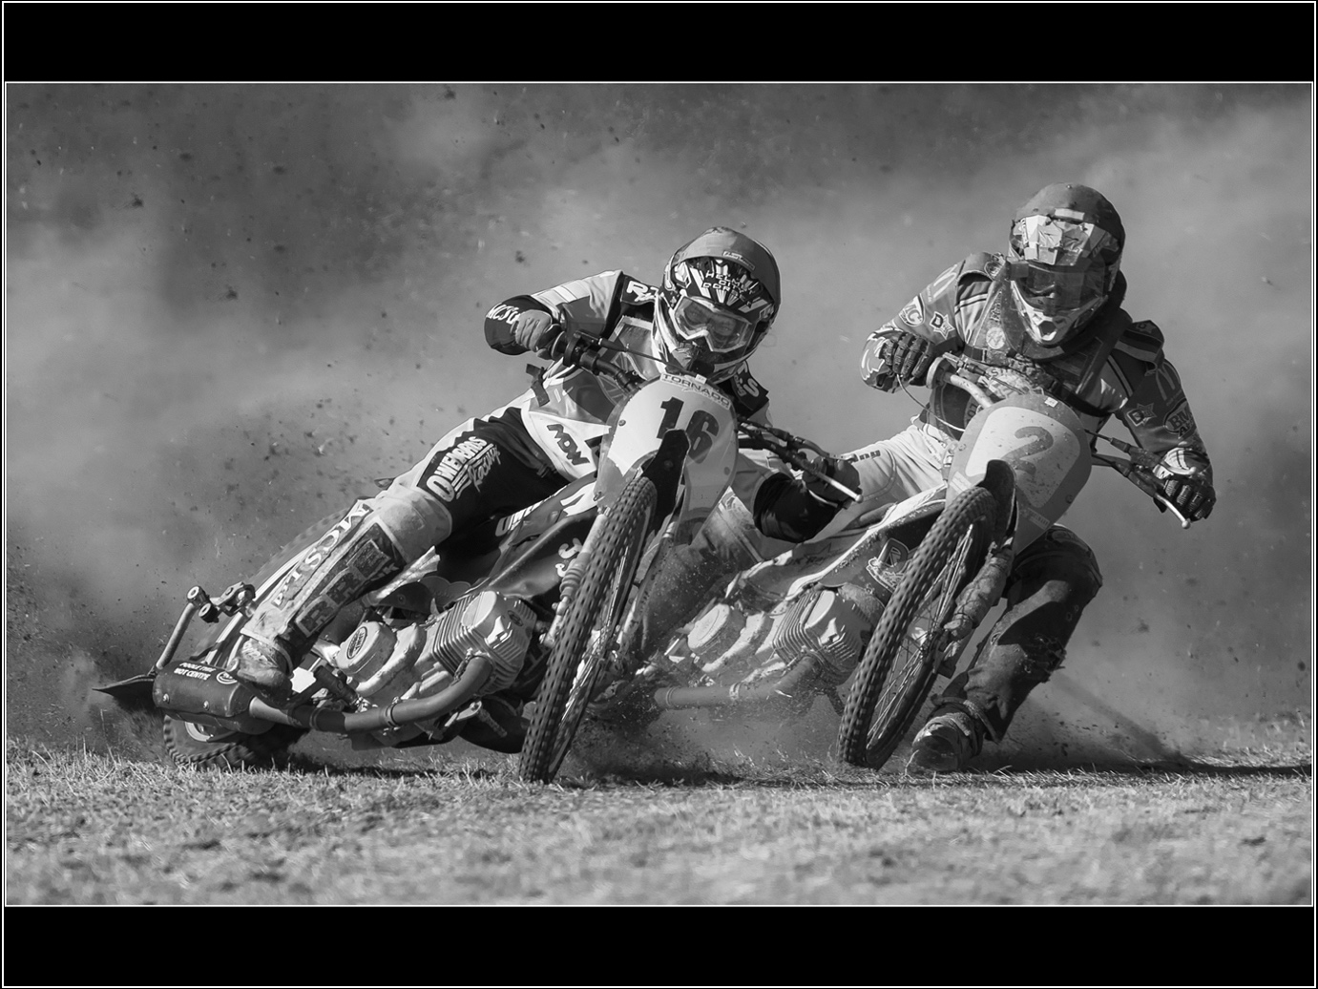
‘Fighting it Out’ by Jeremy Broome-Smith gained Best Digital Image in the Annual competition

Three Way Battle with Oldham and Rochdale
For some years now, the IOM Photographic Society has annually held a three-way digitally projected image competition with the Oldham Society and the Rochdale and District Camera Club.
It is a very special competition in that each club submits 25 images, whilst one of the Oldham members videos the competition on our behalf and we get to show the result a few weeks later as a film show – the only such event in our calendar and one much anticipated as the video is always of a very high standard. There are also the added benefits of being able to watch a (usually very well qualified) UK judge comment on our images as well as compare our skills with two similar clubs from the other island. We have only won this competition once, the Oldham Society otherwise having been the winners each year – they are a very competitive club with a number of members winning at UK national level.
All images are marked out of a maximum of 20 points, the usual judging process being a quick review without comment of all the entries, followed by an in-depth analysis and the award of a score. Images of particular interest demanding closer examination are normally held back till later – usually for the award of a high mark, and adding considerably to the suspense. At the half-way stage with those images scored, we were in close touch of Oldham with Rochdale already lagging somewhat – but Oldham had more images in the “yet to be scored” category. As these later scores emerged, Oldham moved into a decisive lead, the eventual result giving Oldham a score of 416 versus IOMPS with 400 and Rochdale on 380. As Club President Chris Blyth pointed out, the key to such a competition is strength in depth – scoring just three-quarters of a point more on average per image would have given a different result. As it was, an image from our own Jeremy Broome-Smith of a buzzard eyeing a wasp flying close by was awarded the “best image of the evening” and a maximum score of 20 – we just needed a few more of that quality ! Maybe next year….
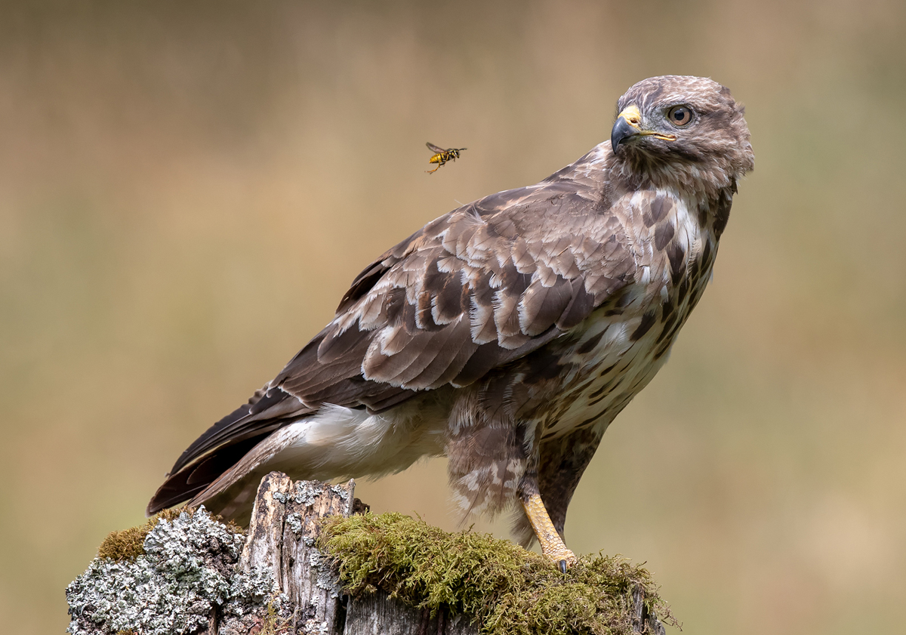
Common Buzzard by Jeremy Broome-Smith

Two Way Digital Battle 20th March 2019
A “Two Way Digital Battle” with the North West Bristol Club was the subject of this week’s meeting of the IOM Photographic Society – an event which has been running for a number of years and one always keenly fought between two broadly equivalent clubs. The event is unusual in that the event is judged at both clubs – thirty images from each club being entered, each with a maximum score of 20 points – with the scores of the two judges being amalgamated to decide the overall winning club. Fortunately, the judges have always agreed which club has won although the scores of individual images have obviously varied, sometimes quite significantly.
Our judge was Steve Babb, well known local photographer, a media arts teacher, and Chairman of the Western Society – so well qualified to assess the images being presented. He duly performed above and beyond all expectations, with an enthusiastic and knowledgeable commentary which held the attention of our members. He had very clearly studied all the entries in great detail, and provided a full justification for all his scores – assessing each with an excellent eye and a real appreciation of the opportunity taken by each photographer to “get the shot”, and of just how each might have been improved.
At the halfway stage, our home team had a modest scoring advantage – but any image thereafter scoring a low mark could have had a major impact on the result, so suspense remained high. However, our final entry – appropriately titled “Saving the Best Till Last” – saw Jeremy Broome-Smith’s image gaining the only maximum score of 20 on the night and ensuring the win for the IOM Society – a club total of 492 points to Bristol’s 470. The Bristol judge happily agreed with the result, having scored the competition overall in very similar fashion 482 for the IOMPS to Bristol’s 461 – though with 4 of the IOPMS entry getting a maximum score from the Bristol judge compared with just one for their team.
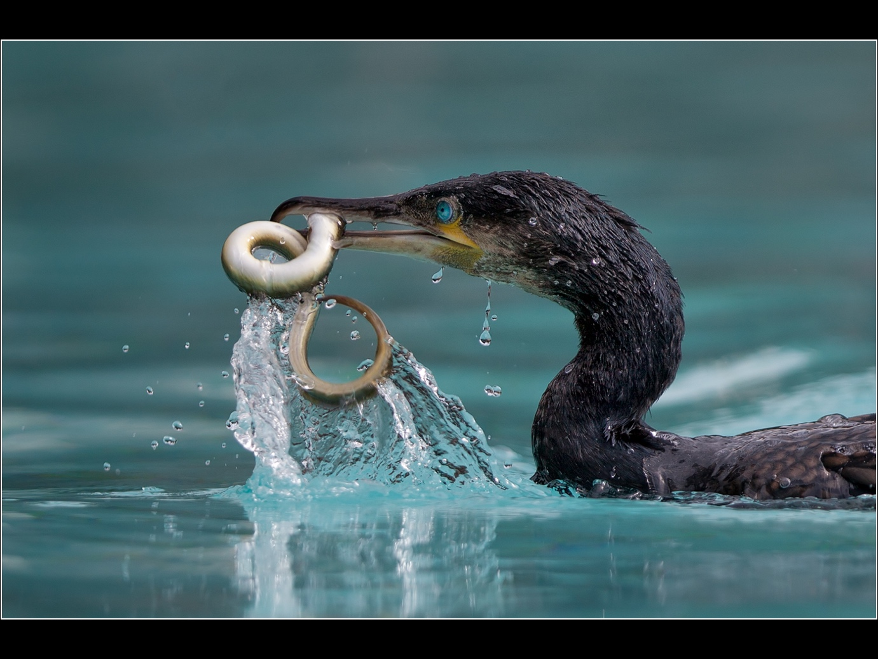
LAST CATCH OF THE DAY by IOMPS

3rd Assignment Competition, After Dark.
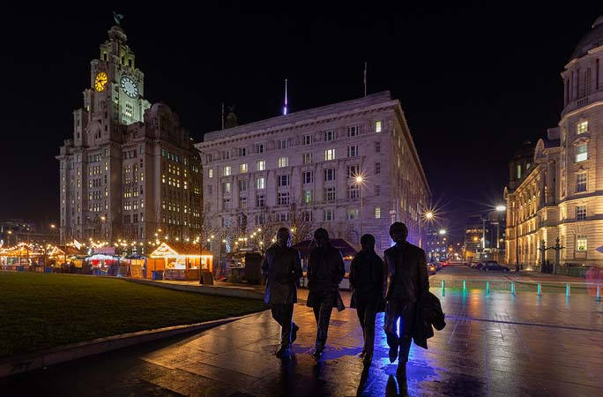
The IOM Photographic Society held its third assignment competition this week, the set subject being “After Dark”, a theme in part inspired from an earlier presentation from the Astronomical Society where night shots of the moon, stars and the Milky Way had featured. It was also intended to “stretch” the skills of our members with the need to understand the technical requirements for such a theme – of longer exposures or higher iso settings when compared with daylight work.
Our judge was Ron Strathdee, an island based photographer with his own website “”digitalmanphotography.com”) featuring several hundred images of the island, including night-time shots – so well qualified to assess our members’ work, as indeed his well-paced commentary showed.
Claire Schreuder dominated in the Intermediate Print section, taking honours in the monochrome section with “Sax in the City” – a delightfully back-lit shot of a saxophonist against a shopping centre backdrop – and similarly in the colour section with a super night shot of Wawel Castle in Krakov. A larger entry in the Advanced class saw close competition. In the monochrome, Sue Blythe and Jeremy Broome-Smith vied for the award, both scoring highly but Jeremy’s print of the Milky Way from Niarbyl having the edge. In the colour section, Chris Blyth and Sue Blythe both scored maximum marks, but Sue winning the judge’s eye with a beautifully back-lit image of the “Fab Four” taken on Liverpool waterfront, and which deservedly gained the judge’s preference as the print of the evening.
The Intermediate digital entries saw Janet Henry getting the judge’s preference in both monochrome and colour sections – a lovely shot of a bench in the park lit by moonlight in the monochrome, and an atmospheric and misty shot of “Stevensons Way” in the colour. The Advanced class was again highly competitive, with Ruth Nicholls, Sue Blythe and Barry Murphy all awarded a similar score in the monochrome section, but Barry’s pub image of a pint glass of Guinness “One for the Road” gaining favour. In the colour section, Ruth had two images with high scores, her shot of a shopping centre and the reflections off wet pavements and street-side cafe tables being preferred. Janet Henry’s image “Bench in the Moonlight” was awarded digital image of the evening.

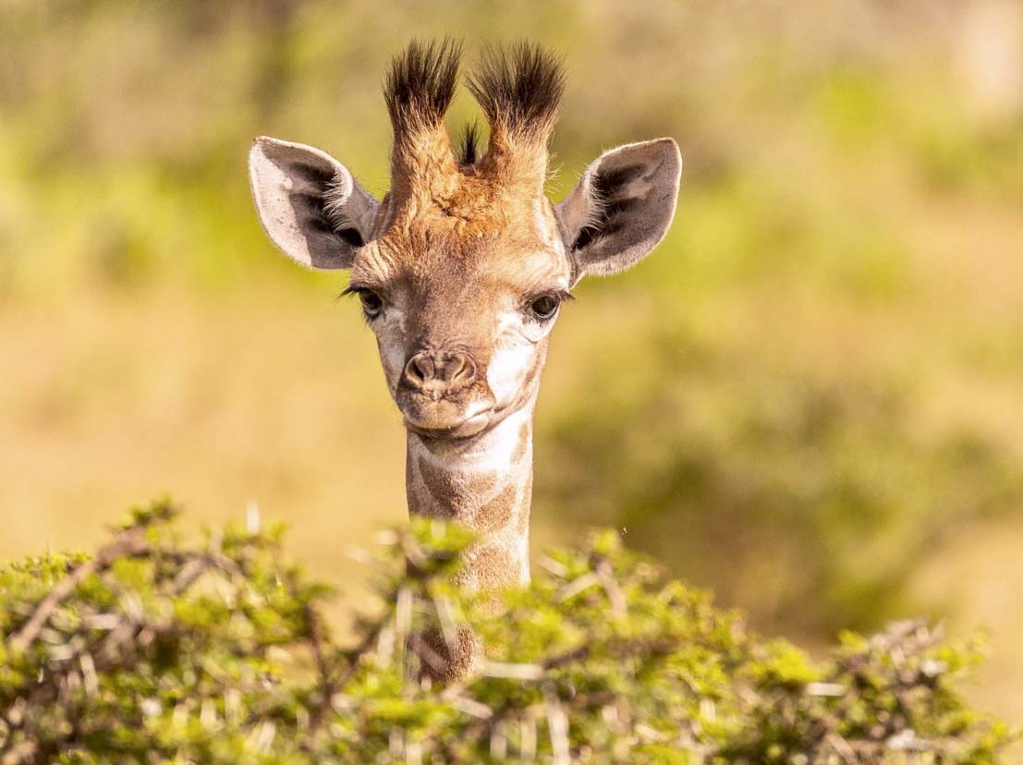27th February “Magic of Africa”
It was the turn this week of Graham Harvey to make a presentation to the IOM Photographic Society with a selection of over 200 digital images entitled “Magic of Africa” – and he did a superb job, to the great enjoyment of our members. Graham is well known for his work both in the IOM Lions Club and at the Curraghs Wildlife Park, where he takes responsibility for stimulating corporate sponsorship and managing the volunteers in helping develop and maintain the facilities. He also now spends some of his time volunteering at the Kariega Game Reserve near Port Elizabeth in South Africa – making annual trips for the last five years – which has given him privileged access to the wildlife there and providing the opportunity for some close-up photography.
Graham’s presentation split neatly into two halves – the first being of the wildlife where his images were spectacular. Antelope such as springbok, kudu, blesbok, water buck and eland featured, as well as predators such as lions, serval, and cheetah, rhinos, hippos, and giraffes – often in the company of their young offspring and making for some delightful shots. Birdlife was also shown with a number of images of unusual and very brightly coloured species such as the narina trogon, glossy starling, and malachite kingfisher, but also including predators such as secretary birds and fish eagles. A more serious problem was finding a highly poisonous boomslang (literally “tree snake”) in one of the bedrooms……perhaps a close encounter of the wrong kind!
The second section was of a more serious social nature, covering the charity work with the local Xhosa people and particularly with a school and a soup kitchen providing food for the children in the local township of Ekuphumleni. The images were fascinating. and revealed much about local life and the issues facing modern South Africa – poverty, education, social inequality and unemployment – issues very clearly exposed with the power of photography.

13th February 2019 – 3rd Open Competition
An abundance of top quality images being judged by Andrew Barton, well known local professional and a great friend to the IOM Photographic Society provided the activity at this week’s meeting. Members had submitted nearly 100 entries for our third Open Competition, where the images can be of any subject. A gargantuan task, and unusually, Andrew had chosen to make his decisions “on the fly” – judging on the night without previous knowledge of the entries. It proved very successful, his comments helpful and given with great aplomb, whilst his selections were well accepted.
Print images were judged first, with Jeremy Broome-Smith vying with Barry Murphy for the top position but taking the honours in the Advanced colour section – his “Atlantic Coast” being a lovely pastel composition. The monochrome section was particularly difficult with high marks for images from Sue Blythe, Sue Leeming, Jeremy Broome-Smith and Barry Murphy, but the latter taking the judge’s eye with a well printed image of Worthing Pier. In the Intermediate group, a lovely profile shot of a red panda earned Claire Schreuder the win in the colour section, with Geoff Atkinson and Jonathan Carey in close pursuit. A silhouette shot of the Ben-My-Chree against the Tower of Refuge. and a lone walker on the beach in the foreground gave Jonathan the edge in the monochrome.
In a closely contested Advanced colour digital section, Jeremy was again the one to beat, with two of his images receiving top marks, the image “Passages 100 Years On” of barnacle encrusted ruins in shallow water against a sunset sky being the judge’s favourite, both of this section and of the evening. Di McCudden produced a beautifully composed image of the groynes at Glen Mooar to gain the award in the Advanced monochrome section, again in a close contest with four other members. The Intermediate colour digital saw Beryl Quayle and Claire Schreuder both get top marks, with Claire’s image being the judge’s preference – a lovely portrait of Angelika, the lighting very well handled. Pat Larkham, Jiri Podobsky and Jonathan Carey were all in close pursuit. Claire repeated her success in the Monochrome, this time with a close-up portrait of a chess competitor in deep concentration of her next move.

January 23rd 2019
The latest meeting of the IOM Photographic Society provided lots of interest for our audience – the first half being an assignment competition on the set subject of “Sports and Leisure”, and the second half the showing of the results of our monthly “fun project”, this time the December theme of “reflections”.
Our judge for the assignment competition was Geoff McCann, MD of a local copier and print company with considerable experience of photography and, perhaps understandably, with a stated affection for print rather than digitally projected work. His comments were brief, sometimes humourous, but very much to the point, with an expectation, for example, that images for the subject required “energy” and “movement” to create atmosphere, emotion and impact, and to draw the viewer into the image.
The Advanced Colour Prints were first up, with Jeremy Broome-Smith gaining selection as the judge’s favourite in this section – a motor bike shot “Me and My Shadow at Church Bends” where the rider and bike were clearly in motion and with the shadow defined against the background scenery. Sue Blythe demonstrated her expertise with the award in the Advanced Mono Prints – a lovely canine action portrait, “Dog Agility”. In the Intermediate Group, Claire Schreuder took the honours in both Colour and Mono Prints, a delightful and pin sharp show-jumping image “Eyes Forward” in the colour, and an image of a child hanging upside down from a swing in the mono, “The Isle of Upsidedown” – a “different approach” to quote our judge.
The Advanced Colour Digital again saw Jeremy Broome-Smith in favour, a superb (if nervous) selfie of his legs in a kayak, a curious seal very obviously taking a very close interest in his toes! In the Advanced Mono section, Barry Murphy emerged with the award, a striking and characterful portrait “The Mechanic” taking the honours. Mike Howland’s image of a trials biker climbing a steep grass bank was the stand-out image in the Intermediate Digital Colour whilst Beryl Quayle’s image of a kite surfer at Port Erin gave her a well deserved award in the mono section.

January 16th 2019
Two very talented photographers (as it happens, husband and wife) – two presentations, both travelogues and both highly enjoyable – provided the programme for this week’s meeting of the IOM Photographic Society. And, like a school essay question, our audience had the opportunity to “compare and contrast” their styles and their work.
First off was husband Chris Nicholls presenting travel shots of Slovenia – a “broad brush, macro” approach starting in the port of Piran, a well preserved mediaeval town with narrow cobbled streets, its historical relationship with Venice evident in the architecture of the church and houses. We then traversed Slovenia, taking in many images of churches, caves, castles and countryside. The church at Hrastovije with wonderful fresco paintings dating from the 12th Century, whilst the deep limestone gorge and resulting caves at Skotchan and nearby Predjama Castle were particularly impressive. We then moved on to the Julian Alps – with wonderful mountain scenery – and onwards to the popular destination of Lake Bled with its iconic church on a small island in the middle. A side trip to Lake Bohniji included images of a typical village with hay barns, wood stores and old houses – some very evocative. It was a well considered and presented traditional travelogue.
By contrast, wife Ruth Nicholls took a more “micro” approach, concentrating her presentation on the town of Rovinj in nearby Croatia – again a port with an attractive harbour, a church perched high on a hill overlooking the town, and narrow streets. As well as giving us a detailed view of the town and harbour area, the presentation was very much a “photographers tour” – yes, a travelogue but with a definite artistic slant, with interest in both the wider picture and in the smaller scale detail. There were shots of the same (or very similar) scene taken at different times of day or night to show just how the mood and feel of an image changes with the light – for example, the “blue hour” around the dawn with a slightly “cold” feel, the “golden hour” near sunset when everything has a much “warmer” hue – all beautifully shown and explained.
Both photographers have recently changed their camera systems to Fuji – and the realistic colours and pin-sharp images throughout both presentations were noted in a well deserved vote of thanks given by the club president, Chris Blyth.

December 2018
The IOM Photographic Society is this week in its mid-winter break for Christmas and New Year, so this is perhaps an opportune moment to reflect upon our season so far – and we’d like to think, a very successful one!
The highlights have been many – some excellent and well-received presentations, several practical sessions, and our programme of regular competitions well supported with a myriad of high quality entries – all contributing to a balanced range of activities to be enjoyed by our members. Presentations so far have included ones by Shan Fisher (on portraiture), Carmen Norman (landscape) and Jake Huxley and Kevin Deakes from the Astronomical Society (astrophotography) – all representing popular genres and ones which our members have been keen to understand and to improve upon.
The practicals have covered some fairly basic techniques but ones for which many members would have had limited experience – each being led by more advanced members. The first was on macro (close-up) photography using for example, some thinly sliced fruit back-lit to show structure and colour or bubbles in oily water for some colourful pattern shots. Our most recent session included model portraiture using either flash or continuous lighting in typical studio sets with a range of backdrops.
A particular satisfaction has been the level of participation in our various internal competitions with the quantity and quality of the entries being excellent in both our Intermediate and Advanced groups – and resulting in some very close contests. The 3 Way Digital Battle with the two other island clubs was a much anticipated and enjoyed event, bringing together many of the island’s photographers in our annual social challenge – the resulting win therefore a big morale boost.
Members have also been encouraged to show their work in non-competitive “monthly assignments” set by Barry Murphy – and the wide range of images resulting has been a very clear demonstration of the artistic talent in the Society – something the committee is particularly keen to continue.
The next meeting in our formal season will be on Wednesday 9th January when Club President, Chris Blyth, will be giving a presentation of his work. The Society meets on Wednesday evenings at the Art Society building in Withington Road, Douglas, starting at 7:30pm. Meantime, we would wish all our readers a “Happy and Healthy New Year”.
Chris Blyth

