Second Open Competition – 5th December 2018
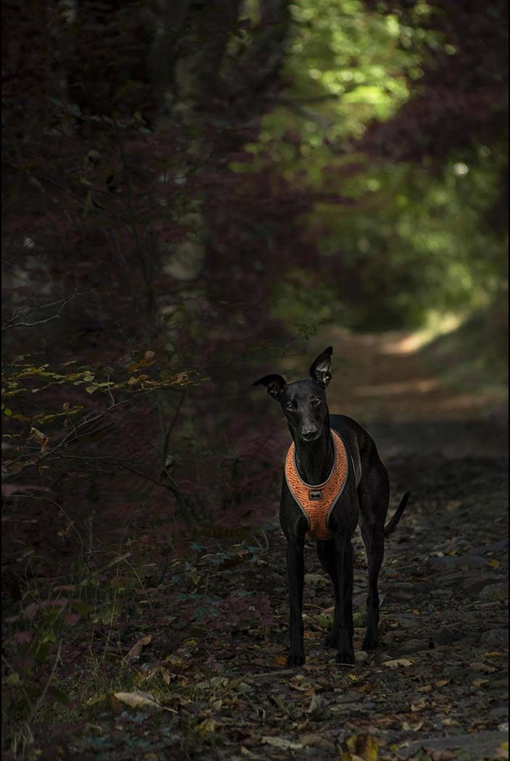
“My Boy Pixel” – by Janet Henry
The IOM Photographic Society continued its programme this week with the Second Open Competition of the season, where the author is free to choose the subject matter for their images. An excellent – and competitive – evening was ensured, with the membership providing more than 100 entries, as usual split between prints and digitally projected images, between colour and monochrome, and between our Intermediate and Advanced members.
Judging is no easy task when the images are of high quality and with widely varying subjects. Fortunately, Mike Radcliff, a locally based professional photographer proved well up to the requirement – his comments were necessarily concise but relevant, his marking consistent, and his awards at the end of each section well accepted.
In the Advanced Colour Prints, three authors with 5 images between them – Jeremy Broome-Smith, Sue Blythe and Annette Slater – all gained top marks of 20, but it was the latter with an image of a woodpecker close-up who got the judge’s favour. In the Advanced Monochrome Prints, Sue Leeming competed with Sue Blythe for the honours, both again having been awarded top marks for their entry, but Sue Blythe’s portrait – “The Look Of Love” – of a Mum and Dad with a new-born baby in their hands and excellent lighting gained preference. Claire Schreuder dominated the Intermediate Prints in both Colour and Monochrome sections – two beautifully composed and lit cookery still-life images gaining maximum marks in the Colour section, whilst her shot of Rome’s Colosseum gained award in the Monochrome.
The digital sections proved extremely competitive with a wealth of top quality images. The same three authors who dominated the Colour Prints again proved the ones to beat in the Digital Colour – Annette Slater, Jeremy Broome-Smith and Sue Blythe all gaining maximum scores of 20 and all with natural history images. However, Sue Blythe took the award with a really close-up shot of a tiger, the whiskers and teeth pin sharp. Annette again proved very competitive in the Monochrome, vying with Nigel Owen for the award, both with top marks. However, Nigel’s image – of a bowing iris almost in silhouette – gained preference. New member Janet Henry emerged smiling in the Intermediate Colour section with a delightful image “My Boy Pixel” – a dog in a woodland surrounding – gaining maximum points, with Geoff Atkinson, Steve Johnstone and Claire Schreuder all in contention. In Monochrome, Geoff’s lovely shot of the Point of Ayre lighthouse against a beautifully captured cloudscape took the judge’s eye for the top award.
Chris Blyth

Photographing the Night Sky – 28th November 2018
The wonders of the night sky – and how to photograph it and them – provided the IOM Photographic Society with the subject matter for this week’s meeting – from satellites to the International Space Station, from far-off galaxies to eclipses and the beauty of the aurora borealis. Given one of our assignment competitions later in the season is “After Dark”, it was a particularly relevant topic for our members, and one we had eagerly anticipated.
We were therefore delighted to welcome two expert speakers from the IOM Astronomical Society to present to us – Jake Huxley and Kevin Deakes, the latter a Fellow of the Royal Astronomical Society. Both had very clearly tailored their presentations to our audience of keen photographers, with a wealth of superb images of the night sky, each carefully explained in terms of its context and science. Jake started our evening with a particular focus on eclipses – partial and total, with images from a number of eclipses from around the world. Clearly a widely travelled man, his fascination with eclipses and the associated solar flares and sun spots provided us with much to enthuse about.
For the second half, Kevin Deakes was kind enough to explain that many of the images to be shown were shot with quite basic camera equipment, and – perhaps surprisingly – shot from his garden here on the island. The message was clear – some great shots are possible given the commitment (images necessarily taken when most people are sound asleep in bed !). A rapid explanation of his kit – a digital camera with a range of fairly standard lenses and a very firm tripod plus a knowledge of the stars (perhaps assisted with some “apps” such as “stellarium” on a mobile phone or computer) – and we were off on a tour of the possibilities for night-time images. Eclipses, meteorites, satellites, the International Space Station, the aurora borealis, even deep space galaxies were all beautifully illustrated and clearly explained.
Chris Blyth, President, gave a deserved vote of thanks on behalf of the membership.

3 Way Battle
As current holders of the title, the IOM Photographic Society was this week delighted to host the Annual 3 Way Digital Battle with the island’s two other camera clubs, the Southern and the Western Societies. The event was held at the South Douglas Old Friends Association – it proved a very popular venue, the room allowing an excellent view of all the images for our large audience.
Our judge for the night was Ian Aldcroft ARPS, President of the Lancashire and Cheshire Photographic Union (the federation to which all three clubs belong) who was invited in particular as it has been some years since the last visit by a member of the L&CPU executive. Ian has had a distinguished career in the photographic world, his monochrome portraits in particular being classic images of high quality and beautifully lit. and which gained him the ARPS qualification. In justifying his scores (all being out of a maximum of 20), his commentary was affable, softly spoken and knowledgeable.
All three clubs have a membership of excellent photographers so a very competitive evening was assured, with 30 images from each club being judged. The key to such a competition however is strength in depth – of having a mix of entries across the board which all gain a good to high score. And so it proved on the night. The IOMPS entry included 3 images gaining maximum 20’s (from Sue Leeming and Jeremy Broome-Smith). These were matched by 3 images from the Southern also gaining maximum scores, one of which ( from Andrea Thrussell – a lovely sunset seascape with kayaks returning to shore) won the Judge’s favour as the individual image best meeting his own preferences – he confessed during the evening to enjoying sunsets, cats and portraiture.
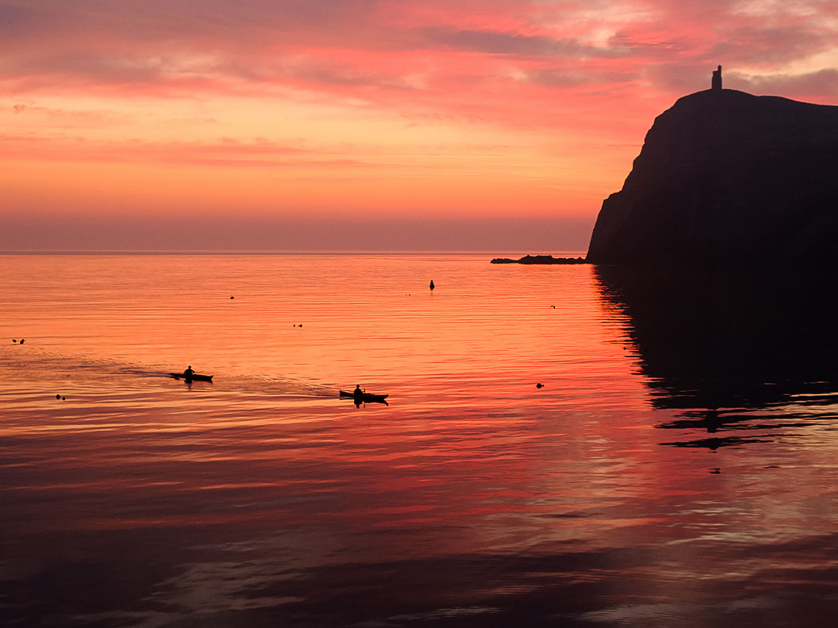
Heading home by the SPS
However, the IOM Photographic Society had established an early overall lead, never gave it up, and ended the evening with a winning score of 533 points to the Southern’s 508, and with the Western on 493.
Chris Blyth

Assignment Competition Landscapes 21 November 2018
The first of our Assignment Competitions provided the subject matter for this week’s meeting of the IOM Photographic Society – the assignment being “‘Scapes”, meaning any variation on themes such as landscape, seascape, townscape, skyscape etc – a very open topic with a variety of interpretations, but one chosen specifically to attract a wide entry. The resulting entry of 62 digital images and 45 prints, spread over both monochrome and colour sections, and split between both Intermediate and Advanced members, gave our judge a particularly onerous task.
Fortunately, we had the pleasure of welcoming Dorothy Flint ARPS AFIAP BPE4* from the Western Society to judge for us – one of the most experienced and qualified photographers on the island who proved well up to the task. She has an excellent eye, takes enormous effort and time to consider every image presented to her, and whilst her comments were necessarily brief, they were very much to the point.
The prints proved particularly competitive, with very high quality images across the board – albeit a real difficulty for our judge in differentiating her marking. Jonathan Carey’s entry in the Intermediate Colour Prints of a well balanced and busy image of the Port of Livorno narrowly winning favour over two images of Venice from Claire Scheuder. However, Claire then took honours in the Intermediate Mono Prints with another image from Venice, this time of the Basilica of Santa Maria Dell Salute, with Beryl Quayle closely following with two images from a trip to Liverpool. In the Advanced Prints, a number of images were awarded top marks of 20 in both the Mono and Colour sections – Sue Blythe and Jeremy Broome-Smith in Mono and both joined by Ruth Nicholls for the Colour section. However, Dorothy chose images by Jeremy in both sections as her favoured selections for the evening – a landscape in the Colour section (“View Over Conors Pass”) and a lakeside image in the Mono (“Ashness”).
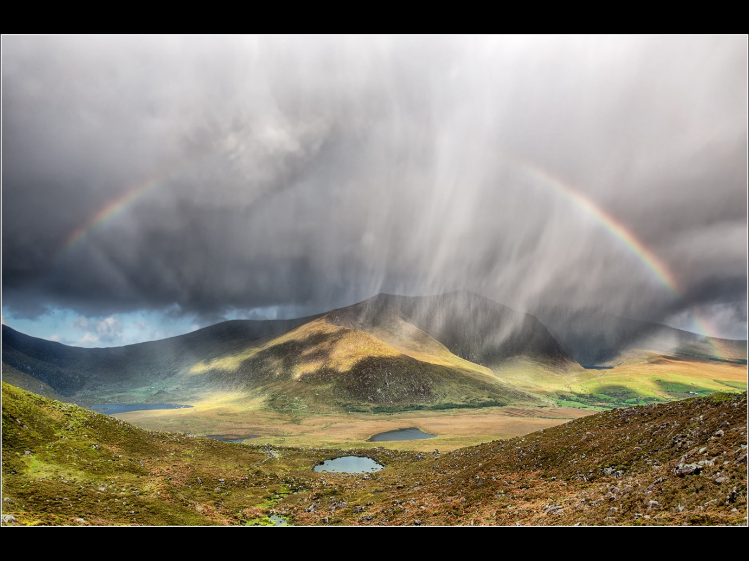
View over Conor’s Pass by Jeremy Broome-Smith
It was a similar story for the digital sections, with the same authors always in close contention for the judge’s preference – Jonathan Carey’s lovely image of the blue domes of Santorini scoring highly in the Colour Intermediate section, with Janet Henry and Beryl Quayle providing close competition, whilst Claire Schreuder won favour in the Mono section with another image of the Basilica in Venice with Richard Shafto and Janet henry close behind. In the Advanced section, Jeremy Broome-Smith completed a clean sweep of all sections, his image of Scarlett Point gaining preference in the Colour competition with images from Ruth Nicholls, Sue Blythe and Nigel Owen closely following, whilst Jeremy’s image of the Dingle Peninsula took honours in the Mono, with images from Sue Leeming and Sue Blythe providing close competition.
Club President Chris Blyth gave a well earned vote of thanks, with special thanks to the competitors for providing a really excellent set of images for all to enjoy and for the judge to ponder on.
Chris Blyth

Report for 7th November 2018
The First Open Prints competition (where the photographer is free to choose the subject matter) provided the entertainment for this week’s meeting of the IOM Photographic Society – with Dennis Wood from the Western Society proving to be a very discerning and knowledgeable judge, forthright in his commentary on the near 50 images presented in competition. Dennis has been a regular judge for our Society, respected because of his expertise both behind the camera and in his understanding of “post-production” digital processes such as photoshop, and the manipulations they make possible on a computer. Members will have learnt much from the very detailed, almost forensic analysis of each image, and particularly the need to check each entry to ensure the judge has little to critique and much to admire…..
Four sections were judged – the two member groups (Intermediate and Advanced) encouraged to enter both monochrome and colour sections. With a scoring system based on a maximum of 20, and with the judge able to award this score to multiple images, we no longer refer to “winners” but to the “Judge’s Selection” or “Preference” in each section. A strong entry in the Advanced Colour saw Jeremy Broome-Smith’s image of a Peregrine carrying its prey in its talons was favoured , with a deserved maximum score – the bird flying straight towards the camera and the image pin sharp. There was an equally strong entry in the Advanced Monochrome with our judge selecting Annette Slater’s image “Best Viewed From Above” as his preference – a very detailed, pin sharp landscape of a valley, the mist and low clouds on the hills in the background, and a dog highlighted on a crag in the foreground making a bold impact on the image.
The Intermediate Colour selection saw the judge prefer new member Claire Scheuder’s still life of fruit and vegetables “Casserole Tonight” – a well organised and beautifully lit shot including garlic, onions and grapes on a black background. The evening finished with the Intermediate Monochrome and Richard Shafto’s almost (but not quite) silhouetted image of a line of cormorants sitting on posts near shore getting his approval.
The Society meets at the Art Society Building (Thie Ellyn) in Withington Road, Douglas, with all meetings starting at 7:30pm. Our next meeting on Wednesday, 21st November will be the judging of our first assignment competition – ‘Scapes (meaning landscapes,, seascapes, townscapes etc). Meetings are open to the public, and all will be given a very warm welcome. Full details of our programme can be found on our website at www.iomps.com.
Chris Blyth

Report for 31/10/2018
The latest meeting of the IOM Photographic Society came in two halves – the first comprised a session of members’ images taken either on Society outings during our “summer break” or on two non-competitive assignments set by Barry Murphy to encourage the use of a camera during idle moments….
This proved very successful with a wide range of excellent images from the membership – the outings included visits to Tynwald, the Gaiety, Kentraugh Mill, the Ayres Nature Reserve, and a day trip to Liverpool – and resulted in some almost iconic shots. The two challenges – “summer activities” and “images taken within 100yards of your house” – required members to submit two images on each assignment and provided a wide range of interpretations, some taken inside the house, some outside – some lovely images of leaves in bird baths or plastered against a wet window for example were particularly noteworthy, whilst Richard Shafto’s image of derelict properties in Spain (the result of their financial crash since 2009) was quite dispiriting but an excellent example of “reportage” current affairs style.
The second half was the showing of a folio of 60 images from the Lancashire and Cheshire Photographic Union, which for the first time was shown as digitally projected images rather than as prints. This gave the immediate benefit that all members had a good view of the image and were able to appreciate the skills exhibited in the various images – and led to a good discussion of the strengths (and sometimes weaknesses) of each image, important for members in developing their awareness of image quality and of being able to critique an image to identify possible improvements.
Our next meeting on Wednesday, 14th November will be the Island Three-Way Digital Battle between the IOM Photographic Society (current holders of the title) and our rivals at the Western and Southern Clubs. This will be held at the South Douglas Old Friends Association in Finch Road, Douglas. Meetings are open to the public with an entry fee for this special event of £4, and all will be given a very warm welcome. Full details of our programme can be found on our website at www.iomps.com.

‘Moods in Landscape’ presentation by Carmen Norman 24th October 2018
From time to time, members of the Society have the opportunity to hear an experienced guest presenter from the adjacent island. So, it was a particular pleasure when our Vice-President, Dr Ruth Nicholls, invited us to give a warm welcome to Carmen Norman LRPS, CPAGB from the Keswick Photographic Society in Cumbria recently. Carmen had titled her presentation ‘Moods in Landscape’ which was filled with basic educational and useful advice on landscape photography, in which genre she has won awards and had work accepted for publishing in various photo magazines. In fact, from her base in the Lake District she also runs various landscape photography courses and workshops which receive rave reviews! Moreover, she has also had published a set of field notes on how to derive the most from your chosen location and viewpoint.
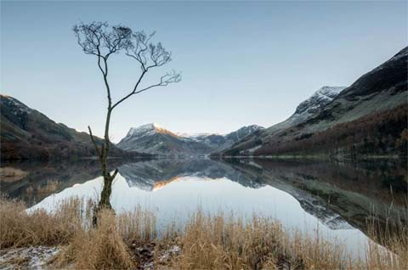
Carmen began by giving details of the type and range of equipment she normally uses for her land and seascapes, before proceeding to project examples of her work. She then gave a simple demonstration on how she had used software to enhance her images in order to focus the viewer’s attention by highlighting the key features. Her easy presentational style made for an interesting evening during which you could have heard a pin drop as she illustrated a step by step guide to processing RAW images. Her advice on perspective, exposure compensation, the rules of composition (Thirds and Phi), and on setting different modes of White Balance, depending on the desired results, were particularly instructional and well received.
This was an extremely high quality presentation, broken into broadly 6 segments before and after refreshments, which gave just enough detail without becoming overly technical. She also drew on a few relevant quotations from a number of notable people as diverse as Sir Robin Knox-Johnston CBE RD, the oldest yachtsman to complete a round the world solo voyage, and American poet and educator, Henry Wadsworth Longfellow. She had decided to close with a short video accompanied by appropriate background music.
It fell to one of the Society’s Life Members, Brenda Shimmin, to propose a vote of thanks on this occasion which she did in her customarily eloquent style and which drew an enthusiastic response from the enthralled audience.
By Antony Hamilton

First Open Digital Competition 17 Oct 2018
The latest meeting of the IOM Photographic Society proved a very successful introduction to the competition programme with over 70 entries for the first Open Digital. The evening also saw the introduction of a new scoring system, with all images given a score out of 20. There were 4 sections being critiqued – Intermediate and Advanced groups each split into mono and colour images. Our judge for the evening saw the return of Doug Allan – a long-term favourite of the Society who has judged on a number of previous occasions. His comments are always carefully considered, concise, well researched and supportive of the entrant whilst his scoring was well calibrated and consistent.
The first section – Advanced Colour – saw a series of extremely high quality images, particularly of natural history subjects – with 5 images from 4 different authors (Jeremy Broome-Smith, Sue Blythe, Dianne McCudden and Barry Murphy) all gaining a maximum score of 20, the judge unable to separate them in terms of technical excellence. Only on the judge’s personal preference did Jeremy’s image “Peregrine with Prey” get the winning nod.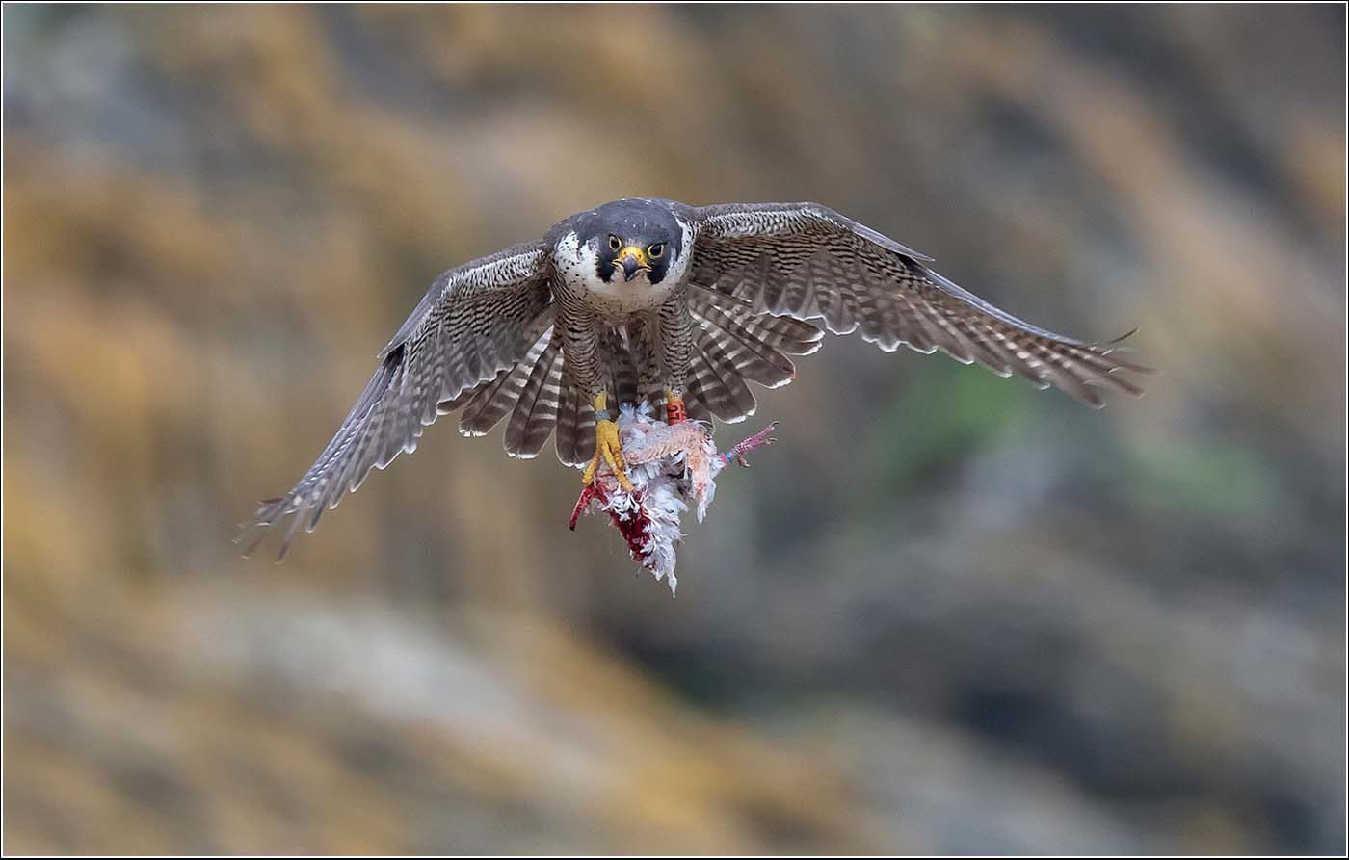
The Advanced Mono section was again won by Jeremy with a sports action shot of two grass track motor-bikers racing neck-and-neck. A superb image from Sue Blythe of a tiger’s face very close-up and with every hair clearly seen ran a (very) close second place, in turn hotly pursued by images from Sue Leeming and Barry Murphy.
The Intermediate Colour section saw new member Claire Schreuder winning on her maiden outing with a colourful image of two ladies taking a picture of flowers decorating two houses, their dresses mirroring the colours of the walls. Lara Howe’s red squirrel feeding on a wet day took second place.
The final section – Intermediate Mono – saw two images gaining scores of 19 – an old lady accordion player by Jonathan Carey and an image of the Steam Railway engine “Kissack” from Mike Howland, with the latter gaining the judge’s favours. Beryl Quayle as always proved a strong competitor with effectively the third place score.
Whilst Jeremy’s image of the peregrine taken on the island was judged the overall winner on the night, the close competition – in all sections – and quality of the images augurs well for a highly competitive season with some great shots in prospect. Doug Allan’s performance as judge also gained a well-deserved round of applause.
Our website at www.iomps.com includes full details of our programme. Meetings are held at Thie Ellyn (the Art Society building) in Withington Road, Douglas on Wednesday evenings starting at 7:30pm, with the next on 31st October being a digital presentation of a folio from our federation, the Lancashire and Cheshire Union, to be followed by members showing some of their images from IOMPS events. All meetings are open to the public, non-members with a modest entry charge, and all will be made very welcome. We look forward to seeing you there….
Chris Blyth

Presentation by Shan Fisher 10/10/18
Another delightful evening this week at the IOM Photographic Society, with Shan Fisher – a well known and award winning photographer on the island – presenting her work as a portrait / wedding / maternity / babies / and fashion photographer.
Some 15 years ago, Shan was a member of the society – young but very successful in our competitions. She then disappeared for some years to London to complete her studies but has now carved out a career here on the island, with an enviable reportoire of skills and a portfolio of images of the highest quality.
She believes the secret to her success lies in building a rapport with her clients, and in preparation, planning and organising the events – a comprehensive plan which times in considerable detail the various elements of a photographic shoot and the shots the client would like, but always with a degree of flexibility – baby’s feeding times or naps for example necessarily cannot always be anticipated ! She also believes very strongly that one should always strive to improve – to be the best at whatever you choose to do (a “life choice” drilled into her by her mother) – and to share an empathy with other people. For her, images are highly emotional – a record to cherish and to love as a permanent reminder of life’s events. Her presentation was richly illustrated with promotional videos and images of her work – and deservedly got a well earned round of applause at the end of the evening.
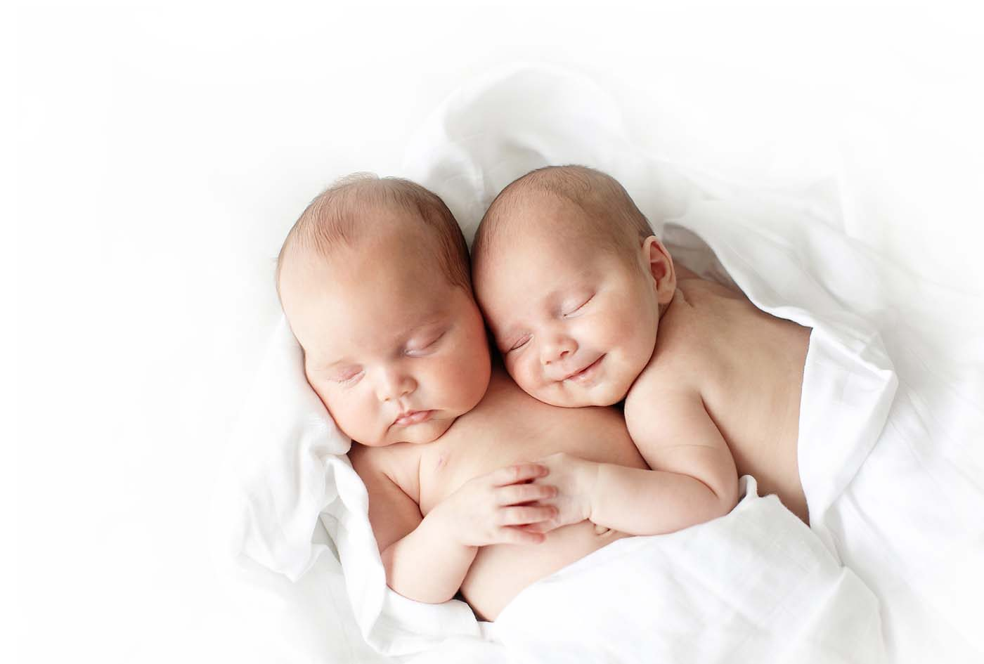
Our website at www.iomps.com includes full details of our programme and a map showing our location. Our meetings are held at Thie Ellyn (the Art Society building) in Withington Road, Douglas on Wednesday evenings starting at 7:30pm. Our next meeting on 24th October is a presentation by Carmen Norman entitled “Landscape Moods”. She is a well known landscape worker from the Lake District – with all that beautiful scenery right on her doorstep, it is certain to be a fascinating and stimulating evening. All meetings are open to the public, non-members with a modest entry charge, and all will be made very welcome. We strive to be the island’s meeting place for all with a love of photography. We look forward to seeing you there….
Chris Blyth

Macro Photography 03/10/18
The latest meeting of the IOM Photographic Society proved a major success as members were given a demonstration of macro (close-up) photography followed by the opportunity to practice the use of their own cameras and to get “the shot” for themselves. In particular, the evening required members to use purely “manual” settings on their cameras rather than the default “automatic” setting with which most of us are happy to use most of the time.
Three set-ups, complete with the necessary lighting arrangement, were provided by our Competitions Secretary, Jeremy Broome-Smith who was ably assisted by Nigel Owen for the evening. The first was of a glass dish filled with an olive oil and water mixture, back-lit and fitted with various coloured backgrounds and when suitably agitated, provided the opportunity for some colourful and surprisingly vivid images of bubbles. The second arrangement enabled the photography of thin slices of fruit such as kiwi, orange or lemon – again back-lit with a light panel. No excuses on these set-ups as the bubbles and fruit don’t move and the photographer has complete control of the arrangements! The third set was also a very simple one – a clear glass vase filled with water into which a strawberry or a lemon slice was being dropped, the idea being to capture the “splash” as the fruit hit the surface and the bubbles as it descended through the liquid. Here timing was everything – too soon and the fruit was still in the air, too late and the shot was missed.
Much banter ensued amongst the members as they explored the various arrangements – and whilst not all the shots were necessarily perfect, the intent was to stimulate and provide ideas which could then be replicated at home. Assuming ownership of a camera and a flash-gun, none of the arrangements required specialist equipment or would be difficult to set up – just a certain amount of time and the enthusiasm to “have a go”.
Our website at www.iomps.com includes full details of our programme. Our meetings are held at Thie Ellyn (the Art Society building) in Withington Road, Douglas on Wednesday evenings starting at 7:30pm. All meetings are open to the public, non-members with a modest entry charge, and all will be made very welcome. Our next meeting on Wednesday 17th October is an “Open Digital” competition. If you enjoy photography in any or all of its forms, we’d be delighted to see you…
Chris Blyth

Summer Shots! (for 26/9/18)
It was a spectacular start to our new season, with more than a dozen of our members showing their enthusiasm by taking turns to show images of their “summer” activities. The intent was to have a “social evening” and the opportunity to chat and reminisce – and it turned out to be a much enjoyed evening.
Holidays and travel obviously featured large – with Chris and Ruth Nicholls showing images of life in rural France as well as a major wedding anniversary celebrated on a break in Annecy on the Swiss border. Jonathan Carey also celebrated an anniversary, sharing some excellent images taken on a Mediterranean cruise around Greece, whilst Ron and Brenda Shimmin, threatened with strike action in France, took the opportunity to switch their destination to Genoa.
Closer to home, Sue Leeming enjoyed kayaking and time on the Calf of Man, Beryl Quayle showed a love of natural history shots as well as an evocative image of Archallagan in the mist, Barry Murphy enjoyed shooting kite surfers at Ballaugh, whilst Richard Leach demonstrated a multi-talented range of skills, including both cake-making (we look forward to a practical evening?) and his fitness, having completed a 15km marathon swim on the Thames. But Jiri Podobsky is possibly our fittest member, showing images of his exploration of the manx countryside using a hybrid scooter/bicycle – a scooter with bicycle size wheels and capable he says of more than 30mph and on which he has so far travelled more than 1000miles.
“Projects” were well demonstrated, with Bill Callow wandering the streets of Ramsey looking for dogs and their owners to photograph, whilst Martyn Parnell continued to show his TT bike expertise as well as the image quality possible with an 800mm ultra-telephoto lens – a shot of Kates Cottage taken from Douglas Head was pin sharp and very detailed. At the other end of the photographic world, Jeremy Broome-Smith enjoys macro work and his images included several close-up images of a very hairy jumping spider – some in the audience thought it “cute”….. others perhaps not so sure !
Richard Shafto provided the “aaah” moment of the evening with a lovely shot of two kittens whilst the Red Arrows and their Italian counterparts provided several members with action shots including Mike Trout.
The Society meets at the Art Society Building (Thie Ellyn) in Withington Road, Douglas, with all meetings starting at 7:30pm. Our next meeting on Wednesday, 10th October will be a presentation by Shan Fisher on her portrait work. Meetings are open to the public, and all will be given a very warm welcome. Full details of our programme can be found on our website at www.iomps.com.
Chris Blyth

