A Wet Assignment – Water – 4th March 2020
Tonight the 3rd Assignment Competition of the year was held. The theme was Water, to be interpreted by the photographer in any way that produced a good photograph. The judge for the evening was Doug Allan, long-time member of the Western Photographic Society, who was introduced by our President, Jeremy Broome-Smith.
Doug started by saying that he had no knowledge of photography or judging, a statement that we quickly learned was definitely untrue ! There was a very wide variety of subject matter submitted and our judge welcomed this variation. Naturally, rough seas and waves created by the recent storms were popular subjects, but there were also many tranquil scenes and some novelty shots showing splashes frozen by the camera’s flash.
Our judge was uncompromising but fair with his comments, and always explained why he had not awarded a higher mark. Often this was because the picture did not fit the brief: i.e. there was very little water in it or water was not the main subject. He pointed out that many of these photographs were in fact very good and might do well in a different competition.
The competition was divided into eight sections, for Prints or Digital images, for Monochrome or Colour and for Intermediate or Advanced photographers.
The Intermediate Monochrome prints section was won by a very highly commended photograph of the waterfall on the Silverburn River by Steve Johnstone. Steve also claimed first place in the Colour section for his photo of “Sunset on Incoming Tide”.
In the Advanced section for Monochrome prints Jeremy Broome-Smith’s “Silver Surfer” and Chris Nicholls’ “Flowing” tied on points for first place, but Jeremy’s print was deemed to have the edge and he was awarded the winner in this section. Ruth Nicholls was the winner in the Advanced Colour prints section with her “Magnificent Cascade”. This image was also judged to be the best print of the competition.
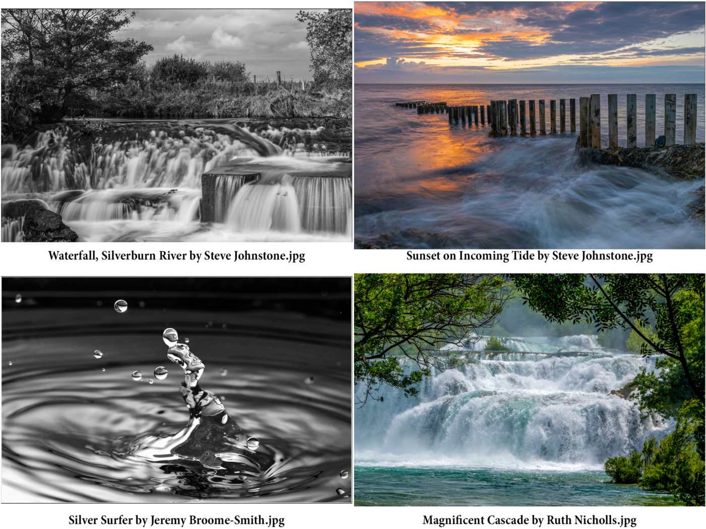
In the Digital images, Beryl Quayle won the first place in Intermediate Monochrome section for a shot of Glen Maye waterfall with icicles (amazing!). In the Colour section it was another picture of stormy weather that won first place – “Stormy Waters” by Michael Howland.
Once again it was a weather photograph that took first place in the Advanced Monochrome Section and Sue Blythe’s “Storm Force” was the winner. The Advanced Colour section was won by Barry Murphy with an image titled “Manx Draught” – a peat-coloured stream that did indeed look like beer.
Finally, our judge rated Beryl Quayle’s image of “Glen Maye Waterfall” as the best digital image in the competition.
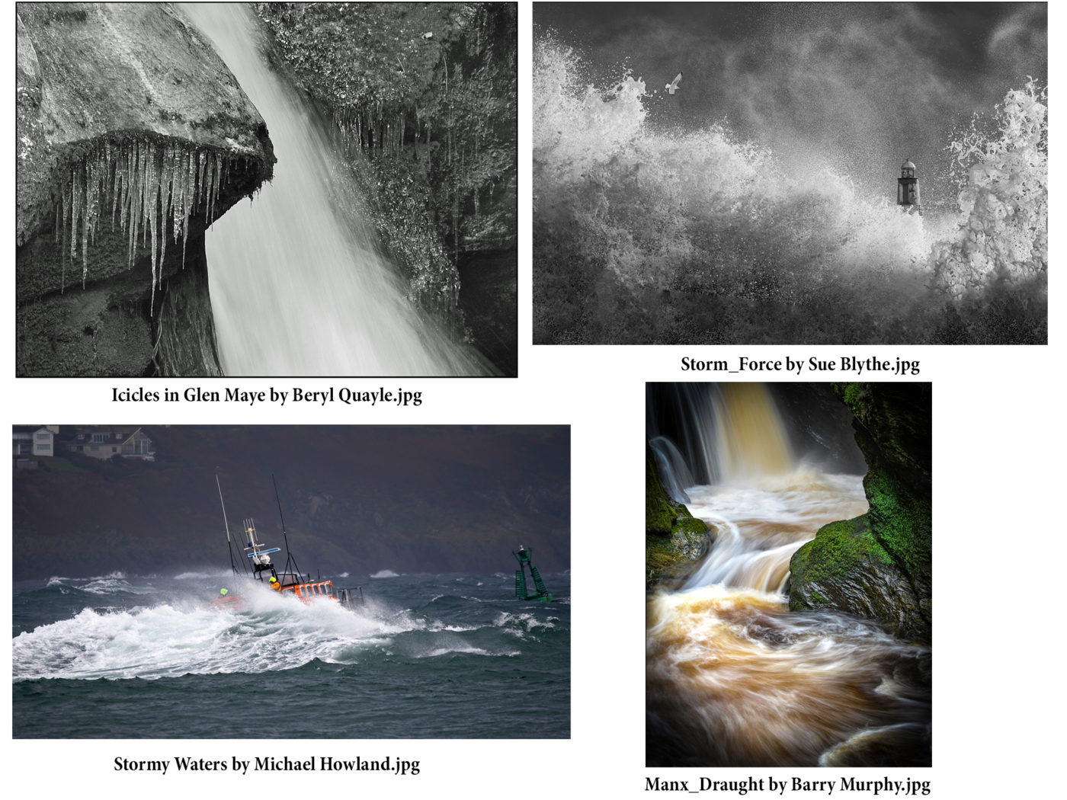
Our President thanked Doug Allan for the very thorough and detailed judging of all the photographs. The photographers of the Society were also thanked for their entries, as without their participation there would not have been a good competition.
Richard Shafto

Antarctica, the Falklands, South Georgia, by Lara Howe 26th February 2020
Antarctica must surely be on most people’s “Bucket List” as a place to visit – and that will certainly include all photographers. It was a privilege therefore this week to welcome Lara Howe, one of our members, to give a digital slideshow of her visit there a year ago. Lara is an excellent photographer, and her career as a keen nature conservationist with the Manx Wildlife Trust gives a particular focus to her travels around the world – she has now visited all seven continents.
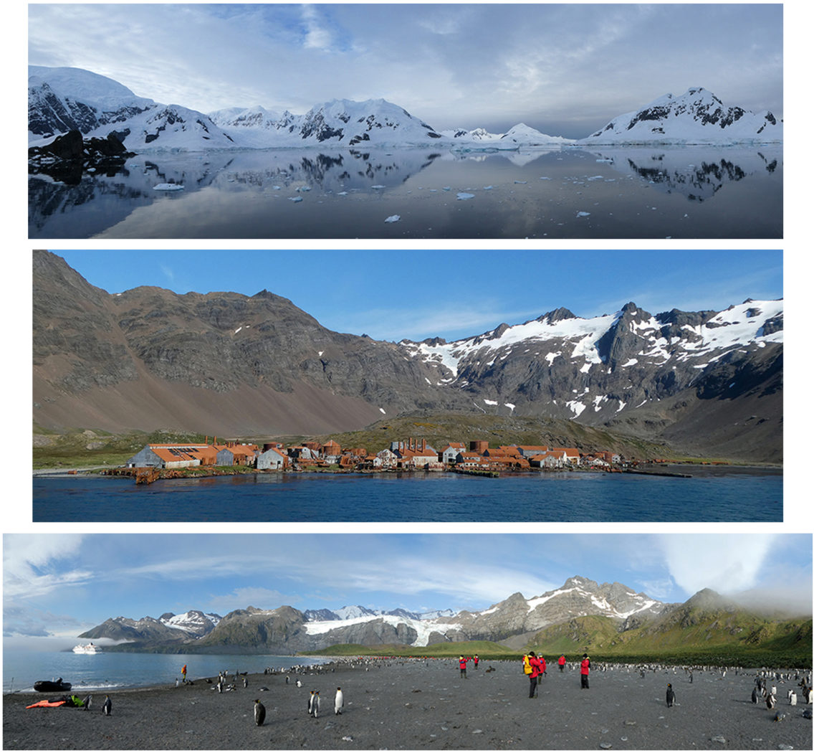
Her visit to Antarctica started and finished in Ushuaia, located on the Tierra del Fuego archipelago at the southernmost tip of South America. Her ship was a specialist expedition vessel, with only 100 or so passengers on board, amongst whom were expert speakers on the wildlife, photography and on Antarctica itself – so fully equipped for maximum information and advice. A small ship also has the advantage of getting close to shore, and allowing shore visits by ribs to get really close to the wildlife, especially penguins and seals.
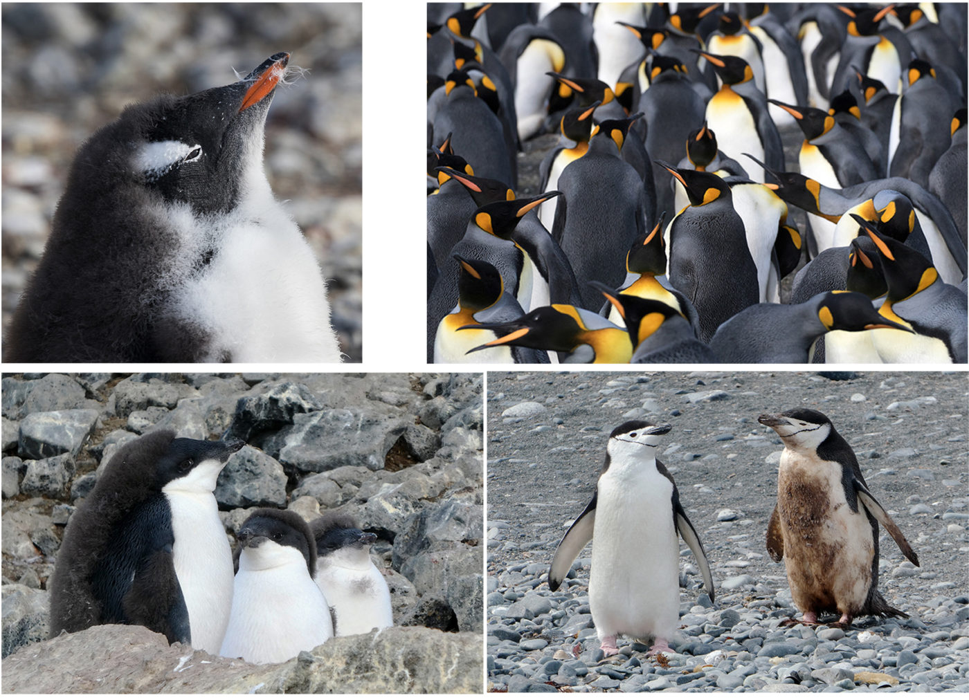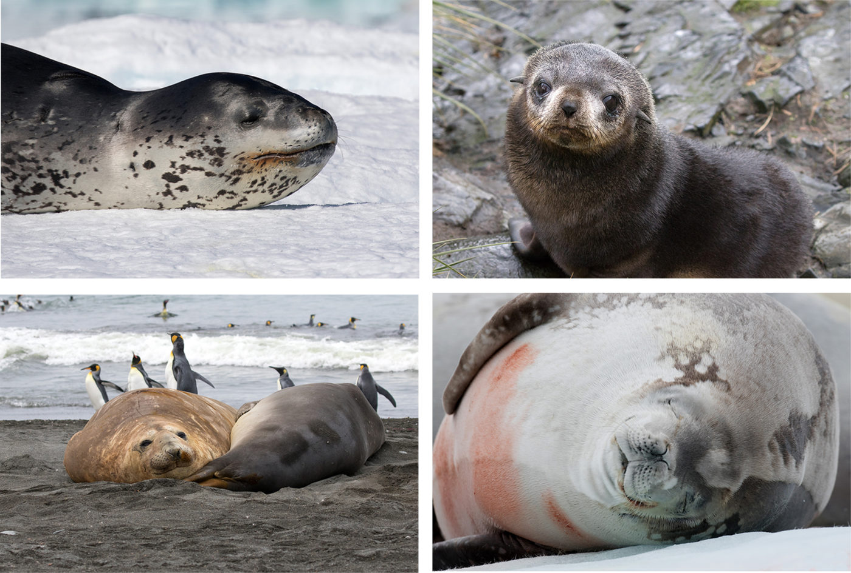
The trip took in visits to the Falkland Islands, South Georgia, Elephant Island, Deception Island as well as the Antarctic Peninsula proper. Fortunately, apart from storm conditions whilst crossing the Drake Passage, the weather during what is called the summer season was generally fair. Accompanied by friends Karin and Rebecca, the trio apparently spent their time on deck, on the water or on beaches getting as close to the wildlife and the ice as they possibly could – enabling Lara to gain some absolutely stunning images for our delight.
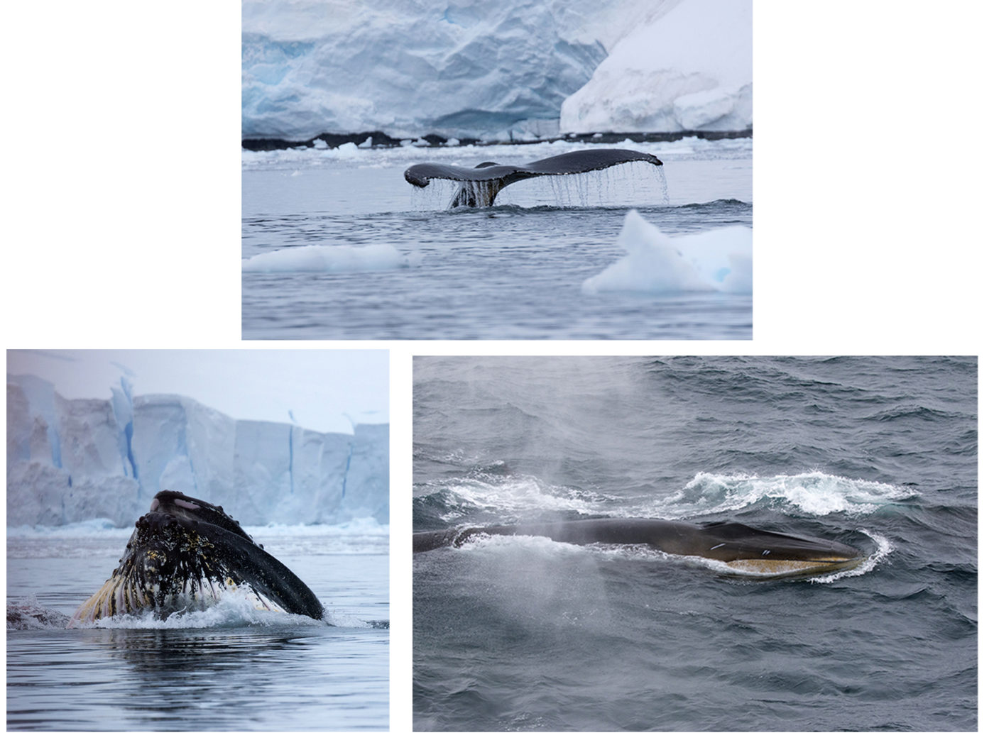
Wispy clouds over rocky islands, storm fronts approaching, ice and yet more ice, glaciers and ice bergs, albatrosses, whales, all the varieties of penguins seen in Antarctica except for the emperor (busy in the interior feeding their chicks), elephant seals, leopard seals, fur seals, the dereliction of deserted whaling stations – and all in glorious colour and really close-up with pin sharp detail. 800 images later and including a very informative commentary, her presentation gained a deserved round of applause from our audience.
Ruth Nicholls, Vice-President, gave the vote of thanks.
Chris Blyth

26th February 2020 Presentation by NFU Mutual of a cheque, a donation as thanks to the club.
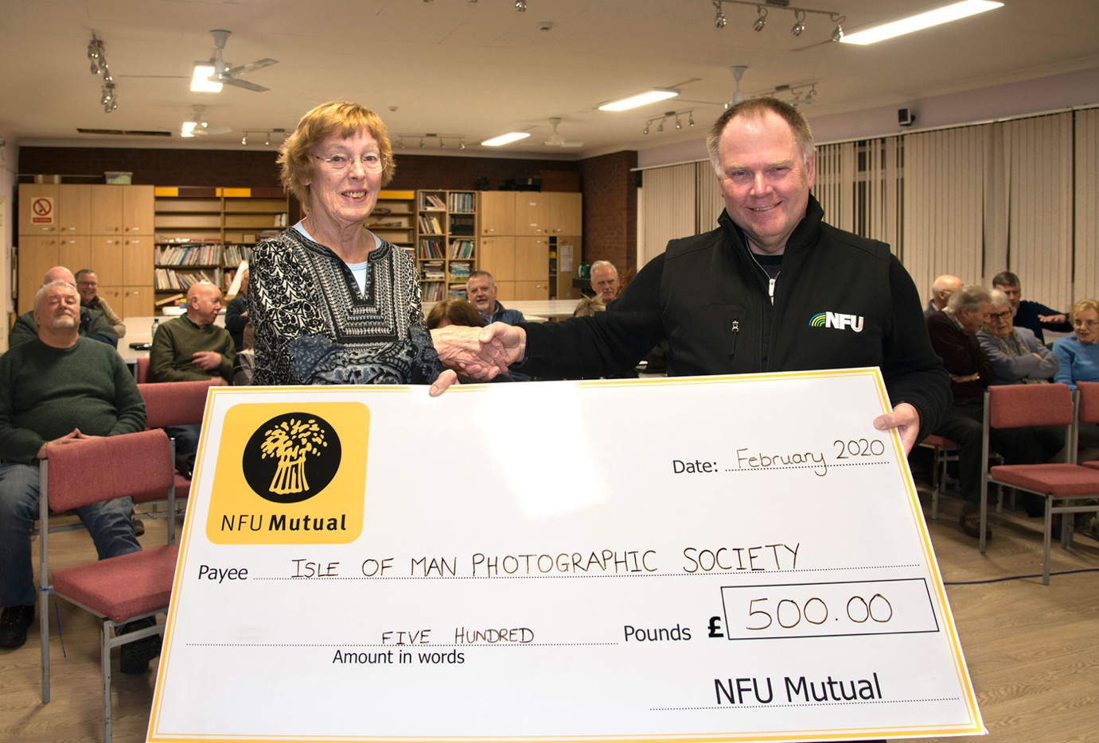
This evening we were delighted to welcome David Wilkinson, Branch Manager of NFU Mutual. He presented the Society with a handsome cheque as a reward for the work the members had done to provide a stunning set of images to illustrate NFU’s Calendar for 2020.
Ruth Nicholls, Vice President, received the cheque from David, and thanked him and his organisation on behalf of the members. She said how much the members had enjoyed the challenge of capturing images of the Manx countryside at all seasons of the year, and that the Society really appreciated the generous figure which will be put to good use to enhance our projection equipment.
Ruth Nicholls

Masterclass on Practical Food Photography with Andrew Barton 19thFebruary 2020
This week, on a wet and windy evening, we welcomed the return of local professional photographer, Andrew Barton, an Honorary Life Member of the Society, to give another of his occasional demonstrations and tutorials on a key skill – table top photography.
Honed by years of practical experience from the days of film and the necessity of using studio lighting for portrait and product photography, Andrew’s presentation became something of a masterclass for our members.
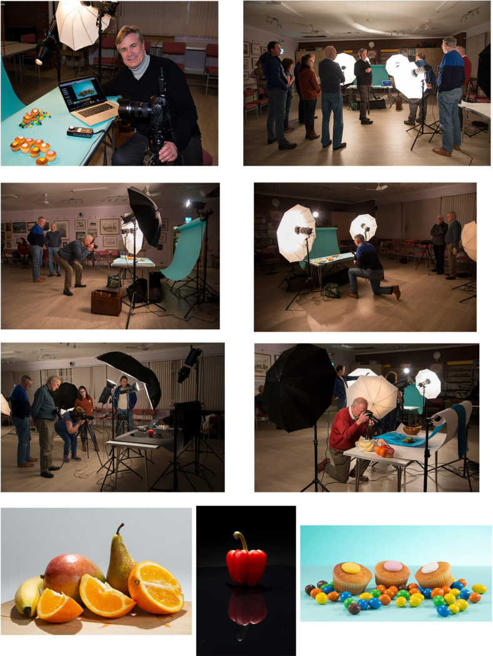Club members enjoying the Food Photography workshop which Andrew Barton kindly guided us through. And some results!
Studio lights have an enormous benefit for the photographer – they are totally under his or her control. Very specific effects of light, shadow and depth of field can be created, so that the final image can be exactly as the photographer’s, or client’s, “vision” of the intended shot. For someone working, for example, for an advertising agency, and needing an image for a magazine or newspaper, being able to provide the exact image required isn’t just helpful – it’s essential to a career and perhaps being paid.
Aided by his colleague, Sue Jones, three set-ups had been arranged – each with a set of lights, and each with a different colour background – white, black and blue. The products to be photographed included fruit, cakes and sweets, and a red pepper. For portability, Andrew’s demonstration used mostly umbrellas – both “shoot through”, translucent and reflective – whereas in a more permanent studio set-up, he would recommend softboxes which offer greater controllability. With his camera tethered to a lap-top for immediate review and comment, we moved through the various arrangements, making small changes to the lighting to show the effect on the image. It became clear that even very small changes to the position and angle of the lights and their intensity could and did make enormous differences to the final image. It was also clear that practice (lots of it!) could only be of benefit to our own work…..
Jeremy Broome-Smith, President, gave the vote of thanks for a really interesting and helpful practical demonstration.
Chris Blyth

3rd Open Competition 12th February 2020
This week, the 3rd Open Competition provided a wealth of entries, both prints and digitally projected images, to test our judge, Eddie Fryer. Eddie is a member of the Western Society and on his own count, has been visiting and judging at the IOMPS for over twenty years – so very experienced and always welcome, with a carefully considered yet apparently effortless commentary and critique of every image.
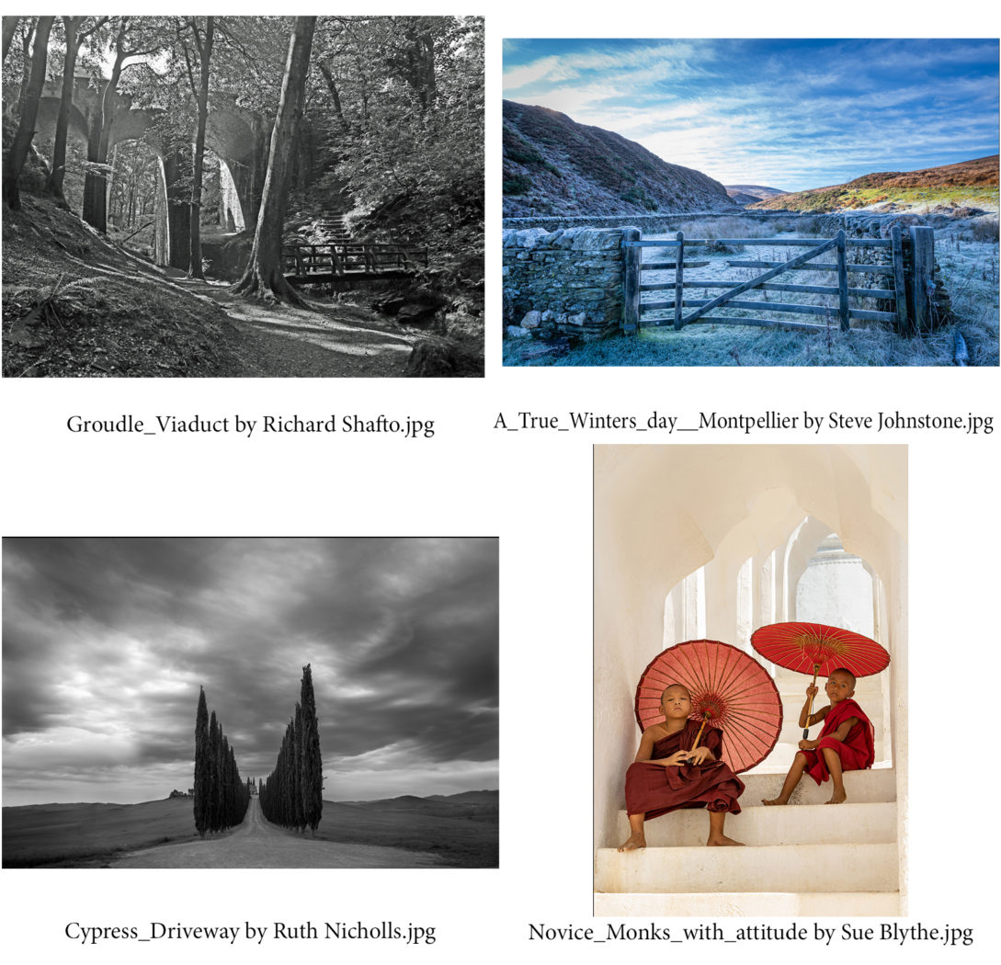
Richard Shafto enjoyed a good start to the evening with a lovely image of the viaduct in Groudle Glen taking the top spot in the Intermediate Mono prints, followed by images from Jonathan Carey and Steve Johnstone. Steve got his reward in the Intermediate Colour section with a superb print of a snow-covered hillside at Montpelier, again with close competition from both Richard and Jonathan. In the Advanced class, Ruth Nicholls’ classic image of a cypress tree driveway in Tuscany, the drive and trees giving a strong lead-in to a villa in the background, gained the judge’s preference in the Mono section, just pipping Ron Shimmin and Sue Blythe. A sensitive colour print of two novice monks in Myanmar, with saffron robes and parasols in a well-chosen composition, earned Sue Blythe top marks and best print of the evening, with Ron Shimmin again close behind.
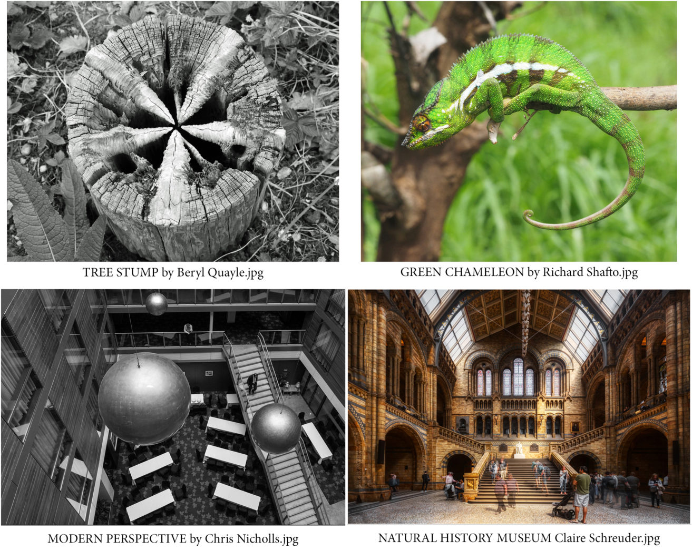
There was a large digital entry in all classes, Beryl Quayle taking top place and best digital image of the evening in the Intermediate Mono section with a close-up of a tree stump, the eroded woodwork providing a star-shaped pattern which intrigued our judge. Steve Johnstone and Martin Sanderson were runners-up. In Intermediate Colour, a lovely image of a green chameleon got Richard Shafto his second win of the evening, with Janet Henry and Martin Sanderson gaining the same score but placed just behind. A view looking down into the atrium of a building pleased the judge in the Advanced Mono section for Chris Nicholls, the geometric shapes of windows, balconies and stairway providing an interesting composition. Sue Blythe and Barry Murphy were close behind. A stunning image of the main hall of the Natural History Museum from Claire Schreuder took the honours in the Advanced Colour with Sue Blythe and Barry Murphy again in close contention.
Jeremy Broome-Smith, President, gave the vote of thanks.
Chris Blyth

Studio session with models 5th February 2020
Take three different studio lighting set-ups, include three different models, add twenty or so keen photographers, and stir gently for an excellent evening of “foto fun” and practical entertainment – this was exactly what transpired at this week’s meeting of the IOM Photographic Society.
Two of the three studio lighting arrangements were standard studio flash equipment (two or more flash heads plus softboxes) provided by members Tony Curtis and Chris Blyth. These need a trigger to fire, which means that only one photographer can use the set at any one time. The third arrangement, supplied by Nigel Owen and Jeremy Broome-Smith, was of continuous LED lights – lower power but the big advantage of continuous lighting is that multiple members can take their shots at the same time – a significant benefit when we have a good number of members attending.
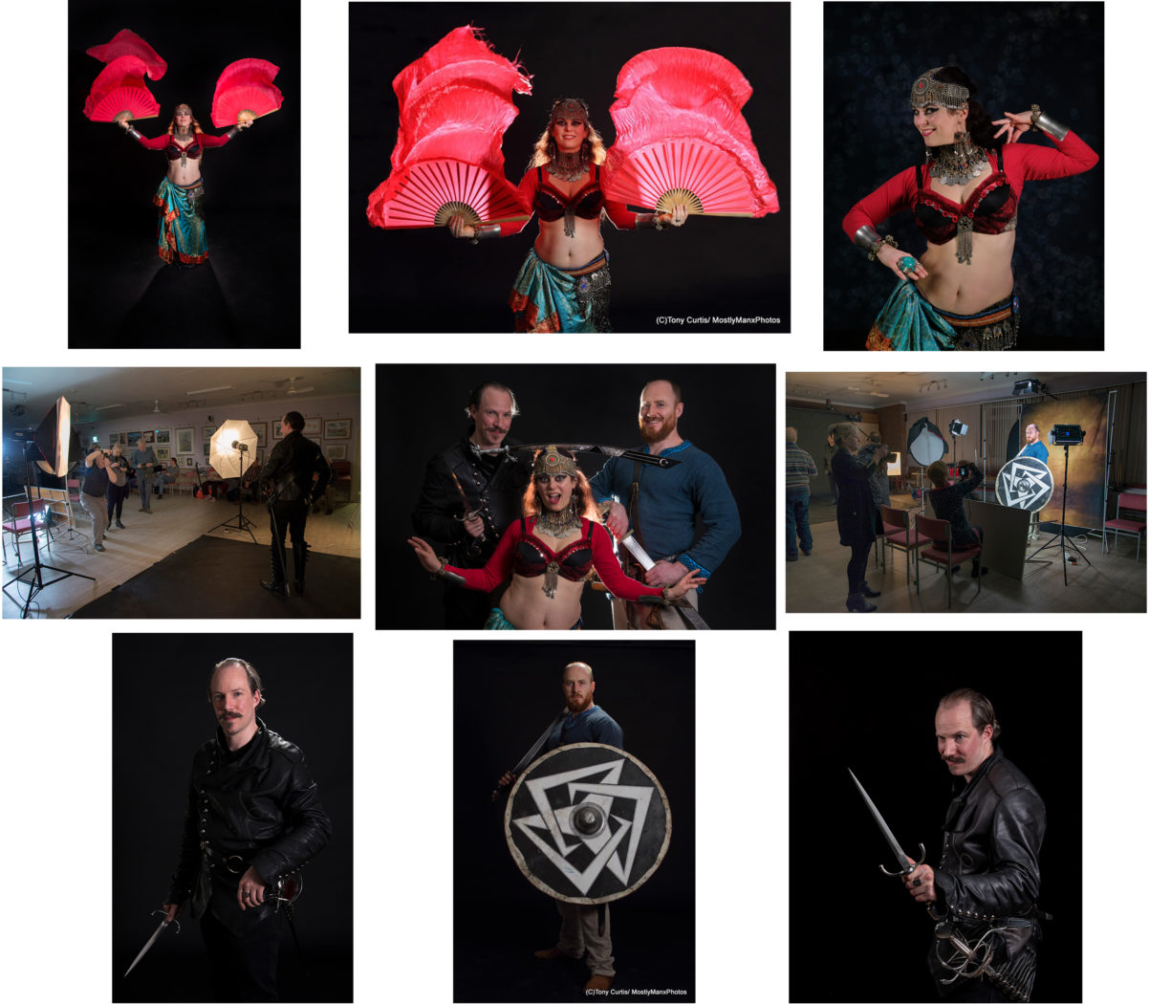Photos by Sue Jones, Ruth Nicholls, Tony Curtis, with thanks to Gwenael La Sirene,Steve Corfield, and Peter Crellin, and Tony, Nigel, Barry and Jeremy for the lighting and guidance.
Our three models represented three different styles – Steve Corfield came as a swordsman, Peter Crellin as a Viking, whilst Gwenael La Sirene was dressed as a belly dancer and was talented in her ability to move her body in beautiful sinuous curves – with all three guest models moving around the various lighting arrangements to provide our members with their photo opportunities. As always, it was a very popular and intriguing evening, with members requested to provide sample images to the models for their portfolios – a modest reward for their efforts but likely to include some top-class photographs.
Jeremy Broome-Smith thanked all involved for their input and participation.
Chris Blyth

Presentation by Antony Hamilton, The Camino de Santiago de Compostela, 29th January 2020
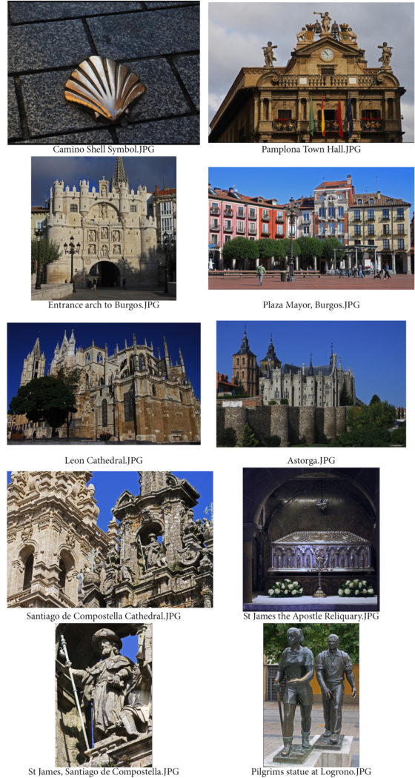Images by Antony Hamilton, the Camino de Compostela, northern Spain.
Antony Hamilton is a Life Member as well as an ex-President of the Society, and with his wife Sandra, much travelled. His travelogues – an occasional but fairly regular feature of our programme – are always carefully prepared and meticulously presented with lots of top-quality images and an excellent commentary. This week was no exception – a presentation on the Camino de Santiago de Compostela in northern Spain, otherwise known as The Way of St James.
The pilgrimage to Santiago de Compostela is the third most important in the Christian calendar after Jerusalem and Rome, more than 300,000 taking the route in 2018. There are several different routes to the destination, Antony and his wife chose the route from San Sebastian, known as the ‘French route’, starting close to the Pyrenees and the French border, and covering more than 650 kilometres. There are also several different methods of travel – to gain a ‘passport’, stamped at various points along the way, to prove the pilgrimage, a walker needs to have have walked at least 100 kilometres of the route, and a cyclist at least 200 kilometres. There is also a ‘luxury’ version of the pilgrimage involving only modest exercise, a coach and a week or so staying in top class hotels, known in Spain as Paradors. This was Antony’s very sensible choice!
Starting in the Basque city of San Sebastian the trip included Pamplona, famous for the author Hemingway and its bull run, Logrono, Burgos, and Leon, each with its own richly decorated cathedral with spires and high altar. Antony’s presentation showed these, all beautifully depicted and he carefully explained their history. Local food from tapas bars varied from city to city, each having its own specialities, whilst any visit to the region has to include a winery, in this case, one in the Rioja area. The Peninsular War and the 1809 Battle of La Corunna also got a mention, an image being shown of the memorial to Sir John Moore (the defeated British Commander) which interestingly was commissioned by his French adversary, Marshall Soult. The effort made by the pilgrims was also clear – their tired arrival in Santiago proving that earning a passport certificate is indeed hard work!
Ruth Nicholls, Vice President, gave the vote of thanks for an excellent presentation.
Chris Blyth

2nd Assignment Competition – Shapes & Patterns – 22nd January 2020
The assignment competition for both prints and digital images was on the subject of “Shapes and Patterns” – a topic which members found to be more difficult than the committee had expected. Our judge was the ever popular Ray Kelly – the author and photographer of three beautifully illustrated books on Manx Tholtans. He has an artistic eye for a good image, and as always, gave us a commentary demonstrating his knowledge and experience and a willingness to share it with us.
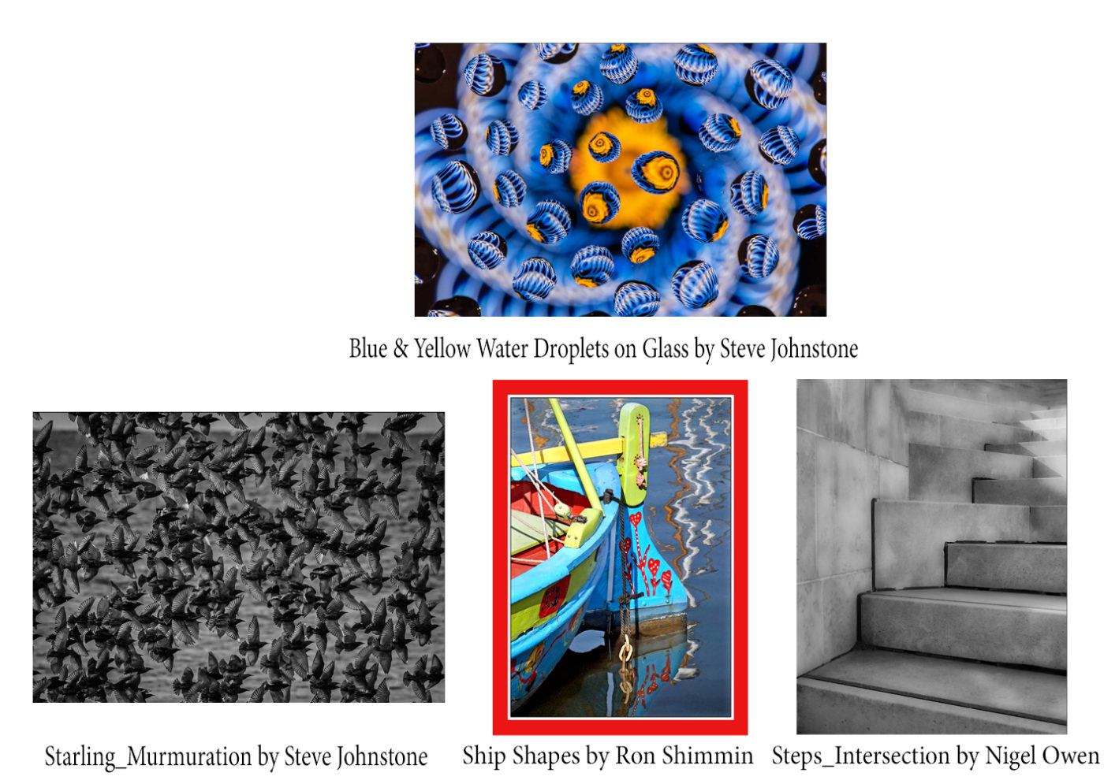
The meeting opened with the Intermediate print entries, Steve Johnstone taking the honours in both the mono section with a very busy image of a ‘Starling Murmuration’, and in the colour section with ‘Water Droplets on Glass’, which also gained the judge’s approval as his favourite print in the competition. Steve was kind enough to explain his technique for this latter shot – basically a mixture of water droplets and glycerine on glass overlaying a colour image, suspended over four toilet rolls, the colours being reflected back into the droplets – it certainly proved a very successful process with a wonderfully bright and bold image resulting. In the Advanced group, Nigel Owen’s mono image of a flight of steps was outstanding – the interplay of lines and shadows showing high artistry, whilst Ron Shimmin demonstrated his skills in the colour section with ‘Shipshapes’, a bright image of a boat’s prow, it’s colours reflected in the water.
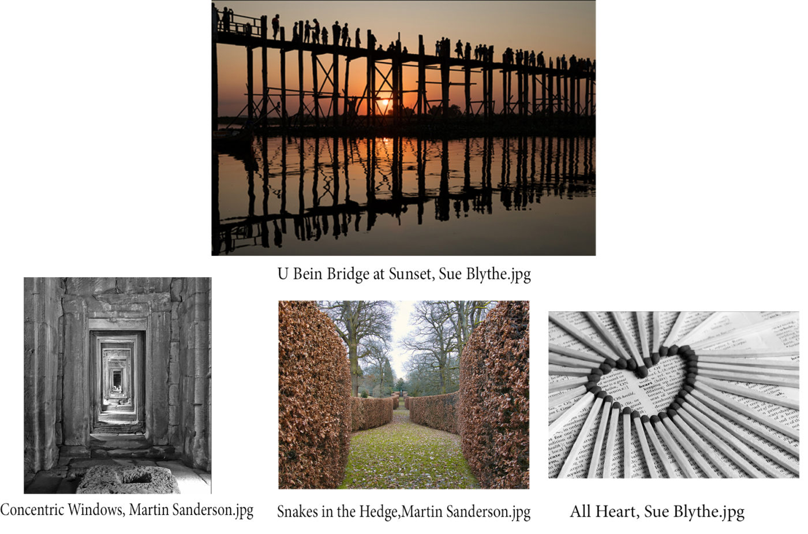
Despite strong competition from Beryl Quayle, Steve Johnstone and Richard Shafto, Martin Sanderson proved to be the one to beat in the Intermediate digital class, taking the lead in both the mono and colour sections – his mono shot of ‘Concentric Windows’ showing good detail as the rectangular windows repeated into the distance, whilst a symmetrical winding hedge called ‘Snakes in the Hedge’ won the colour section. Similarly, Sue Blythe swept the board in the Advanced digital class, with ‘All Heart’, an imaginative arrangement of matches in the shape of a heart leading the mono class, and in the colour section the historic U Bein Bridge at Mandalay in Myanmar, with spectators silhouetted against a sunset in the colour section. This became the judge’s favourite digital image in competition.
Ruth Nicholls, Vice President, gave the vote of thanks for an excellent evening.
Chris Blyth

Presentation by Diane McCudden, the Masai Mara, Kenya 15th January 2020
This week we were treated to a wonderful presentation on the Masai Mara in Kenya by one of our members, accomplished photographer Diane McCudden, CPAGB, BPE*. Diane is particularly good at nature, wildlife and people pictures and her experience shone through in her presentation.
Her visit to the Masai Mara National park some years ago was illustrated by many very interesting and varied images, accompanied by traditional vocal music of the area. We saw the comfortable tented accommodation that she and her husband used, complete with flushing bathroom facilities! And the not-so-comfortable jeeps that the group were transported round the park in, under the careful eye of their guide, John. She noted that many of the local Masai tribesmen had British names. Their tent was not fenced and at night they could hear wild animals close by, and woke to find footprint evidence in the morning.
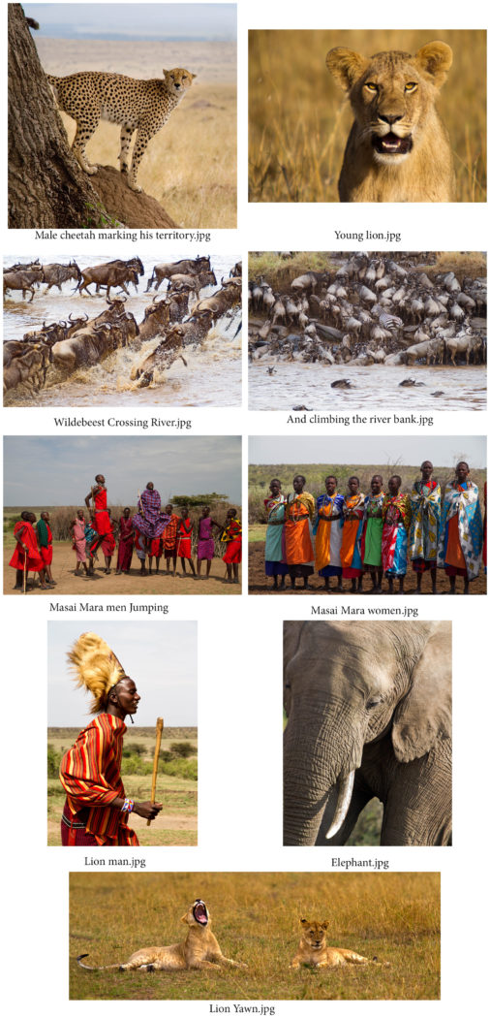
Nearby was a well-filled river, with crocodiles and hippopotami. Nothing daunted the group’s meals including breakfast were served outside, and no-one came to any harm.
Diane captured many photographs of the famous Marsh Pride of lions, male, female, and young. We also saw leopards, cheetahs, gazelles, and perhaps most impressive was the migration across the Mara river of thousands of wildebeest. They leap into the crocodile-infested water, to swim across in search of greener pastures, and on the other side, the slippery muddy river bank is so steep that many animals fall back, breaking their limbs and never make the trek successfully. Diane’s images flowed into each other so smoothly that it was almost like watching a video.
We also saw hippos, buffalo, elephants, zebra, jackalls, giraffes, Secretary birds and of course the ever-present scavengers, hyena, circling vultures and storks.
Diane had some fascinating photos of the Masai Mara people, no longer ‘warriors’. Their houses are built from sticks and mud, living with their animals and cooking and sleeping on the floor. They wear vivid coloured clothing, often red, multicoloured beads, and sometimes a headdress made from lion fur. They pride themselves in how high they can jump.
When President Jeremy Broome-Smith thanked Diane, he said it had made him ever more determined to go and see for himself.
Ruth Nicholls

President’s Evening and Laxey Challenge 8th January 2020
A fascinating start to the second half of our season – Society President Jeremy Broome-Smith treated the members to a travelogue on India, followed by images of Laxey taken by a number of members, as a non-competitive challenge.
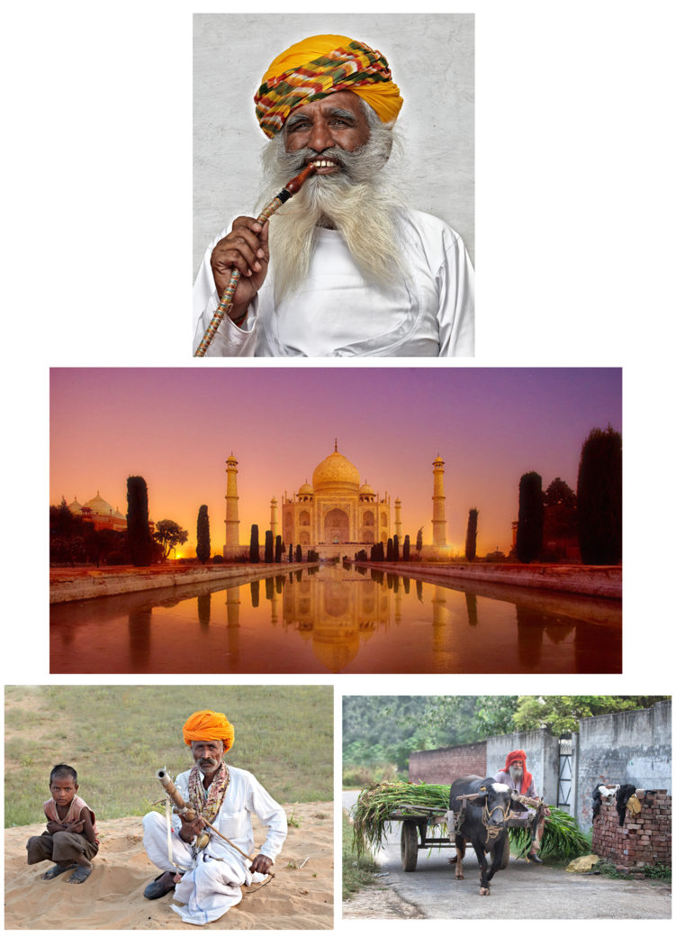The Real India, by Jeremy Broome-Smith
Jeremy, in the company of two friends, Mahindra and Bob,(the former himself an Indian and clearly delighted to show off his home country), spent several weeks in 2011 touring the country by car and taxi. The resulting images and videos showed a country of extremes – of wealth and poverty, of grandeur and ordinary, of busy roads and quiet countryside. It started with a video of the traffic conditions from Delhi airport to their first stop-off point – and the quite terrifying volume of vehicles, constant sound of horns, and apparent lack of “normal” road safety rules – an interesting introduction to the country and which fortunately they survived! From there we moved around, visiting the Golden Temple of Amritsar, the Red Fort of Delhi, the Taj Mahal and various palaces and religious sites, as well as a visit to the traditional summer stop-over of Shimla – the architecture, the people and the scenery all very obviously much enjoyed, with great hospitality being shown to the tourists, the presence of Mahindra a great help in ensuring that arrangements went smoothly.

