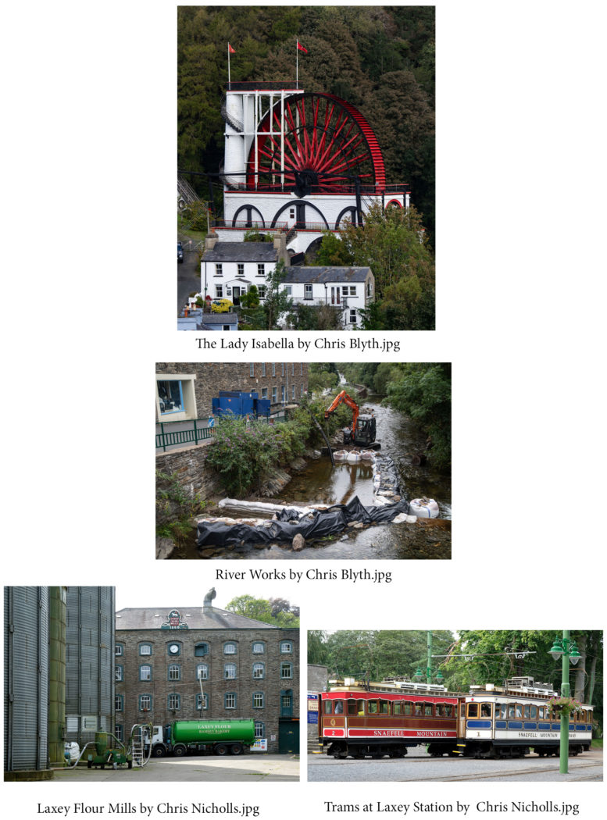
The second half saw images of Laxey from Nigel Owen, Ruth and Chris Nicholls, Chris Blyth, Barry Murphy and Steve Johnstone, all taken to show the different interpretations by each member, given the same brief. Whilst most of the images could be described as “poster shots” of Laxey scenes, Barry’s excellent sporting images were all of a football match between Laxey and Rushen (the action being particularly well caught), whilst Nigel had chosen to emulate the well-known American photographer Elliott Erwitt with a highly artistic sequence of shots taken from low down (a “dogs-eye view”) of the Laxey tram station, the railway tracks leading off into the distance and of the church.
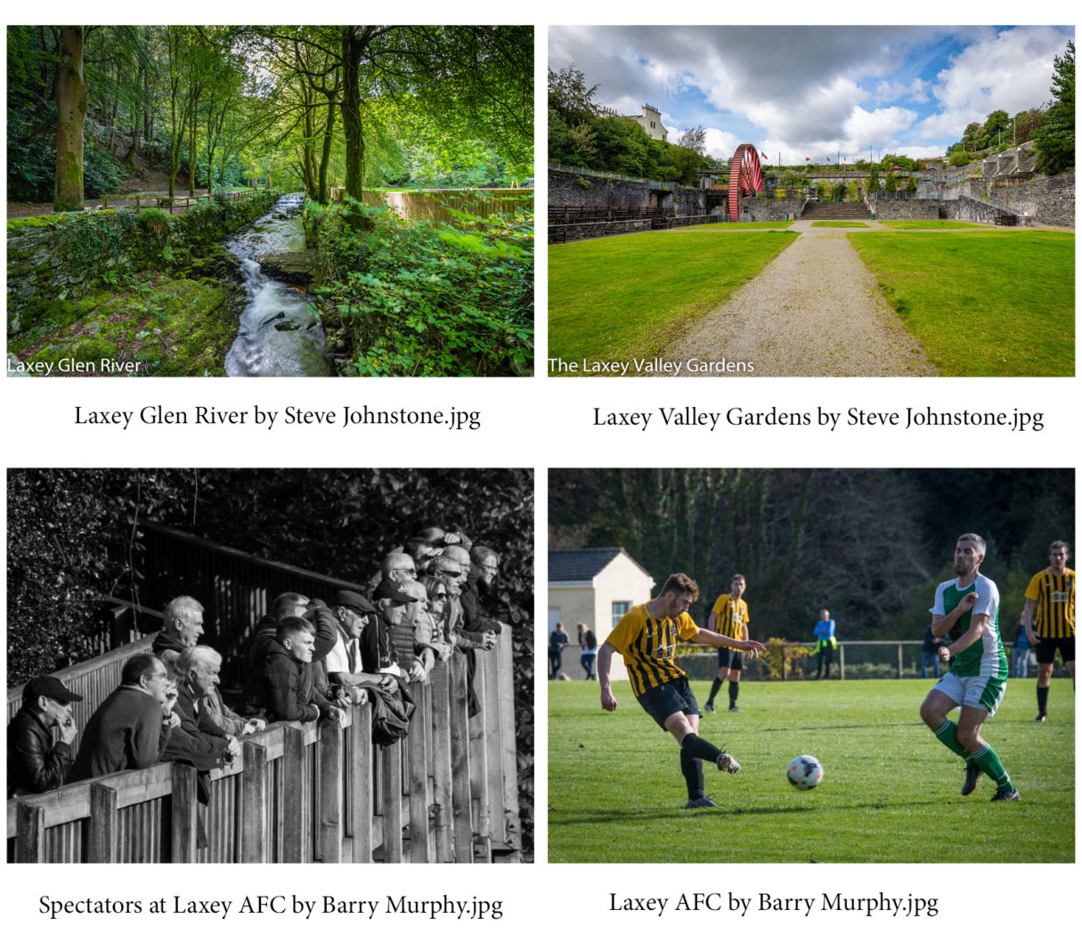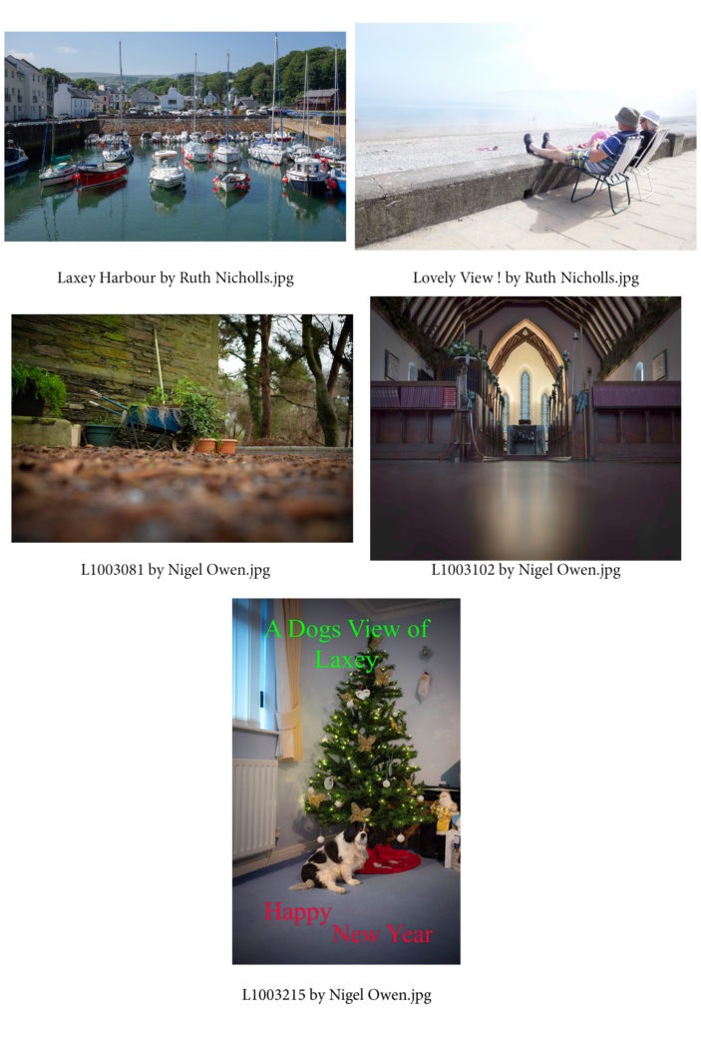
Chris Blyth

Presentation by Andrew Haddock 11th December 2019
This week when we were pleased to welcome Andrew Haddock as our guest speaker. Andrew has recently retired from the IOM Police force where he was a SOCO – Scene of Crimes Officer, with a particular specialisation in photographing and documenting reported incidents. In the first half of the evening he told us about his recruitment into the force and how he unexpectedly became their forensic photographer.
It very quickly became apparent just how meticulous a SOCO photographer needs to be in recording the scenes of incidents, be it a traffic accident or criminal activities – particularly in light of possible court action thereafter and cross-examination as to the evidence being presented. Everything needed to be carefully measured and recorded, nothing could be discarded which might prejudice a possible verdict. A particular feature of Andrew’s presentation was just how much his job had changed over his 25 years’ experience. At first, film cameras, often heavy and very bulky, with specialist equipment for recording fingerprints for example, and needing darkrooms and wet processing, with all the uncertainty and stress of not knowing just how good a job had been done, – to the modern day when lightweight digital cameras or even a mobile phone can provide an equivalent performance, and instantly able to be checked for accuracy and exposure.
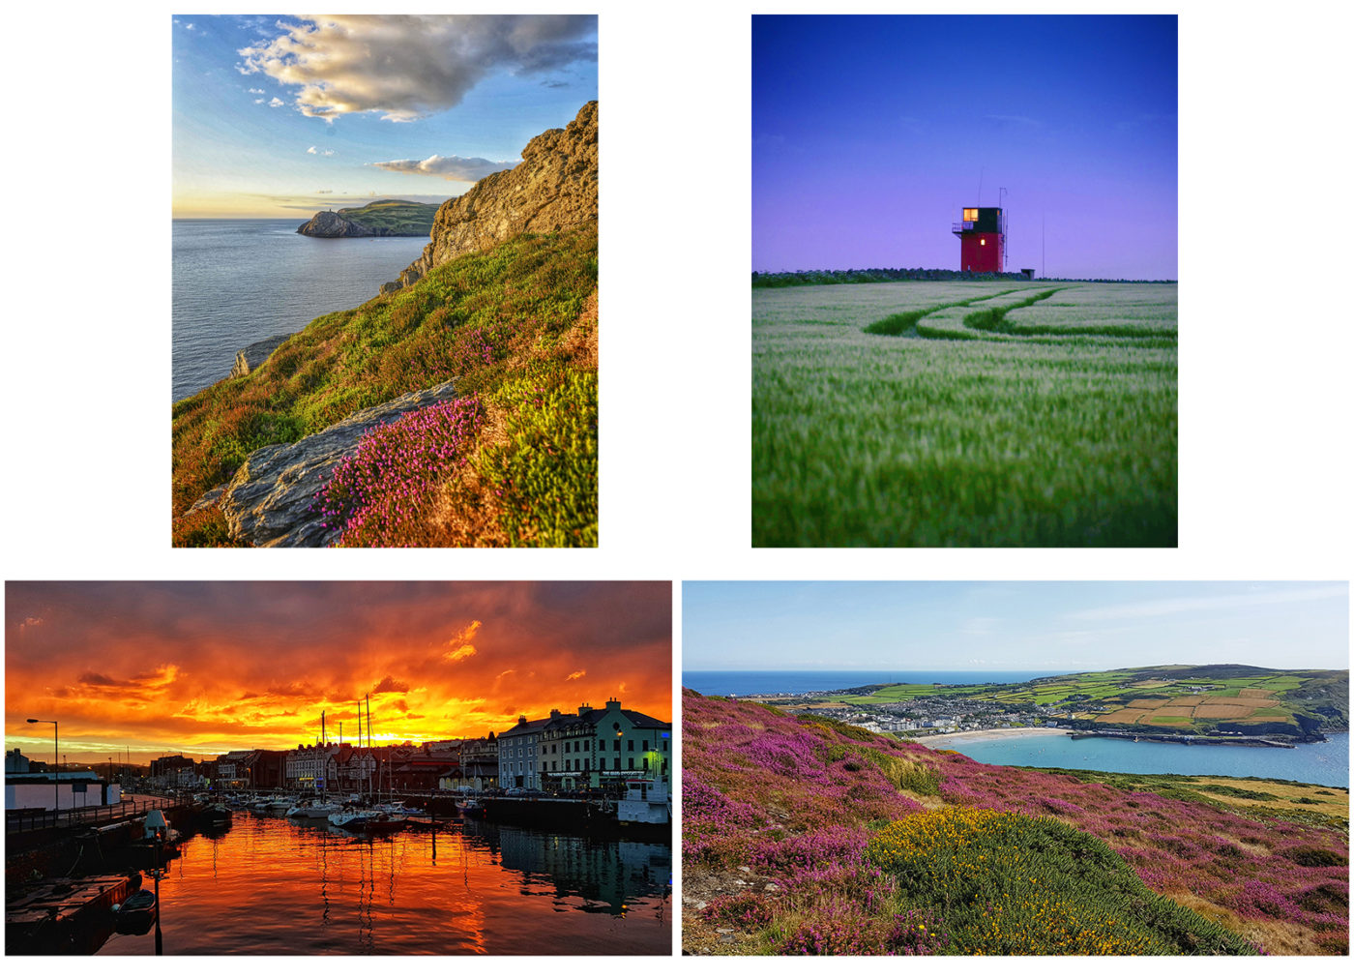
The second half was filled with Andrew’s own personal photography – images taken almost exclusively here on the island, mostly when walking our hills with his dog. And what a pleasure – images that proved that one doesn’t need to travel to far-off places to get some fantastic scenic shots, nor highly expensive equipment – just a very good eye and the imagination, artistry and creativity to “see the picture”. Oh – and a willingness to put on the walking boots and climb up into those hills!!
Club President Jeremy Broome-Smith thanked him for a wonderful evening.
The Society is now to take a short break for the Christmas holidays, with our next meeting planned for Wednesday, 8th January, when Jeremy will be giving a presentation of some of his work. Given the acknowledged excellence of his images, this will be a meeting not to be missed.
Chris Blyth

2nd Open Competition 4th Dec 2019
At this week’s meeting we had the 2nd Open Competition for both prints and digitally projected images – ‘open’ in the sense that the images on display could be of any subject. Our judge, from the Western Photographic Society, was Pat Tutt, well known as an architect and keen photographer and a popular visitor to our society, with a reputation as a good speaker with an excellent eye. And so it proved – she was quick to identify areas for improvement such as a colour cast or a highlight spot which drew attention from a main subject, but also scrupulously fair in identifying the good points of composition and the hard work or artistry of the author in getting the shot.
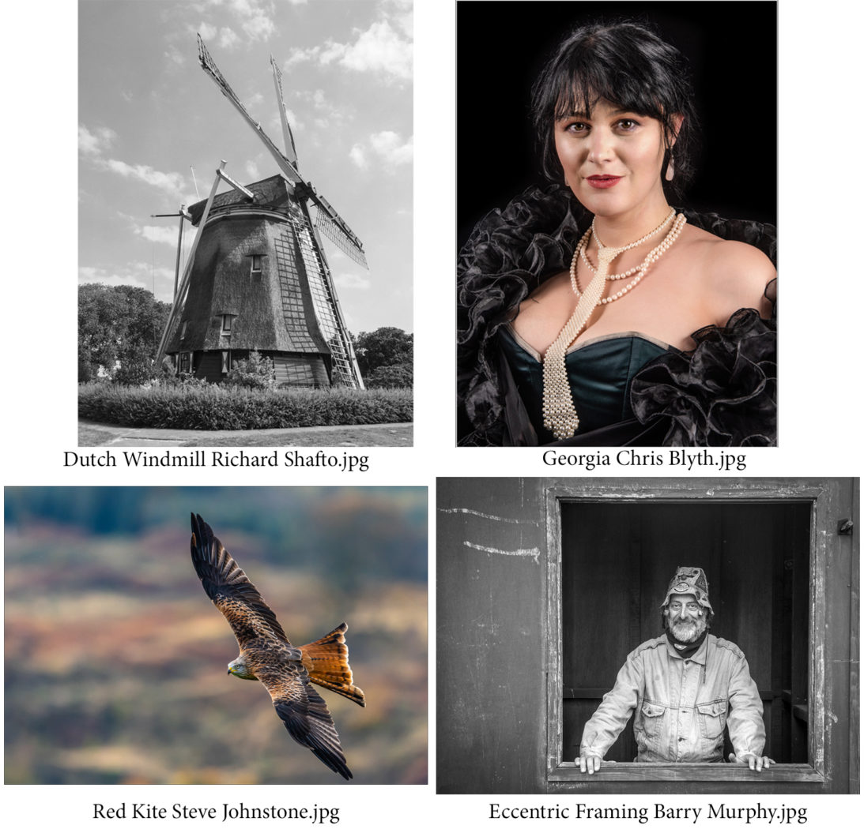
In the Intermediate Mono Prints, Richard Shafto did well with a lovely, well printed image of a Dutch windmill, just gaining the edge over Steve Johnstone’s image of a grey heron. Steve however dominated the Intermediate Colour Prints, with a superb image of a red kite in flight taking the honours, as well as the award of Best Print of the evening. The Advanced Mono Prints saw Barry Murphy get top score with the thoughtfully titled ‘Eccentric Framing’, a characterful man in a window set to one side in the composition. Chris Blyth’s attractive portrait of Georgia, taken at a recent club studio evening, scored top marks in the Advanced Colour section.
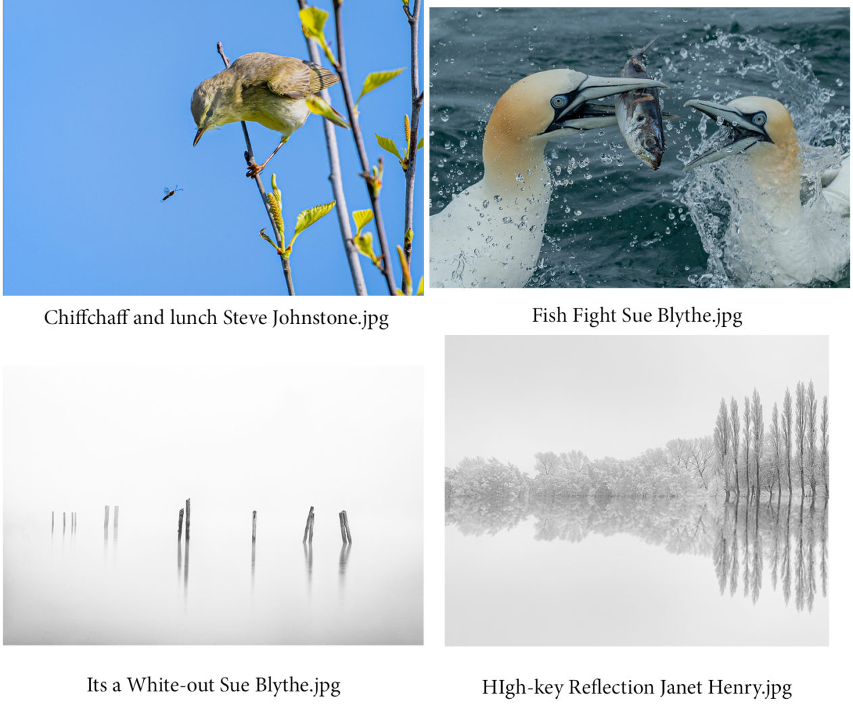
Minimalism and natural history proved the winning themes in the digital image sections. Janet Henry’s shot of trees in snow – the heavily frosted branches and trunks beautifully reflected in still water gaining her the top spot in the Intermediate Mono section, whilst Steve Johnstone’s lovely shot of a chiffchaff eyeing an insect for its meal did the same in the Colour section. Sue Blythe dominated in the Advanced group, taking top spot in both Mono and Colour sections – her minimalist photograph of posts emerging from a white mist on Derwentwater gaining the Mono award and a natural history action image of gannets arguing over a fish taking both the Colour section and Pat’s favour for the overall winning Digital image of the night. Club President Jeremy Broome-Smith gave the vote of thanks.
Chris Blyth

Members’ presentations, Richard Shafto and Kevan Osborn – 27thNovember 2019
Some of our members like putting together a digital show of their work to present on a club night. But for others that is something they wouldn’t wish to do. It is perfectly OK just to attend our meetings and sit back and enjoy looking at the work of other members and gather ideas and inspiration.
It is always a pleasure to see members volunteering to present their work and to see their approach to photography and any special interests they may have. So it is a bonus when two members offer to make a presentation – which was the case this week when both Richard Shafto and Kevan Osborn each showed us some of their work.
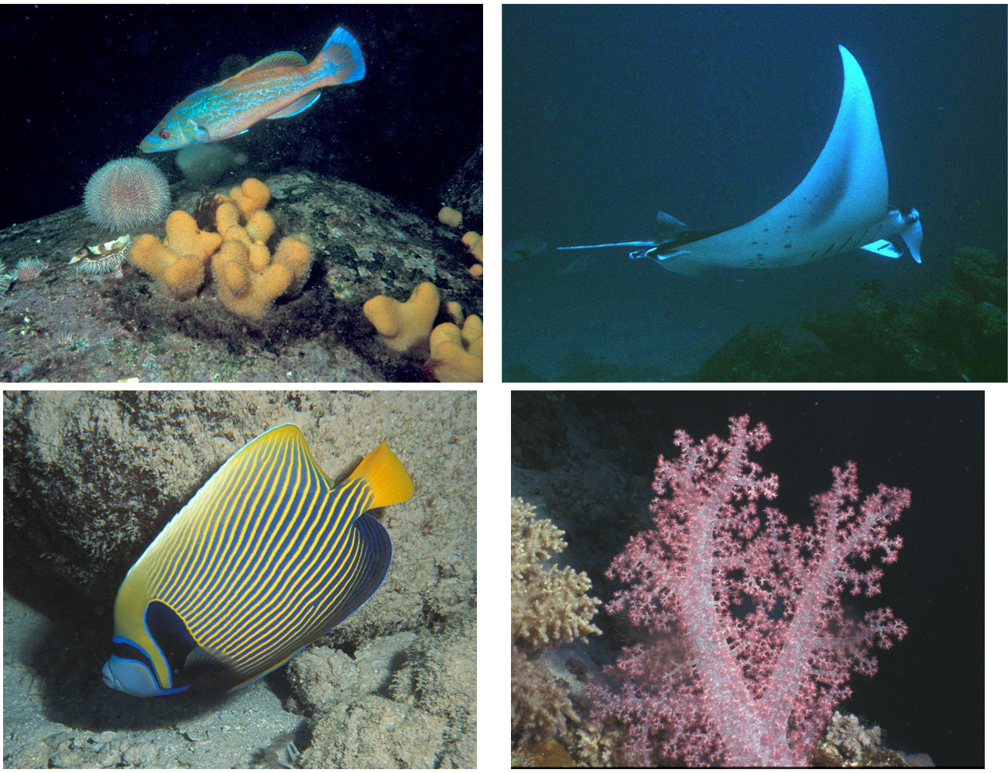Underwater photography by Richard Shafto
It transpired that Richard had been a very experienced scuba diver, with over 500 dives in Manx waters during the 20-year period from 1989 to 2010, plus other dives as far afield as the Red Sea, Australia, the Maldives and the Caribbean. During that time he used a Nikonos film camera to take hundreds of images of underwater life and – despite the difficulties of filming underwater which he explained in some detail – was able to show more than 200 images all of which had been scanned digitally for the purpose of his presentation. The images included many superb shots of fish both large and small, crustaceans such as crabs and lobsters, beautiful corals and anenomes and – scarily – some rather close-up shots of sharks. The macro shots in particular, aided by the use of flash to improve the lighting conditions, clearly demonstrated the vivid colours, stunning variety and beauty of life underwater.
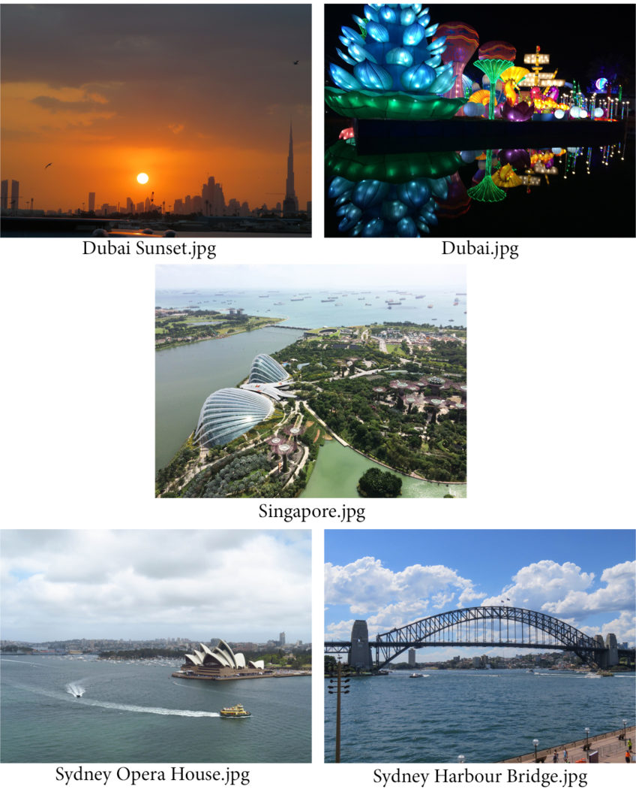by Kevan Osborn
By contrast, Kevan’s presentation was perhaps more typical of most members’ work – holiday shots taken on a trip to Australia via stop-overs in Dubai and Singapore – but proved equally enjoyable. The vibrant life of Dubai and Singapore, the “bling” of skyscrapers and their modern architecture, the hustle and bustle of their shipping and streets was all well shown. However, the main focus was on Australia with, in particular, Sydney, the harbour and the iconic Harbour Bridge and Opera House, together with shots taken during one of the cricket Tests against England. Despite some technical difficulties, Kevan coped brilliantly with an amusing and much enjoyed presentation.
Another presentation to look forward to, on 11th December, will be given by Andrew Haddock from the Manx Police on the use of photography in the fight against crime.
Chris Blyth

1st Assignment Competition – On the Beach – 20th November 2019
This proved to be a good topic with a wide range of interpretation, and one fully explored by our members. Our judge was well known local professional photographer, Clare Payne, who specialises in wedding and social photography. She proved a very capable and articulate judge with an excellent commentary on the various images presented, and with interesting asides as to her own experiences with a camera.
She opened the evening by explaining her judging criteria – firstly the composition and the viewpoint taken by the author, then how well the technical aspects have been handled, and finally the creative elements and input of the photographer – which set the scene for her marking of the entries.
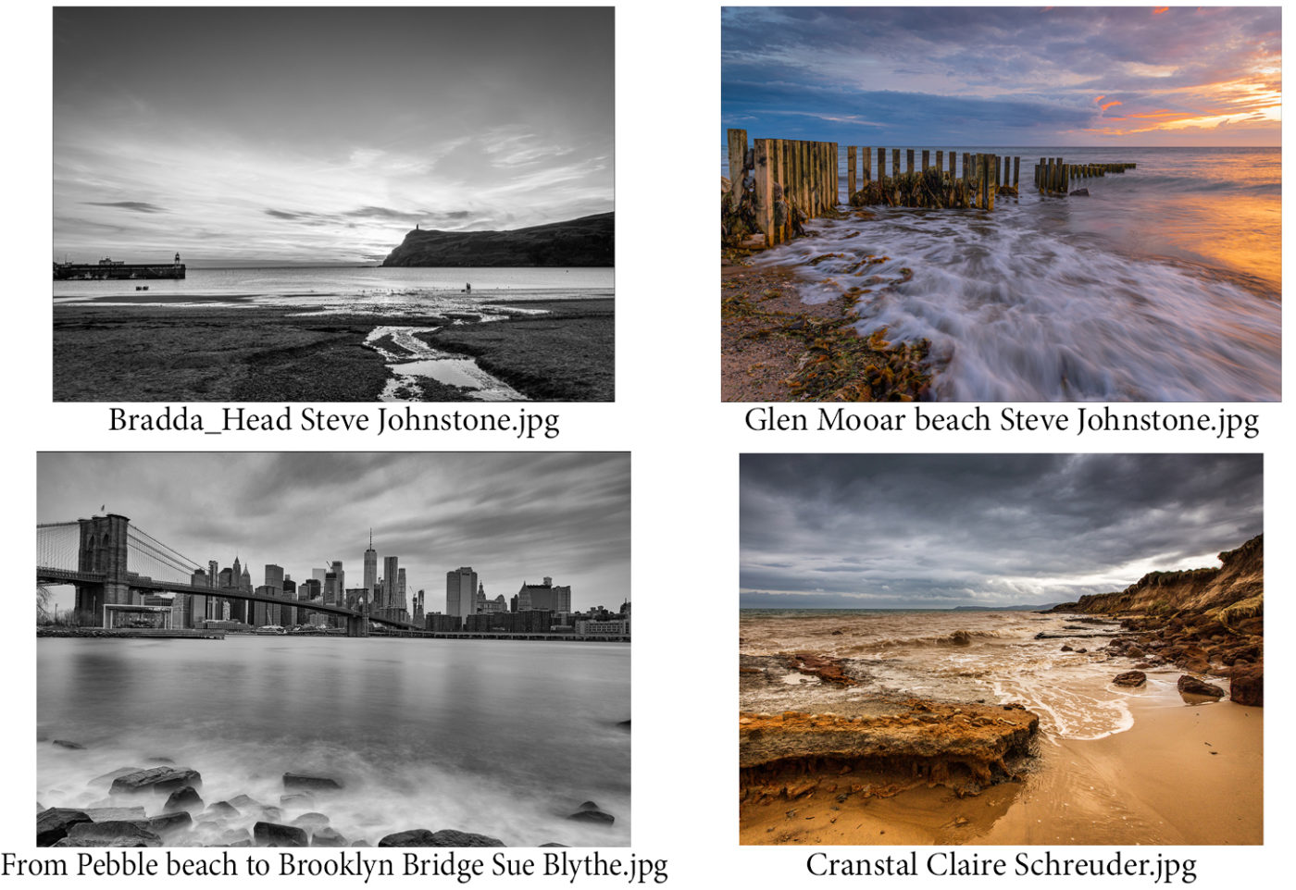
In the Print sections, only two Intermediate members participated, with Steve Johnstone taking the honours over Richard Shafto in both mono and colour with pleasing images of the beaches at Port Erin and at Glen Mooar. The Advanced group saw an excellent Print entry, with Sue Blythe’s image of Brooklyn Bridge in New York topping the mono section, whilst Claire Schreuder’s dramatic and well-saturated shot of the beach at Cranstal emerged as the judge’s choice for the colour section and as the ‘Print of the evening’.
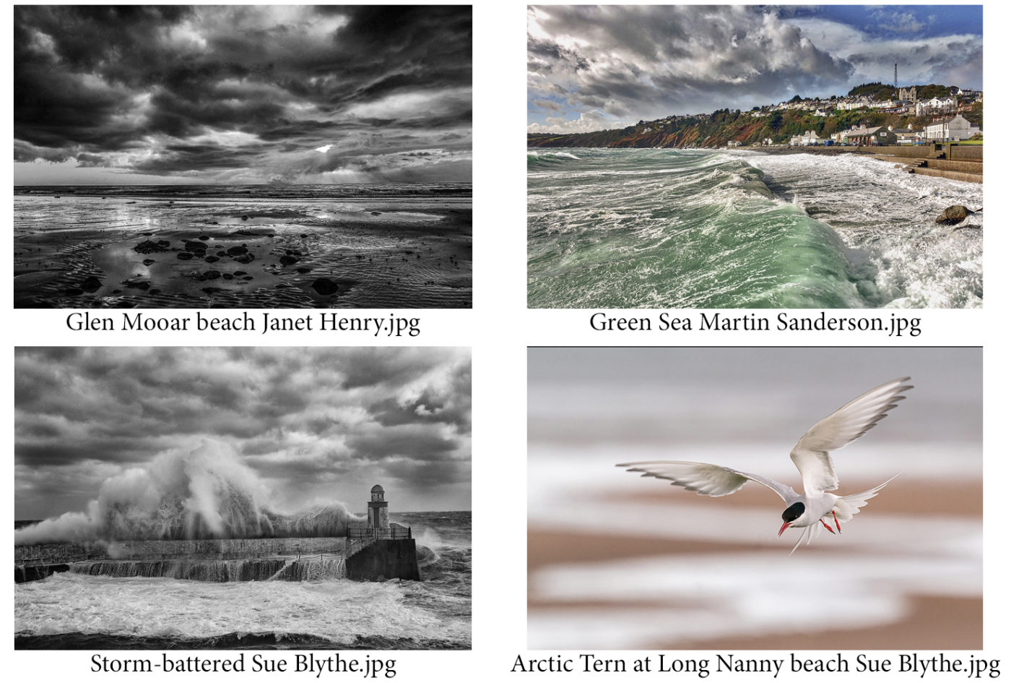
There was a large entry in each of the digital categories, Janet Henry’s image of Glen Mooar beach winning the Intermediate mono class. Clare faced the dilemma of liking equally two images in the Intermediate colour class, but since both were by Martin Sanderson, it was less of a problem than it might have been – her preference in the end being a lovely shot of waves on Laxey promenade taken from the pier. Laxey Pier again featured in the winning shot in the Advanced mono class, Sue Blythe’s image of a storm surge breaking over the outer pier proving the judge’s choice, and Sue’s entry of a tern in flight also proved the outstanding image in the Advanced colour section and as the ‘Digital image of the evening’.
Society President Jeremy Broome-Smith gave the vote of thanks for a superb commentary and a much-enjoyed evening. Our next competition, on 4th December, will be our second Open Competition of the season, including both prints and digital images, with Pat Tutt from the Western Society to judge for us.
Chris Blyth

Presentation by Howard Parkin, Astronomer 13th November 2019 ‘The Space Race’, and ‘Cruising’
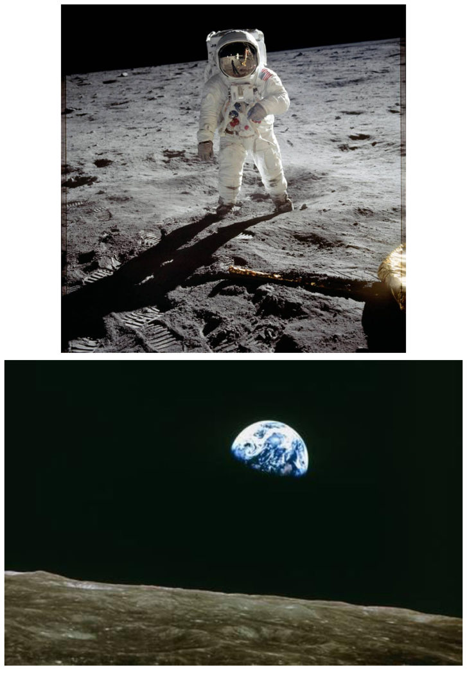
This week the Society had the pleasure of Howard Parkin as our guest speaker. Howard is an excellent and very experienced speaker, having been a teacher and lecturer. He is a Fellow of the Royal Astronomical Society, and has an exceptional knowledge of astronomy and space exploration. This expertise has recently led him into the area of guest lecturing on board cruise liners – with the added bonus of travel around the world at cruise company expense. As he freely admits, it’s a tough job but he’s lucky enough to have it!
2019 is the 50th anniversary of the first moon landing by Neil Armstrong and Buzz Aldrin with Apollo 11 in 1969 and this provided the material for the evening’s first half, a mixture of video and sound clips of the history of space flight. Spurred on by the Russian launch of Sputnik in 1957 as the first Earth orbital flight and the subsequent launches of a dog called Laika and then astronaut Yuri Gagarin, the then US President John F Kennedy determined to recover the initiative and the USA landed a man on the moon no later than 1969. This, ever afterwards known as the “space race”, was explored in considerable historical detail via the successive and ultimately successful developments of the various Mercury, Gemini and Apollo missions. Howard’s presentation of that epic 1969 event – “one small step for man – one giant leap for mankind” – included the numerous scientific discoveries (for example, teflon and memory foam) that have followed, and has today led to the possibility of commercial flights and space tourism, as well as a new US initiative to send Man to Mars.
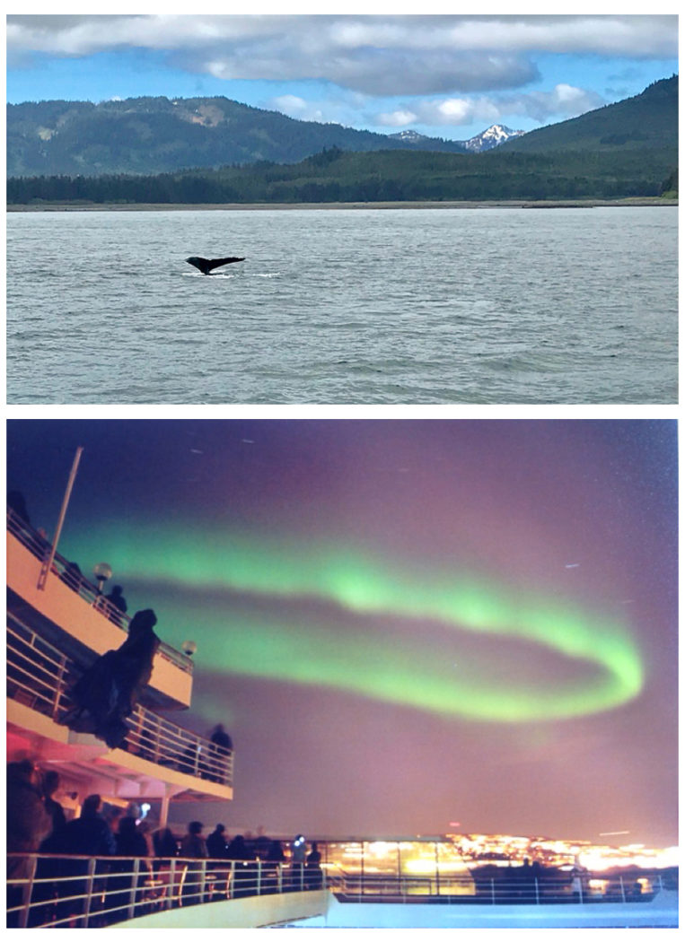
The second half covered Howard’s experiences as a lecturer on astronomy on board ship, and the various cruises he has been fortunate enough to have enjoyed in recent years. These have sometimes been linked to major astronomical events such as eclipses and aurora. And as cruise ships have become ever more sophisticated in terms of the “experiences” available to their customers, his input to the design and inclusion of planetaria in their on-board facilities .
Howard received an enthusiastic round of applause for a well-paced and authoritative delivery, the clips of the space race in particular reminding us all of the many historic moments we have seen on TV and in film.
Chris Blyth

Presentation by Charles Guard, 6th November 2019
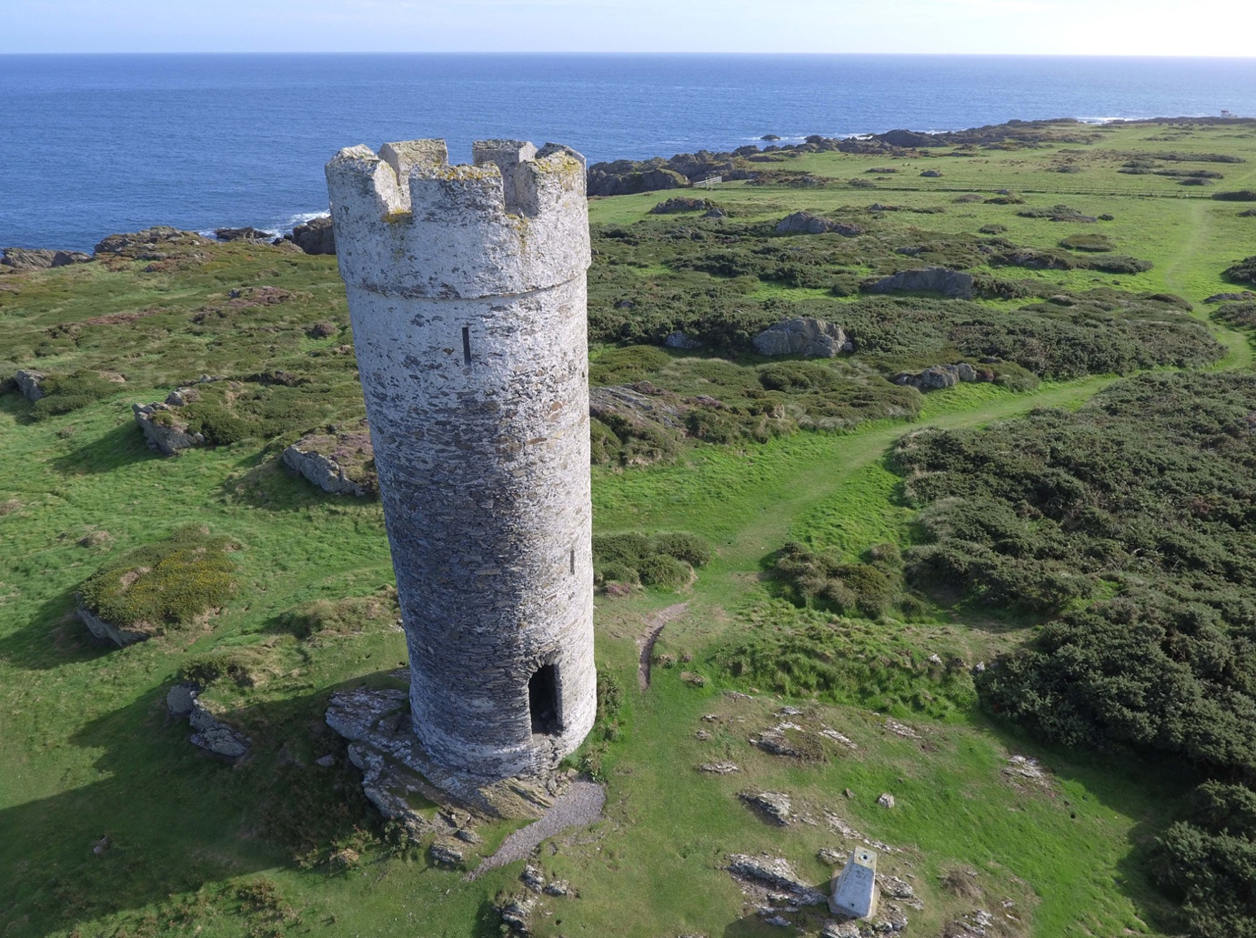Herring Tower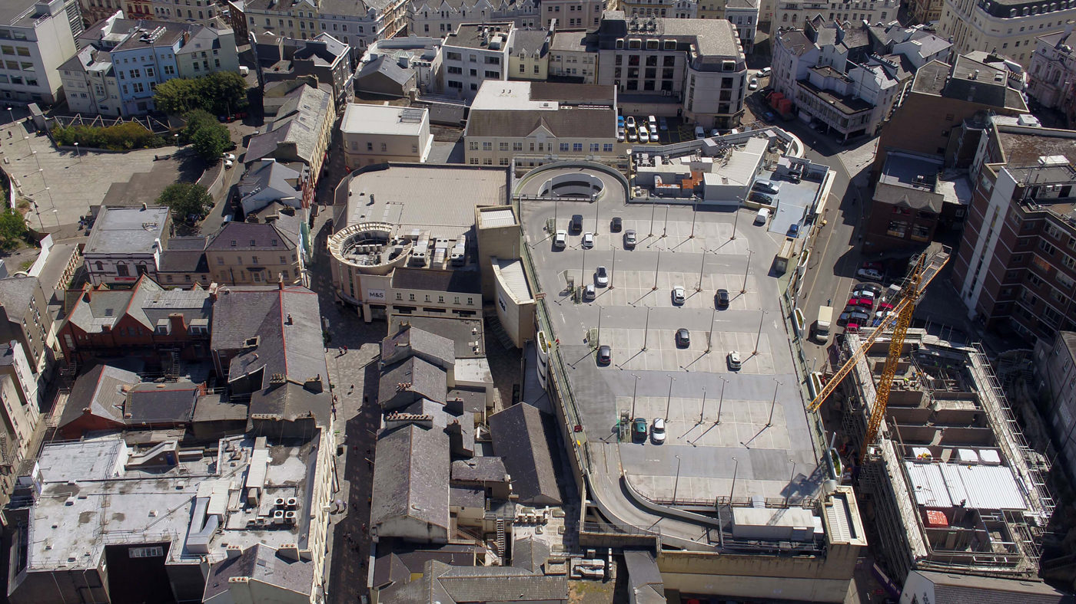Part of Douglas
We were delighted to have Charles Guard as our guest presenter this week – a passionate speaker with a love of the island, highly articulate and with great knowledge of all aspects of our history and culture. He is, of course well known as the “face” for many videos of the island, but perhaps less so as a music composer and (once upon a time) as a member of the island’s Planning Committee.
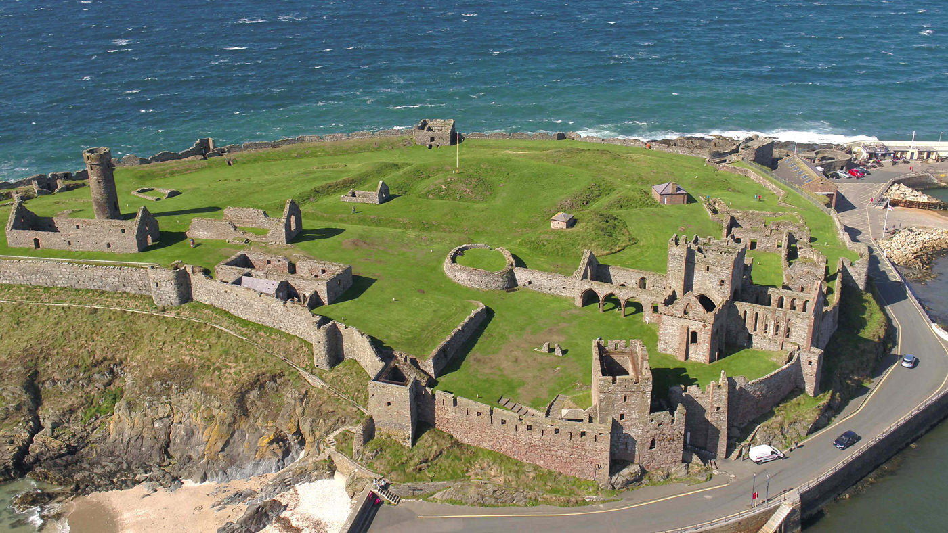Peel Castle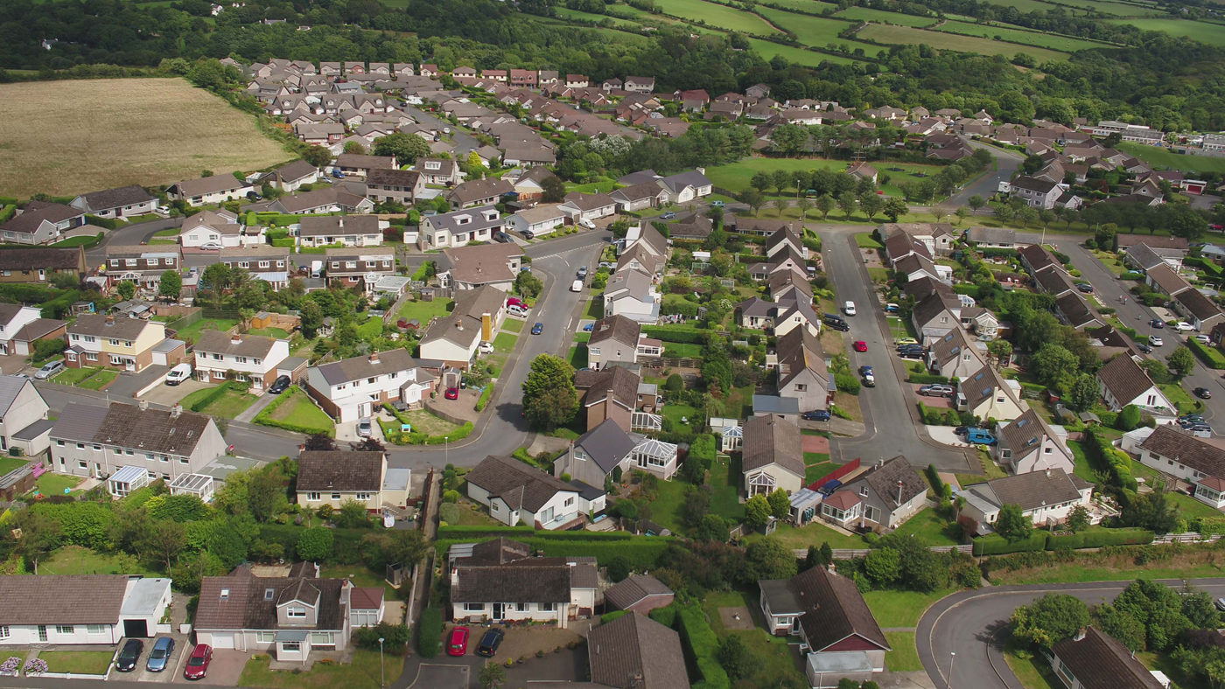Onchan
Our evening with him came in two halves – the first, an exploration of the island through drone photography and a comparison with filming via helicopter to get similar aerial images. It was quickly evident that drones give better access, ready availability and an affordability not possible with a helicopter. Historic sites such as Cronk Sumark, the tholtans of the Sulby Valley, Peel Castle and Castle Rushen, the mine workings around the Laxey Valley, Bradda Head and Maughold, were all explored in great detail. Charles’s experience in the Planning Committee also made a contribution – a liking for much of our urban landscape such as Douglas promenade, and the town centre of Peel, though perhaps not the tower at Peel Power Station…. A striking sequence of images showing coastal erosion on the island’s west coast made for a major discussion – the erosion now endangering housing in the Kirk Michael area, the displacement of the gravel banks at the Point of Ayre and continuing erosion around the old Wrights Pit East tip will in the not too distant future cause severe issues for government.
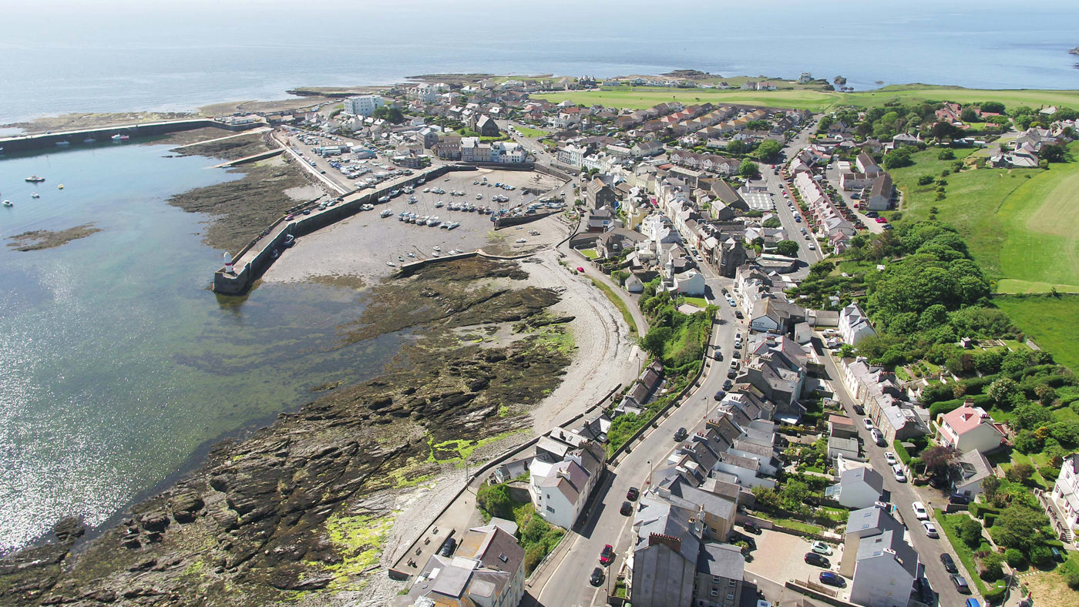Port St Mary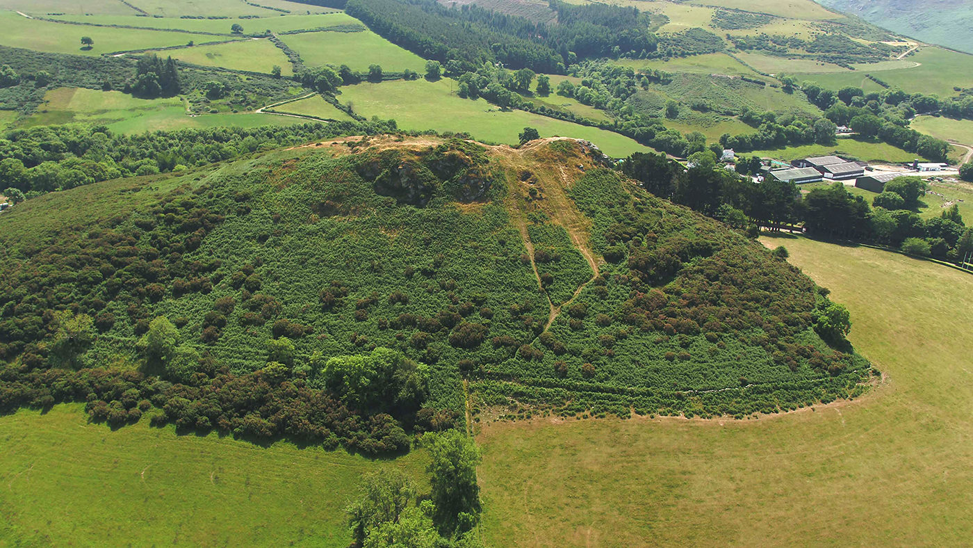Cronk Sumark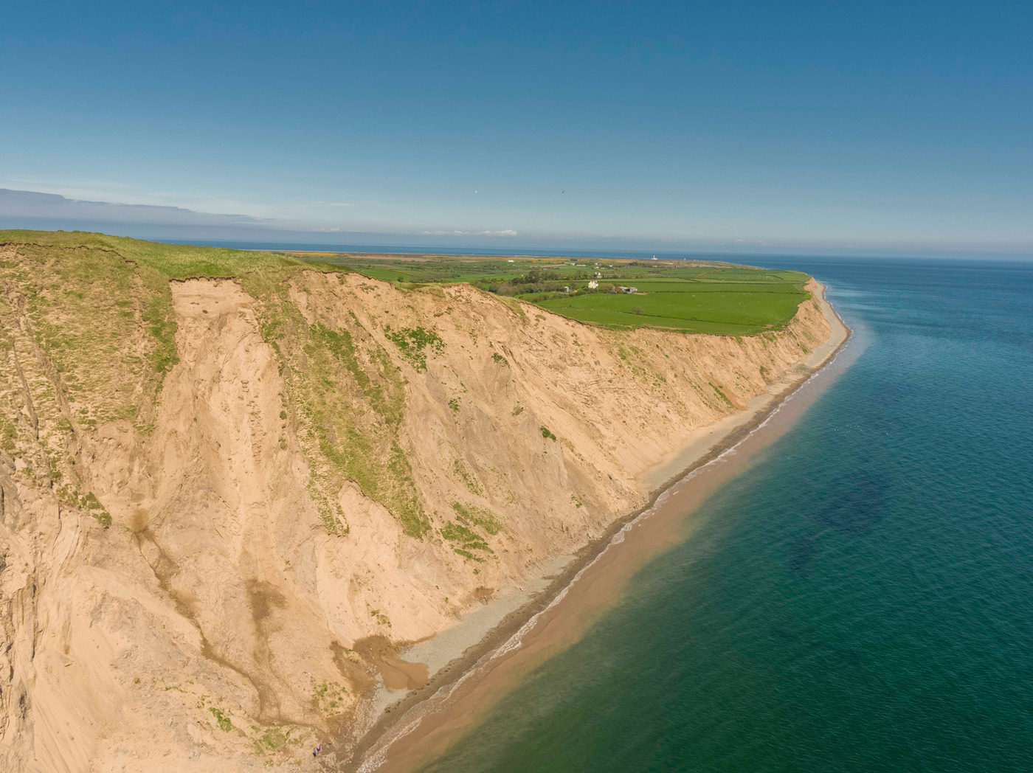Sandcliffs
The second half of our evening covered the island’s activities during World War Two – including the conscription of many workers, the cessation of tourism and resulting economic difficulties for the hotels and boarding houses, the use of the island as an internment centre, the development of Jurby, Andreas and Ronaldsway airfields and their use for training of aircrews, and the 4 radar stations built around our coastline. The remnants of these activities – e.g. the bunkers, pill boxes and bomb stores – are now almost unique in the British Isles, and thus well worth preservation as being of major historic significance, but need government action to protect them – which is yet to happen.
Society President Jeremy Broome-Smith gave a well-deserved vote of thanks for an excellent evening.
Chris Blyth

Members’ Autumn and Macro Images 30th Oct 2019
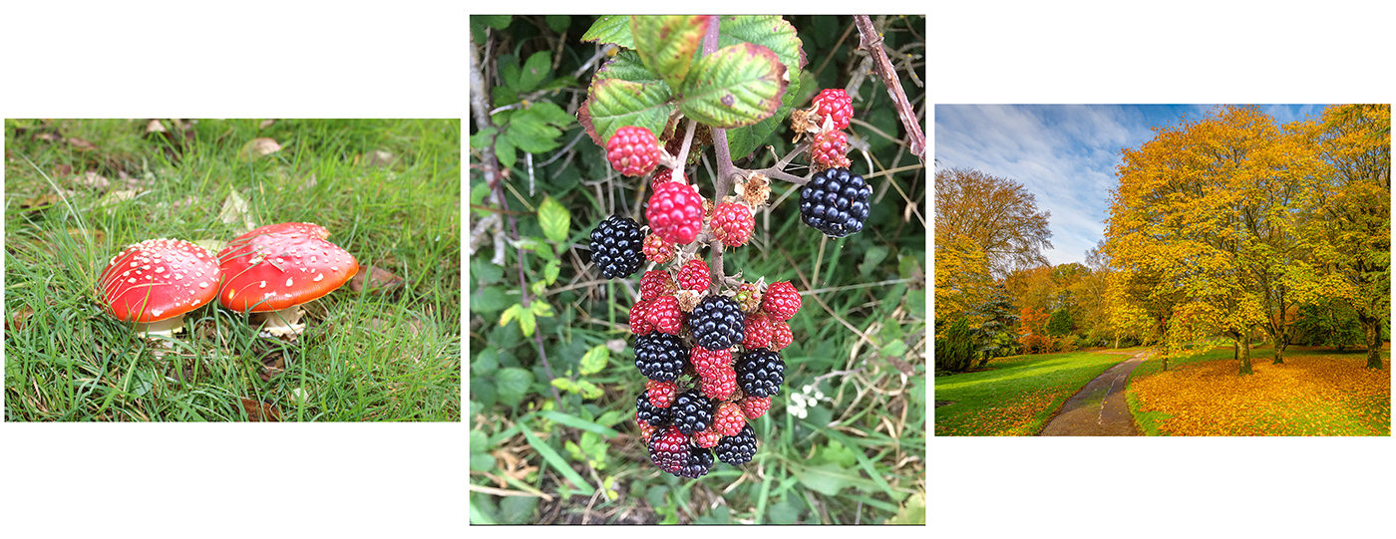
This week we had the pleasure of seeing all the entries for the October Challenge ‘Autumn’. Without a doubt our biggest participation ever for this non-competitive format with an amazing 39 images in total being put forward. Especially pleasing to see so many of our new members taking part. Special thanks to Beryl Quayle for selecting a great theme. Bearing in mind many of these images were taken on mobile phones and without editing, the quality of the entries was extremely good.
This is our second season running this regular challenge, we have tried to make it as easy as possible for people to enter with few restrictions or rules, no sizing, no uploading etc. The emailing of the images has been successful to date, but unfortunately this month 2 images failed to get through, apologies to Andrew Cairns.
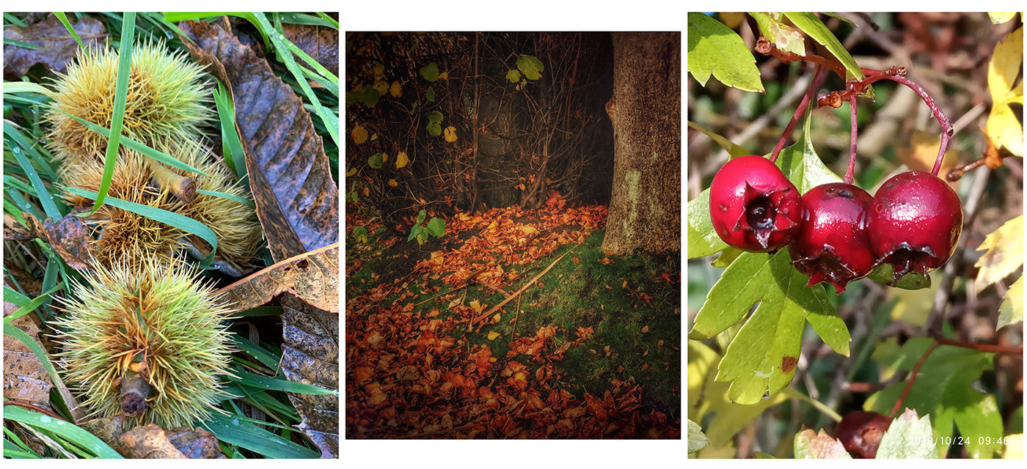
Bearing in mind I do this totally voluntarily and in my own time, the volume of submissions is making this more time consuming than initially envisaged. I don’t want to make rules for this, but to assist me I am going make some special requests with regard to titles & submitting for next months challenge. See our members Facebook page for more details.
The November Challenge has been chosen by Jonathan Carey, it is to be ‘Bridges’, these must be taken on the Island, and NOT in a Glen. Now that is a challenge!
Barry Murphy
We also had members showing their images from the summer macro challenge held at Ballaghennie.
The brief was two hours in a restricted area to study and photograph the smaller things in our world.
All photos were to be taken between 11am & 1pm within walking distance of the Ballaghennie car park with members given the challenge of photographing insects, plants and flowers and shoreline.
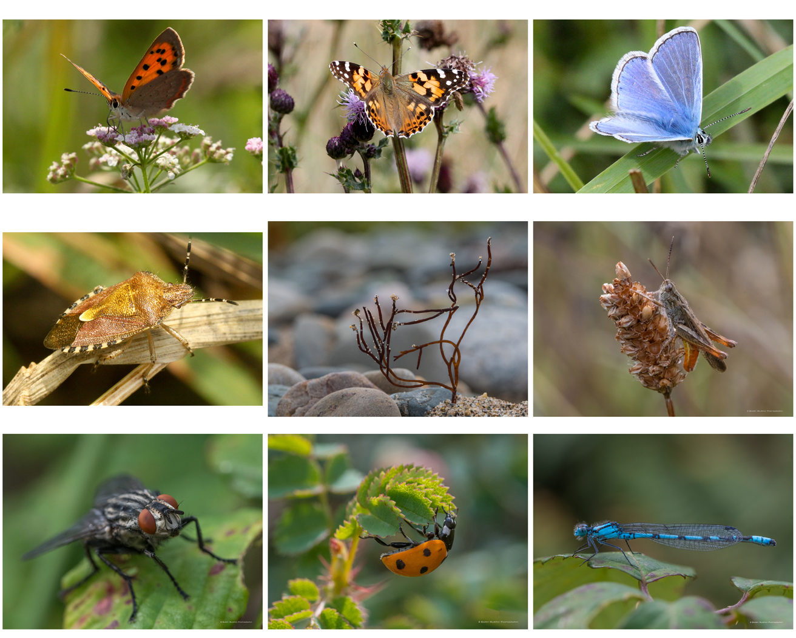
The macro challenge and the monthly challenge together gave us in excess of one hundred images many with commentary from the members who took the images.
By Jeremy Broome-Smith
First Open Competition 23 Oct 2019
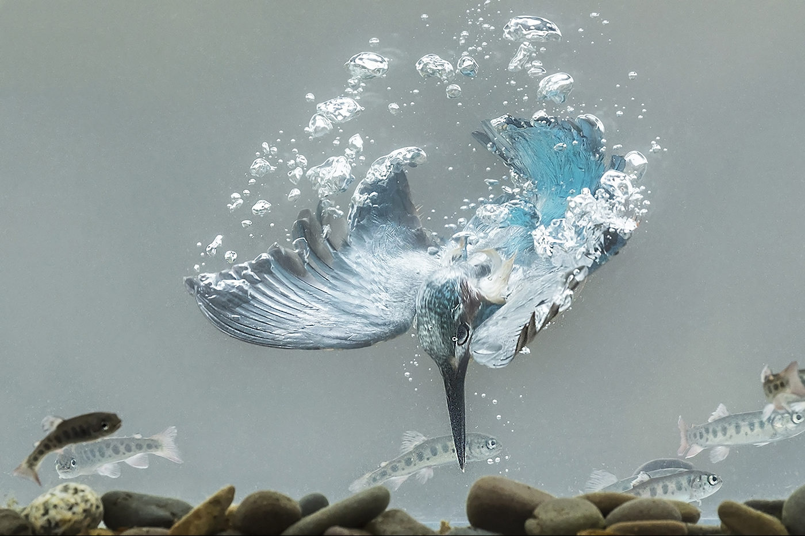Underwater Kingfisher by Sue Blythe
The Isle of Man Photographic Society held the first Open competition of the year. Open, meaning that any subject was eligible. There was a good entry spread over colour and monochrome images, in both prints and projected digital images.
We were delighted that Dennis Wood had accepted our invitation to judge the images. Dennis is an active member of the Western Photographic Society, and is no stranger to judging our competitions. He gave us his considered opinions on our images, explaining how he formed his decisions, taking into consideration the range of tones in an image, the composition, use of light, the story-telling nature of the picture, the quality of the image and any post-processing.
All sections were well supported, and the scores given were generally high, with no images gaining less than 14 out of 20 possible marks. The winner in the Intermediate mono print section was a lovely print of a train ‘On the Embankment’, by Geoff Atkinson. And the Advanced section winner was Ruth Nicholls with an image of old memorabilia, entitled ‘Precious Memories’.
In the colour print sections Nature images did particularly well. In the Advanced colour prints Nigel Owen’s artistic interpretation of a thistle head gained top place and the winner in the Intermediate section was a beautiful image of a grey squirrel by Steve Johnstone, entitled ‘Lunchtime’, which was also chosen as the Best Print in the competition.
After refreshments and some friendly chat, came the projected digital images. The judge’s choice as the best Intermediate mono image was of a ‘Dandelion’ seed-head almost silhouetted against the sky, by Janet Henry, and in the Advanced mono section he chose a view of the ‘Mountain Road’ by Annette Slater.
Colour PDIs followed, and another Manx image was the judge’s favourite, the Snaefell tram ‘Starting the Descent’ with a beautiful view of the North of the island and the distant hills across the sea, by Geoff Atkinson. In the Advanced section, the photograph that stole the show was an amazing capture of an ‘Underwater Kingfisher’, with outstretched wings, air bubbles streaming off it, and fish swimming round it. Dennis awarded it Best PDI, and also the Best Image Overall of the competition, by Sue Blythe.
Ruth Nicholls

16th October 2019 – A Practical evening of Studio Photography – a session with the IOM Burlesque and Steampunk Group
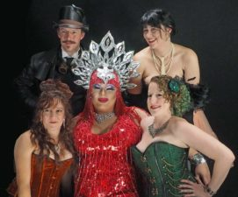The five models from the IOM Burlesque and Steampunk Group
It is unusual for our society to have live models to photograph, but on 16th October we were treated to a visit by the Island’s Burlesque and Steampunk group. Steampunk is a fashion that combines historical elements with anachronistic technological features inspired by science fiction. Burlesque is older and includes the revealing costumes from a bygone era of variety and cabaret. Both styles provided ample opportunity for exotic photographs. The colours and variety of the garments we saw were dazzling.
The Art Society’s meeting room was well prepared for the evening, with three mini photographic studios. Thanks to Barry Murphy and Jeremy Broome Smith for this. Each area had provision for lighting the models by flash and the backdrops needed for serious photography were set up by the more experienced photographers in the IOMPS. About thirty members attended the meeting, all with at least one camera.
Of course, the stars of the night were the Burlesque and Steampunk Group members, Steven, Hazel, Trees, Georgia and Gareth. As expected the costumes were outrageous – they had to be! During the evening some of them changed costumes to provide even more variety. At the start we were advised to ask the models to pose as we wanted and that is exactly what they did over a one and a half hours, with only a short break for refreshments.
There is insufficient space here to describe all the clothes in detail. We saw Georgia in a gorgeous red dress, Trees with her fans and Steven in a long black coat with a sci-fi gun. Hazel wore a sexy green corset. Just when we thought that the evening’s photography might be over, a late arrival by Gareth in his exotic red outfit and stunning headdress amazed us all. At the end of the evening all the models posed together for a group shot. I realised I did not know the difference between Burlesque and Steampunk – but does that really matter ? Everyone there had a wonderful experience.
Richard Shafto

Technical Evening Report. October 9th 2019
Being a member of a photographic club sometimes isn’t just a case of being able to “point and press” the button on a mobile phone or camera and taking a shot, but also of developing skills to show one’s work to best advantage – whether as a print or as a digitally projected image. So the meeting this week of the IOM Photographic Society was both a social evening with the opportunity for members to discuss their shared enthusiasm, but also a “technical evening”, designed to explain the intricacies of mounting a print and of preparing a digital image for competition purposes and projection on to a screen. This was an evening aimed first and foremost at our new members – of whom there are a pleasing number – but also at existing members as a refresher session and to answer any queries that may arise.
The mounting of a print was covered in demonstrations by Ruth Nicholls and by Jeremy Broome-Smith – the first and cheaper method essentially being a simple adhesive application to the back of a print and placing on to a single mountboard (a rolling pin being very helpful to ensure no air bubbles are left behind!). The second is a “sandwich” or “window” process requiring two boards (and hence slightly more expensive) – an aperture being cut into a top board of a size to suit the print, and then both fixed to a lower board.
Preparing a digital image for uploading to our competitions website was explained by Nigel Owen and Chris Blyth, both showing fairly simple processes in editing software such as Photoshop – but also requiring an understanding of the rules and the necessity of ensuring compliance such that we all enter competitions on a standard footing.
By Chris Blyth
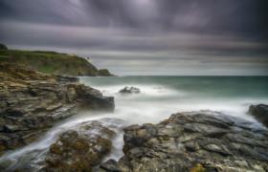An image taken by Jeremy Broome-Smith at Port Mooar was used to demonstrate how to window mount a print for competition during our recent “technical evening”
2nd October 2019 ‘Manx Countryside’ Calendar for NFU Mutual
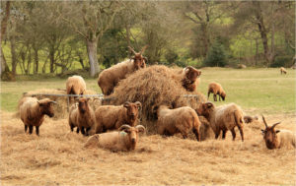
This week the Society welcomed David Wilkinson, MD of NFU Mutual based here on the island, together with two of his staff, Voirrey Horne and Natalie Mason, for a showing of more than 150 images offered by the membership as possible shots to be used in the NFU’s 2020 calendar. The theme of the calendar was broadly “The Manx Countryside”, and the images shown included some of the very best aspects of the island – from our beautiful landscape and seascape scenery to farm animals and our wildlife, from sunsets and star shots to images of our national glens and wild flowers.
David and his team had taken considerable time to make their selection of ‘winning’ images – their selection included some obvious ‘calendar’ shots straight off a Christmas card or a biscuit tin, but also some quirky shots with a definite touch of humour. After showing all the entries, the evening finished on a climax with the thirteen images actually chosen for the calendar, one for each month plus one for the cover.
It was a particular pleasure to note that many members contributed images to the display, including several who do not normally participate in club competitions but who are highly regarded photographers – and so a pleasant surprise that Brenda Shimmin’s image of the Calf of Man in the snow earned a place as the image for January, whilst two of Sue Jones’s landscapes have also been included. To his considerable surprise, Steve Johnstone was our ‘star on the night’, achieving three images in the calendar whilst other members work to be selected included Jeremy Broome-Smith, Barry Murphy, Sue Blythe, Jonathan Carey, Mike Howland and Ron Shimmin. The cover image, revealed as the last of the evening, was of loaghtan sheep enjoying a feast of hay, entered by Beryl Quayle – a shot that gained a big round of applause from our audience.
Club President Jeremy Broome-Smith thanked NFU Mutual for entrusting the Society with the calendar, Barry Murphy and Jonathan Carey for their help in gaining the assignment, as well as all the members who had contributed – truly a massive co-operative effort, but with an excellent result and a ‘showpiece’ calendar for NFU, demonstrating the best of the island.
The Society is most appreciative of the support that NFU Mutual has pledged towards our funds.
Chris Blyth

Opening Night 25 September 2019
The new season of regular weekly Wednesday evening meetings for the IOM Photographic Society started with a real “tour-de-force” – a large audience including a pleasing number of both new and returning members was given a very warm welcome by our new President, Jeremy Broome-Smith. His opening remarks made clear that the key objective for him and for the committee was that members enjoyed their photography, shared their knowledge and expertise, and had fun whilst doing so – and the programme was geared to achieving this.
Once details of the programme had been explained, and as had been requested for the meeting, a dozen or so of the membership provided images of their summer activities – a total of some 120+ images resulted, with each member providing background information on their selection. It started with Jeremy’s own images – images with an emphasis on his particular interest in both macro shots of insects and in long exposure landscapes which produces interesting results for clouds and seascapes. Family holidays, both home and abroad, featured large – children and grand-children, and landscapes of Italy and Switzerland, a Mediterranean cruise, Spain, the Lake District and USA were shown by a number of members, including Janet Henry, Chris and Ruth Nicholls, Jonathan Carey and Chris and Moira Blyth. Steve Johnstone showed his continuing fascination with natural history images with some excellent shots of birds, a subject also enjoyed by Beryl Quayle. Jiri Podobski provided some lovely images of his hobbies – of folk dancing and scootering, Barry Murphy’s interest in macro shots, stimulated by a practical session in our last season, provided a further sequence of shots, whilst Martyn Parnell’s enthusiasm for motorcycle shots of TT racing was clearly evidenced with a dozen or more shots, all pin sharp – the bikes in various states of “flying” at top speed.
Chris Blyth
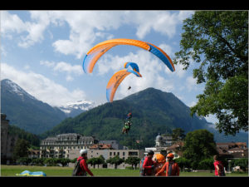
IMAGE: Tandem Hang Gliding, Switzerland by Chris Nicholls was one of many excellent images shown by members on the first evening of the new season

Summer Newsletter
Dear Member,
I thought it would be good to make contact now with some good news.
(1) Website. Richard Shafto has spent much time migrating our website to a faster service and it is now back up and running. It is much faster. Passwords for members’ access remains the same as before.
(2) Manx calendar. The closing date for uploading your images is 31 July. The format needs to be A4 . For uploading to the website they must be 1400×1050. Barry Murphy has had meetings with the NFU and judging will take place towards the end of August. It is planned to show the images and announce the 12 winners on a special club night 2nd Oct . Please note that at present the thumbnails of the calendar pictures don’t appear after uploading an image but the title is visible and an option to delete or add further images remains. Richard Shafto is aware of this glitch in the software which he will resolve after 31 July. (Note, now resolved, all Competition upload sections are working. Sept)
(3) Programme. You will be pleased to see that it is now published on the website. It is not fully completed yet. The committee has been working hard to produce this varied and interesting programme.
(4) The Isle of Man Bank have withdrawn their sponsorship , so in future the trophy will be called “ The Bank Cup “ . The set choice/assignment this season is “Nature“ . The criteria/definitions are the same as our guidelines for Nature in our Annual Competition and the Competition Rules can be found on the website under Documents.
(5) Funding from the Arts Council. An application will be submitted during July to request some funding to cover the cost of our Annual Judge. The application forms have become complex, requiring a lot of detail, and letters of support. Thanks to a few dedicated people on the committee the application is practically complete. (Note, Sept. Application accepted by the Arts Council, funding for the Annual received. We greatly appreciate the support we receive from the Arts Council)
(6) Annual Judge. We have been extremely fortunate that Rod Wheelans has agreed to visit us and judge our competitions which will be held on Wednesday April 1 and Thursday April 2. ( this is because Rod has to return to U.K on the Friday ). Rod is well-known in the club scene, he adjudicates for PAGB qualifications, and has lots of photographic letters including FRPS , MPAGB , MFIAP .
(7) Photo Challenge. Laxey. The object of the exercise is to try to have a ‘theme’ for your project. There are lots of possibilities. the harbour, the beach, the station, the trams, the tram-lines, the wheels (two of them), the people, the river, the village shop-windows, the quaint houses, the gardens, the flour mill, King Orry’s grave, or a ‘Tourist Board’ brochure, etc..
If you can do a few more than 10, that’s great. Let’s say up to 20, no more.And if you can sequence them so that one leads nicely to the next, so much the better. Make them the usual 1400×1050 size, no need to fill in with black, put them on a flash drive to plug into the club laptop, and bring that to the club on the night.
We expect to arrange for you to show your pictures and talk just a bit about them (again not strictly necessary) about halfway through the first half of the programme, ie a bit before Christmas. Again like the Summer Project it is non competitive , just for fun , not point scoring .
(8) Assignments . (set subjects ) out of 20 suggestions the chosen 3 are “ On the Beach “~~~ “ Shapes & patterns “ ~~~ “ Water “ .
Images taken for the Laxey project can be used again in the assignments!
(9). Events / Summer Outings . on July 20th there is a boat trip to the Calf. Contact Barry Murphy on Facebook or by e mail .
There will be a get-together on Saturday 3rd August 2019 at 10.45am – 1pm @ Ballagennie Plantation carpark (on road to Ayres Visitor Centre) Bride. for a Macro session, details on our Facebook page. And we hope to run a similar Fungi day, later.
(10)Facebook . Some members have reported pictures posted by them on the club Facebook page have been copied without permission. The only advice the committee can give is to make sure the images are no more than 800 pixels on the longest side , this will render them too small for most cases of plagiarism.
So enjoy the summer and take your camera about to capture things you’re involved with here in our Island, or away on holiday, and explore Laxey to take some for that project! Also keep the assignments / set subjects in mind .
Take care . Jeremy ( President )

