IOMPS Reports During September 2014

4th September 2014 - The President’s Letter to all Members of the Society
At the AGM earlier this year, the membership elected me to serve as the President of the Society and I must say I feel honoured to serve you all once more in this capacity. As I indicated at the time, I offered myself only so that others might have a bit more time to consider taking on this role in the future. I did say, however, that it could only be for one year this time (instead of the customary two) for personal reasons concerning Sandra’s health.
Your Committee has been extremely busy over the Summer months dealing with a range of matters. As I know the membership is anxious at this time of the year to know, I can reveal that the Committee has decided that the assignment competition topics for the coming year will be :-
- Reflections
- People
- Flora (i.e. plant life, including Flowers)
- Manx Culture ( a print only competition for the IOM Bank Cup)
2013 - Our 75th Anniversary Year
Let me begin by reflecting on this important milestone in the history of the Society. It has certainly been a memorable year in several ways.
Our Anniversary ‘Exhibition of Photography’ at the House of Manannan in Peel from May to August 2013 was highly acclaimed, being opened by our Patron, the Lieutenant Governor, Mr Adam Wood. There were good attendances throughout and much favourable comment from both locals and from visitors to our Island. Those who undertook the task of planning and preparing the exhibition to show something of the history of photography on the Island and a range of top class images from members did a great job!
We were grateful to well known local photographer, Andrew Barton LBIPP, LMPA, BIPP for his active support over the Summer months. He ran four successful full day workshops in June and July, 2013, covering an introduction to photography, studio still life, portraiture, and a final one he titled ‘photo fun’. A positive spin-off from these workshops was that we were able to welcome several new members to our Society which is something we are keen to see. Indeed, the quality of work being produced by some of our newer members is keeping the more experienced members ‘on their toes’. They dare not rest on their laurels!
Then, the Society held another exhibition at the Loom Gallery at Laxey Woollen Mills. Opened by Mr Steve Rodan SHK, Speaker of the House of Keys, this was also well received with several images being sold. This is now becoming an annual event but it could not happen without the active support of the membership and much hard work by Chris Blyth.
During the year, we also competed for the third time in a three-way digital ‘battle’ with the Oldham Photographic Society and the Rochdale Camera Club. This event is now well established in our annual programme. The Committee is keen to seek out opportunities such as this for friendly rivalry with other clubs because it helps us to gauge our progress measured against other amateur photographers. The competition was won once more by Oldham but our images did very well and we were certainly not disgraced! Indeed, Shirley Lotfy's image "Lady in Red" was awarded 19 points (out of 20).
Our Annual Competitions at the end of the year were judged by John Sixsmith PPSA, EFIAP BPE5* EPSA , and his wife, Margaret (ARPS and EFIAPg, FBPE, EPSA), both highly respected judges from the Lancashire & Cheshire Photographic Union. He judged the projected digital images and she judged the print entries. They then entertained the membership with presentations of their own work, demonstrating the standards to which we should also aspire.
It seems like only yesterday that we drew last season’s activities to a close at the Cherry Orchard Hotel in Port Erin with our social evening and presentation of trophies. That was a most enjoyable occasion – good food and good company - but in just over a month’s time we shall be resuming our weekly gatherings again at Thie Ellyn. I do hope that you have all managed to enjoy a restful break in the (mostly) pleasant weather and kept your cameras at the ready throughout. It is always good to see everyone returning in the Autumn with fresh ideas and brimming full of enthusiasm!
John Dale RIP
We were greatly saddened to learn of John’s recent passing. He had fought his illness with much courage and yet had still remained cheerful in spite of the treatment he had to endure. I went to school with John so we go back a long way. He was always a ‘larger than life’ character and I know we shall all miss him and his creativity, which often brought a smile to our faces. We send our condolences to his family.
The Society
As a Society, I believe we can be pleased at the improving quality of the work being produced by our members on a regular basis. Many of our visiting judges have been very complimentary about this over the last year or so. Over the years that I have been a member of the Society, I have noted a steady improvement, particularly in the presentation of print entries. Believe me, the contrast between even 10 years ago (and I can go back quite a bit further) and now is remarkable. But we cannot allow ourselves to become complacent!
The Society’s strong links with the L&CPU and the PAGB remain important as is our continuing liaison and collaborative working with other local photographic clubs and societies. We have tried, periodically, to offer encouragement and advice to our less experienced members through practical evenings, but I hope any member who has a query will not be afraid to ask for guidance whenever they feel the need. Our more experienced members are happy to share their knowledge and experience and to offer constructively advice.
The Society prides itself on being friendly club and, as I mentioned earlier, new faces are always welcome. We all have a part to play in greeting ‘strangers’ and in helping them to feel ‘at home’.
We cannot stand still as a Society. Consequently, the thoughts and suggestions of members are most important in seeking to take the Society forward. Please don’t be shy as your feedback is most welcome and will be considered by the Committee.
The Committee of the Society
Your Committee has met several times since last May and has been working very hard arranging outings and devising an interesting and varied new programme. I would like to place on record my thanks to the Committee members for their suggestions for summer outings and for guest presenters. In particular, my grateful thanks go to our hard-working Secretary, Claire Stringer, for co-ordinating the new programme so efficiently. The Society would struggle to function without their continuing commitment throughout the year in so many ways.
Re-Classifications for 2014/15
Each year, one of the more difficult tasks facing the Committee is to review the points scored in the preceding year’s photographic competitions. This can never be an exact science but the Committee does spend quite a bit of time, carefully examining the results over the whole of the previous year. A range of different factors is taken into account before a final decision is reached and the Committee’s aim is always to ensure the outcome is as fair as can be to all members and in the best interests of the Society. Naturally, we are sorry if anyone is disappointed by the Committee’s decision but all I can say is that it does approach the task with complete objectivity.
This year, the Committee concluded that there should be no re-classifications from the Intermediate Class to the Advanced Class but it did agree that two members, Nessie Gillen and Mark Falconer, should be elevated from the Standard to the Intermediate Class.
The Summer Outings, 2014
Chris Blyth organised two more successful boat trips from Port St Mary in the Summer which were fully subscribed. (Sadly, I was off Island on both occasions and missed them!) Then, we had a trip to the Ballanette Nature Reserve at Baldrine, Lonan. Unfortunately, the Meteorological Office advice caused us to postpone the trip from the Sunday to the following evening. This proved to be the correct decision and we were blessed with a lovely evening in beautifully scenic surroundings. The Society is most grateful to Barbara and Stewart Clague for their generous support, given so willingly. It was a pity that the disposable camera competition in Peel had to be cancelled at short notice due to inclement weather, but we thank Tony Curtis for making all the arrangements.
It is gratifying that all of these outings have proved to be so popular.
The New Programme for 2014/15
The Autumn and Winter Programme is scheduled to start on Wednesday, 1st October, 2014, with a prompt start at 7.30 pm, as previously agreed! The Committee has tried to construct a programme with broad appeal to suit all tastes and I hope it will be well received by the membership. Full details will be posted on the iomps.com website shortly.
There will be a change this coming year to the method for submitting competition entries for the projected digital images. Fear not, the Committee is arranging for guidance to be given to everyone at the start of the season to help you all with this. (I am assured it will not be difficult to follow the guidance!)
Whilst we all take our photography fairly seriously, it has always been my personal view that our main focus should be on enjoying our weekly gatherings and each other’s company in a convivial atmosphere. We should all try to have a little fun and to create a relaxed atmosphere where photographers of all abilities and levels of experience can share ideas and make new friends. I hope, therefore, that members will try to persuade guests to come along to our meetings so that, if they are interested in photography, they might feel inspired to return on a regular basis and become full members.
New members should not be made to feel pressured into entering competitions or that they need to be proficient photographers in order to join us. Our membership comprises a wide range of abilities from beginner to ‘expert’ and those wishing to improve their photography should know that help and advice on photographic problems is available on club nights from those who are more experienced and knowledgeable. If we don’t have the answers to every query, we probably know someone who does! We are very fortunate in the Society that most of our more experienced members are willing to take time out to provide advice to those asking for guidance.
IOMPS Laxey Exhibition
Though it seems some way off, you might like to know that the Society has been invited to stage another exhibition in February/March, 2015, at the Hodgson Loom Gallery. Your Committee believes this is a good opportunity to showcase the work of the Society and has accepted. Details have yet to be finalised but will be announced as soon as they have been confirmed. At this stage, we are looking at a possible preview evening for the exhibition on Friday, 13th February. As in the past, I expect we shall need around 100 images and we shall be asking members to provide prints about 2 to 3 weeks in advance for display on the basis that the majority will be for sale to the public.
The Society’s Website
As you know, Mark Stringer is our Web Master and he has done a great job in the past maintaining the Society’s website at iomps.com. It requires a good deal of dedication and constant attention to keep the information up to date. So I place on record a big ‘thank you’ to Mark for his diligence.
Thanks to Our Sponsors
I would like to place on record the Committee’s gratitude to the Isle of Man Arts Council, Manx National Heritage, Isle of Man Bank and the Loom Gallery for their support over the past year, not forgetting all of the judges we call upon and who give their time so freely.
I am looking forward with eager anticipation to the new season and to welcoming you all back to our first meeting at the beginning of October. On the first night, we are hoping to feature the annual digital entries from last March which most of the membership will not have seen before. So, it will be a gentle phasing in and an opportunity to get to know each other again and exchange tales of those ‘shots’ that didn’t quite come off as hoped!
With my very best wishes and thanks for your continuing support,
Antony Hamilton
Society President
Start here

IOMPS Reports During October 2014

30th October 2014
The Isle of Man Photographic Society recently held an Open Digital competition which attracted over fifty entries from members, and which was judged by John Keelan.
John is the chairman of the Southern Photographic Society that meets in Castletown.
What John doesn't know about photography is negligible as he's been a keen photographer for most of his life. His first camera was the old Box Brownie. He joined his college photographic society, doing all his own processing, and hasn't looked back since.
John enjoyed looking at all the images but admitted that it was difficult to judge an Open competition because of the sheer variety of subjects. In a themed competition the subjects are virtually the same and it's easier to judge the quality of one image against another.
John displayed a different perspective to judging due to his vast experience as a photographer. His critiques were interspersed with humour and with practical lessons on how each image could have won higher marks.
The winner of the Standard group was a really good shot of two gulls flying. It had very good exposure and was full of movement. It was by Karen Norton and entitled "Winging It".
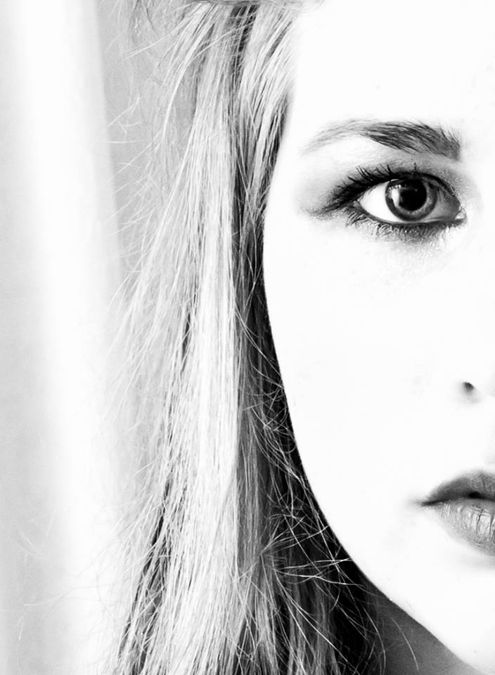Nessie Gillen had the best image in the Intermediate group. "Kiera" was a 1960's style, half face portrait in black and white. It was a striking portrait and a good example of high key photography.
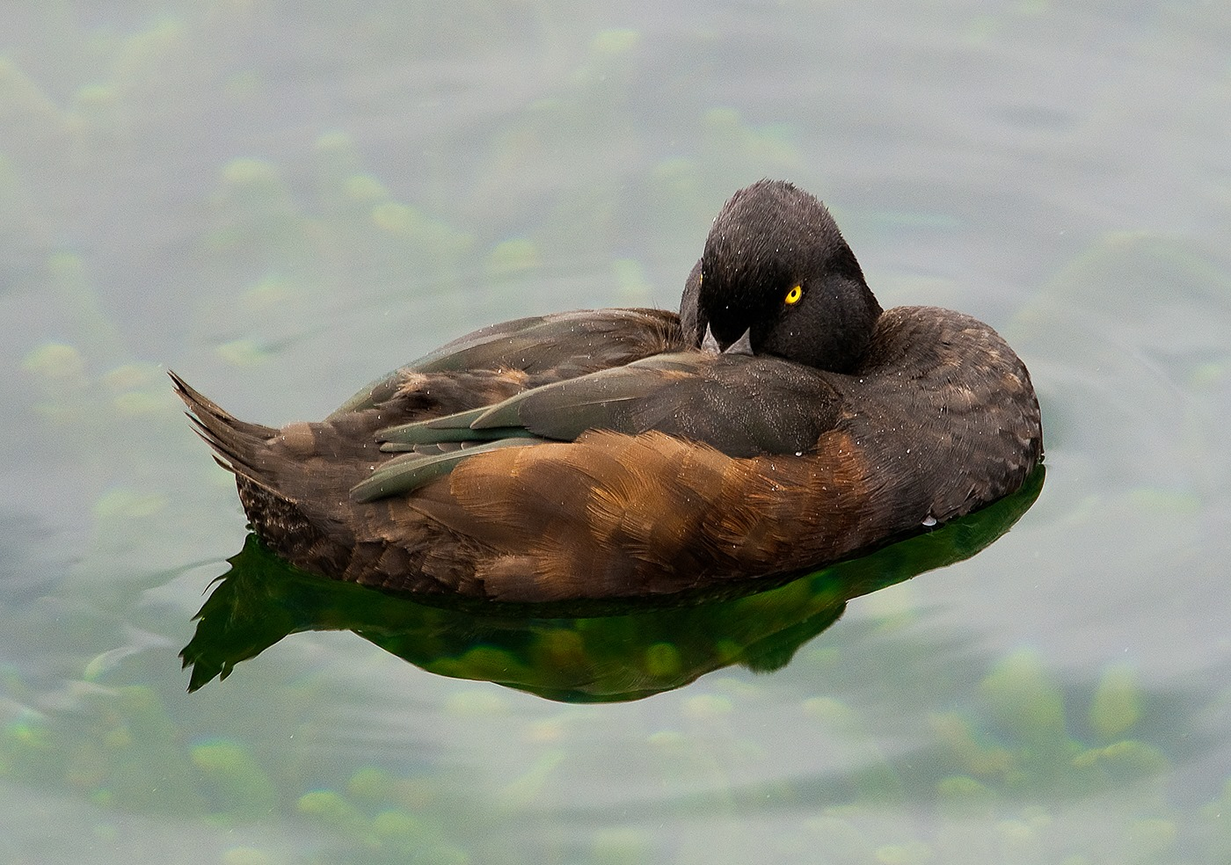The Advanced group was won by Patricia Harvey's image of a resting duck on water. Entitled "Papango – A New Zealand Scaup", John Keelan described it as "a duck with attitude" as it had bright yellow eyes staring out menacingly. This well seen image had good exposure and sharp focus.
John also had the unenviable task of selecting an overall winner from all of the entries. I think everyone agreed with his selection. It was Karen Norton's photo of flying gulls called "Winging It".
Well done Karen! Especially as she beat off competition from more seasoned photographers.
Best image in the Digital Open competition went to Karen Norton for "Winging It" (Image Missing)
RESULTS
Standard – 1st Karen Norton. 2nd Graham Harvey. 3rd Peter Keena. 4th Lara Howe. 5th Beryl Quayle. 6th Richard Leach.
Intermediate - 1st Nessie Gillen. 2nd Annette Slater. 3rd Mark Falconer. 4th Hazel Walsh. 5th Martyn Parnell. 6th Shirley Lotfy.
Advanced - 1st Patricia Harvey. 2nd Claire Stringer. 3Rd & 4th Chris Blyth. 5th Mark Stringer. 6th Bill Callow.
Lloyds bank is sponsoring a new competition to find the best amateur photographers on the island. You can use a camera, smart phone or even tablet and enter as many categories as you like. Along with an overall winner there will be individual winners in a variety of categories. You will find the exciting details in local papers and at branches of the bank.
If any member would like to enter images for the Bebington Salon you will find all the information and entry forms on our website www.iomps.com. Entries must be in by 26th November.
Our next club competition is an assignment to be held on November 5th, entitled "Reflections". Visitors are always welcome at Thie Ellyn off Withington Rd. each Wednesday evening from 7.30pm.

23rd October 2014

Robert Louden Brown returned to the Society as its guest judge for the October ‘open’ prints competition and a warm welcome was extended to him by the President. Introducing him to members and guests, the President summarised Robert’s distinguished career. He had become a commercial photographer in 1957 in Glasgow with the Northern Press Photo Agency of Cheshire. In 1960, he had moved into the highly specialised field of medical photography, graduating in 1969 as a member of the British Institute of Professional Photography. Ten years later, he became the Director of Medical Illustration for Glasgow University and from 1990 to 2002 be was Visiting Professor to the John Hopkins University in Baltimore, USA. From 2001 to 2007, Robert served as Adviser in Medical and Scientific Photography to the UK Government from his Edinburgh base before being appointed as Specialist in Public Health to the Isle of Man Government from 2001 until he retired to the south of the Island in 2007. So, there could be absolutely no doubt that Robert was highly qualified to fulfil the role of judge again.
There were fewer entries than normally anticipated at this time of the year but perhaps this was because the ‘Indian Summer’ we have all been enjoying recently might have encouraged members to think they were still on holiday! Leaving that aside, Robert started by outlined his approach to judging and was quickly into his stride. He had found the overall quality of the entries to be very good in both colour and monochrome. Indeed some he regarded as ‘outstanding’.
With his own gentle style and good humour, Robert’s perceptive comments covered composition, sharpness, the use of different shutter speeds to capture the desired effects, the importance in producing the full tonal range in the mono images, and the choice and style of mounting - but all were constructive and designed to be helpful. He had looked for impact and even praised inventiveness in choosing appropriate titles.
There was a wide range of subject matter before him, but he had found the variety pleasing.
Some of the digitally enhanced entries he had found more difficult to critique but, in spite of this, he decided his final ‘orders of merit’ as follows :-
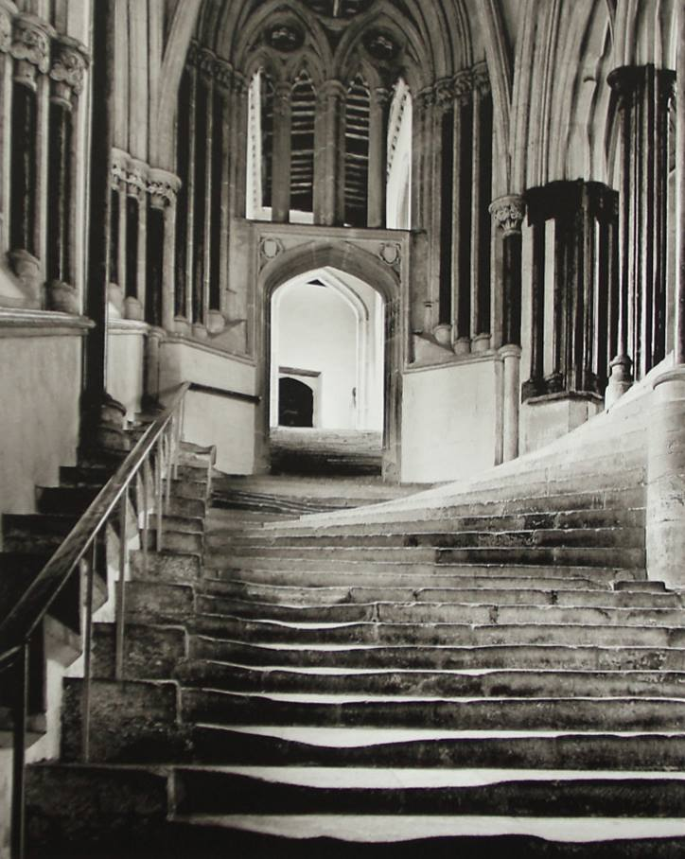
Best image in the first open print competition of the season went to Ron Shimmin for ‘Stairs to the Chapter House, Wells Cathedral’
Results:
Standard Class Mono – 1st ‘Gone Fishing’ by Lara Howe (one of our new members); 2nd & 3rd ‘World at War’ and ‘Carrbridge’ by Joy Brodie.
Standard Class Colour – 1st ‘Don’t Look Down’, again by Lara Howe; 2nd ‘Juvenile Sparrow’ by Beryl Quayle; 3rd ‘Dunlop – On the Limit’ by Paul Dougherty; 4th ‘Reeds’ by Beryl Quayle; 5th ‘Fishing on the Mekong’ by Paul Dougherty; and 6th ‘Tower Bridge’ by Joy Brodie. ‘Brown Bear Feeding’ by Richard Shafto was commended.
Intermediate Class Mono – 1st ‘Cat on the Tiles’ by Jenny Shanley; 2nd ‘Finishing Touch’ by Mark Falconer; 3rd ‘Inside the Hive’ by Jenny Shanley; 4th ‘What Did You Say’ by Nessie Gillen; 5th ‘In The Zone’ by Mark Falconer; and 6th Splashing Time’ by Nessie Gillen.
Intermediate Class Colour – 1 ‘Not Forgotten’ by Shirley Lotfy; 2nd Belting Through Ballaugh’ by Mark Falconer; 3rd ‘Brighten West Pier’ by Nessie Gillen; 4th ‘Santa Ponsa, Majorca’ by Ian Lumsden; 5th ‘Berried Bike’ by Nessie Gillen; and 6th ‘The Only Answer to Mankind’s Problems’ by Ian Lumsden. Three entries were highly commended. These were ‘Crane Fly’ and ‘Pride of Madeira (Echium Candicans)’ by Jenny Shanley; and ‘Common Blue Damselfly’ by Shirley Lotfy.
Advanced Class Mono – 1st ‘Stairs to the Chapter House, Wells Cathedral’ by Ron Shimmin; 2nd ‘Steam Up’ by Sue Jones; 3rd ‘Grasshopper’ by Chris Blyth who also had ‘Spinnaker Tower, Portsmouth’ placed 4th; 5th ‘Footbridge, Salford Quays’ by Ron Shimmin; and 6th ‘At Home with the Vikings’ by Tony Curtis. Patricia Harvey was highly commended for ‘The Stairs’, as was Sue Jones for ‘Misty Morning’.
Advanced Class Colour – 1st ‘Haddon Hall’ by Ron Shimmin; 2nd ‘The Smithy’ by Sue Jones; 3rd ‘Altar', Salisbury Cathedral’ by Ron Shimmin; 4th ‘Bearded Dragon’ by Tony Curtis; 5th ‘Poetry in Motion’ by Bob Servante; and 6th Cormorant’ by Tony Curtis.
Patricia Harvey was highly commended for her image ‘Osprey with Catch’. Four entries were commended. These were ‘Common Blue Damselfly’ and Over the Top and Tally Ho’ by Chris Blyth; ‘Time to Cross’ by Patricia Harvey; and ‘Stroll Through Bluebell Woods’ by Bob Servante
Robert had been set one final task and this was to select the best overall image in the competition to qualify for the season long competition for the ‘best of the best’ and the award of the Brian Kershaw Memorial Trophy. This went to Ron Shimmin for ‘Stairs to the Chapter House, Wells Cathedral’.
Giving a well-deserved vote of thanks, John Phipp commented on how fortunate the Society was to be able to call upon such an experienced and well qualified ‘local’ judge. It was clear that considerable care and time had been devoted to the task he had been set and the Society was extremely grateful.
On the 29th October, we shall have our first ‘small prints’ (7.5 x 5in) competition and a presentation by Gary Harrison on ‘Putting Things In Perspective’. The entries will also be due in that evening for the first assignment competition on the subject ‘Reflections’
Looking ahead to the 7th November, we have a photographic ‘battle’ with the Western and Southern Photographic Clubs at Edwards Restaurant, Onchan, for which tickets are now available from our secretary or Treasurer.
The Society meets every Wednesday at 7.30 pm at Thie Ellyn, off Withington Road, Douglas, when new members and guests (for a nominal charge) are always most welcome.

15th October 2014
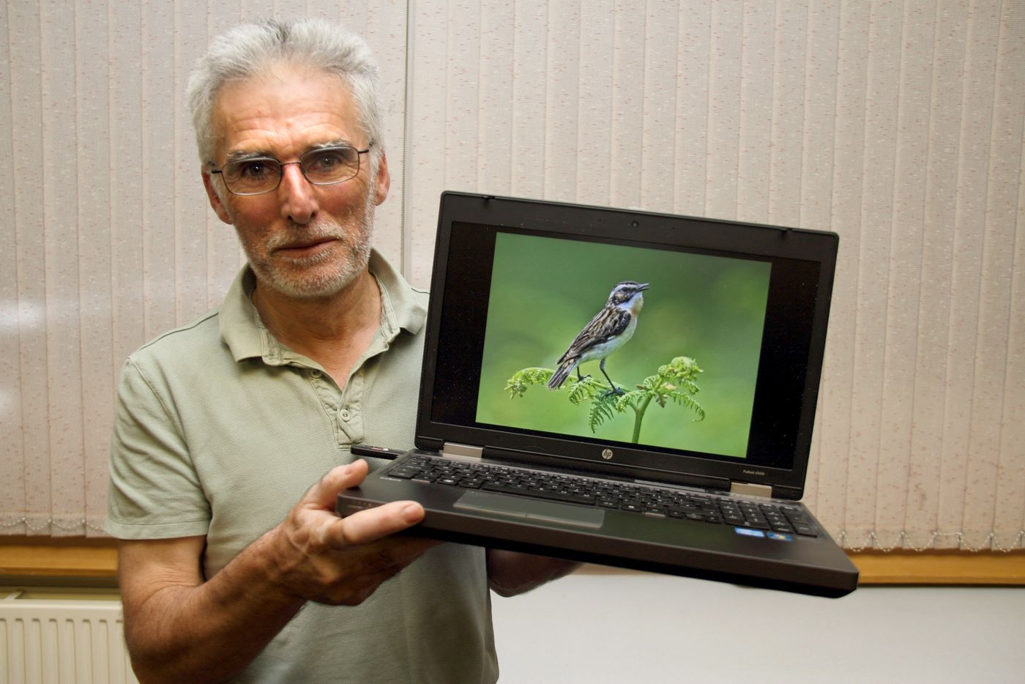
The skills of our members know few bounds – or so it would seem!! The latest meeting of the IOM Photographic Society revealed both a “techie extraordinaire” and a “twitcher extraordinaire” - and a stimulating and fascinating evening resulted, with our members engrossed throughout.
The “techie bit” concerned the IOMPS website – www.iomps.com - which has been comprehensively updated over the past three years or so by our resident webmaster, Mark Stringer, and with the latest enhancements must surely be right up with the very best, and the envy of any similar club. It already contains all the usual material - a history of the society, rules and constitution, weekly reports, together with a “members’ gallery” section showcasing examples of the work and images taken by each member. With the latest upgrade, carefully and clearly explained by Mark, members will now have full control over any personal details (and whether for publication or not), and importantly, members will be able to upload their digital competition entries on-line – with significant efficiencies for both members and our competitions administration.
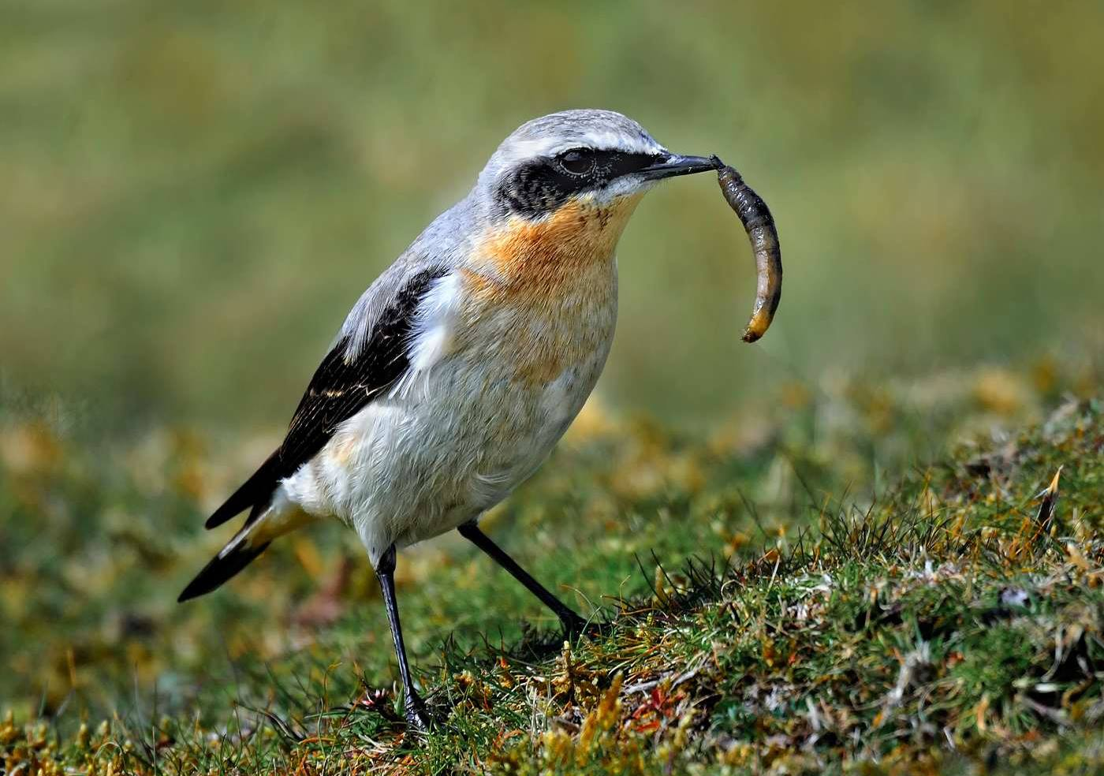
The main part of the evening programme, however, was a presentation by Bill Callow of his bird photography. The club has a high standard of natural history work, but what ensued was an hour of some of the very best bird images for which one could have wished – accompanied by a commentary demonstrating great expertise and a love of the topic. All the images (and there were lots!) were of birds from the Isle of Man, presented in a “seasonal format” – those which one might see in Spring / Summer, or Autumn / Winter (depending upon migration patterns), or resident birds that might be seen at any time, as well as “rarities” – birds only occasionally seen, perhaps blown off course by storms. The images were superb, and of reference book standard – the birds clearly seen, the plumage colours accurately shown, a commentary full of information as to the number of birds to be found on the island, habitat, likely spots for sightings, seasonal variations etc. Bill denied any skill as an ornithologist, but his presentation demonstrated a complete command of the camera and an understanding of the island’s bird life – and an absolute pleasure to have attended.
Our president, Antony Hamilton, gave a well-deserved vote of thanks to both the presenters.
Report by Chris Blyth

14th October 2014 - 3 Way Battle & Bebington Salon
3 Way Battle
The 3 Way Battle with Southern and Western Photographic Societies in on Friday 7th November at Edwards (King Edward Bay) Onchan
If you would like any entries considered for selection for this battle please upload them onto the site selecting the 3 way battle dropdown.
We will be taking names and money for the buffet (£12.50 per head excluding teas & Coffee’s) Friends and Family are welcome.
Bebington Salon
We have been fortunate enough to secure Bob Dennis coming over again to present the Bebington Salon. This is part of the BPE exhibition circuit and you can enter this BPE through www.bebington.org.uk The link to the entry form is at the top of the written page, below the titles, shown as “BSOP2015DOC” Closing date is the 26th November. So why not have a go and enter the Salon, you never know we could be seeing your images during the show!

13th October 2014 - Courier Reports / New Trophy
Dear Member,
As some of you may or may not be aware, the IOM Newspapers has requested that IOMPS change the style of photo used for our press column.
They have asked for us to showcase the excellent images more, which has given us a dilemma because as you know there can be six different winners in one evening (nine if it's print and digital), so which one do we use?
In order to solve this problem the committee have decided to ask the judge to choose a best in competition and that is the image that will be the one used.
We will still be taking the usual group photo which will be used for the website and Facebook.
To add to this David Kershaw is presenting a shield to the society in honour of his father, which will be the "Brian Kershaw Memorial Trophy". This will be presented to the member who has the most best in comp wins.
In order to help to keep things as fair as we can, the Small Print competitions will also be included for this trophy, thereby having four competitions per season that the Advanced group are unable to enter.
I hope this will give an added incentive for members to compete during the season whilst satisfying the Newspapers request and ensuring that we keep the regular column in the paper which is read by many.
Kind Regards
Committee

8th October 2014
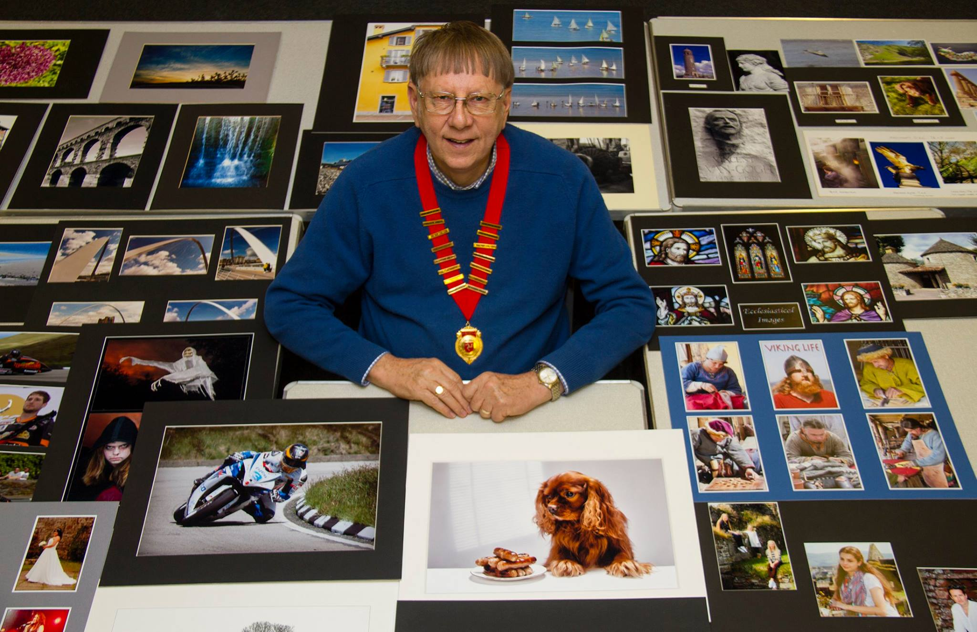
New IOMPS President Antony Hamilton surrounded by some of the prints on display during the first meeting of the new season
“An excellent start to the new season” was the verdict on the first meeting of the year for the IOM Photographic Club, with two digitally projected image sequences providing the entertainment during what was billed as a “social evening” get-together after the lengthy summer break.
The first part of the evening was a showing of all the digital images entered into last season’s Annual Competition, the first opportunity for members to see the entire entry in what was a high quality competition. Shown in the sequence that our Annual judge saw them, the images were wide-ranging, covering the open monochrome and colour sections, natural history, record, and creative categories. With 5 categories each split into the “standard”, “intermediate” and “advanced” groups, it must be reported that our lady members deservedly won 14 of the 15 sections - which, at the least, suggests the men will have to try (a lot) harder this year…..and perhaps adds something to the “Mars versus Venus” theory of the male and female brain…. The winning images however, included a lovely image of a marine iguana by Patricia Harvey which won both the natural history section and best digital image in show award – a close-up and colourful portrait which caught the animal in a stunning pose.
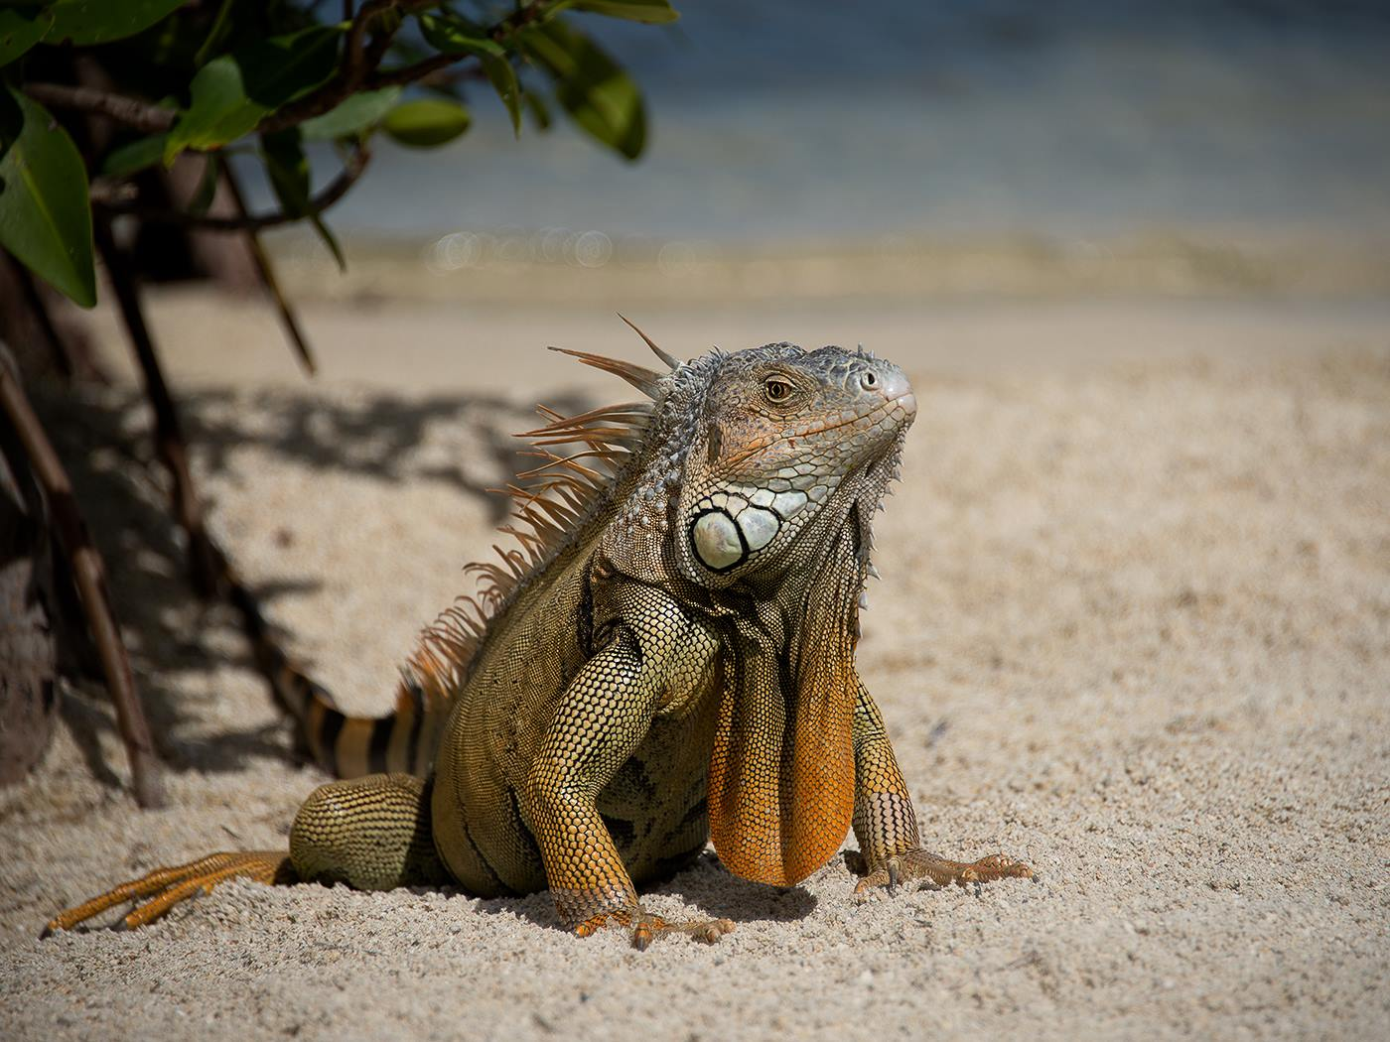
The mid-session break gave the opportunity for the “social” part of the evening, with members mingling and updating with exploits and adventures of the summer, and the chance to chat to those new to the club, all helped with light refreshments kindly donated by some of the members.
The evening concluded with a showing of digital images from the Bebington Salon – a selection of superb shots in the Open Colour, Open Mono and Landscape sections of this national competition under the British Photographic Exhibitions banner. Accepted images for such exhibitions earn points, which cumulatively qualify the photographer for BPE* awards and the right for the initials on your letterhead. Entries for this year’s Bebington Salon are now in preparation, with entries due by 26th November at latest – further details and entry forms will be shown on the club website shortly, with the Salon already scheduled for showing on the island in April of next year.
Club meetings are on Wednesdays, starting at 7:30pm, and held at the Art Society Building (Thie Ellyn) in Withington Road, Douglas. The next meeting, on the 15th October, will be an Open Prints competition. All meetings are open to the public, with an entry fee of £1 for non-members.

IOMPS Reports During November 2014

27th November 2014
Best image in the recent small print competition went to "Moody Scarlett" by Steve Meadows (Image missing)
Last Wednesday November 19th The Isle of Man Photographic Society held a Small Print competition followed by a practical session on flash metering and studio lighting.
The small print competition is open to both standard and intermediate groups with prints no bigger than 5” x 7.5” and without mounts. This is less expensive than other competitions and encourages the less confident members to show their work and receive valuable feedback. The society trialled a new system for showing small prints – of projecting them, rather than mounting them on a board. Whilst the benefit of a much enhanced image visible throughout the room was immediately clear, a significant improvement to the lighting to give a better colour rendition of the images is anticipated when some additional lighting kit is received.
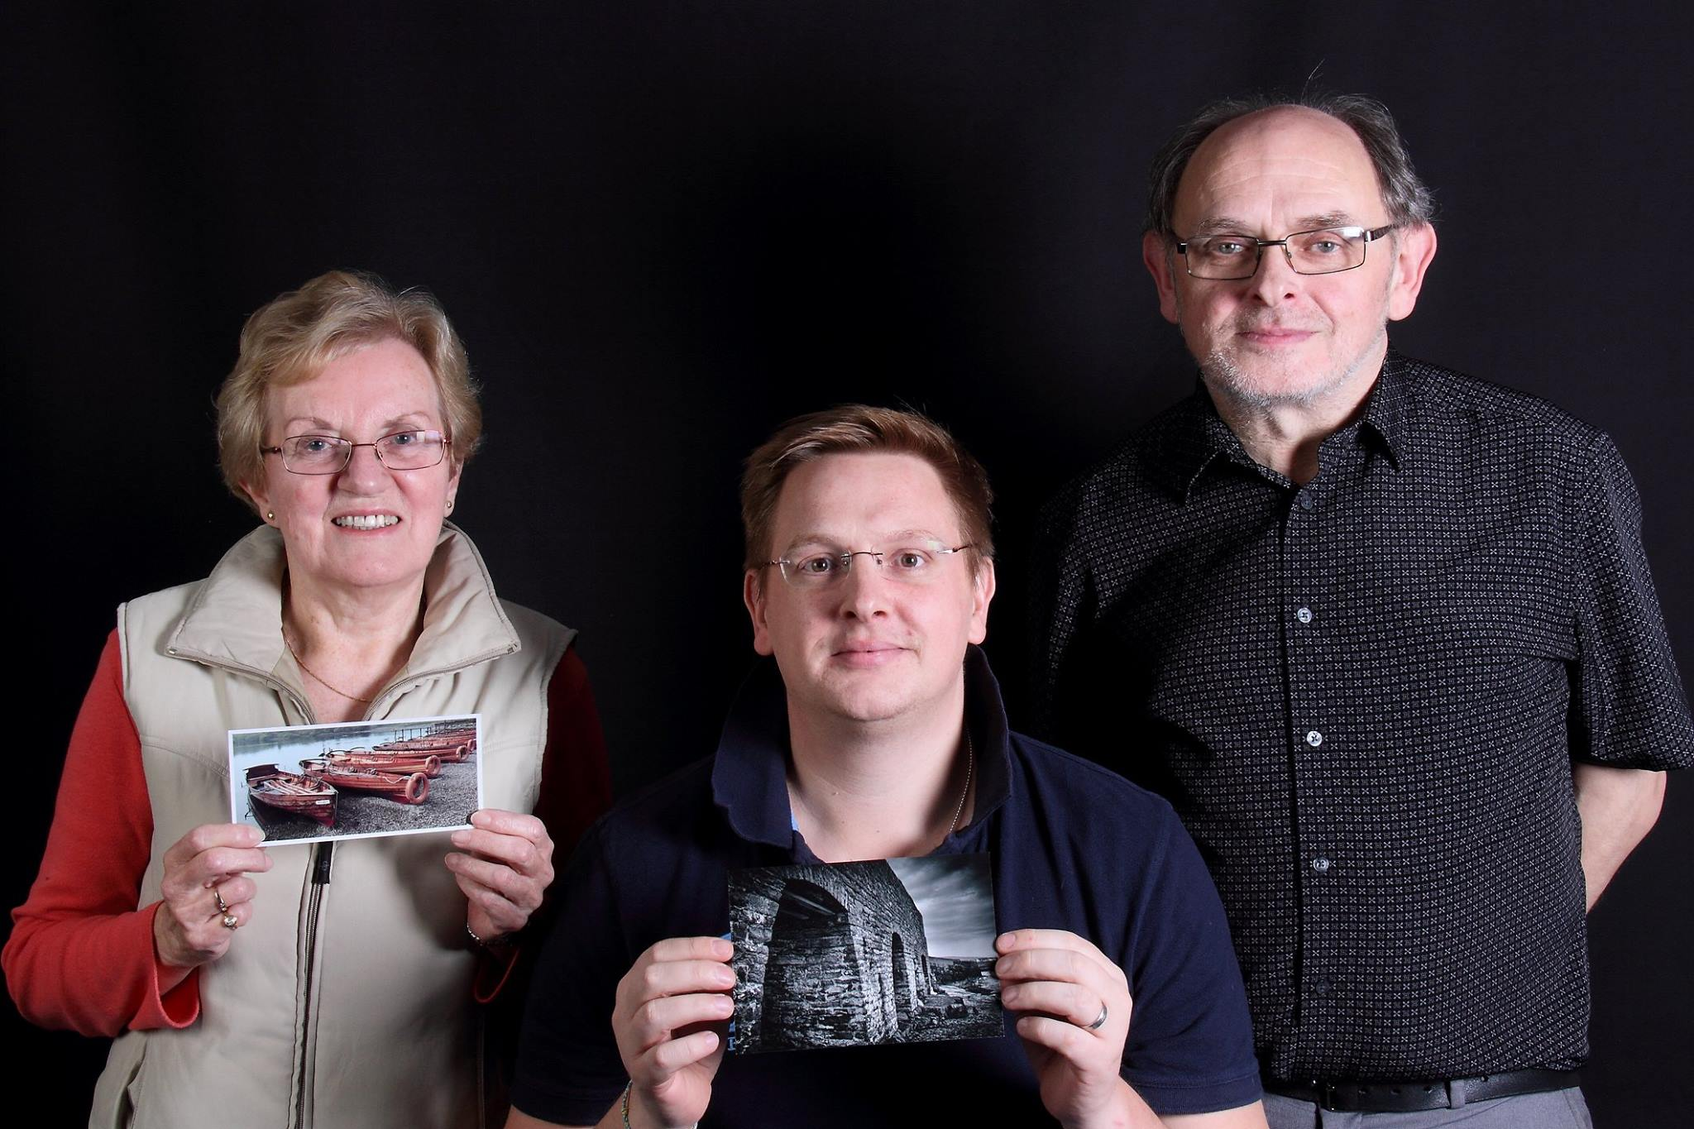
Small Print competition winners Shirley Lotfy and Steve Meadows with Judge Seamus Whelan
Judging the thirty four entries was Seamus Whelan from the Southern Photographic Society based at the Cherry Orchard. Despite the initial difficulties with the new system, Seamus's experience and qualifications were quickly evident as he seamlessly critiqued each image in his softly spoken Irish accent. He conceded that judges were not his favourite people as they always disappointed everyone except the winner! Nevertheless, our audience found otherwise, his helpful comments and gentle humour providing a most enjoyable start to the evening. Seamus was impressed by the quality of the entries, especially those by newer members. His favourite and overall winning photograph from both groups was a stunning black and white image by Standard group member, Steve Meadows, of old stone arches titled “Moody Scarlett”. Seamus said that it had great exposure and was very sharp, and would make a great large format picture.
The Intermediate group's winner was a sharp and well composed image of lakeside rowing boats by Shirley Lotfy.
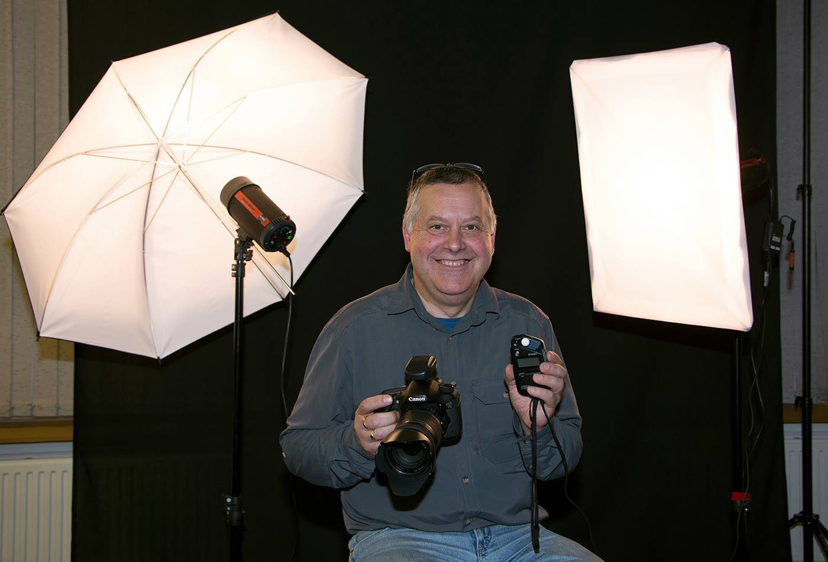Tony Curtis who gave IOMPS members an excellent presentation on studio flash
The evening finished with an excellent presentation by Tony Curtis on studio flash and the use of a flash meter to get an accurate exposure. Explaining the difference between incident and reflected light, and of average and spot metering, Tony showed with careful metering, how different power settings on two studio flash units can be used to achieve shadows (and therefore modelling and shape) in subjects such as portraits or objects. Indeed, the presentation finished with a demonstration of how even a black background can become almost white when using studio flash – and giving the photographer almost total control over the final image.
RESULTS : Standard Group – 1st, & 4th . Steve Meadows 2nd Karen Norton. 3Rd & 5th Mark Thorsby. 6th Thomas Carr. Intermediate Group - 1st & 4th Shirley Lotfy. 2nd Mark Falconer. 3rd Anne Bidwell. 5Th & 6th Annette Slater.
The Society meets at the Art Society Building (Thie Ellyn) in Withington Road, Douglas, with all meetings starting at 7:30pm. Full membership is £25 per year, with a guest fee entry of just £1. Meetings are open to the public, and all will be given a very warm welcome. Full details of our programme can be found on our website at www.iomps.com. Our next meeting on Wednesday, 3rd December includes an Open Digital Images competition.
By Anne Bidwell

20th November 2014
November began on a high note for the Society when it entertained the Southern and Western Photographic Clubs at Edwards Restaurant in Onchan for a social evening at which the annual ‘battle’ between our three clubs took place. After enjoying a splendid hot and cold buffet, the serious business of the evening began with the independent judge being introduced. This was well known professional photographer, Andrew Barton LBIPP LMPA. His wealth of experience over many years and his enthusiastic approach to the task in hand made him an ideal choice to judge the 90 digital images (30 from each club). Naturally, the outcome was eagerly anticipated by all concerned.
Andrew’s approach was thorough and he quickly impressed with his patient, fair-minded approach and eye for detail. He took time to offer praise and gentle criticism in equal measure, though he said how impressed he had been over all with what was an excellent range of well presented images. He offered suggestions for improvement in a number of cases, commenting particularly on the essential elements of a good composition and lighting. His advice was down to earth, sound and well received by members of all three clubs.
After awarding a mark out of 20 for each image and explaining why he had rated some images higher than others, the final result was announced as follows -
Isle of Man Photographic Society – 457 points
Western Photographic Club – 452 points
Southern Photographic Club – 414 points
A close outcome to a good-natured contest concluded with the presentation of the magnificent shield to Antony Hamilton, the proud President of the Isle of Man Society. A smaller, but equally impressive, shield was presented to Dorothy Flint of the Western Club for her image (‘Water Horses’), judged to be the best overall entry.
The following Wednesday, the Society welcomed two of its own members, Ruth and Chris Nicholls, as guest presenters. Both are highly accomplished amateur photographers and the subject of their fascinating show and excellent commentary on this occasion was the City of Venice, which they had visited twice.
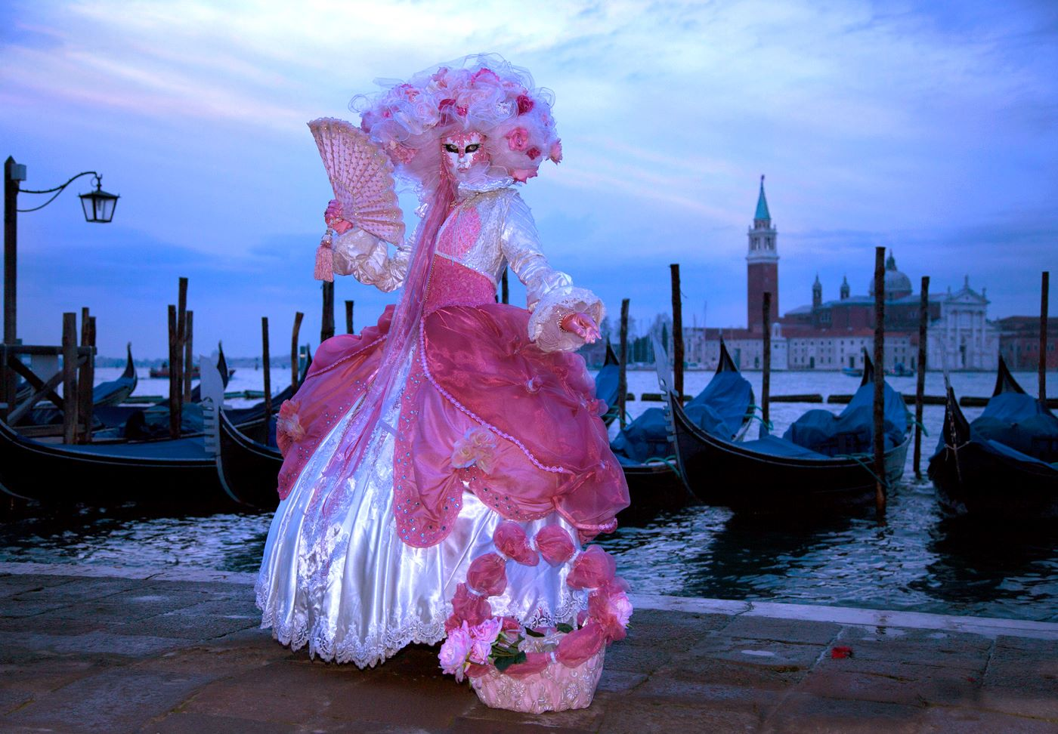
"Pink Dawn" by Ruth Nicholls, one of many excellent images from a presentation by Ruth and Chris Nicholls spanning their two trips to Venice
Chris began with a potted history of this unique city, with its magnificent canals and numerous bridges. To start, we were shown several images taken from the roof of the San Giorgio Maggiore, a 16th-century Benedictine church located across from St Mark’s Square on the Island bearing the same name. This view illustrated the geography and layout of the city very well. He then moved on to the annual Venice Carnival and Ruth had cleverly captured many pictures of the international models wearing their wonderfully coloured costumes and hand-painted masks.
Residents of Venice seem perfectly relaxed that parts of the city are flooded by the sea several times each year, simply going about their daily business, almost as usual. For them it is, of course, not unusual! Chris explained that a major project to construct a barrage around Venice to hold back the high tides, when they occur, is under construction. The first of the barriers have been tested successfully but the project has been delayed for financial reasons. Not being residents used to the flooding, however, Ruth and Chris found that there was the odd occasion when even their wellington boots were unsuitable for wading through the streets in February!
Tourists bring much needed income to Venice but the many visiting cruise ships also cause environmental problems. In fact, measures are being introduced to limit the visits by the larger ships, some of which carry around 3,000 passengers or more, to protect the city.
It was easy to understand from the excellent projected images of all the principal sights, taken with such creative skill, why so many visitors – over 2 million every year – should wish to see Venice for themselves. It had been a thoroughly enjoyable show, covering two visits to the city at different times of the year, and the appreciative audience were rightly impressed by what they had been shown.
By Antony Hamilton

14th November 2014 - Inter-club photography challenge exposes ‘fearsome’ talent
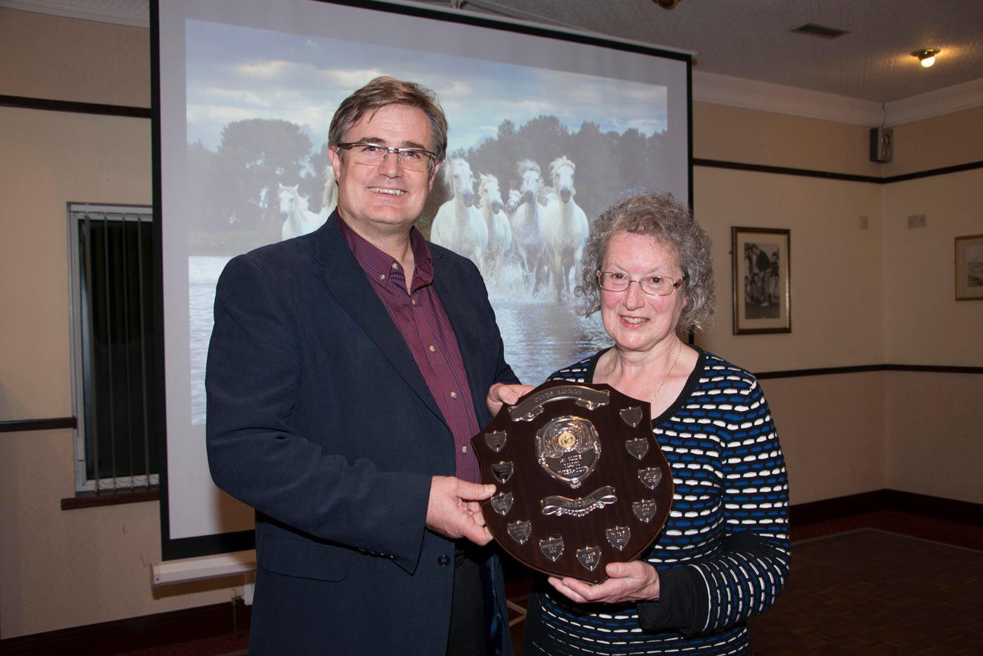
Winning Club President Antony Hamilton IOMPS with competition judge Andrew Barton LBIPP LMPA and Best Image winner Dorothy Flint Western PS
The Isle of Man Photographic Society (IOMPS) has emerged winner of a closely fought competition which pitted its members’ skills against those of the Western and Southern photographic societies.
Entries were judged by the Island’s foremost professional photographer Andrew Barton LBIPP LMPA, who applied his many years of experience to providing an insightful critique of the 90 submissions - 30 from each club - which included settings as diverse as Madeira, Maughold and Cyprus and subjects ranging from damselflies to dogs, crocuses to chameleons.
At the prize presentation held at the King Edward Bay Golf Club in Onchan members heard Andrew praise some submissions for their ‘mind-blowing’ clarity, others for their ‘fearsomely sharp focus’. ‘Sky-rich’ backgrounds also gained the seal of approval; some offerings were ‘flat…but superb’ while the occasional standout submission was applauded for appearing to be ‘bouncing off the screen’.

Best Overall Image: “Water Horses” by Dorothy Flint (Image missing)
The award for Best Overall Digital Image went to Western Photographic Society member Dorothy Flint for ‘Water Horses’, which captured the horses’ grace, energy and movement to mesmerising effect.
The judging concluded Andrew said entries had been of an exceptionally high standard. The 90 images had, he said, ‘been a pleasure to look at.’
In his vote of thanks IOMPS president Anthony Hamilton praised Andrew for his ‘painstaking’ approach to critiquing and lending his ‘professional eye’ to the entries which he, too, agreed were of an outstandingly high quality.
Images were rated out of 20, with the Isle of Man Photographic Society scoring 457, Western Photographic Society 452 and Southern Photographic Society 414.
www.iomps.com
www.southernphotographicsociety.org
www.westernphotographic.org

13th November 2014
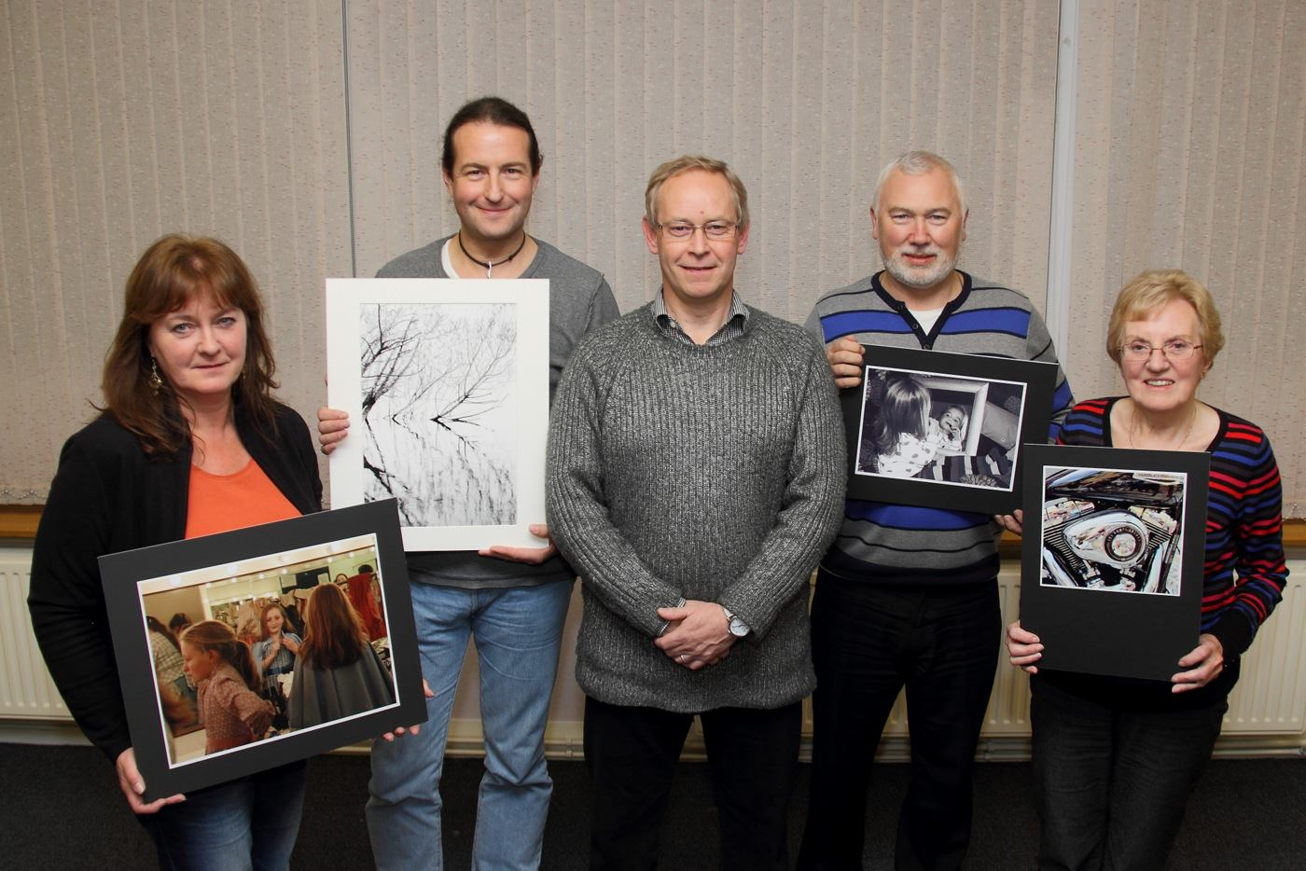
Print winners Beryl Quayle, Nigel Owen, Mark Thorsby and Shirley Lotfy with Judge Ray Davies
An assignment competition on the topic of “reflections” comprised the subject matter for this week’s meeting of the IOM Photographic Society. The competition, comprising some 100 entries in both print and digital image categories was ably judged by Ray Davies, one of our members but whose busy lifestyle has prevented a more active participation in our programme in recent years. Whilst most of the entries took the assignment in the literal sense of a reflection, either in a mirror or a reflective surface such as water or a wet pavement, a few entrants took a different approach, with images showing thoughtfulness, contemplation and memories as their interpretation. The topic was clearly a popular one, and gave opportunity for a wide range of subject matter to be presented – including portraits, trees, wild life, architecture and even some quite abstract images such as one with the strong colours of bright neon lights reflected in a puddle.

Judge Ray Davies with the best digital image in the competition (Image missing)
Ray, an excellent photographer himself, understood the assignment completely, and his commentary was both detailed and full of encouragement for all entrants, with the overall quality of a high standard. Interestingly, the awards were widely spread, with no member winning more than one section - which augurs well for later in the season for those of a competitive bent. Best digital entry on the night went to Anne Bidwell, for an intriguing reflection of a tree in a puddle, whilst “Treeflection”, a superb black and white print by Nigel Owen of tree branches reflected in a lake deservedly won “best print” – as Ray commented, he could “happily take that one home”. Tony Curtis gave a well-earned vote of thanks.
Members were reminded that entries to the Bebington Salon of Photography are due at latest by 26th November, and the winning exhibits will be shown on the island in April next year. In addition, one of our members, Paul Dougherty, currently has an exhibition of his work on show in the Tynwald Library and which will be well worth a visit.
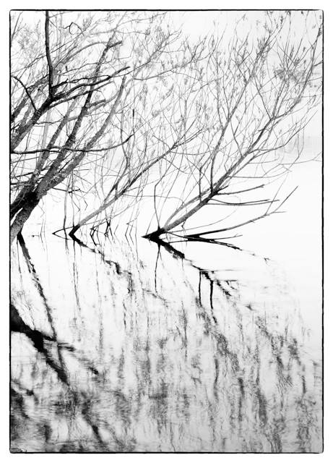
“Treeflection”, by Nigel Owen won the overall “best print” in the "Reflections" assignment competition
Results – Standard Group Digital: Lara Howe (1 & 2), Peter Keena (3), Mark Thorsby (4), Mike Trout (5), Karen Norton (6). Mono Prints : Mark Thorsby (1 & 6), Beryl Quayle (2), Mike Trout (3 & 5), Joy Brodie (4). Colour Prints : Beryl Quayle (1), Joy Brodie (2), Norma Cowell (3), Richard Shafto (4 & 6), Mike Trout (5). Intermediate Group Digital : Anne Bidwell (1), Chris Nicholls (2), Mark Falconer (3), Nessie Gillen (4 & 5), Shirley Lotfy (6). Mono Prints : Mark Falconer (1 & 6), Chris Nicholls (2 & 5), Nessie Gillen (3 & 4). Colour Prints : Shirley Lotfy (1), Chris Nicholls (2 & 4), Annette Slater (3), Mark Falconer (5), Nessie Gillen (6), Jenny Shanley (C). Advanced Group Digital : Claire Stringer (1 & 4), Chris Blyth (2), Mark Stringer (3), Diane McCudden (5), Patricia Harvey (6). Mono Prints : Nigel Owen (1), Ron Shimmin (2), Sue Jones (3 & 6), Chris Blyth (4),Ruth Nicholls (5). Colour Prints : Ron Shimmin (1 & 2), Ruth Nicholls (3), Sue Jones (4 & 6), Bob Servante (5). Overall winner of the digital sections was Anne Bidwell, whilst Nigel Owen’s mono print captured Ray’s award for best print in competition.
The Society meets at the Art Society Building (Thie Ellyn) in Withington Road, Douglas, with all meetings starting at 7:30pm. Full membership is £25 per year, with a guest fee entry of just £1. Meetings are open to the public, and all will be given a very warm welcome. Full details of our programme can be found on our website at www.iomps.com. Our next meeting on Wednesday, 19th November will include both a small prints competition and a practical session.
By Chris Blyth

6th November 2014
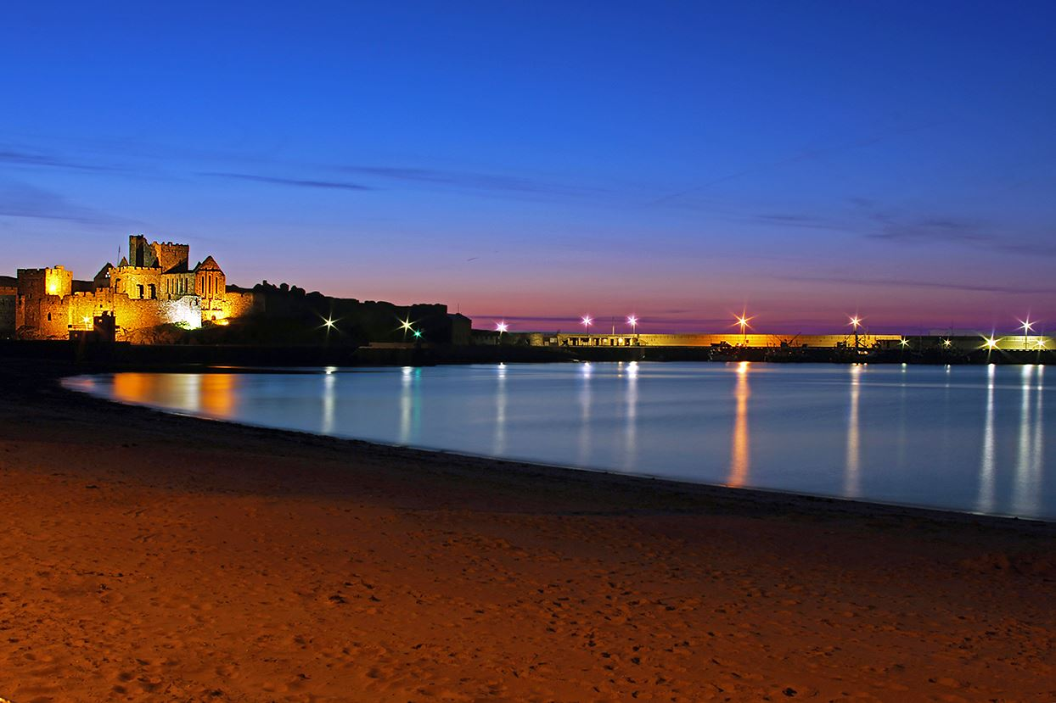Peel Castle at dusk was one of many excellent images from a presentation by Gary Harrison
Last Wednesday October 29th The Isle of Man Photographic Society was delighted to welcome Gary Harrison to give a presentation of his work. You will see some of Gary's images on the walls of Port Jack Chippy.
Gary said that he was both happy and humbled to be invited as he knew that some great work comes out of the club. He presented a diverse portfolio of subjects as he hasn't yet found a particular niche in which to specialise. He likes to break some of the rules of photography and likes to add effects to project a real feel of the images. So it was refreshing to see images taken from Gary's unique perspective.
The members and guests were treated to some beautiful land and seascapes with awesome sunsets and sunrises. There were night shots and silhouettes as well mountain views and glens. Raindrops, flowers, insects and birds from his back garden delighted the viewers.
Gary had taken some stunning shots of the Red Arrows as well as some dynamic T.T. Action. Some of his best were studies of the riders waiting for the off, showing the intense concentration on their faces.
The most amazing thing about Gary is that he only took up photography four years ago, but anyone seeing his work would think that he was a seasoned professional. It is true to say that the members were inspired by Gary's presentation, and by his approaches to and perspectives of his subjects.
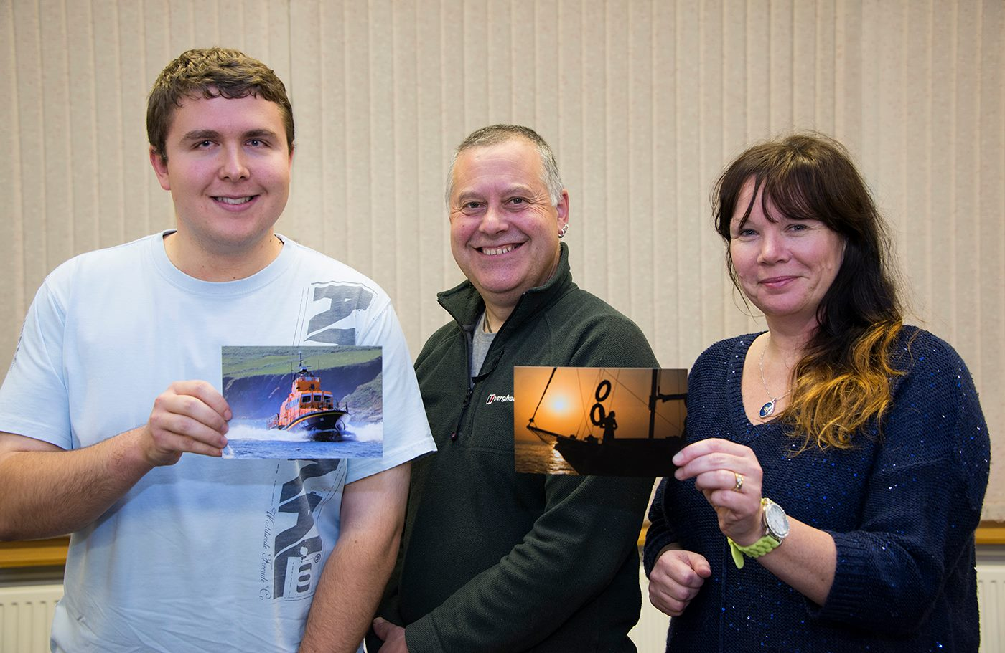After welcome refreshments and lots of conversation, the first Small Print competition of the season was held. The entries from the standard and intermediate groups were of various subjects and the competition was judged by past president, Tony Curtis, who whittled the images down to places and winners.
The standard group's winning photograph was titled “On The Move” by Thomas Carr. A lifeboat hurrying through the water with the hills behind it.
Nessie Gillen of the intermediate group took top spot with “Sundown, Turkish Waters”. It was a stunning scene of a boat and crew in silhouette against a golden sunset. In fact, Tony judged this to be the best image in the competition overall.
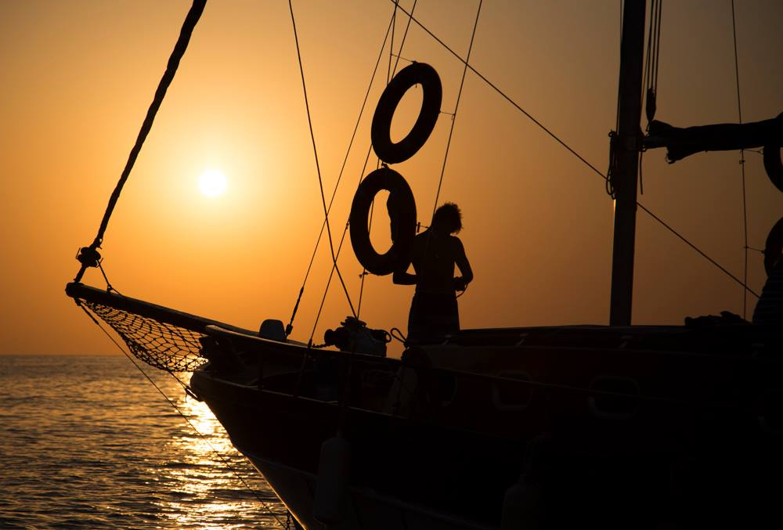
“Sundown, Turkish Waters” by Nessie Gillen was judged best overall image in the first Small Print competition of the season
RESULTS
Standard – 1st, 4th & 6th Thomas Carr. 2nd Lara Howe. 3rd Joy Brodie. 5th Norma Cowell.
Intermediate - 1st & 5th Nessie Gillen. 2nd Mark Falconer. 3rd & 6th Shirley Lotfy. 4th Ian Lumsden.
Visitors are always welcome to join us at Thie Ellyn, off Withington Rd. each Wednesday evening from 7.30pm.
By Anne Bidwell

IOMPS Reports During December 2014

25th December 2014 - Members Evening
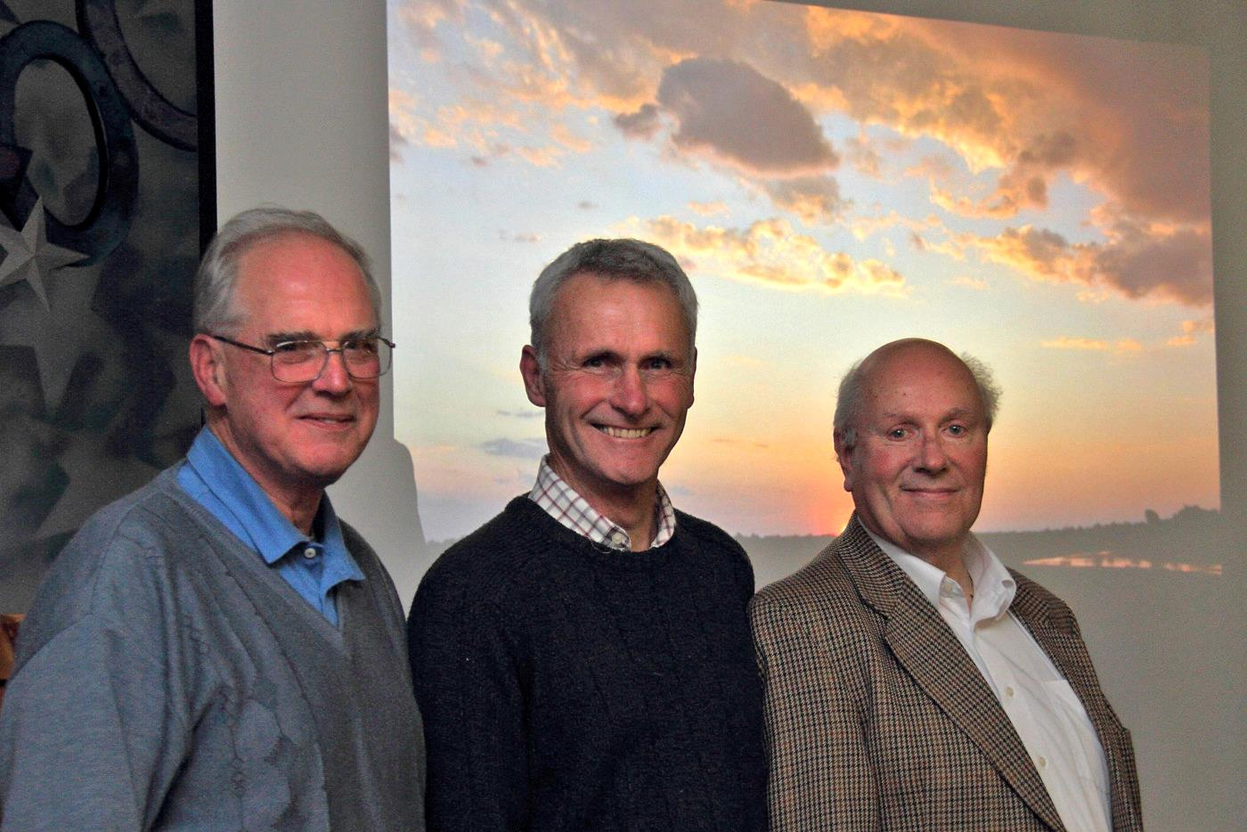
Chris Blyth, Richard Shafto and Mike Trout who each gave a presentation as part of Members Night
Last Wednesday December 17th The Isle of Man Photographic Society held a social evening where members were treated to, among other things, a picture quiz devised by vice president Chris Blyth. It was fun putting names to newsworthy faces and was won by “Team Norton” with 35 points out of a possible 40.
Two members, Mike Trout and Richard Shafto bravely volunteered to give short presentations of some of their work. Mike began with several stunning images of pink flamingoes using different types of focus. Some of the best were of just the bird's head with dominant eyes, and another just of the soft curves of their necks.
There were some really nice floral shots where differential focus and good light showed amazing details within the flower petals. Also pin sharp fungi with fascinating detail despite their dull, muted colours.
Mike also enjoys sport photography and showed a variety of action shots. He said he would really like to do more watersport photography in the future.
Richard Shafto has been fortunate in the past to have visited several African national parks and reserves including the Serengeti, Okavango and Luangwa. He displayed a variety of wildlife images taken during those visits for the members to enjoy.
One was of a baby elephant visiting camp and Richard had no idea that its mother was behind him at the time! He was very lucky to get several shots of leopard (mostly sleeping) because they can no longer be found in much of Africa. Also, Rhino are no longer to be found in Zambia because of the shameful poaching industry.
There were some lovely relaxed images of cheetah which Richard photographed inside a cheetah rescue centre. Indeed his wife was seen stroking one.
Another highlight for Richard was meeting a BBC production team who were busy making a new wildlife series with the well known wildlife photographer, Simon King to be screened next year.
Afterwards and due to the members generosity, everyone enjoyed a buffet with tea and coffee, sandwiches, savouries and plenty of festive favourites.
The evening ended with a showing of the Lancashire and Cheshire Photographic Union's current portfolio of mixed colour and black and white prints. They were of extremely high quality and gave our members a benchmark to aim for.
Vice president Chris Blyth made a point of thanking Ian Lumsden, Mark Stringer and Tony Curtis for their work in organising the L&CPU images. He also praised everyone who contributed to the successful members evening, from both Mike Trout and Richard Shafto to the people who brought in snacks and goodies. Big thanks are also due to Claire Stringer and the volunteers who make the drinks and wash up every week.
The society's next meeting will not be until January 7th when Antony Hamilton will present his “Presidents” evening. Entries will also be due for the Small Print competition.
The Isle of Man Photographic Society would like to wish all of its members and their families a Merry Xmas and a Happy New Year.
by Anne Bidwell

18th December 2014
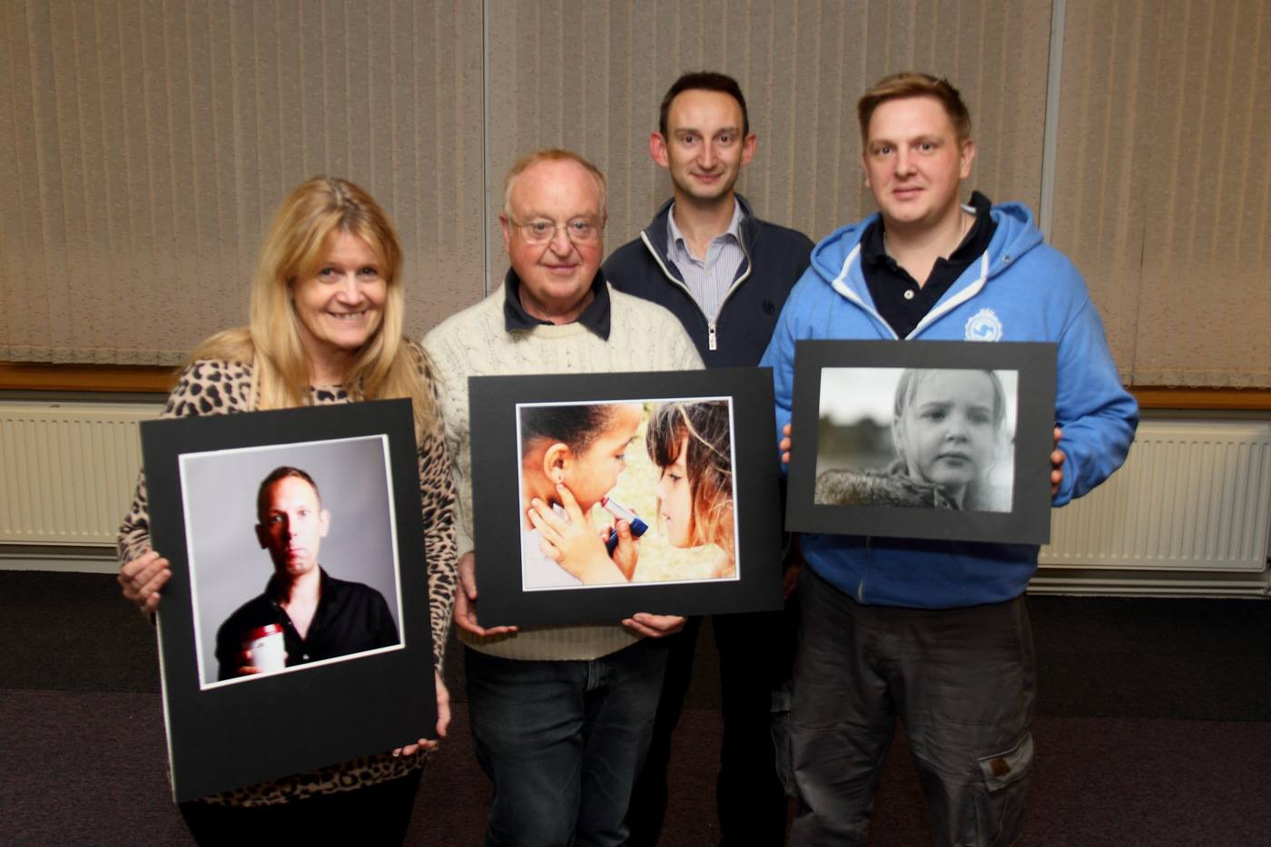
Joy Brodie, Chris Nicholls and Steve Meadows with Judge David Kneale
‘People’ was the topic set for the Society’s second assignment competition earlier this month for which members had entered 42 prints plus 53 digital images for projection.
To judge these entries, the Society was pleased to welcome back to Thie Ellyn Manxman, David Kneale. David is a professional photographer who is currently working as a photo-journalist with Isle of Man Newspapers. His own excellent photography, particularly of the 2008/09 Volvo Oceans Race, had been enjoyed by the membership in the past so there could be no doubting his impeccable credentials as a judge!
David was very complimentary about the high standard of the entries, which he had enjoyed viewing. He observed that the attention to detail by the entrants in all three Classes was much in evidence in their presentation of the images and he commended the Society in producing this level of quality. Members had wondered beforehand whether David would be strict or relaxed in his interpretation of the set topic. They need not have worried. He had adopted a fairly liberal approach because, in his view, "Any image which includes one or more persons qualifies as ’a people shot’ as the human interest always draws the eye of the viewer".
As was to be expected, David gave a clear, objective and fair assessment of every image. His relaxed, descriptive style was entertaining and punctuated by a nice touch of humour. His personality and natural enthusiasm of photography shone through as he offered sound advice and suggestions for improvement on the entries. His comments were constructive and helpful and any slight criticism was delivered in a kindly way and well received. Perhaps unsurprisingly in view of his current occupation, David’s approach was refreshingly different from what might be termed ‘the judging norm’ because he placed a strong emphasis on the importance of the story telling aspect of images. He wished to understand what the photographer was aiming to convey, so the context in which each image had been captured needed to be fairly obvious to the viewer. Facial expressions were one of the key elements of any ‘people’ picture as, to use his words, "these set the tone of the image". He also advised that the viewer generally welcomed and preferred to see a subject that was "doing something interesting" rather than being too static.
It is not unusual for there to be a debate in photography circles about whether the rules should be adhered to slavishly or broken from time to time. David’s view was that breaking the rules occasionally could result in a pleasing image, so he was prepared to accept anything, provided that it worked!
It was abundantly clear that David had devoted a great deal of time to view all the entries and his preferences were explained thoughtfully. He announced the competition results as follows -
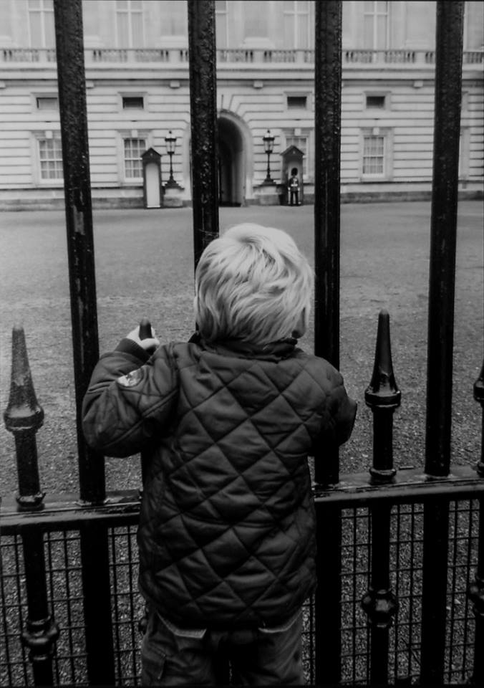
Best Overall Print Image went to Nessie Gillen for her image ‘Watching Guard’
Print Results:
Standard Group (Mono) – 1st ‘Chloe’ by Steve Meadows; 2nd ‘ Helen’ by Joy Brodie, who also took 3rd place with ‘‘A Bygone Era’; 4th ‘Three Little Monkeys’ by Steve Meadows; 5th ‘How Can One Little Insect Attract So Much Attention?’ by Beryl Quayle, this also taking the imaginary prize for the snappiest title! Mike Trout was 6th with ‘Beer for Breakfast?’
Standard Group (Colour) – 1st ‘Ouch! Burnt Mouth’ by Joy Brodie; 2nd ‘Shine Bright like a Diamond’ by Steve Meadows, who was also awarded 3rd place with ‘The Conqueror’; 4th ‘Wow! That was Fun’ by Richard Shafto; 5th ‘Love and Laughter’ by Beryl Quayle; and 6th ‘Man in the Street, Seattle’ by Richard Shafto.
Intermediate Group (Mono) – 1st ‘’Watching Guard’ by Nessie Gillen; 2nd ‘Party People’ by Chris Nicholls, who was also awarded 3rd place for ‘True to Life’; Nessie Gillen had her entry ‘Everyone’s Different’ placed 4th.
Intermediate Group (Colour) – 1st ‘Sisters’ by Chris Nicholls; 2nd ‘Rolling Out’ by Nessie Gillen; 3rd ‘Confetti Fun’ by Chris Nicholls; 4th ‘Juggling Egg, Frying Pan and Baguette’ by Nessie Gillen; 5th ‘Souvenir Seller’ by Shirley Lotfy; 6th ‘Daddy, What Big Shoes You’ve Got’ by Ian Lumsden.
Advanced Group (Mono) – 1st ‘Rising Steam’ by Ron Shimmin; 2nd ‘90 Years Old’ by Nigel Owen; 3rd ‘Contemplation’ by Sue Jones; 4th ‘A Bite to Eat’ by Ron Shimmin; 5th ‘Guitar Man’ by Sue Jones; and 6th ‘The Rider’ by Chris Blyth.
Advanced Group (Colour) – 1st ‘Marathon Run’ by Ron Shimmin; 2nd ‘Victorian Apparition’ by Sue Jones; 3rd ‘Napoleon’s Troops’ by Ron Shimmin; 4th ‘Splash of Colour’ by Sue Jones; 5th ‘Wet, Wet, Wet’ by Chris Blyth; and 6th ‘At the Punch and Judy Show’ by Ruth Nicholls.
David Kneale judged that the top award for ‘the Best Overall Print Image’ should be given to Nessie Gillen for her image ‘Watching Guard’ in the Intermediate Mono Class.
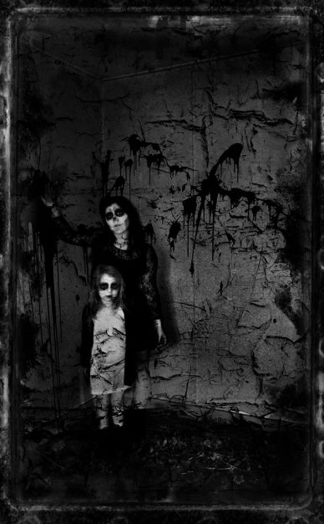
Best Overall Digital Image in the "People" assignment went to Hazel Walsh for "There's Nowt So Queer as Folk"
Projected Digital Images Results:
Standard Group – 1st ‘Beach Stroll’ by Steve Meadows; 2nd ‘Kids at Play’ by Graham Harvey; 3rd ‘The Brothers’ by Richard Shafto; 4th ‘Ready for a Bath?’ by Joy Brodie; 5th ‘Max’ by Steve Meadows; and 6th ‘High Street Fishing’ by Peter Keena. Mark Thorsby was commended for his image of ‘Street Performers, Teguise Market’.
Intermediate Group – 1st ‘There’s Nowt So Queer as Folk’ by Hazel Walsh; 2nd ‘The Rush’ by Nessie Gillen; 3rd ‘Dream Girl’ by Hazel Walsh; 4th ‘In the Zone’ by Martyn Parnell; 5th ‘Tea for Alice’ by Chris Nicholls; and 6th ‘Queen of the Fairy People’ by Nessie Gillen.
Advanced Group – 1st ‘I Caught it, You Clean It’ by Mark Stringer; 2nd ‘Fun in the Sun’ by Patricia Harvey; 3rd ‘Guy Martin’ by Diane McCudden; 4th ‘Guardian of the Vortex’ by Sue Jones; 5th ‘Ava’ by Patricia Harvey; and 6th ‘Evacuees’ by Ruth Nicholls.
David Kneale chose ‘There’s Nowt So Queer as Folk’ by Hazel Walsh in the Intermediate Group for the top award as ‘the Best Overall Digital Image’.
The President’s Evening’ will be held on Wednesday, 7th January, 2015, when guests will be welcome to attend and members’ entries will also be due for the next ‘Small Prints’ Competition.
By Antony Hamilton

11th December 2014
The IOM Photographic Society was pleased to have Alex Maddrell as our judge for an Open Digital Images competition this week. Alex has been a long-time supporter of club activities and has a proven track record as a judge, with the experience and skill to make judicious commentary on the entries, and to give helpful advice as regards possible improvements to the images – though always with the explicit warning as regards any thoughts being “in his opinion”. Nearly 60 entries were in contention, spread through the usual standard, intermediate and advanced sections into which our members are allocated. Alex proved a generous judge, with a large number of entries gaining “commended”(C), “highly commended” (HC) and even “very highly commended” (VHC) as well as the usual placings.
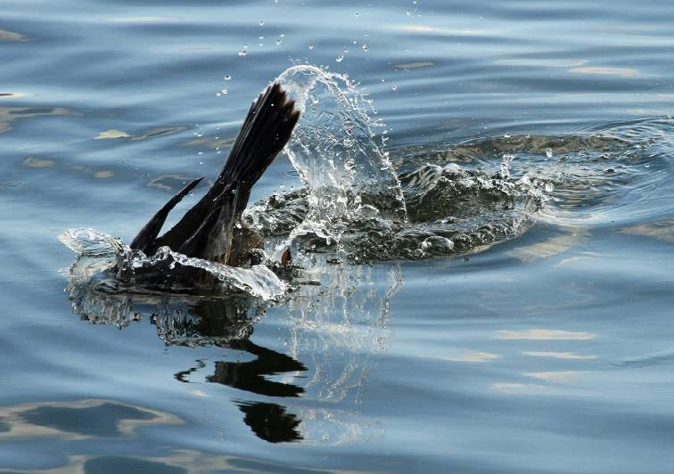
Best image in the digital open competition went to "Gone in a Splash" by Beryl Quayle
The standard group comprised the largest group with 26 entries, and provided some close competition, with Beryl Quayle emerging as the section winner with an intriguing image - “Gone in a Splash” - the tail of a shag “duck-diving” into the water in search of food, the water droplets as it dived being perfectly caught in the image and with interesting ripples in the water surface.
The Intermediate group was also very competitive, with another natural history entry coming out on top – “Robin Redbreast” – a close-up and very seasonal image by Anne Bidwell, the feather detail and red breast colours of a robin vivid and well caught. Chris Nicholls produced both second and third placed images in this section – his delightful image of Camargue white horses running in water spray coming second, and perhaps giving Alex a difficult decision as to his placings.
The smallest entry came with the advanced group, just 14 entries, but all of high quality. A still-life won this section – “Pastel petals” – an arrangement beautifully handled by Ruth Nicholls of petals with their soft, translucent colours, just holding off the challenge of a superb natural history shot of a marine iguana by Patricia Harvey. Alex awarded his “best image in competition” to Beryl Quayle for the image of the shag diving – further evidence of the narrow gap between our groupings, and the need for advanced members to stay on their toes….
Results of Open Digital Competition – Standard Group : Beryl Quayle (1 & 4), Richard Leach (2), Richard Shafto (3 & 6), Tim Norton (5 & C), Steve Meadows (HC), Lara Howe (HC), Karen Norton (HC),Mark Thorsby (C), Sakkie Meeuwsen (C). Intermediate Group : Anne Bidwell (1), Chris Nicholls (2 & 3), Martyn Parnell (4 & VHC),Shirley Lotfy (5 & C), Annette Slater (6 & VHC), Jiri Podobsky (VHC x 2), Jenny Shanley (HC & C), Hazel Walsh (HC & C). Advanced Group : Ruth Nicholls (1 & 6),Patricia Harvey (2 & VHC),Claire Stringer (3 & C), Sue Jones (4 & 5), Chris Blyth (VHC x 2), Diane McCudden (VHC & HC), Mark Stringer (C).
The Society meets at the Art Society Building (Thie Ellyn) in Withington Road, Douglas, with all meetings starting at 7:30pm. Full membership is £25 per year, with a guest fee entry of just £1. Meetings are open to the public, and all will be given a very warm welcome. Full details of our programme can be found on our website at www.iomps.com. Our next meeting on Wednesday, 17th December will include a members evening, together with a showing of a portfolio of images from the Lancashire and Cheshire Photographic Union – sure to be excellent images as they are selected from the very best of the entries submitted in competition by the member clubs.
By Chris Blyth

4th December 2014
The IOM Photographic Society was delighted to welcome Dennis Wood from the Western club to judge our latest competition, for Open Prints. As usual, the members were split into three sections – Standard, Intermediate and Advanced, with members each competing in both monochrome (essentially black and white) and colour classes. Competition success over the season provides the opportunity for promotion (though it is to be noted some members occasionally regret that there is no equivalent mechanism for demotion !)…..
Dennis is an experienced photographer with wide-ranging skills, able to understand the techniques behind an image, whether in the moment of its taking, or in its printing. He is a very confident and competent judge, with an excellent “eye” to appreciate a composition and, importantly, just what is needed to enhance the final image – but all with the caveat that any comments are predicated “in his opinion”. The 70 images in competition were each given a full commentary, with the good points emphasised but – particularly in the Advanced section - possible areas for improvement identified, and with a resulting loss of position.
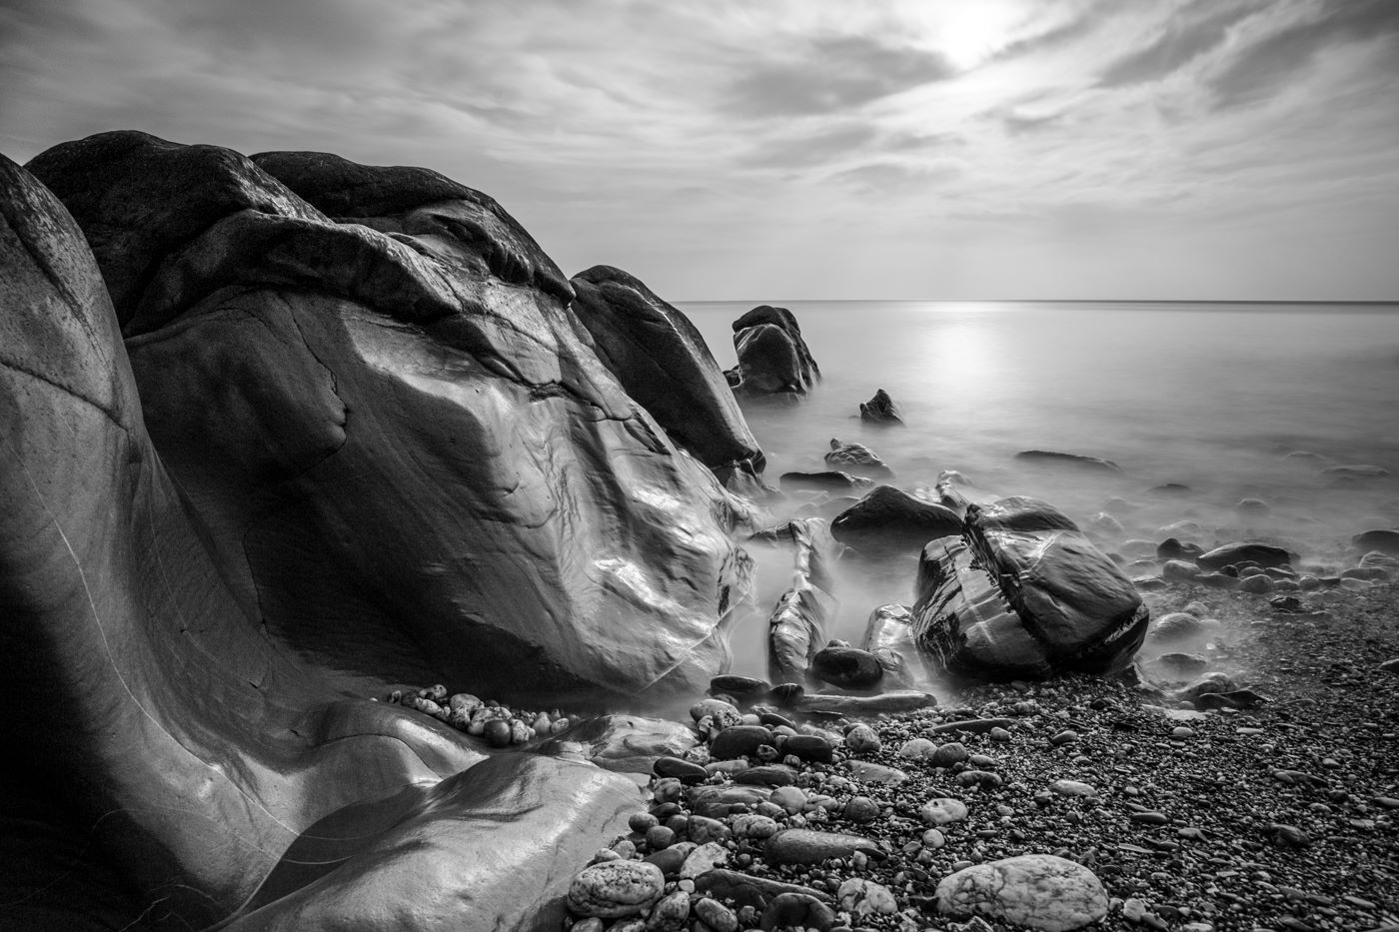
Best image in the Open print competition” went to Nessie Gillen for her mono entry “Nature’s Art”
As an open competition, the images shown covered a wide spread of topics – from portraits to landscape, from natural history to still life – and of an excellent standard. Indeed, a number in the Standard and Intermediate sections earnt some very complimentary remarks, and bearing comparison with anything seen in the Advanced section – a sign of the very competitive nature of our members, and the ready availability and accessibility of today’s excellent technology in cameras, computers and printers. To prove the point, Dennis’s choice of “best image in competition” went to Nessie Gillen in the Intermediate group for her mono entry “Nature’s Art”, a lovely beach scene beautifully printed, with rocks dominant in the left hand side of the image, and balanced by a calm sea with sunlight (possibly moonlight?) reflections on the right hand side.
Also of note was the strong performance by Mike Trout in the Standard Mono class with two excellent prints getting him a first and second, a superb print of a sand-racing motorbike at Peel giving Beryl Quayle top position in the Standard colour, whilst Ian Lumsden’s lovely colour rendition of the London Eye gained him a first in the Intermediate colour. Meanwhile, Sue Jones and Ron Shimmin continued their long-running battle for supremacy in the Advanced group, with Sue triumphant in the mono with a re-enactment portrait of a Home Guard, and Ron reversing the position in the colour section with a delightful portrait of a young girl, studying in a museum.
Nigel Owen, Club Treasurer, gave the vote of thanks.
Open Prints Competition Results : Standard Section Mono - Mike Trout (1 & 2), Lara Howe (3 & 4), Tim Norton (5), Richard Shafto (6). Colour – Beryl Quayle (1), Paul Dougherty (2), Lara Howe (3 & 5), Richard Shafto (4), Mike Trout (6). Intermediate Section Mono – Nessie Gillen (1), Chris Nicholls (2 & 4), Annette Slater (3), Jenny Shanley (5 & 6). Colour – Ian Lumsden (1), Annette Slater (2), Shirley Lotfy (3), Chris Nicholls (4 & 5), mark Falconer (6). Advanced Section Mono – Sue Jones (1 & 5), Ron Shimmin (2 & 4), Nigel Owen (3), Ruth Nicholls (6). Colour – Ron Shimmin (1), Sue Jones (2 & 4), Ruth Nicholls (3), Dave Welsh (5 & 6).
The Society meets at the Art Society Building (Thie Ellyn) in Withington Road, Douglas, with all meetings starting at 7:30pm. Full membership is £25 per year, with a guest fee entry of just £1. Meetings are open to the public, and all will be given a very warm welcome. Full details of our programme can be found on our website at www.iomps.com. Our next meeting on Wednesday, 10th December, will include an assignment competition on the topic of “People”, in both print and digitally projected formats.
By Chris Blyth

IOMPS Reports During January 2015

29th January 2015 - Digital Flora and Small Prints
The Isle of Man photographic Society recently held a double competition evening. The first was an Open digital assignment entitled Flowers/Flora, and was judged by a long time friend of the society, Eddie Fryer. The second was a Small Print competition expertly judged by Ruth Nicholls. Both judges are experienced photographers and are active in the Western Photographic Society in Peel.
There were 46 entries in the Open Digital competition covering both standard, intermediate and advanced abilities. All the entries were of a very high standard and featured many types of flower and plant.
The winner in the standard group was Tim Norton with a strong image of a long, stripy leaved Aguava plant in a natural setting. “Our Roses” was the winning image for intermediate member, Nessie Gillen. It was a soft black and white picture of four beautifully displayed rose stems. The runaway winner in the advanced section was Claire Stringer's image of the inside of a clematis flower. With its papery textured petals and sublime purple colour it also took the title of Best Overall image of the assignment.
It was obvious to everyone that Eddie Fryer had taken a lot of time and care in making his selections, and he'd found it a difficult task due to the high standard of the members work.
Moving on to the Small Print competition, it was Ruth's turn to examine the entries and decide on the best ones. Of the standard group's 20 entries, the winning image belonged to Joy Brodie and was a very pleasing shot of parasailing with a big multi coloured parachute against a classic blue sky. This high impact photo also took Best Overall winner in the competition. The intermediate group had fewer entries and was won by Shirley Lotfy with “Street Performer”, an image of a man in a mask and jester type costume playing a large mandolin.
Open Digital Assignment Results
Standard
1st Tim Norton, 2nd Karen Norton, 3rd Richard Leach, 4th Richard Shafto, 5th Beryl Quayle, 6th Mark Thorsby.
Intermediate
1st & 5th Nessie Gillen, 2nd & 4th Shirley Lotfy, 3rd Chris Nicholls, 6th Jenny Shanley.
Advanced
1st & 4th Claire Stringer, 2nd Chris Blyth, 3rd Nigel Owen, 5th & 6th Sue Jones.
Small Print Competition Results
Standard
1st Joy Brodie, 2nd & 3rd Richard Shafto, 4th & 5th Steve Meadows, 6th Tim Norton.
The society is holding its annual photographic exhibition at the Loom Gallery, Laxey from 14th Feb - 14th March
by Anne Bidwell

22nd January 2015 - Cancelled Meeting
The adverse weather last Wednesday unfortunately resulted in a decision to cancel that evening’s meeting of the IOM Photographic Society, a decision which was welcomed by many members reluctant to leave the warmth of their homes. The committee will be announcing shortly whether and how the planned events can be re-scheduled within the remaining part of the season.
In the meantime, there is much to be working towards, with a number of other competitions still to be decided, and in particular, the members’ exhibition to be held at the Hodgson Loom Gallery at the Laxey Woollen Mills, opening to the public Saturday 14th February until Saturday, 14th March.
The exhibition is to be opened by the Speaker of the House of Keys, The Hon Stephen Rodan, who is, of course, also the MHK for the local constituency of Garff. The Gallery provides a superb display area – warm, intimate, and with excellent lighting –and as always, it will curated by Julia Ashby-Smyth, allowing the works to be shown to maximum advantage. The IOMPS is delighted to have the opportunity for the exhibition, now in its fourth year at the gallery, and which is a highlight event in their calendar.
The works, some 80 in total, will feature a wide variety of work by members of the society – some exhibiting for the first time – with most images on display being available to purchase. The exhibition will include both a wide range of subject matter (for example, portraits, natural history, landscape, and architecture) and the work of a wide number of members of the society, which includes some of the island’s finest photographers. Amongst the better known names of those exhibiting will be
- Dr Ruth Nicholls LRPS DPAGB BPE3* EFIAP – perhaps the “most qualified” photographer, having had her work accepted at numerous exhibitions both nationally and internationally, her landscapes and floral studies in particular of the highest quality
- Ron Shimmin LRPS – a long-time member with an enviable record for producing highly artistic images with a meticulous attention to detail, whether architectural shots or street reportage
- And Sue Jones CPAGB – another long-time member, now a full-time professional working with Andrew Barton from his Ramsey studios, and who produces top quality images in a wide range of genres
More than twenty members are expected to be included as exhibitors, each showing some of the best of their work, and all contributing to what will be an exceptional display of photographic talent, and making a visit to Laxey well worth while.
by Chris Blyth

15th January 2015 - Presidents Evening
Presentations by Antony Hamilton, President of the IOM Photographic Society, are always eagerly awaited – he has made a number of digital slideshows in recent years as part of his “official duties”, and can be relied upon to provide some excellent photography together with a brief but informative commentary – usually with a number of asides and comments whose dry wit is both entertaining and much appreciated…..
This week’s slideshow, the re-start of the society’s programme after the Christmas break, was the story of a cruise around Iceland in 2012 on board the Celebrity Eclipse. The introductory tour of the ship, following boarding in Southampton, made clear that life on board was not uncomfortable, with some delightful facilities including luxury cabin, well stocked library, and a variety of excellent restaurants and bars……
Arriving in Iceland, a tour of Reykjavik took in some of the sights and an explanation of some of the history and culture. Iceland’s location on the mid-Atlantic ridge and the shifting tectonic plates between Europe and North America explains the ready availability of geothermal energy providing cheap and very accessible central heating / hot water and electricity - something to be envied in the middle of a manx winter. Other direct comparisons with the Isle of Man were clear – the Icelandic Parliament (the Althing) is the world’s oldest having been founded prior to Tynwald, but has an interrupted history so is not the oldest continuous parliament. Several place names were recognisable, sharing a common norse linguistic ancestry – such as Snaefell, for example – whilst the architecture of Reykjavik cathedral proved to be stunning, with a steeply pitched roof, and superb interior with some wonderful woodwork.
Departing Reykjavik, the cruise then went on to Akureryi on the north coast, a remote port but the second city of Iceland, with some beautiful scenery as a backdrop – all shown in a well-constructed slideshow of just the right length. The presentation finished with a selection of images taken over a number of years and which demonstrated the range of Antony’s photographic interests. The evening ended with refreshments and the opportunity for members to socialise and chat, following the mid-season break.
Our next meeting on Wednesday 21st January includes an assignment competition for both prints and digital images on the topic of “Flowers and Flora”. The Society meets at the Art Society Building (Thie Ellyn) in Withington Road, Douglas, with all meetings starting at 7:30pm. Full membership is £25 per year, with a guest fee entry of just £1. Meetings are open to the public, and all will be given a very warm welcome.
by Chris Blyth

14th January 2015 - Tonight Cancelled
With the weather conditions set to deteriorate as the evening progresses, we have taken the decision to cancel tonight's meeting, If you know of any members who won't see this message can you please forward onto them, and we will be in touch with alterations to the programme in due course.

8th January 2015 - “When the going gets tough…..”
Now at the half way point in our current season, the race is on ….and with the pace accelerating for the final run-in to the completion of the programme in April, with a series of competitions to decide the awards and cups at the end of the season. The season so far has been exciting, with new members making their presence felt with some very competitive performances, and several judges having remarked that the older, more senior members need to “up their game” if they want to stay ahead…. Meantime, the general standard of photography has been excellent, giving good entertainment for our members, and providing lots of discussion points……
In the Standard group, there are three members leading two classes each – Lara Howe is in front for the open mono prints and assignment digital classes, Beryl Quayle the front runner in the open colour prints and open digital classes, and Joy Brodie leading the assignment prints in both mono and colour classes. However those close behind and making for a really competitive finish to the season include Mike Trout, Paul Dougherty, Karen Norton, Richard Leach, Graham Harvey, Steve Meadows, Peter Keena and Richard Shafto.
The Intermediate group shows a wide spread of talent, with no clear winners at this stage, but everything to fight for – Chris Nicholls is leading both the open digital class and the assignment colour prints, and co-leading the assignment mono prints, and showing strongly in several other classes as well, so is perhaps the obvious front runner. However, Nessie Gillen is leading in the assignment digital class, and sharing the lead with Chris in the assignment mono prints, so will clearly be one to watch. Meanwhile Jenny Shanley is leading the open mono prints class, whilst Shirley Lotfy shares the lead in the open colour prints class with Ian Lumsden. As in the Standard group, a number of other members are close behind, such as Anne Bidwell, Mark Falconer and Hazel Walsh, and a good performance in any one of the competitions ahead could well be a winning one.
The Advanced group is seeing something of a minor upset, with Ron Shimmin – always a top quality worker - leading all the print classes (mono and colour in both open and assignment sections) with Sue Jones perhaps unusually in second position. And whilst the digital sections are always a closely fought battle, this year the contenders featuring strongly include Patricia Harvey, Claire Stringer, and husband Mark Stringer.
As always, our thanks go to our judges for their hard work and essential contribution to our programme, and to our speakers. Meanwhile, our programme for 14th January next week includes a digital presentation by Pete Geddes MBE, and a small print competition. The Society meets at the Art Society Building (Thie Ellyn) in Withington Road, Douglas, with all meetings starting at 7:30pm. Full membership is £25 per year, with a guest fee entry of just £1. Meetings are open to the public, and all will be given a very warm welcome.
by Chris Blyth

IOMPS Reports During February 2015

26th February 2015 - Travels in Nicaragua & Small Print Competition
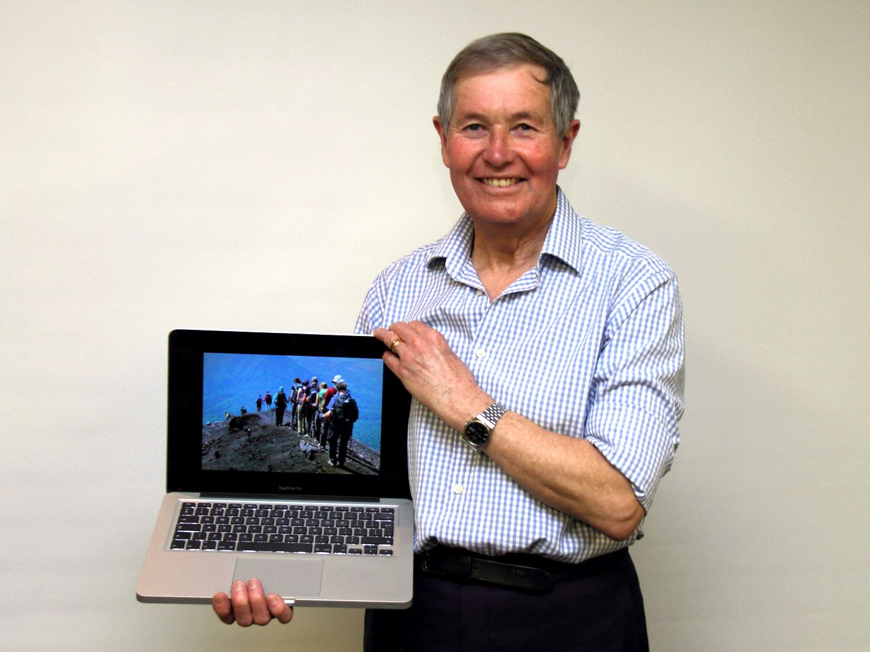
Peter Clague with one of his amazing images from Nicaragua
When most of us think of holidays, we usually have in mind a pleasant, relaxing trip to a warmer climate for a little sun, or a cultural break, perhaps even a river or deep sea cruise. Not so the amiable and multi-talented Peter Clague, ex school teacher, still fondly remembered by hundreds of ex-Douglas High School pupils. For Peter, something rather more adventurous and energetic is the norm, often to far away, remote places where the number of visitors is relatively small. Of course, the members of the Society knew what to expect. After all, they have delighted in previous photographic presentations from Peter as he has searched out the sites of volcanoes and satellite telescopes across the globe since his retirement!
On this occasion, Peter transported us all to the tropical Republic of Nicaragua, a land of Volcanoes and Lakes, most notably Lakes Nicaragua and Managua. This Spanish, central American country has a population of about 6 million people and is bordered by Costa Rica to the south and Honduras to the north. He had flown in 2013 with American Airlines from London Heathrow (via Miami) to the Nicaraguan capital, Managua, the third-largest city in Central America. Here he met his travelling companions for the first time, a mix of hardy, like-minded British and Germans adventurers. The first stop was at the colonial city of Granada, Nicaragua’s oldest Spanish city, to see the sights on foot. Whilst there, they visited the Masaya Volcano at dusk, with its hot, choking gases, followed by the Mombacho Volcano, the latter involving a very steep ride up to the crater region. They were then driven north, through Managua, to their first campsite near Laguna El Tigre.
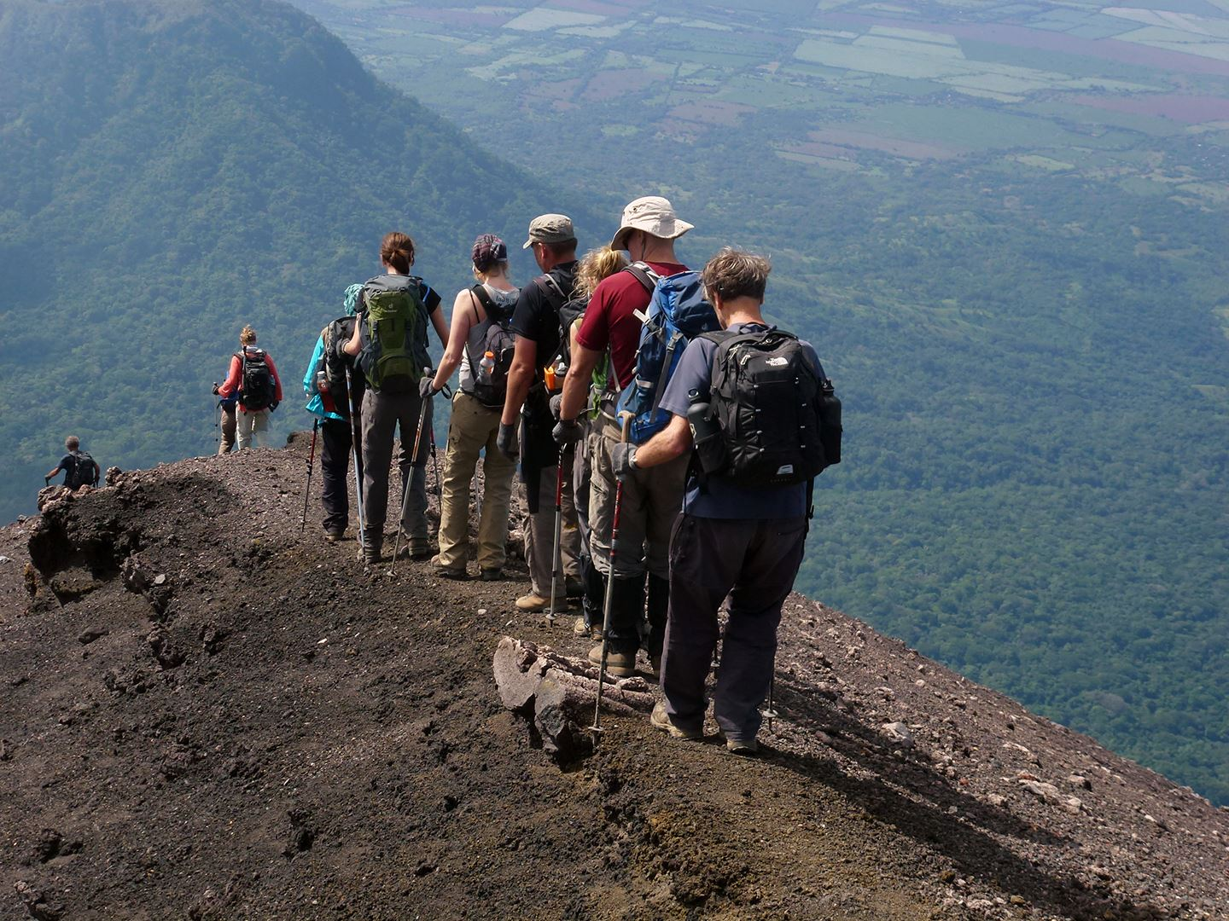
Descending the volcano San Cristobal, one of many excellent images from Peter Clague's presentation "Travels in Nicaragua"
It was from here that the 'long trek' began, lasting 6 days in a generally northern direction. The group of 14 were led along off road tracks, sleeping in tents along the way. What facilities there were could only be described as basic. There was no running water in the camps, but there was fresh milk and filling food. The tracks were mostly through the bush where only the experienced guides could lead the way safely. The climbs were highly challenging and slippery under foot as the terrain was principally a fine gravel-like surface on the steep gradients. One imagines that even sure-footed goats would have had difficulty!
In total, the group visited 7 of the 9 ‘active’ volcanoes in the country and wearily climbed 5 of them, namely Momotombo on the side of Lago de (Lake) Managua, El Hoyo, Cerro Negro, Telica and San Christobal, the highest at 5725 feet. A good head for heights and reasonably agility seemed to be pre-requisites, but Peter assured us that the views from the top and into the craters were worth the tortuous climbs!
Peter’s lasting memories of this arduous trek were of the vibrant colours of the unsophisticated local artwork, the abundant flora and fauna, the many mammals, reptiles and giant insects and the beautiful birds. He reserved a special mention of the poor but friendly indigenous people who welcomed their intrepid visitors with a cheerful smile and asked only to be photographed with them. The commentary given by Peter was both fascinating and educational – none of us knew before, for example, that 50% of the world’s Sloth population live in Nicaragua! He was thanked by the Society for his excellent photography and for a most entertaining evening of armchair travel.
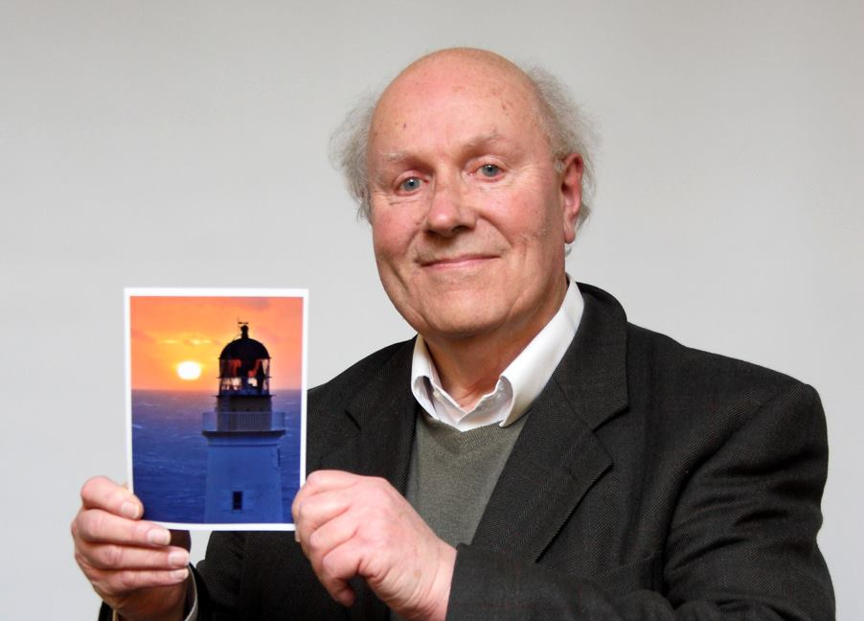
Small Print Judge Mike Trout with the overall winning image
The judge for the final Small Print Competition in the programme was one of our own members, Mike Trout. Though this was the first time he had been asked to judge a photographic competition, he was quickly into his stride. There were 21 entries in the Standard Class, for the least experienced photographers, but only 6 in the Intermediate Class. The images were all very good and he commented on each one in both classes.
Mike had been thorough in his appraisals and his awards as follows:-
Standard Class – 1st Barry Murphy with ‘Douglas Head Sunshine’, an excellent image of the lighthouse against the rising Sun; 2nd Joy Brodie with ‘Model Boat Racing’; 3rd and 4th Beryl Quayle with ‘Patterned Stones’ and ‘Twisted Chimney’ respectively; 5th Barry Murphy with ‘Arctic Tern’; and 6th Richard Shafto with ‘The Seattle Great Wheel’. Steve Meadows was Highly Commended for ‘Princess Pansy’ and Karen Norton was Commended for ‘Point of Ayre Lighthouse’.
Intermediate Class – 1st Jenny Shanley with ‘Happy Shoppers’; 2nd Shirley Lotfy with ‘Tulip’, 3rd Jenny Shanley with ‘Loughtan Ram’; 4th Shirley Lotfy with ‘Kayaks’ and she was also placed 6th with ‘Boats’.
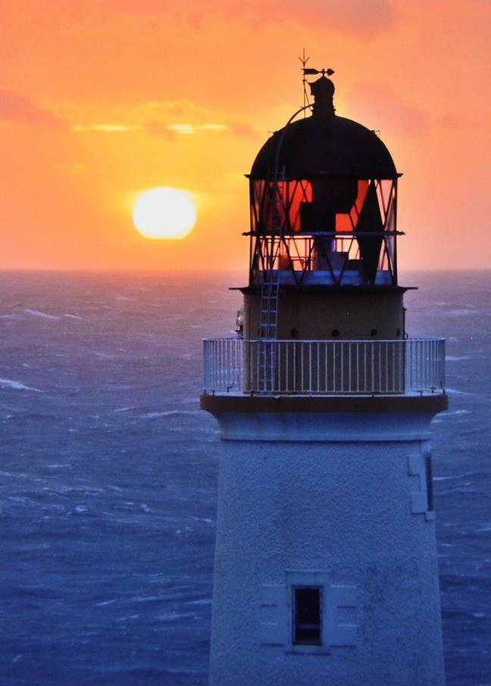The overall winner on the night was judged to be Barry Murphy’s image of ‘’Douglas Head Sunshine’.
By Antony Hamilton

19th February 2015 - OPEN DIGITAL COMPETITION
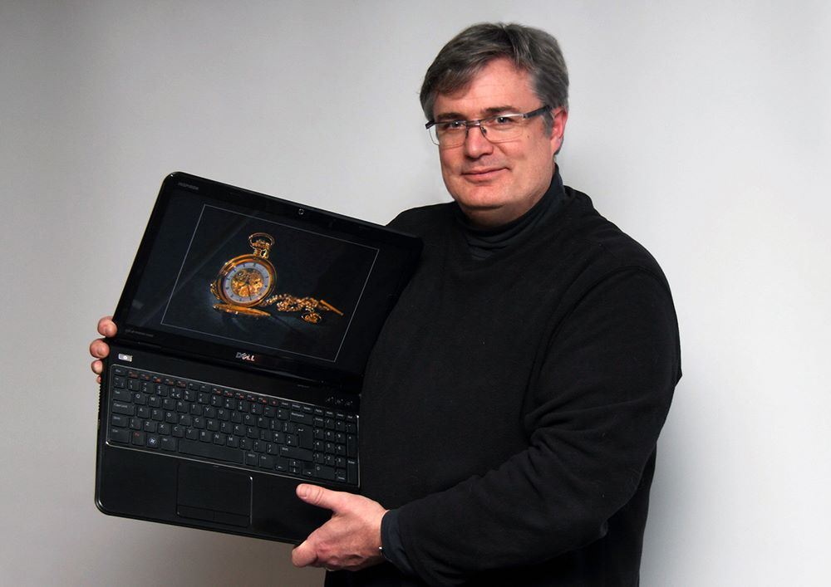
Judge Andrew Barton with the Best Overall digital image
The Isle of Man photographic Society recently held their third Open Digital competition of the current season. There were a total of 58 entries which were expertly judged by Andrew Barton LBIPP LMPA.
Andrew is a very successful professional photographer based in Ramsey. He was made an honorary member of the IOMPS after many years of friendship and support for the club.
Andrew said that he was very pleased to be invited to judge this competition as the entries were good quality across the board. He noted that the standard of photography at the club had increased massively over the years.
Andrew's gentle but valid criticisms were paired with thoughtful input and helpful advice. His expertise and knowledge were very obvious to all, especially his insight into the use of camera and light sources.
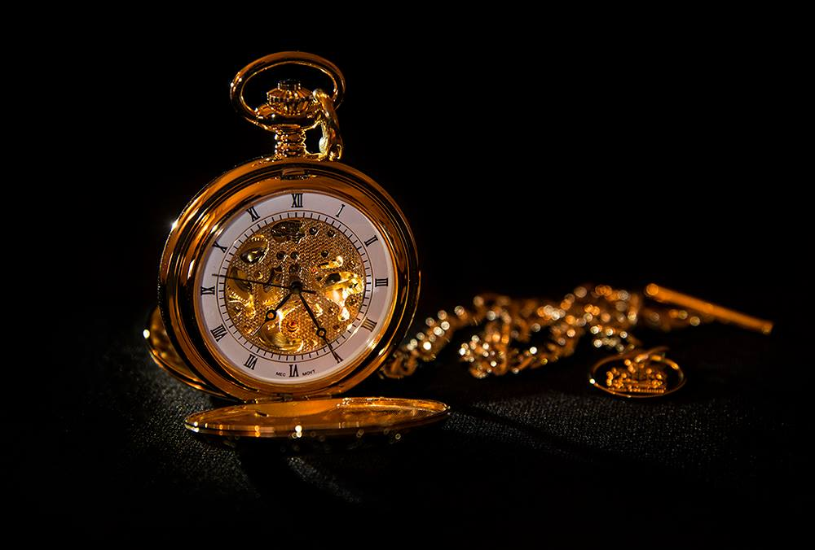
Best image in the Open Digital competition went to Sue Jones for "Timepiece"
Of the standard group's entries, Andrew judged Barry Murphy's “Battery Pier Light” as the clear winner. The top part a lighthouse against a dramatic dark blue, starry sky had strong light with warmth and movement.
The winner in the Intermediate group was a well shot photo of two dapple grey stallions standing in the early morning mist, by Chris Nicholls. “Stallions Out Early” was a strong image with lovely soft lighting.
The clear winner in the Advanced group was a wonderful composition by Sue Jones. The strong light and beautiful warm feel of an open pocket watch and chain in gold was Andrew's favourite and also his choice of Best Overall image of the competition.
RESULTS
Standard
1st & 4th Barry Murphy, 2nd & 3rd Steve Meadows, 5th Richard Shafto, 6th David Norton, HC Mark Thorsby.
Intermediate
1st & HC Chris Nicholls, 2nd Jenny Shanley, 3rd Martyn Parnell, 4th & 6th Nessie Gillen, 5th Shirley Lotfy.
Advanced
1st & 3rd Sue Jones, 2nd Ruth Nicholls, 4th & 5th Claire Stringer, 6th John Phipp.
The society has an exhibition at the Loom Gallery in Laxey going on until March 14th. It is well worth a visit to view or purchase some outstanding photographic images.
On February 25th will be a presentation by Pete Geddes MBE on "The Work of the Laxey Mines Research Group". Entries will also be due that night for the Isle of Man Bank Cup.
by Anne Bidwell

12th February 2015 - February Open Print Competition
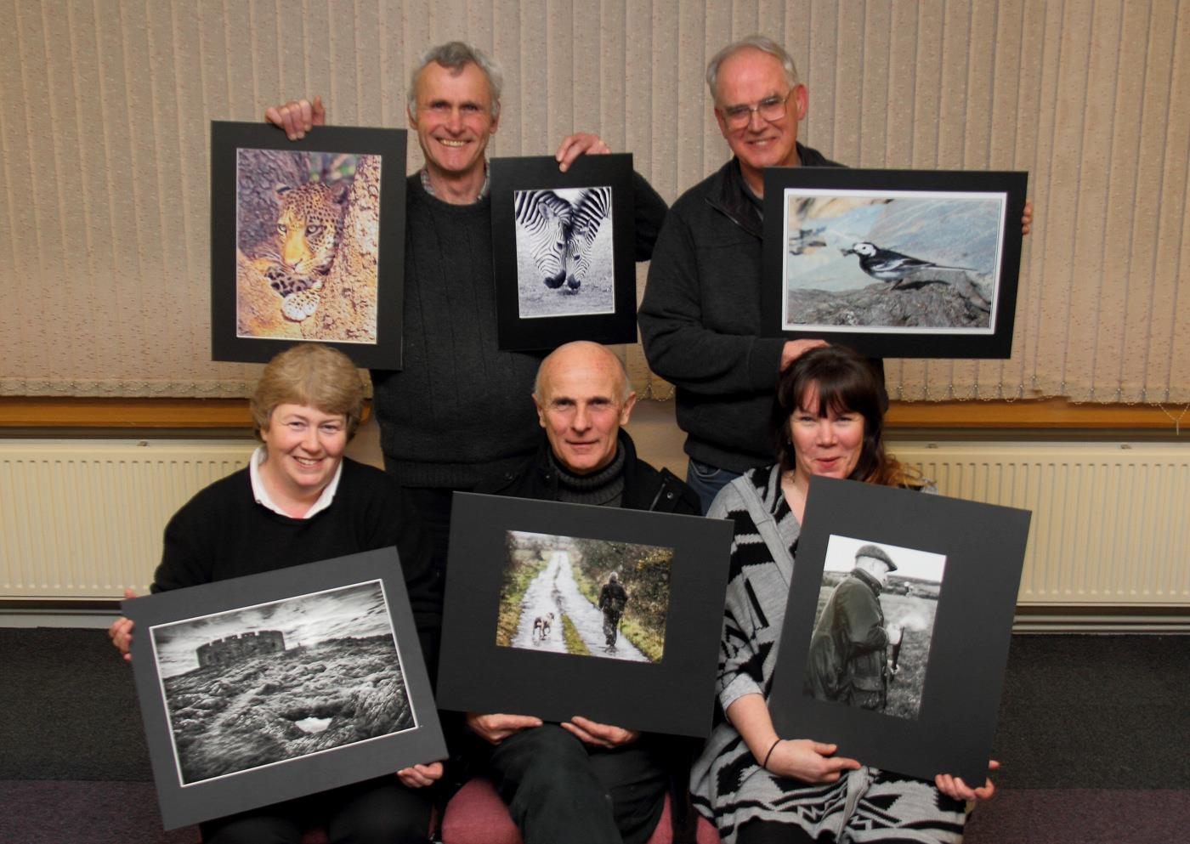
Open Print winners Sue Jones; Richard Shafto; Chris Blyth and Nessie Gillen with Judge Ray Kelly
The latest Open Prints competition for the IOM Photographic Society was held this week, and ably judged by Ray Kelly. Ray is always a popular visitor, frequently called upon to make judgement of our efforts. He has a good eye and a considerable knowledge of photography, plus a stream of insightful comment and a ready wit – a sure-fire mix with which to amuse and entertain our members, yet always ensuring a clear understanding of his thoughts on the merits (or otherwise) of the images under consideration. An “open” competition is particularly difficult in that the subject matter is entirely the choice of the photographer - and how does a judge decide that one image is better than another when comparing a natural history image with an architectural interior, or a portrait against an abstract? And yes, it becomes subjective – a different judge on a different night may give a different result – but that’s all part of the enjoyment (and perhaps consolation) for the competitors!
Natural History images proved a popular subject, providing a number of entries and winning several classes. The Standard group was dominated by Richard Shafto, who has been fortunate to visit the South Luangwa National Park in Zambia and seen close-up some of the superb wildlife still available there. He recently gave a talk to the members about his travels, but confessed he was saving his best images for competition – several of which duly emerged this week! A close-up and very emotive image of a zebra mare and foal nose-to-nose won the mono section, whilst another close-up, this time of a leopard, took the honours in the colour section.
Similarly, Nessie Gillen dominated the Intermediate group, again winning both sections, this time with portraits – the mono class with an image of a gentleman with a shotgun, the cartridge cases caught being ejected from the barrels, and in the colour section, an image of a man and his dog walking into the distance, the track providing a strong lead-in to the image.
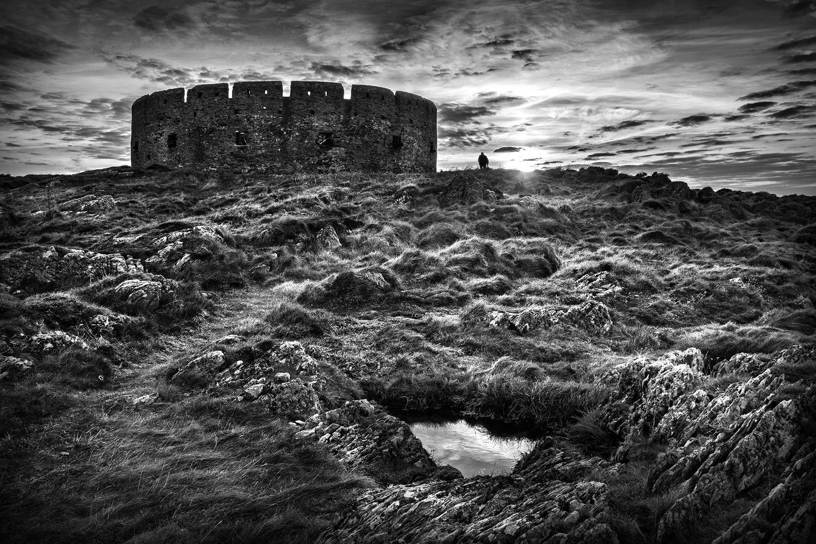
"Fort Island" by Sue Jones won best overall image in the Open Print competition
In the Advanced group, Chris Blyth’s close-up shot of a pied wagtail enjoying a tasty fly for its lunch on the beach at Niarbyl attracted Ray’s approval, whilst Sue Jones won the mono section with a superb high contrast image of Fort Island, the detail of the grasses and a path leading the eye up towards the fort being very well shown. It deservedly won the award for “best image of the competition”.
A public exhibition of members work is on show at the Hodgson Loom Gallery at the Laxey Woollen Mills from 14th Feb – 14th March, with most of the images being available for purchase.
RESULTS – Open Competition. Standard Mono Prints - Richard Shafto (1 & 3), Mike Trout (2 & 4), Beryl Quayle (5 & 6). Colour Prints – Richard Shafto (1 & 3), Beryl Quayle (2 & 5), Paul Dougherty (4), Mike Trout (6), Joy Brodie (HC), Tim Norton (C). Intermediate Mono Prints – Nessie Gillen (1 & 5), Chris Nicholls (2), Jenny Shanley (3 & 4). Colour Prints– Nessie Gillen (1 & C), Chris Nicholls (2 & HC), Shirley Lotfy (3 & 4), Ian Lumsden (5), Jenny Shanley (6). Advanced Mono Prints – Sue Jones (1 & 2), Ron Shimmin (3 & 4). Colour Prints – Chris Blyth (1 & HC), Sue Jones (2 & C), Ruth Nicholls (3 & 5), Ron Shimmin (4 & 6).
by Chris Blyth

5th February 2015
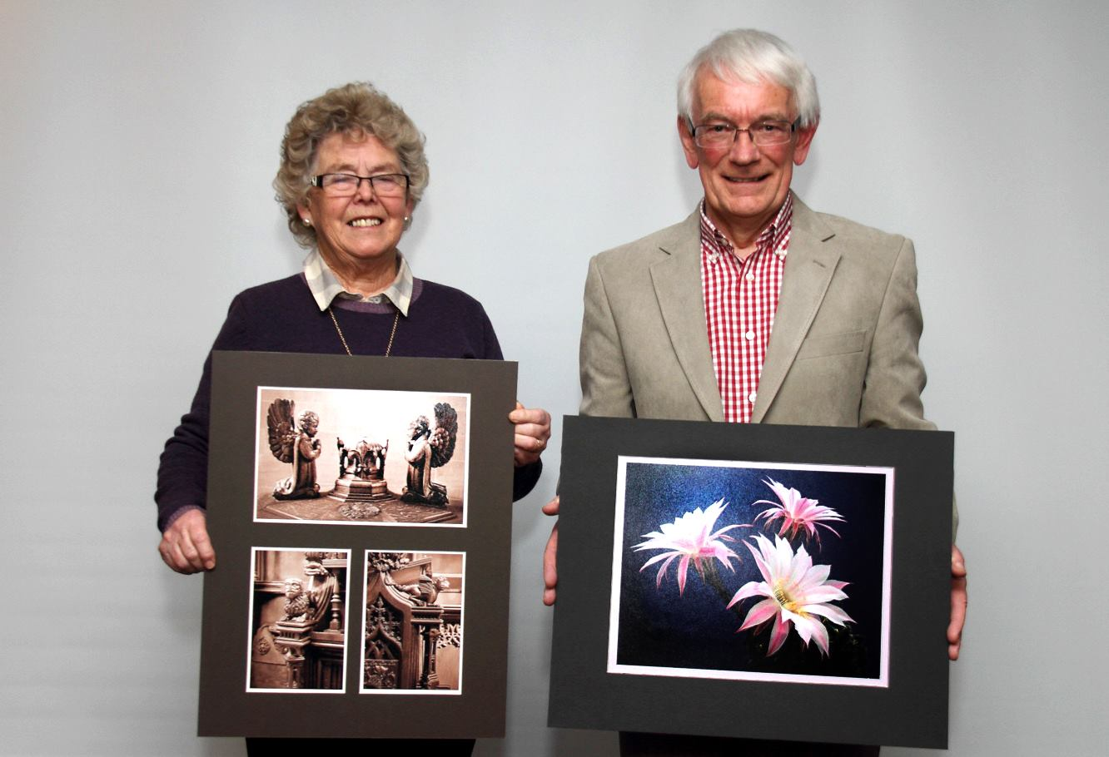
Our two Judges Pam Kershaw and Eddie Fryer with the winning prints
I suppose we have to accept that, at this time of the year, we often have to battle against the elements if we wish to pursue our hobby. For those of us who are fair weather photographers – and I am one who falls into that category - this can come as a bit of a shock to the system, but diehard enthusiasts are not so easily deterred! We had already been forced to cancel one Wednesday evening earlier in January because the Meteorological Office at Ronaldsway had issued a ‘red warning’, advising motorists to stay at home to avoid storm force winds so the arrival of heavy snow in the east of the Island at the end of January 2015 was the last thing we needed. As expected in such conditions, our attendance was severely limited but the snow had arrived sooner than expected and too late for us to abandon the evening’s schedule anyway! In spite of this, the atmosphere inside ‘Thie Ellyn’, was warm and friendly, as it always is. We decided to proceed.
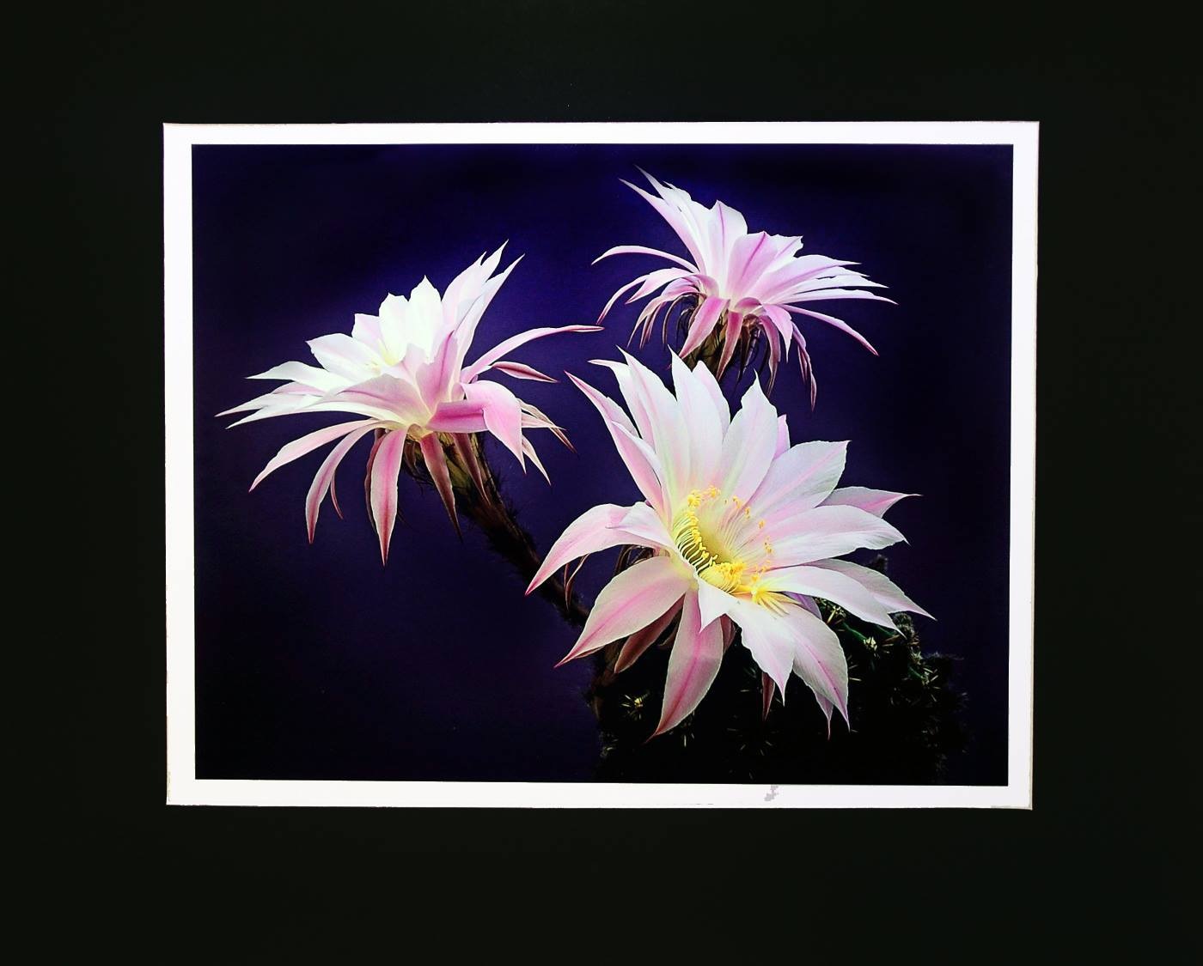
Best image in the Flora/Flowers print assignment went to "Cactus Flowers" by Ron Shimmin
We had two separate competitions on the evening’s agenda, the first being an ‘assignment’ competition for print entries and the second, the annual TripTych competition. We viewed the assignment print entries on Flora (including flowers) first. For this, we were highly appreciative of the good nature of well known local judge, Eddie Fryer who had readily agreed to return for a second week to complete the task he had been set. (He had judged the projected digital images on this assignment the previous Wednesday).
Eddie began by explaining his approach to judging. Whilst confessing to be anything but an expert on flora, he had applied his knowledge and experience in looking for evidence of technical ability, awarding higher marks for any images that had impact, displayed the natural colour of the vegetation, good presentation, best use of available lighting and sound composition. The images he had examined ranged from those with strong, punchy colours to those of a more delicate, subdued nature consistent with the subject matter. He had enjoyed viewing them and he said his task had been made more difficult by the overall high quality of the entries.
After commenting on each entry, the judge gave the following awards –
Standard Class Mono – 1st ‘New Zealand Flax Flower Remains’ by Beryl Quayle; 2nd ‘Prickly Cactus’ by Joy Brodie who also took 3rd place with ‘Lilies’.
Standard Class Colour – 1st and 2nd ‘Amazing Flowers on an Echinopsis Cactus’ and ‘Common Spotted Orchid at Close Sartfield’ respectively by Richard Shafto; 3rd ‘Globe Thistle’ by Beryl Quayle; 4th ‘Tulip’ by Joy Brodie; 5th ‘Poppy’ by Beryl Quayle; and 6th ‘Deeply Amaryllis’ by Karen Norton.
Intermediate Class Mono –1st ‘Moon Daisies’ by Chris Nicholls who was also awarded second place with ‘Caper Blooms’; 3rd and 4th ‘Dead Daffs’ and ‘Flowering Kale’ respectively by Nessie Gillen.
Intermediate Class Colour –1st ‘Blue Geranium’ by Shirley Lotfy; 2nd ‘Flanders Poppies by Chris Nicholls; 3rd ‘Zig Zag’ by Jenny Shanley; 4th ‘Mulberry Bark Detail’ by Chris Nicholls; 5th ‘ Rouge Red Ranunculus’ by Nessie Gillen; and 6th ‘Poppies at the Gate’ by Jenny Shanley.
Advanced Class Mono – 1st ‘Hogweed’ by Ron Shimmin; 2nd ‘Illuminated Lily’ by Sue Jones; 3rd ‘Misty Morning’ by Ron Shimmin; 4th ‘Petal Pattern’ by Sue Jones; 5th ‘Looking Back’ by Nigel Owen, who was also awarded 6th place with ‘The Lady’.
Advanced Class Colour – 1st ‘Cactus Flowers’ by Ron Shimmin; 2nd ‘Grey-Green Foliose Lichen’ by Ruth Nicholls; 3rd and 4th ‘Trio’ and ‘Freesias’ respectively by Sue Jones; 5th ‘Twolips Kiss’ by Nigel Owen who was also awarded 6th place with ‘Together’. Ruth Nicholls was also ‘Commended’ for her beautiful study of ‘Old English Roses’
Eddie then chose Ron Shimmin’s ‘Cactus Flowers’ as the best overall image in the competition, thus Ron continued his recent run of sparkling form!
The Society then turned to the Triptych competition. In order to qualify as a triptych, an entry was required to be of three separate images on a common theme to be mounted on board and these had to relate clearly to each other. Triptychs are used for those occasions when a sequence of photos can tell a story more effectively than a single image.
The judge for this competition was Pam Kershaw, a long-standing member and a past President of the Society. There were only 11 entries but what was lacking in quantity was more than made up for in quality! Pam gave a constructive critique on each entry, commenting that she had particularly liked to see the inter-relation between the presented images, the ‘cleanness’ of the mounting, the positioning of the images on the mounts, and a sense of progression between them. Pam offered several suggestions for improvement and these were well received.
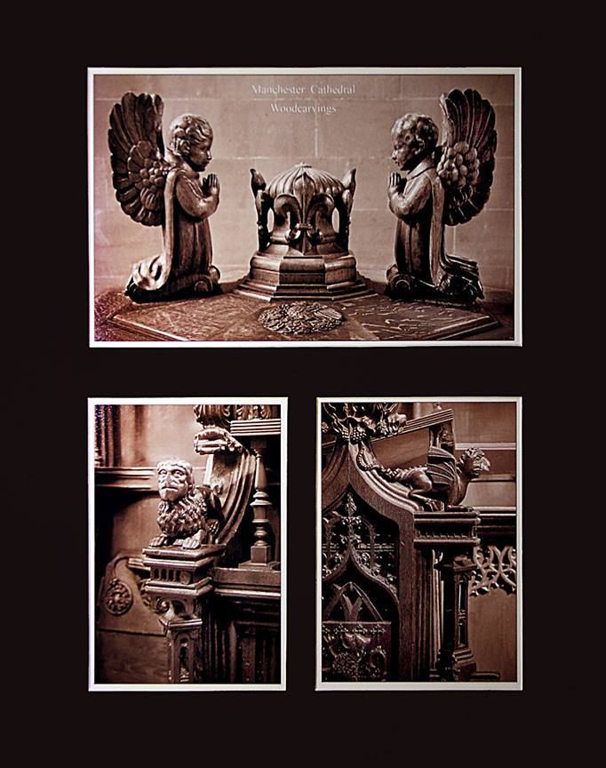
Ron Shimmin's winning triptych 'Woodcarvings, Manchester Cathedral'
After viewing all 11 entries and comparing their relative merits, Pam chose ‘Woodcarvings, Manchester Cathedral’ by Ron Shimmin as the best. This was a board produced by a perfectionist and any ‘professional’ photographer would have been proud to have entered it. It demonstrated considerable skill in the presentation of three perfectly complementary images, all mounted with wonderful precision and displaying supreme sharpness and balance. Second place went to ‘Time to Move – Hermit (Crab) Style’ by Patricia Harvey; 3rd ‘Wing Walkers’ by Chris Blyth; 4th Wildlife Park Portraits’ by Sue Jones; 5th ‘The Bee-Eaters of South Luangwa’ by Richard Shafto; and 6th ‘A Perfect Calm, Albert Dock, Liverpool’ by Beryl Quayle.
The two judges were then thanked by the Society President for braving the weather to give their valued input and to present their findings. He also complimented all those who had entered the competitions on the high standard of their photography.
by Antony Hamilton

IOMPS Reports During March 2015

19th March 2015
The final competition in the programme for ‘open’ prints was held by the Society in mid March when Steve Babb was given a warm welcome as the guest judge. It was his first appearance as a judge at Thie Ellyn. Steve grew up in Laxey and is now an accomplished photographer specialising in subjects as wide-ranging as weddings, landscapes, candid and formal portraiture, and sport. His professional studio is to be found in Union Mills.
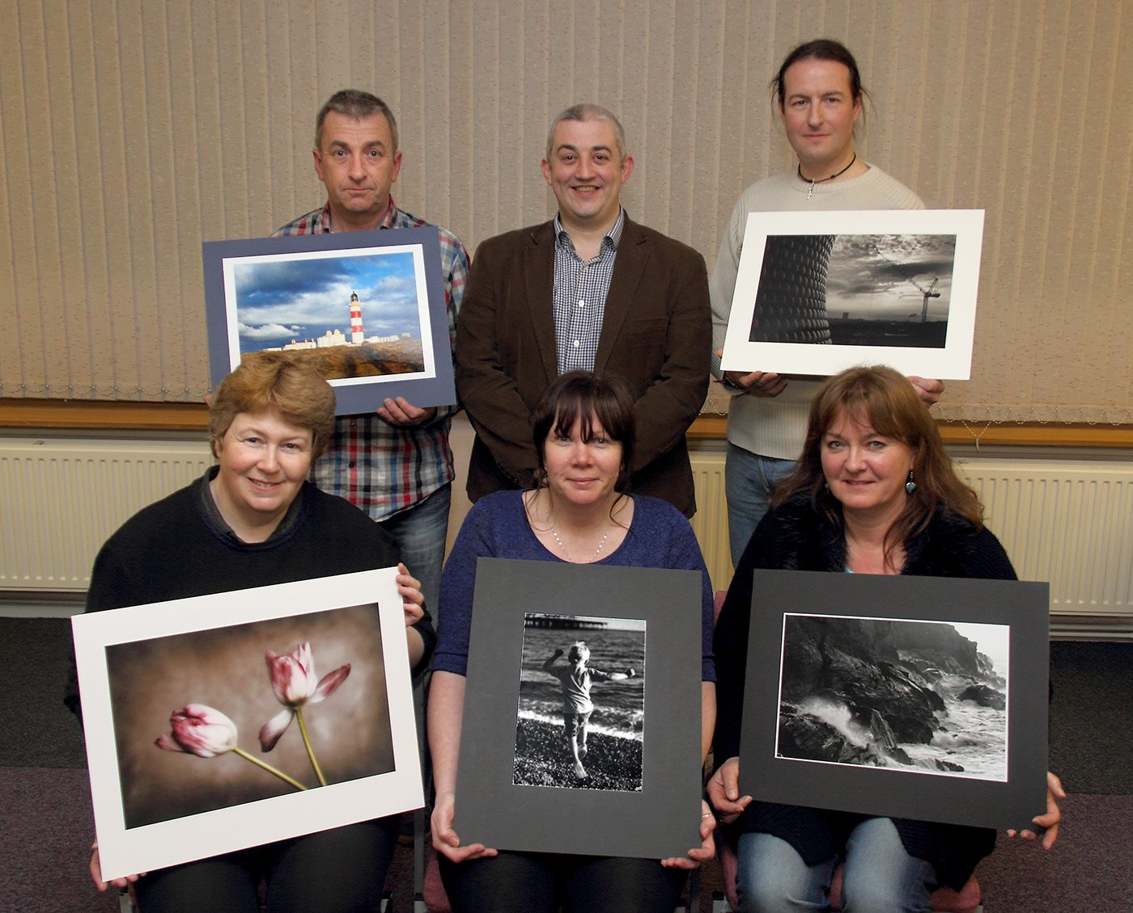
Open Print winners Sue Jones; Barry Murphy; Nessie Gillen; Nigel Owen and Beryl Quayle with Judge Steve Babb
Steve began by explaining that his interest in photography had begun as a hobby and developed from there. He regarded himself as something of a perfectionist and was now much involved in ‘product photography’. He was a firm believer that photography was in the eye of the beholder, in that it was a combination of various elements, including technical skills and emotion. He had greatly enjoyed examining the entries in the competition which he regarded as being of a very high standard overall.
There were over 60 prints entered across the different levels of experience in the Society and Steve took time to offer constructive comments on each one of them in turn. His lively delivery, interspersed with humour, made for an entertaining evening. He suggested some radical cropping in some cases to remove any aspects which either added nothing to the image or which constituted a distraction to the main subject. He gave advice on composition and colour balance and used his experience to guide the authors on how they might improve their work.
Though there was a wide range of subject matter before him, he confidently narrowed down his final ‘orders of merit’ as follows :-
Results:
Standard Class Mono – 1st Beryl Quayle with ‘Fenella Beach, Waves on Rocks’ an image full of energy showing the power of the sea; 2nd ‘Urban Snakes and Ladders’ by Mike Trout; 3rd ‘Portrait of a Leopard’ by Richard Shafto; 4th ‘Snowdrop, Ferry Cross the Mersey’ by Beryl Quayle; 5th ‘Gracious Swan’ by Joy Brodie; and 6th Symphony Hall, Birmingham’ by Mike Trout. ‘Niarbyl in Sepia’ by Karen Norton was also commended.
Standard Class Colour – 1st Barry Murphy with Point of Ayre Lighthouse’, a beautiful image with good natural colours and lighting; 2nd ‘Winter Fair’ by Mike Trout; 3rd Glen Wyllin Waterfall by Barry Murphy, 4th ‘Teamwork’ by Paul Dougherty; 5th ‘Lobster Pot Wall, Niarbyl’ by Karen Norton; and 6th ‘Lion Cubs on a Log by the Luangua River’ by Richard Shafto. ‘Up Ahead’ and ‘Rapid Responder’ by Thomas Carr and Mike Trout respectively were both commended.
Intermediate Class Mono – 1st Nessie Gillen with ‘Oh I do Like to be Beside the Seaside’, an image of a young lad, showing lovely movement on Ramsey Beach with the Pier just visible in the background; 2nd ‘Laxey Wrought Ironwork’ by Jenny Shanley; 3rd ‘Spreading Forms’ by Chris Nicholls; 4th ‘Roxy’ by Nessie Gillen; 5th ‘Light and Shade’ by Chris Nicholls; and 6th ‘Joey Dunlop Memorial’ by Jenny Shanley.
Intermediate Class Colour – 1st Chris Nicholls with ‘Lauterbrunnen’, a snowy scene taken early in the morning mist; 2nd ‘Playing Aeroplane’ by Nessie Gillen; 3rd ‘Running in Heels’ by Jenny Shanley; 4th ‘Paraglider’ by Shirley Lotfy; 5th ‘London Emerging from the Economic Gloom’ by Ian Lumsden; and 6th ‘Mr Graffiti’ by Nessie Gillen.
Advanced Class Mono – 1st Nigel Owen with ‘Sentinel’, a clever mix of urban and industrial elements, with superb definition; 2nd A Helping Hand’ by Nigel Owen; 3rd ‘Weary Passengers’ by Ron Shimmin; 4th ‘Hunt the Wren’ by Sue Jones; 5th Break for a Burger’ by Ron Shimmin; and 6th ‘Group Arrangements’ by Ruth Nicholls.
Advanced Class Colour – 1st Sue Jones with ‘Fading Beauty, a wonderfully ‘soft’ image of contrasting reds and greens; 2nd ‘Remembrance’ by Ron Shimmin; 3rd ‘Winter’s Tale’ by Nigel Owen; 4th ‘At the Fair’ by Sue Jones; 5th ‘Christmas Shopping, Princes Street, Edinburgh’ by Chris Blyth; and 6th ‘Harvested’ by Ruth Nicholls.
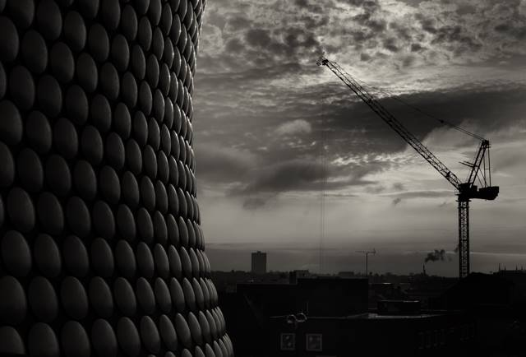
Best Image in the Open Print competition went to Nigel Owen for his Birmingham image titled ‘Sentinel’
Steve had been set one final task and this was to select the best overall image in the competition to qualify for the season long competition for the ‘best of the best’ and the award of the Brian Kershaw Memorial Trophy. This went to Nigel Owen for his Birmingham image titled ‘Sentinel’
by Antony Hamilton

12th March 2015 - Manx Culture Assignment
The competition for the IOM Bank Cup is unique for the IOM Photographic Society in that it is awarded for the best print in competition, whether monochrome or colour, has to be on a Manx theme, and is competed for on a fully open basis between all members. This year’s theme was “Manx Culture”, and was judged by Pat Tutt from the Western Photographic Society. Pat is an architect by profession, and her photography often reflects this – with beautifully composed images of the interiors or exteriors of buildings, the images always carefully constructed, full of detail, and always well printed.
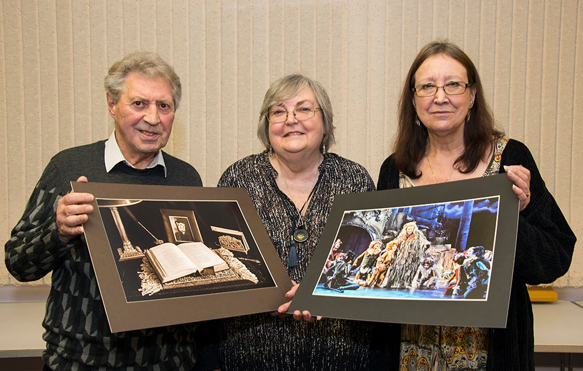
Manx Culture assignment winners Ron Shimmin and Janet Servante with Judge Pat Tutt
Pat proved the perfect judge for this competition – she had obviously researched the entries, knew the locations or details of many, and was meticulous in applying her photographic knowledge to the demands of the assignment. Entries covered a wide range of interpretation of the assignment – whether buildings such as the Gaiety or one of our churches, memorials such as that for Hall Caine, traditional Manx dancing, farming with horses, or theatre performances. Both elements in the assignment – “Manx” and “culture” figured large in Pat’s assessment. Whilst Pat was happy to accept that all the images entered qualified the criteria for the competition, she initially suggested and felt that perhaps only one photographer had taken the assignment to heart, had carefully considered the interpretation, then presented an image which met fully both elements AND had the impact to be a winner.Her comments throughout were clear, concise, gently critical when needed but also complimentary wherever possible, and always with an excellent “photographers eye”, aware of the restrictions imposed by the light, the viewpoint or the space available. Judging the monochrome images first, her winning entry came from Ron Shimmin, deservedly winning with a still-life of a TE Brown poetry book on the desk, open at his poem “Tommy Big Eyes”, his photo in a small frame behind, and nicely arranged, as you would expect. Runner-up was Sue Jones with a close-up image of the Hall Caine memorial in Maughold Churchyard. In the colour section, Janet Servante presented a super and winning image of a performance of “Cats” at the Gaiety, the lighting giving an intriguing dark purple background but ensuring attention was focused on the brightly lit performers in the foreground. Sue Jones was again in second place with an image of St Ninian’s churchyard.
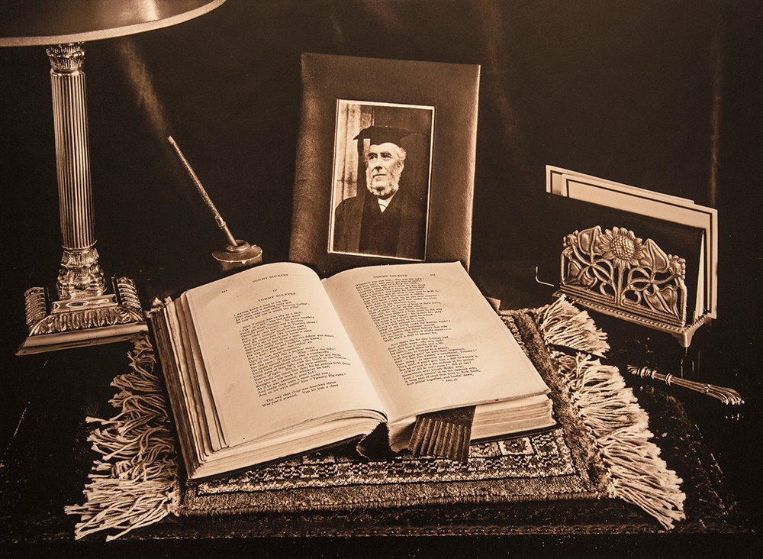
Ron Shimmin's print "Manx Poetry - Tommy Big Eyes by T.E Brown" was the overall winning image for the Manx Culture assignment and Ron wins the The Isle of Man Bank Cup
Unfortunately, there could only be one winner, and when tasked to choose between the mono or the colour image, Pat’s choice was emphatic and in favour of Ron Shimmin with his monochrome TE Brown entry – and the one that she felt had been taken specifically to meet both elements of the “Manx culture” assignment. A clear message to all competitors from a very able judge to “pay attention”……
The Society would wish to take the opportunity to thank the IOM Bank for their continued sponsorship of this competition and of the Society.
Results of the IOM Bank Cup : Mono Section – Ron Shimmin (1), Sue Jones (2), Chris Nicholls (3), Barry Murphy (4), Bob Servante (5), Tim Norton (6), Richard Shafto (HC), Karen Norton (C). Colour Section – Janet Servante (1), Sue Jones (2), Karen Norton (3), Ron Shimmin (4), Richard Shafto (5), Bob Servante (6), Barry Murphy (HC), Chris Nicholls (C).
by Chris Blyth

5th March 2015 - Going Underground with Pete Geddes and the Laxey Mines Research Group
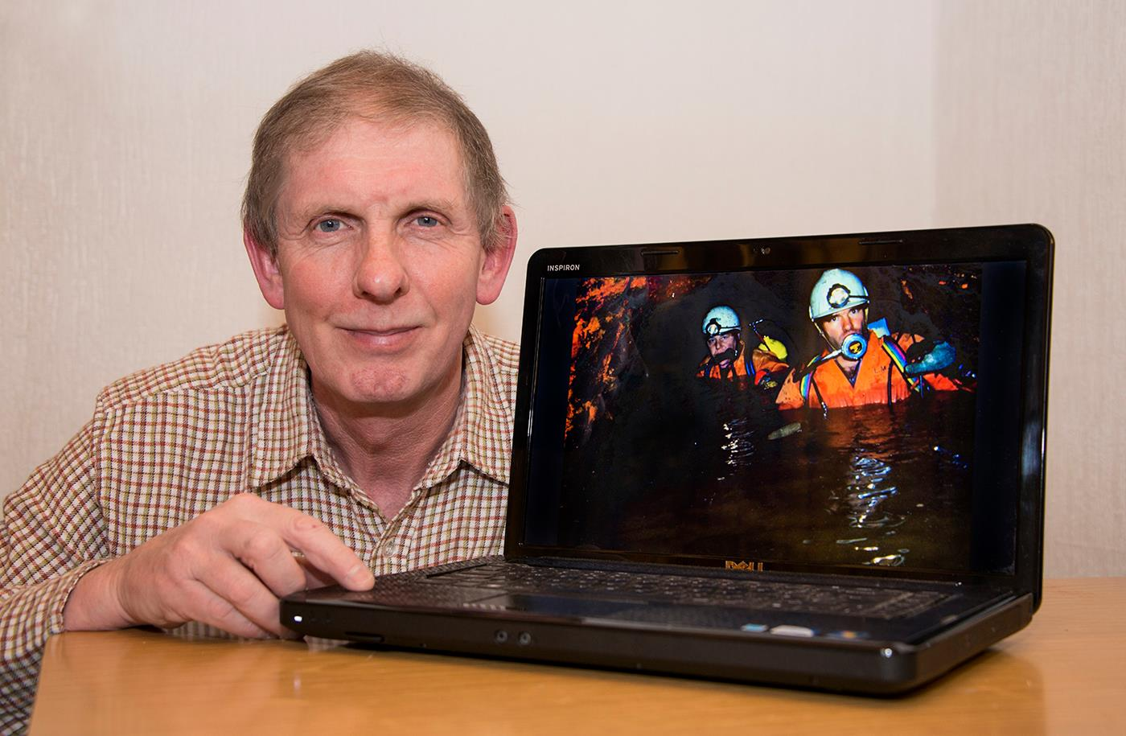
Pete Geddes MBE with one of many fascinating pictures from an excellent presentation on the work of the Laxey Mines Research Group
The Isle of Man Photographic Society was delighted last Wednesday evening, to welcome guest speaker Pete Geddes MBE. Pete is an expert in electronics and signal engineering. He modestly denies being a photographer but often takes his camera with him, even when climbing high on a transmitter mast for an aerial rigging job.
Pete is also heavily involved in the Laxey Mines Research Group. With a dedicated group of volunteers, he is often to be found deep underground surveying, repairing and restoring badly decayed mine shafts and entrances and tunnels.
With 40 years of photographic knowledge behind him and a great eye for detail, Pete's images clearly showed just how difficult, dirty and dangerous the restoration work can be.
Evidence has been discovered of copper mining on the Isle of Man as far back as the 1200 BC. There are about 120 old mines on our Island and they all have to be surveyed and made safe. This can involve removing hundreds of tons of rock, stone and other debris, including mud and water from inside the shafts and the many miles of tunnels.
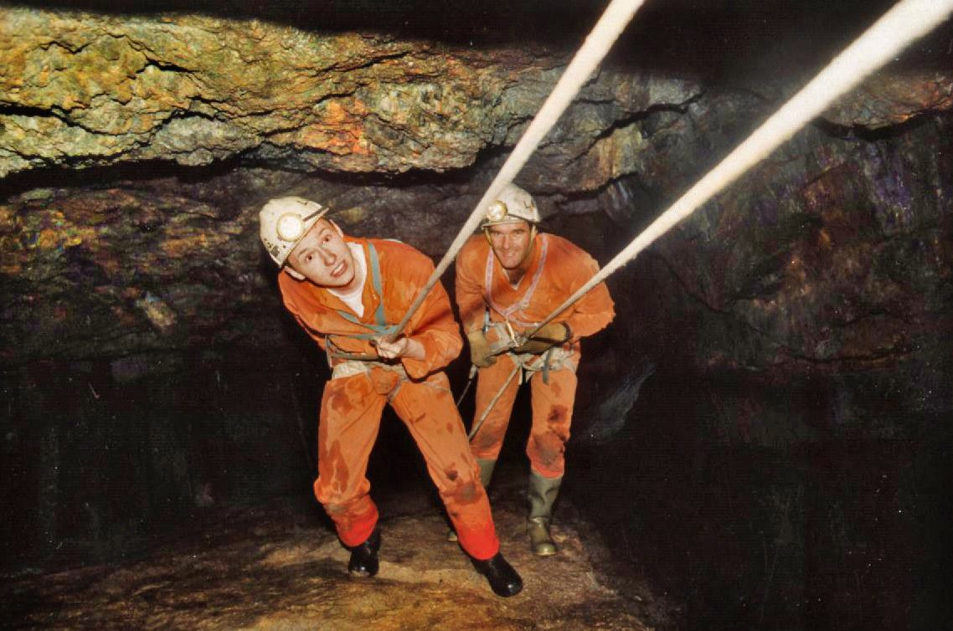
LMRG members deep inside Laxey Mine
Pete showed us many photos of the team doing everything from rigorous safety training to toiling in inhospitable conditions, removing and replacing ceiling supports, stone walls and roofing. Much of the work is done in water and in a cold and slippery wet environment. Breathing gear is often necessary where oxygen levels are very low and noxious gasses have built up.
Pete's pictures showed some beautiful colours of mineral formations deep inside the mines including copper, zinc and even the very rarest of underwater minerals, the Cave Pearl.
As well as working on the mines projects, Pete and the volunteers work on other industrial heritage sites including the Laxey Mines Railway and the Snaefell Wheel restoration. They've even opened up an old well in Bucks Road to remove the lead pipes and all of the filth.
In fact whenever the government become aware of a suspicious looking ancient hole in the ground, the Mines Group are called in to measure it, assess it, clear it, fill it and make it safe! He takes meticulous photographs of all his projects and gives them to the museum so they have a record of everything.
All in all, Pete's presentation was very well received as both educational and entertaining with some wonderful, gritty photos to illustrate his talk.
To find out more about the Laxey Mines Research Group visit: www.facebook.com/LaxeyMinesResearchGroup
The second part of the evening was taken up by the annual Three Way Battle. This is a digital competition between the IOMPS, Rochdale District Camera Club and Oldham Photographic Society. All of the entries were of an extremely high standard and judged in Oldham by distinguished photographer Terry Donnelly.
It was great to be part of a national competition and in the end the results were very close with Oldham coming out on top with 416 points. The IOMPS were second with 374 points and Rochdale a very close third with 362 points.
The best image of the competition was by Christine Widdall titled “Naughty And Nice”, of two identically dressed girls holding a yellow balloon, standing on a long pier with a helter skelter at the far end.
by Anne Bidwell

IOMPS Reports During April 2015

30th April 2015 - Bebington Salon 2015
Following the recent visit of our highly accomplished UK judge from the Lancashire and Cheshire Photographic Union, Robert Millin DPAGB BPE5* EPSA UPI Hermes LRPS EFIAP/b. to our Society, we last week greeted two more VIP guests, Bob Dennis APAGB, CPAGB BPE3* and fellow photographer, Gordon Reid. Over the past few years Bob has been good enough to help several Isle of Man amateur photographers to gain their Photographic Alliance of Great Britain qualifications. We are most grateful to him for giving his time and experience so generously in this way.

However, the main purpose of Bob’s visit was to present the widely acclaimed Bebington Photographic Salon for 2015 and the Society was delighted to be hosting it for a seventh successive year on behalf of amateur photographers across the Island. The presentation by Bob, a former President of the L&CPU, took place at Thie Ellyn where the Society normally meets. Members of the Western and Southern photographic clubs had also been invited to join us and were there in good number. Under the umbrella framework of the British Photographic Exhibitions, the Bebington Salon was first introduced in 2003 and has produced an annual selection of images each year since. This latest presentation comprised some 500 images of the highest quality, chosen by a panel of highly respected UK judges out of more than 3,100 submissions. The Salon, which visits over 20 different clubs each year, comprises four categories. These are Colour; Monochrome; Landscape; and Nature. Usually included is a humorous section to entertain the many who attend the event each year.
From past experience, expectations for the evening were high as Bob made his introductory remarks as the large crowd settled into their comfortable seats. None of those present was to be disappointed because a wide variety of images was projected, many of them amazingly breath-taking. The images conveyed that all important ‘wow’ factor for which we all strive, with those essential ingredients of impact, story telling, and different emotions. Some of the sections had well-chosen musical accompaniment which added to the pleasing experience. The humorous commentary also raised a few smiles!
The Nature category is always a real eye-opener and this year was to be no exception! These images were particularly stunning, leaving many of us to wonder just how much time and patience had been devoted to capturing them. Not all of these were from far away places: some of the animals, birds and insects are to be found much closer to home.
Quite apart from our love of high quality photography, inviting the Bebington Salon back to the Island each year enables us all to monitor our progress and to keep abreast of current trends in amateur photography in the adjacent island. For those living in a relatively small Island community, there is a great value in this because it reduces the risk of our progress falling short of other photographic clubs and societies.
The evening concluded with a vote of thanks given by the Society’s President.
By Antony Hamilton

23rd April 2015 - Annual Competition Digital
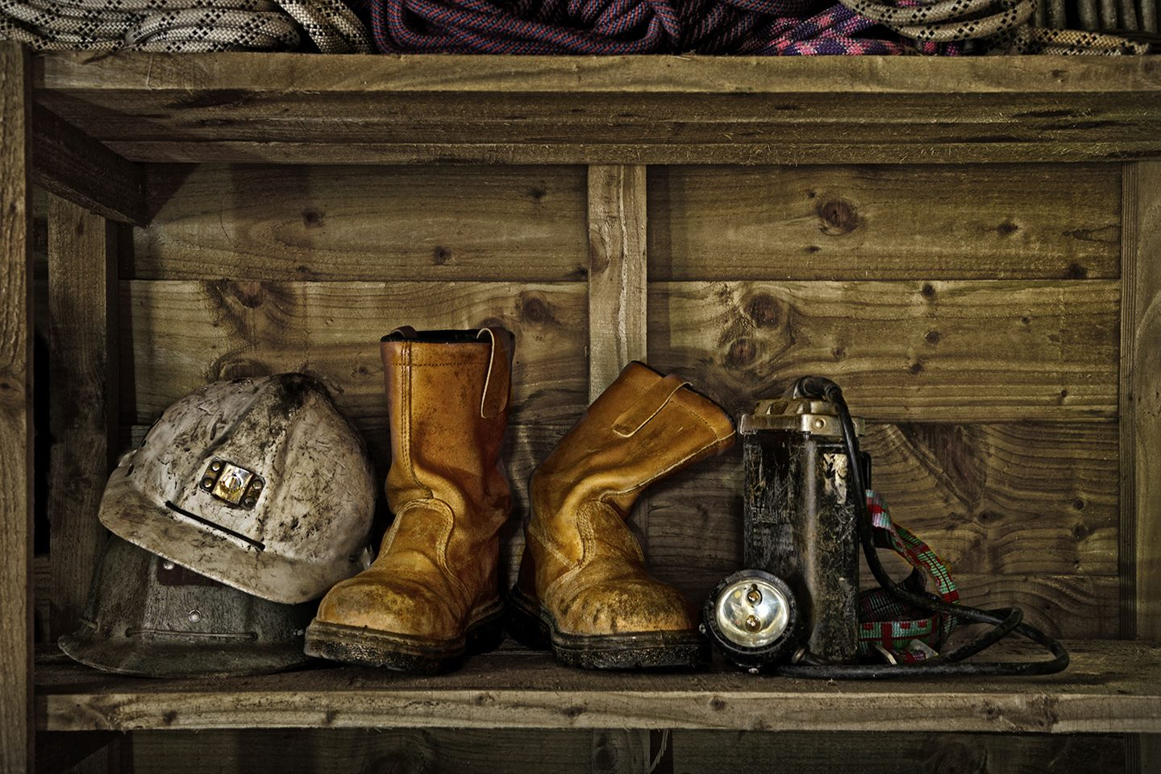
“End of Shift” by Sue Jones won Best Digital Image in the Annual Competition
Robert Millin DPAGB BPE5* LRPS EFIAP/b AFIAP EPSA UPI Hermes was the highly qualified judge for the IOM Photographic Society’s Annual Digital Projected Images competition this year. Having already had the benefit of his thoughts on the previous evening’s print competition, members knew what to expect – discerning comments in a very relaxed and eloquent flow, a requirement for good technique, an understanding for composition, some artistry, and images with impact. Images lacking in any of these areas were destined not to be amongst the awards – as Robert made clear, don’t leave it to the judge to find the errors! Images with atmosphere and an emotional appeal were often rewarded, as were those which “told a story” or stimulated the viewer’s imagination in some way.
As with the prints, the list of winners is too long to comment on in detail. However, the best digital image in competition was judged to “End of Shift” by Sue Jones – an image showing the boots, helmet and other work clothes of a miner on a wooden shelf – which won the Mistral Trophy. The best digital natural history award went to Diane McCudden, whose image of a stonechat on a twig against a neutral plain background, was also judged to be the best natural history image in both prints and digital, and accordingly won the Spiers Trophy.
The evening finished with Robert’s presentation on the various awards available to photographers in the world of exhibitions and competitions – something for which he has an obvious enthusiasm if not obsession, believing that competition, and wanting to do well, is a major motivational force. He compared the requirements for a number of the major awards, pointing out the great variability – a Licentiate of the Royal Photographic Society (LRPS) requires submission and acceptance of a panel of 10 different (but themed) images, whilst the first “star” in the British Photographic Exhibition awards (BPE1*) requires 25 acceptances of images into various exhibitions or salons. His presentation was illustrated with his own images – from his very first entries into competition, self-confessed to being no more than “snaps” (and unsuccessful), through to some of his most recent images (and much more successful both nationally and internationally).
Ian Lumsden gave the vote of thanks for two, very satisfying days of intensive photography!
Annual Competition Digital Results – Standard Section : Colour (Henry Roy Welsh Memorial Cup) : Barry Murphy (1, 2,VHC & C), Mike Trout (3), Joy Brodie (VHC & C), Steve Meadows (VHC, 3xC), Thomas Carr (C), Patricia Larkham (2xC),Richard Leach (C). Mono (Barrule Cup): Steve Meadows (1, VHC & 3xC), Peter Keena (2 & C), Mike Trout (3), Joy Brodie (VHC). Natural History (York Trophy): Sakkie Meeuwsen (1 & 3xC), Richard Shafto (2), Richard Leach (3), Patricia Larkham (VHC), Beryl Quayle (2xC). Creative (Salisbury Cup): Joy Brodie (1). Record (Atlantean Trophy):Patricia Larkham (1 & C), Richard Leach (2 & 2xC), Joy Brodie (C), Peter Keena (C). Intermediate Section : Colour (Brockenhurst Cup): Chris Nicholls (1, 3 & C), Martyn Parnell (2, 2xC), Nessie Gillen (VHC), Hazel Walsh (VHC), Mark Falconer (C), Shirley Lotfy (C). Mono (Glen Darragh Trophy): Chris Nicholls (1), Mark Falconer (2 & 3), Hazel Walsh (VHC),Nessie Gillen (C). Natural History (Jensen Trophy): Shirley Lotfy (1, 2 & C). Creative (Sheiling Cup): Hazel Walsh (1). Record (Summerhill Cup): Shirley Lotfy (1 & 2), Mark Falconer (C). Advanced Section : Colour (Andrew Barton Cup): Sue Jones (1, VHC & C), Bob Servante (2), Diane McCudden (3 & 2xC), Ruth Nicholls (VHC, 2xC), Claire Stringer (VHC), Chris Blyth (C). Mono (Glendown Trophy): Bob Servante (1, 2xC), Sue Jones (2 & C), Diane McCudden (3, VHC). Natural History (Kelly Cup): Diane McCudden (1 & 2), Ruth Nicholls (3), Bob Servante (2xC), Chris Blyth (C), Claire Stringer (C). Creative (Malew Cup): Sue Jones (1 & 3), Bob Servante (2). Record (Dreeym Beary Trophy): Sue Jones (1), Ruth Nicholls (2), Claire Stringer (C).
By Chris Blyth

16th April 2015 - Annual Competition Prints
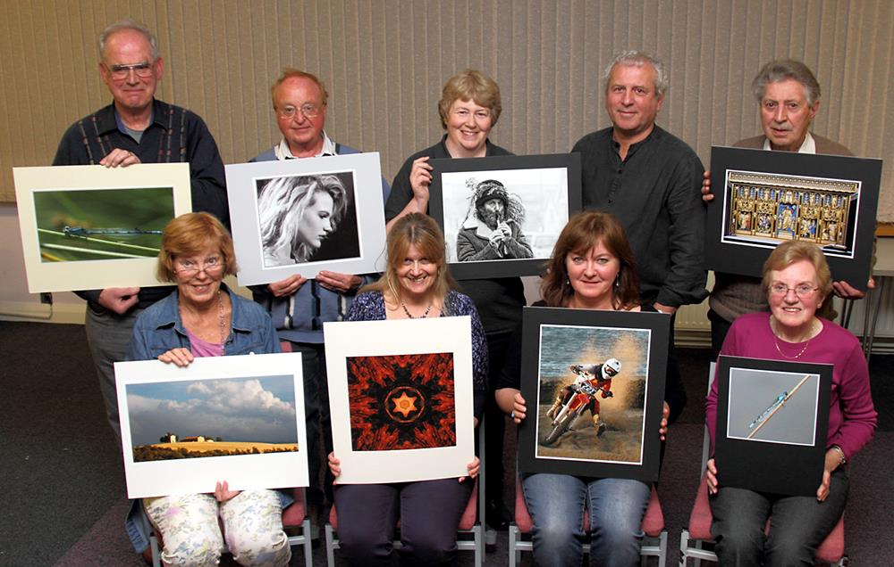
Annual Competition Print Winners with Judge Robert Millin
The Annual Competition signals the end of the competitive calendar for the IOM Photographic Society, and it is a highly anticipated event, always involving a well-qualified judge imported from one of our neighbouring islands especially for the occasion. This year our judge was Robert Millin DPAGB BPE5* LRPS EFIAP/b AFIAP EPSA UPI Hermes – clearly garlanded with awards, and astonishingly, all accumulated in the past five years, since taking up photography as a hobby (though described by himself more realistically as an obsession!) In addition he is a member of Wigan 10, a very select group of just 11 photographers who do not compete amongst themselves but mentor each other for the purpose of external competitions both personal and as a club – and who are now four-times FIAP (International Federation of Photographic Art) club world champions. So, a formidable judge, used to working at the very highest levels of quality…..
The format of our two day event is that prints are judged on the first day, digitally projected images on the second. The judge reviews all the entries during a morning session, and – given the sheer number of entries – is then expected to comment only upon the winning selection in the evening. This is then followed by a showing of personal work – which is always stimulating and inspirational for the members.
The process of judging a photograph is admittedly subjective, though there are obvious requirements for technical quality, artistic input and impact – and Robert proved an excellent judge, sharing his thought process as to why some images succeeded and others did not. It was clear that technical quality was essential – images lacking sharpness and clarity in key areas or distracting highlights, for example, were marked down. However, he was also generous in his comments and awards, commending those who were willing to “stretch boundaries” and try new techniques or a different viewpoint to get the effect they wanted. Whilst the general standard of work was excellent, Robert felt that “creative” was the one area where more work was required. “Creative” in the photographic world is now defined more as “altered reality”, and usually requires a high level of artistic imagination as well as computer skills to merge a number of different images to create a seamless finished work. The effect is often that the final image stretches credibility, but is realistic enough to require a second or third look……
The awards are too numerous to go through in detail, but the best mono print in the competition and winning the Mackie Cup was “Hunt the Wren”, a superb portrait by Sue Jones, whilst the best colour print was a lovely Italian landscape “Heaven and Earth” by Ruth Nicholls, which won the Redwood Trophy.
To finish our evening, Robert’s presentation – with lots of helpful advice - confirmed a primary interest in sports and travel photography, but his “addiction” to competitions requires him to provide images on a wide range of subjects, so his work covers many topics and genres. However, success comes at a cost – both financial and in terms of time and effort. Robert is now retired so time is available, and lives near Chester, which means many world class sporting events held in the Manchester / Liverpool / North Wales area are accessible – identifying and attending as many of these as possible maximises the opportunity to build and develop a portfolio of work. Obtaining a press pass to ensure the best vantage points, offering non-distracting backgrounds for example, is helpful in achieving success. As regards his travel portfolio, Robert pointed out that, living as we do on the Isle of Man, travel photography doesn’t have to mean long distance – one’s own locality provides many opportunities for successful images which demonstrate culture, landscape and way of life.
Brenda Shimmin gave the vote of thanks for a very good evening.
Annual Print Competition Results. Standard Section – Mono (Tranter Cup) : Mike Trout (1), Beryl Quayle (2), Joy Brodie (3, VHC & C), Richard Shafto (HC). Colour (Woodbourne Cup): Beryl Quayle (1 & C), Thomas Carr (2), Richard Shafto (3 & VHC), Mike Trout (HC). Natural History (Baldwin Shield) : Beryl Quayle (1, 2xC), Richard Shafto (2), Michael Howland (3 & C), Mike Trout (VHC, HC & C). Creative(Greeba Cup) : Joy Brodie (1). Record (Dreemfroy Trophy) : Beryl Quayle (1), Richard Shafto (2), Joy Brodie (3 & VHC). Intermediate Section – Mono (Ballure Cup) : Chris Nicholls (1,2,3,VHC & HC). Colour (Coombe Cup): Chris Nicholls (1, 2, 3 & VHC), Ian Lumsden (VHC, 2xC), Shirley Lotfy (2xC). Natural History (Ballaragh Cup) : Shirley Lotfy (1, 3 & VHC),Chris Nicholls (2). Creative (Carnane Cup) : Nessie Gillen (1). Record(Lezayre Trophy) : Nessie Gillen (1 & C), Shirley Lotfy (2 & VHC). Advanced Section – Mono (Bridge Cup) : Sue Jones (1, VHC & C), Ruth Nicholls (2, VHC, 2xC), Nigel Owen (3, VHC & C), Ron Shimmin (3xC). Colour (Sanderson Cup) : Ruth Nicholls (1,3, VHC & C), Ron Shimmin (2, 2xC), Nigel Owen (VHC & C), Mark Stringer (VHC & C), Chris Blyth (C), Sue Jones (C). Natural History (Caraghan Cup) : Chris Blyth (1,2 & C). Creative(Snaefell Cup) : Ruth Nicholls (1 & 2), Sue Jones (C), Mark Stringer (C). Record (Glenrigh Cup) : Ron Shimmin (1 & 2).
By Chris Blyth

9th April 2015 - Two-Way Digital Battle with North West Bristol Camera Club
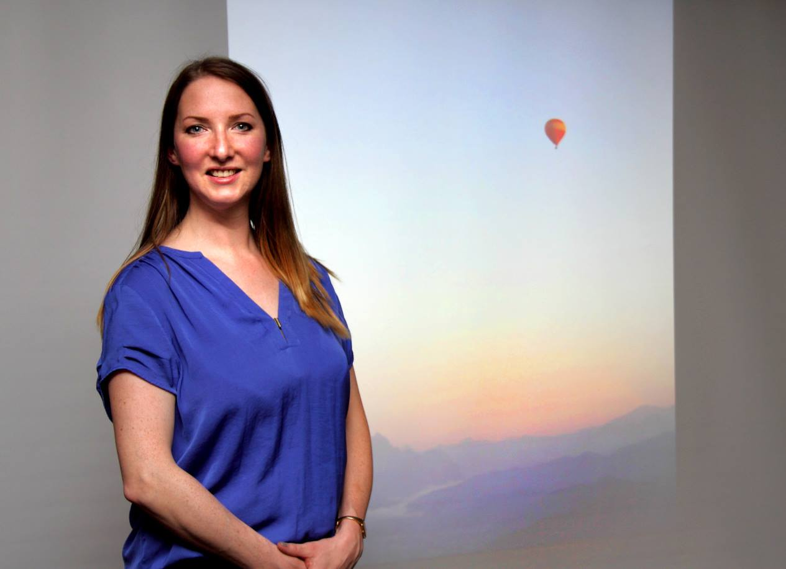
IOM Judge Clare Payne with one of the images which scored 20 points
The Two-Way Digital Battle with Bristol is an eagerly awaited contest in the annual calendar of the IOM Photographic Society – it is a unique event in that the competition, comprising 25 images from each club, is judged independently at both venues (both judges marking all entries out of a maximum of 20 points) – and the scores from both added together to decide the overall winner.
Clare Payne was the IOM judge this year, and proved absolutely superb in the role…..she is a qualified Licentiate member of the British Institute of Professional Photography and the Society of Wedding & Portrait Photographers. Clare has a reputation for friendly professionalism and excellent photographic skills, talents readily apparent in a well-paced, eloquent and knowledgeable commentary, the good points on each entry being fully acknowledged, and any perceived shortcomings handled with helpful advice and tact – in short, everything one could wish for in a judge!
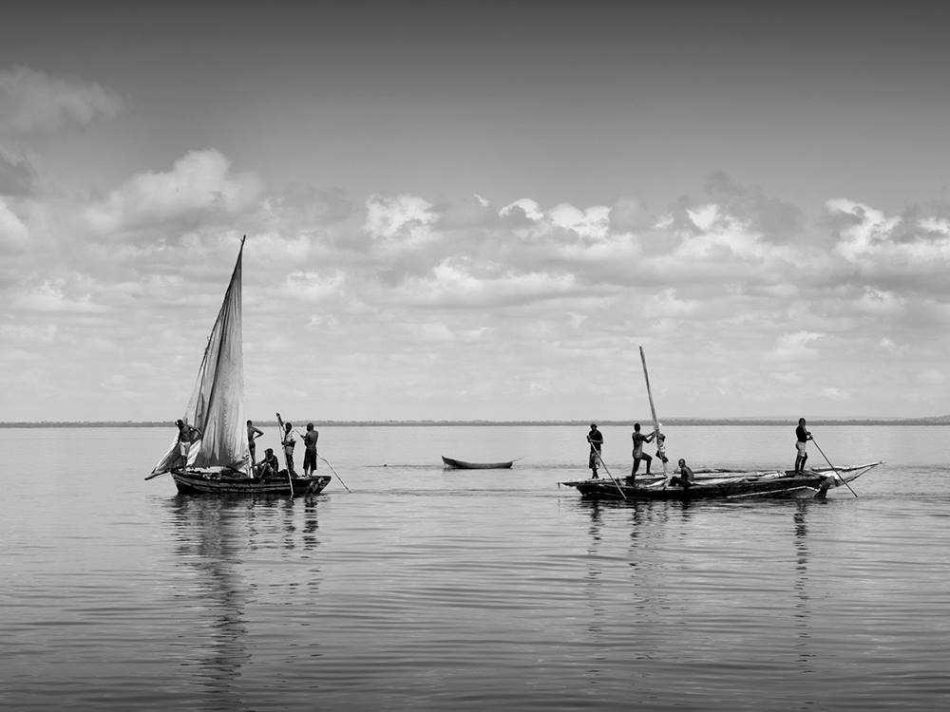
'Gone Fishing' by Lara Howe scored 20 points in the digital battle between IOMPS and Bristol
Bristol having won last year’s competition, the hope was that the IOM Society would get their revenge this year. The entry from both clubs was excellent, with many delightful images – but both Clare and the Bristol judge were in agreement in favouring the Bristol entries (albeit only slightly).
Bristol Judge Clare Payne Overall
Bristol Club 452 415 867
IOMPS 437 403 840
So, alas, another loss and another year before we get the opportunity to reverse the result – as Antony Hamilton, Club President, remarked, our reputation for consistency in this competition has been hard earned! Antony gave a well-deserved vote of thanks to Clare at the end of the meeting.
by Chris Blyth

2nd April 2015 - GARY HARRISON JUDGES
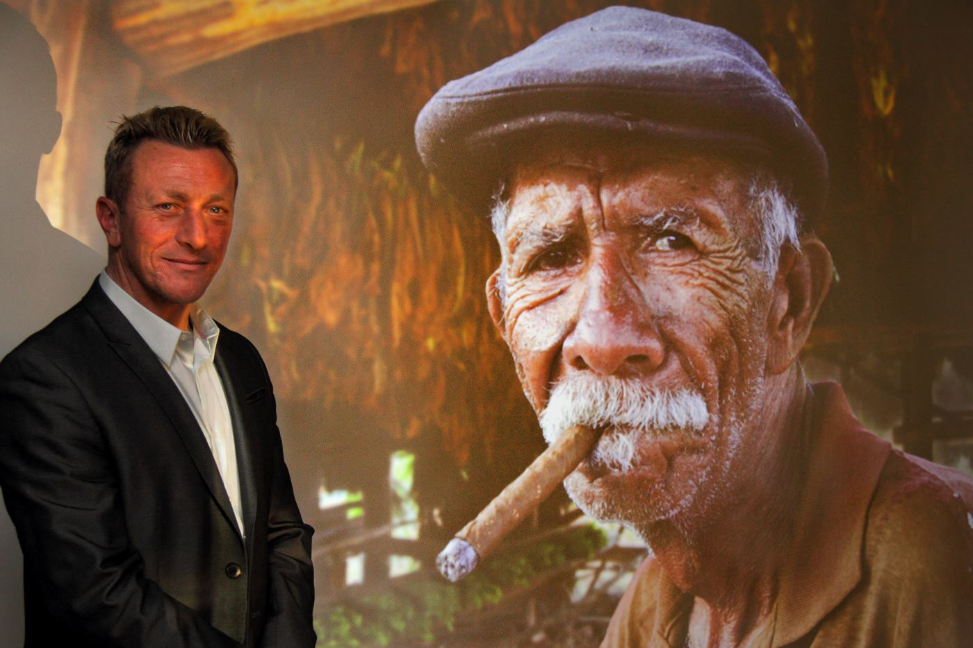
Digital Open Judge Gary Harrison with the Best Overall Image
The Isle of Man Photographic Society held it's last Open competition of the season last week. It was an Open Digital competition judged by well known local photographer Gary Harrison.
This was Gary's first outing as a judge and he was understandably nervous. However, he had no need to worry as his sense of humour and obvious expertise soon won over both the audience and competitors. Gary's background in art and design shone through, especially with his great eye for perspective and detail.
He asked questions of the authors, wanting to know where and at what time of day a particular image was taken or what sized aperture or shutter speed was used. Gary was very impressed with the quality of the entries, especially those from the standard group whose work, he said, could have been shown in the advanced group.
Gary commented on each image in turn without the use of notes, showing his knowledge of camera use and which settings had been used and to what effect. He gave some good practical advice on how some of the entries could have been improved, and explained why he'd placed one entry over another in the placings. His friendly nature and humorous comments made for a lively and enjoyable evening.
You can view Gary's outstanding portfolio of work on his website www.manxmania.com.
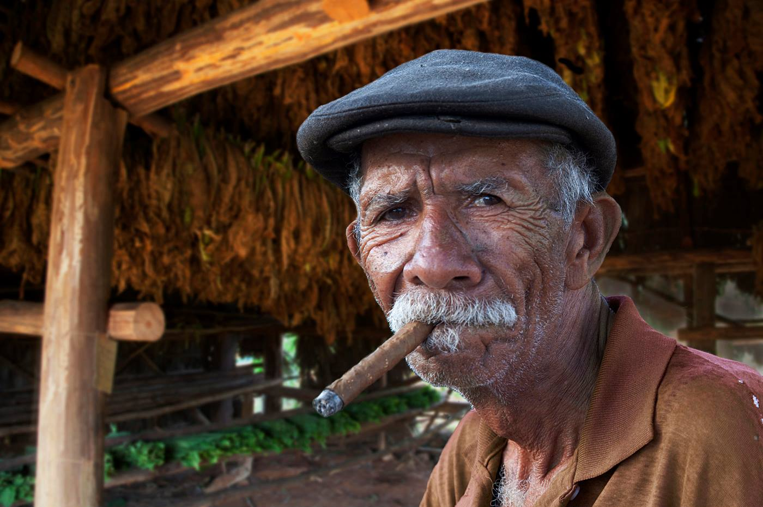
"Tobacco Worker" by Chris Nicholls gained Best Overall Image in the final digital open competition of the season
Gary's first choice from the standard class was a wonderful moment in nature shot by Richard Shafto, of an adult leopard guarding it's freshly caught prey.
The intermediate class winner was Chris Nicholls with a stunning portrait of an aged cigar smoking Cuban man outside a tobacco drying hut. Gary thought this image really told a story and awarded it the best overall image of the competition.
“The Busker” by Mark Stringer was Gary's favourite picture from the advanced group's entries. It showed a grey haired man sitting by a wall playing his guitar.
RESULTS
Standard
1st Richard Shafto, 2nd Barry Murphy, 3rd Karen Norton, 4th Beryl Quayle, 5th Saakie Meeuwsen, 6th Joy Brodie.
Intermediate
1st Chris Nicholls, 2nd Hazel Walsh, 3rd Nessie Gillen, 4th & 6th Shirley Lotfy, 5th Martyn Parnell.
Advanced
1st Mark Stringer, 2nd Sue Jones, 3rd & 5th Claire Stringer, 4th Patricia Harvey, 6th Chris Blyth.
by Anne Bidwell

IOMPS Reports During May 2015

14th May 2015 - End of 2014 - 15 Season*
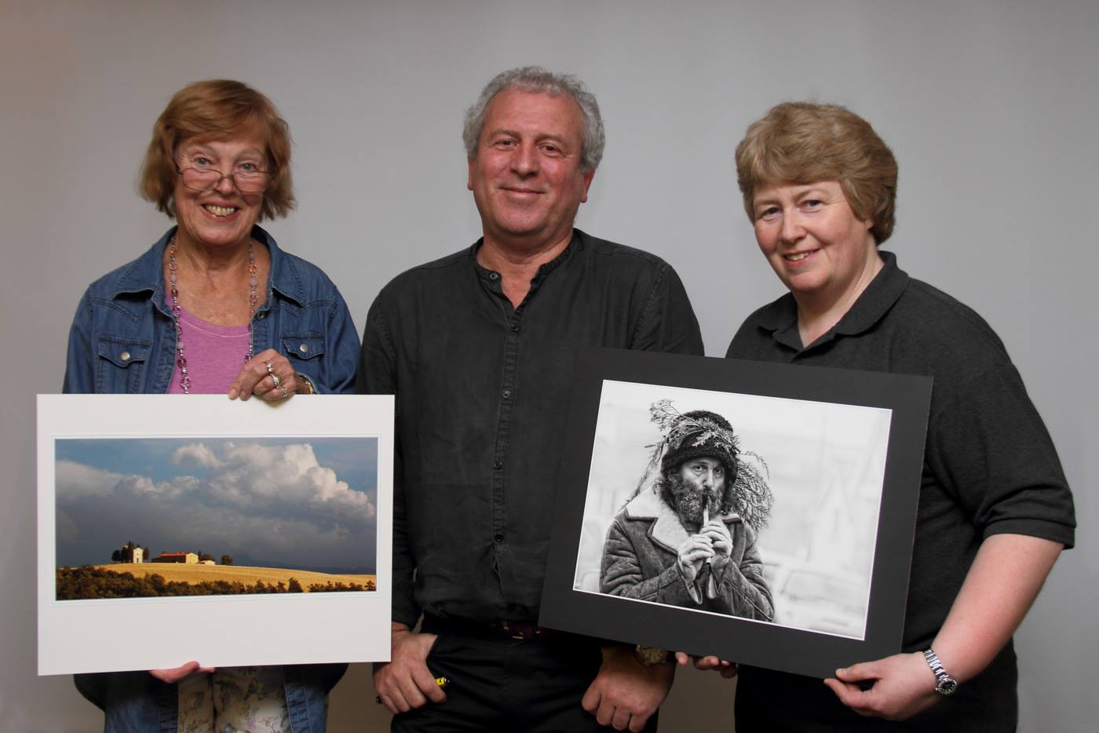
Annual Competition Judge Robert Millin with the Best Colour and Best Mono Print winners
Well, another year in the life of the IOM Photographic Society has come to an end … and what an excellent year it has been! It has included entertaining presentations by both external speakers and by various club members, some superb imagery at all levels in our various weekly competitions, several well-fought if eventually unsuccessful competitions with clubs from our adjacent island, our now traditional members annual exhibition at the Laxey Woollen Mills, and overall, a programme that hopefully has engaged the membership and perhaps stimulated their aspirations and improved their skills….
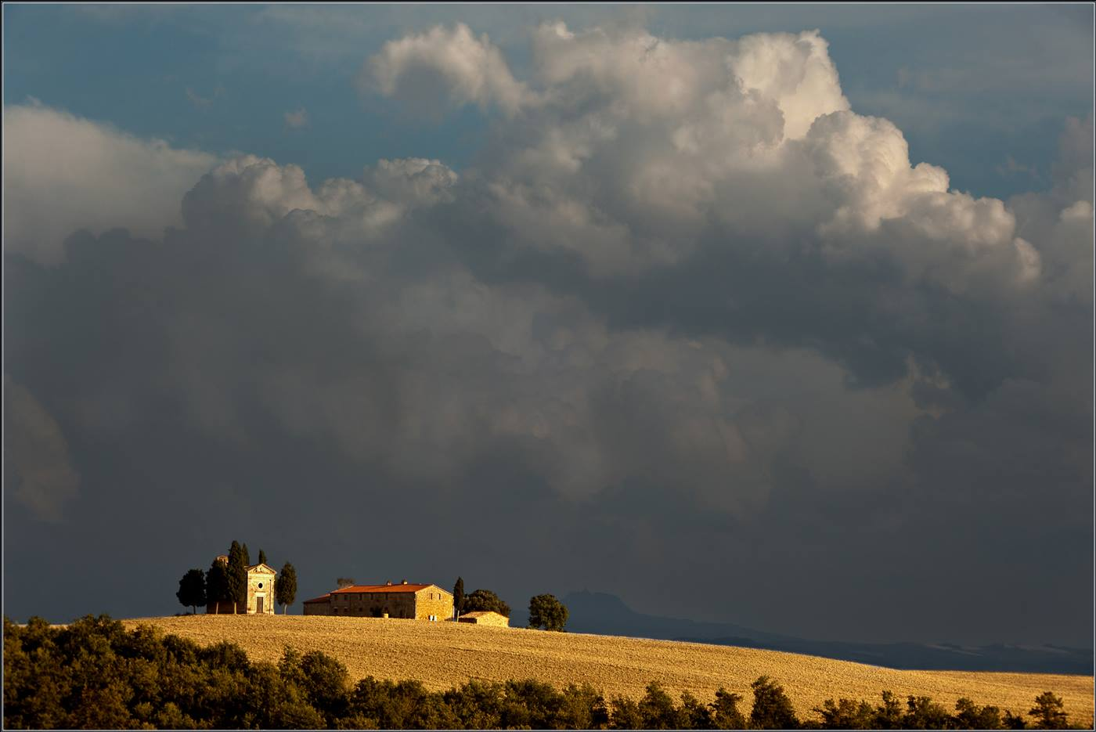
"Heaven and Earth" by Ruth Nicholls won Best Colour Print
The presentations included "bird photography" with Bill Callow, who showed some wonderful images of the birdlife of the island, including the best places and time of year to find the various species – but who admitted that sometimes several hundred shots were required to get the very best image. That was followed by "Venice", a presentation from Chris and Ruth Nicholls which explored the delights of the annual carnival as well as the canals and buildings of this iconic city – somewhere every photographer should have on their "to do" list ! On another evening, Richard Shafto showed some superb natural history shots taken on a safari in the South Luangwa Park in Zambia – arguably the best place in Africa for wildlife, whilst Mike Trout entertained with images taken much closer to home in the West Midlands.
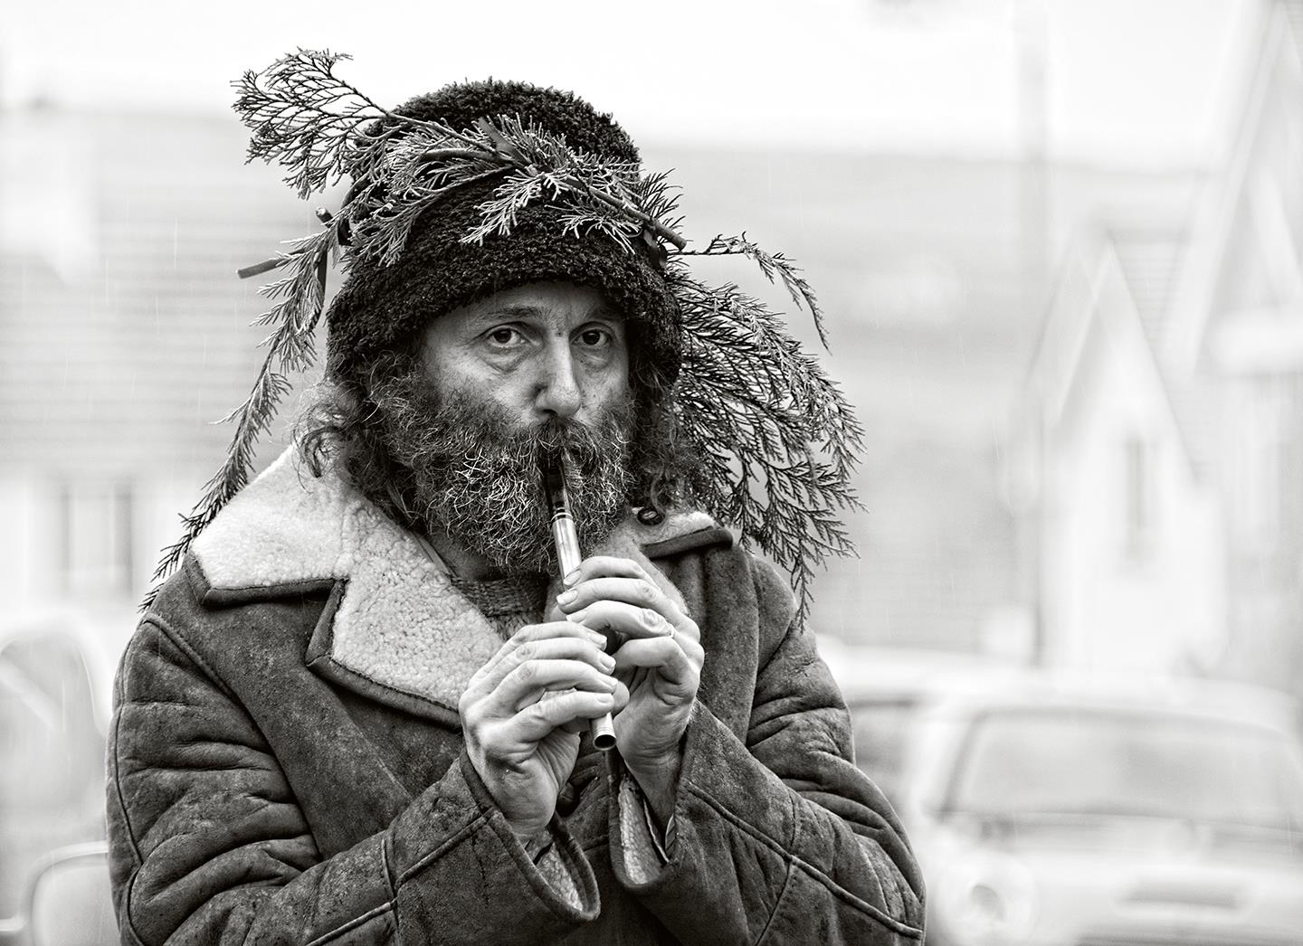
"Hunt the Wren" by Sue Jones won Best Mono Print
A special "thank you" goes to our external speakers who gave their time and expertise to their presentations – to Gary Harrison for "Putting things in perspective", to Ralph Haslett for his "Adventures in Asia", and to Peter Clague for his return visit to present "Travels in Nicaragua" – all much enjoyed by our members.
The 3-way battle with the Oldham and Rochdale Camera Clubs is always great fun, and includes some great images, but Oldham, a very competitive club with a number of highly skilled and well qualified members, emerged comfortable winners, with the IOMPS narrowly squeaking home in second place, just beating the Rochdale Club. The 2-way battle with the Bristol Club unfortunately also resulted a second place for the IOMPS – judged independently at both clubs, the two judges both gave the result to Bristol, with a "must try harder next year" message to the IOMPS !
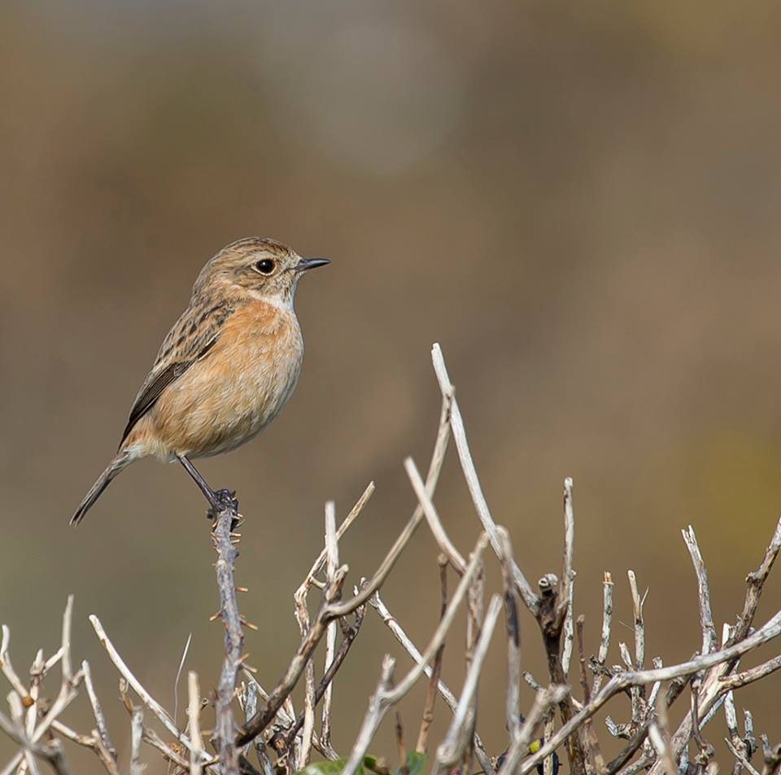
"Female Stonechat" by Diane McCudden won Best Natural History Image
The opportunity to thank the many local judges – too numerous to name individually - who support our competitions programme is essential; their ready willingness to entertain us with their thoughts and expert commentaries on our images is always very much appreciated.
"End of Shift" by Sue Jones won Best Digital Image
And going forward, the new committee will shortly be announcing the programme of summer events and outings which will be designed to give opportunities for more photography and hopefully, to take advantage of this wonderful Island of ours. Assignment topics for 2015/16 are: Squares; Light and Shade, Collections and, for the IOM Bank Cup, Manx Transport.
Details of all events and of the re-start of the formal seasonal programme (which commences in late September) will be given on the website.
By Chris Blyth

7th May 2015 - Annual Dinner and Prize Presentation
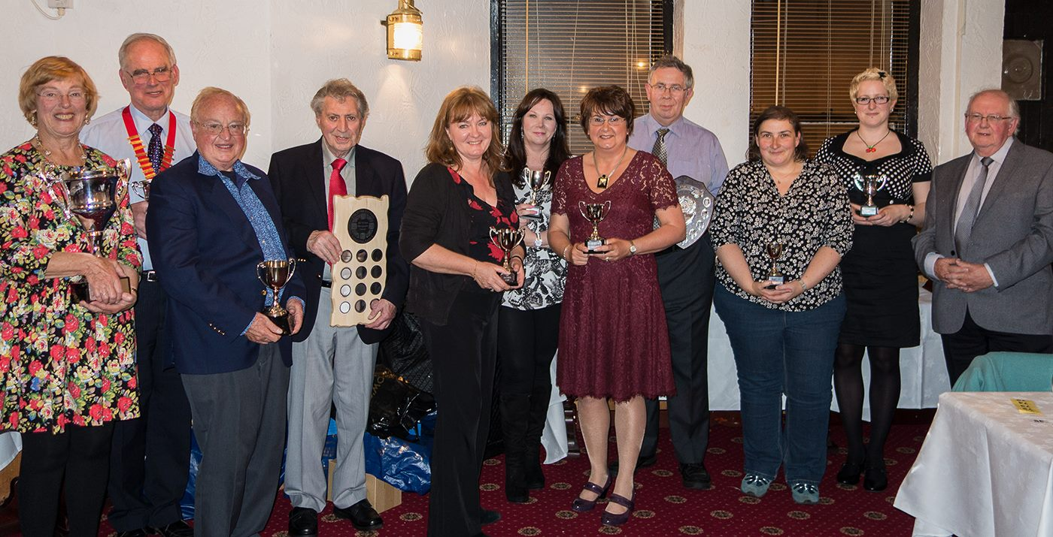
Some of the trophy winners at the annual dinner and prize presentation evening
The Annual Dinner is a definite reminder for the IOM Photographic Society that the official programme and our season of speakers / competitions / practical sessions is at an end - and an excellent meal at the Hydro Hotel in Douglas was an apt way to finish a very busy year.
Attended by nearly 40 members, partners and guests, it was also the occasion for the presentation of awards – the cups and certificates - for those members who have been competing in various competitions throughout the year. The occasion was of particular significance for a number of reasons. This is the first year that the society has had a "best of the best" award, given to the member with the greatest number of wins for the "best image in competition" on each of our (many) competition evenings. The award, a lovely wooden shield, designed and made at the Manx Workshop for the Disabled at the old Nobles Hospital, was given in memory of Brian Kershaw , who was for many years a member of the society. Ron Shimmin, who has had a very successful and consistent year in competition, deservedly won the award, which was presented by David Kershaw, Brian’s son.
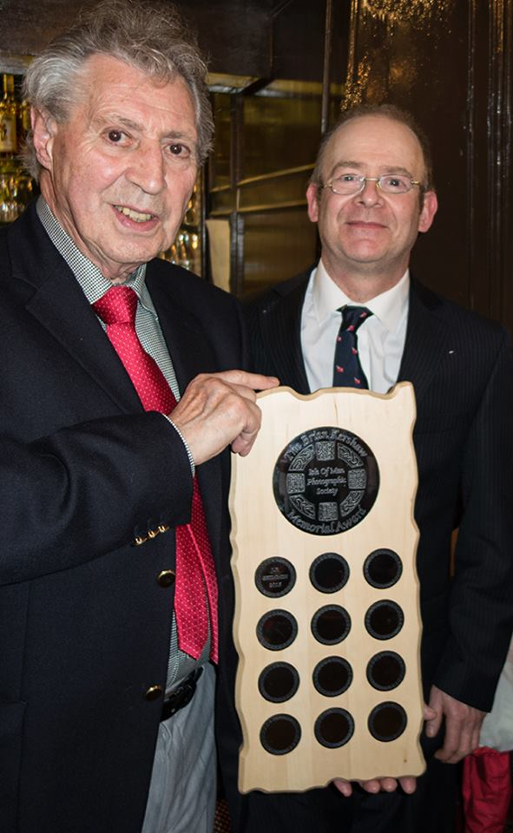
David Kershaw presents Ron Shimmin with the Brian Kershaw Memorial Plaque
Our retiring President, Antony Hamilton, also had the pleasure of announcing that members of the society had been successful in completing a project on behalf of the Philatelic Bureau at the IOM Post Office. The project was to photograph some of the animals and birds at the Ballaugh Wildlife Park, the resulting images to be used in a set of 6 stamps commemorating the 50th anniversary of the park, and, following royal assent, will be issued later this summer. It was particularly poignant that 2 of the accepted images had been taken by Patricia Harvey who has subsequently and very sadly passed away. Pat was an excellent natural history photographer, and the stamps will be a vivid and appropriate reminder of her skills.
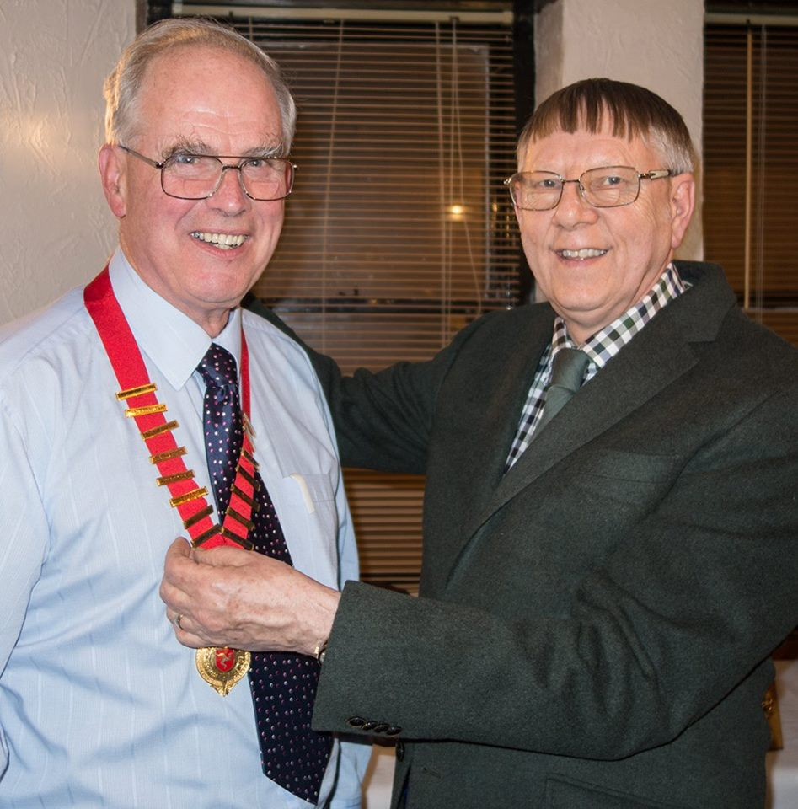
Antony Hamilton hands over the Presidents ribbon to Chris Blyth
The new President, Chris Blyth, congratulated Antony on a successful year, noting his ability to provide just the right "light touch" of humour and tact in handling club affairs, and in presiding over our weekly meetings. A programme of summer events and outings will be announced shortly – members and anyone interested in photography should please check regularly the club website for details. The new season of weekly meetings will re-commence in late September.
By Chris Blyth

IOMPS Reports During July 2015

12th July 2015 - President's Letter
President’s Letter to Members July 2015
Hi to all members and prospective members – and I hope that you are enjoying the summer and your photography! With the new 2015 / 2016 programme now rapidly approaching, I thought it appropriate to remind you of events, happenings, and anything relevant to the Society and its interests, preparatory to the start of the new season when the regular weekly meetings will obviously give opportunity for a more regular update ... so, here goes.
THANKS
I want to put on the record my formal thanks to both Antony Hamilton (as the outgoing President) and to Anne Bidwell (committee member) for their contributions to the club over the past year. Antony again proved a superb leader of club activities, tactful yet decisive, an excellent speaker and chair for our events, and with a lovely sense of humour. I appreciate only too well that he will be a hard act to follow ! Anne’s role was lower key but nonetheless a very good committee member, and in particular, a much valued author of many of the regular Courier articles through the season - an essential part of much of our public relations effort. Thank you to you both !
YOUR NEW COMMITTEE
The new committee is working hard and well, and includes three new members – Richard Shafto, and Chris and Ruth Nicholls. I am delighted to welcome them onto the committee where they are already proving invaluable members, playing a very active role in the development of the new programme.
A (SLIGHTLY) NEW DIRECTION - DEVELOPMENT + INVOLVEMENT + EMPOWERMENT
Your committee has long been concerned that the club each year suffers a “rate of churn” in the membership - the loss each year of a number of members (often new or recent joiners) and the consequent need to replace them with further new members to keep our numbers up.
In addition, the club has traditionally had a very strong emphasis on competition work as a means of developing members’ skills – of learning from the feedback given by our judges, and seeing what makes for successful winning images – and in a process rather like osmosis, the hope that skills and better images then result. There has been little time devoted to the development of skills from tutorials, workshops or presentations by the membership. It has been suggested that the heavy stress on competitions and a lack of skills development (in camera use and controls, in image manipulation etc) could themselves be seen as possible causes for the turnover.
The ending of the small print competitions has released several evenings for other activities with new possibilities.
Accordingly, and in response to the issues identified above, your committee is including in the new programme a greater emphasis on skills development and for workshop / training opportunities, as well as giving members the opportunity to show their images in mini-presentations in a non-competitive environment. It is hoped that members will find these opportunities encouraging, supportive and (in management speak) empowering ! To be effective and successful, these new initiatives will require members to get involved and be willing to participate – but your committee believe it to be a risk worth taking……. The committee will, for example, be seeking volunteers – members willing to present (say) 15-25 of their images in mini-presentations on any subject of their choosing (e.g. a travelogue, a technique such as macro, maybe a selection of portraits or of wildlife) and just talking through the why / how / when / where of the images…… please contact Claire if you think you would be willing to “give it a go”…… !!
SUMMER ACTIVITIES
Your committee is providing a programme of activities during the summer to tempt members out of their gardens, or off the beaches (well, OK, in between the showers).
· Visit to Glen Maye – my thanks to Tony for arranging a visit to Glen Maye at the end of June, a delightful glen (and fairly short walk) - well worth exploring. I’m just sorry that only a half dozen or so of the membership joined us for the event…
· Boat Trip - A dozen of our membership will be going (weather depending !) on a boat trip out to the Calf of Man in mid-July – and hopefully seeing lots of the bird and sea life around our beautiful coast
· Castletown “disposable camera” day – thanks again to Tony Curtis for organising this event, something very different from our usual digital day, and a reminder of the quality available even with the cheapest of film cameras. Please book up early with Tony (tonycurtisiom@hotmail.co.uk) for the outing on 2nd August….we need some notice to ensure the purchase of the disposable cameras !
· A visit to Scarlett led by Ian Lumsden is in planning – details to be issued shortly…
· And finally, a visit to the two Motor Museums now in Jurby – one has free of charge entry, the other is chargeable BUT with concessions for a group. Negotiations are in process…
· Please keep an eye on the website and check your emails over the next few weeks for more details as we sort out the arrangements for each event….
IOM POST OFFICE / BALLAUGH WILDLIFE PARK
Members will remember that the club was invited last December to participate in the photography of a number of rare or endangered animals and birds at the Wildlife Park in preparation for the issue of a new series of stamps for the IOM Post Office to mark the 50th Anniversary of the Park. The 6 stamps in the issue went on sale from 3rd July, and to mark the occasion, an exhibition of a selection of members’ images submitted for consideration has been put on display at the Park. It will remain on display until late July – and the PR opportunity to promote the work of the Society has obviously been taken.
RULES
No major change in the rules for club competitions is planned, though the decision to drop the small print competitions has obvious implications for our programme (see above). However, as members will probably be aware, the L&CPU this year amended the rules for their print competitions – and we are now required to submit a digital copy (in the standard 1400x1050 pixels format) together with all print entries in L&CPU competitions. This is to enable the L&CPU to enter inter-federation competitions using the best images available, in either print or digital formats as appropriate to the various competitions.
As a result, we would like to follow a similar path, and hope that members will co-operate from the start of our new season by using the website to submit their print entries exactly as they do for their digital entries – ie submit the details of all print entries using the “competitions” area of the club website, AND include a digital copy of their print entries at the same time. This will NOT be mandatory for the moment BUT is very strongly recommended for all members, and will be very helpful for our own competition planning – it will make the preparation of the club entry much easier for the various digital battles in which we compete (the inter-Island-club 3-way battle, the 2-way battle with Bristol, the 3-way with Rochdale and Oldham, and the L&CPU club battle). It will hopefully also make the preparation and administration of our normal club print competitions much easier.
The website is currently being updated to allow this change, and it will be functional for the start of the new season. I would stress that the programme includes an early opportunity for a training session on rules, mounting of prints, entry processes etc so that new (or old) members can be brought up to speed on these requirements.
CHANGES IN COMPETITION “CLASS GROUPINGs”
Your committee has discussed the changes to members “classification” for competition purposes, and decided that the following members would be re-classified for the new season :
· Joy Brodie, Richard Shafto and Beryl Quayle are all promoted from Standard to Intermediate
· And Chris Nicholls goes from Intermediate to Advanced
And congratulations and a “well done” to all of them !
PROGRAMME
The provisional programme for the new season is now “live” on our website – please keep an eye on it and on your emails for any developments. The new season will start on Wednesday 30th September with a showing of all the digital entries from last season’s Annual Competition, something of a social evening, and a discussion led by myself and Ruth of the competitions environment / photographic qualifications / mentoring and training opportunities……
I look forward to welcoming as many existing and new members as possible on the occasion….
Very best wishes
Chris Blyth

IOMPS Reports During August 2015

26th August 2015 - Studio session at Andrew Barton Photography

Members who took part in the recent studio session at Andrew Barton's new studio in Douglas
The IOM Photographic Society starts its new season on Wednesday 30th September, with an open invitation to anyone with an interest in photography (and perhaps with a wish to improve their skills) to come along and join in our programme. Traditionally, our programme has emphasised competition work and the feedback from the judges as a means to develop photographic ability, but our programme from September this year specifically introduces a series of events linked to training and skills development.

For a number of our members, this initiative has already included an evening with Andrew Barton - a life member of the society and a very committed supporter of club activities. The venue was his new studio in Douglas, studying the techniques of studio portraiture, and using both studio flash equipment and constant light units. Our two male "physique" models, Shaun and Lance Wyllie, gave their time in return for images to be provided by the photographers. Andrew was both helpful and patient, explaining clearly the camera settings and the variations in the placing of the light units required to achieve the different effects possible - images which in particular emphasised the impressive musculature and body tone of our models. Altogether a very satisfying and enjoyable evening, albeit just a bit different to our usual activity - and with particular thanks to both Andrew and our models!

To continue the "skills development" theme, the new programme now includes :
· a workshop on camera controls - e.g. aperture, shutter speed, ISO settings, depth of field and flash, and how they interact
· an introduction to "digital basics" - file formats (RAW, tiff, psd, and jpeg) and digital software adjustments such as brightness, contrast, levels, curves, white balance, mono conversions, and sharpening
· an introduction to photoshop layers, gradients and the adjustment brush
· a "critique session" to help members identify the strengths and weaknesses often to be found in images - e.g. poor composition, colour casts, or a lack of sharpness - and to be critical of their own images
Of course, the programme also includes our usual "stand-byes" - a number of speakers with photographic presentations, together with competitions when independent judges will make comment upon the various entries. But a programme is always a compromise - intended to please as many members as possible for as much time as possible. It is hoped that the new programme will provide a better balance, with a wider spectrum of activities to enthuse our members, to raise standards and improve overall skills and competencies, but at the same time, ensure we all continue to enjoy a shared enthusiasm for photography and have some fun whilst doing it.
The Society is particularly proud of its website - www.iomps.com - which is state of the art, and covers both the details of our programme and a wide range of information about the society, its history, and the members. For example, entry into our digital competitions is all done "on-line" in a very simple and easy process, with results similarly recorded and shown. A regular weekly report on club activities is always maintained, whilst all members have the benefit of a personal gallery - in effect, their own personal website - to showcase their work.
The Society is known for the very warm welcome given to all visitors, and the excellence of its facilities in the Art Society building in Withington Road, Douglas. All meetings start at 7:30pm, with a refreshments break midway through the evening, and finishing usually shortly after 10pm. We look forward to welcoming one and all to our meetings, starting on 30th September.
By Chris Blyth

