IOMPS Reports During September 2015

24th September 2015 - New Season Begins
Most of us have a camera, or at least a mobile phone with a camera incorporated, and most of us take images of friends, family, or of our holidays which will go on to facebook or into the family album. And whilst technical advances in cameras mean that the "auto" settings enable generally reasonable and reliable quality, many will wish their images were more in focus and better composed, not just snapshots taken on the fly.
For those facing that predicament, the winter programme for the IOM Photographic Society starts next week - Wednesday evening 30th September at 7:30pm sees the first event in our new programme, with a showing of all of the digital images entered by the members in the Annual Competition held earlier in the year.
There will also be a discussion, led by Club President Chris Blyth, of amendments to the "usual" programme which have been made to allow a more focused approach to developing the photographic skills of our members. Space has therefore been made in the programme for a number of tuition sessions - the first on basic camera controls (aperture, iso setting, shutter speed, depth of field etc), the reasons why the photographer may wish to use certain settings, and the advantages and disadvantages of making a change to those settings. In due course, this will be followed with sessions on software - the computer programmes which enable image manipulation - and covering the various file formats for photographic images, basic techniques to adjust colour, contrast, brightness, and the cropping of images, together with the various tools which allow such adjustments to be made selectively.
The programme does, of course, also include a wide range of competitions which members are encouraged to enter as a means of getting helpful feedback as to their merit as well as some possible suggestions for improvement. In addition, the programme includes a number of presentations and speakers on photographic subjects - always informative and interesting.
The new programme will be of interest to anyone with the wish to explore photography, to improve their understanding or just to take some better shots of the family or of their holidays. All will be made welcome - our meetings are held at Thie Ellyn, the Art Society building in Withington Road, Douglas, and are open to the public, non-members with an entry charge of just £1.
By Chris Blyth

IOMPS Reports During October 2015

29th October 2015 - First Digital Open Competition
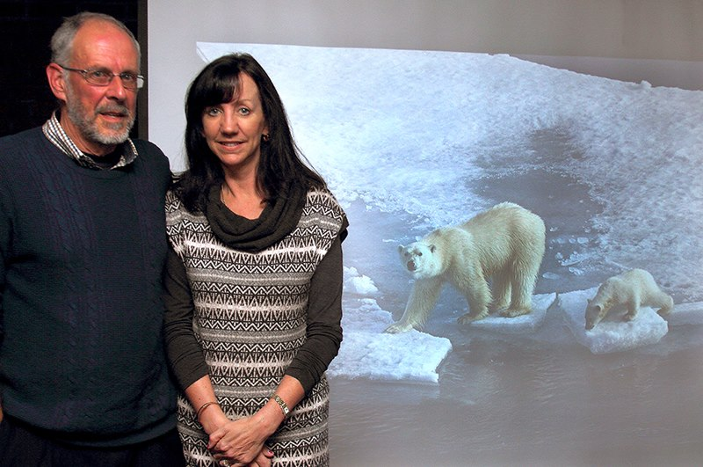
Judge Doug Allen with 'Best Image' winner Sue Blythe
Wednesday 21st October was the first judging of an open digital competition this season for the Isle of Man Photographic Society. We welcomed back last week’s judge Doug Allen from the Western Photographic Society....
Doug told us how much he had enjoyed judging the images and how he is always impressed by the variety of locations and subjects presented. He has an extensive knowledge of the island and various locations and was able to provide historical facts and information relating to many of the images submitted.
He explained that judging the digital images is often more challenging that judging print entries due to issues with screen calibration and the projector – we can never be entirely sure that what we view on the projector is exactly the same as the photographer intended when submitting the image.
Doug remarked on the high quality of entries – particularly within the standard section. In fact, it was the winner of the standard section who also won the award for the best image in the competition – a well exposed image of a mother polar bear and her cub crossing blocks of ice with the cub looking directly at the photographer – the image was titled ‘Living on Thin Ice’ by Sue Blythe.
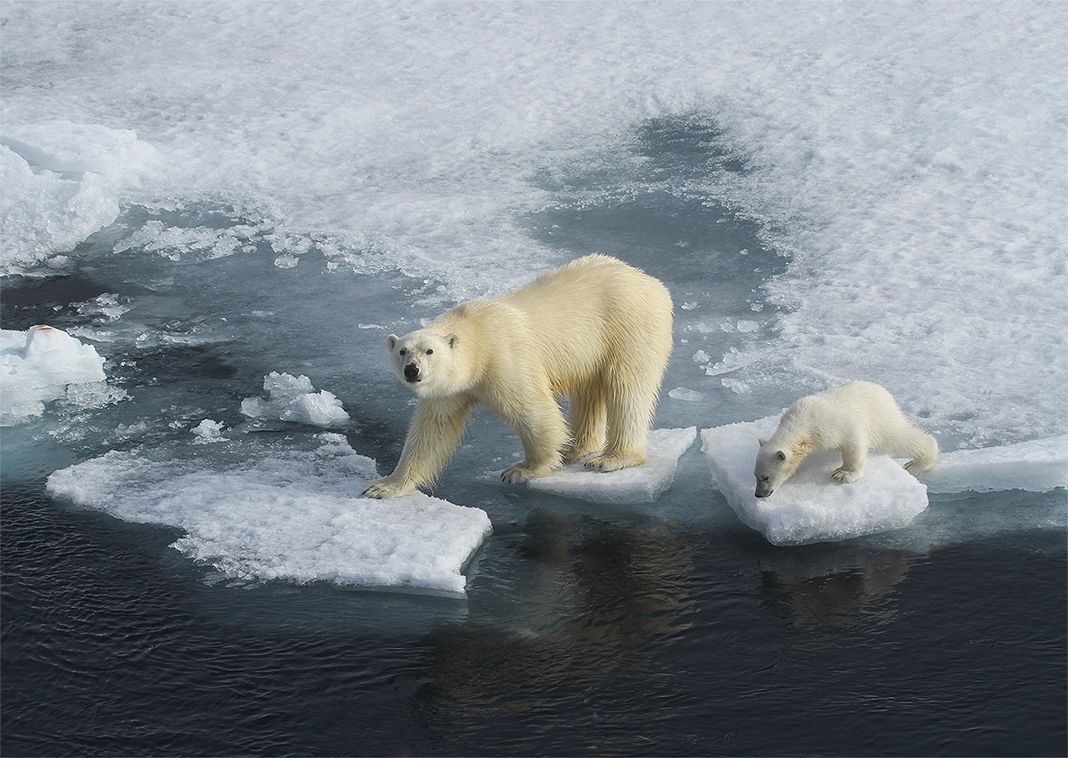
Best Image: 'Living on Thin Ice' by Sue Blythe
The intermediate section also contained a selection of high quality images with first prize going to Annette Slater for her simply stunning beach sunset image ‘Into the Blue’.
Winner of the advanced section was Chris Blyth with a pin sharp image of a ‘Red Kite’. Doug commented on the successful use of depth of field to blur the background and highlight the detail in the kite’s feathers.
Chris Blyth, as president, then provided the vote of thanks and highlighted an upcoming event which is the 3 way battle between Isle of Man Photographic Society, Western Photographic Society and Southern Photographic Society. As last year’s winners the IOMPS will be hosting the event this year at Edwards Bay Golf Club in Onchan on Friday 30th October.
The next club night will be the judging of the season’s first assignment competition – the theme for which is ‘Squares’. This will take place from 7.30pm on Wednesday at Thie Ellyn as usual.
RESULTS:
Standard - 1st & 6th Sue Blythe, 2nd & 3rd Barry Murphy, 4th & C. Michael Howland, 5th Steve Meadows, HC. & C. Tim Norton, C. Mike Rowlands.
Intermediate – 1st & 6th Annette Slater, 2nd & 3rd Beryl Quayle, 4th & 5th Shirley Lotfy, C. Nessie Gillen.
Advanced – 1st & C. Chris Blyth, 2nd & 6th Sue Jones, 3rd & HC. Ruth Nicholls, 4th Claire Stringer, 5th & HC. Mark Stringer, C. Bob Servante.
Best Overall Image – Sue Blythe.
By Hazel Walsh

22nd October 2015 - First Open Print Competition of 2015-16 Season
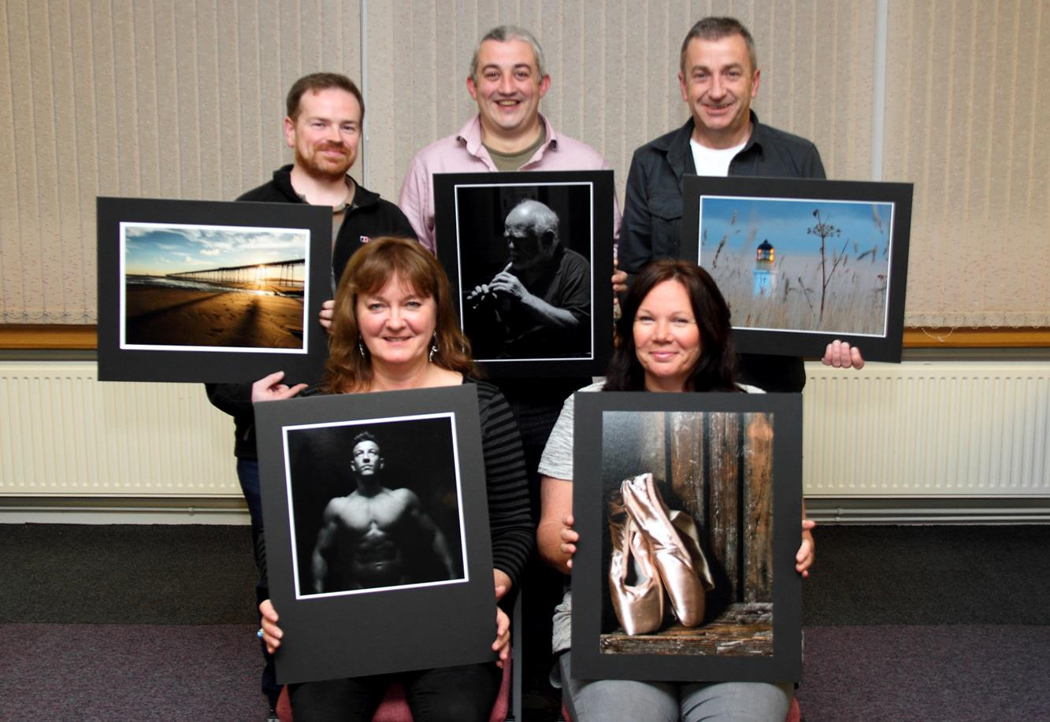
Some of the Open Print Competition winners with Judge Doug Allen
Wednesday Evening 14 October at Thie Ellyn off Withington Road, Douglas was the time and place for the Isle of Man Photographic Society's first Open Print competition of the new 2015 – 2016 season.
Three classes within the Club are Standard, Intermediate & Advanced and anyone can enter up to two Colour and two Mono prints into their class.
Our Judge for the evening was Doug Allen from the Western Photographic Society. Doug has Judged several times at the Club over the years and recalled some of his earlier experiences. He is a very capable photographer with good knowledge of what attributes are required to produce a pleasing image. These attributes include sharpness, contrast, brightness, and composition.
Doug started by judging the Standard Mono entries followed by the Standard Colour. He made useful comment on every print and gave some good suggestions along the way on how an image may be improved. He then continued through the Intermediate and Advanced sections. Doug finally chose his three favourites that were put forward for a separate Best on the Night competition and this was won by Bob Servante for his mono photograph “Rapid Response Unit” shown here.

Best Image went to 'Rapid Response Unit' by Bob Servante
The photograph was taken at this year's Isle of Man Railways' Island at War event at Douglas Station and shows a 1936 Austin Police Car about to respond to an urgent call. Thanks go to Police Officers PC 303 Rebekah Collins and PC 319 Colin Everden for being good sports when asked to pose whilst they were on duty at the Station.
Top placings in each group as follows:-
Standard Mono
1st Heads Up by Sue Leeming
2nd Taking in the View by Steve Meadows
3rd The Tin Cup by Barry Murphy
Standard Colour
1st Plaza Espania Row Boat by Mike Rowlands
2nd Albert Tower by Barry Murphy
3rd The Artist by Mike Rowlands
Intermediate Mono
1st Monster in the City by Richard Shafto
2nd Bonding by Nessie Gillen
3rd Allium Bud Breaking by Beryl Quayle
Intermediate Colour
1st Golden Eyes by Nessie Gillen
2nd Lifebelts by Shirley Lotfy
3rd Linara (Purple Toadflax) & Bee by Beryl Quayle
Advanced Mono
1st Rapid Response Unit by Bob Servante
2nd At Cregneash by Sue Jones
3rd Seat of Learning by Ron Shimmin
Advanced Colour
1st Evening Light by Robert Blyth-Skyrme
2nd Santa Maria Della Salute by Chris Blyth
3rd Stonehenge by Sue Jones
Entries for the first Assignment competition “Squares” both prints and digital are due next week.
By Bob Servante

15th October 2015 - Disposable Camera Competition
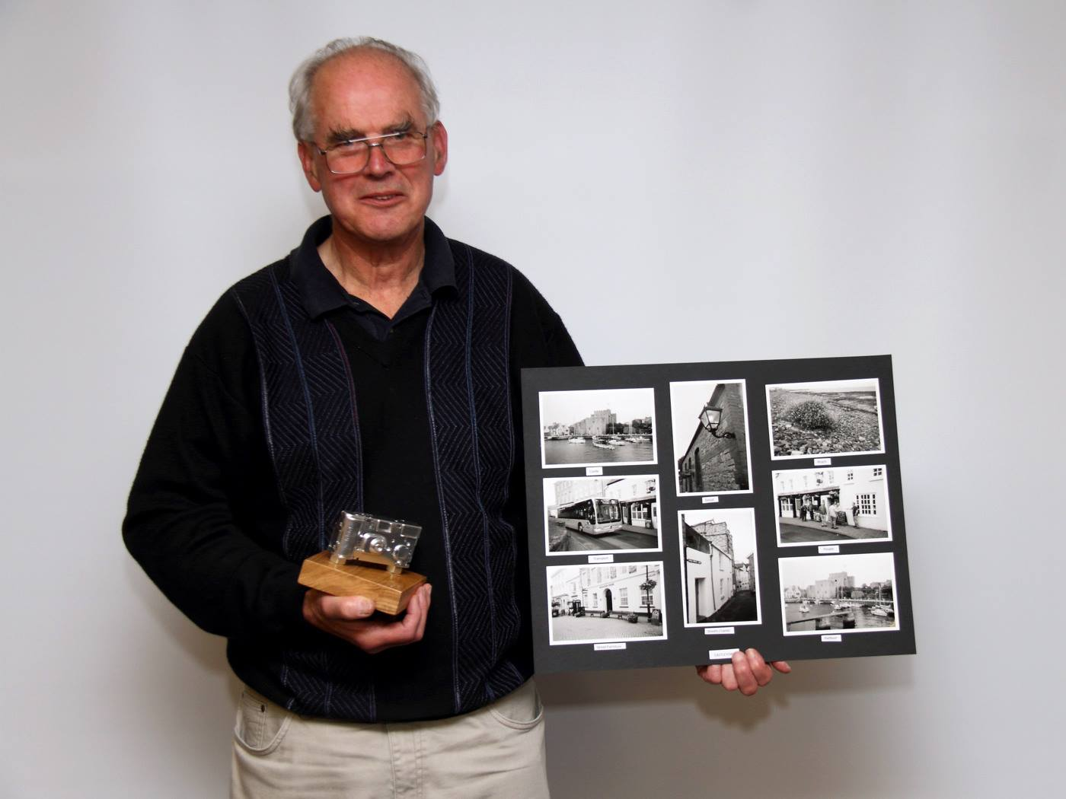
Chris Blyth with his winning panel from this summer's 'Disposable Camera Competition'
For various reasons, not all of the Society’s summer outings went according to plan this year but one that did was the disposable camera competition. Let me explain.
One of the Society’s past Presidents, Tony Curtis, came up with the idea a few years ago of an annual competition for all members of the Society using only inexpensive, fairly basic, disposable cameras. Now, all amateur or professional photographers have their own preferences and favourites when it comes to choosing camera equipment. Some are fortunate enough to be able to purchase the very best cameras and lenses with the highest manufacturing specifications. Others, naturally, are less able to afford the best and have to settle for something rather less sophisticated. Of course, what is important at the end of the day is not ‘fancy’ equipment, but the skill of the photographer in applying the appropriate techniques to achieve the desired results!
The idea of supplying everyone who wishes to enter this competition with identical ‘point and shoot’ cameras is that this creates a completely level playing field where no-one has a perceived unfair advantage. Not only is there no way for the photographer to change such elements as film speed or camera aperture, but no-one is able to manipulate the image post exposure before entering it. This is because all of the numbered cameras are collected in at the end of the time allocated for shooting and the Society arranges for the development of all of the films and the return to the resultant prints to the photographers who exposed them.
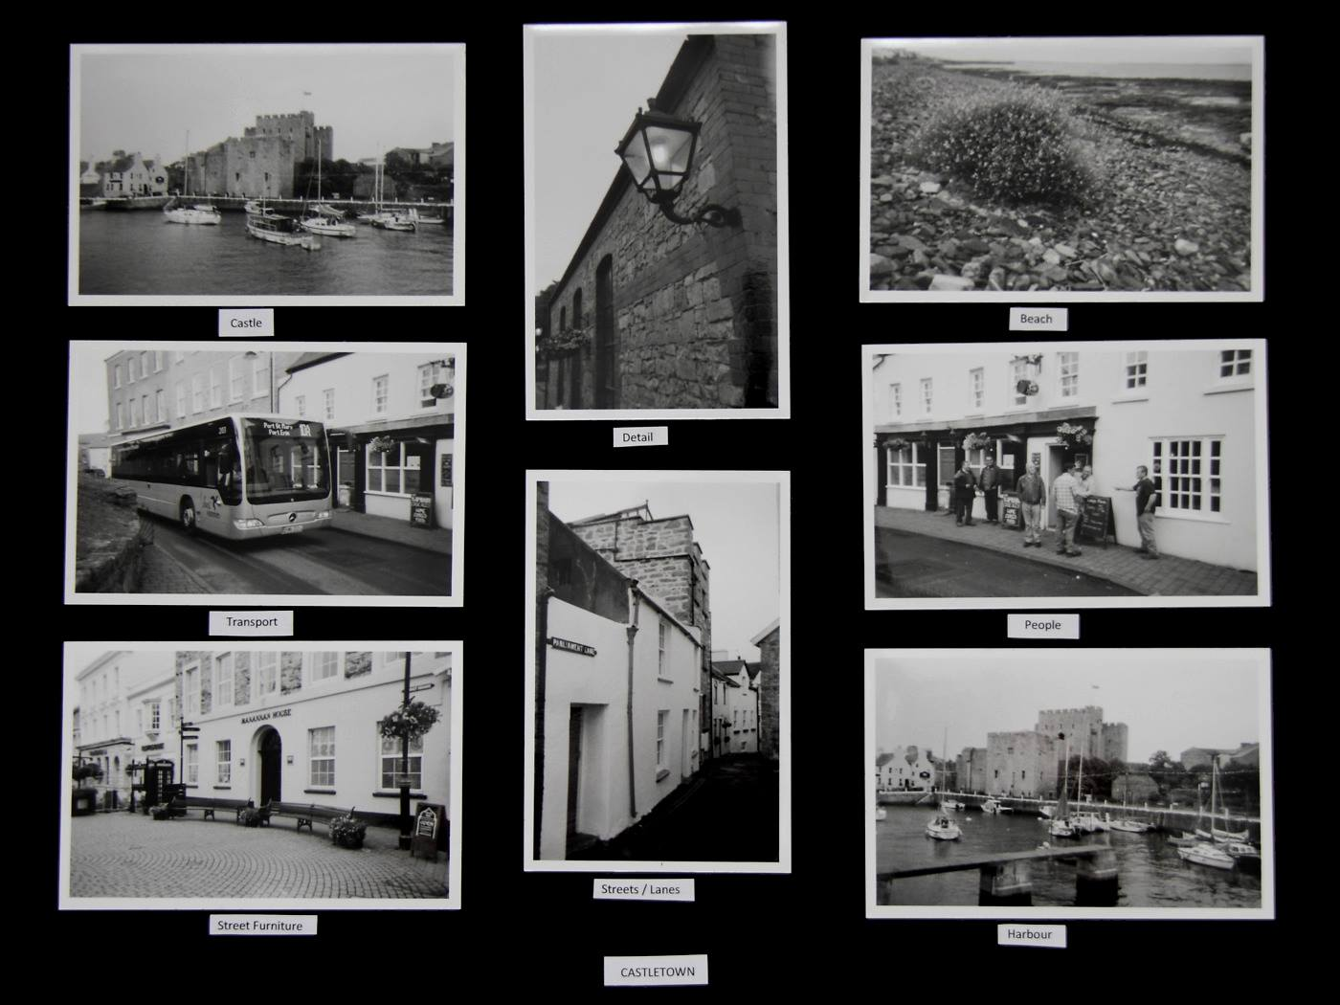
The winning panel
So, on overcast Sunday afternoon in August, those members who had expressed a wish to enter the competition were asked to meet in Castletown where they were each handed a disposable camera. The challenge that Tony has set for them was to produce eight images on set topics around the Island’s ancient capital with the intention that, once the developed prints had been returned to them, they would produce a board containing the eight images of their choice in a presentation style of their own choosing. Black and white film was supplied this year, rather than the usual colour.
Our judge for this competition was Ron Shimmin ARPS, DPAGB, a life member of the Society and former President. Ron is well known in photographic circles for his meticulous, high quality work, especially in producing winning competition prints, some of which have been selected for inclusion in prestigious exhibitions on the adjacent island. Ron began by explaining the marking system he had adopted for the competition, awarding marks for each of the set categories (transport; shoreline/beach; castle/grounds; harbour/boats; streets/lanes; people; detail; and railings/street furniture) plus a mark for presentation. He spoke of the challenges the photographers had faced with the poor lighting and uninteresting sky on the day. Perhaps this might explain why only 10 of the photographers had felt confident enough to submit an entry panel.
Our judge found that, acknowledging the limitations, the standard had been pretty good, though there was evidence in several of the images that some viewpoints had proved to be more successful than others because of the poor light. This is all a part of the learning process, of course! After totting up the overall marks, Ron had found the top two entries had scored exactly the same number. This meant that he had had to decide between these two and award first place to the slightly better presentation of Chris Blyth, with Beryl Quayle a very close second. Jenny Shanley came third with her panel, which was also very commendable.
Because the Society is keen to help its membership to improve the level of their skills, Ian Lumsden then gave an extremely helpful demonstration of how best to mount competition prints entries. As had been witnessed earlier in the evening, presentation can prove to be a deciding factor when entering competitions so it is important to make the finished article conform to the standards now being insisted upon by judges.
The second part of the practical for the week took the form of a useful glossary for members and guests of the different types of file formats for digital images, led by Chris Blyth, and a linked presentation by him of a few of the more popular software tools, including Photoshop. This covered several techniques for re-sizing images, adjusting colour balance, and removing distortion cause by using wide-angled lenses, particularly on buildings. There will be another skills workshop in December, so please watch this space for details a little nearer the time!
As the Society won the three-way battle with the Southern and Western Photographic Clubs the last time it was held, it falls to the Society to organise this year’s rematch! This will take place at Edwards Restaurant, King Edward Bay Golf Club, at 7.30 pm on Friday, 30th October. Further details can be found on the Society’s website (iomps.com) but members (and any non members) are reminded that they need to book as soon as possible to secure a place for this friendly, but keenly contested, annual competition.
All competition entries now have to be submitted by uploading the images (including copies of those for print competitions) direct to the Society’s website iomps.com. A video will appear shortly on the website explaining how to do this successfully. Remember, you have to be in them to win them where photographic competitions are concerned!
Members of the Society are reminded that there will be an ‘Open’ Competition for projected digital images on Wednesday, 21st October, starting promptly at 7.30 pm at Thie Ellyn (off Withington Road, Douglas). Anyone interested in photography is always welcome to come along as our guest and enjoy an evening with us, without any commitment to join, for a nominal entry charge. We would love to see you!
By Antony Hamilton

8th October 2015 - Opening Night Presentations
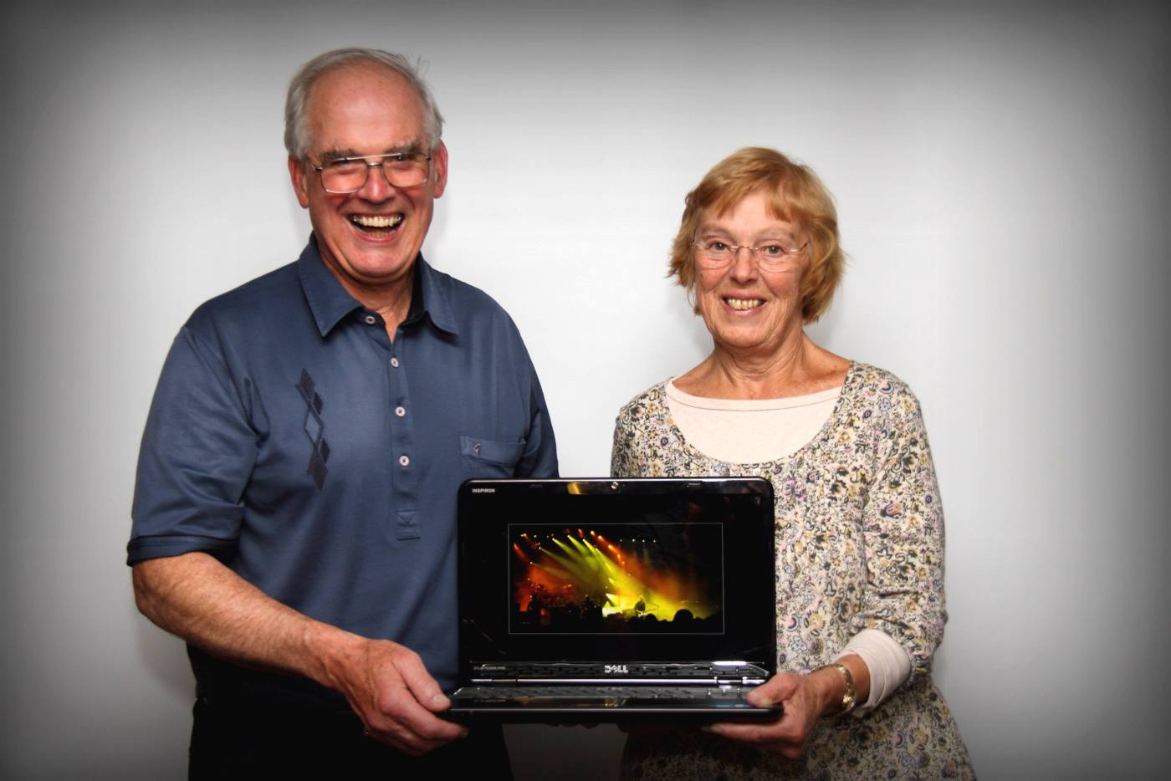
Chris Blyth and Ruth Nicolls with one of a selection of CPAGB qualifying images shown to members on the first evening of the new season
Anybody can do it, and everybody does - take photographs, that is, whether with a camera or their mobile phone. And photography is so simple, it's almost stupid, it's so obvious - just "point and press the shutter"..... at least that's the theory, so why isn't every shot a winner? And what is it that makes a "good photo" or even a "great photo"? Those were the questions posed by Chris Blyth, President of the IOM Photographi...c Society in his introductory presentation to the opening meeting of the season. The answer given more than 60 years ago by Henri Cartier-Bresson, the great French photographer of the twentieth century, was "the decisive moment" - that split second when the subject, the light, and the composition all come together to produce the magic that distinguishes a great shot from a snapshot. It's that "moment of magic" which the good photographer is trying to capture.
And as Chris pointed out, whilst anyone in one of those moments of happy serendipity may occasionally take a "great photo", photography is art, not science - it's not an equation, not a formula, not a list of "tick-boxes" - it takes skills and artistry to produce a consistent body of work. And identifying that magic moment - that distinctive, perhaps unique element is often intangible and inexplicable..... but is nevertheless, something which club members must be encouraged to aspire to and to achieve. The ending of our small print competitions has fortunately allowed our programme to incorporate occasional tuition sessions into our normal competitions and presentation evenings - the objectives being a raising of standards and an encouragement for developing the skills of our members.
As part of this package, Ruth Nicholls LRPS DPAGB EFIAP BPE3* - Competitions Secretary and one of the most qualified (and best) photographers on the Island - explained the various qualifications available and the requirements for obtaining them. In addition, she was able to confirm the offer of a club mentoring system to help any members wishing to attempt one of them, with BPE and CPAGB being perhaps the ones to consider.
The half-time break provided an ideal opportunity to socialise after our lengthy summer break, and the evening concluded with a showing of the digital entries into our recent Annual Competition.
Our next meeting, on Wednesday 14th October, is an Open Digital Competition. All meetings start at 7:30m, and are held at the Art Society Building (Thie Ellyn) in Withington Road, Douglas. Meetings are open to the general public (non-members with a charge of £1, payable at the door). Anyone with an interest in photography is urged to come along – all will be made welcome!
By Chris Blyth

4th October 2015 - Competitions & 3 way battle
Dear Member, Just a reminder that on Wednesday the first open Print entries are due. Please if you can, we would appreciate it if you would also upload a digital copy of your print into the site. Same process as for digital competitions. (This also enables you to put the image straight into your gallery!)
For new members the details on what is allowed / how to enter prints sizes etc is below:
http://www.iomps.com/information/rulesandconstitution
Also the 3 way interclub battle between IOMPS / Southern / Western is coming up and digital entries are due by Saturday 10th October!
So please upload any images that you would like to be considered for the IOMPS club entry by this date.
Details on how to upload digital images can be found in documents (under information)
http://www.iomps.com/information/documents
Please remember that your image size must be 1400 x 1050 filling any space with black. Again details on how to do this is in the documents sections on the website.
Any problems logging in, or any new members unsure of how to enter please feel free to drop us a line. However please don’t leave it till the last minute, so start thinking about it now!
Kind Regards
Claire

1st October 2015 - Looking Forward to New Season
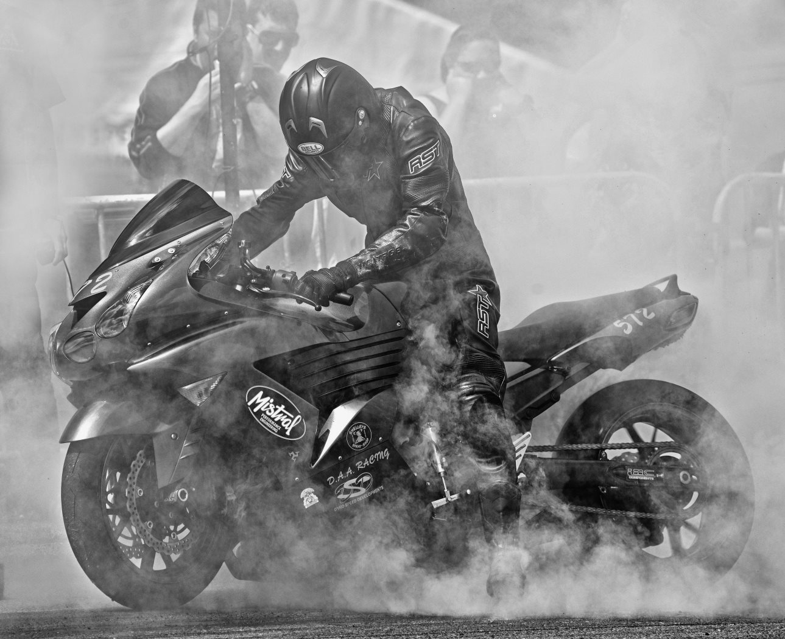
'Urban Burnout' taken by Bob Servante was one of the winning mono images in the latest IOMPS Annual Competition
Another summer passed, and the “season of mists and mellow fruitfulness” will soon be upon us – which means that Manx photographers should bookmark Wednesday evenings for the meetings of the IOM Photographic Society, which started yesterday (30th September) with a showing of the digital entries to the Annual Competition held earlier this year....
It has been a strange summer – the weather has been variable, to say the least! – and our summer outings as a result have had mixed success. The programme included visits to Glen Maye and to Scarlett, the latter in particular being very well organised by Ian Lumsden (from the IOMPS) and Charlotte Shafto (from the Manx Wildlife Trust) who ensured a good understanding of the geology and fossils in the area, as well as the limekilns on the beach. A visit to Castletown, arranged by Tony Curtis, was well attended – the objective there being the use of a disposable film camera with just 27 shots available – and a requirement to shoot 8 “assignments” (harbour, castle, streets etc) with a board to be produced with the best prints to represent the 8 topics for a competition early in the season. This is always a challenge, and the weather – cold, overcast and with a hint of rain – was not helpful to good photography. The annual boat trip to the Calf, despite three attempts, was eventually cancelled due to poor weather on each occasion. A visit to Andrew Barton’s studio, however, was a great success – Andrew was very helpful in explaining the use and placing of studio lighting for portrait purposes, whilst our two subjects (Shawn and Lance) proved excellent models with superb physique and musculature – we are sure their images will duly appear in competition this year.
However, the new season promises to provide a slight change in emphasis from our previous, competition biased programmes. In an effort to develop the photographic skills of the membership, a number of our evenings will be devoted to more practical skills – for example, the use of a camera and its controls, basic skills and techniques in the use of software such as photoshop and lightroom, as well as members presenting some of their images as brief slideshows without the pressure of being in competition. The objective is to encourage our members to develop camera skills, to have greater confidence in using their cameras, and to share a mutual enthusiasm for photography.
All meetings start at 7:30m, and are held at the Art Society Building (Thie Ellyn) in Withington Road, Douglas. Meetings are open to the general public (non-members with a charge of £1, payable at the door). Anyone with an interest in photography is urged to come along – all will be made welcome!
By Chris Blyth

IOMPS Reports During November 2015

26th November 2015 - Open Print Competition
Some of the Open Print winners with Judge Steve Babb
Wednesday 18th November was the second Open Print competition of the season. The judge was well known local photographer Steve Babb. He proved to be an enthusiastic and capable judge offering constructive commentary and advice on a variety of photographic techniques including sharpness, angles, lighting, and exposure.
We began the evening with the advanced entries – there were 7 entries in the Mono section and 11 in the colour section. A well deserved first place in the mono went to Ron Shimmin for his entry – ‘What’s an I-pad?’ a well composed and captured image of a woman seated on a bench alongside two statues who appear to be peering over her shoulder to see what she is doing. First place in the colour section went to Sean O’Moore, a new member of the society, for his beautifully captured image ‘Queens Pier Sunrise’.
Moving onto the standard entries – 11 in the mono section and 17 in the colour this was the highest number of entries in a group and reflects the increase in new members the society has seen recently. First place for mono went to Barry Murphy for his image ‘Tony’. Barry also scooped first place in the colour section with his image ‘Autumn Meadow’ showing the distant light of a lighthouse over a meadow at dusk. A special mention also goes to our new junior member Sarah Bucknall who placed fourth in the mono section and fifth in the colour.
Following the tea break the judging moved onto the intermediate section and Steve commented on the high standard of entries in this group. 10 entries in the Mono section and 13 in the colour. First place in the mono went to Beryl Quayle for her eye-catching studio shot of ‘Lance-Body Sculptor’. Steve was especially impressed with the entries in the intermediate colour section and described how he had struggled to select the order to place them in. One subject that he mentioned throughout the night was the emotion in the images and he chose the winning shot ‘Love my Ballet Shoes’ by Nessie Gillen due to the well composed image, carefully controlled lighting and colour and sense of emotion that the image portrayed.
This image was also selected as the best in the competition.
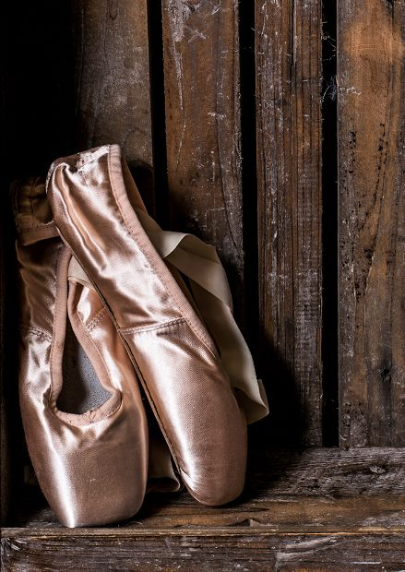
Best image in the Competition went to 'Love my Ballet Shoes' by Nessie Gillen
RESULTS:
Standard Mono – 1st & 5th Barry Murphy, 2nd & C. Steve Meadows, 3rd Sue Blyth, 4th Sarah Bucknall, 6th Sue Leeming, C. John Cullen.
Standard Colour – 1st & 4th Barry Murphy, 2nd & 3rd John Cullen, 5th & C. Sarah Bucknall, 6th & C. Sue Blyth.
Intermediate Mono – 1st Beryl Quayle, 2nd & 3rd Annette Slater, 4th Sam Bucknall, 5th Richard Shafto, 6th Nessie Gillen.
Intermediate Colour – 1st & 3rd Nessie Gillen, 2nd & 5th Annette Slater, 4th & C. Beryl Quayle, 6th Sam Bucknall, HC. & C. Shirley Lotfy.
Advanced Mono – 1st Ron Shimmin, 2nd & 3rd Sue Jones, 4th & 6th Bob Servante, 5th Nigel Owen.
Advanced Colour – 1st & 3rd Sean O’Moore, 2nd & 6th Sue Jones, 4th Chris Blyth, 5th & C. Bob Servante, HC. Nigel Owen.
By Hazel Walsh

19th November 2015 - Members Evening
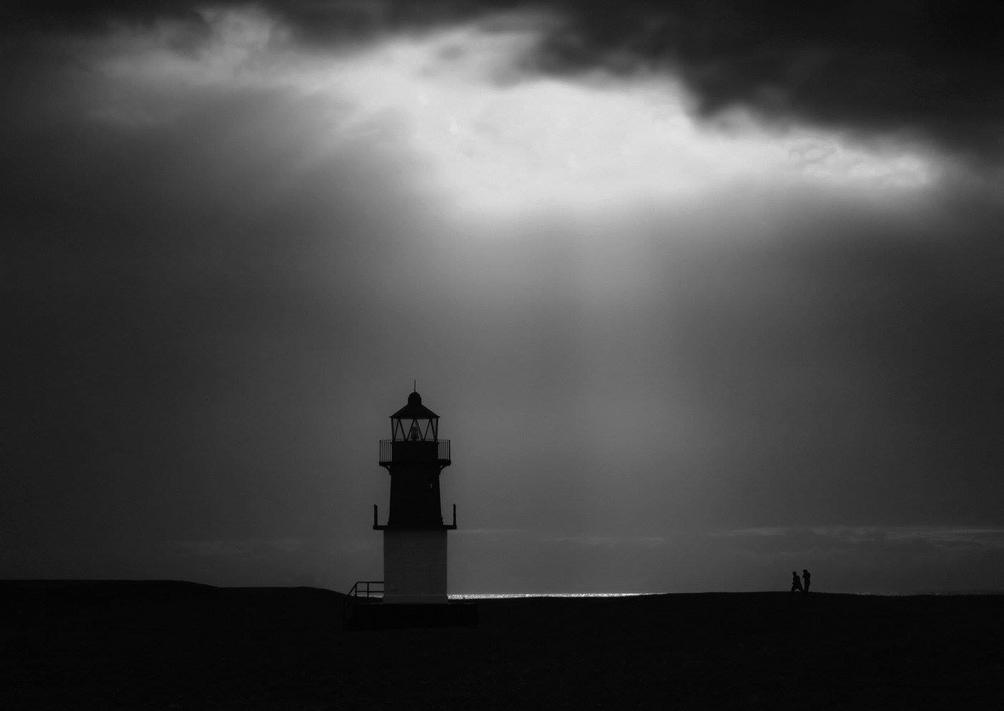
Point of Ayre by Bill Callow
The Society has a reputation for encouraging amateur photographers to share their skills and to help others to improve. Continuing this theme, a few members whose images might not otherwise be seen in competitions had been asked to give a short presentation of their photography. Viewing these personal images by six members turned out to be both successful and enjoyable for everyone present.
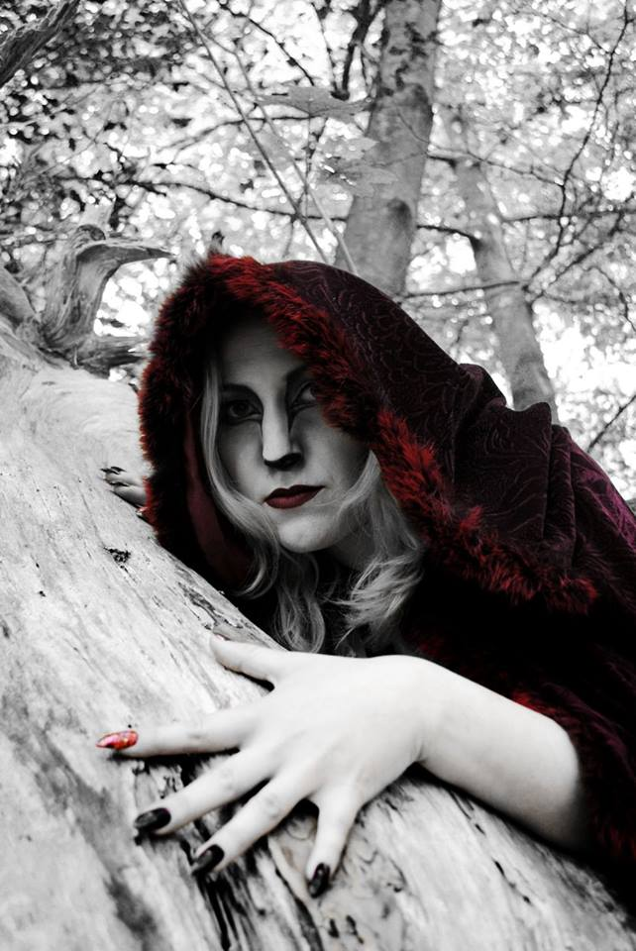Red Riding Hood by Hazel Walsh
The evening began with a presentation by Martyn Parnell of high quality action shots taken at motorcycle racing and rallying events on the Isle of Man. Martyn is well known in motoring circles and has had many images accepted for publication in a variety of specialist magazine over the years. He was followed by Lara Howe, a Marine Biologist, whose delightful presentation comprised miscellaneous images reflecting her interests in both wildlife and travel. It was then the turn of Michael Howland, the volunteer Press Officer for the local branch of the Royal National Lifeboat Institution. His images featured different lifeboat training exercises and call-outs around the Island, both by night and by day.
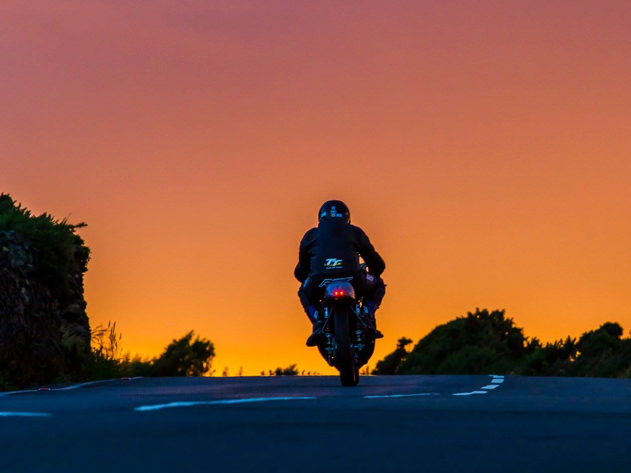
Last Lap by Martyn Parnell
Hazel Walsh’s photography can be a little unpredictable but is never dull and is always guaranteed to make her audience sit up and take notice. Her presentation came next. It was an eye opener of well planned photo shots using different models, costumes and props in various locations across the Island. Next came Tony Curtis, a member of the Laxey Mines Research Group, whose presentation included images of the Group’s activities both above and deep below ground. Finally, Bill Callow presented his personal project of local characters from Ramsey town as an historic record which closed, very appropriately, with the Act of Remembrance at the Ramsey War Memorial held earlier in the day.
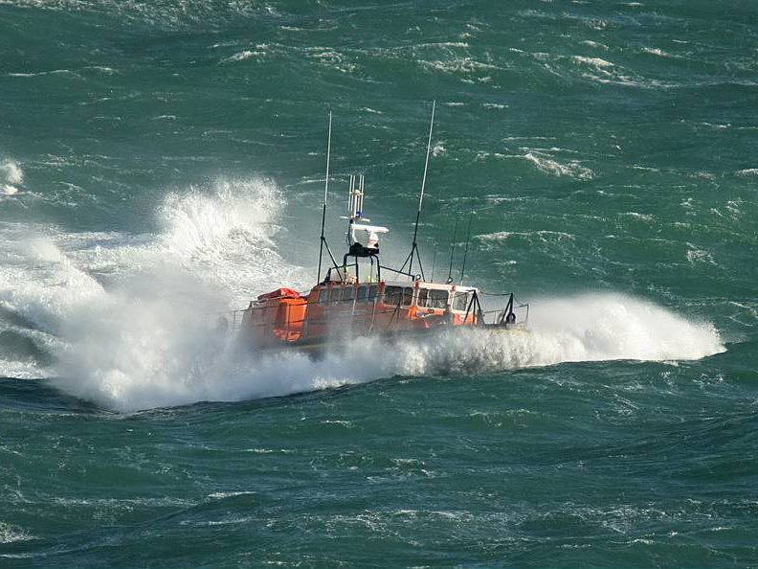
Douglas Lifeboat by Michael Howland
After a break for refreshments, the second part of the evening provided an opportunity for members and guests to view the latest colour and mono print folio from the Lancashire and Cheshire Photographic Union, some 60 images on a variety of topics. These folios are a useful indication of the standards being set and expected by UK competition judges.
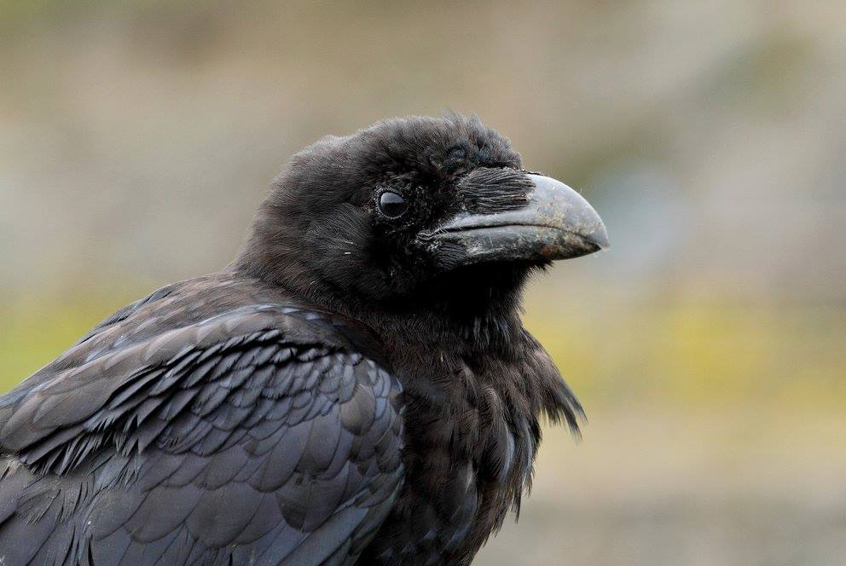
Raven by Tony Curtis
Members of the Society are reminded that there will be an ‘Open’ Competition for projected digital images on Wednesday, 25th November, starting promptly at 7.30 pm at Thie Ellyn (off Withington Road, Douglas). Print and digital entries will also be due in that evening for the next ‘assignment’ competition for which the subject will be ‘Collections’.
Anyone interested in photography is always welcome to come along as our guest and enjoy an evening with us, without any commitment to join, for just a nominal entry charge. We would love to see you!
By Antony Hamilton

12th November 2015 - First Assignment Competition - 'Squares'
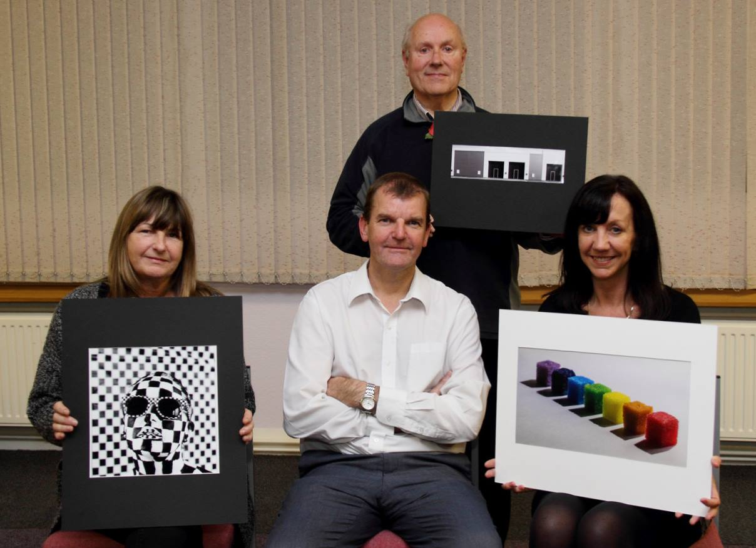
Some of the assignment print winners, Annette Slater, Mike Trout and Sue Blythe with Judge Brian Goldie
Members of the IOM Photographic Society faced a set subject for this week’s assignment competition of “squares” – the exact interpretation then being left to the photographer. So a plethora of images of scrabble boards, chess boards, town squares, and crossword puzzles (amongst others !) faced our judge, Brian Goldie from the Southern Photographic Society.
Brian immediately made clear that a judge’s view is at best only an opinion – and that no-one should take life too seriously – we all participate in photography as a hobby, and we do it for enjoyment and fun. So a judge’s comments are just that – an opinion hopefully intended to help and to be constructive. And Brian lived up to our expectations with a commentary which was delivered effortlessly, with a real knowledge of photography and its constituent elements of composition, use of light, etc. The set subject caused little problem other than that the popularity of scrabble and chess images inevitably meant that many images were effectively competing in a class of their own – and only the best would then feature in competition with the rest! Several images deserve special mention – an image by Nessie Gillen of slices of Battenberg cake very artistically arranged end on to show the multi-coloured squares of cake, for example, whilst a tiered hotel in Malta featuring a very middle eastern style of “block” architecture gave Mark Thorsby a win in the Standard Digital section.
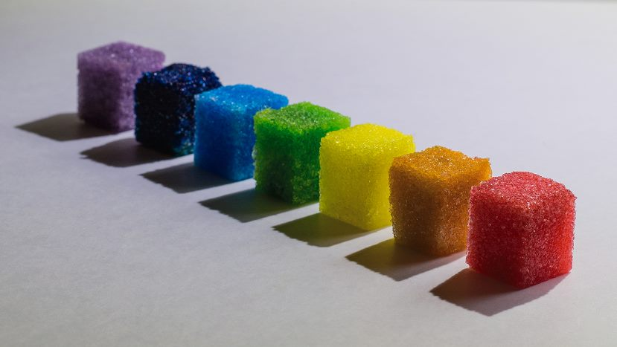
Best Overall Print went to Sue Blythe for “Rainbow Candy Squares”
The overall best print entry was judged to be “Rainbow Candy Squares” in the Standard Group. This was an entry by Sue Blythe which showed a line of sugar cubes which had been soaked in different coloured food dyes to make a simple yet most attractive image, and which demonstrated great thought and initiative in responding to the set subject – a well-deserved winning image ! In the digital competition, the best image award went to Nigel Owen from the Advanced Section with an entry showing a newspaper crossword page (lots of little squares !) with a pair of glasses, and the word “squares” answering one of the clues…. Again, a very considered entry for the assignment.
Results – Open Prints : Standard Group – Mono : Mike Trout (1), Sue Leeming (2), Sue Blythe (3 & 6), Steve Meadows (4 & 5). Colour : Sue Blythe (1 & 6), Sue Leeming (2 & 5), Mike Trout (3), Steve Meadows (4). Intermediate Group – Mono : Annette Slater (1), Nessie Gillen (2 & 3). Colour : Nessie Gillen (1), Annette Slater (2), Shirley Lotfy (3), Phyllis Christian (4), Beryl Quayle (5 & 6). Advanced Group – Mono : Ron Shimmin (1 & 3), Sue Jones (2 & 4), Bob Servante (5 7 6). Colour : Sue Jones (1 & 3), Ron Shimmin (2 & 5), Bob Servante (4), Chris Blyth (6). Overall Best Print in Competition – Sue Blythe with “Rainbow Candy Squares”.
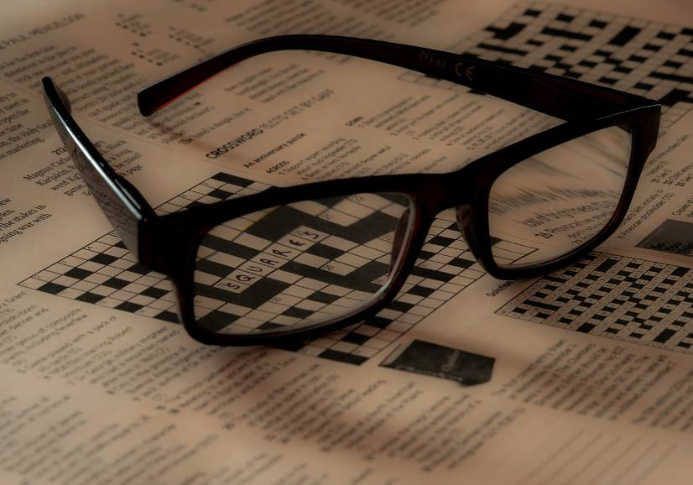
“Mind Games” by Nigel Owen gained Best Overall Digital Image
Open Digital Images : Standard Group - Mark Thorsby (1), Sue Blythe (2 & 3), Mike Trout (4 & 6), Karen Norton (5), Peter Keena (C). Intermediate Group – Nessie Gillen (1), Hazel Walsh (2), Beryl Quayle (3), Jenny Shanley (4), Shirley Lotfy (5), Richard Shafto (6). Advanced Group – Nigel Owen (1 & 4), Sue Jones (2), Chris Blyth (3), Claire Stringer (5), Chris Nicholls (6). Overall Best Digital Entry – Nigel Owen with “Mind Games”.
By Chris Blyth

5th November 2015 - Annual Inter-Club Battle
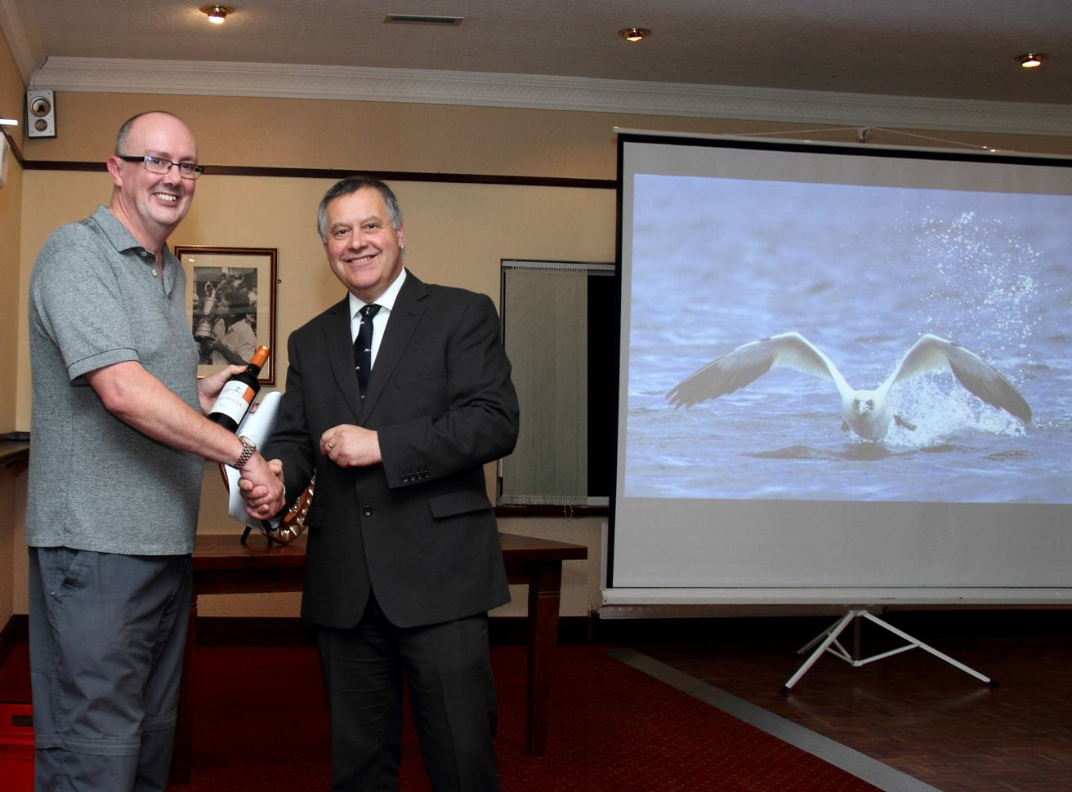
Judge for the evening Adrian Cowin with IOMPS Vice president Tony Curtis
Friday 30th October saw the presentation of the annual Three Way Battle between The Southern Photographic Society, The Western Photographic Society, and The Isle of Man Photographic Society,
hosted by last years winners the IOMPS at Edwards Golf Club in Onchan.
Our judge for the evening was Adrian Cowin, who was suitably qualified for the task as he has been teaching photography at the IOM College for the past twenty seven years, has a Degree in photography and has previously worked at Keigs.
The evening kicked off with a Buffet before heading into the main event.
Adrian was asked to comment on ninety digitally projected images (thirty from each Society) projected in random order and give marks out of twenty.
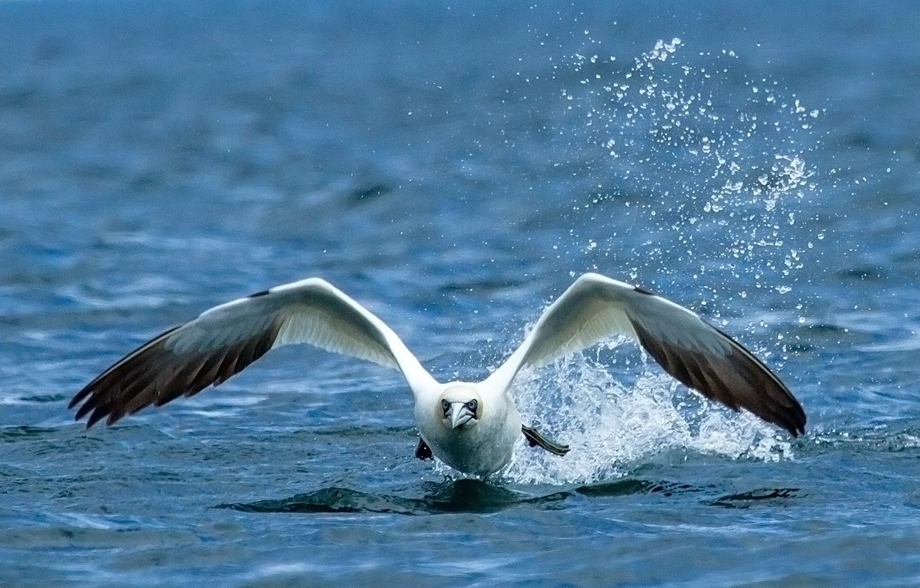
'Take Off' by IOMPS member Sue Blythe gained Best Overall image in the competition
His comments were succinct and helpful and betrayed his knowledge of composition and all the technical sides to the photographers art.
At the half way break the scores were neck and neck between Western and IOMPS with Southern a close third.
The second half continued this trend through to the end with Western triumphing over IOMPS by three points and Southern in third place.
Final scores were: Western 446 points, IOMPS 443 points, Southern 408 points
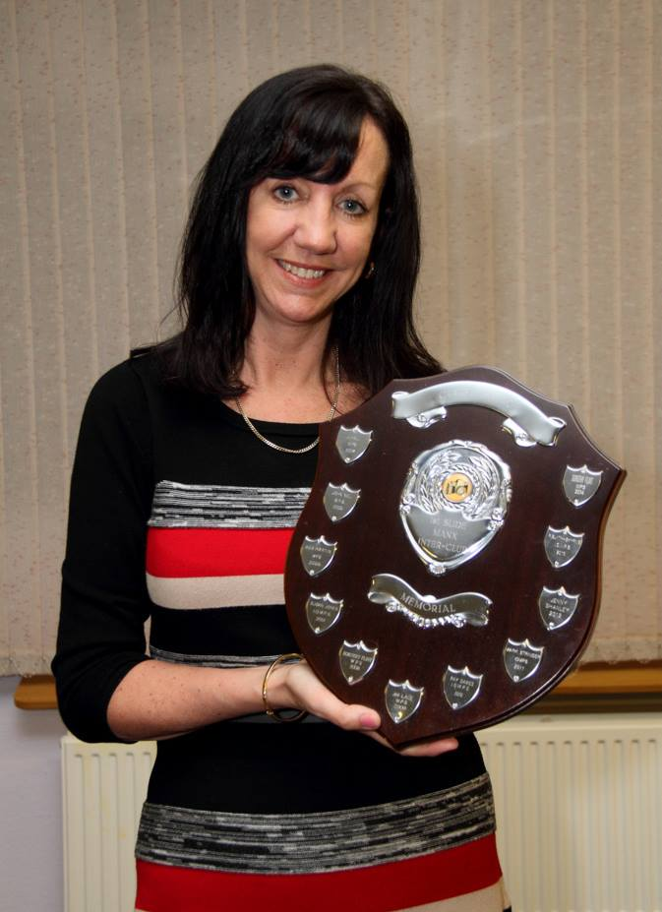
Sue Blythe with the Best Image trophy
The final duty for the judge was to announce the Overall Best Picture in the competition.
Three images had scored the maximum 20 points, with the trophy going to Sue Blythe from IOMPS for 'Take Off' an exceptional shot of a Gannet taking off from the water, but unusual, as it was heading towards the photographer giving chance to capture the face as well as the spread of its wings.
Sue is a new member to the IOMPS this season and looks to be able to give us all a run for our money.
Our host Tony Curtis - Vice president of IOMPS then thanked the judge and all the entrants to the competition and praised their work.
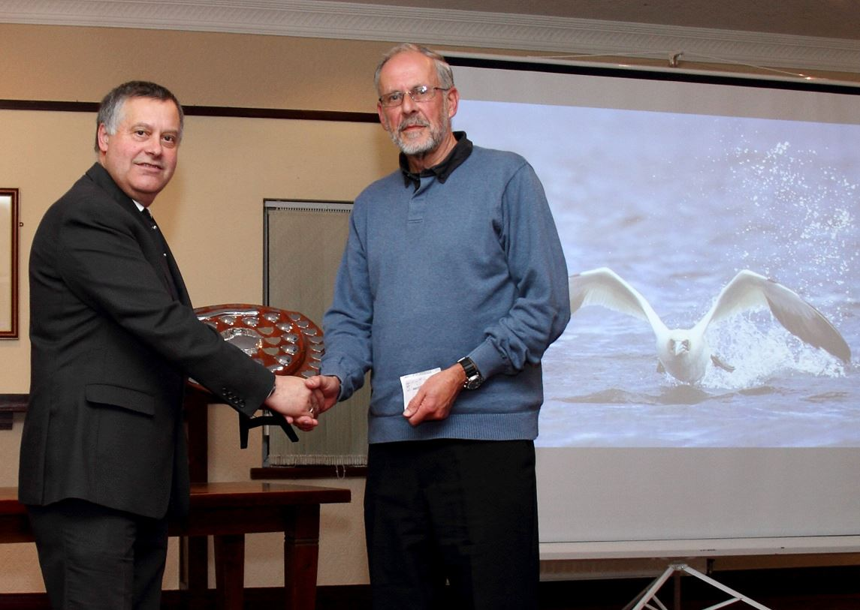
Tony Curtis - Vice president of IOMPS hands over the winning club trophy to Doug Allan - President of Western
He then invited Doug Allan - President of Western to come forward to be presented with the Club trophy.
Doug thanked the judge and the organisers for preparing the evening and the venue for all their work.
Our next meeting on 11th November will be a Members presentation evening along with an L&CPU folio and also entries are due in for the next Open Print Competition.
By Tony Curtis

IOMPS Reports During December 2015

24th December 2015 - Triptych Competition
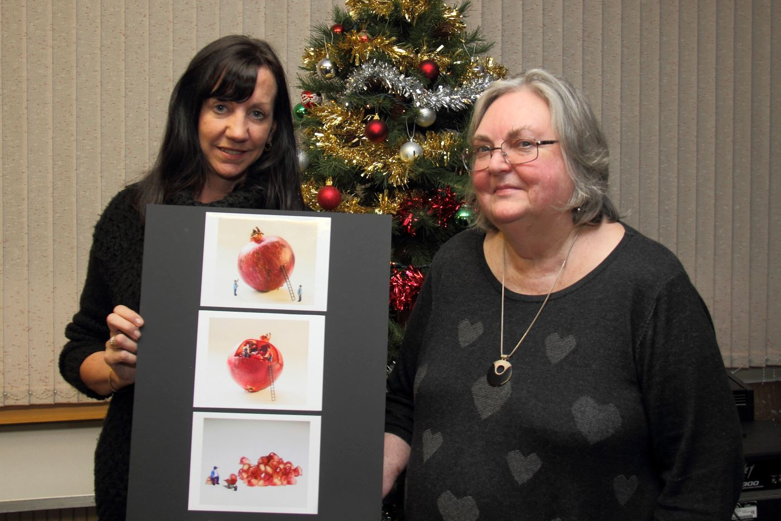Triptych competition winner Sue Blythe with Judge Patricia Tutt
Wednesday 16th December was the Isle of Man Photographic Societies final evening before the Christmas break. The first part of the evening was the judging of a triptych competition. Judge Patricia Tutt, Dip Arch, RIBA, Cert Ed, ARPS, CPAGB, PhD is a semi-retired architectural photographer who completed her PHD on vernacular architecture of the Isle of Man. She also has ten years experience as an Isle of Man College construction lecturer and has published two photography books.
Patricia began by explaining the different forms a triptych can take – the three images can work independently or as a group and can use narrative, comparative, evolutionary or content arrangement to convey an idea or concept. Those scoring highly in the competition used purpose or cohesion to create a successful triptych.
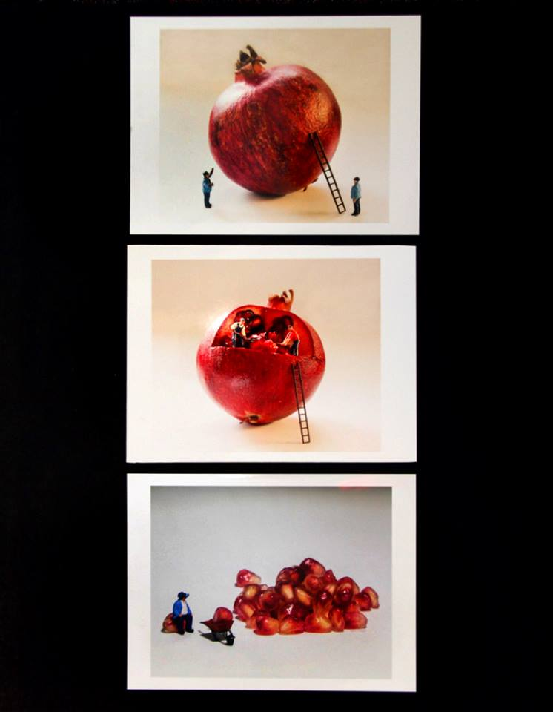
Winner of the triptych competition "The Giant Pomegranate Harvest" by Sue Blythe
There were 19 entries in total with submissions from beginners, intermediate and advanced members judged together. Patricia offered research and insights about the subject matter shown and was careful to explain the reasoning behind her placing of the images.
Third place went to Ruth Nicholls for ‘Sand Impressions’ with a composition of three sand images in a pleasing neutral palate. Second position went to Barry Murphy for ‘Three Leaves’ with a cleverly divided image of three autumn leaves, beautifully captured and presented. The well deserving winner was Sue Blythe, a standard member with her triptych ‘The Giant Pomegranate Harvest’. The delightful set featured miniature figures working to harvest fruit from a pomegranate.
Tony Curtis gave a vote of thanks and then members enjoyed food and drink and the opportunity to socialise. The society will meet back after Christmas on the 6th January and the evening will feature the President's presentation.
RESULTS:
Commended – Breaking Point – Bob Servante
Highly Commended – Tribute to the Great Laxey Miners – Sue Jones
6th – Fondation, Louis Vitton, Paris – Ron Shimmin
5th – Sadie, The Next Super Model – Dave Welsh
4th – Degradation of Fragility – Nigel Owen
3rd – Sand Impressions – Ruth Nicholls
2nd – Three Leaves – Barry Murphy
1st - The Giant Pomegranate Harvest – Sue Blythe
By Hazel Walsh

17th December 2015 - Practical Evening and L&CPU Folio
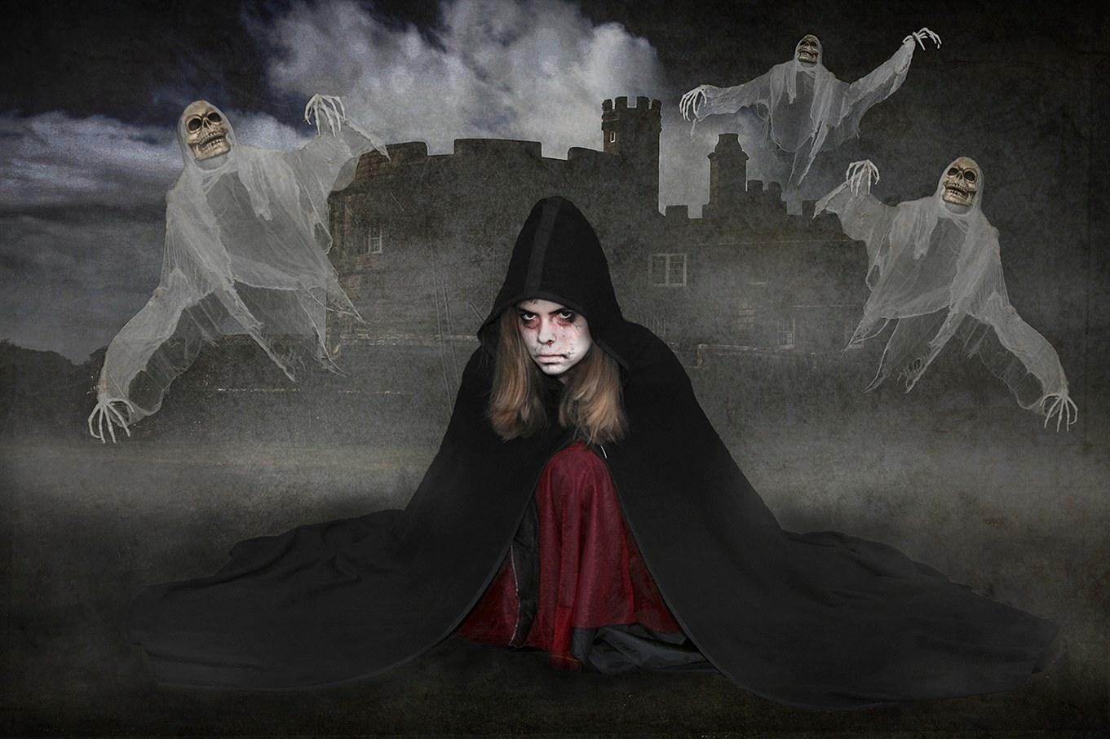
''The Haunting'' by Sue Jones represented the IOMPS in the latest folio of images from the Lancashire and Cheshire Photographic Union
At our penultimate meeting before the Christmas break, the Society presented a personal development session based on Photoshop and, to a lesser extent, on the Elements software. This was led by Ruth Nicholls and Chris Blyth, two of our more experienced members, and was the latest in a series of practical evenings aimed at helping members to improve and refine their post production photographic skills.
Following a brief explanation of the importance played by exposure and a lay person’s description of what layers are and how they work, the two tutors proceeded to give members a step by step guide to a variety of applications with a particular emphasis on the use of ‘levels’, ‘adjustment layers’, curves, and the software’s histogram tool. There was a useful summary of the various different ways of accessing the same manipulative tools in order to achieve the same or similar outcomes too.
The session went on to describe different methods of converting a colour image to monochrome with helpful tips to indicate which were likely to produce the most effective results. Both Ruth and Chris willingly answered questions from the floor in a way that proved most enlightening, contrasting and clarifying the differences between shooting ‘RAW’ images, and the advantages and disadvantages to using ‘JPEG’ (compressed image file format) rather than ‘TIFF’ (tagged image file format) files.
The second part of the evening was devoted to a viewing of the latest folio of images from the Lancashire and Cheshire Photographic Union. This was the ‘C’ folio, a mix of 60 colour and monochrome images, including a few by ‘junior members across the Lancashire and Cheshire region. As always, it was pleasing to see a number of images from amateur photographers on the Island, which included one image from the Society’s Sue Jones. As always, these folios can be quite illuminating as they help to keep Island members abreast of changing trends and provide a useful indication of the standards being set and expected by UK competition judges.
The Society will resume its weekly meetings on Wednesday, 6th January, at the usual time of 7.30 pm at Thie Ellyn (the Arts Society building, off Withington Road, Douglas). That will take the form of the President’s Evening. Anyone interested in photography is always welcome to come along as our guest and enjoy an evening with us, without any commitment to join, for a nominal entry charge. We would love to see you!
By Antony Hamilton

10th December 2015 - Second Assignment Competition - 'Collections'
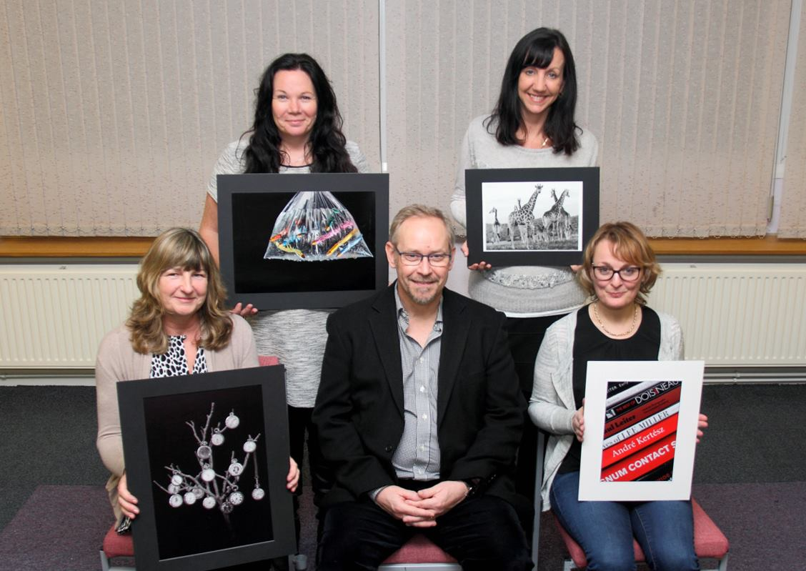
Some of the 'Collections' assignment print winners with Judge Ray Davies
The IOM Photographic Society was delighted to welcome Ray Davies as the judge for this week’s assignment competition. The set subject was “collections” – a rather odd subject which caused many members to scratch their heads and wonder just what to submit as an entry. So everything from stamps to a pile of books, from hatpins to a dandelion head, from charity boxes in the local shop to a montage of TT riders faces – all qualifying as meeting the very general topic of “collections” of one variety or another.
Ray is an ex-member of the society (the “ex-“made necessary by family and job commitments) – and much missed because of his expertise as a photographer and for his presentational skills. Those skills were readily apparent in an extended, very thoughtful commentary which, whilst lavish in its praise, also included many suggestions on the photographic work under consideration – and just how it might have been improved. It was a commentary much enjoyed by the members –a judge looking at the entries through the eyes of a photographer, understanding the technical aspects as well as the artistic, and obviously enjoying the task at the same time….. And Ray’s choice of winners during the evening clearly reflected a good eye, with his selection incorporating the “usual suspects” of our top quality workers.
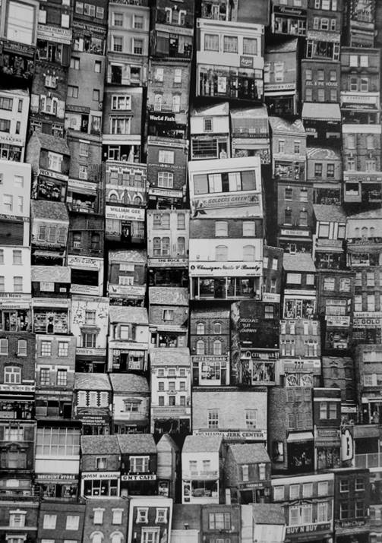
'Built Up Area' by Ron Shimmin gained Best Print Entry in the 'Collections' assignment competition
The award for the best print of the evening went to Ron Shimmin for “Built-Up Area”, a mono montage of shops and buildings, apparently taken from different angles and tightly compressed into a townscape – a townscape physically impossible in reality but as presented, an image of the very highest quality. Meanwhile, Hazel Walsh won the award for best digital image with “The Bone Collector”, also in mono, a goth type image with a collection of skeleton animal heads in a churchyard scene, dark and foreboding, and loaded with atmosphere. Tony Curtis, Acting President, gave a well-earned vote of thanks.
Our next meeting, on Wednesday 16th Dec will be a social evening for members and family, together with a triptych print competition. All meetings are held at Thie Ellyn (The Art Society Building) in Withington Road, Douglas, starting at 7:30pm. Meetings are open to the public, with an entry charge of £1 for non-members.
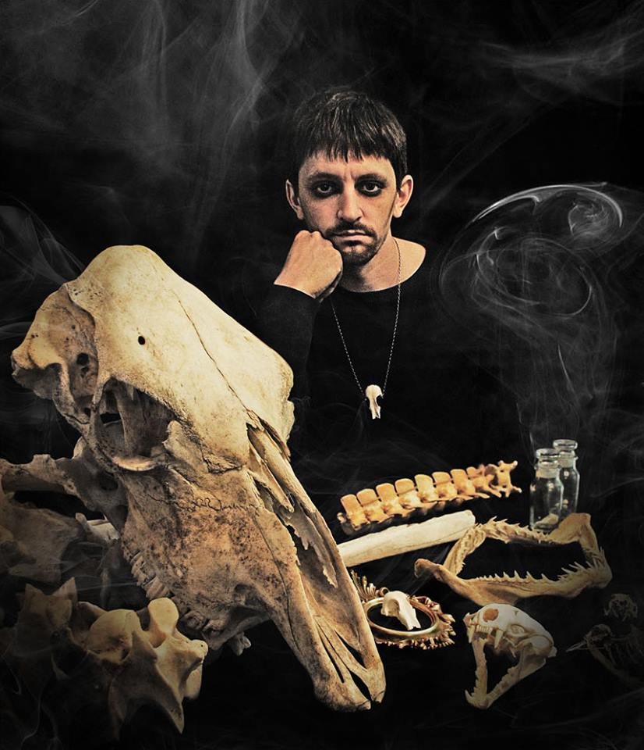
'The Bone Collector' by Hazel Walsh gained Best Digital Image in the 'Collections' assignment
RESULTS
Standard Section Mono Prints : Sue Blythe (1), Barry Murphy (2), Sue Leeming (3 & 5), Steve Meadows (4 & 6). Colour Prints : Deb Turk (1), Steve Meadows (2 & 5), Sue Leeming (3 & 4), Sue Blythe (6). Digital Images : Peter Keena (1), Sue Blythe (2 & 6), Tim Norton (3), Mike Trout (4 & 5), Steve Meadows (C). Intermediate Section Mono Prints : Annette Slater (1 & 3), Nessie Gillen (2 & 4). Colour Prints : Nessie Gillen (1 & 2), Beryl Quayle (3 & 6), Annette Slater (4 & 5), Shirley Lotfy (C). Digital Images : Hazel Walsh (1 & 4), Beryl Quayle (2 & 3), Nessie Gillen (5), Shirley lofty (6). Advanced Section Mono Prints : Ron Shimmin (1 & 5), Sue Jones (2 & 3), Chris Nicholls (4). Colour Prints : Sue Jones (1 & 2), Bob Servante (3), Ron Shimmin (4 & 6), Chris Nicholls (5). Digital Images : Sue Jones (1 & 4), Claire Stringer (2 & 6), Nigel Owen (3), John Phipp (5).
Best Print Entry of the Evening – Ron Shimmin with “Built Up Area”, Best Digital Image of the Evening – Hazel Walsh with “The Bone Collector”.
By Chris Blyth

3rd December 2015 - Open Digital Competition
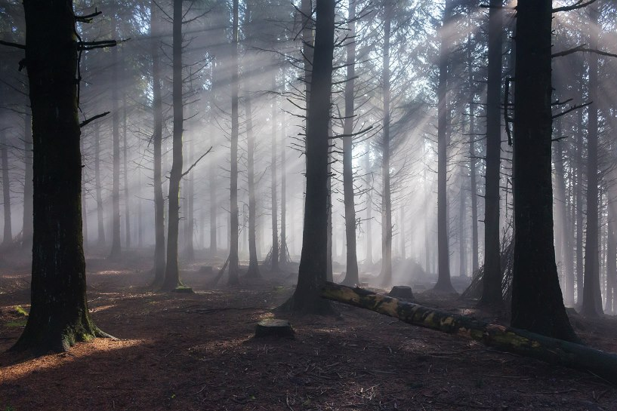
Best image in the November Digital Open Competition was 'Beacon Fell' by Steve Meadows
An Open Digital competition was the subject for this week’s IOM Photographic Society meeting – with local photographer Gary Harrison taking on the task of judging a very wide-ranging set of images. An “open” is always something of a challenge for a judge, because the images can literally be of any subject – from a portrait to a landscape, from a still-life to natural history, and everything in-between.
It proved a very entertaining evening, with Gary engaging in ready banter with our members, asking for the details of when / where / why / how the images were taken in an effort to understand the mindset of the photographer and whether he or she had succeeded in their artistic intentions. The results at the end of each section made clear that Gary had an eye for talent, and had recognised where that talent had been used to produce an exceptional image. All of the winning images showed both skill and determination by the photographers – where an effort had been made to use those skills to produce, not just “snapshots”, but works of the highest quality.
The superb, almost microscopic detail in the splash of a droplet of purple milk against a white background gave Sue Blythe a win in the standard group, whilst a study of a child on a tricycle, set in a faded vignette, earnt Hazel Walsh first place in the intermediate section. Chris Nicholls won the advanced group with a continental street scene, taken from ground level, and with an excellent perspective and lighting. However, Gary also remarked that some of the work being entered in the so-called “standard” section was at least as good as that being shown in the “advanced” - a reminder that experience can perhaps lead to complacency, and that enthusiasm and effort can often produce something quite outstanding. In due course, Gary nominated his “best image of the evening” – which led to a quite unexpected, indeed unheard-of result – his overall winner proved to be an image which had been marked as second in the standard section, a lovely shot by Steve Meadows of light rays penetrating through trees, showing a great understanding of lighting and exposure. Gary explained that he felt the standard section had shown two images of such quality that it would be unfair not to have given both an award – so had split his result such that one won the section and one the overall award.
Our next meeting on 9th December will include a Photoshop “skills development” session with Ruth Nicholls, as well as a folio of images from the Lancashire and Cheshire Photographic Union. IOMPS meetings are held at Thie Ellyn (the Art Society building) in Withington Road, starting at 7:30pm. Meetings are open to the public - non-members with a charge of £1 - and all will be given a very warm welcome.
RESULTS
Open Digitally Projected Images. Standard Group – Sue Blythe (1 & C), Steve Meadows (2 & C), Barry Murphy (3 & C), Peter Keena (4), Deborah Turk (5 & C),Jonathan Carey (6 & C), Patricia Larkham (2 x C), Sue Leeming (2 x C),Mike Howland (C), Tim Norton (C), Karen Norton (C). Intermediate Group – Hazel Walsh (1), Annette Slater (2 & C), Beryl Quayle (3), Nessie Gillen (4 & C), Richard Shafto (5 & C), Jenny Shanley (6), Shirley Lotfy (2 x C). Advanced Group – Chris Nicholls (1 & 6), Diane McCudden (2 & C), Claire Stringer (3 & C), Sue Jones (4 & C), Ruth Nicholls (5 & C),Bob Servante (C), Chris Blyth (C), Nigel Owen (C). Best Image of the Evening – Steve Meadows with “Beacon Fell”.
By Chris Blyth

IOMPS Reports During January 2016

28th January 2016 – January Open Print Competition
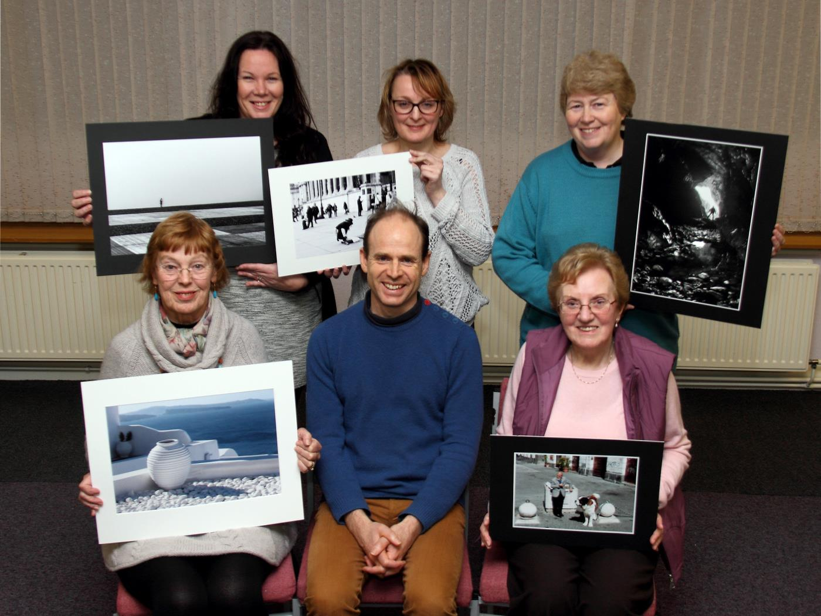
Open Print Winners with Judge Henry Uniacke
An Open Prints competition was the subject of this week’s meeting of the IOM Photographic Club, with Henry Uniacke from the Sayle Gallery as the judge, tasked to comment upon the various images presented. New to the club activities, Henry took the opportunity to introduce himself – and it proved fascinating, with a mix of foreign places and bohemian characters suggesting a life with lots of experiences to recount…..and it soon became clear that his biography included a deep knowledge and understanding of photography. It was obvious that Henry had carefully examined each image and had understood many of the technical challenges faced by those competing – whilst a series of questions to the entrants, quizzing them as to various aspects of their work quickly ensured a very interactive session, with full attention being given to the commentary. This was married with an equally obvious artistic talent, and an understanding for composition and the importance of (sometimes empty) space in an image.
A “candid” shot taken of a street artist and passers-by in Trafalgar Square earned Deb Turk a first place in the Standard Mono class, whilst the Colour award went to Steve Meadows with an image of a cobweb, including much of the surrounding bush – which gave an environmental context to the image, but which many would have been tempted to crop out as being unnecessary. The Intermediate Mono class went to Nessie Gillen, with an image of a small, solitary figure silhouetted against the vastness of concrete and shingle of Brighton Beach – an image very aptly entitled “Solitude”. Another candid, this time by Shirley Lotfy, of a large St Bernard dog and its owner standing against some street sculpture, gave her the winning entry in the Intermediate Colour class. Meanwhile, Ruth Nicholls won the Advanced Colour section with a lovely image from Santorini, a large urn standing in white chalky pebbles on a roof and overlooking a very blue sea – a “cold” image in colour terms but a very serene and restful image. Sue Jones won the Advanced Mono class and Overall Best Image in Competition with “Merlin’s Cave” – a cave interior with deep blacks, reflections from pools of water and wet rock, and a solitary figure silhouetted against a bright cave entrance – work reminiscent of images shown in Henry’s recent exhibition at the Sayle Gallery.
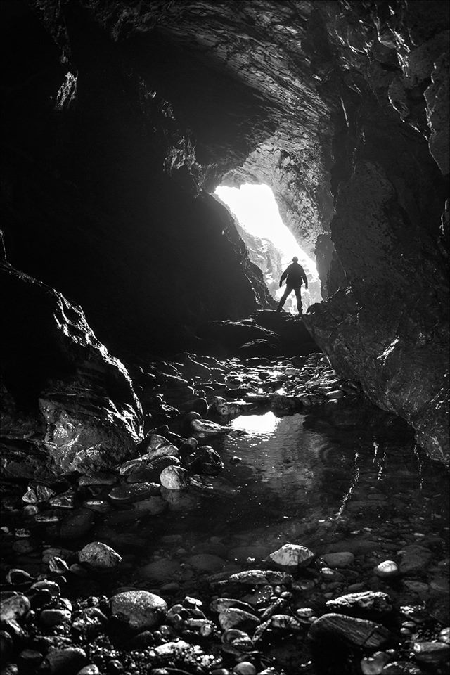
Best Overall Image in the Competition went to ‘Merlin’s Cave’ by Sue Jones
IOM Photographic Society meetings are open to the public – non-members with a charge of £1 on the door – and all will be given a very warm welcome. Meetings are at Thie Ellyn (the Art Society building) in Withington Road, starting at 7:30pm. Full details of our programme can be found on the website at www.iomps.com. Our next meeting on Wednesday 3rd Feb will be an assignment competition on the subject of “Light and Shade”.
RESULTS – OPEN PRINT COMPETITION:
Standard Group – Mono : Deb Turk (1 & 3), Barry Murphy (2 & 4), Steve Meadows (5), Sue Blythe (6), Jonathan Carey (C). Colour : Steve Meadows (1), Barry Murphy (2), Sue Blythe (3), Deb Turk (4 & 6), Jonathan Carey (5). Intermediate Group – Mono : Nessie Gillen (1 & 2), Richard Shafto (3 & 4). Colour : Shirley Lotfy (1 & 6), Richard Shafto (2), Beryl Quayle (3), Nessie Gillen (4 & 5). Advanced Group – Mono : Sue Jones (1 & 3), Ron Shimmin (2 & 5), Ruth Nicholls (4), Chris Nicholls (6). Colour : Ruth Nicholls (1 & 5), Chris Nicholls (2), Bob Servante (3), Tony Curtis (4), Sue Jones (6 & C).
By Chris Blyth

21st January 2016 – January Open Digital Competition
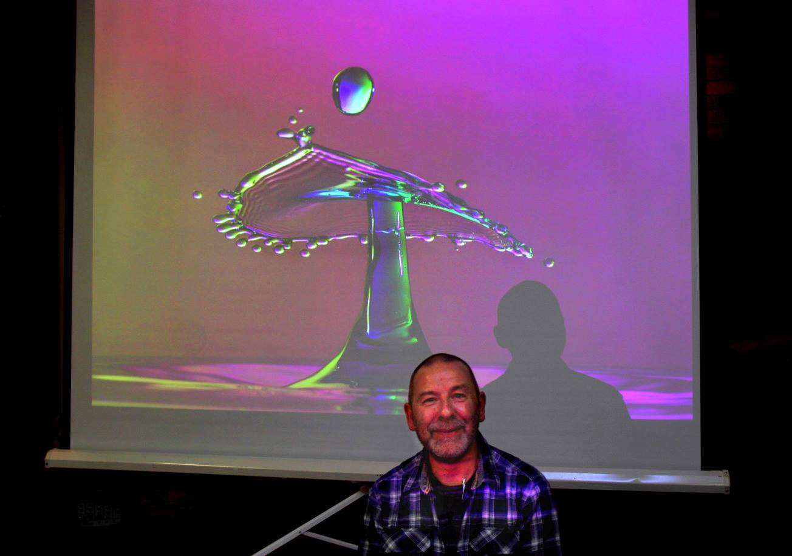
Judge Mike Ashmole with the Best Overall Image
Mike Ashmole was the guest judge when the Society met for its first ‘open’ competition of 2016. He is an accomplished amateur photographer, a former Vice-President Committee of the Western Photographic Club and a Committee member of that Club. …
It quickly became apparent that he had adopted a thorough approach in assessing the 46 projected digital images as he demonstrated meticulous attention to detail with each one. After mentioning the usual elements that make up a successful image and assuring the audience of his desire to be completely objective, he admitted that “Photography is a very personal topic”, so he could not guarantee that his final critique would be completely free of all subjectivity! He then commented briefly on every image, offering a few tips as he gave clear, concise explanations and reasoning to justify the order of merit upon which he had eventually decided, as follows:-
Results:
Standard Group – 1st ‘Rainbow Drops’, a stunning, colourful combination of technical and artistic skills by Sue Blythe; 2nd ‘Making Friends’ by Steve Meadows; 3rd ‘Red Arrow’ by Michael Howland; 4th ‘Mediterranean Chameleon’ by Barry Murphy; 5th ‘Frozen’ by Steve Meadows; 6th ‘Robin in my Garden’ by Michael Howland. The judge also commended ‘Watercolours’ by Sue Blythe.
Intermediate Group – 1st ‘Iris Flower with Pollen Grains’, a most pleasing image of shapes and colours by Jenny Shanley; 2nd ‘Dill in Silhouette’ by Beryl Quayle; 3rd ‘Take Off’ by Annette Slater; 4th ‘Green Veined Whites Mating’ by Shirley Lotfy, who also came 5th with ‘Quayside View’; and 6th ‘Parrot Tulips’ by Annette Slater. ‘Red Riding Wolf’ by Hazel Walsh and ‘May the Force be with You’ by Nessie Gillen were both commended.
Advanced Group – 1 ‘Inventory’ by Mark Stringer, a human interest workplace image; 2nd ‘Vintage Brass’ by Sue Jones, who also came 3rd with ‘Ancient Stones’; 4th ‘Waiting for the Fly’ by Tony Curtis; 5th ‘Tuscany Land and Mists’ by Chris Nicholls; and 6th ‘Gunkanjima Island’ by Mark Stringer. ‘Model with Fan’ by Chris Nicholls and ‘Ballroom Twirl’ by Bob Servante were both commended.
Best Overall Image – ‘Rainbow Drops’ by Sue Blythe.
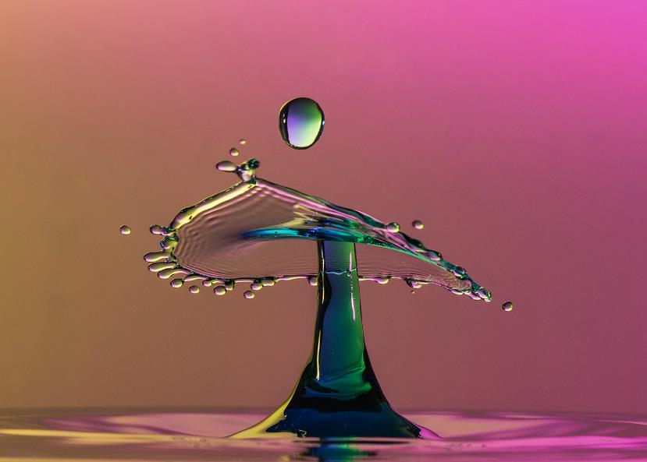
Best Overall Image in the January digital Open competition was ‘Rainbow Drops’ by Sue Blythe
The Society’s Spring Photographic Exhibition at the Hodgson Loom Gallery at Laxey Woollen Mills will be open for a month from the 13th February this year and is not to be missed!
On Wednesday, 27th January at 7.30 pm at Thie Ellyn, off Withington Road, Douglas, the Society has two very special presentations on offer, the first by Chris Sharpe on Ornithology, Chris having been one of the leading lights in producing the excellent ‘Manx Bird Atlas’. The second presentation, by way of contrast, will be on the mystical island of ‘Santorini’, by Chris Nicholls. The entries for the ‘Light and Shade’ assignment competitions will also be due in that night.
By Antony Hamilton

14th January 2016 – Presidents Evening
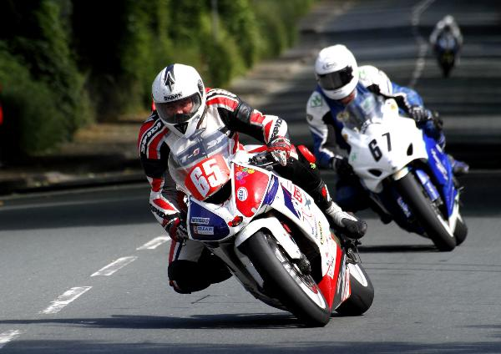
Acting President Tony Curtis with one of the images from his presentation
Following the Christmas break, the second half of the winter season of regular weekly meetings of the IOM Photographic Society re-started this week with a presentation from Acting President Tony Curtis – covering a series of images taken over recent years.
The images were accompanied with a commentary as to when / where and why the images were taken – and which gave both a dimension to the images and an added interest for our members, all committed photographers themselves, and all keen to understand the techniques and skills used in their production. The sequence, whilst wide-ranging, demonstrated a number of Tony’s interests – which perhaps predictably, included motorbikes (with images of both TT and sand races) but perhaps surprisingly, also included images of the wallabies in the Curraghs. The presentation concluded with a particularly striking series covering the work of the Laxey Mines Group, and of the importance given to safety in their activities – both for themselves when working deep underground and for the wider public in preventing unauthorised entry into potentially very dangerous areas. The Group has been operating for a number of years, exploring old mine workings, particularly in the Laxey area but more recently around Bradda Head. Their latest and very exciting project involves refurbishing some of the facilities in the old lighthouses on the Calf of Man – of which I am sure we will be hearing more soon…… Ian Lumsden gave a deserved vote of thanks.
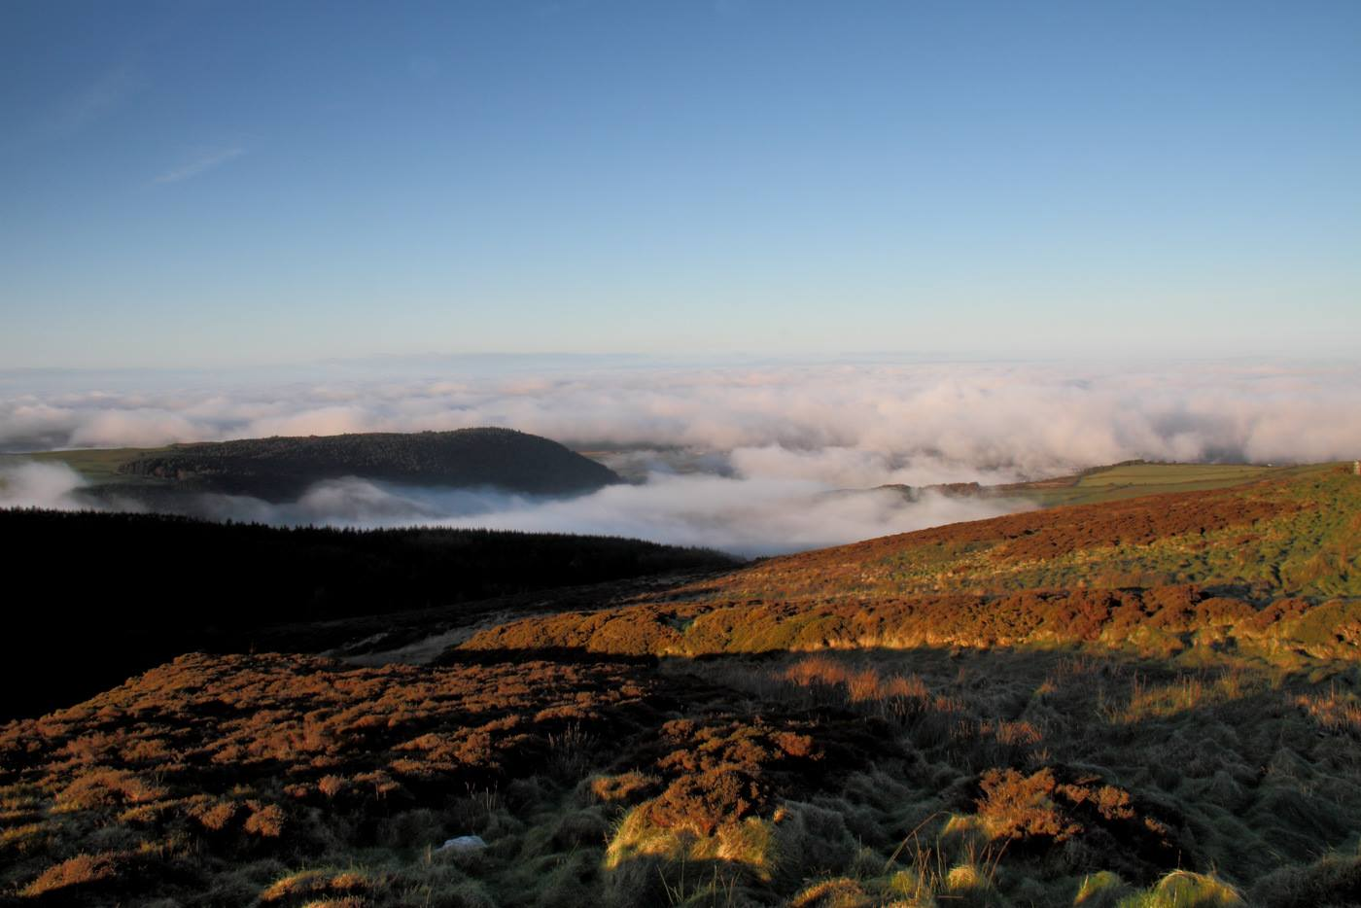
An atmospheric landscape, one of the images featured in the presentation by IOMPS Acting President Tony Curtis
The halfway point in the season is also a good time to review progress so far – and several of our newer members in particular have been setting a cracking pace, with images of superb quality being seen in our weekly competitions. Sue Blythe, Barry Murphy, and Sue Leeming (amongst several others in the Standard Group) have been gaining admirers for some excellent images, whilst Nessie Gillen, Shirley Lotfy, Annette Slater and Hazel Walsh are also producing some very competitive work in the Intermediate Group – and resulting in several of our judges making clear that the (in theory) more advanced members are rapidly being overtaken.
As well as our usual competitions, the programme has also included several “skills development” sessions, and these have been well attended and well received – with a particular focus on camera controls (and getting the best possible image “right first time” in camera), followed up by basic image manipulation techniques in Photoshop or similar software packages. Further sessions are included in the forthcoming programme.
Our next meeting is on 20th January, when an Open Print Competition will be judged by Henry Uniacke from the Sayle Gallery. IOM Photographic Society meetings are open to the public – non-members with a charge of £1 on the door – and all will be given a very warm welcome. Meetings are held at Thie Ellyn (the Art Society building) in Withington Road, starting at 7:30pm. Full details of our programme can be found on the website at www.iomps.com, which also includes a personalised gallery for the display of work by our members.
By Chris Blyth

IOMPS Reports During February 2016

25th February 2016 – February Open Print Competition
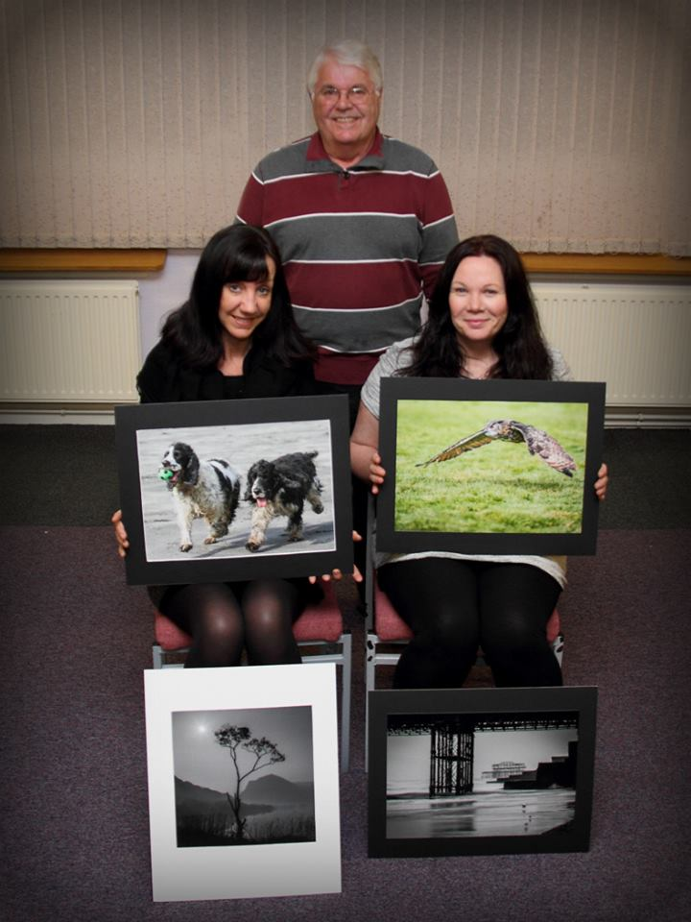
Some of the Open Competition winners with Judge John Keelan
The last of our ‘Open’ print competitions in the current programme was judged by John Keelan, Chairman of the Southern Photographic Club. John has judged for us previously, is known to be an experienced amateur photographer with both prints and projected digital images, and so needed little introduction.
John was quickly down to business, commenting on each of the 53 prints entered across the different classes of experience in the Society. As expected, his professional background guaranteed a highly methodical, painstaking approach to his assessments, though any slight criticisms, where justified, were offered in a kindly fashion.
He to offered helpful tips about how the entries could have been improved. A different angle of view was suggested by him in a few cases and the need to exercise care when using computer software not to over sharpen the subject matter were just two of the points he made. He had enjoyed examining the images and thought about how the various technical elements had been combined with artistic flair to produce the end result. He offered advice on cropping in some cases and also touched on the possible use of filters and different metering options. He talked about composition but was bold enough to admit that, sometimes, the broadly accepted ‘rules’ of photography were there to be broken! Though there was a wide range of subject matter before John, as is usually the case with ‘Open’ competitions, he narrowed down his final ‘orders of merit’.
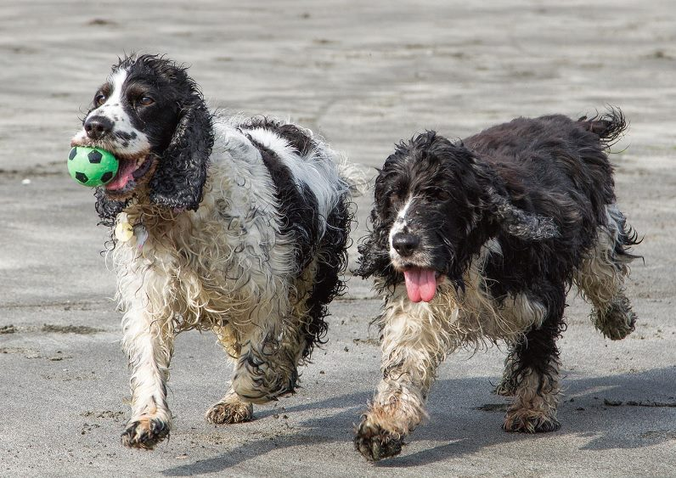
Best Overall image in the February Open Print competition went to ‘The Race’ by Sue Blythe
Sue Blythe continued her winning ways in the Standard Class, gaining first place in both the mono and colour sections. Her image of her two dogs racing each other along the beach drew particularly favourable comment and was also awarded the prize for the best overall image on the night. Titled ‘The Race’, this now qualifies for the season long competition for the ‘Best of the Best’ and the award of the Brian Kershaw Memorial Trophy.
Nessie Gillen led the field once more in the Intermediate Class with ‘Low Flying Owl’ winning the colour section and ‘Under the Pier’ first in the mono section, the former being a beautifully graceful and yet intense image of an owl hunting its prey. Honours were shared in the Advanced Class with Ron Shimmin winning the best mono print with ‘Face to Face’, two figures in silhouette beautifully seen and captured, and Sue Jones being placed first in the colour section with ‘Vintage Lamp’, an image with vibrant colours and a real sense of a bygone era.
The Society will next be meeting at 7.30 pm on Wednesday, 2nd March at 7.30 pm at Thie Ellyn, off Withington Road, Douglas, when we shall have a members critique evening. This should be quite illuminating and new members and guests (for a nominal charge) are always most welcome to join us.
Results:
Standard Class Mono – 1st ‘Sunrise and Silhouettes’ by Sue Blythe, who was also awarded 4th place for ‘Stilts’; 2nd ‘Daisies’ by Barry Murphy, who gained 5th place for ‘Walk’; 3rd Paul Dunderdale with ‘Booth Kelly’s, Ramsey’; and 6th was Sue Leeming with ‘Centred’.
Standard Class Colour – 1st Sue Blythe with ‘The Race’; 2nd ‘Paul Weller’ (in concert) by Deb Turk; 3rd Sue Blythe with ‘The Mane Event’; 4th ‘The Rook’ by Barry Murphy; 5th Paul Dunderdale with ‘Union Pacific’; and 6th ‘Pipe Organ, Reykjavik Cathedral’ by Sarah Bucknall (one of our junior members). ‘Dirty Washing’ by Deb Turk and ‘Leaf Light’ by Paul Dunderdale were both commended.
Intermediate Class Mono – 1st and 2nd Nessie Gillen with ‘Under the Pier’ and ‘White Rose’ respectively; 3rd ‘Cuban Lady Resting’ by John Mackenzie; 4th and 5th Beryl Quayle with ‘Stanley Park Palm House’ and ‘Spaceship in the Sand Dunes’; 6th ‘The Marina’ by John Mackenzie.
Intermediate Class Colour – 1st and 2nd Nessie Gillen with ‘Low-Flying Owl’ ‘Toned’ respectively; 3rd ‘Red Rooster’ by Shirley Lotfy; 4th and 5th ‘Sunset, Formby Beach’ and ‘Robin On The Gate’ respectively, both by Beryl Quayle; and 6th ‘Mirror Shed, Corner’ by Jenny Shanley.
Advanced Class Mono – 1st Ron Shimmin with ‘Face to Face’; 2nd ‘A Wily Customer’, also by Ron Shimmin; 3rd and 5th Sue Jones with ‘The Cottage’ and ‘Statue Detail, Salisbury Cathedral respectively; 4th and 6th Chris Nicholls with ‘Soaring Splendour, Nantes Cathedral’ and ‘Shaded Courtyard’ respectively.
Advanced Class Colour – 1st Sue Jones with ‘Vintage Lamp’; 2nd ‘Coronation Coach Detail’ by Ron Shimmin, who also took third place with ‘A Quiet Corner, Antibes’; 4th ‘Twilight’ by Sue Jones; 5th and 6th ‘Benedictine Monastery Church, Tuscany’ and ‘St Peter In The Valley, 1st Century, Umbria’ respectively, both by Chris Nicholls.
By Antony Hamilton

18th February 2016 – “Members Evening”
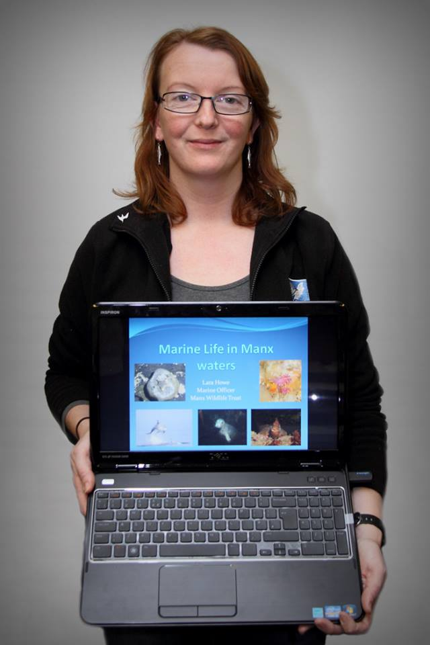
Manx Wildlife Trust Marine Officer Lara Howe
The IOMPS was delighted to have a “members evening” this week, which started with an excellent and greatly appreciated presentation by Lara Howe. Lara is the Marine Officer with the Manx Wildlife Trust and her presentation featured her work – “Marine Life in Manx Waters”. She is well qualified for the job, having earned her doctorate from Liverpool University and which included the (rather close) observation of the underwater life around the… sewage outfalls then on the island – not the usual way we think of the pleasures of academic life!
However, despite (perhaps because of ?) the circumstances of her training, she is very obviously an enthusiast about her work – her presentation was very professional as well as clearly conveying the joy she gets from her job. Because of our relative remoteness from large populations, and the strong tidal currents around the island, our waters are generally clean and nutrient rich – and hence both the diversity and the wealth of life in our waters. Sadly unless you are a scuba diver like Lara, this rich marine environment is hidden for most of us.
Starting with the larger creatures we may see – the seals, dolphins, porpoises, whales, sharks and even the occasional leatherback turtle – the presentation was highly descriptive and engaging, covering in particular the threats to our marine life, from over-fishing to the dumping of litter. Turtles for example feed on jelly fish – but balloons and plastic bags can be mistaken for a jelly fish and if eaten by a turtle, unfortunately cannot be digested and which results eventually in the death of the turtle. The presentation concluded with a slide sequence of the smaller delights of the underwater world – fish such as blennies and wrass, crustaceans such as lobsters and crabs, and beautiful sea anenomes – with their colours often astonishingly bright and vivid.
Mark Stringer finished the evening for us with a brief explanation about Lightroom, a computer software package – and featuring the first two modules – the “library” module (perhaps better called the image catalogue) and the “develop” module (and in particular the “camera RAW converter” element which offers very powerful image manipulation options.
Tony Curtis, Club President, gave the well-deserved vote of thanks.
Our next meeting is on 24th February, when an Open Digital Competition will be judged by Andrew Barton LBIPP LMPA, well-known local professional photographer and an Honorary Life Member of the Society. IOM Photographic Society meetings are open to the public – non-members with a charge of £1 on the door – and all will be given a very warm welcome. Meetings are held at Thie Ellyn (the Art Society building) in Withington Road, starting at 7:30pm.
By Chris Blyth

11th February 2016 – Third Assignment Competition – ‘Light and Shade’
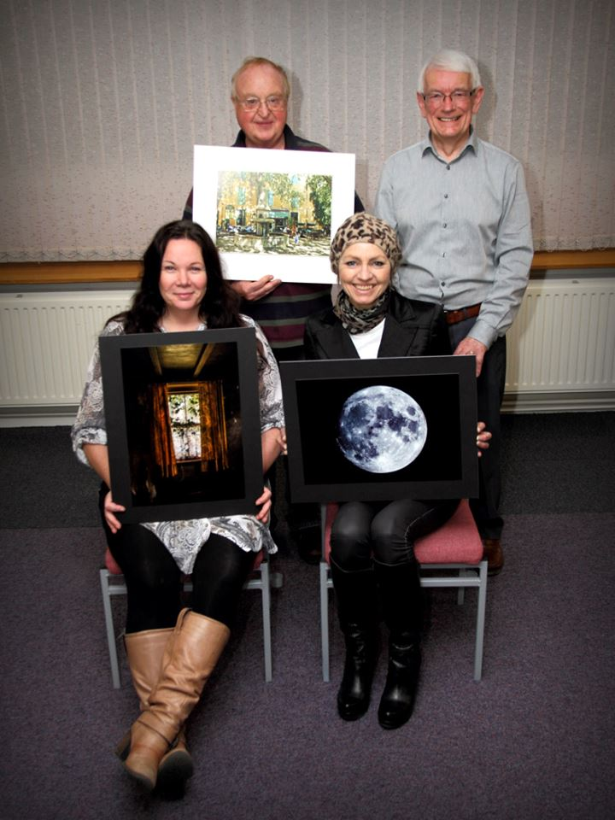
Some of the ‘Light and Shade’ Assignment print winners with Judge Eddie Fryer
Wednesday 3rd February revealed the results of the 3rd themed competition of the season. The theme was Light and Shade which produced a wide variety of subject matter. Eddie Fryer was the judge for the evening and he first explained how he had himself defined the theme, counting the lighting and shading as anything between burnt out white and jet black and every shade in between.
The judging commenced with the standard mono prints for which there were 14 entries. First place went to a striking image of sunlight through the trees in a forest titled ‘Rays in Cool Mist’ by Steve Meadows. In the standard colour prints there were 11 entries with first place going to a well executed technical shot of ‘Blue Moon’ by Sue Leeming, showing the shadow and light created by the craters and seas on the surface of the moon. Moving onto the intermediate mono prints of which there were only 4 entries, first place went to an evocative image titled ‘Shady Goings On’ which depicted a dungeon cell featuring a variety of chains and shackles by Nessie Gillen. In the intermediate colour prints there were 6 entries and again Nessie Gillen took first place with ‘Let there be Light’. A strongly emotive image of a neglected window and curtains inside a derelict house. Advanced mono prints featured 9 entries with first place going to Sue Jones for a well lit portrait study titled ‘Light to Dark’. This image was also judged to be the best print image in the competition. In the advanced colour prints there were 10 entries and Chris Nicholls took first place with his image ‘Place Du Palais’, a sun dappled daytime scene in a French Courtyard.
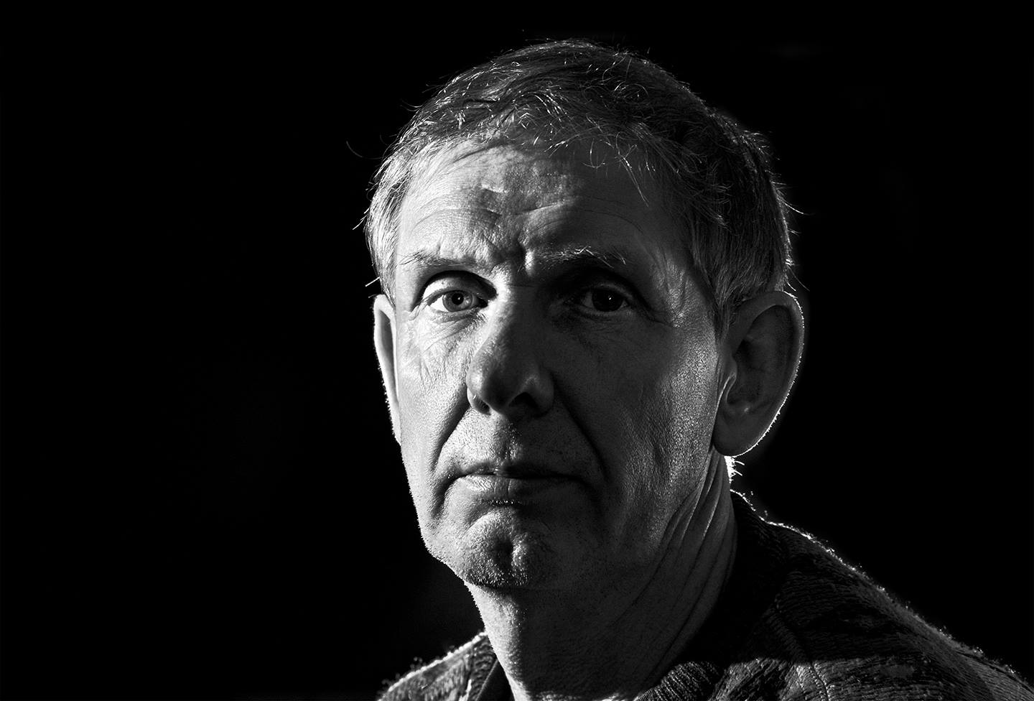
‘Light to Dark’ by Sue Jones was Best Overall Print in the assignment
After the break the judging moved to the digital entries, commencing with the standard group for which there were 19 entries. First place went to Sue Blythe for her image ‘Match Lit’, a simple yet effective image of a lit match being cupped in a persons hands. In the intermediate group there were 9 entries and Nessie Gillen scored a hat-trick and once again took first place with her image ‘Blueberries’. The advanced section featured 6 entries with first place going to Chris Nicholls for his image ‘Light Fantastic’. A shot of three metal figurines entwined as a light fixture. This image was also judged to be the best digital image in the competition.
Tony Curtis gave the vote of thanks and once again the judge praised the high standard of entries across all competition groupings.
The society’s Annual Photographic Exhibition at the Hodgson Loom Gallery in Laxey opens on the 13th February and visitors are guaranteed a wide selection of subjects, themes and ideas presented by a broad spectrum of the clubs members.
Next Wednesday 17th February sees the group meeting for the judging of the seasons 4th and final open print competition.
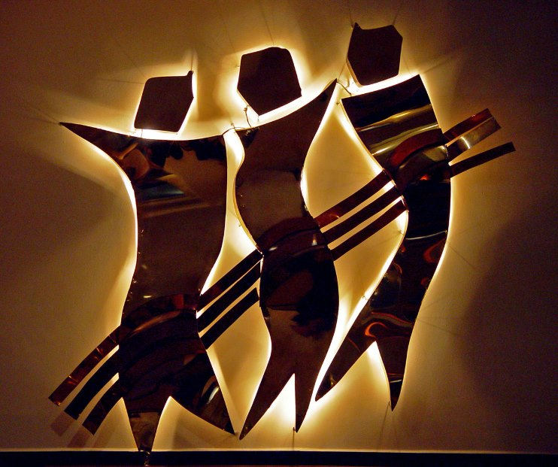
‘Light Fantastic’ by Chris Nicholls was Best Overall Digital Image in the competition
RESULTS:
Mono Prints
Standard – 1st Steve Meadows, 2nd Paul Dunderdale, 3rd & 5th Barry Murphy, 4th Deb Turk, 6th Sue Blythe, HC. Sue Leeming.
Intermediate – 1st & 3rd Nessie Gillen, 2nd & 4th Beryl Quayle.
Advanced – 1st & 2nd Sue Jones, 3rd Ron Shimmin, 4th Bob Servante, 5th Chris Nicholls, 6th Ruth Nicholls.
Colour Prints
Standard – 1st Sue Leeming, 2nd& HC. Steve Meadows, 3rd Barry Murphy, 4th & 5th Sue Blythe, 6th Paul Dunderdale.
Intermediate – 1st & 3rd Nessie Gillen, 2nd & 5th Shirley Lotfy, 4th & 6th Beryl Quayle.
Advanced – 1st Chris Nicholls, 2nd & 6th Sue Jones, 3rd Ruth Nicholls, 4th Ron Shimmin, 5th Nigel Owen.
Best Overall Print – Sue Jones.
Digital
Standard – 1st & 5th Sue Blythe, 2nd Michael Howland, 3rd & C. Tim Norton, 4th Barry Murphy, 6th & HC. Peter Keena, C. Kevan Osborn.
Intermediate – 1st Nessie Gillen, 2nd & 3rd Beryl Quayle, 4th & 5th Hazel Walsh, 6th & C. Shirley Lotfy.
Advanced – 1st & 6th Chris Nicholls, 2nd & 3rd Sue Jones, 4th & 5th Claire Stringer.
Best Overall Digital Image – Chris Nicholls.
By Hazel Walsh

10th February 2016 – IOMPS Laxey Exhibition 2016
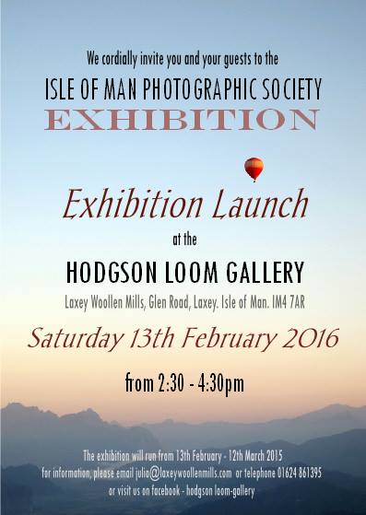
Our Exhibition at the Hodgson Loom Gallery, Laxey Woollen Mills, starts this coming Saturday, 13th February, with the official opening by the President at 2:30pm, and runs until 12th March.
More than 20 members have contributed over 80 images, so there will be a wealth of diversity in the exhibition.
The gallery is one of the best display venues on the Island – a lovely space, excellent natural and artificial lighting, and a cafeteria on site for tea and cakes (also exceptionally good!)
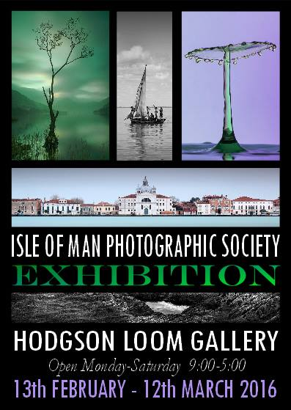

4th February 2016 – Presentations by Chris Sharpe and Chris Nicholls
On the 27th January, a large attendance of members and guests gathered for an evening of delightful contrasts with two contrasting presentations.
First, was Chris Sharpe, a well know amateur ornithologist and Principal Editor of the widely acclaimed Manx Bird Atlas, published in 2007. Describing himself as ‘a researcher and cameraman’ these days, he spent part of 2013 and 2014 netting and ringing birds at the Landsort Bird Observatory on the granite island of Öja, an hour south of Stockholm, Sweden. Öja is less than 3 miles long and under a mile wide and sits in a north-south orientation in the archipelago. It is acknowledged to be a resting place for almost 500 different species of migratory birds who feed on the local insects and berries. The remote observatory is blessed with most (but not all) essential comforts so only very dedicated ornithologists need apply!
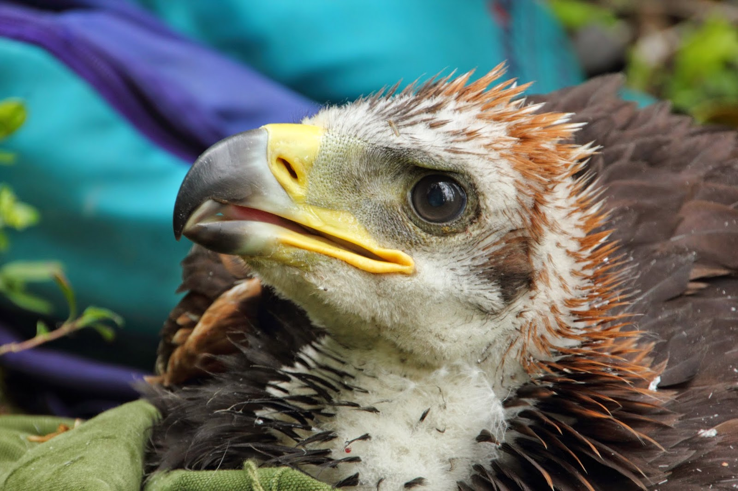
Golden Eagle chick by Chris Sharpe
Chris gave a fascinated illustrated talk during which he projected clear and close-up images of many beautiful birds which had been caught, ringed and recorded. His commentary displayed his comprehensive ornithological knowledge which has earned him a much deserved and growing reputation. Also featured were images of the Landsort lighthouse, the oldest in Sweden, and the general environment, all greatly enjoyed by an appreciative audience.
Chris then showed a short video film he had made in October and November, 2015, in Madagascar, a visit to study 3 different endangered species of Lemur (the Common Brown, the Coquerel’s Sifaca and the Aleotra Reed Lemur) for the Durrell Wildlife Conservation Trust.
Santorini by Chris Nicholls
Next came a splendidly impressive travelogue by Chris Nicholls, showing the unique, picturesque island of ‘Santorini’ in the Agean Sea. With his wife, Ruth, he had taken a tour by car in 2014 with local photographer, Olaf, who advised him to ‘follow the Rule of Cs’, when capturing his images, namely control, composition, curiosity, creativity, communication and cheek.
Santorini is the largest island of a small, circular archipelago and is a popular port of call for cruise passengers. It is also a romantic location for wedding photographs, particularly for the Japanese, it seems. The southernmost member of the Cyclades group, the island is easily recognisable by its blue roofed, whitewashed buildings, many perched precariously high on the rim around the Caldera (the sea). They visited several of the hundreds of pretty churches as well as the black volcanic beaches and the archaeological site of Akrotiri. Chris’s high quality images were much admired.
On the 10th February at 7.30 pm at Thie Ellyn, there is a presentation by Lara Howe and another practical session. The entries for the Open Print Competition competition will also be due that night.
By Antony Hamilton

IOMPS Reports During March 2016

31st March 2016 – Isle of Man Bank Cup Competition
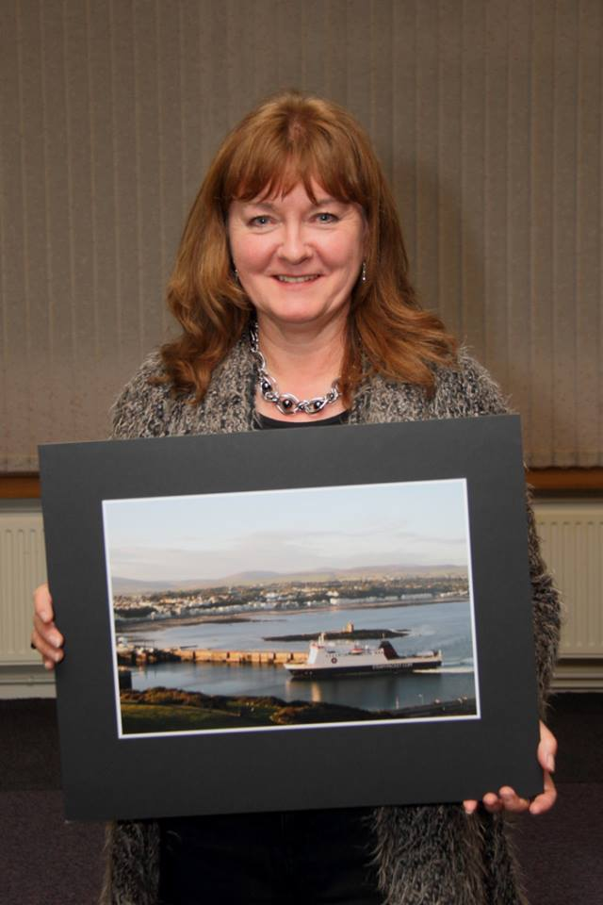
Manx Transport assignment overall winner Beryl Quayle
On Wednesday 23rd March the Isle of Man Photographic Club welcomed Stan Basnett to judge the Isle of Man Bank Cup competition. This was only the second time Stan had judged for the club but his comments provided food for thought. There were only 16 entries for the competition, divided into mono and colour, with the theme being Manx Transport. Steam trains featured heavily on the night but it was nice to see a few alternative modes… of transport too, such as the Steam Packet’s Ben-my-chree and the horse trams, and who knows how much longer we will be able to photograph these pieces of history.
Stan awarded six places in each of the classes. In the mono class 6th place went to Bob Servante with Refuelling the engine; 5th place went to Karen Norton for Peveril perspective; 4th place went to Tim Norton with A sign of the times; 3rd place went to Paul Dunderdale with Going up; second place went to Ron Shimmin with Old timers, with Chris Blyth winning the group with At the end of the day.
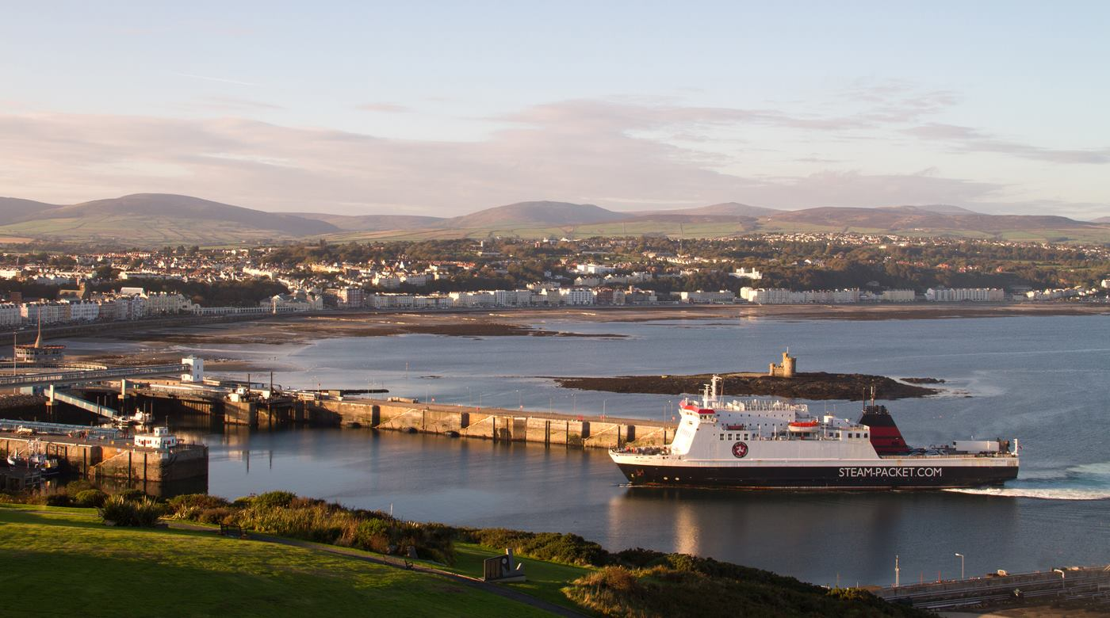
‘Steam Packet docking, Douglas Harbour’ by Beryl Quayle was judged Best Overall image in the Manx Transport assignment competition and wins the Isle of Man Bank Cup
In the colour class Tim Norton came 6th with Classy Chassis; in 5th place was Bob Servante with Reversing the locomotive; in 4th place was Shirley Lotfy with Horse trams; Ron Shimmin came 3rd with Leaving Port Erin; 2nd place went to Paul Dunderdale with There’s a boat in the morning and in 1st place was Beryl Quayle with Steam Packet docking, Douglas Harbour. The overall Isle of Man Bank Cup winner was Beryl Quayle with her beautiful image taken from Douglas head looking down over Douglas harbour and the bay and hills in the background. The lighting was a just right and gave a lovely feel to the photograph.
The next meeting will be a two way digital battle with Bristol Club. Why not come and see for yourself which club takes a better photograph. Guests are most welcome.
By Lara Howe

24th March 2016 – Inter-Club Battle between IOMPS, Oldham and Rochdale
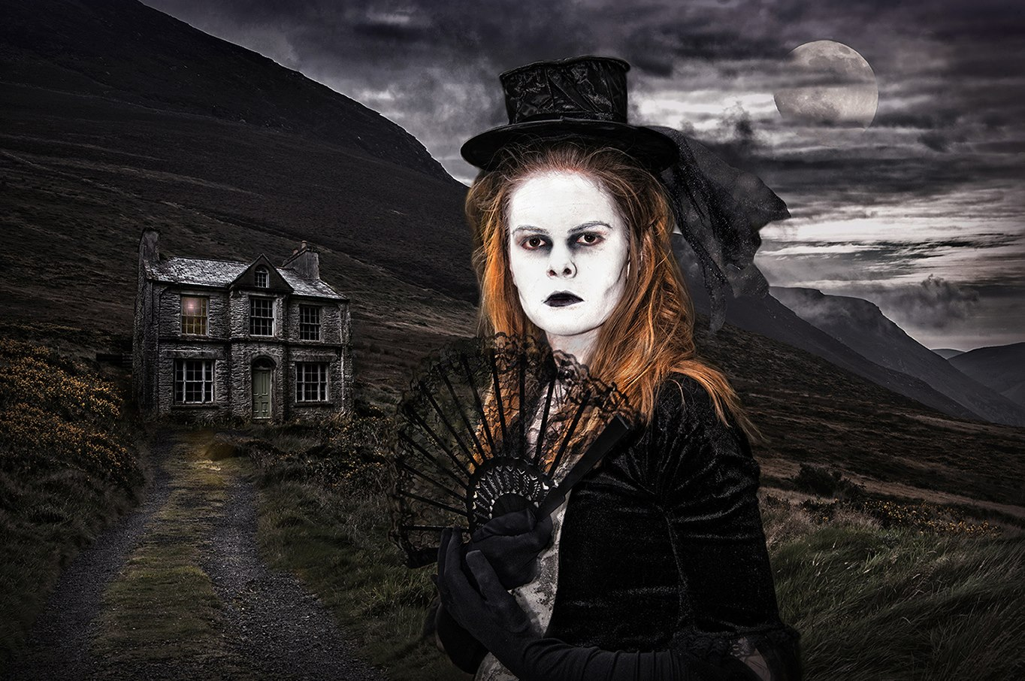
‘The Homecoming’ by Sue Jones gained best overall image for the Isle of Man out of the three Clubs at the recent battle between the IOMPS, Oldham and Rochdale
On the 16th March 2016 members of the Isle of Man Photographic Society assembled for the three way inter-club digital battle with Oldham Photographic Society and Rochdale and District Camera Club. The competition took place at Oldham Photographic Society and was judged by David Butler MFIAP, ARPS, PPSA, BPE5. The event itself took place on the 28th January and was filmed so that Isle of Man members could watch and hear the judges comments.
Each image was awarded marks out of a possible 20 and Isle of Man members results were as follows:
12 – Sue Jones – ‘Tulips’, Richard Leach – ‘Cyprus Sunset’.
14 – Sue Blythe – ‘Living on Thin Ice’ & ‘Rainbow Drop’, Hazel Walsh – ‘Face Off’, Claire Stringer – ‘White Nymph Butterfly’.
15 – Steve Meadows – ‘Don’t mess with me’, Hazel Walsh – ‘There’s nowt so queer as folk’, Ruth Nicholls – ‘Cottage Window’, ‘Fugitive’ & ‘Mysterious meeting’, Chris Nicholls – ‘Wild Horses’, Claire Stringer – ‘Buffalo, Catalina’.
16 – Sue Jones – ‘End of Shift’, Hazel Walsh – ‘The Bone Collector’, Bob Servante – ‘Urban Burnout’.
17 – Chris Nicholls – ‘Tobacco Worker’, & ‘Stallions out Early’, Ruth Nicholls – ‘Prayer Chapel’, Diane McCudden – ‘Laxey Pier’.
18 – Richard Shafto – ‘Leopard carrying impala faun’, Hazel Walsh – ‘Alice’.
Once the judge had scored all the images there remained 4 that he had ‘held’ back. These were reviewed in greater detail and were:
‘Bleak House’ – Sue Jones IOM
‘The Homecoming’ – Sue Jones IOM
‘Finland, Red Squirrel’ – Patricia Larkham IOM
‘Common Blue Butterflies, mating’ – Christine Widdall Oldham
We were then told that all remaining images had scored full marks and the Judge selected his winning image. This was ‘The Homecoming’ by IOMPS advanced member Sue Jones.At the end of the competition the club results were:
Oldham – 401
Isle of Man – 397
Rochdale – 386
A very close second place for the Isle of Man.
The 30th March sees another inter club battle – this time a two-way digital competition with Bristol Club. Members are reminded that there will be no meeting on Wednesday 6th April as the annual competition will be judged on the Thursday 7th and Friday 8th.
By Hazel Walsh

17th March 2016 – ‘More travels around Thailand’ with John Phipp
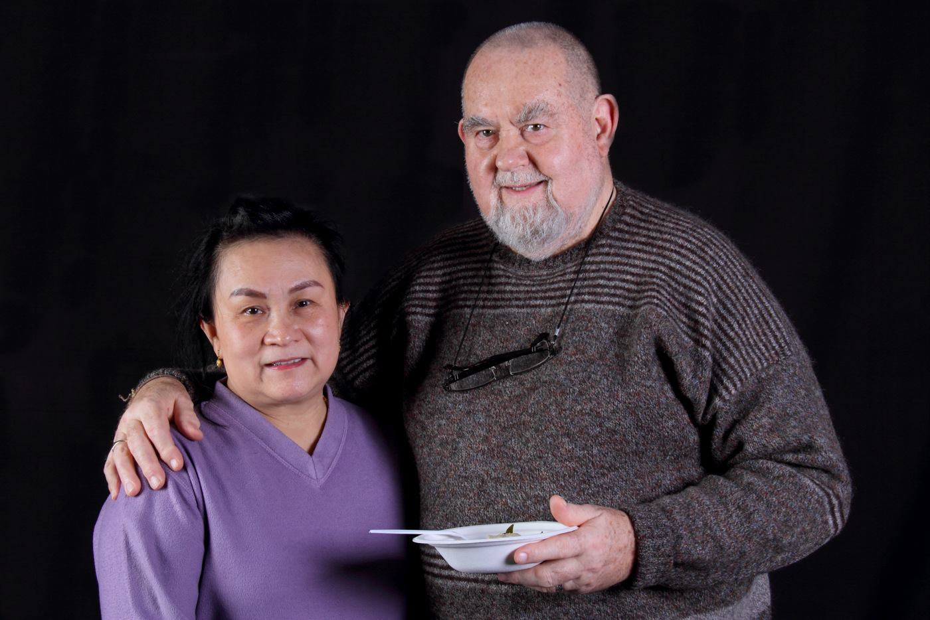
John Phipp and Pornlah with the Thai green curry
‘More travels around Thailand’ was the title of the latest photographic presentation by John Phipp CPAGB, last week. It was particularly pleasing to be able to welcome John’s wife, Pornlah, on this occasion – but more about her presence later!…
John has visited the Kingdom of Thailand many times. Formerly known as Siam, Thailand is at the centre of the Indochinese peninsula in South East Asia.
This presentation mainly featured the country’s capital, Bangkok, and its suburbs. Bangkok is located in the Chao Phraya River delta in central Thailand. It’s a truly cosmopolitan city with an estimated population of over 8.5 million and growing at a rapid pace. Most of those living there are of Thai ethnicity, though there are very large numbers of Japanese, Chinese, Cambodians and Burmese in the mix too. Thailand has an emerging economy and low unemployment (less than 1%).
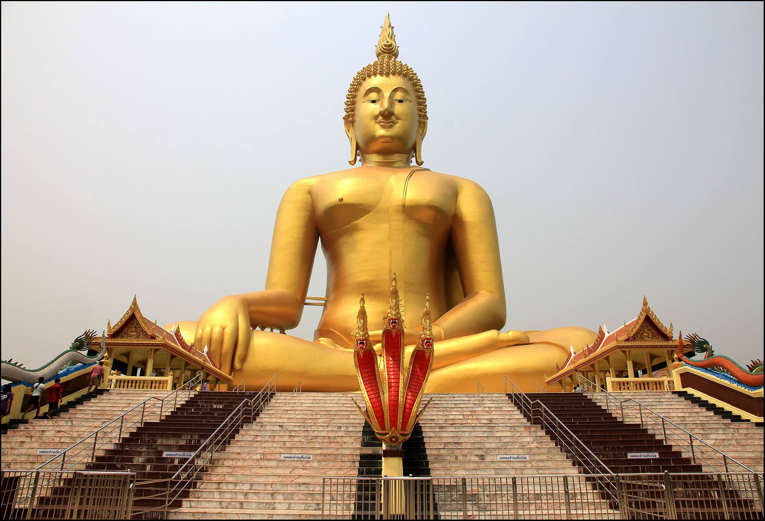
With musical accompaniment, we were transported to this vibrant tourist destination and saw images of the horrendous traffic and the busy street stalls, selling foods and other household items. The power and communications cables are most noticeable because they are strung between the buildings in an unsophisticated fashion that would not be acceptable in the west. The tuk tuks are still one of the main ways of making short journeys in the city, if you are prepared for some exhilaration and excitement! By way of stark contrast, the very modern Sky Train with its tracks raised high above street level on concrete pillars is evidence of modernity and progress.
John and Pornlah visited a sweets factory and a nature reserve where he was able to stroke the magnificent tigers which are protected there. What a marvellous experience that must have been!
One visit away from the bustling and colourful city of Bangkok was to visit the bridge over the River Khwai (made famous by the 1957 feature film of that name) where they enjoyed a short trip on the railway, and to see the beautifully tranquil and maintained war cemetery at Kanchanaburi, where more than 5,000 Commonwealth and 1,800 Dutch casualties are buried.
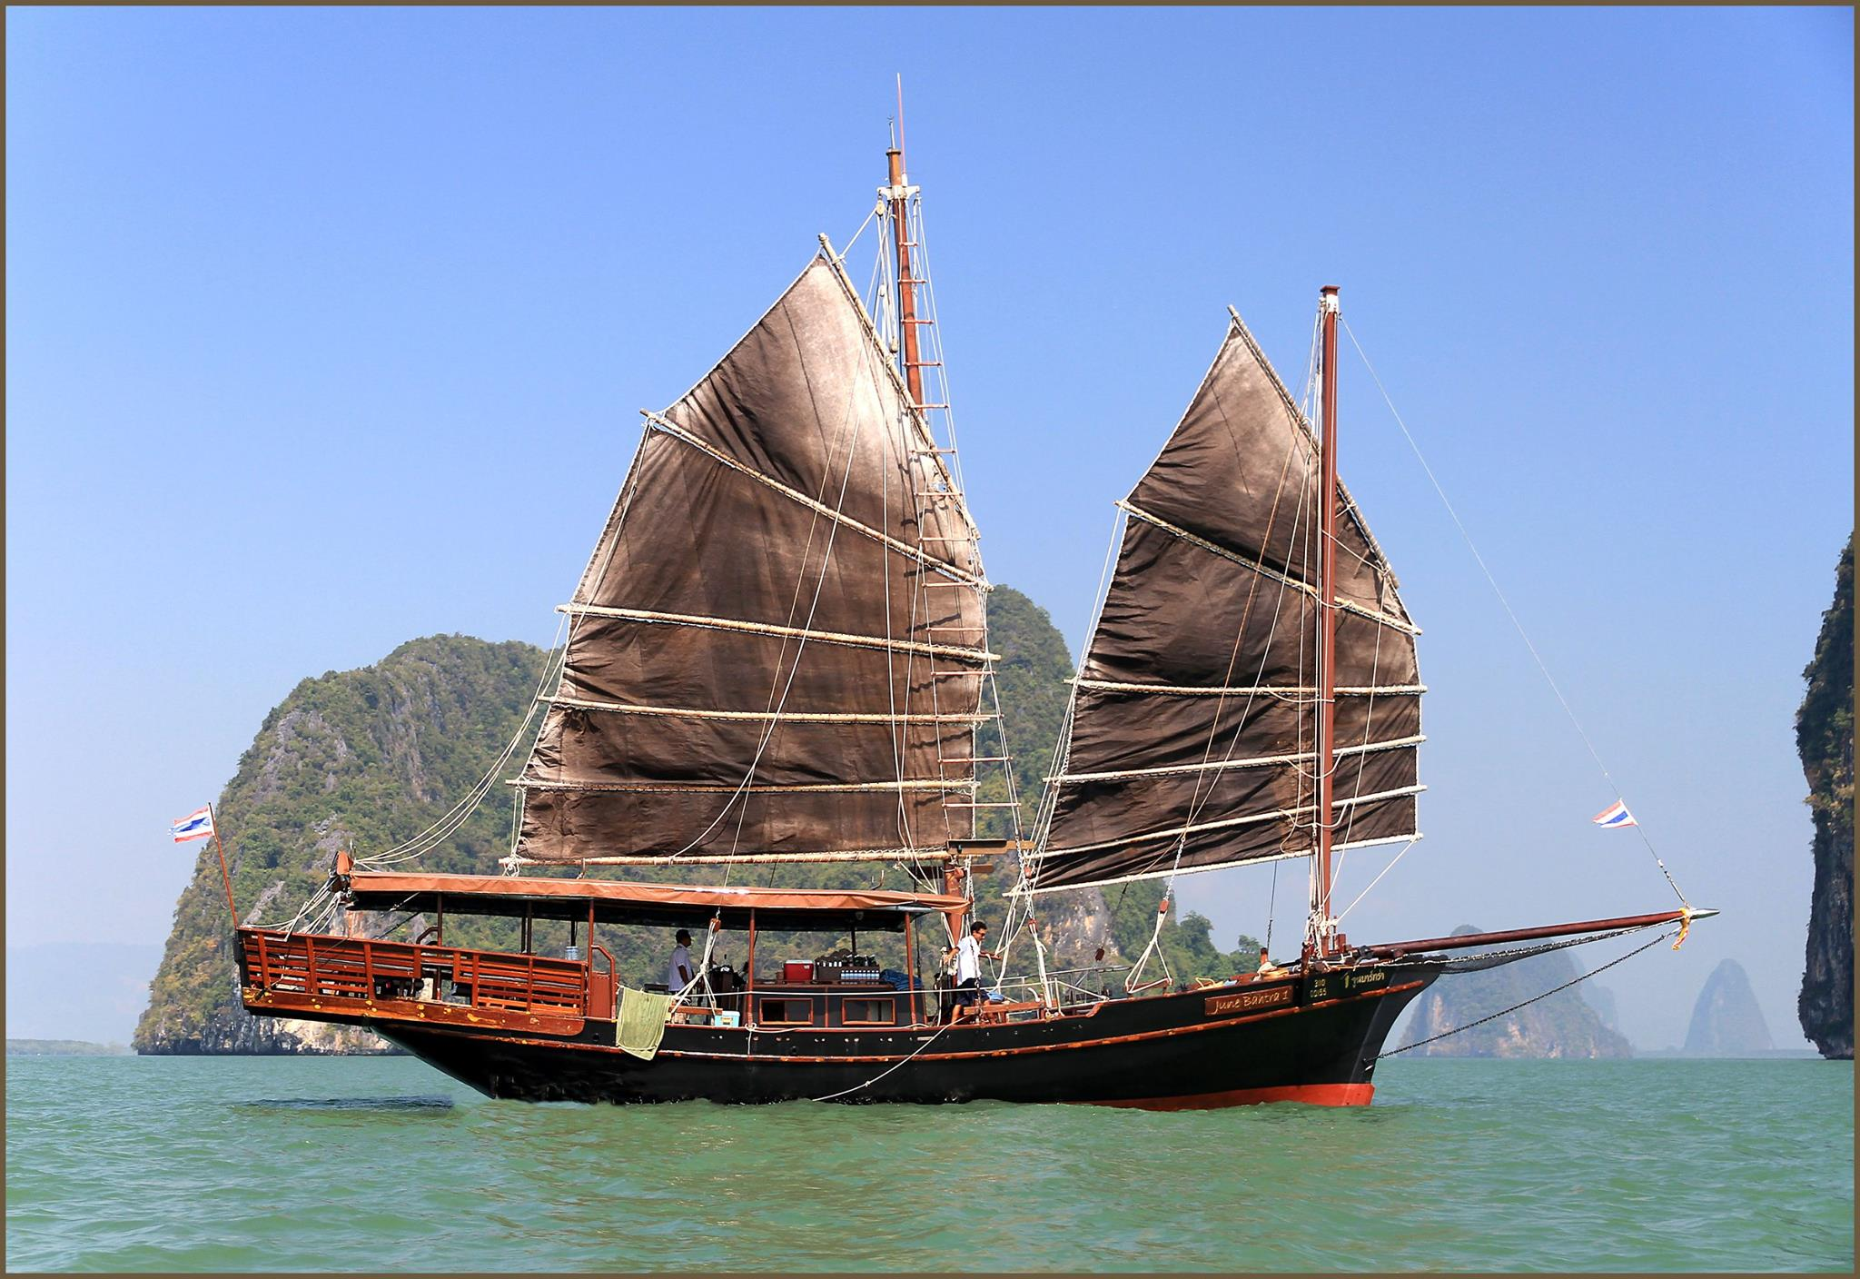
The Thai theme concluded when Pornlah, who had been busy in the kitchen all evening, produced a delicious green curry for everyone to taste and enjoy.
Tony Curtis gave a well deserved vote of thanks and then led a studio lighting tutorial for beginners. His clear explanations of the basics were extremely helpful and well received, as was the opportunity for members to ‘have a go’.
The Society will be meeting at 7.30 pm on Wednesday, 23rd March when the prints competition will be staged for the coveted Isle of Man Bank Cup. This will be at ‘Thie Ellyn’, off Withington Road in Douglas where guests will be made most welcome.
By Antony Hamilton

10th March 2016 – Members Critique Evening
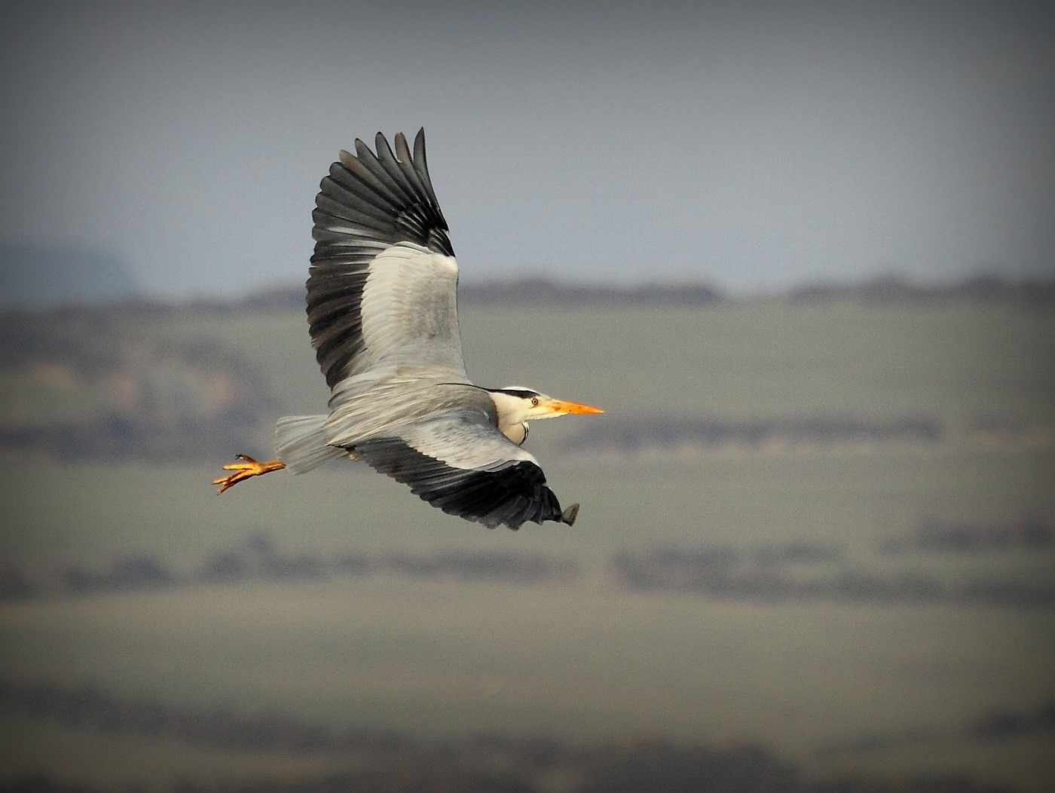
‘Heron in flight’ by Tony Curtis was one of the prints put forward for comment by IOMPS members
A twist on the normal events provided a most interesting first half to the evening this week at the IOM Photographic Society. Club members were provided with a selection of prints supplied by various (mainly committee) members, and asked to adjudicate on them as though judging a competition – to provide an immediate commentary on the image, its merits and possible areas for improvement, and to mark it on the standard points scoring system. It was slightly unfair in that our judges are usually given the images several days in advance so that they have time to consider and to prepare their thoughts. Whilst the chosen members did very well with their comments, in the midst of (and perhaps despite) some vocal participation with other members, it demonstrated in the clearest of terms just what a debt the club owes to our regular weekly judges who provide the advice and commentaries for our many competitions.
Several images provoked major comment and conjecture as to just how the image had been captured. A striking and very sharp image of a green beetle was the first to be queried – mainly on the basis of the small size of the insect and yet a superb control of the depth of field had been achieved despite this usually being extremely difficult given the requirement for use of a macro (close-up) lens. The author, Richard Shafto, confessed that he had used a technique called “focus stacking” whereby some 6 or more images (essentially “slices” each covering a section from front to rear of the insect)had been “stacked” using only the sharp parts of each shot to produce the final image. An image by Bill Callow similarly caused comment – ostensibly a beautifully atmospheric moonlit shot of Laxey Bay taken from the headland above the harbour, but which turned out to be a mid-afternoon shot darkened by use of various neutral density filters –an image produced by an author having an artistic vision AND the skills required to produce it.
The second half of the evening comprised a folio of prints supplied by the Lancashire and Cheshire Photographic Union and which included a wide variety of genres – some superb landscapes, portraits, sport and natural history images – all of the highest quality and intended to demonstrate the standard expected of top class club participants. The folio included several prints from members of the Western Club – so a “well done” to them!
Our next meeting on Wednesday 16th March will be a showing of the Three Way Digital Battle with the Oldham and Rochdale clubs – each club providing 25 images, each of which are scored out of a maximum of 20 points, with the highest scoring club winning. An entertaining evening is guaranteed, although history says that Oldham will be a very strong competitor and hard to beat. Our meetings are held at Thie Ellyn (the Art Society building) in Withington Road, starting at 7:30pm. Meetings are open to the public, non-members with a charge of £1, and all will be given a very warm welcome.
By Chris Blyth

9th March 2016 – Wings and Things
HI All; Please see the attached flyer for an exhibition by one of our members – Mike Trout.
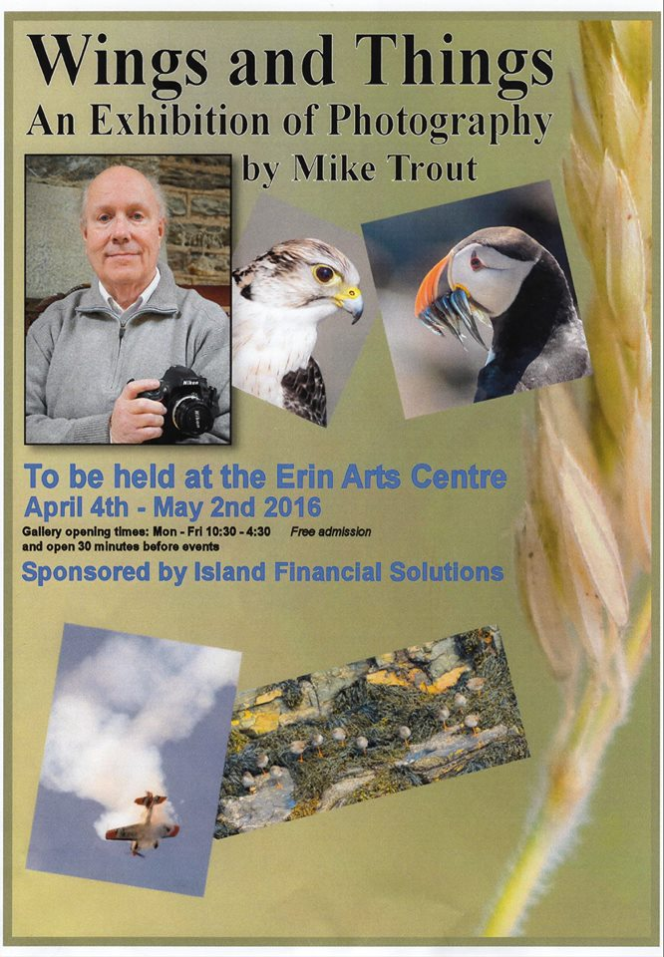

3rd March 2016 – February Open Digital Competition
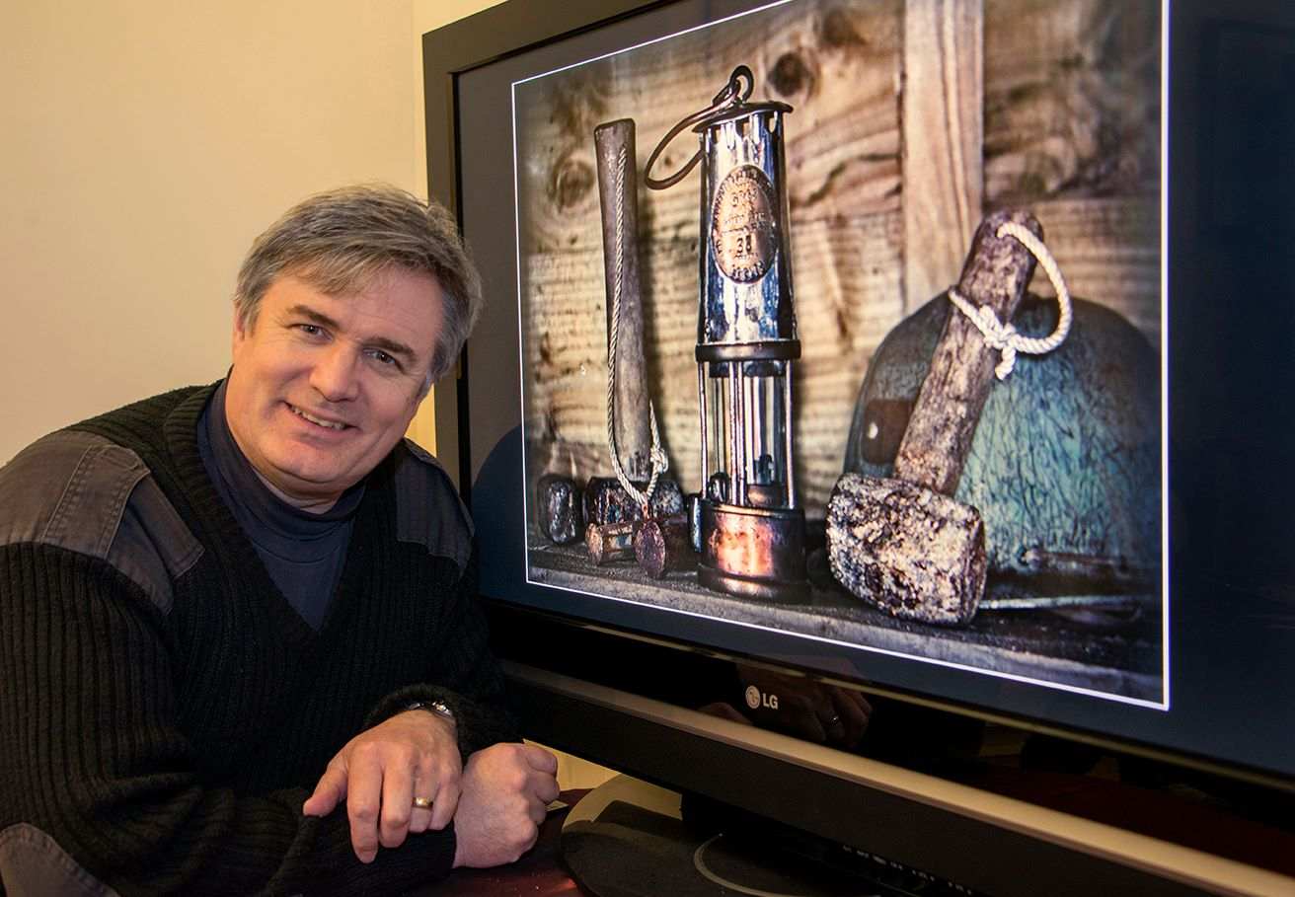
Open Digital competition Judge Andrew Barton with the best overall image
Wednesday 24th February was the judging of the final open digital competition of the season. Honorary life member and professional photographer Andrew Barton was the evenings judge and demonstrated his vast knowledge & experience both behind the camera and post production on the computer.
Andrew was careful to explain techniques that could be used to improve images, particularly with regard to the cold/warmth of an image and opposing colour adjustments. He provided in depth guidance for each image including a thorough outline of ways in which the images could be improved and which areas were especially successful.
There were 21 entries in the standard group. 3rd place went to Barry Murphy for a striking black and white image ‘The Night Stroller’ which featured a close up of a person walking over wet flagstones at night. In 2nd place was ‘Miss Izzy’ by Sue Leeming, an adorable and very well lit image of a King Charles spaniel. 1st place went to Barry Murphy for his image ‘The Swan and the Lilies’, a vibrant, well composed and well timed image.
In the intermediate group were 9 entries, 3rd place went to Beryl Quayle for her well-timed yachting action shot ‘Hold on tight, we’re going over’. In 2nd place was ‘Looking out a dirty old window’, a beautifully composed black and white image of a female nude looking over her shoulder towards a derelict window. 1st place went to Hazel Walsh for ‘Kinderkrankenhaus, Children’s Hospital, Berlin’, a well handled image of a derelict stairwell and graffiti.
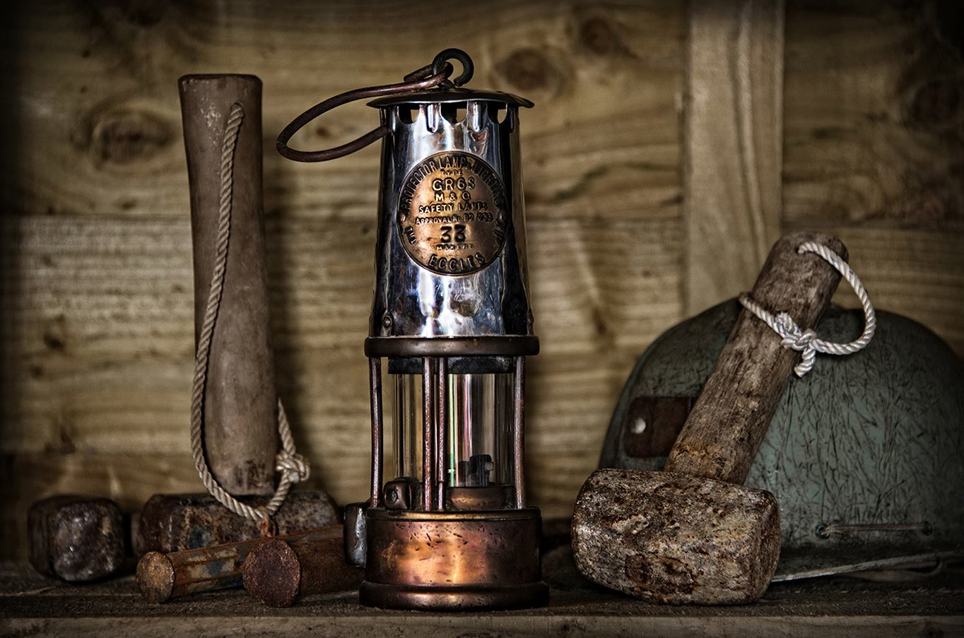
Best overall image went to ‘Miner’s Lamp’ by Sue Jones
The advanced group featured only 5 entries with 4th and 5th place going to Claire Stringer for her travel images ‘Working in the Fields’ and ‘River Boat’. In 3rd place was Tony Curtis with ‘Tools of the Trade’, a studio image of a selection of camera and photography equipment. 2nd place went to Sue Jones for ‘Chess’, a close up studio image of chess pieces on a board, and Sue Jones also took 1st place with ‘Miners Lamp’, a thoughtful and carefully composed, rustic image of an old miners lamp and assorted tools.
Sue’s image ‘Miners Lamp’ was also judged to be the best overall image.
If you haven’t yet visited the Societies exhibition at the Hodgson Loom Gallery in Laxey Woollen Mills you have just over a week to do so, it is open until the 12th March and features a wide selection of images from the societies members. The next club night will feature a presentation by John Phipp entitled ‘Thailand’. This will take place from 7.30pm on Wednesday at Thie Ellan as usual.
RESULTS:
Standard – 1st & 3rd Barry Murphy, 2nd Sue Leeming, 4th Paul Dunderdale, 5th Deb Turk, 6th Sue Blythe.
Intermediate – 1st & 4th Hazel Walsh, 2nd & 6th Nessie Gillen, 3rd Beryl Quayle, 5th Jenny Shanley.
Advanced – 1st & 2nd Sue Jones, 3rd Tony Curtis, 4th & 5th Claire Stringer.
Best Overall Image – Sue Jones.
By Hazel Walsh

IOMPS Reports During April 2016

28th April 2016 – 2015 – 16 Season round-up
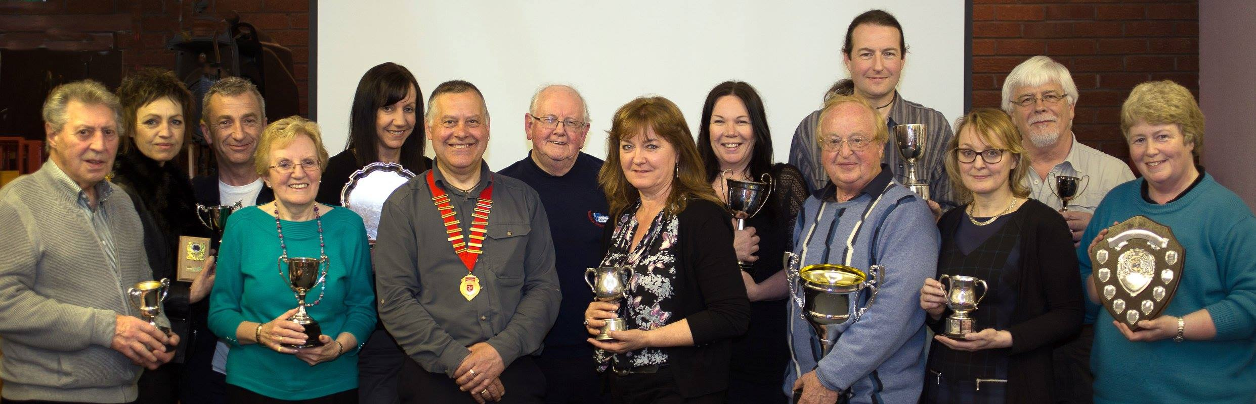
Trophy winners with President Tony Curtis and guest speaker Bob Dennis at the prize presentation evening
The annual season for the IOM Photographic Society is now drawing to a close – and it is appropriate to consider the major events of our year. The summer outings of last year were very successful – an outing to Scarlett to explore the geology, coastal scenery and wildlife was well supported, a studio portrait session with Andrew Barton and couple of male models to demonstrate lighting set-ups was greatly appreciated), and a disposable camera project at Castletown resulted in more than a dozen of our members taking part.
Once into our autumn season, the programme included entertaining presentations by both external speakers and by various club members, some superb imagery at all levels in our various weekly competitions, several well-fought if eventually unsuccessful competitions with clubs from our adjacent island, our now traditional members annual exhibition at the Laxey Woollen Mills, and overall, a programme that engaged the membership, perhaps stimulated their aspirations, and hopefully improved their skills….
A special “thank you” goes to our external speakers who gave their time and expertise – to Dr Adam Standring for “The Other World – A Night With the Fairies”, and to Chris Sharpe for his presentation on “Birds”, both much enjoyed by our members. Ian Lumsden and Ruth Nicholls explained some of the basic requirements for photographic competitions – particularly the mounting of prints and the various formal qualifications available. Meanwhile, members presentations included a series intended to improve both camera and computer manipulation skills – with John Phipp, Ruth Nicholls, Chris Blyth and Mark Stringer all contributing. In addition, several members gave presentations of their images – Chris Nicholls, Lara Howe and John Phipp deserving special mention, whilst Martyn Parnell, Michael Howland, Hazel Walsh, Tony Curtis and Bill Callow gave short presentations introducing their particular photographic interests with a range of images.
The 3-way battle with the Oldham and Rochdale Camera Clubs is always great fun – beautifully recorded as a DVD with a full commentary from the judge and including as ever some great images – but Oldham, a very competitive club with a number of highly skilled members, pipped the IOMPS for first place by just 4 points, with the Rochdale Club in third place. The 2-way battle with the Bristol Club unfortunately also resulted a second place for the IOMPS – this competition is judged independently at both clubs, and controversially the two judges disagreed as to the winning club, but on a “total points awarded” basis, Bristol emerged as overall winner.

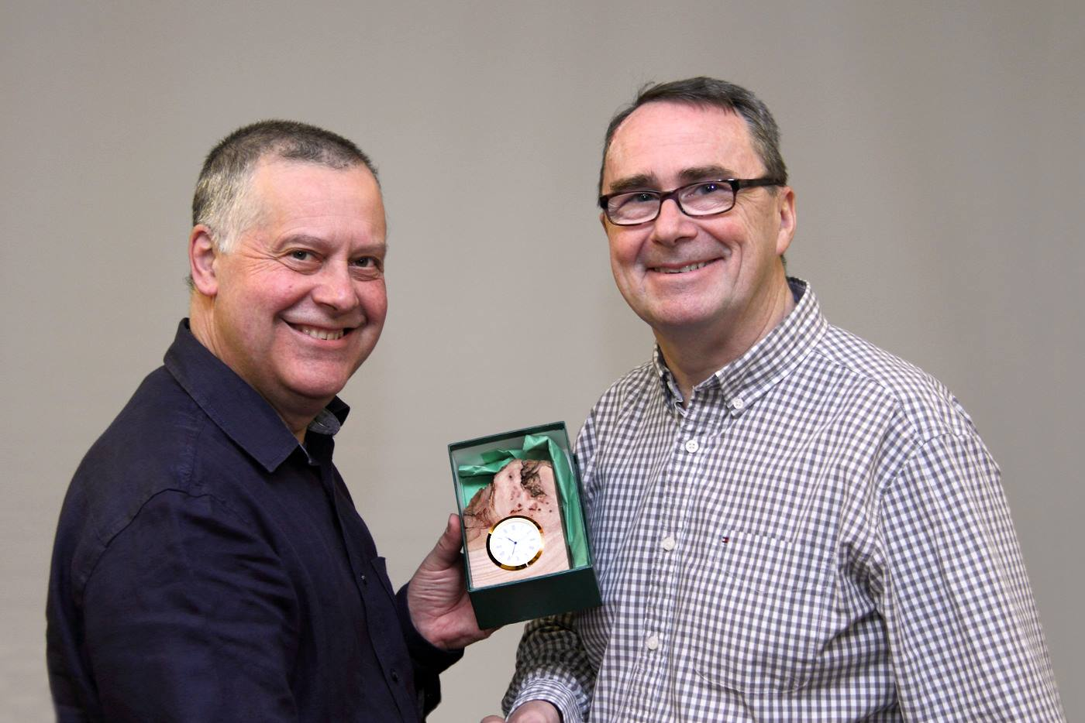President Tony Curtis presenting this year’s Annual Judge Terry Donnelly with a clock encased in locally sourced wood from Glen Darragh
The opportunity to thank the many local judges – too numerous to name individually – who support our competitions programme is essential ; their ready willingness to entertain us with their thoughts and expert commentaries on our images is always very much appreciated. And a big “thank you” as well to Terry Donnelly FRPS FSWPP MPAGB FBPE EFIAP who recently and very ably judged our Annual Competition and thanks also to the Isle of Man Arts Council for their sponsorship.
Going forward, the new committee will shortly be announcing the programme of summer events and outings which will be designed to give opportunities for more photography and hopefully, to take advantage of this wonderful island of ours.
By Chris Blyth

21st April 2016 – Annual Competition 2016 – Digital Images
‘Polar Bear and Cub’ by Sue Blythe was awarded Best Digital Image and Best Natural History Image in this year’s Annual Competition
One of the “highlight events of the year” for the IOM Photographic Society is its annual photographic competition – and in particular, having a top-rated external judge from the Lancashire and Cheshire Photographic Union to scrutinise and comment upon the entries. This is made possible by the kind sponsorship provided for the event by the Arts Council, and to whom we are very grateful. This year, our judge was Terry Donnelly FRPS, FSWPP, MPAGB, FBPE, EFIAP – a highly regarded and clearly well qualified photographer, and a regular winner himself of national and international awards. We were delighted to have him to judge our entries – all done with ease and skill, and a helpful commentary loaded with advice as regards adjustments, points to watch, and ideas as to how images could be improved.
The competition is split into the three classes (standard, intermediate and advanced) – and each into 5 categories (open colour, open mono, natural history, creative and record) – so too numerous to mention the individual winners. However, Terry was kind enough to point out the very high standard of entry which he considered at least comparable with any equivalent club from the adjacent island. One entry in particular, however, was considered to be of national, award winning quality – a wonderful image of a polar bear and cub stepping over several small ice floes, the cream coloured fur of the bears standing out well from the sheer whites of the ice and the deep blues of the arctic ocean. This was an entry from Sue Blythe, a new member for the Society this year, who deservedly won the Mistral Trophy for Best Digital Image in Competition as well as the Spiers Trophy for Best Natural History Image.
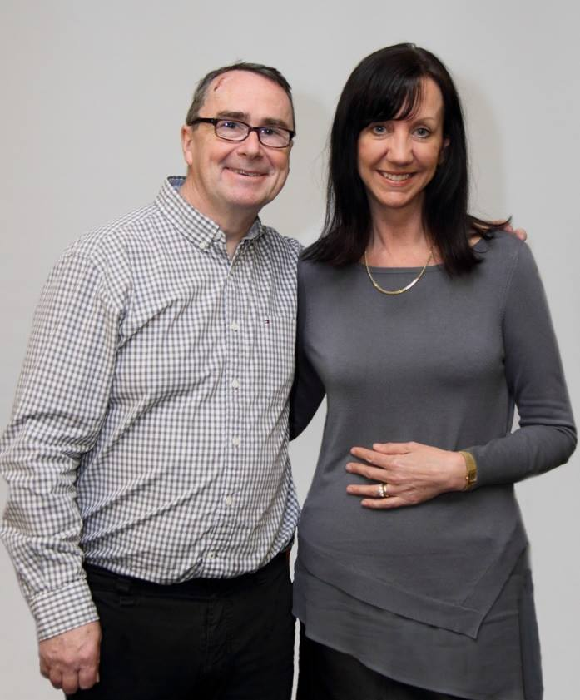
Sue Blythe with Judge Terry Donnelly
Terry completed our evening with a presentation of his sports images, accompanied by a commentary to help and to inspire anyone intent on photography as a hobby or career. The images used were superb – a wide range covering sports such as horse racing, polo, rugby, football, athletics, and cycling – and demonstrating that great images can be found close to home. However, crucial to getting good images is an understanding of one’s equipment and the skills to use it, knowledge of the rules for each sport and an awareness of just where the best images are likely to occur (start and finish lines, fences in horse racing etc). In addition, getting “something different to the usual” is often essential to getting sales – so head-on shots of competitors, a fish-eye lens giving the big picture, or shots of the spectators or stadia were all demonstrated to excellent effect. President Tony Curtis gave the vote of thanks.
The club season finishes on Wednesday 27th April with a showing of the Bebington Salon of Photography – a digital presentation of some of the best images entered in a competitive UK national exhibition (400+ winners from an entry of some 3000+) and covering a number of genres. Anyone with an interest in the arts or photography is welcome to attend – it is sure to be another excellent evening!
Results of the Annual Competition – Digitally Projected Images
Open Colour Section – Standard (Henry Roy Welch Memorial Cup): Sue Blythe (1 & 3), Barry Murphy (2 & C), Paul Dunderdale (VHC), Sue Leeming (2 x C), Michael Howland (C). Intermediate (Brockenhurst Cup): Shirley Lotfy (1 & C), Hazel Walsh (2 & 3), Nessie Gillen (VHC, 2 x C), Beryl Quayle (VHC). Advanced (Andrew Barton Cup): Chris Nicholls (1, 3 & 2 x C), Sue Jones (2 & C). Open Mono Section – Standard (Barrule Cup) : Sue Blythe (1), Michael Howland (2 & C), Paul Dunderdale (3), Barry Murphy (VHC), Sue Leeming (2 x C). Intermediate (Glen Darragh Cup) : Nessie Gillen (1), Beryl Quayle (2), Hazel Walsh (3). Advanced (Glendown Trophy) : Sue Jones (1, 3 & C), Bob Servante (2). Natural History Section– Standard (York Trophy) : Sue Blythe (1, 2 ,3 & VHC), Paul Dunderdale ( 2 x C). Intermediate (Jensen Trophy): Shirley Lotfy (1 & 3), Beryl Quayle (2 & 2xC). Advanced (Kelly Cup) : Chris Nicholls (1 & 2), Bob Servante (3). Creative Section – Intermediate (Sheiling Cup) : Nessie Gillen (1), Hazel Walsh (2 & 3). Advanced (Malew Cup): Sue Jones (1, 3 & HC), Bob Servante (2). Record Section– Standard (Atlantean Trophy): Paul Dunderdale (1), Patricia Larkham (2), Michael Howland (3). Intermediate (Summerhill Cup) : Shirley Lotfy (1 & 2), Hazel Walsh (3). Advanced (Dreaym Beary Trophy) : Sue Jones (1,2 &3).
Best Digital Image in Competition (Mistral Trophy) and Best Natural History Image in Competition (Spiers Trophy) – Sue Blythe with “Polar Bear and Cub”.
By Chris Blyth

19th April 2016 – Bebington Salon 2016
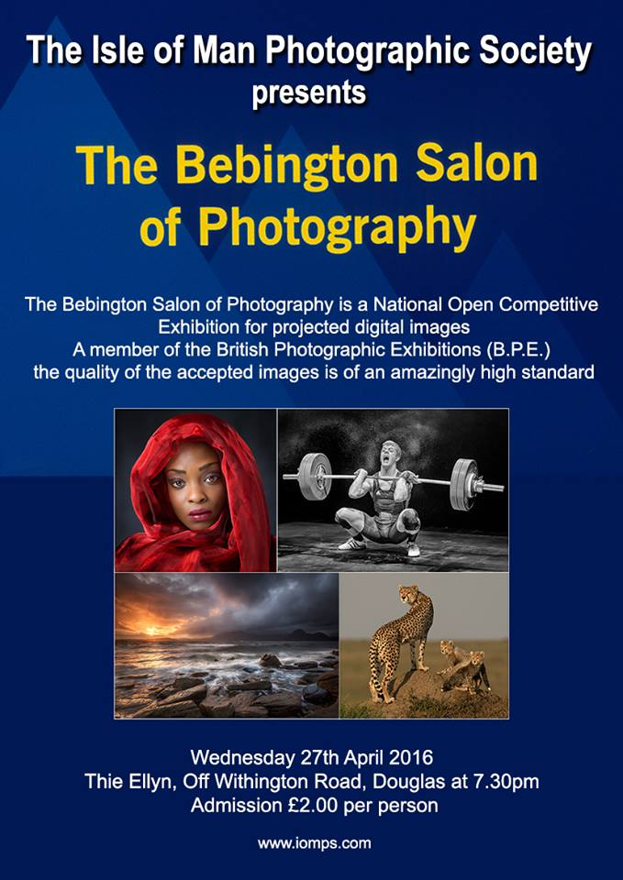
The Bebington Salon of Photography, sponsored by the IOMPS and the last official event shown in the club calendar, is scheduled for Wednesday, 27th April, starting at 7:30pm at Thie Ellyn (the Arts Society Building in Withington Road, Douglas). As in previous years, it will be presented by Bob Dennis APAGB AFIAP BPE4*
This is a “national standard” photographic exhibition of some 400+ images shown in a digital presentation, each image having been selected competitively from an entry of more than 3000, and covers the genres of open colour, open mono, natural history, landscape and creative – so a very wide-ranging series of images, some of which will be shown as “audio-visual” sequences. Accepted images count towards the award of the British Photographic Exhibition “crowns” (BPE*), a prestigious series of photographic awards which require multiple acceptances in order to qualify, and is a very visible evidence of the author’s expertise.
It is with pleasure that I can report that at least one of our members has had images accepted for the Salon and which I anticipate will be included in the evening’s presentation.
The exhibition is another “highlight event” in our calendar and well worth attending. The images being shown are all of the highest quality, and will excite, inspire, stimulate, and intrigue anyone with an interest in the visual arts and of course, especially photography.
To cover costs, there will be an entry charge to members and non-members of £2 each – a very modest cost for what will be an excellent and highly entertaining evening.
The meeting is an open event – members and non-members, family and friends – and all will be given a very warm welcome.
By Chris Blyth

14th April 2016 – Annual Competition 2016 – Prints
Some of the Annual Print winners with Judge Terry Donnelly
The Society’s annual photographic competitions are the highlight of the year for its membership. The aspect which sets these competitions apart from others held throughout the year is that a judge from the adjacent Island is invited to scrutinise and comment upon the entries.
This year’s judge was Terry Donnelly FRPS, FSWPP, MPAGB, FBPE, EFIAP. He lectures for the Lancashire and Cheshire Photographic Union, and judges competitions regularly for them as well as being a national judge for British Photography Exhibitions. Moreover, in the last two years, Terry has been awarded the title of ‘Photographer of the Year’ on three occasions in major national and international print competitions across different genres, the most recent being judged by a panel of 16 judges! We were fortunate to secure his expert services, in view of his impeccable credentials.
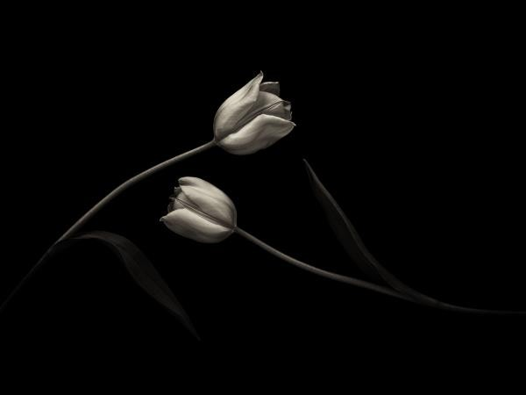
Best Mono Print was awarded to Nigel Owen for ‘Yin-Yang’
The first evening was devoted to the print competitions, which are central to Terry’s interest in photography as he devotes most of his energies into pursuing personal projects to produce high quality prints. He began by telling us that “Photography is not real unless you print it, so all images should be captured with that end result in mind!” There were 160 entries in total and Terry had spent the morning assessing them all before selecting his top awards. He commented on each of his ‘favourites’, giving clear explanations with typical scouse humour. In doing so, he demonstrated keen attention to the smallest detail. Helpful pre and post production tips aimed at raising standards were offered freely and greatly appreciated by those present. His belief is that images showing something out of the ordinary to ‘engage the brain’ were usually the most pleasing. Equally important was that photographers do not need to go to exotic locations to secure the best results: there is potential to be successful using everyday objects on our own doorstep. Finally, he advised we shouldn’t be afraid to copy the work of others as there was no point re-inventing, when all that was needed was to be stimulated into putting our own personal stamp on the outcome.
The award for the ‘Best Monochrome Print’ went to Nigel Owen for ‘Yin-Yang’ in the Advanced Monochrome Category. The award for the ‘Best Colour Print’ was awarded to Deb Turk for ‘Paul Weller in Concert’.
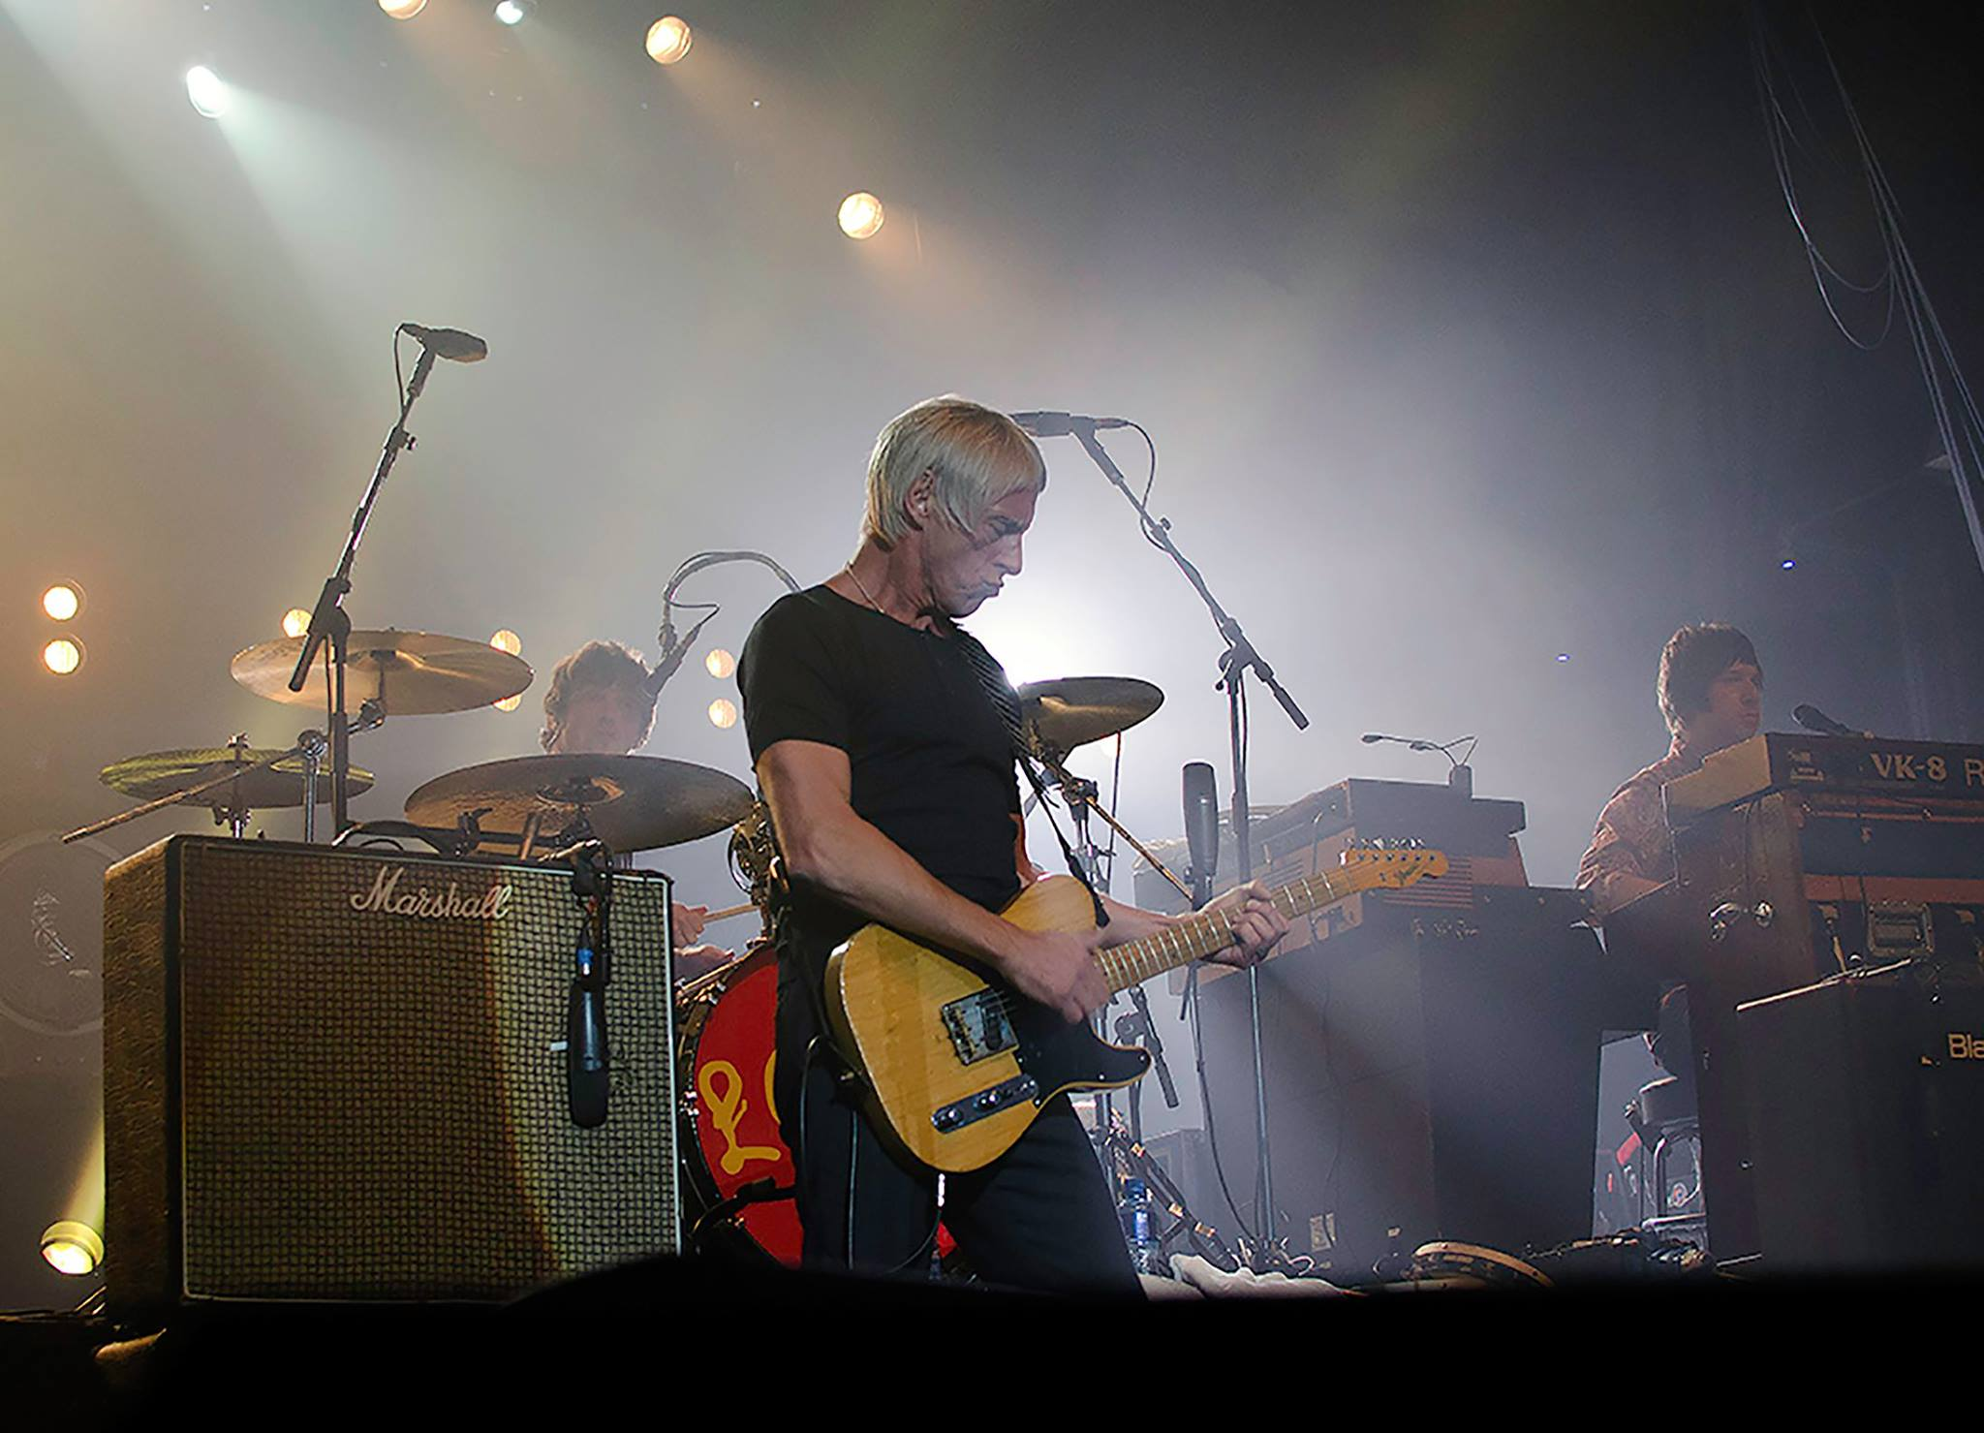
Best Colour Print went to Deb Turk for ‘Paul Weller in Concert’
Terry then gave several audio-visual presentations of his winning portfolios and other work illustrating his own personal development. These offered an opportunity to learn from a master, providing an insight into his approach to photography. The images were all of superlative quality, many being either paid commissions or sold to various publications.
At 7.30 pm on Wednesday, 27th April at Thie Ellyn, off Withington Road, the Society will be hosting an ‘open’ evening to enable those interested in photography to view the latest Bebington Salon. This includes the crème de la crème and should not be missed!
RESULTS:
Standard Monochrome – 1st ‘Heading Home’ by Barry Murphy (Tranter Cup); 2nd ‘Stilts’ by Sue Blythe ; and 3rd ‘Walk’ by Barry Murphy. Commended, ‘Dhoon and Gloom’ by Barry Murphy; ‘Silhouettes at Sunrise’ by Sue Blythe; and ‘Spike Island Prison’ by Barry Murphy.
Standard Colour – 1st ‘Paul Weller in Concert’ by Deb Turk (Woodbourne Cup); 2nd ‘Dirty Washing’ by Deb Turk; and 3rd ‘Winter Sun at Castlerigg’ by Sue Blythe. Commended, ‘Workshop Window, Bewdley Museum’ by Paul Dunderdale; ‘Rainbow Drops’ by Sue Blythe and ‘The Race’ by Sue Blythe.
Standard Natural History – 1st Common Fiscal’ by Sue Blythe (Baldwin Shield); 2nd ‘Dandelion Head’ by Sue Blythe; and 3rd ‘Gannet in Flight’ by Sue Blythe. Commended, ‘Heron’ by Sue Leeming and ‘Male Cheetah’ by Sue Blythe.
Intermediate Monochrome – 1st ‘Protection’ by Nessie Gillen (Ballure Cup); 2nd ‘White Rose’ by Nessie Gillen; and 3rd ‘Allium Bud Breaking’ by Beryl Quayle;. Commended, ‘Spaceship in the Sand Dunes’ by Beryl Quayle; ‘Stanley Park Palm House’ by Beryl Quayle; and ‘Torso’ by Nessie Gillen.
Intermediate Colour – 1st ‘Toned’ by Nessie Gillen (Coombe Cup); 2nd ‘Water Colours’ by Nessie Gillen; and 3rd ‘Cold in Fur’ by Nessie Gillen. Commended, ‘Sunset, Formby Beach’ by Beryl Quayle, ‘Shaded Leafy Pathway’ by Shirley Lotfy and ‘Patiently Waiting’ by Shirley Lotfy.
Intermediate Natural History – 1st ‘Low Flying Owl’ by Nessie Gillen (Ballaragh Cup); 2nd ‘Common Buzzard’ by Shirley Lotfy; and 3rd ‘Crab’ by Nessie Gillen.
Intermediate Creative – 1st ‘Princess Zara’ by Nessie Gillen (Carnane Cup); 2nd ‘A Colourful Lady’ by Nessie Gillen; and 3rd ‘Daisy, Golden Sphere’ by Beryl Quayle.
Intermediate Record – 1st’Italian Church Window’ by Shirley Lotfy (Lezayre Trophy); 2nd Mosaics’ by Shirley Lotfy; and 3rd ‘Mask’ by Nessie Gillen.
Advanced Monochrome – 1st ‘Yin-Yang’ by Nigel Owen (Bridge Cup); 2nd ‘Seat of Learning’ by Ron Shimmin; and 3rd ‘Room 213’ by Ron Shimmin. Commended, ‘The Home Guard’ by Sue Jones and ‘Mining Collection’ by Sue Jones.
Advanced Colour – 1st ‘Santorini Scene’ by Chris Nicholls (Sanderson Cup); 2nd ‘Lauterbrunnen’ by Chris Nicholls; and 3rd Sea Horses’ by Chris Nicholls. Commended, ‘The Chocolate Café’ by Ron Shimmin; ‘Lift Off’ by Chris Nicholls; and ‘Winter on the Grand Canal, Venice’ by Chris Nicholls.
Advanced Natural History – 1st ‘Bracket Fungus’ by Chris Nicholls (Caraghan Cup); and 2nd ‘Burnet Moth’ by Chris Nicholls.
Advanced Creative – 1st ‘Geometry’ by Ron Shimmin (Snaefell Cup); 2nd ‘Squares Framed’ by Sue Jones; and 3rd ‘Street Angles’ by Ron Shimmin.
Advanced Record – 1st ‘Shakespeare window’ by Ron Shimmin (Glenrigh Cup); 2nd Window Panel, Peel Cathedral’ by Sue Jones; and 3rd ‘Great Laxey Miners’ Plaque Detail’ by Sue Jones.
The award for the ‘Best Monochrome Print’ went to Nigel Owen for ‘Yin-Yang’ in the Advanced Monochrome Category. The award for the ‘Best Colour Print’ was awarded to Deb Turk for ‘Paul Weller in Concert’.
By Antony Hamilton

7th April 2016 – Inter-Club Battle between IOMPS and North West Bristol Camera Club
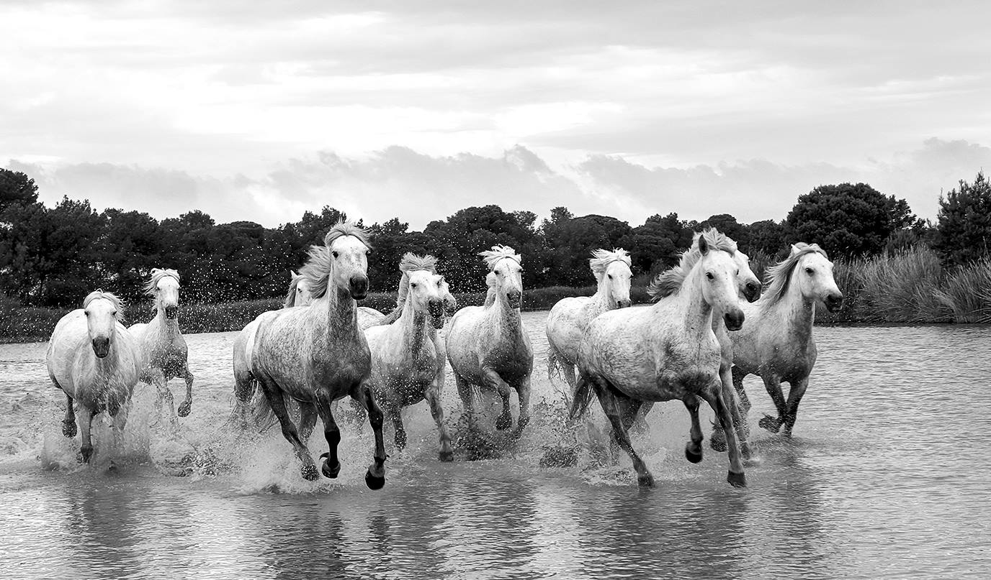
The Isle of Man’s Best Image in the recent battle with Bristol went to ‘Wild Horses’ by Chris Nicholls
30th March at the Isle of Man Photographic Society saw another interclub battle taking place – this time against North West Bristol Camera Club. The format was different to the previous inter-club battle between Oldham, Rochdale and ourselves, in that images were judged in both locations by different judges and the results combined to determine the victor.
In Bristol, entries were judged by Peter Ottley who awarded each image a mark out of 20 and commented: “The quality of the images overall was very good and I had a really hard job not to award nearly every image with a high mark. I have hopefully given a spread of marks as requested that sort of ranks the images in some sort order.”
Meanwhile on the Isle of Man local professional photographer Andrew Barton LBIPP LMPA stepped in after the scheduled judge was unable to attend. He noted that it was difficult to assign scores out of 20 but that he had taken a number of elements into consideration when marking the images. Andrew took the time to discuss each image and the scores from himself and the Bristol judge were read out.
Two images were scored 20 points by Andrew, both images by Isle of Man members, ‘Cairns Shore’ by Diane McCudden – an evocative seascape and ‘Wild Horses’ by Chris Nicholls a monotone shot of a group of horses running through water. ‘Wild Horses’ was judged by Andrew to be the best image in the competition. Bristol’s judge scored these images 16 and 17 respectively and whilst there were some differences between the judge’s scores in other cases both judges awarded the same or similar marks.
Peter Ottley, the Bristol judge, also awarded 20 points to two images, this time both by Bristol members. One titled ‘War Time Evacuation’ was a lovely portrait of two small children and the other ‘Sea Pool Steps’ by Sandie Cox was a long exposure seascape. Andrew awarded both these images 19 points. ‘Sea Pool Steps’ was considered best in competition by Peter.
At the end of the competition Andrew’s scores totalled 438 for Bristol and 453 for Isle of Man with Peter’s scores totalling 482 for Bristol and 438 for Isle of Man. This gave a final result of 891 for the Isle of Man but it was Bristol who won with a total score of 920.
Thursday 7th April sees the judging of the annual print competition and Friday 8th will be the judging of the digital entries, both evenings will also feature a presentation by the judge – Terry Donnelly FRPS FSWPP MPAGB, a member of Wigan 10.
By Hazel Walsh

