Results of our Annual 2019-20 Print Competition
INTERMEDIATE
Mono – Ballure Cup Martin Sandersom
Colour – Coombe Cup Steve Johnstone
Nature – Ballaragh Cup Steve Johnstone
Creative – Carnane Cup Martin Sanderson
ADVANCED
Mono – Bridge Cup Barry Murphy
Colour – Sanderson Cup Ron Shimmin
Nature – Caraghan Cup Sue Blythe
Creative – Snaefell Cup Ron Shimmin
Best Mono In Competition – Barry Murphy with “Eccentric Framing”
Best Colour in Competition – Ron Shimmin with “Shipshapes”
Congratulations to the winners and everyone who took part and especially to our judge on the night Pat Tutt for such an enjoyable evening.
Home and Garden, April Challenge, 2020
As we have all still been staying at home as much as possible, it was decided that the members’ challenge for April should be titled ‘Home and Garden’ to encourage us. As we have been having a different topic each month and so it was decided it would be nice to continue this through the summer months even though we can’t meet in person. The idea is that we take a number of photos on the topic, during the month, and upload them to our members’ Facebook page. Hopefully when we start to have club meetings again we will be able to show them one evening.
So what did we decide to photograph? We had a very good entry of around 80 images, and the most popular subject by far was garden birds. The Courier has recently published a couple of articles on photographing birds and small insects, written by Chris Blyth, and our members have made good use of his advice. The beautiful chirpy robin and our little sparrows were popular subjects. Robins in particular are one of the easiest birds to photograph as they aren’t too easily frightened off. Sparrows on the other hand never seem to keep still, at least not for me! We also had gold- and green-finches, and some thrushes. All beautiful birds, it was difficult to choose which one to include with this article, but I hope you will agree that this cheeky almost tame robin waiting to be fed, is lovely. Taken by Diane McCudden. and the little sparrow getting nesting material from a pampas grass is beautiful too, by Sue Jones.
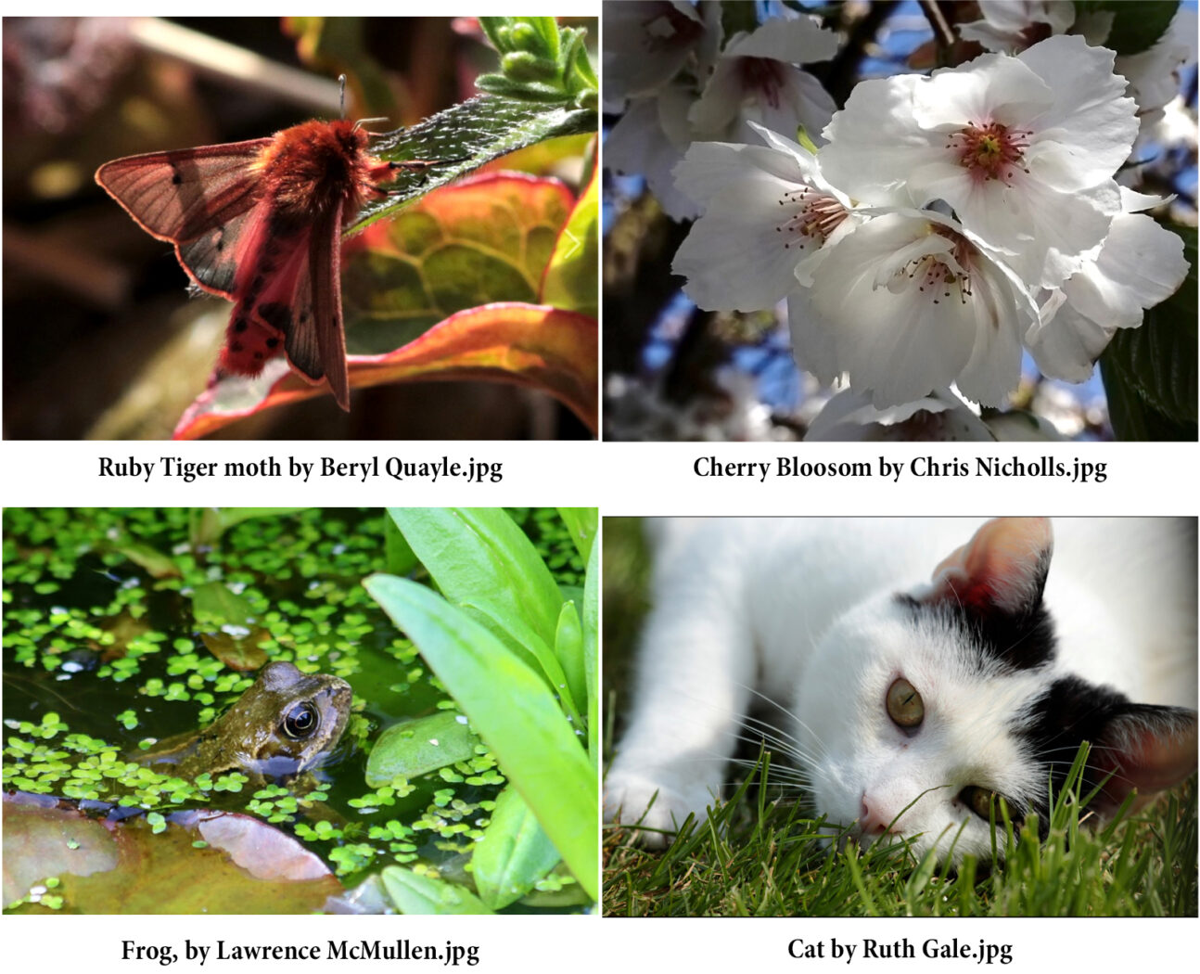
Butterflies and other insects were also very popular subjects. The weather here in the Island in April was unusually warm and sunny and this helped to bring forward the flowers, so providing attraction and food for the insects. Bees, various kinds of fly, a red admiral butterfly and a ruby tiger moth all featured. The image is by Beryl Quayle.
A few other animals crept into the mix, some lovely cats, this one by Ruth Gale, a couple of frogs, the image here captured by Lawrence McMullen, a hedgehog, and even ….. a longtail!
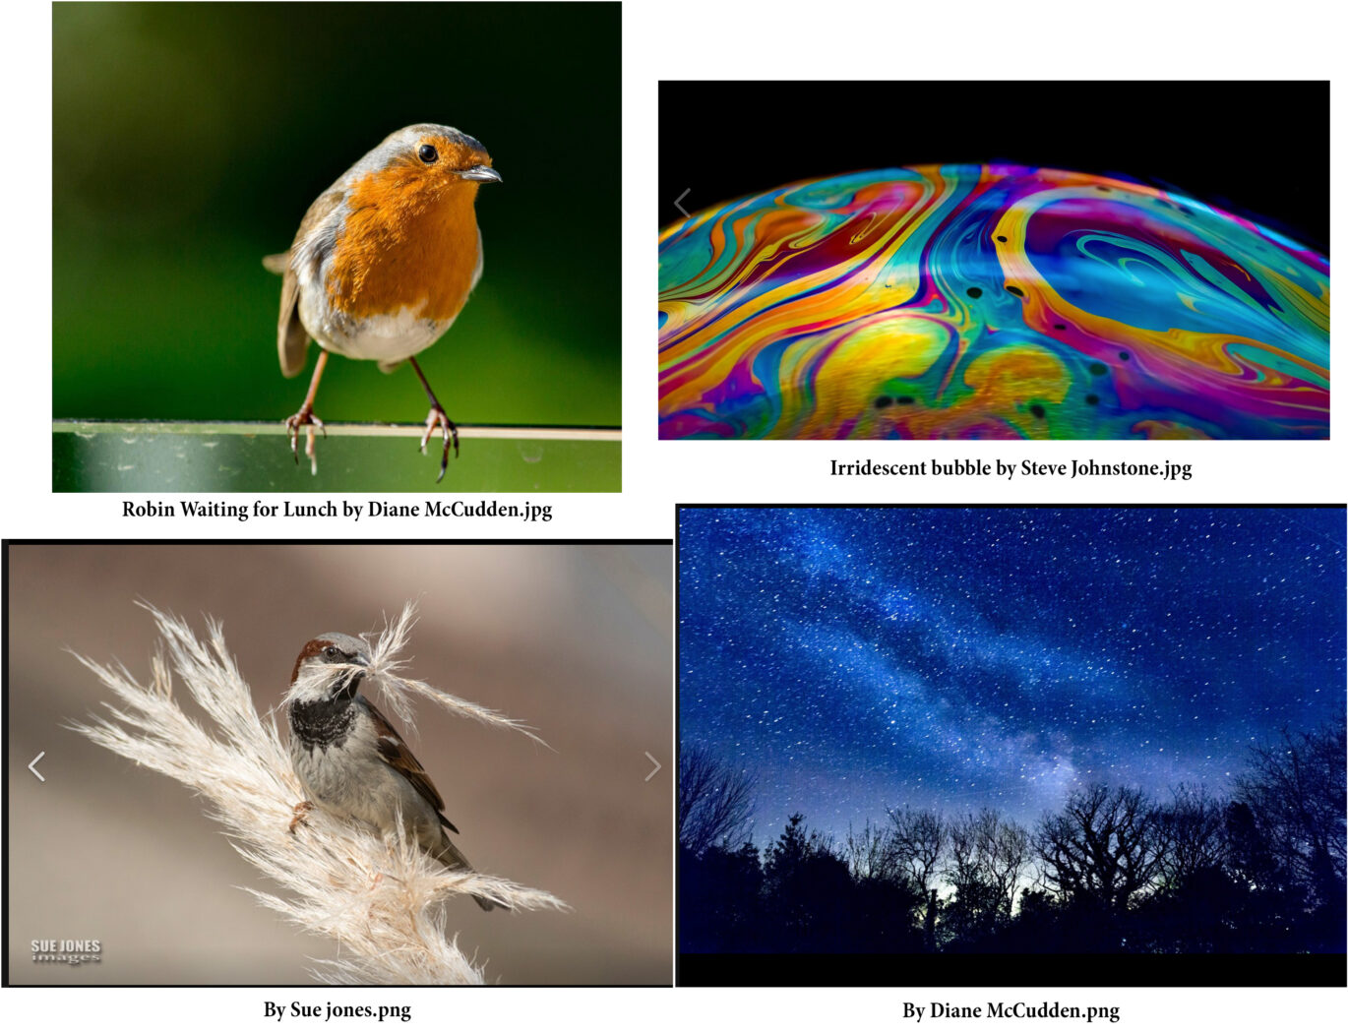
Flowers featured well too, with primroses, cowslips, tulips, and masses of blossom images. The cherry blossom is by Chris Nicholls.
Some members ventured into the garden after dark, warmly wrapped up against the cold, we hope. During the month we had a super-moon, and really clear night skies. The Milky Way capture is by Diane McCudden.
There were surprisingly few indoor images, but what we got were lovely still life shots, portraits, and some really creative work, such as the beautiful iridescent bubbles by Steve Johnstone.
I hope you have enjoyed this small sample of our images, and will watch out for more things to photograph in your gardens as we patiently wait for things to become more like normal.
Ruth Nicholls

A Wonderful Archive, collated by Tony Curtis
Recently, Tony Curtis put a large number of images that he had collected on his computer over the years onto the club’s Members’ Facebook page. Photos that had been taken at club meetings and events over the years, by Tony himself in most cases, except for a couple by Sue Jones, when Tony was the subject of the photo. Mostly they were taken to be sent to the newspaper, and we are lucky that he kept them.
I have kept them in order, and collected them into groups according to the year. I am sure most of us will recognise most people in these pictures, although there may be a few faces unfamiliar to our newer members.
I hope they will bring back some happy memories.
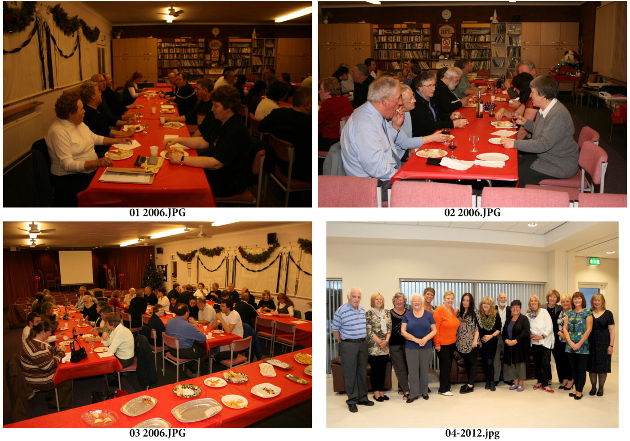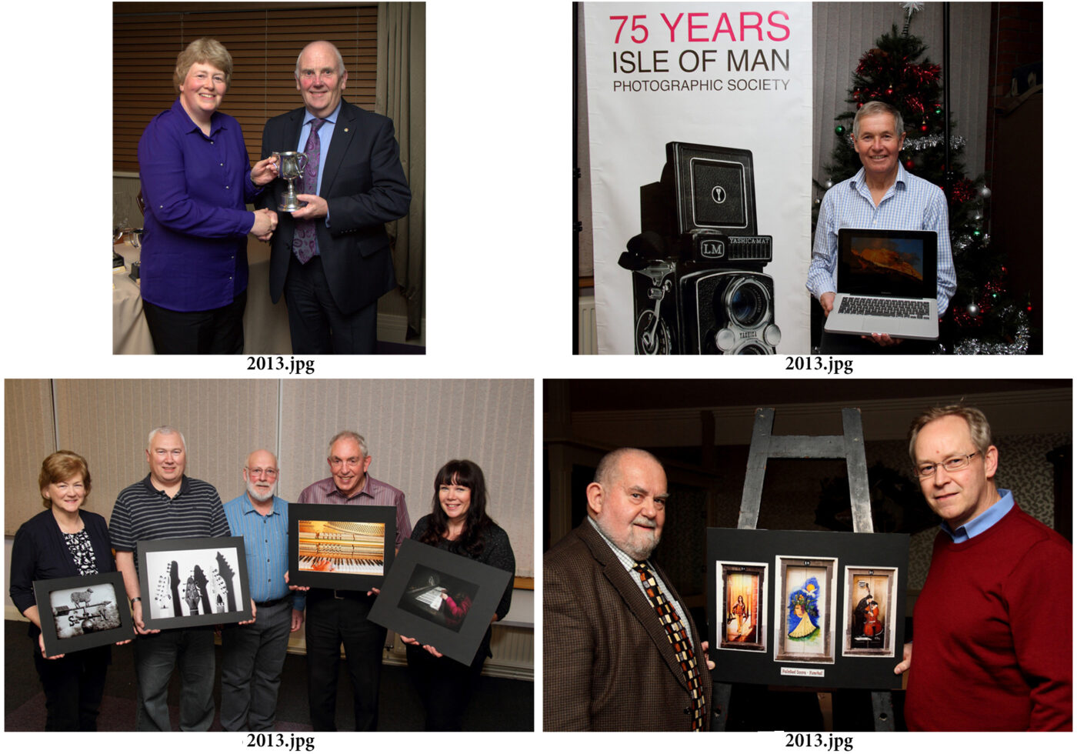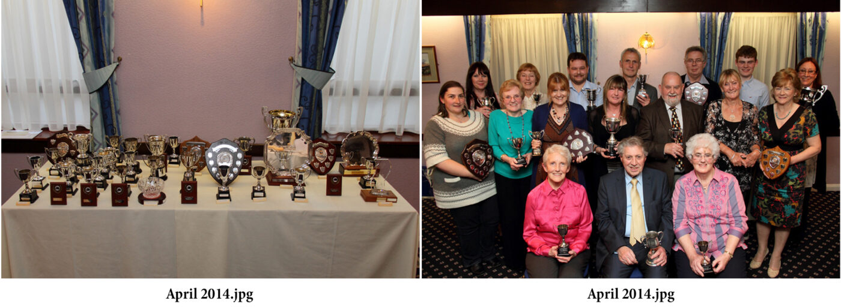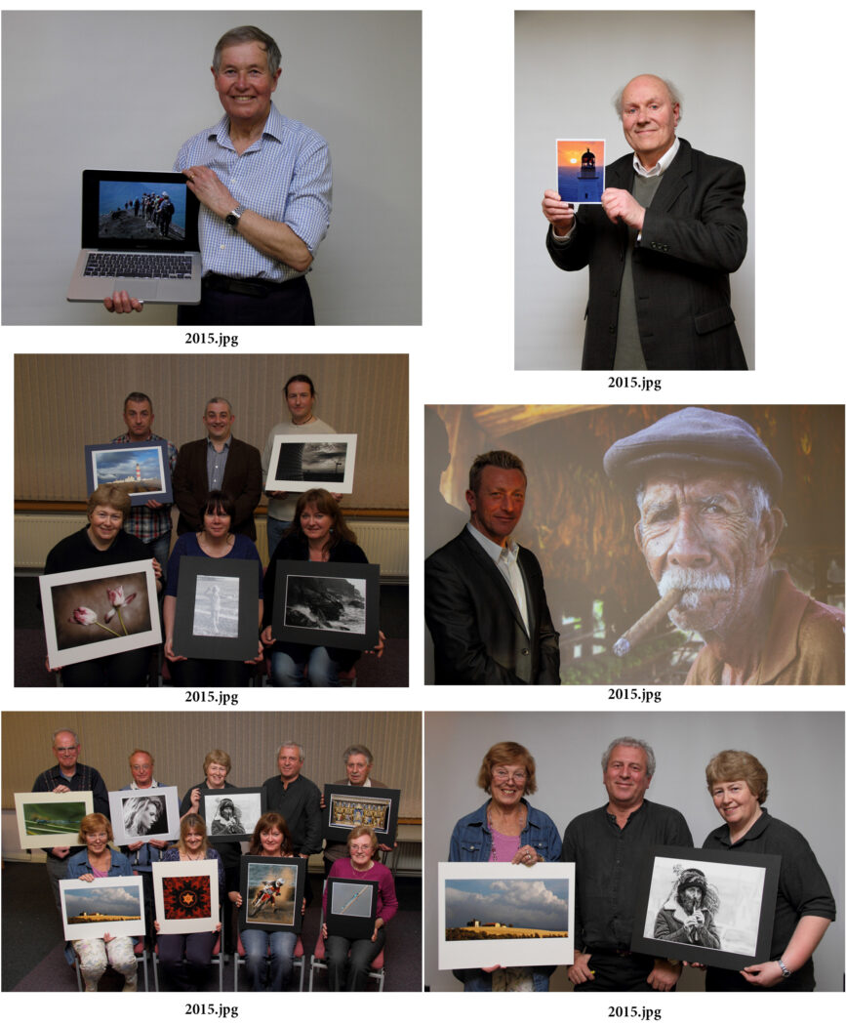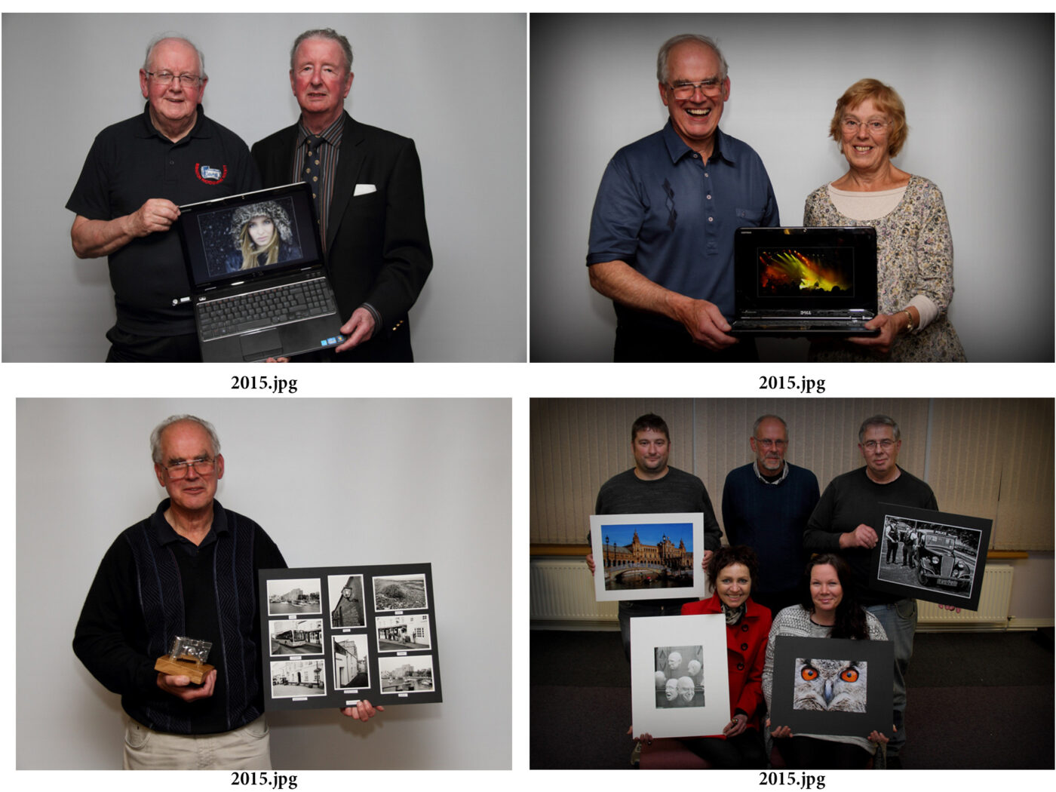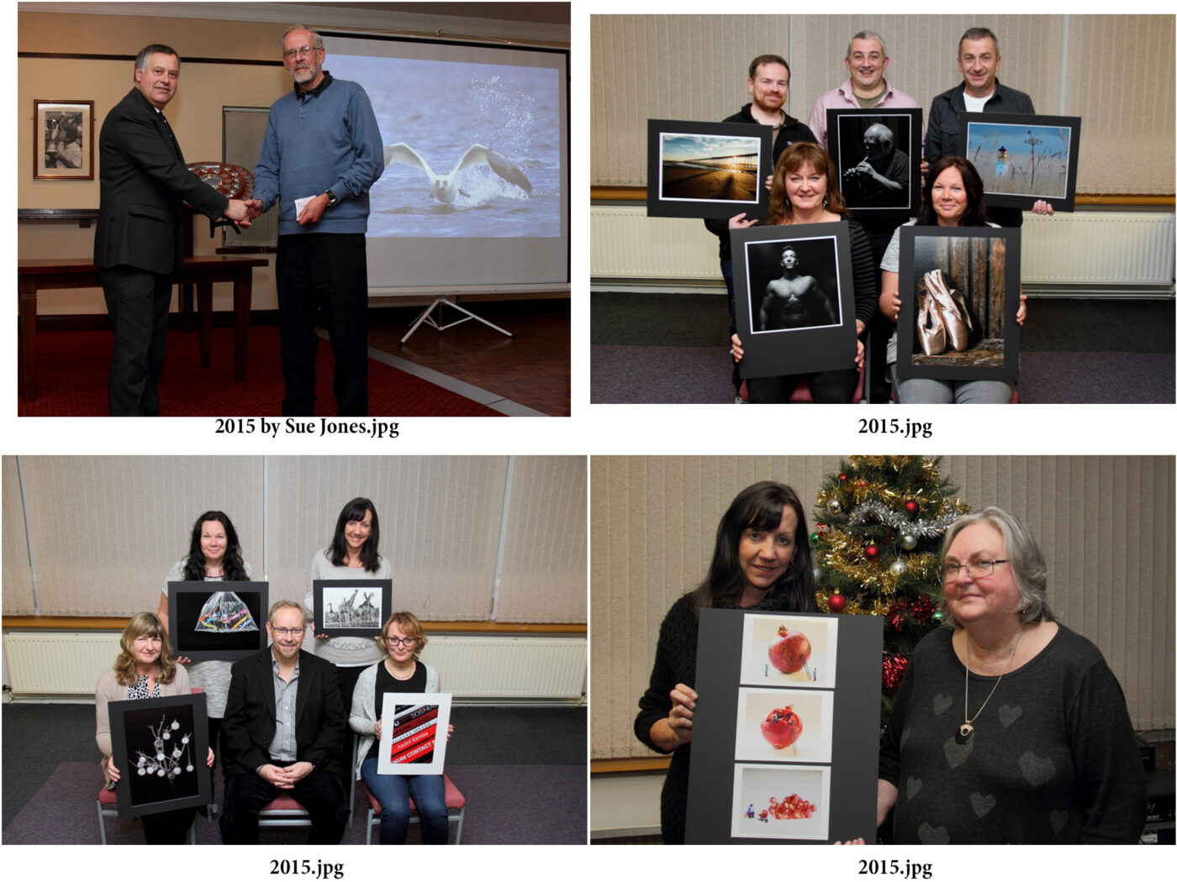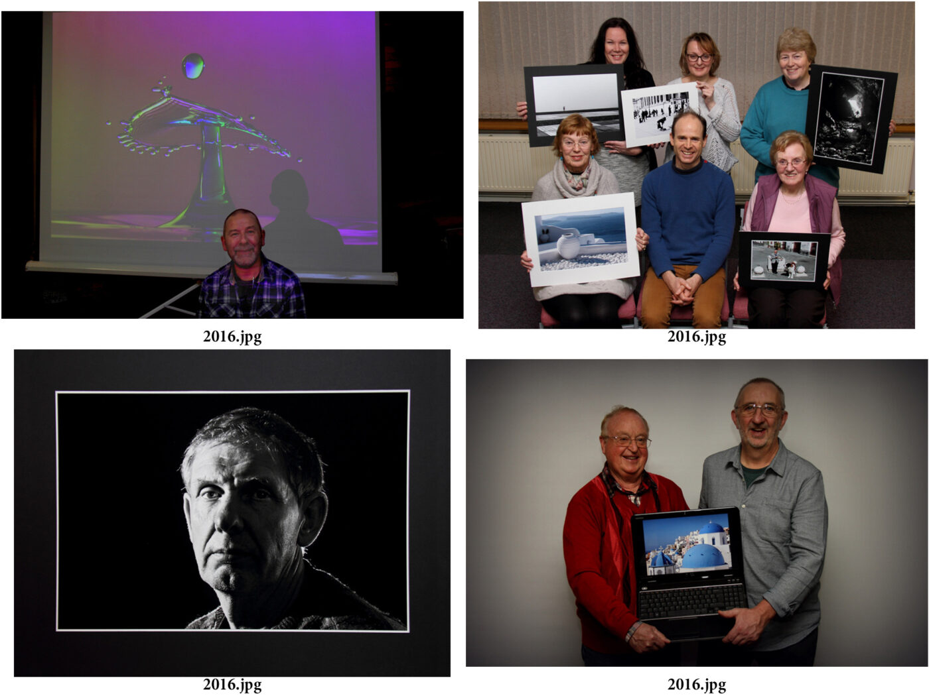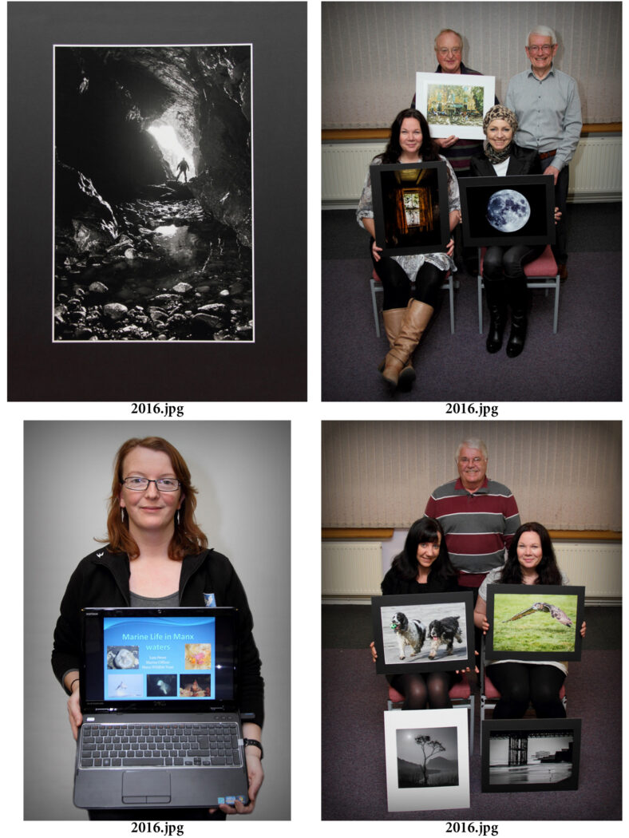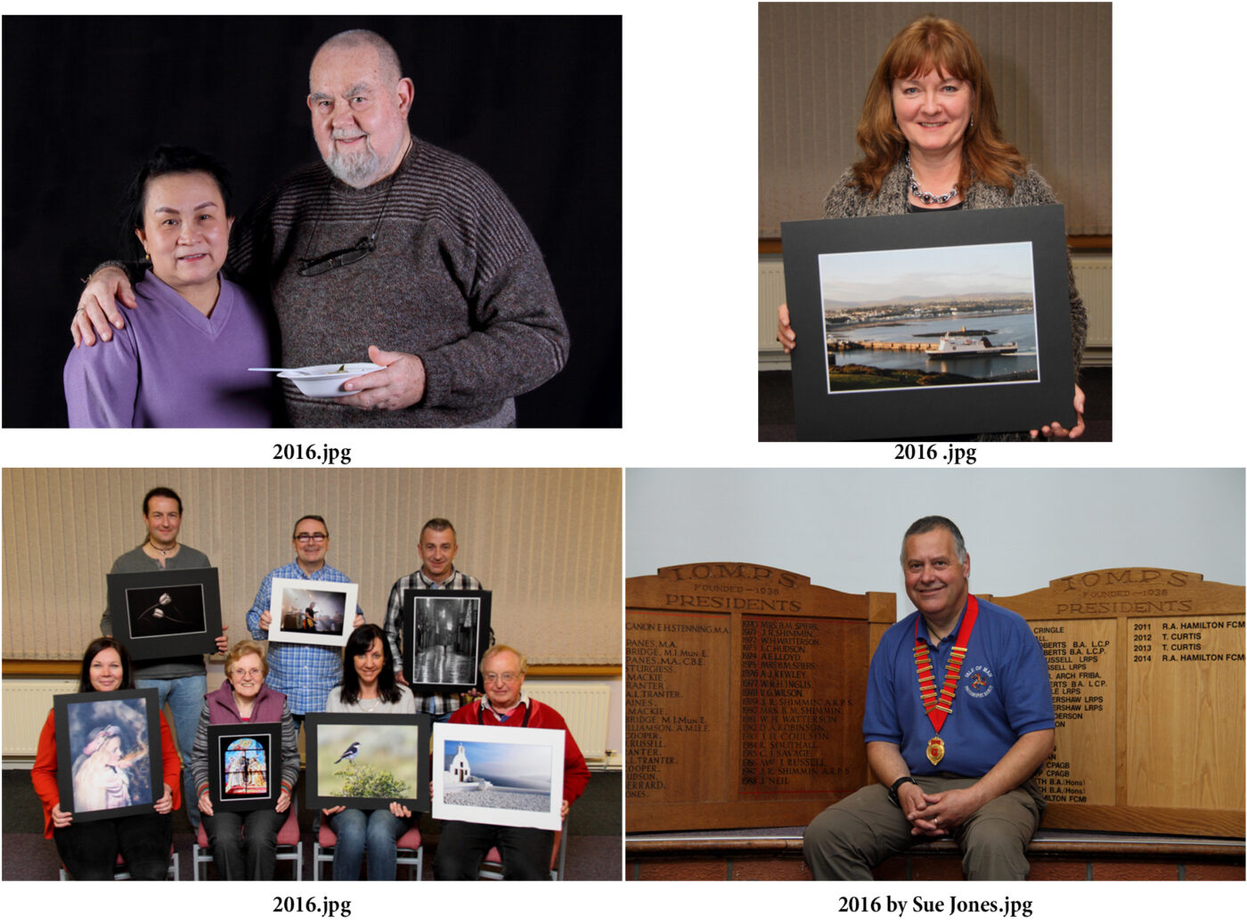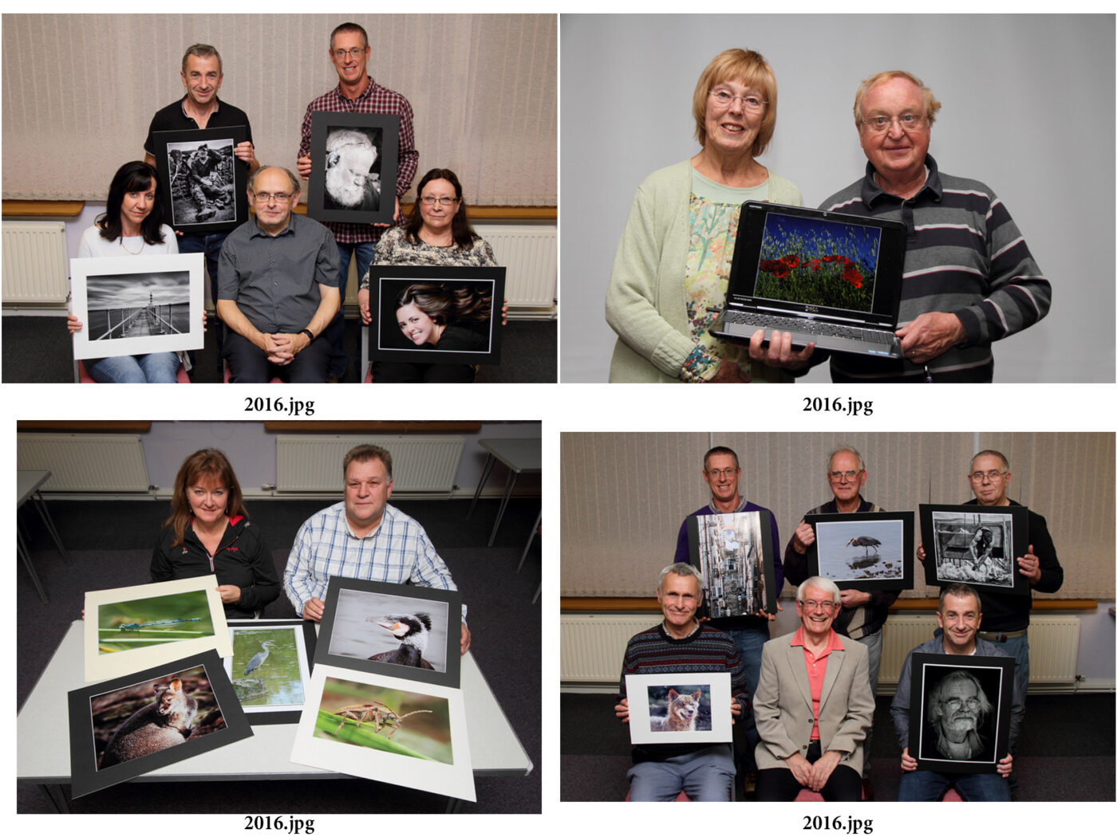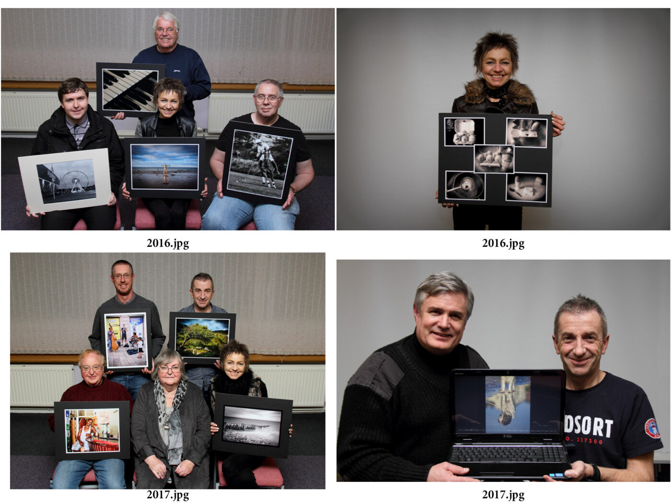
This is as far as Tony’s collection goes, sadly. It mainly ceased as there was a change to recording the winning image rather than the photographer.
Ruth Nicholls

Garden birds make a great subject for photography April 17th 2020
Given the ongoing instructions to avoid going out, now is a good opportunity to photograph the birds in your garden – they are truly beautiful, each species has its own special charm, and they make great subjects. But getting a high-impact shot can be difficult – most species are shy of allowing humans into close contact and immediately fly off if approached. And most birds are actually quite small, so getting a high resolution shot which includes good feather and eye detail requires a really good lens, typically something in the range of 200mm – 500mm (either that or lots of luck!). If you don’t have a really long lens, a “teleconverter” (sometimes called a “multiplier” or “lens extender”) can be an economical way of increasing the focal length of a lens – usually by a factor of 1.4x or 2.0x – so a 200mm lens with a 2.0x converter is equivalent to a 400mm lens. Their disadvantage is a reduction in the light entering the camera so you will need a larger aperture setting or an increase in the ISO setting to compensate. There are often good deals available on eBay or Amazon.
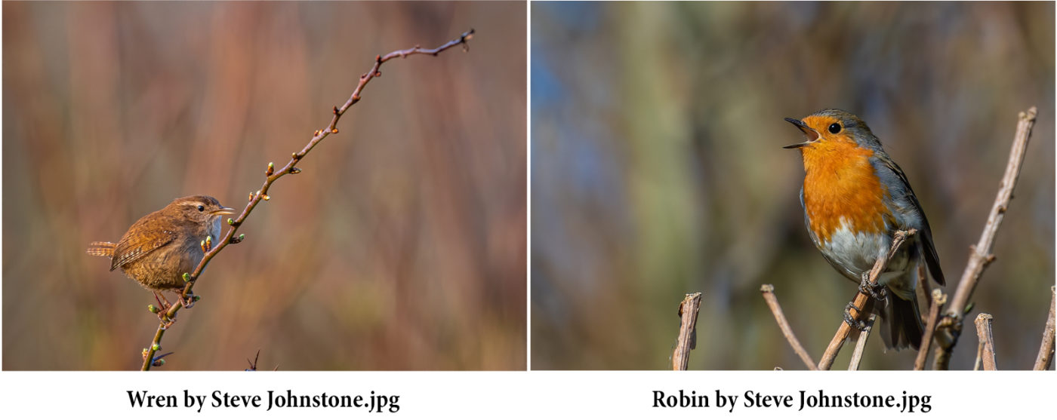
Having garden feeders to encourage the birds into your garden will provide a ready source of talented models for your images – robins in particular are very approachable and even larger birds such as gulls will allow reasonably close contact when food is on offer.
Patience, quiet, and minimal movement will prove helpful in “getting the shot”, whilst the guidelines on composition given in an earlier article apply just as with a landscape image, so the “Rule of Thirds” is a good starting point.
Whether to go for the really close-up image or a more distant shot with a landscape or seascape environmental context is up to you – I have provided several images to show the sort of image possible. It helps the impact if the background can be kept relatively uncluttered, even if not totally defocussed, so the viewer’s attention is drawn to the bird – and whilst movement in flight may render the wings out of focus, it is vital that the eye stays sharp, ideally with that little catchlight sparkle too. So, camera settings of a wide aperture (say f2.8- f4.0), ISO at 200 or 400 for maximum quality and reduced noise, and a fast speed setting of at least 1/500th are suggested. And as a “piece de resistance”, the bird in action, singing, catching its prey or feeding its young will make for a stunning image, even perhaps a masterpiece. Good luck with your photographic efforts – and be aware that you’ll likely take dozens of photos before getting one that really pleases. Bird photography is not easy! These two photos by courtesy of member Steve Johnstone.
Chris Blyth

Out in the Garden: An IOMPS Socially Distanced Get Together 11th April 2020
As we are unable to hold regular meetings due to coronavirus restrictions, we were delighted when Honorary Life Member of the society, Andrew Barton LBIPP LMPA,leading Island photographer offered to arrange a “webinar” (web based seminar) from his garden to give a tutorial on the subject of “depth of field”. To do this he set up a very complicated arrangement in his garden, including two cameras on tripods, his computer plus the cables to connect with the internet, thereby enabling our members to join in and ask questions or comment on the process. It was clearly a major effort on his part to manage all this when he would usually have an assistant with him to carry some of the load. It proved challenging but successful. It was a “first” for our society and hopefully a possible rehearsal for the future.
With the slopes of the North Barrule hillside visible in the background, Andrew had arranged several set-ups to demonstrate the concept of “depth of field”. Essentially depth of field is the distance between the closest and furthest objects in your image which appear sharp – anything closer or further away becoming less and less sharp and ultimately becoming totally defocussed. It is a fundamental aspect of photography and one, when understood, can be exploited by the photographer to enhance an image. It is usually considered important that the main subject should be in focus – but it then depends on the subject (and the photographer’s vision of the intended image) as to how much of the rest of the image is in focus.
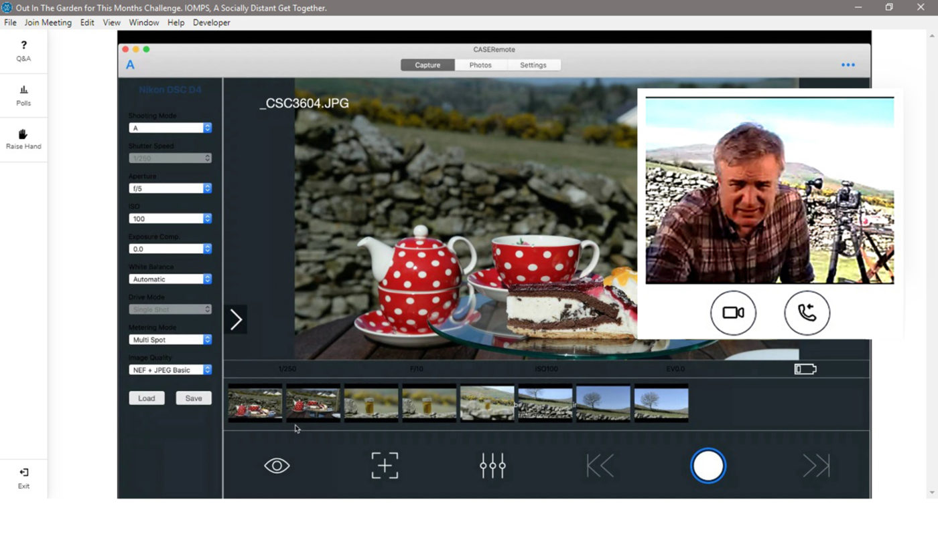Screen shot captured during the webinar
For our webinar and to tie in with the month of March challenge of “Home and Garden”, Andrew had arranged an “afternoon tea” set-up, with cups, a tea pot and a slice of delicious-looking chocolate cake – and showed how a wide-open lens aperture (say at f2.8) held only the cake in focus, whilst the smaller the aperture the more the other components came into focus until at f22 (a very small aperture) even the background was becoming clear. But please note that each change to a smaller aperture requires a compensating adjustment with a slower shutter speed setting.
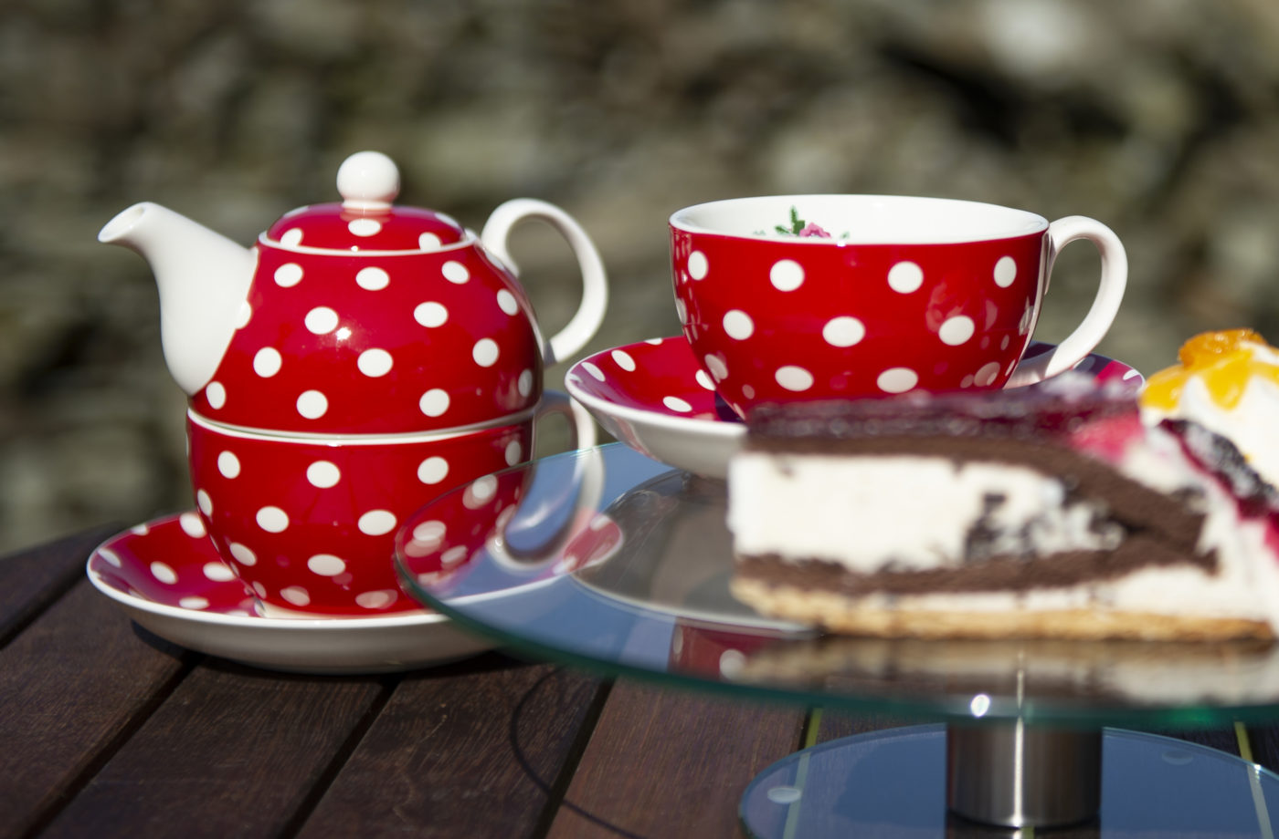The “afternoon tea” set up demonstrating a shallow depth of field
Andrew also demonstrated a way of shooting macro images on a mobile phone with a lens costing under £5, this is an attachment that just clips on to the existing lens!
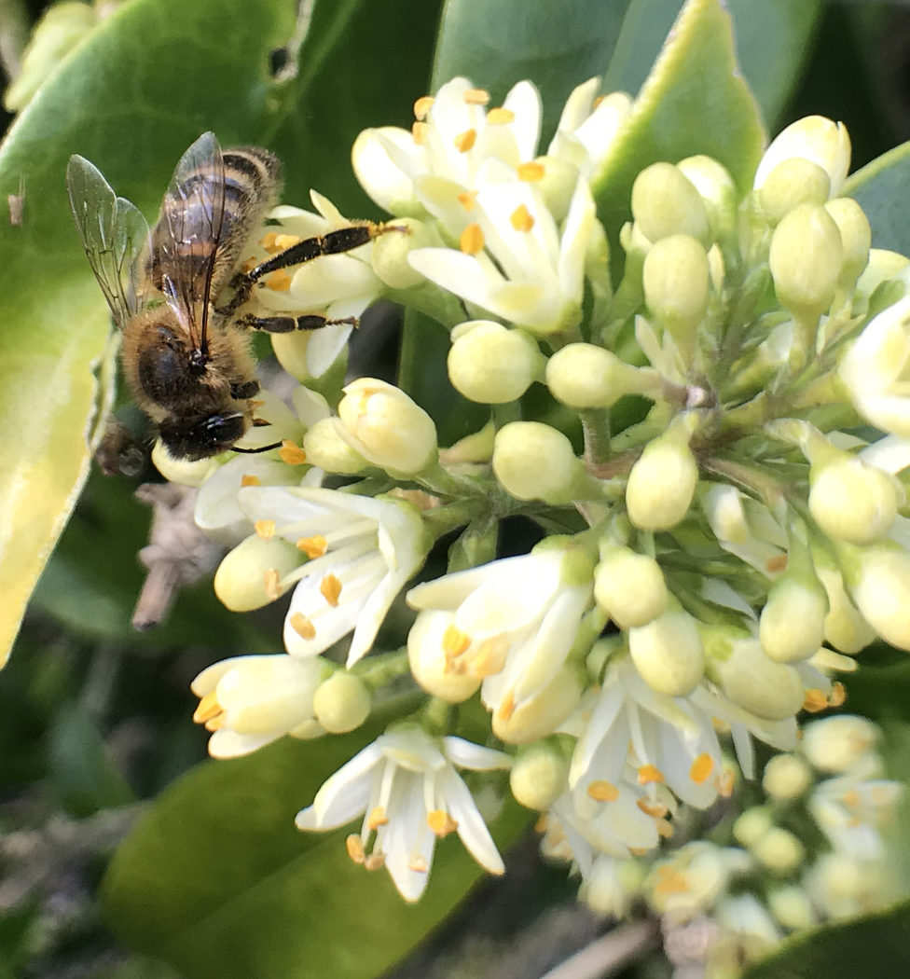Macro image taken on a mobile phone with a £4.99 attachment
Why not try a few shots in the garden – maybe a family member sitting in a chair, using different apertures as an experiment – you’’ll soon get the hang of a quite difficult concept.
Thank you Andrew for arranging the webinar – it was well worth the work and thought you put into it.
However you take your images, if the result is pleasing and you like it, then good enough – your shots will provide a record of the day or the event and will always be there to remind you of it.
Chris Blyth

2020 March Challenge – Minimalistic.
While the Isle of Man Photographic Society is unable to meet, we are holding monthly ‘challenges’. The challenge for March was chosen by member Janet Henry, she chose Minimalistic as the topic. All the entries have been published on our Facebook page and some of them here.
I have picked out two from each member who entered, the ones I think best illustrate the basic principles behind minimalism. So apologies if you think I should have chosen differently!
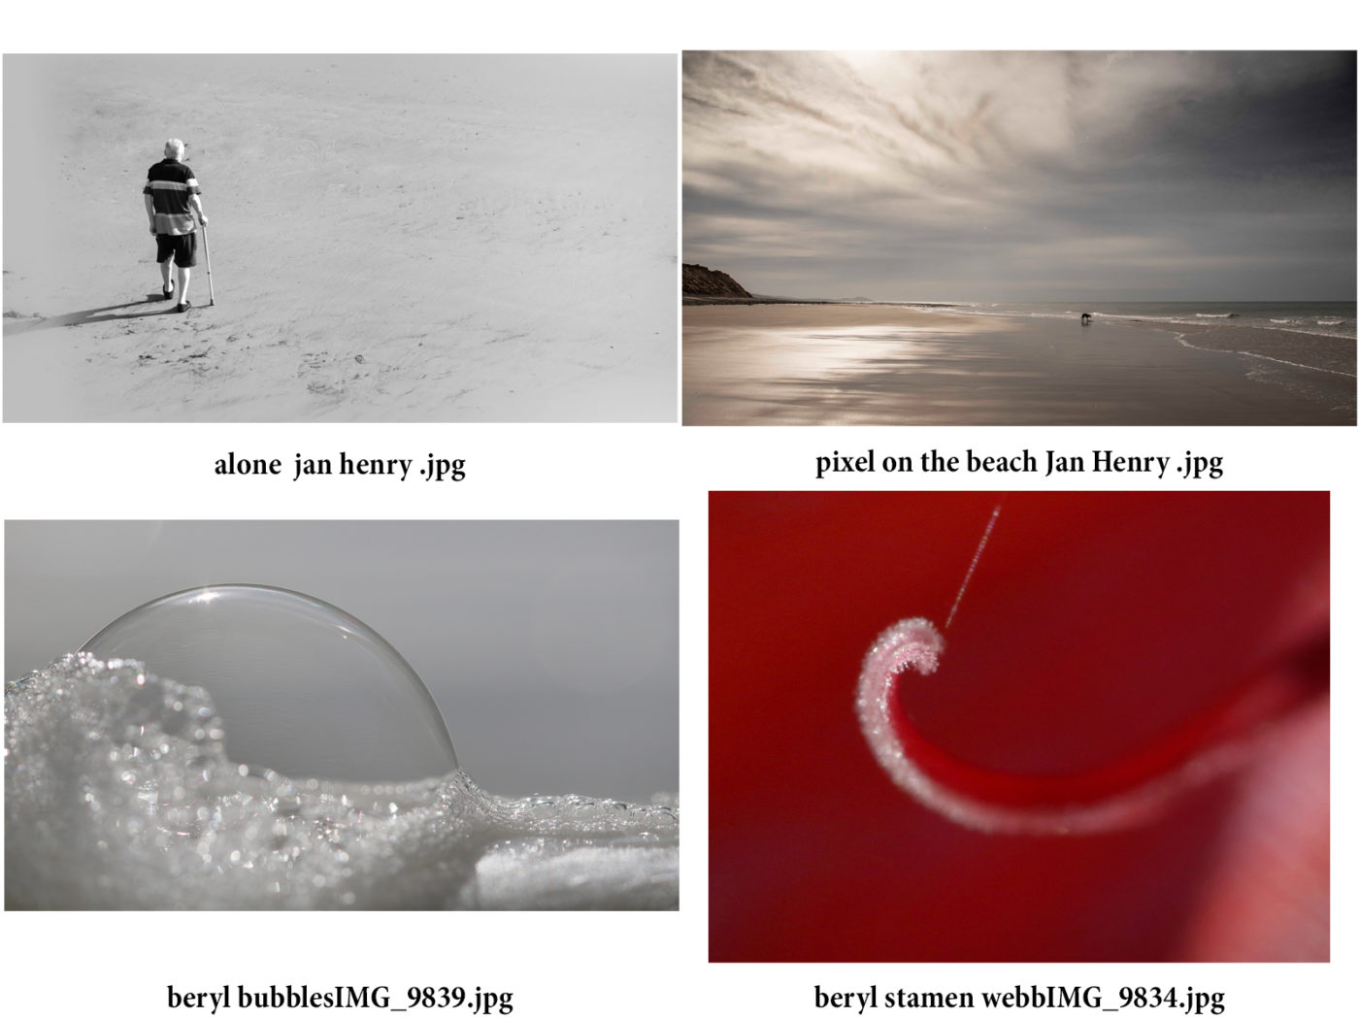
Here are some comments and tips on what Minimalism means and how to create suitable photographs.
Minimalist photography – Leonardo da Vinci said “Simplicity is the ultimate sophistication.”
There should be nothing in the image that distracts from the subject the photographer intends the viewer to see. But you need to consider a few other points to make your photo stand out from the rest.
You need to choose an interesting subject. In our members case, this should be something that interests you, personally, as we are not trying to be commercial, we only have ourselves to please. Our club has many talented Nature photographers, so flowers and birds tend to feature prominently as favourite subjects.
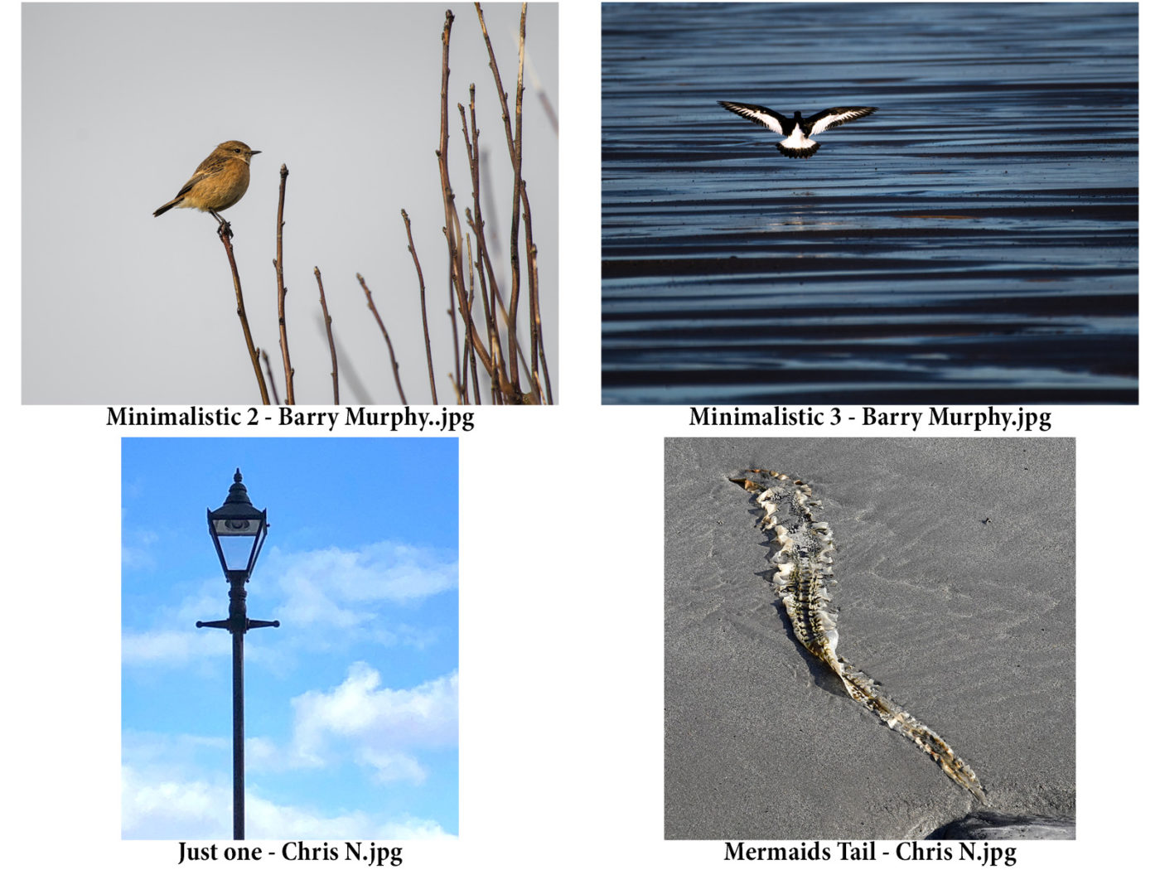
Composition is important. Most usually a minimalist photo will have one object, and quite a lot of ‘space’ filled with a background which is not distracting or busy. Sometimes the subject and the background together combine to tell a story, or evoke an emotion, such as a solitary figure on a beach, or a single boat on an expanse of water.
Sometimes a repeating pattern, which in itself might be either too busy, or boring and lacking variety, can be used to great effect as a background to a single subject, a person, an animal, an object, or a small group.
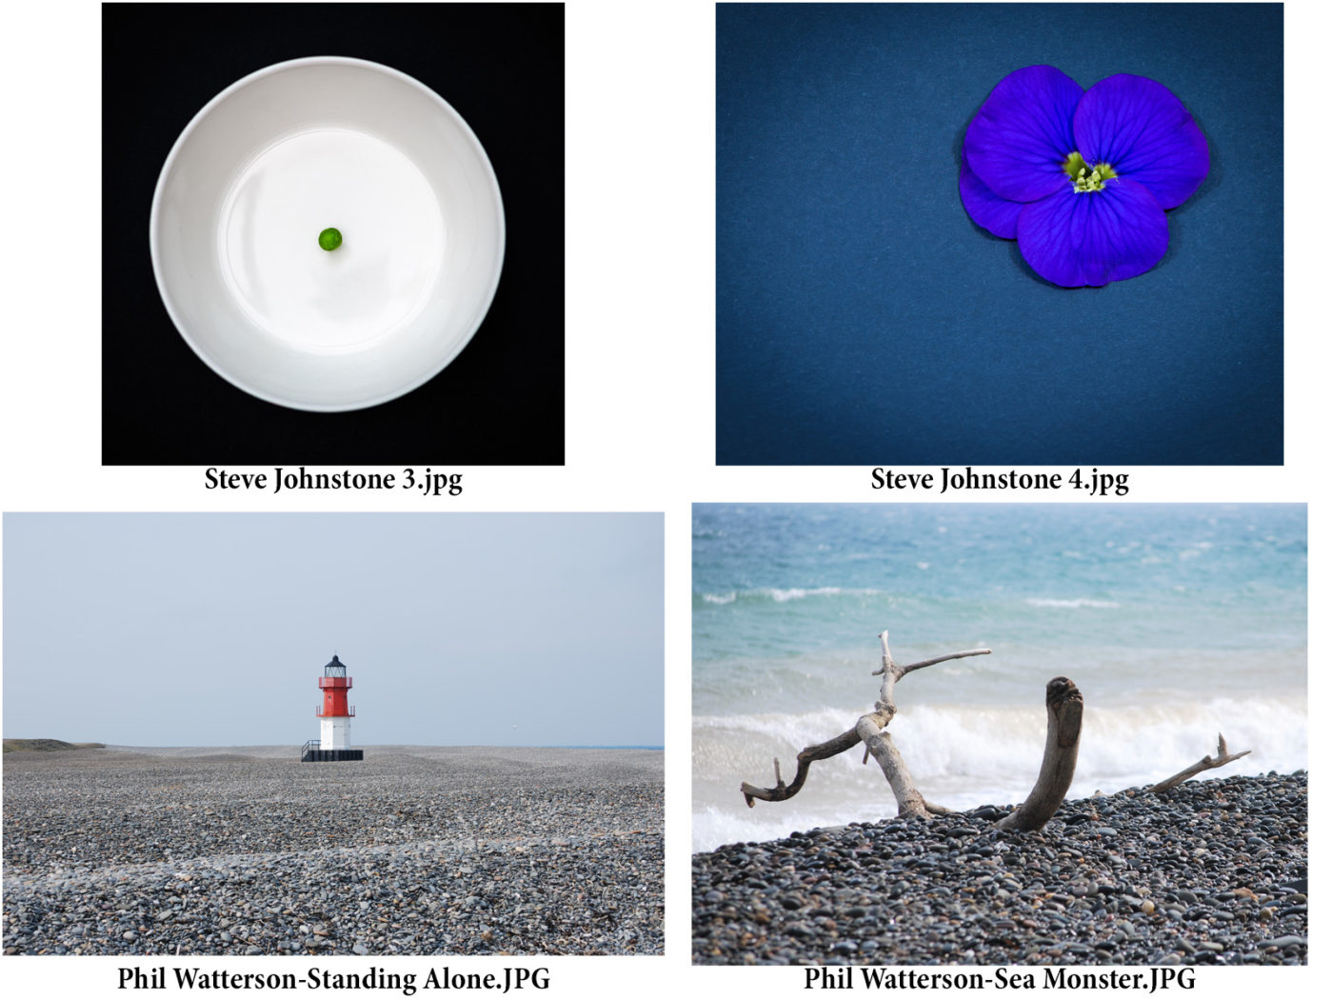
Another important addition to a good composition is to try to have a ‘leading line’. Put simply, this is usually something going from the front of the image towards the subject. Most usually a path, a track, a line of something such as stones, or footsteps. But in a minimalist image, the lines in the background can work well. Clouds in a sky leading to a solitary bird, likewise waves or sand patterns, or your image taken so that the subject is positioned at a cross-section in the background, eg a single figure on a corner of a cross-roads.
Having said all that, a stunning object, not too big, correctly placed on a complimentary background, will fit the criteria perfectly.
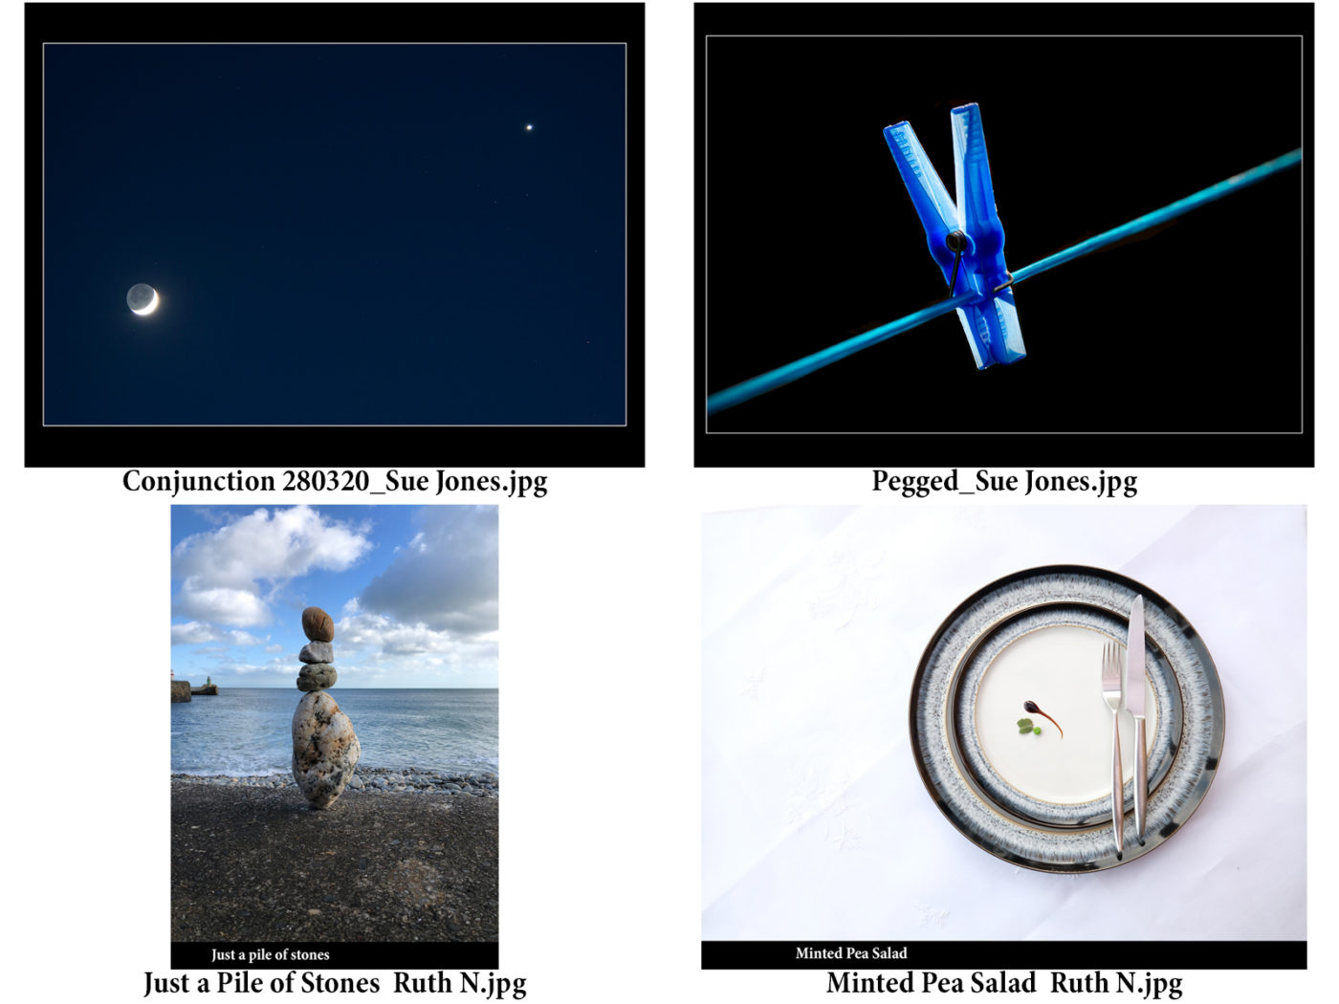
Ruth Nicholls

20200318 IOM Bristol Battle in spite of the Corona virus
We live in interesting if rather odd times, when circumstances seem to alter very rapidly and change is forced upon us – and the IOM Photographic Society is no different. As a result of the current difficulties, we have had to cancel our formal Wednesday evening meetings and seek other means to satisfy our photographic interests.
So…. this week’s meeting was expected to be a 2 Way Digital Image competition with the North West Bristol Camera Club but in the absence of a meeting, our judge, Steve Babb, kindly agreed to score remotely, and to provide his scores. Our members’ images are shown below, with scores from the Bristol judge and from our judge, in that order, in the title below each image. The Bristol club’s entries will be available as a slide show on the website soon.
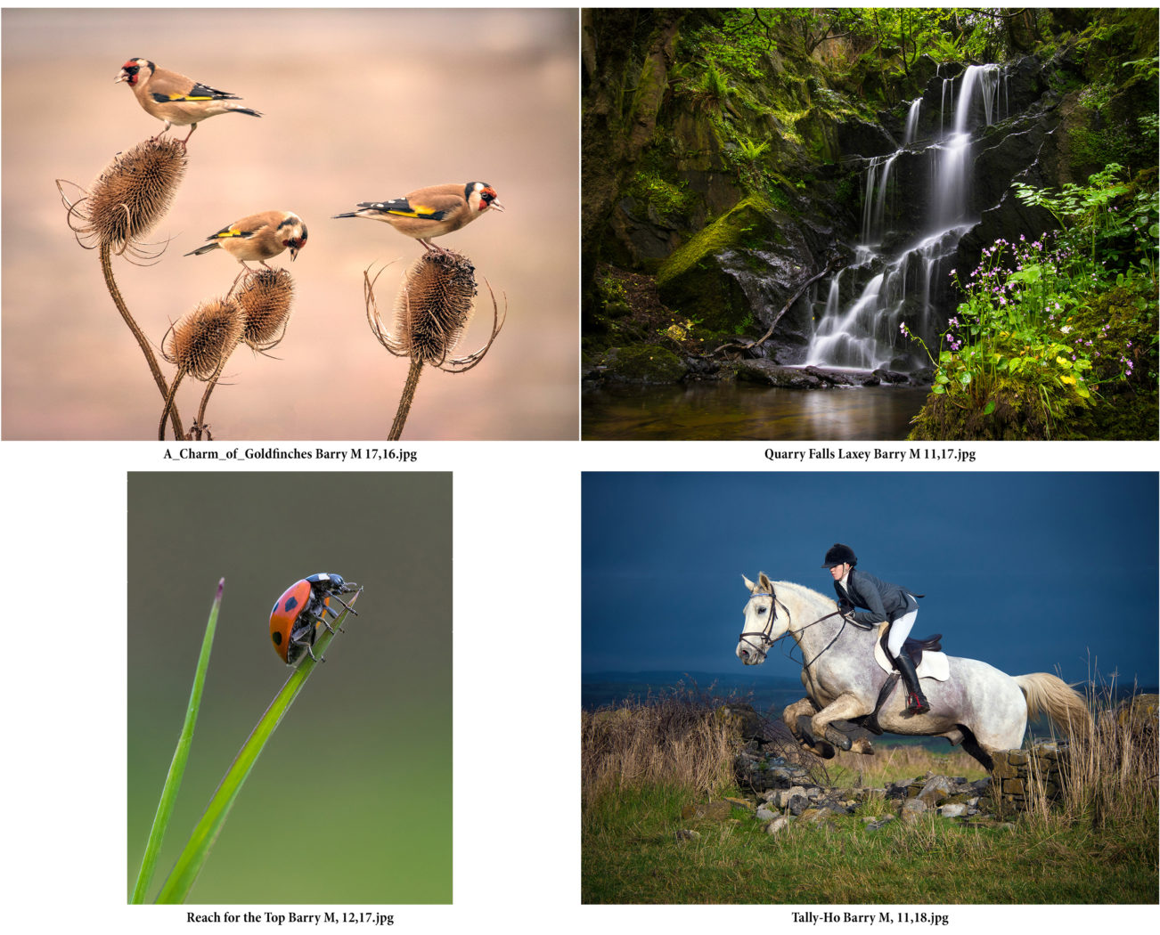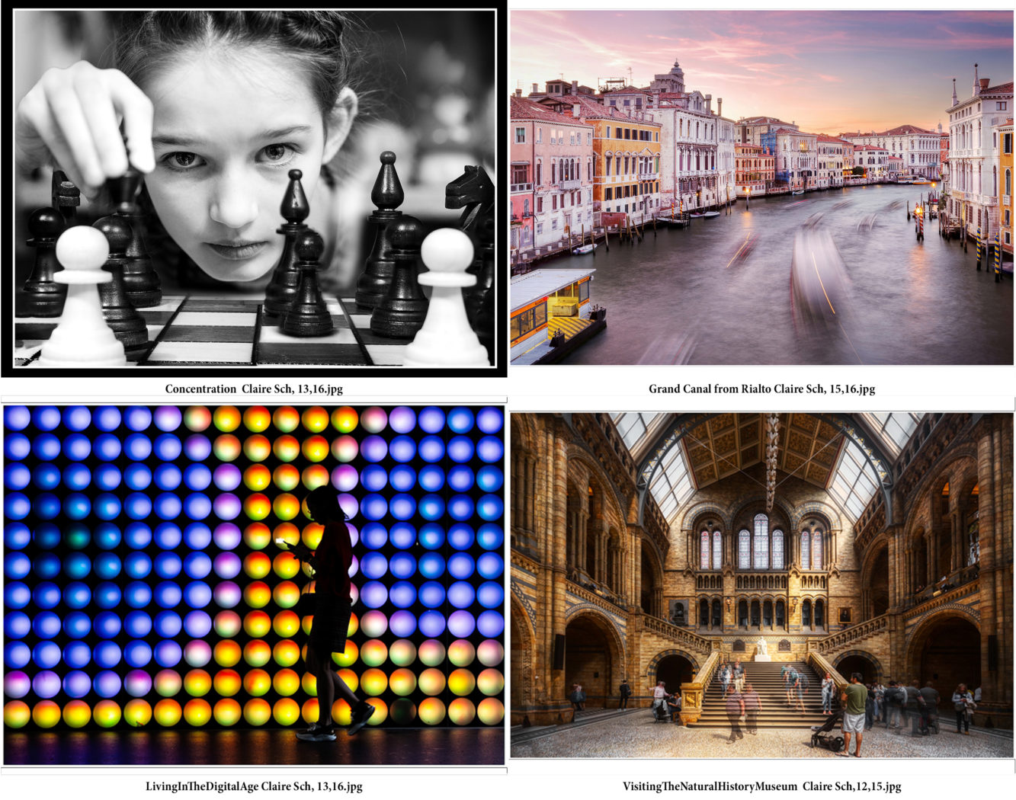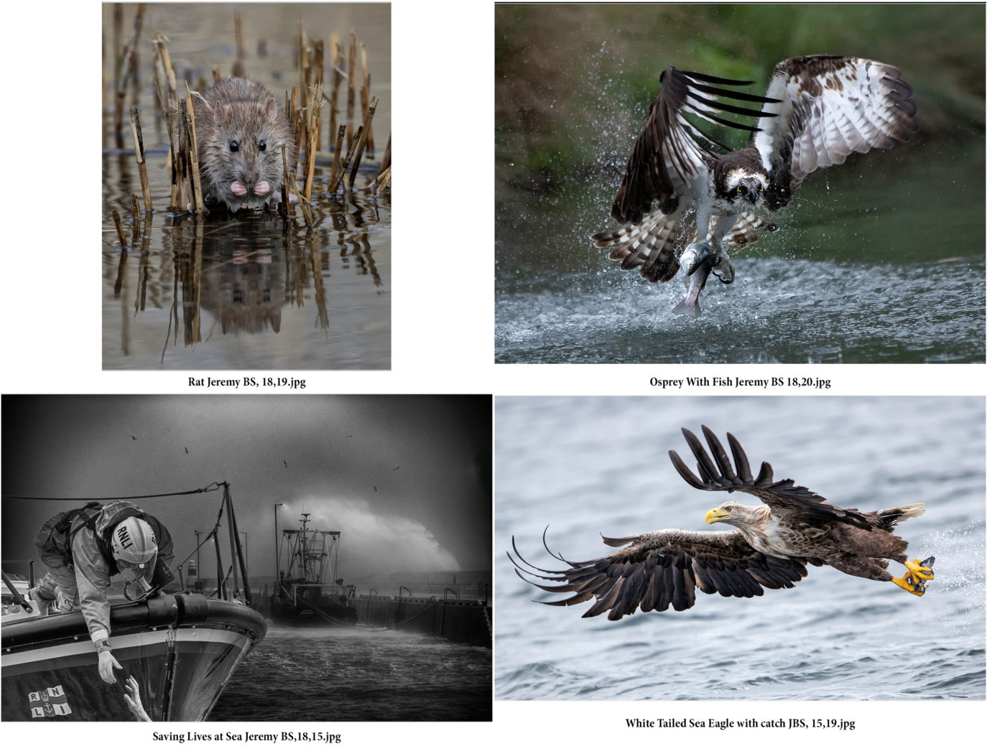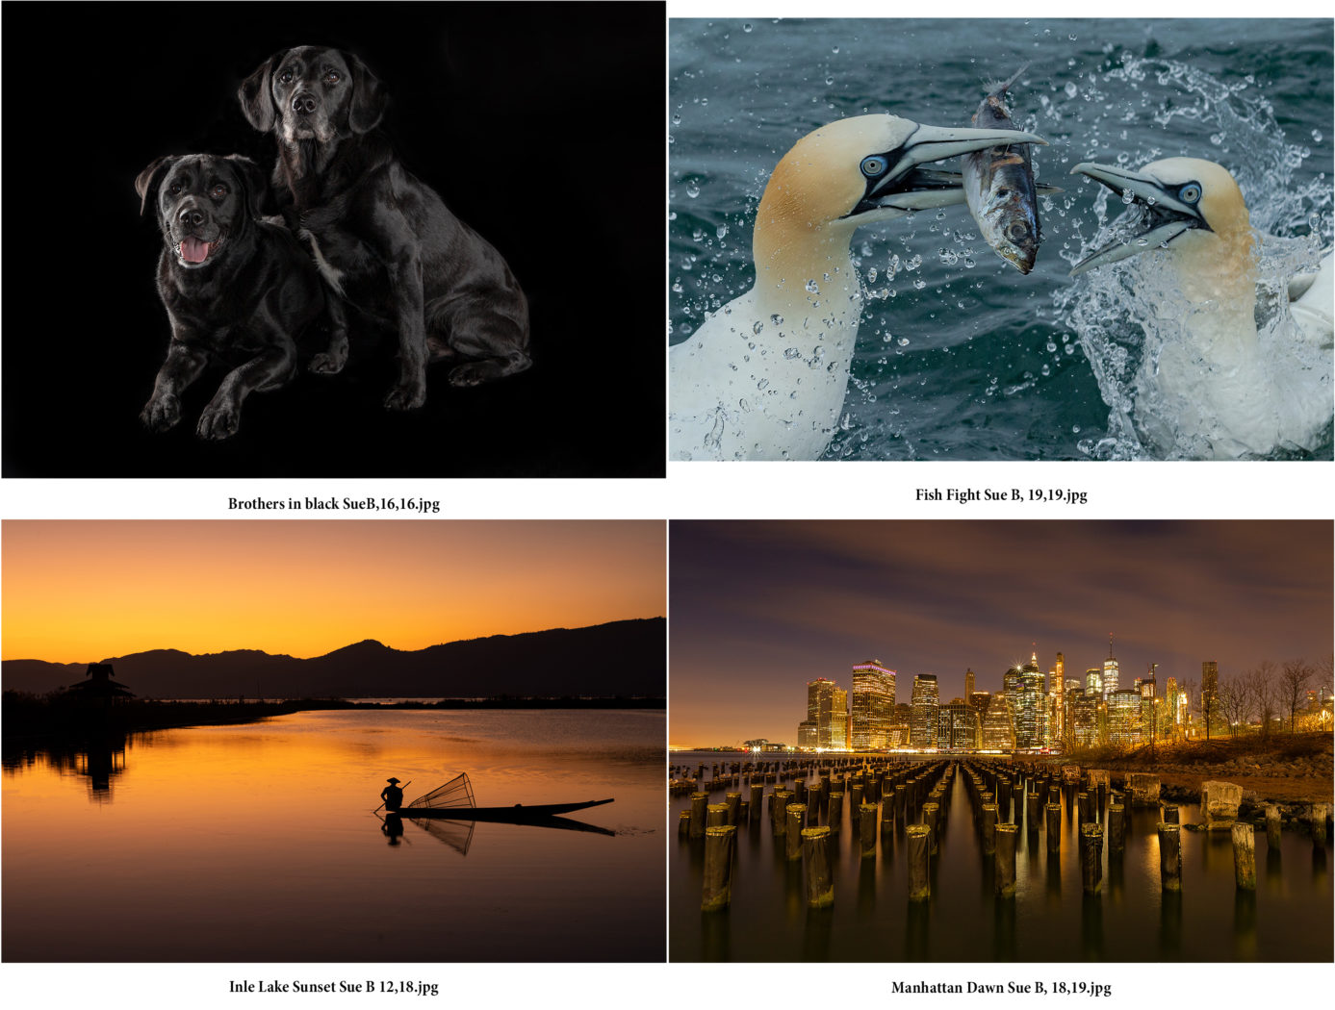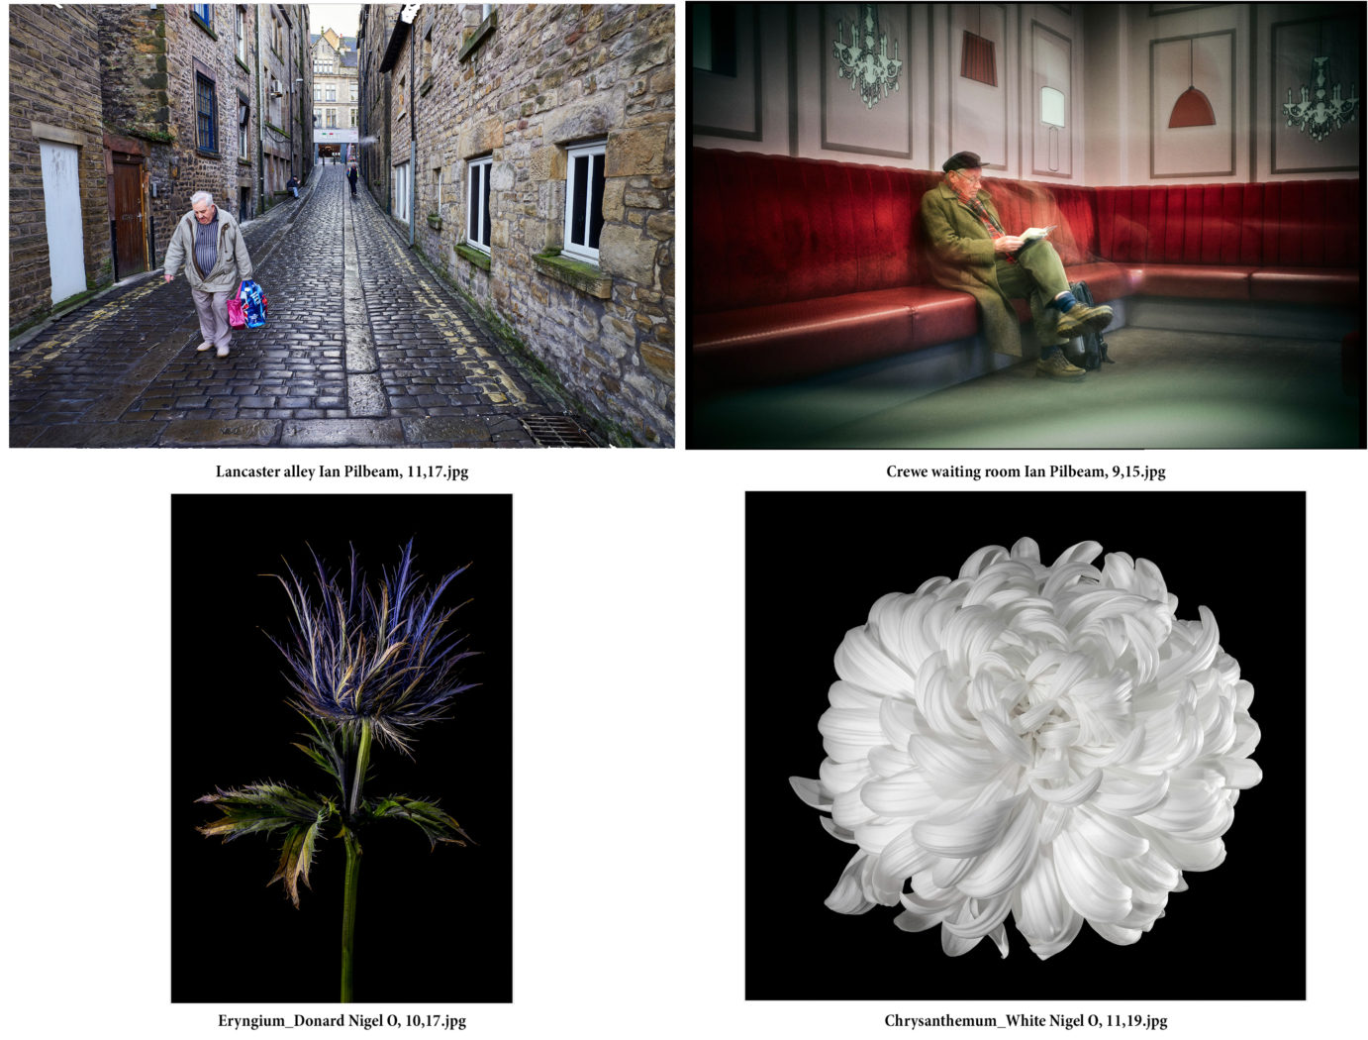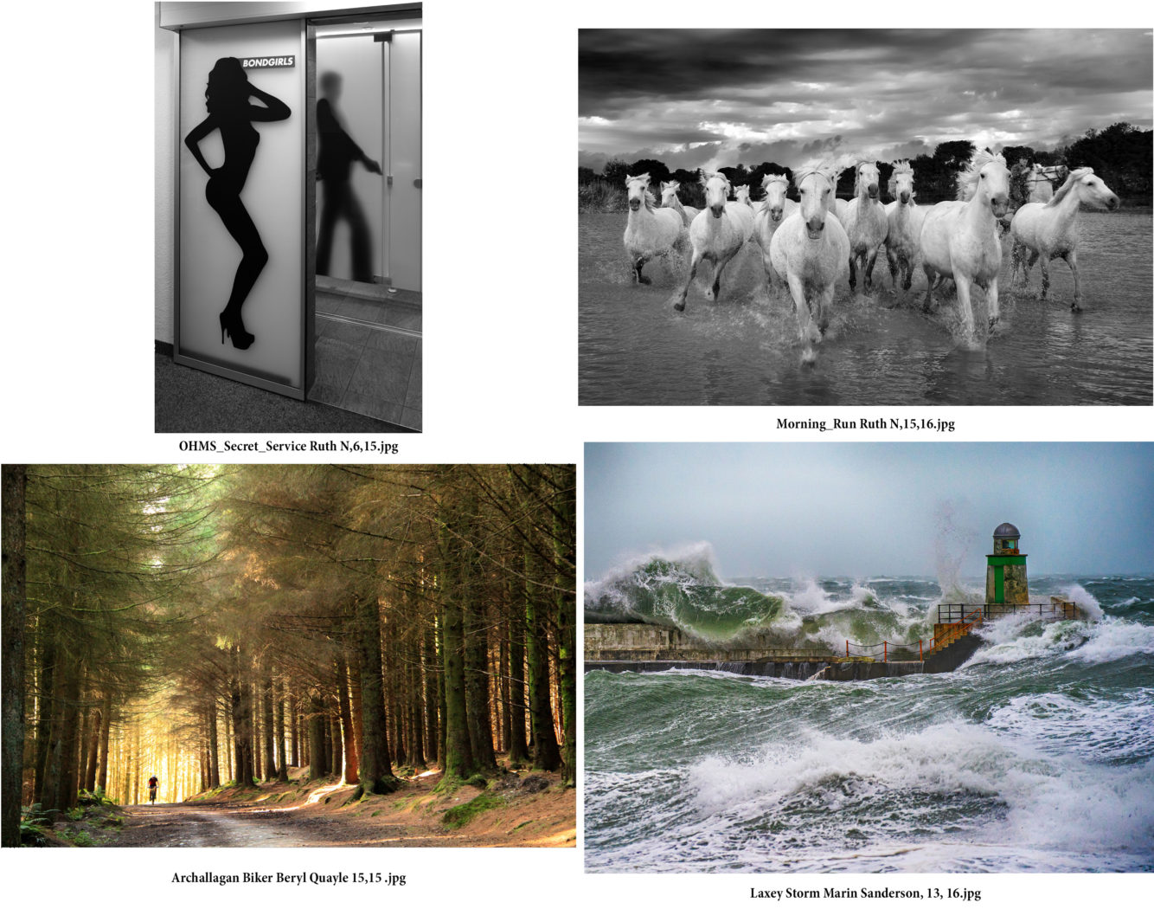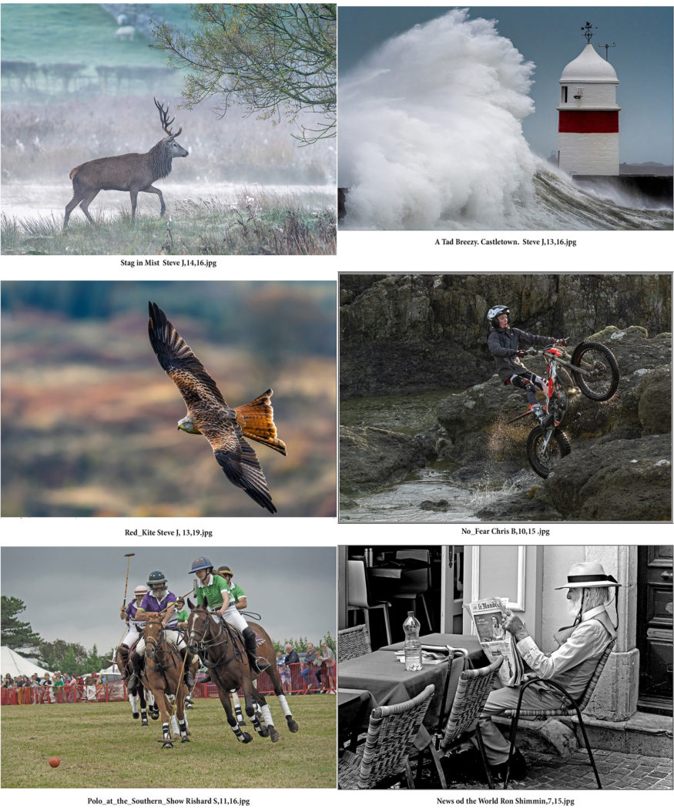
The 2 Way Battle is an annual event of some years standing – and one with an unusual format. The 2 clubs both provide 30 images – no more than 4 from any one member, all images scored out of a maximum of 20 each, with both clubs arranging a local showing and judging, the overall winner to be the result of amalgamating the scores from both clubs. It is a matter of record that over the years of the competition, the scores allocated by each judge for any particular image often disagree (sometimes quite significantly) BUT the overall total score allocated has always agreed as to the winning club.
And this year was no different. The Bristol judge generally scored low – with the Bristol club scoring 309 point to the IOMPS score of 396, whilst Steve Babb, using a more usual club scoring system also got the right result, giving Bristol 466 points compared to the IOMPS with 503. Yes – a wide points discrepancy but an agreement that the images from the IOMPS deserved their win. The IOMPS has a number of very talented members and their images provided the backbone to the winning score, in particular Jeremy Broome-Smith, Sue Blythe, Steve Johnstone, Barry Murphy and Nigel Owen. Our thanks to Steve Babb for his time and expertise in judging.
Looking ahead, given the enforced “distancing” we are likely to face for some weeks to come, maybe this is the opportunity to get into the garden or to walk some of our beautiful countryside, as long as this is allowed, and to get some local Manx images for future use.
Chris Blyth

Mostly Manx, images by Tony Curtis 11th March 2020
This week the Isle of Man Photographic Society had the pleasure of an evening of diversity, with all images originating from our members.
First-up was Tony Curtis, long-standing member of the club. He showed us an eclectic selection of his photographs. Not to be outdone by other Nature photographers in the club, he started with some lovely wildlife shots, including the wallabies in the Curraghs, difficult to photograph. Then we had a trip to Cornwall, a favourite haunt of his. While there, he photographed the annual Triathlon at Perranporth. This is named the ‘Surfswim, Cycle, and Painful Run’ with good reason, as the last leg involves a very steep hill overlooking the bay.
We were treated to a good selection of photos of his other passion, the work undertaken by the Laxey Mines Research Group, with a very interesting explanation of the amazing amount of underground mine workings that the group are surveying and making safe and secure, with the authorisation of the IOM Government.
Next we were taken round the TT course with a few excellent bike shots, and finally Tony showed us some of his accomplished portrait work, on which he was kind enough to give guidance as to how we could achieve similar results.
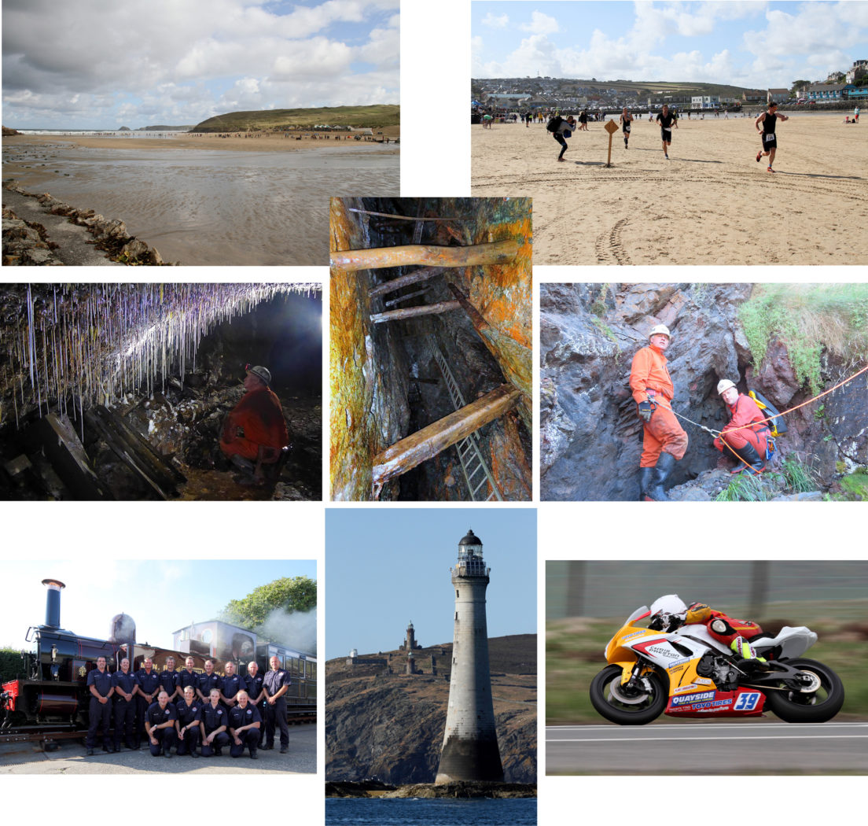

More Manx, Churches, and Wheels and Circles, also 11th March 2020
After the break we enjoyed seeing the club members’ ingenuity in sourcing unusual ‘outside the box’ images of two fun, non-competitive Challenges – ‘Churches’, set by Geoff Atkinson and ‘Wheels and Circles’, the choice of Lawrence McMullen. The challenges were the brain-child of member Barry Murphy and has proved very popular with members. The church images came from all over the island, from cathedral to ruin, and inside and out.
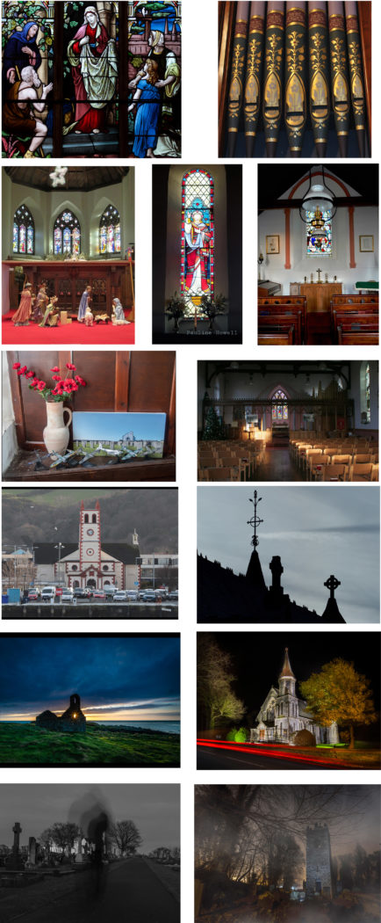
The Wheels and Circles challenge was more varied, from seen items to objects set up indoors to fulfil the brief.
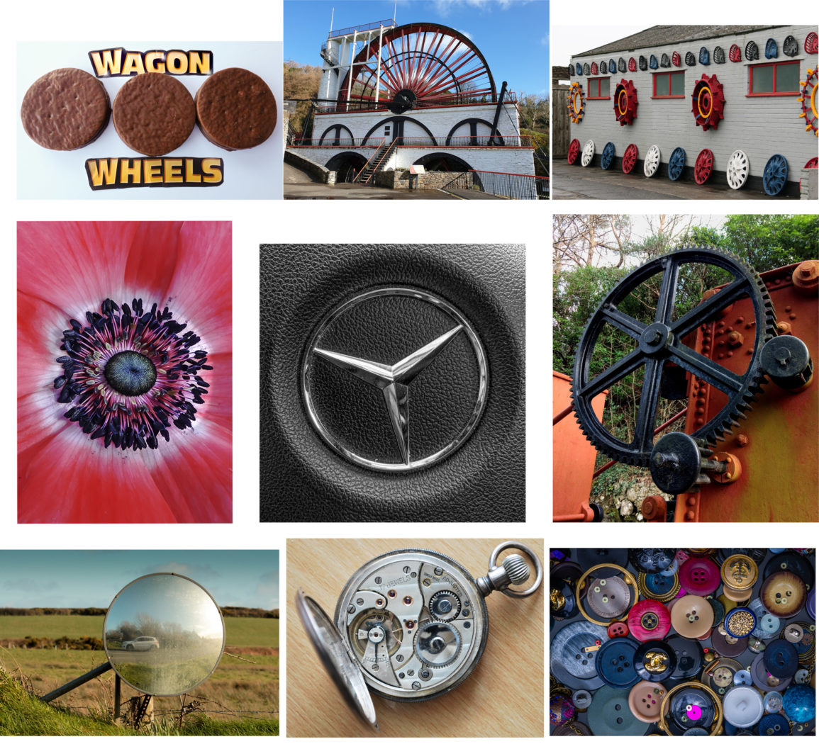
I have included one image from each member who submitted entries. The next Challenge is ‘Minimalism’, chosen by Janet Henry, to be taken before the end of March.
Everyone thoroughly enjoyed the evening, and President Jeremy Broome-Smith gave a very appreciative and enthusiastic vote of thanks.
Ruth Nicholls

